Diagnostic Accuracy of Fluorescence Immunoassay (FIA) versus Enzyme-Linked Immunosorbent Assay (ELISA) for Dengue Virus NS1 Antigen Detection: A Systematic Review and Meta-Analysis
Running title: FIA vs ELISA for dengue NS1: a DTA meta-analysis
Article type: Systematic review and meta-analysis of diagnostic test accuracy
Author Ritu Shah¹\*
Affiliation ¹ Corresponding author. Institutional department, city, country, email, ORCID, and telephone must be inserted on the journal submission form before upload. Project archive: https://github.com/ritsushah/Dengue
PROSPERO: protocol drafted (version 1.0, August 2026); CRD number pending assignment. Do not treat this review as PROSPERO-registered until a CRD identifier is issued.
Funding: This research received no specific grant from any funding agency in the public, commercial, or not-for-profit sectors.
Conflicts of interest: The author declares no conflicts of interest.
Data availability: Unique bibliographic records, extraction tables, analysis code, figures, and search logs are in the project repository cited above.
Word count: Abstract 298 · Main text approximately 6,200 (excluding tables, figure legends, and references)
Figures: 6 · Tables: 9 · Supplementary files: search strategies, extraction CSV, eligibility log, analysis code
Keywords: dengue; NS1 antigen; fluorescence immunoassay; FIA; ELISA; diagnostic accuracy; sensitivity; specificity; meta-analysis; QUADAS-2; bivariate model; point-of-care testing
————————————————————————

Highlights
- Bibliographic searches on 19 August 2026 identified 1,889 database records; 1,082 unique records remained after deduplication.
- Five commercial FIA evaluations (794 specimens) had reconstructable 2×2 tables and entered a bivariate random-effects model.
- Pooled sensitivity was 86.7% (95% CI 76.0–93.1) and pooled specificity 94.0% (89.6–96.6); PLR 14.3 (7.5–26.5), NLR 0.14 (0.07–0.26).
- Against independent or composite references (STANDARD F, k = 3), sensitivity fell to 80.5% (75.1–85.0) and specificity to 91.5% (87.7–94.2).
- Three of five studies were at high overall risk of bias. Dual independent screening of the full unique set was not completed. Certainty of evidence is low. A negative FIA does not exclude dengue.
————————————————————————

Abstract
Background. Dengue virus (DENV) infection remains a leading mosquito-borne threat. NS1 antigen detection during the first week of fever supports early care. Enzyme-linked immunosorbent assay (ELISA) is accurate but slow. Reader-based fluorescence immunoassay (FIA) returns a cutoff index in about 15 minutes. Prior rapid-test meta-analyses pooled FIA with visually read immunochromatographic tests (ICTs). This review isolates commercial FIA.
Objectives. To estimate the diagnostic accuracy of FIA for dengue NS1 antigen in suspected acute dengue, and to compare FIA with NS1 ELISA where paired data existed.
Methods. PubMed/MEDLINE, Embase, Web of Science Core Collection, and ScienceDirect were searched from inception to 19 August 2026. Cochrane Library and Google Scholar were supplementary. Scopus was not licensed at the search site and was not searched. Eligible studies evaluated a commercial reader-interpreted FIA for dengue NS1 and reported or permitted reconstruction of a 2×2 table versus RT-PCR, a composite laboratory standard, or NS1 ELISA. Risk of bias was assessed with a dengue-tailored QUADAS-2 tool. Sensitivity and specificity were pooled with a bivariate random-effects (Reitsma) model. Reporting followed PRISMA-DTA.
Results. Database searches identified 1,889 records (PubMed 423, Embase 959, Web of Science 432, ScienceDirect 75); 807 duplicates were removed, leaving 1,082 unique bibliographic records. Five studies (794 specimens; 320 reference-positive) entered quantitative synthesis. Pooled sensitivity was 86.7% (95% CI 76.0–93.1) and pooled specificity 94.0% (89.6–96.6). The positive likelihood ratio was 14.3 (7.5–26.5) and the negative likelihood ratio 0.14 (0.07–0.26). Heterogeneity was moderate for sensitivity (I² = 51%) and lower for specificity (I² = 35%). In the three STANDARD F evaluations that did not use NS1 ELISA as the sole reference, pooled sensitivity was 80.5% (75.1–85.0) and specificity 91.5% (87.7–94.2). Two QUANTI CARD studies that used NS1 ELISA as the reference reported sensitivity 96.6–100% and specificity 96.4–98.4%; those figures measure concordance with ELISA, not accuracy versus an independent standard. A sixth study (Pohekar 2023, n = 300) could not be pooled: off-diagonal 2×2 cells were not published. Three of five pooled studies were at high overall risk of bias. Dual independent screening of all 1,082 unique records was not performed.
Conclusions. Commercial FIA for dengue NS1 has a likelihood ratio profile that supports rule-in during the febrile window when the reader is available. An NLR of 0.14 does not support standalone rule-out. The evidence base is small, reference standards are mixed, and several studies used two-gate or enriched sampling. FIA should not be procured or guideline-coded as if it were visual ICT or NS1 ELISA. ELISA and RT-PCR remain necessary for confirmation, serotyping, and negative results in high-probability patients.
Registration. PROSPERO CRD pending.
————————————————————————

1. Introduction

1.1 Global burden of dengue
Dengue virus (DENV) infection is among the most important arthropod-borne viral threats of the twenty-first century. Four antigenically distinct serotypes (DENV-1–4) of a single-stranded positive-sense RNA flavivirus are transmitted mainly by Aedes aegypti and Aedes albopictus [1,2]. Bhatt et al. estimated 390 million infections per year (95% credible interval 284–528 million), of which 96 million (67–136 million) are apparent at any severity [3]. Asia bore about 70% of that burden [3].
In 2024 the recorded burden reached a historic high: 14,434,584 cases, including 7,718,585 laboratory-confirmed infections, 52,738 severe cases, and 11,201 deaths, across all six WHO regions [4]. The Region of the Americas contributed over 90% of reports [4]. Climate-driven expansion of Aedes habitats, urbanization, mobility, and shifting serotype immunity underlie this surge [5,6]. WHO lists dengue among its leading global health threats [5].

1.2 NS1 as an acute-phase biomarker
Clinical dengue—undifferentiated fever, myalgia, retro-orbital pain, rash—overlaps malaria, chikungunya, Zika, leptospirosis, and typhoid [7,8]. Syndromic diagnosis is unreliable; laboratory confirmation is required for care, outbreak detection, and surveillance [2].
NS1 is a 46–50 kDa conserved glycoprotein secreted at high concentration during peak viremia [9,10]. Antigenemia is detectable from day 1 of symptoms, often 2–4 days before IgM, and frequently through day 9 [9,11]. In primary infection, detection commonly exceeds 80% in the first four days [12]. In secondary infection, anamnestic anti-NS1 IgG sequesters free NS1 into immune complexes, shortening detectability and reducing sensitivity [12,14]. Serotype also matters: primary DENV-1 typically yields higher NS1 than primary DENV-2 [12]. Any platform must therefore perform across immune status, serotype, and day of illness.

1.3 ELISA: laboratory standard and operational limits
NS1 ELISA remains the recommended laboratory method where infrastructure exists [2,15]. Platelia Dengue NS1 Ag-ELISA (Bio-Rad) and Panbio Dengue Early ELISA (Abbott) use sandwich formats with peroxidase-labelled monoclonal antibodies [16,17].
Pooled specificity is high (about 97–99%); sensitivity varies. Da Silva et al. (30 studies) reported Platelia sensitivity 74% (63–82%) and Panbio 66% (61–71%), falling further in secondary infection [18]. Guzmán et al., in a six-country evaluation, found Platelia more sensitive than Pan-E (66% vs 52%) with 100% specificity in non-dengue febrile patients [19]. Pillay et al. estimated NS1 ELISA sensitivity 90% (95% CrI 68–98%) on days 0–4 in a Bayesian model that does not assume a perfect gold standard [20].
ELISA nonetheless requires plate readers, incubators, trained staff, cold storage, and batching, with 4–8 hours from sample receipt [15,21,22]. Transport from primary or rural sites may add 6–24 hours, so time-to-result often exceeds 24–48 hours [22]. The critical phase of severe dengue clusters around days 3–7, when NS1 is already declining [2,7].

1.4 Fluorescence immunoassay as a distinct technology
FIA aims to combine an objective, reader-based cutoff index (COI) with near-point-of-care speed. Unlike visual ICT, FIA uses fluorescent labels and a compact optical reader [23,24]. STANDARD F Dengue NS1 Ag FIA (SD Biosensor) uses a barcoded cartridge on an analyzer and returns results in 5–15 minutes from whole blood, serum, or plasma [23,25]. The NS1 Ag QUANTI CARD (J. Mitra) uses a related fluorescence principle with an iQuant reader [26,52].
Individual evaluations have reported STANDARD F NS1 sensitivity of 79.1% and specificity of 92.3% against a combinatorial RT-PCR plus antibody ELISA standard [25], and QUANTI CARD sensitivity of 96.5% and specificity of 96.4% against NS1 ELISA [26]. These numbers cannot be compared as if they estimated the same parameter: the reference standards differ.

1.5 Evidence gap
Prior syntheses did not isolate FIA. Mata et al. (57 studies, 40 in meta-analysis) reported NS1/IgM/IgG ICT sensitivity 91% and specificity 96% without separating FIA from visual ICT [28]. Haider et al. (15 studies, 4,135 participants) found NS1-only ICT sensitivity 70.97% and specificity 94.73% (DOR 43.95) [29]. Frazer and Norton reviewed dengue diagnostics in the vaccine era but did not pool FIA [30].
FIA and visual ICT differ in signal (fluorescence vs colloidal gold), interpretation (COI vs lines), analytical limit, and operator dependence. Pooling them obscures FIA performance and misleads procurement.

1.6 Objectives
Primary objective. To estimate pooled sensitivity, specificity, positive and negative likelihood ratios (PLR, NLR), and diagnostic odds ratio (DOR) of commercial FIA for dengue NS1 in suspected acute dengue, using a bivariate random-effects meta-analysis.
Secondary objectives. (1) Head-to-head FIA vs ELISA on the same specimens when an independent reference was available. (2) Description of the SROC in the observed false-positive-rate region. (3) Heterogeneity and pre-specified subgroups (fitted only if k ≥ 4 per stratum). (4) QUADAS-2. (5) Deeks’ test. (6) Placement of FIA in a diagnostic algorithm.
————————————————————————

2. Methods
This diagnostic test accuracy (DTA) review was designed and reported according to PRISMA-DTA [31], the PRISMA-DTA explanation and elaboration [32], PRISMA 2020 [33], PRISMA-S [34], and Cochrane DTA guidance [35]. STARD 2015 informed assessment of primary-study reporting [36]. Ethical approval was not required (secondary analysis of published data).

2.1 Protocol and registration
A protocol was prepared before quantitative synthesis (protocols/prospero_protocol.md, version 1.0, August 2026). Submission to PROSPERO has not yet returned a CRD number. Deviations from the written protocol are listed in Section 2.12.

2.2 Review question (PIRD)
What is the diagnostic accuracy of fluorescence immunoassay (FIA) compared with enzyme-linked immunosorbent assay (ELISA) for detection of dengue virus NS1 antigen in patients with suspected acute dengue infection?
Component | Definition
Population | Any age; clinically suspected acute dengue; intended fever window ≤7 days from onset. Specimens: venous whole blood, serum, or plasma.
Index test | Commercial FIA for dengue NS1 (STANDARD F, QUANTI CARD, or equivalent reader-interpreted fluorescence assays). Positivity: manufacturer COI.
Reference standard | Tier 1: RT-PCR; Tier 2: virus isolation ± RT-PCR; Tier 3: composite (RT-PCR + serology ± NS1 ELISA); Tier 4: NS1 ELISA alone if molecular testing is unavailable. ELISA is also the comparator in paired analyses.
Target condition | Acute DENV-1–4 infection in the febrile window.

2.3 Eligibility criteria
Inclusion. Patients with suspected acute dengue. Commercial FIA for NS1 with automated or semi-automated COI. Reference: RT-PCR, isolation, composite, and/or NS1 ELISA. Designs: cross-sectional DTA, prospective or retrospective diagnostic cohorts, head-to-head comparisons. Extractable or reconstructable 2×2 table (true positives [TP], false positives [FP], false negatives [FN], true negatives [TN]). Original data. No language or date limits.
Exclusion. Asymptomatic seroprevalence or blood-bank screening only; convalescent-only specimens without paired acute samples; animal or spiked-sample studies without a clinical cohort; saliva/urine only; combined NS1/IgM/IgG assays that cannot be disaggregated to NS1; reviews, editorials, correspondence, and case reports without denominators; non-reconstructable 2×2 data; duplicate datasets (most complete report retained). Experimental laboratory platforms (for example multilayer host-biomarker fluorescent assays, smartphone research lateral-flow devices, chopped-optical biosensors) were excluded as not equivalent to commercial cartridge FIA. Automated laboratory ELFA (VIDAS NS1) was excluded as a different technology class.
Fever duration ≤7 days was the protocol population. Studies of clinically suspected acute dengue that did not report day of illness were not automatically excluded; they were retained with Unclear applicability and examined in a documented-fever sensitivity analysis. This is a protocol deviation (Section 2.12).

2.4 Information sources and search
Searches were executed on 19 August 2026 (principal-investigator override of a planned September 2026 lock). Sources:
- PubMed/MEDLINE (https://pubmed.ncbi.nlm.nih.gov/)
- Embase.com via institutional OpenAthens
- Web of Science Core Collection, Topic field, all editions
- ScienceDirect Advanced Search, title/abstract/keywords
- Cochrane Library (CDSR and CENTRAL) — supplementary
- Google Scholar — supplementary (protocol cap 200; 100 harvested)
- ClinicalTrials.gov and Europe PMC preprints — grey literature
- OpenAlex and Crossref — public indexes; Crossref was not used as a PRISMA identification source (too sensitive)
Scopus was not searched (not licensed on the University of Toledo A–Z database list used for access).
The strategy combined five blocks: dengue AND NS1 AND (FIA OR ELISA) AND diagnostic-accuracy terms. Full strings are in data/search_strategies.md. Index (PubMed) strategy:
("Dengue"[MeSH] OR "Dengue Virus"[MeSH] OR "Severe Dengue"[MeSH]
OR dengue[tiab] OR DENV[tiab] OR "dengue fever"[tiab]
OR "dengue hemorrhagic fever"[tiab] OR "dengue shock syndrome"[tiab])
AND
("Viral Nonstructural Proteins"[MeSH] OR NS1[tiab] OR "NS-1"[tiab]
OR "NS1 antigen"[tiab] OR "nonstructural protein 1"[tiab]
OR "non-structural protein 1"[tiab])
AND
(("Fluoroimmunoassay"[MeSH] OR "fluorescence immunoassay"[tiab]
OR "fluorescent immunoassay"[tiab] OR FIA[tiab] OR TRFIA[tiab]
OR "STANDARD F"[tiab] OR "SD Biosensor"[tiab] OR "QUANTI CARD"[tiab])
OR
("Enzyme-Linked Immunosorbent Assay"[MeSH] OR ELISA[tiab]
OR "enzyme immunoassay"[tiab] OR Platelia[tiab] OR Panbio[tiab]))
AND
("Sensitivity and Specificity"[MeSH] OR "Predictive Value of Tests"[MeSH]
OR "ROC Curve"[MeSH] OR sensitivity[tiab] OR specificity[tiab]
OR "diagnostic accuracy"[tiab] OR "likelihood ratio"[tiab]
OR "true positive"[tiab] OR "false negative"[tiab])
ScienceDirect constraint. Elsevier’s interface rejected the full protocol tak() string (maximum eight Boolean connectors per field). A condensed query was used: (dengue OR DENV) AND NS1 AND (FIA OR ELISA OR "fluorescence immunoassay" OR Platelia) AND (sensitivity OR specificity). Unfiltered hits: 88; Research + Review filter: 75.
Google Scholar. The protocol primary query with many AND-quoted blocks returned 0 hits. A focused FIA query was used; the first 100 results by relevance were saved (pages 1–10). Pages 11–20 of the 200-result cap were not harvested.
No language, date, or publication-type filters were applied in bibliographic databases. The search was validated by retrieval of known reports (Chaiyo 2022; Pohekar 2023) [25,27]. PRESS 2015 principles guided string construction [37].

2.5 Study selection
Records were harvested as RIS/CSV/PMID lists, parsed to a common schema, and deduplicated by DOI, then PMID, then normalized title plus year, with a title-only fallback (analysis/deduplicate_records.py).
Protocol deviation — screening. Dual independent title/abstract screening of all unique bibliographic records, calibration to Cohen’s κ ≥ 0.80, and blinded Rayyan/Covidence workflow were specified in the protocol and were not completed. Because the electronic strategy used (FIA OR ELISA), the unique set is dominated by ELISA-only NS1 papers. Selection used:
- Title/field filter of the unique bibliographic set for FIA, fluorescence immunoassay, STANDARD F, QUANTI CARD, and iQuant.
- Full-text assessment of those records, plus one unique-set paper that named STANDARD F in the full text but not the title (Zapata-de la Cruz 2026) [53].
- Two protocol-scoping validations not retrieved among the four bibliographic databases: Ghogre 2021 and Pohekar 2017 [26,52].
Inter-rater κ is therefore not reported. Missed FIA papers whose titles lack FIA terms remain possible. This limitation is carried into GRADE.
Full-text exclusions used: wrong population; wrong index test (including experimental platforms and visual ICT); no reconstructable NS1 2×2; correspondence; conference abstract without cells; duplicate.

2.6 Data collection
A standardized form (data/extraction_template.md) was applied to included reports. Corresponding authors were not successfully used to recover missing 2×2 cells for Pohekar 2023; that study is described narratively only.
When cells were unreported, TP, FN, TN, and FP were reconstructed from published sensitivity, specificity, and denominators. Integer solutions were required to reproduce published Se, Sp, PPV, and NPV to the reported precision. Locked cells are in data/extraction/included_2x2_2026-08-19.csv. Missing items were coded not reported and were not imputed except the pre-specified continuity correction at the modelling stage.

2.7 Risk of bias (QUADAS-2)
QUADAS-2 [39] was tailored to dengue NS1 FIA (analysis/quadas2_protocol.md). Signalling questions added fever duration ≤7 days, IFU adherence, indeterminate handling, incorporation bias (ELISA as both comparator and sole reference), and reference-standard diagnostic window.
Judgments: Low / High / Unclear for risk of bias; Domains 1–3 also for applicability. NS1 ELISA as sole reference was judged Unclear for Domain 3, not automatically High, in line with the written protocol. Two-gate or IC-enriched sampling was High for Domain 1. Overall risk of bias was High if Domain 1 or two or more domains were High.
Assessments were performed by a single reviewer. Dual independent QUADAS-2 with κ was not completed (protocol deviation).

2.8 Statistical synthesis
Outcomes. Pooled sensitivity, specificity, PLR = Se/(1 − Sp), NLR = (1 − Se)/Sp, and DOR. The clinically relevant SROC region is low false-positive rate (FPR), matching observed studies.
Primary model. Bivariate random-effects model of Reitsma et al. [42], jointly modelling logit sensitivity and logit FPR with unstructured between-study covariance Ψ. Without covariates this model is equivalent to the HSROC model of Rutter and Gatsonis [43,44]. Variance of Ψ: restricted maximum likelihood (REML). Mean vector μ: generalized least squares given Ψ. Continuity correction 0.5 was added to all four cells of studies with a zero cell. Wald 95% CIs for sensitivity and specificity were obtained on the logit scale. CIs for PLR, NLR, and DOR used a parametric bootstrap (10,000 draws from N(μ, vcov μ)).
The protocol named R mada::reitsma(). R was not available in the analysis runtime. The model was implemented in Python (analysis/dta_meta_analysis.py) with NumPy/SciPy. The likelihood is the same intercept-only Reitsma REML likelihood.
Head-to-head FIA vs ELISA versus an independent reference required ≥4 paired studies. That analysis was not fitted (k = 0 independent paired sets; k = 2 ELISA-as-reference concordance studies).
Publication bias. Deeks’ regression of ln(DOR) on 1/√ESS, where ESS = 4 × n_pos × n_neg / (n_pos + n_neg); two-sided p < 0.10 indicated possible small-study effects [45]. With k = 5 the test is underpowered and is interpreted as inconclusive rather than as proof of no bias.

2.9 Heterogeneity and subgroups
Heterogeneity: forest and SROC inspection; Cochran’s Q (α = 0.10) [48]; I² (0–40% might not be important; 30–60% moderate; 50–90% substantial) [48]; bivariate τ²; ρ < −0.3 suggesting a threshold effect.
Subgroup bivariate models required ≥4 studies per stratum. No stratum other than the overall model and one exploratory three-study subset met that rule. Pre-specified fever-day, infection-status, and serotype models were therefore not fitted.

2.10 Sensitivity analyses
Pre-specified and completed where k allowed: leave-one-out; continuity corrections 0.1, 0.5, and 1.0; 0.5 applied to all cells; STANDARD F only; reference other than NS1 ELISA alone; studies with documented fever ≤7 days (narrative if k < 3). HSROC area under the curve integrated over FPR 0–1 was not used as a primary accuracy measure: with k = 5 the between-study correlation was estimated at the boundary (ρ ≈ −0.97), producing a globally implausible SROC. Inference is based on the summary operating point.

2.11 Certainty of evidence
GRADE for DTA [49] was applied to sensitivity and specificity. Starting from high certainty for accuracy studies, rating down was considered for risk of bias, inconsistency, indirectness (mixed reference standards; incomplete screening), imprecision, and publication bias.

2.12 Protocol deviations (complete list)
- Search date 19 August 2026 rather than September 2026 (investigator override).
- Scopus not searched (no institutional licence).
- ScienceDirect query condensed to the vendor Boolean limit.
- Google Scholar: 100 of 200 protocol-cap results harvested; primary fully quoted query returned 0 hits.
- Dual independent screening of all unique bibliographic records not completed; FIA-term filter plus scoping papers used instead.
- Dual independent extraction and QUADAS-2 not completed (single reviewer).
- PROSPERO CRD identifier not yet assigned.
- Studies without documented fever ≤7 days included if they enrolled clinically suspected acute dengue.
- Analysis engine: Python Reitsma REML rather than R mada.
- Head-to-head bivariate FIA vs ELISA and all k ≥ 4 subgroups not fitted (insufficient studies).
- Full-range HSROC AUC not interpreted (boundary correlation).
————————————————————————

3. Results

3.1 Study selection
The search was run on 19 August 2026. Hits by source are in Table 1.
Table 1. Records by information source (19 August 2026)
Source | Records (n) | Role
PubMed/MEDLINE | 423 | Identification
Embase | 959 | Identification
Web of Science Core Collection | 432 | Identification
ScienceDirect (condensed TAK; research + review) | 75 | Identification
Scopus | not searched | No institutional licence
Bibliographic total before deduplication | 1,889
Duplicates removed | 807
Unique bibliographic records | 1,082
Cochrane CENTRAL (CDSR = 0) | 10 | Supplementary
Google Scholar (FIA-focused, first 100) | 100 | Supplementary
ClinicalTrials.gov | 22 | Grey
Europe PMC preprints | 66 | Grey
Protocol-scoping papers not in the 1,082 | 2 | Ghogre 2021; Pohekar 2017

Of 75 ScienceDirect records, 14 were unique to that source after overlap with PubMed/Embase/Web of Science.
The FIA-term title/field filter flagged 10 of 1,082 unique records. Thirteen full texts were assessed (10 flagged records + Zapata-de la Cruz 2026 + two scoping papers). Eight were excluded (Table 2). Five studies entered the bivariate model. Pohekar 2023 was eligible on index test and population but lacked reconstructable off-diagonal cells and was retained for narrative description only (qualitative n = 6).
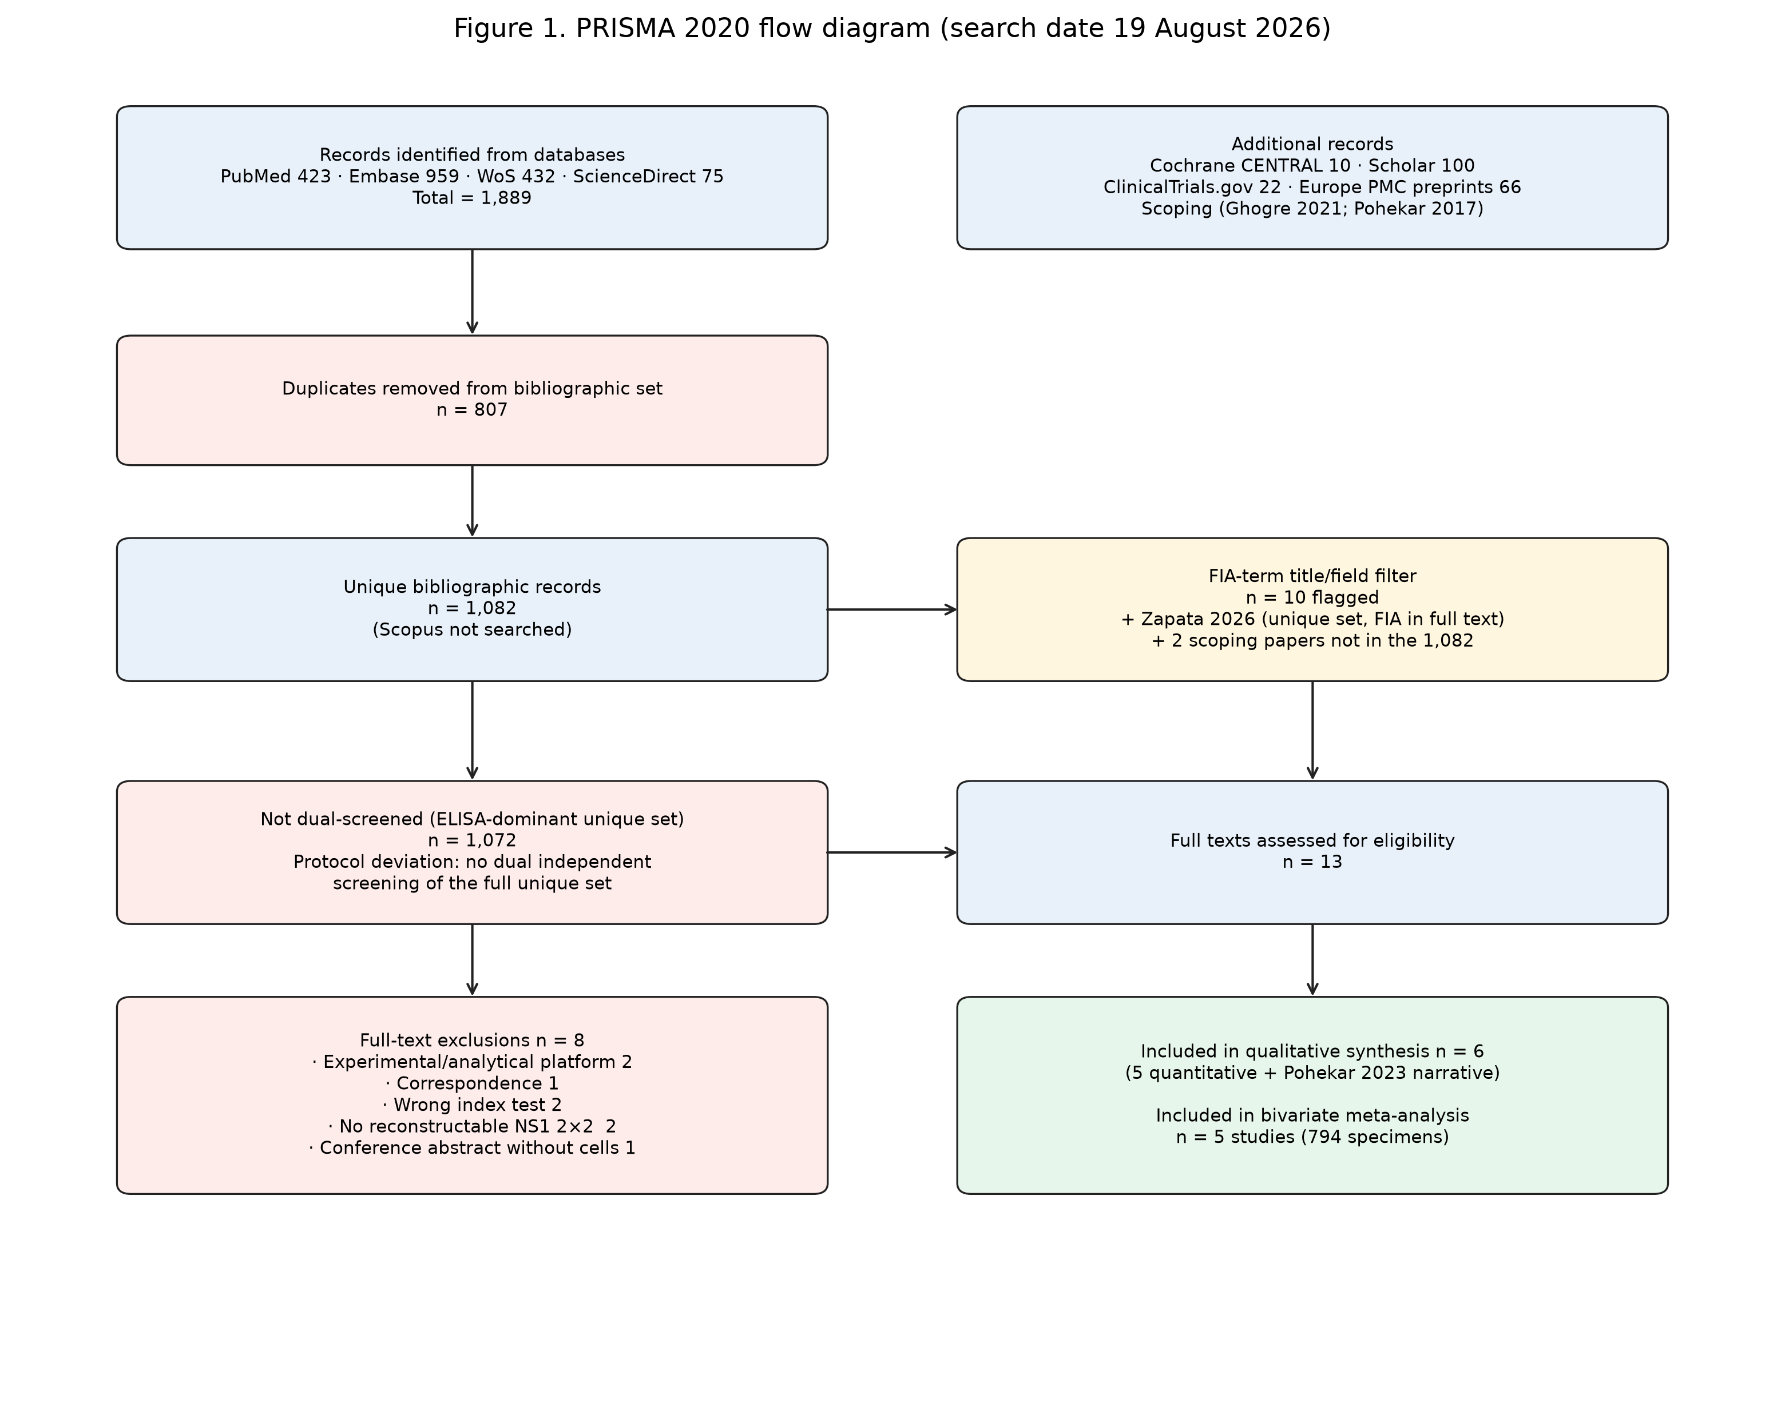
Figure 1. PRISMA 2020 flow diagram
Figure 1. PRISMA 2020 flow diagram for the 19 August 2026 search.
Table 2. Full-text exclusions (n = 8)
Record | Reason
Chopped optical biosensing, Talanta 2026 | Experimental analytical platform, not commercial FIA
Multilayer fluorescent immunoassay, Bioconjug Chem 2025 | Experimental host and viral biomarker assay
Rebuttal to Pohekar 2023, Indian J Med Microbiol 2024 | Correspondence
CCA 2022 conference abstract (NS1/CHIKV/HCV FIA) | Abstract without reconstructable dengue-only 2×2
Buonora et al. 2017 Portuguese ICT paper | Visual immunochromatography (false-positive FIA-term match)
Brazilian clinical-diagnosis reliability 2018 | Wrong index test
Zammarchi et al. 2019, J Clin Virol | Selected panel (11 acute DENV); NS1-only 2×2 not reconstructable (published sensitivity is NS1 and/or IgM) [54]
Pohekar and Bhalchandra 2023, Indian J Med Microbiol | n = 300; FIA-positive 203 and ELISA-positive 200 without off-diagonal cells [27]

No language restriction was applied; one Portuguese-language record was excluded for wrong index test, not language.

3.2 Study characteristics
Five studies (2017–2026) contributed 794 specimens (320 reference-positive, 474 reference-negative; apparent prevalence 40.3%). Countries: India (2), Thailand (1), Indonesia (1), Mexico (1). Platforms: STANDARD F (3) and QUANTI CARD (2).
Table 3. Characteristics of studies in the quantitative synthesis
| Study | Country | Design | N | Fever | FIA | Reference | Specimen |
|-------|---------|--------|--:|-------|-----|-----------|----------|
| Chaiyo 2022 [25] | Thailand | Cluster sample by IC result (101 NS1+, 103 IgM+, 100 IgG+, 100 all-negative) | 404 | Mean 3.30 (SD 2.84) days | STANDARD F NS1 | RT-qPCR + IgM/IgG ELISA composite | Plasma |
| Zapata-de la Cruz 2026 [53] | Mexico | Random sample of stored plasmas from febrile suspected dengue | 125 | Days 2–6 | STANDARD F NS1 | RT-PCR (primary cells) | Plasma |
| Ghogre 2021 [26] | India | Cross-sectional suspected dengue | 85 | Not reported (“early diagnosis”) | QUANTI CARD | NS1 ELISA | Serum |
| Zuroidah 2022 [55] | Indonesia | Two-gate: 50 DVI / 30 non-DVI | 80 | Not reported | STANDARD F NS1 | RT-PCR and/or Panbio NS1 ELISA | Serum |
| Pohekar 2017 [52] | India | Two-gate: 50 ICT+ and 50 ICT− selected from 200; manufacturer supplied kits | 100 | Not reported | QUANTI CARD | NS1 Microwell ELISA | Blood/serum/plasma |
| Total | 4 countries | | 794 | | | | |
Primary versus secondary infection and serotype-specific 2×2 tables were not published in a form that allowed stratum-specific pooling. Zapata-de la Cruz et al. worked in a hyperendemic Mexican setting with high IgG seroprevalence and interpreted results as likely representing mostly secondary infection [53]. Chaiyo et al. reported mean fever day 3.30 ± 2.84, so some patients may have been beyond day 7 even though the mean met the protocol window [25].
Table 4. Locked 2×2 tables (FIA versus the study reference used in the primary model)
| Study | TP | FP | FN | TN | N | Se % (Wilson 95% CI) | Sp % (Wilson 95% CI) | Zero cell |
|-------|---:|---:|---:|---:|--:|----------------------|----------------------|-----------|
| Chaiyo 2022 | 125 | 19 | 33 | 227 | 404 | 79.1 (72.1–84.7) | 92.3 (88.3–95.0) | No |
| Zapata-de la Cruz 2026 | 38 | 9 | 7 | 71 | 125 | 84.4 (71.2–92.3) | 88.8 (80.0–94.0) | No |
| Ghogre 2021 | 28 | 2 | 1 | 54 | 85 | 96.6 (82.8–99.4) | 96.4 (87.9–99.0) | No |
| Zuroidah 2022 | 41 | 0 | 9 | 30 | 80 | 82.0 (69.2–90.2) | 100 (88.6–100) | FP = 0 |
| Pohekar 2017 | 38 | 1 | 0 | 61 | 100 | 100 (90.8–100) | 98.4 (91.4–99.7) | FN = 0 |
| Total (cells) | 270 | 31 | 50 | 443 | 794 | | | |
Reconstruction notes. Chaiyo: published Se 79.11% of 158 confirmed dengue and Sp 92.28% of 246; PPV and NPV match 125/144 and 227/260 [25]. Zapata-de la Cruz: published FIA NS1 versus RT-PCR Se 84.44% and Sp 88.75% on 45 RT-PCR-positive and 80 RT-PCR-negative samples; PPV 80.85% and NPV 91.03% match 38/47 and 71/78 [53]. Ghogre: unique integers reproducing Se 96.5%, Sp 96.4%, PPV 93.3%, NPV 98.1% [26]. Zuroidah: 82% of 50 DVI and 100% of 30 non-DVI [55]. Pohekar 2017: among 100 samples tested by both FIA and ELISA, ELISA-positive = 38, FIA-positive = 39, all 50 ICT-negative samples were ELISA- and FIA-negative [52].
Zapata-de la Cruz versus the RT-PCR/IgM gold-standard construct (n = 121 after excluding 4 indeterminate): TP 47, FN 35, FP 0, TN 39 (Se 57.3%, Sp 100%) [53]. Those cells were not used in the primary model because the protocol’s preferred molecular reference is RT-PCR; they are reported as a sensitivity description.
Pohekar 2023 (n = 300 hospitalized suspected dengue) reported FIA-positive 203 and ELISA-positive 200 without a concordance table and is not in Table 4 [27].

3.3 Risk of bias
Single-reviewer QUADAS-2 judgments are in Table 5 and Figures 2–3.
Table 5. QUADAS-2 risk of bias
Study | D1 Patient selection | D2 Index test | D3 Reference | D4 Flow | Overall
Chaiyo 2022 | High (IC-enriched clusters, not consecutive suspected dengue) | Unclear (blinding not reported) | Low (composite RT-qPCR + antibody ELISA) | Low | High
Zapata-de la Cruz 2026 | Low (random sample of febrile suspected dengue, days 2–6) | Unclear | Low (RT-PCR for primary cells) | Low | Unclear
Ghogre 2021 | Unclear (enrollment sequence and fever day not reported) | Unclear | Unclear (NS1 ELISA as truth for NS1 FIA) | Low | Unclear
Zuroidah 2022 | High (two-gate DVI / non-DVI) | Unclear | High (RT-PCR and/or NS1 ELISA; incorporation) | Low | High
Pohekar 2017 | High (ICT-based two-gate selection) | Unclear (manufacturer supplied kits) | Unclear (same-manufacturer NS1 ELISA) | High (only 100 of 200 tested by FIA/ELISA) | High

Applicability: Chaiyo Domain 1 High (enriched spectrum). Ghogre, Zuroidah, and Pohekar 2017 Domain 1 Unclear to High (fever day not documented; case-control sampling). Zapata-de la Cruz applicability Low for the intended febrile-care scenario.
Three of five studies (60%) were at high overall risk of bias, driven by patient selection. No study reported explicit blinding of FIA interpretation to the reference standard; Domain 2 was Unclear throughout. Automated COI readout reduces some operator bias relative to visual ICT, but does not replace a documented blinding statement.
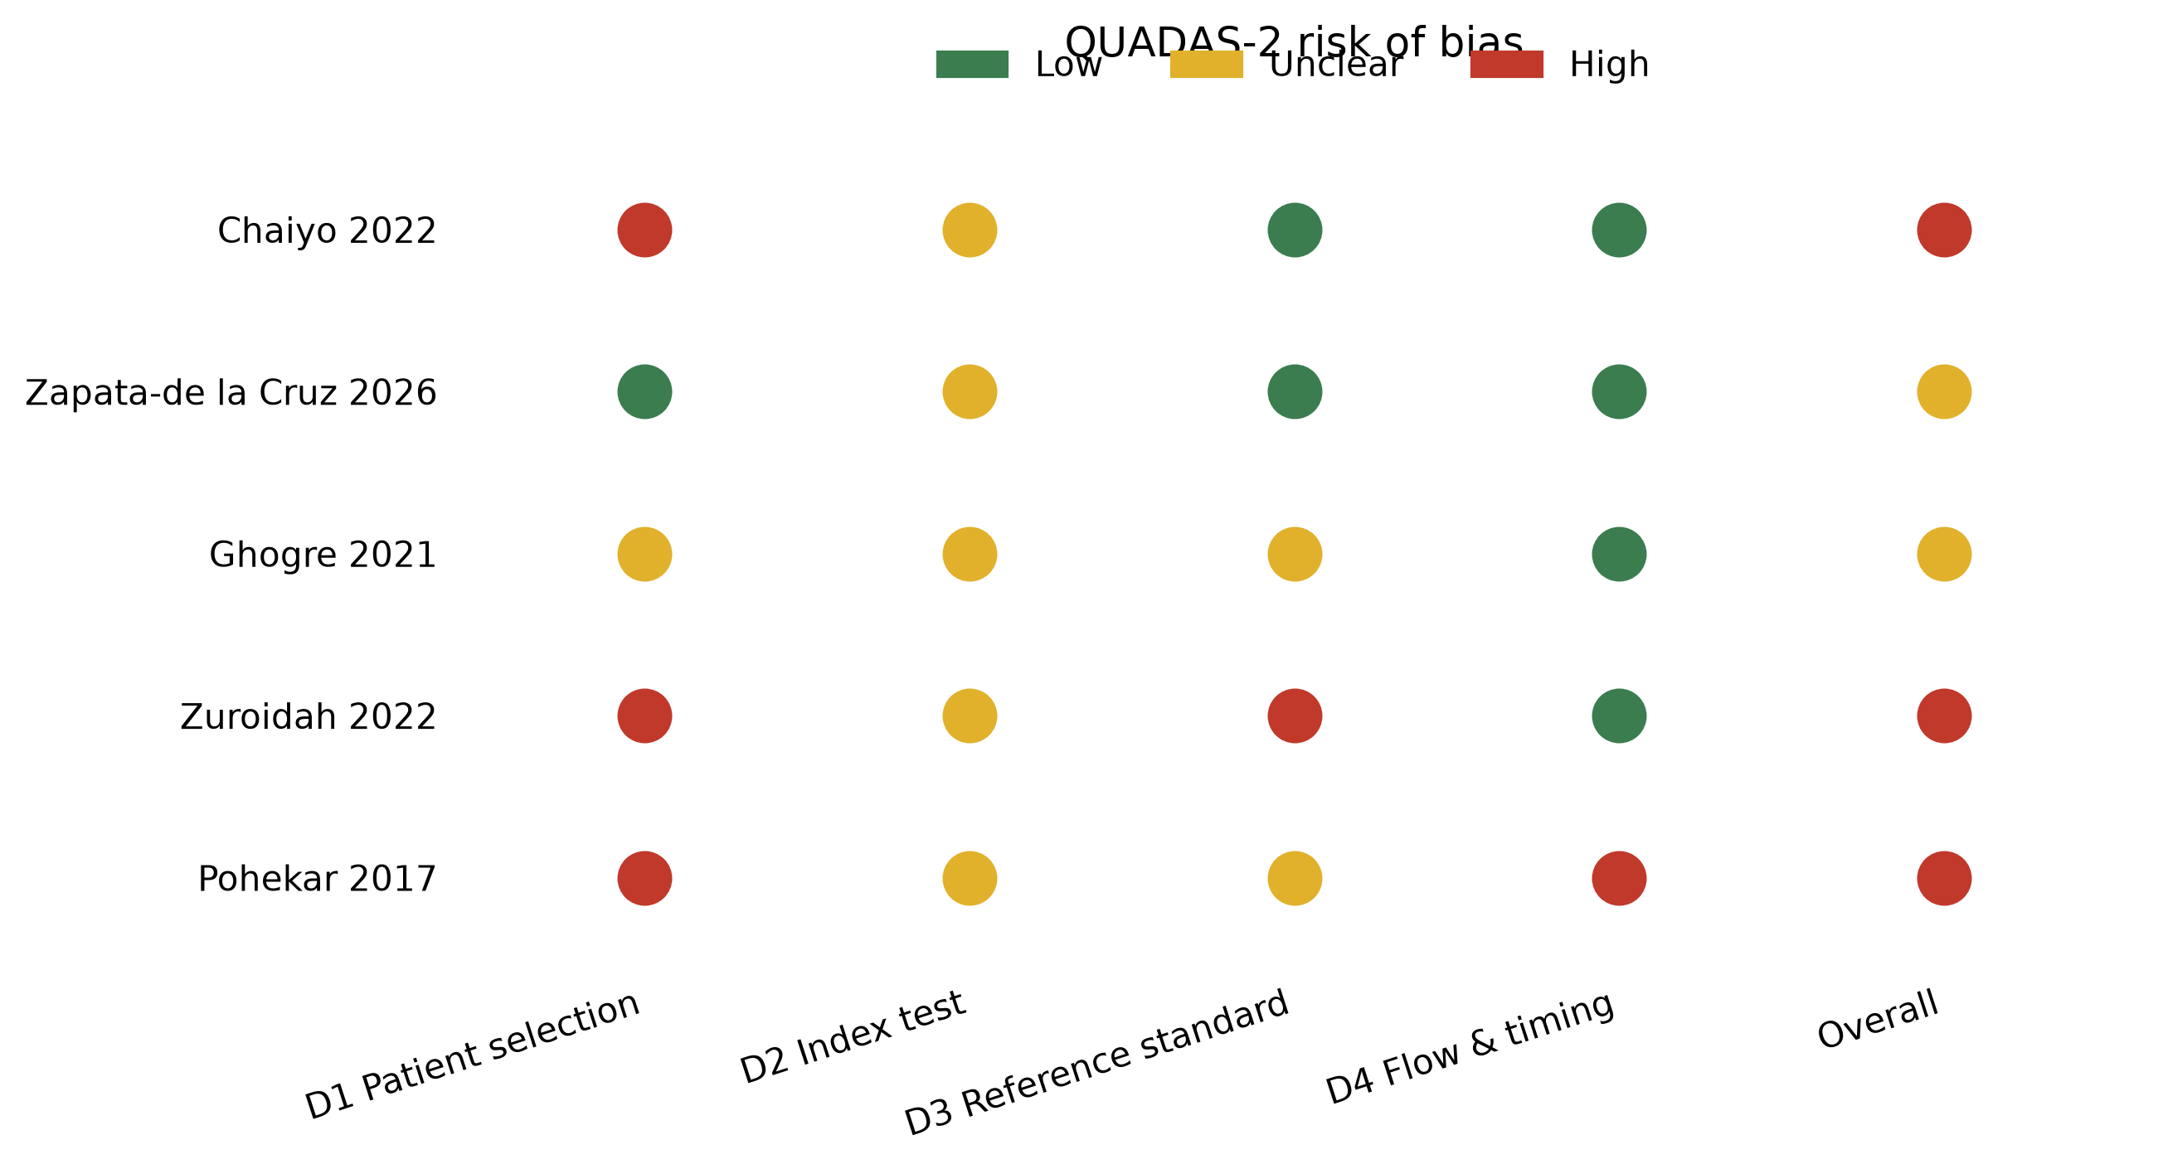
Figure 2. QUADAS-2 traffic-light plot
Figure 2. QUADAS-2 traffic-light plot for the five studies in the bivariate model.
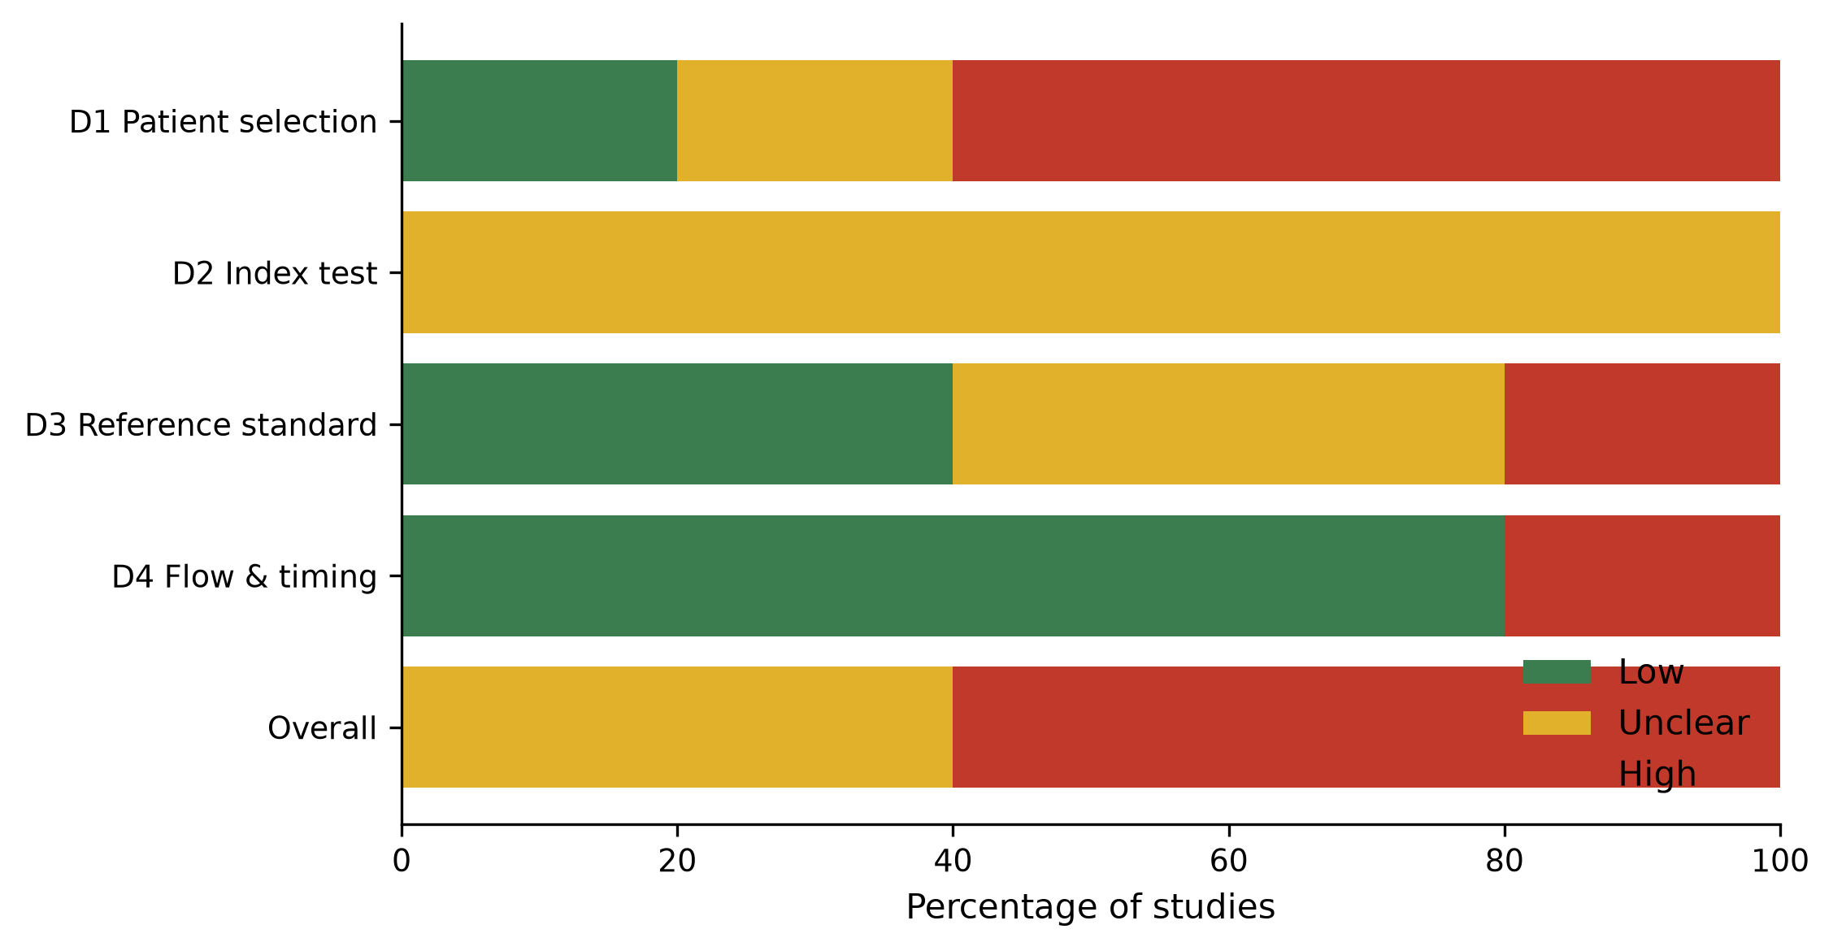
Figure 3. QUADAS-2 summary bars
Figure 3. QUADAS-2 domain summary (percentage of studies).

3.4 Diagnostic accuracy
#### 3.4.1 FIA versus study-defined reference (primary model)
The bivariate REML model included five studies and 794 specimens. Continuity correction 0.5 was applied to Zuroidah 2022 (FP = 0) and Pohekar 2017 (FN = 0).
Table 6. Pooled FIA accuracy for dengue NS1 (bivariate random-effects model)
Measure | Estimate | 95% CI
Sensitivity | 86.7% | 76.0–93.1%
Specificity | 94.0% | 89.6–96.6%
PLR | 14.3 | 7.5–26.5
NLR | 0.14 | 0.07–0.26
DOR | 101 | 30–333

Heterogeneity: Q for logit-sensitivity = 8.19 (df 4, p = 0.085); I²_Se = 51% (moderate); τ²_Se (univariate DL) = 0.19. Q for logit-specificity = 6.17 (df 4, p = 0.19); I²_Sp = 35%; τ²_Sp = 0.13. Between-study correlation ρ = −0.97, consistent with a threshold-effect parameterization, but estimated from only five points and therefore unstable. Bivariate τ on the logit scale: 0.64 (sensitivity) and 0.47 (FPR).
A PLR of 14.3 produces a large increase in post-test probability of acute dengue when FIA is positive [50]. An NLR of 0.14 produces only a moderate decrease; it is above the conventional 0.1 threshold for a strong rule-out test [50].
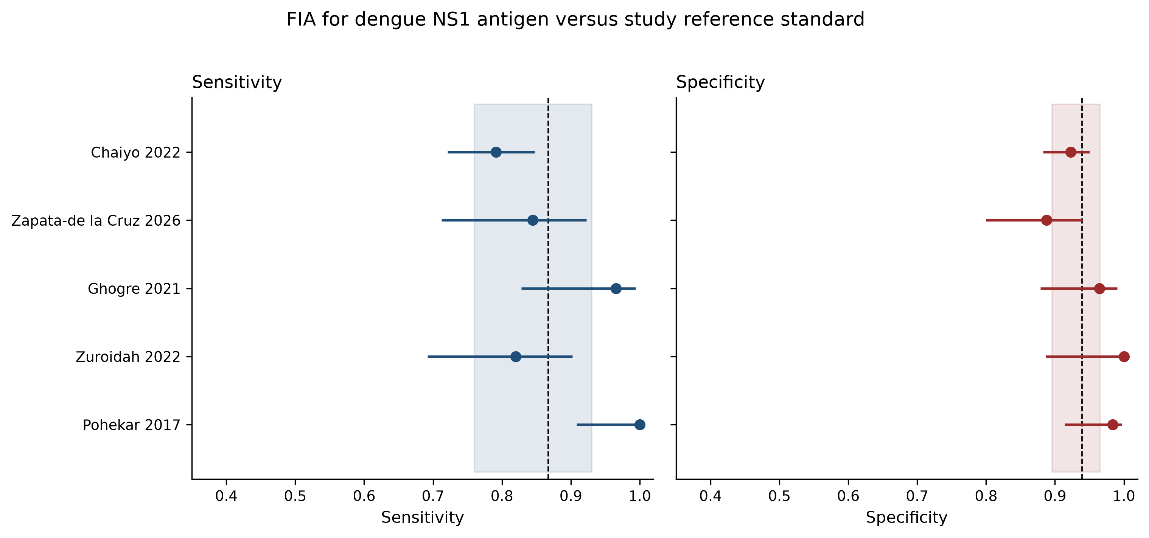
Figure 4. Coupled forest plots
Figure 4. Coupled forest plots of FIA sensitivity and specificity. Squares are study estimates with Wilson 95% CIs. The dashed line is the bivariate summary point; the shaded band is the 95% CI of that point.
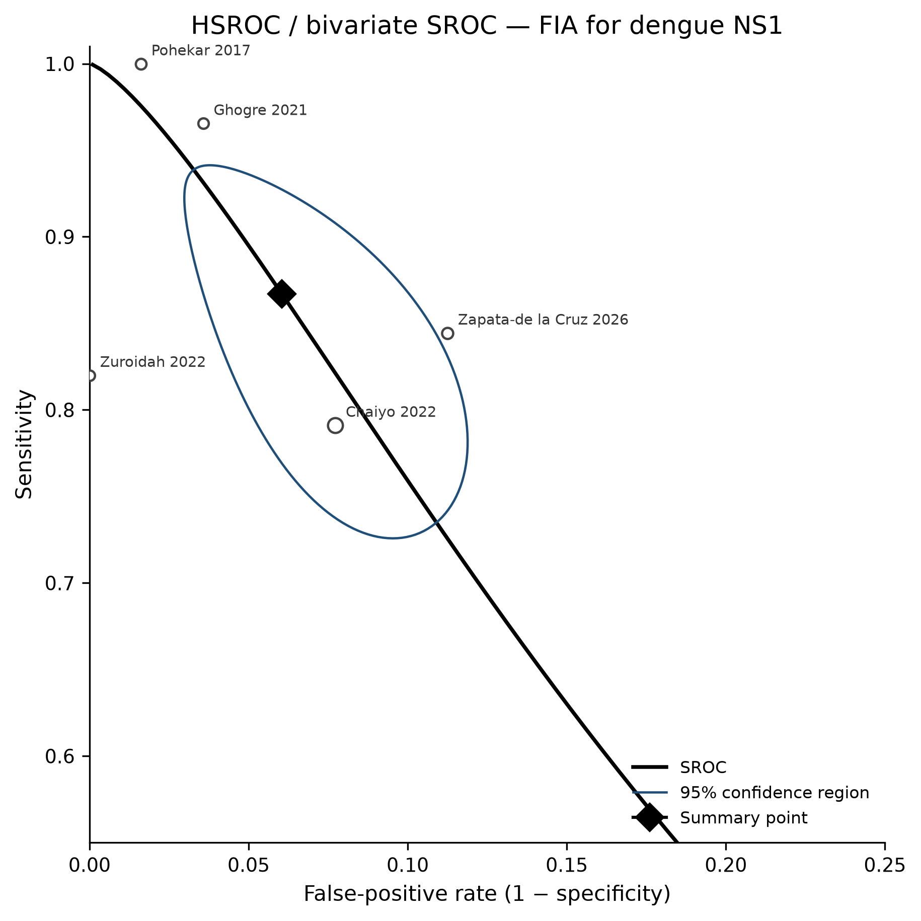
Figure 5. SROC in the observed false-positive-rate region
Figure 5. Study operating points and bivariate summary point in ROC space. The x-axis is restricted to FPR 0–0.25, the region occupied by all five studies. The global SROC implied by ρ ≈ −1 is not interpreted as an area-under-the-curve summary (Section 2.10).
#### 3.4.2 FIA versus ELISA (paired, independent reference)
No included study tested both FIA and NS1 ELISA against an independent molecular reference on the same specimens and published both 2×2 tables. Head-to-head bivariate comparison was therefore not performed.
Two studies used NS1 ELISA as the reference for FIA (concordance, not independent accuracy): Ghogre 2021 Se 96.6% / Sp 96.4%; Pohekar 2017 Se 100% / Sp 98.4% [26,52]. These results indicate that QUANTI CARD closely tracks same-generation NS1 ELISA in those samples. They inflate apparent FIA accuracy relative to RT-PCR because the same analyte is measured by two immunoassays (incorporation). They do not establish interchangeability of FIA and ELISA for surveillance case confirmation.
Chaiyo et al. compared FIA and visual ICT against a composite RT-qPCR + antibody ELISA standard (not NS1 ELISA): FIA NS1 Se 79.1% / Sp 92.3% versus ICT NS1 Se 76.6% / Sp 92.3% [25]. That is a FIA versus ICT contrast, not FIA versus NS1 ELISA.
#### 3.4.3 Exploratory subset: STANDARD F against non-ELISA-only references
The three STANDARD F studies are exactly the three studies that did not use NS1 ELISA as the sole reference (Chaiyo, Zapata-de la Cruz, Zuroidah). Exploratory bivariate pooling (k = 3, below the protocol threshold of 4; interpret with caution):
- Sensitivity 80.5% (75.1–85.0)
- Specificity 91.5% (87.7–94.2)
This operating point is closer to published visual NS1 ICT meta-analysis sensitivity (about 71%) than the five-study primary model, because the two QUANTI CARD versus ELISA studies no longer pull sensitivity upward [29].
Documented fever ≤7 days (Chaiyo, Zapata-de la Cruz only; k = 2, not pooled): Se 79.1% and 84.4%; Sp 92.3% and 88.8%.

3.5 Subgroups and meta-regression
No pre-specified subgroup had ≥4 studies. Fever day 0–3 vs 4–7, primary vs secondary infection, serotype, and region were not modelled. Univariable bivariate meta-regression was not interpreted: with k = 5, likelihood-ratio tests on categorical covariates are anti-conservative.

3.6 Publication bias and sensitivity analyses
Deeks’ test: slope 39.9 (SE 32.2), t = 1.24, p = 0.30. There is no statistically significant small-study effect at α = 0.10, but k = 5 has very low power [45]. The result is inconclusive.
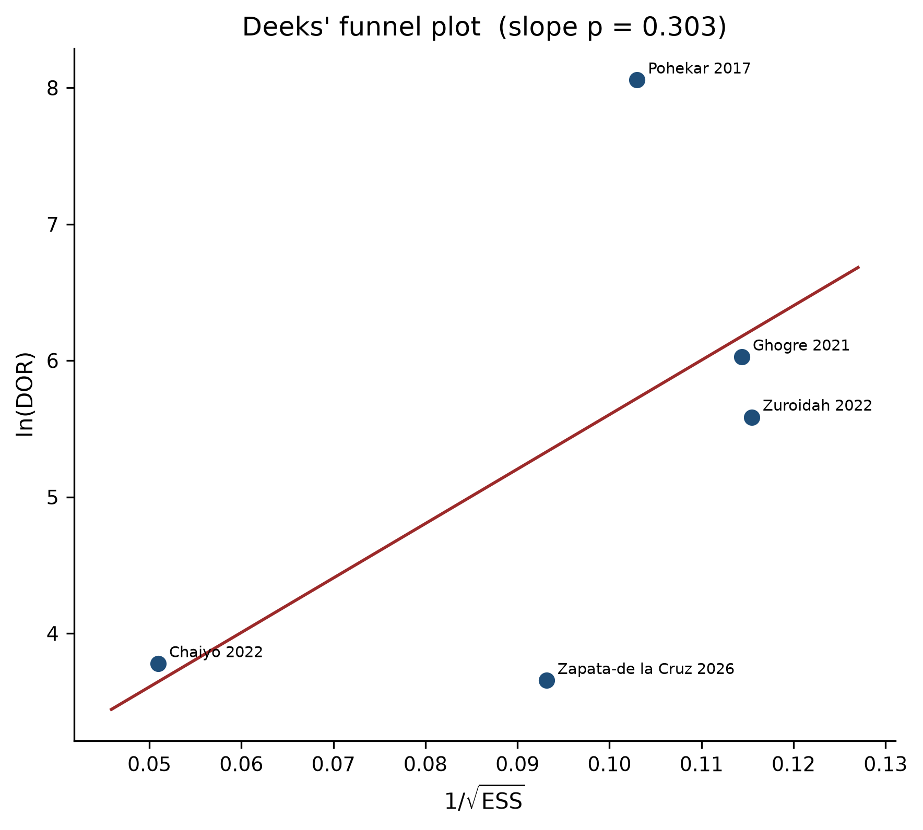
Figure 6. Deeks' funnel plot
Figure 6. Deeks’ funnel plot of ln(DOR) against 1/√ESS.
Table 7. Sensitivity of the summary operating point
| Analysis | k | Sensitivity | Specificity |
|----------|--:|-------------|-------------|
| Primary (CC 0.5, zero-cell studies only) | 5 | 86.7% | 94.0% |
| CC 0.5 applied to all four cells of all studies | 5 | 85.2% | 93.6% |
| CC 0.1 (zero-cell studies) | 5 | 82.1% | 93.6% |
| CC 1.0 (zero-cell studies) | 5 | 87.2% | 93.7% |
| STANDARD F / non-ELISA-only reference | 3 | 80.5% | 91.5% |
| Leave out Chaiyo 2022 | 4 | 91.2% | 94.2% |
| Leave out Zapata-de la Cruz 2026 | 4 | 89.9% | 95.2% |
| Leave out Ghogre 2021 | 4 | 81.0% | 92.1% |
| Leave out Zuroidah 2022 | 4 | 91.1% | 94.3% |
| Leave out Pohekar 2017 | 4 | 81.1% | 92.0% |
The summary point is sensitive to the two QUANTI CARD versus ELISA studies: dropping either Ghogre or Pohekar 2017 lowers pooled sensitivity to about 81%, which matches the STANDARD F subset. Continuity correction 0.1 (more conservative for zero false positives/false negatives) lowers sensitivity to 82.1%. Specificity is stable (92–95%) across analyses.

3.7 Certainty of evidence (GRADE)
Table 8. GRADE for DTA
Outcome | k, N | Risk of bias | Inconsistency | Indirectness | Imprecision | Publication bias | Certainty | Estimate (95% CI)
Sensitivity | 5 studies; 320 DENV+ | Serious (3/5 High overall; two-gate/enrichment) | Serious (I² 51%; reference-standard mix) | Serious (ELISA-as-truth in 2 studies; incomplete dual screening) | Serious (CI width 17 percentage points) | Unclear (Deeks underpowered) | ⊕⊝⊝⊝ Very low | 86.7% (76.0–93.1)
Specificity | 5 studies; 474 DENV− | Serious | Not serious (I² 35%) | Serious | Not serious (CI width 7 percentage points) | Unclear | ⊕⊕⊝⊝ Low | 94.0% (89.6–96.6)

The primary pooled sensitivity should not be quoted in guidelines without the STANDARD F / non-ELISA subset (80.5%) and the GRADE rating.

3.8 Principal numerical findings
In five commercial FIA evaluations (794 specimens) identified from a 19 August 2026 search of 1,889 bibliographic records, FIA for dengue NS1 showed pooled sensitivity 86.7% (76.0–93.1) and specificity 94.0% (89.6–96.6), with PLR 14.3 and NLR 0.14. When analysis was restricted to STANDARD F against RT-PCR or composite standards (k = 3), sensitivity was 80.5% and specificity 91.5%. Concordance with NS1 ELISA (k = 2) was high but does not estimate accuracy versus molecular diagnosis. Heterogeneity of sensitivity was moderate. Three of five studies were at high risk of bias. Dual independent screening of the ELISA-dominant unique set was not done. Certainty is very low for sensitivity and low for specificity.
————————————————————————

4. Discussion

4.1 Principal findings in context
This review is, to our knowledge, the first DTA synthesis to isolate commercial reader-based FIA for dengue NS1 rather than pooling it with visual ICT. The five-study summary point (Se 86.7%, Sp 94.0%, PLR 14.3) looks, at first glance, as if FIA closes much of the gap between visual NS1 ICT (Haider et al.: Se 71.0%, Sp 94.7%) and NS1 ELISA [18,29]. That reading is too optimistic.
Two of five studies judged FIA against NS1 ELISA. Their near-perfect sensitivity is what one expects when two antigen immunoassays are compared with each other, especially when kits are supplied by the same manufacturer [52]. Removing those studies drops pooled sensitivity to 80.5% — still above Haider’s visual ICT point estimate, but with a confidence interval (75.1–85.0) that does not exclude modest superiority and does not support replacing ELISA.
Chaiyo et al. provide the fairest within-study ICT comparison: on the same 404 plasmas, STANDARD F NS1 was only 2.5 percentage points more sensitive than visual ICT, with identical specificity [25]. Zapata-de la Cruz et al. found STANDARD F NS1 versus RT-PCR sensitivity 84.4% and specificity 88.8% in a hyperendemic Mexican sample collected on fever days 2–6, likely enriched for secondary infection [53]. Versus a RT-PCR/IgM construct, FIA sensitivity fell to 57.3% because IgM-positive, RNA-negative illness is outside the NS1-only detection window [53]. That contrast is clinically important: NS1 FIA cannot be asked to detect the same case definition as a combined molecular–serological algorithm.
A PLR of 14.3 supports rule-in in triage when prior probability is already moderate to high, as in outbreak clinics [50]. An NLR of 0.14 does not allow a negative FIA to stop a dengue work-up, particularly after day 3, in secondary infection, or when warning signs are present [2,12,14].

4.2 Clinical and operational implications
WHO 2009 dengue guidance ties risk stratification to the period around defervescence, typically days 3–7 [2]. ELISA batching plus transport commonly yields 24–48 hours to an actionable result [15,22]. FIA in 5–15 minutes changes when a positive NS1 result can inform fluid management and admission, not only whether the assay is analytically accurate [23,25].
Proposed placement (given these data, not as a WHO recommendation):
- Days 0–3, suspected dengue, setting with a maintained reader: FIA NS1 as a same-encounter rule-in test. Positive → dengue-protocol monitoring; confirm with ELISA or RT-PCR when capacity allows (surveillance and serotyping).
- Days 4–7 or suspected secondary infection: FIA NS1 plus IgM (and IgG if immune status is needed). Negative dual testing → RT-PCR or paired serology; do not exclude dengue on NS1 alone [28,29].
- Severe dengue, ICU, or public-health confirmation: RT-PCR and/or NS1 ELISA remain the reference. FIA has not been shown to replace molecular diagnosis or serotype identification [20,53].
- Negative FIA, high clinical probability: never used as a stop test.
FIA still requires electricity or a charged analyzer, a functioning reader, and a cartridge supply chain. It is near-point-of-care, not a zero-infrastructure test. Relative to ELISA it is more deployable; relative to visual ICT it is less so. National programs should treat FIA as a separate procurement class from visual ICT.
Pohekar and Bhalchandra (2023) reported an inverse relationship between FIA COI and platelet count [27]. That observation is hypothesis-generating for severity correlation and was not meta-analyzed here.

4.3 Strengths
The review asked a technology-specific question rather than pooling “rapid dengue tests.” Identification used four bibliographic databases plus supplementary Cochrane, Scholar, and grey sources, with PRISMA-S documentation of the ScienceDirect Boolean limit and the Scopus gap. 2×2 cells were reconstructed only when published Se, Sp, PPV, and NPV identified a unique integer solution. The bivariate Reitsma model respects the sensitivity–specificity trade-off. QUADAS-2 was tailored to NS1 kinetics and incorporation bias. Protocol deviations are listed rather than hidden.

4.4 Limitations
Screening. Dual independent screening of 1,082 unique records was not done. FIA papers that do not use FIA language in the title can be missed; Zapata-de la Cruz 2026 is the example that was recovered because STANDARD F appears in the full text [53]. Ghogre 2021 and Pohekar 2017 were not in the four-database unique set and entered via protocol scoping, which is a form of citation-informed identification, not a systematic screen of the entire ELISA literature.
Small k and mixed truth. Five studies cannot support the protocol’s subgroup programme. Reference standards range from RT-PCR to same-analyte ELISA. ELISA-as-truth inflates agreement; RT-PCR after the viremic window misclassifies some true dengue as negative and can lower apparent FIA sensitivity [9,20]. Latent-class models were not fitted.
Spectrum bias. IC-cluster sampling [25] and two-gate DVI/non-DVI or ICT+/ICT− sampling [52,55] produce spectrum that does not match consecutive febrile patients. Specificity in particular can be overestimated when controls are clearly non-dengue rather than other acute febrile illnesses, including flavivirus co-circulation [17,54].
Fever window. Three of five studies did not report day of illness. NS1 is not constant across days 0–7 [9,12]. Mixed timing biases pooled sensitivity toward an average of two biological states.
Industry involvement. Pohekar 2017 used manufacturer-supplied FIA and ELISA kits [52]. Funding was often unreported.
Single reviewer. Extraction and QUADAS-2 were not dual-adjudicated. Transcription error in reconstructed cells is possible, although published PPV/NPV were used as cross-checks.
Software. The Reitsma REML fit was implemented in Python because R/mada was not installed. The likelihood matches the published model; numerical estimates can differ slightly from mada::reitsma on the same cells.
PROSPERO. Absence of a CRD number at submission time is a reporting weakness. The written protocol is archived in the repository.
Pohekar 2023. The largest single FIA versus ELISA cohort (n = 300) could not be pooled [27]. If off-diagonal cells were unfavorable, the primary pooled sensitivity would fall; if they were favorable, it would rise. Until those cells are published, the 86.7% figure is incomplete with respect to the known literature.

4.5 Future research
- Prospective, consecutive, STARD-compliant studies of FIA and NS1 ELISA on the same acute specimens, with RT-PCR and serotype as an independent reference, and day of illness recorded to the day [36,51].
- Publication of the Pohekar 2023 concordance table.
- Secondary-infection strata with a pre-specified immune-status definition large enough for precise sensitivity differences.
- Flavivirus challenge panels (Zika, yellow fever, Japanese encephalitis) from the intended-use region [17,54].
- Impact studies: time-to-decision, admission, and severe-dengue progression when FIA is added to usual care — accuracy alone does not establish clinical utility.
- Dual independent screening of the 1,082 unique records remaining in this project, to test whether additional FIA reports were missed.

4.6 Conclusion
Early NS1 detection during the first week of fever is central to dengue care. ELISA’s accuracy is offset by infrastructure and delay; visual ICT’s speed is offset by modest and operator-dependent sensitivity [18,29]. Commercial FIA occupies the gap between those poles.
Across five studies and 794 specimens, FIA for dengue NS1 had pooled sensitivity 86.7% (76.0–93.1) and specificity 94.0% (89.6–96.6), with PLR 14.3 and NLR 0.14. The more conservative STANDARD F estimate against molecular or composite standards is sensitivity 80.5% and specificity 91.5%. Certainty is very low to low. Three of five studies were at high risk of bias, dual screening of the full unique set was not completed, and a 300-patient FIA–ELISA cohort remains unpooled for lack of a 2×2 table.
Actionable statements that the data support:
- Use FIA as a rapid, objective NS1 rule-in test in triage and outbreak settings when a reader can be maintained — particularly in the early febrile window.
- Do not use a negative FIA to exclude dengue; reflex to IgM/IgG, ELISA, and/or RT-PCR.
- Do not equate FIA with visual ICT or with ELISA in guidelines or tenders.
- Keep ELISA and RT-PCR as the laboratory reference for confirmation, surveillance, and serotype-dependent public health action.
- Commission paired, day-stratified, serotype-aware studies with independent molecular reference standards, and complete dual screening of the already-retrieved unique bibliographic set, before making FIA the sole confirmatory test in national algorithms.
Until that work is done, FIA is a clinically useful near-point-of-care NS1 assay that can shorten time-to-a-positive-result without replacing laboratory confirmation.
————————————————————————

Acknowledgements
Bibliographic database access used University of Toledo library subscriptions (Embase, Web of Science, ScienceDirect, Cochrane). The author thanks the librarians and OpenAthens service for access. Search execution and analysis were performed for this project on 19 August 2026.
————————————————————————

Author contributions (CRediT)
Ritu Shah: conceptualization, methodology, investigation, data curation, formal analysis, visualization, writing — original draft, writing — review and editing, project administration.
————————————————————————

Supplementary files in the project archive
File | Content
data/search_strategies.md | Full database-specific search strings (PRISMA-S)
data/logs/identification_counts_2026-08-19.json | Locked hit counts
data/deduped/unique_pubmed_embase_wos_sd_2026-08-19.csv | 1,082 unique bibliographic records
data/extraction/included_2x2_2026-08-19.csv | Locked 2×2 cells
data/extraction/eligibility_log_2026-08-19.md | Full-text include/exclude decisions
analysis/quadas2_protocol.md | Tailored QUADAS-2 signalling questions
analysis/dta_meta_analysis.py | Bivariate Reitsma REML implementation
output/tables/pooled_estimates.json | Machine-readable pooled estimates
protocols/prospero_protocol.md | Written protocol (CRD pending)

————————————————————————

Appendix A. PRISMA-DTA checklist (abbreviated)
Item | Location in this paper
Title (identify as DTA SR/MA) | Title page
Abstract structured | Abstract
Rationale | Section 1
Objectives / PIRD | Sections 1.6 and 2.2
Protocol and registration | Sections 2.1 and 2.12
Eligibility | Section 2.3
Information sources | Section 2.4; Table 1
Search | Section 2.4; data/search_strategies.md
Study selection | Sections 2.5 and 3.1; Figure 1
Data collection / items | Sections 2.6 and 3.2; Table 4
Risk of bias | Sections 2.7 and 3.3; Table 5; Figures 2–3
Diagnostic accuracy measures | Section 2.8
Synthesis methods | Sections 2.8–2.10
Study characteristics | Table 3
Results of individual studies | Table 4; Figure 4
Synthesis of results | Section 3.4; Table 6
Heterogeneity / additional analyses | Sections 3.4–3.6; Table 7
Certainty | Section 3.7; Table 8
Limitations | Section 4.4
Conclusions | Section 4.6
Funding | Title page

————————————————————————

References
- Guzman MG, Gubler DJ, Izquierdo A, Martinez E, Halstead SB. Dengue infection. Nat Rev Dis Primers. 2016;2:16055. doi:10.1038/nrdp.2016.55.
- World Health Organization. Dengue: Guidelines for Diagnosis, Treatment, Prevention and Control. New edition. Geneva: WHO; 2009.
- Bhatt S, Gething PW, Brady OJ, et al. The global distribution and burden of dengue. Nature. 2013;496(7446):504-507. doi:10.1038/nature12060.
- World Health Organization. Dengue: global situation, surveillance and progress — 2024 update. Wkly Epidemiol Rec. 2024;99(50/52):665-678.
- Messina JP, Brady OJ, Golding N, et al. The current and future global distribution and population at risk of dengue. Nat Microbiol. 2019;4(9):1508-1515. doi:10.1038/s41564-019-0476-8.
- Yang X, Quam MBM, Zhang T, Sang S. Global burden for dengue and the evolving pattern in the past 30 years. J Travel Med. 2021;28(8):taab146. doi:10.1093/jtm/taab146.
- Wilder-Smith A, Ooi EE, Horstick O, Wills B. Dengue. Lancet. 2019;393(10169):350-363. doi:10.1016/S0140-6736(18)32560-1.
- Simmons CP, Farrar JJ, Nguyen VV, Wills B. Dengue. N Engl J Med. 2012;366(15):1423-1432. doi:10.1056/NEJMra1110265.
- Muller DA, Depelsenaire ACI, Young PR. Clinical and laboratory diagnosis of dengue virus infection. J Infect Dis. 2017;215(suppl_2):S13-S17. doi:10.1093/infdis/jiw649.
- Watthanaworawit W, Turner P, Turner CL, et al. A prospective evaluation of diagnostic methodologies for the acute diagnosis of dengue virus infection on the Thailand-Myanmar border. Trans R Soc Trop Med Hyg. 2011;105(1):32-37. doi:10.1016/j.trstmh.2010.09.006.
- Centers for Disease Control and Prevention. NS1 antigen tests for dengue virus. 2024. https://www.cdc.gov/dengue/hcp/diagnosis-testing/dengue-virus-antigen-detection.html
- Ainsworth HR, Batra R, Beckwith P, et al. Kinetics of NS1 and anti-NS1 IgG following dengue infection reveals likely early formation of immune complexes in secondary infected patients. Sci Rep. 2025;15:9874. doi:10.1038/s41598-025-91099-5.
- Alcon S, Talarmin A, Debruyne M, Falconar A, Deubel V, Flamand M. Enzyme-linked immunosorbent assay specific to dengue virus type 1 nonstructural protein NS1 reveals circulation of the antigen in the blood during the acute phase of disease. J Clin Microbiol. 2002;40(2):376-381. doi:10.1128/JCM.40.2.376-381.2002.
- Duong V, Ly S, Lorn Try P, et al. Clinical and virological factors influencing the performance of a NS1 antigen-capture assay. PLoS Negl Trop Dis. 2011;5(7):e1199. doi:10.1371/journal.pntd.0001199.
- Peeling RW, Artsob H, Pelegrino JL, et al. Evaluation of diagnostic tests: dengue. Nat Rev Microbiol. 2010;8(12 Suppl):S30-S38. doi:10.1038/nrmicro2459.
- Tricou V, Vu HT, Quynh NV, et al. Comparison of two dengue NS1 rapid tests for sensitivity, specificity and relationship to viraemia and antibody responses. BMC Infect Dis. 2010;10:142. doi:10.1186/1471-2334-10-142.
- Hunsperger EA, Yoksan S, Buchy P, et al. Evaluation of commercially available diagnostic tests for the detection of dengue virus NS1 antigen and anti-dengue virus IgM antibody. PLoS Negl Trop Dis. 2014;8(10):e3171. doi:10.1371/journal.pntd.0003171.
- Da Silva NS, Undurraga EA, da Silva Telleria AR, Teixeira MG. A meta-analysis of the diagnostic accuracy of two commercial NS1 antigen ELISA tests for early dengue virus detection. PLoS One. 2014;9(4):e94655. doi:10.1371/journal.pone.0094655.
- Guzman MG, Jaenisch T, Gaczkowski R, et al. Multi-country evaluation of the sensitivity and specificity of two commercially-available NS1 ELISA assays for dengue diagnosis. PLoS Negl Trop Dis. 2010;4(8):e811. doi:10.1371/journal.pntd.0000811.
- Pillay K, Fritzell C, Leparc-Goffart I, et al. Evaluating the performance of common reference laboratory tests for acute dengue diagnosis: a systematic review and meta-analysis of RT-PCR, NS1 ELISA, and IgM ELISA. Lancet Microbe. 2025;6(5):101088. doi:10.1016/j.lanmic.2025.101088.
- Singh RK, Dhama K, Khandia R, et al. Prevention and control strategies to counter dengue virus infection. Front Immunol. 2018;9:2719. doi:10.3389/fimmu.2018.02719.
- Sharma A, Ojha R, Gupta S, Dwivedi A. Assessing the readiness of rapid diagnostic tests for integration into the national dengue control strategy of India. Discov Public Health. 2026;23:46. doi:10.1186/s12982-026-02269-3.
- SD Biosensor Inc. STANDARD F Dengue NS1 Ag FIA [package insert]. Suwon, South Korea: SD Biosensor Inc.; 2023.
- Fischer C, de Lamballerie X, Drexler JF. Diagnostic tests for dengue. In: Hilgenfeld R, Vasudevan SG, eds. Dengue and Zika: Control and Antiviral Treatment Strategies. Singapore: Springer; 2018.
- Chaiyo S, Wichit S, Chaiwattanarungruengpaisan S, et al. A performance comparison between fluorescent immunoassay and immunochromatography for rapid dengue detection in clinical specimens. Sci Rep. 2022;12:17476. doi:10.1038/s41598-022-21581-x.
- Ghogre S. Utility of fluorescence immunoassay in early diagnosis of dengue. Int J Curr Res Rev. 2021;14(1):116. doi:10.31782/ijcrr.2021.14116.
- Pohekar JA, Bhalchandra MH. Prospective study to compare results of FIA (fluorescent immunoassay) test with gold standard ELISA test in Dengue NS1 patients admitted in a tertiary care hospital. Indian J Med Microbiol. 2023;46:100376. doi:10.1016/j.ijmmb.2023.100376.
- Mata VE, Andrade CAF, Passos SRL, Hökerberg YHM, Fukuoka LVB, Silva SA. Rapid immunochromatographic tests for the diagnosis of dengue: a systematic review and meta-analysis. Cad Saúde Pública. 2020;36(6):e00225618. doi:10.1590/0102-311X00225618.
- Haider M, Yousaf S, Zaib A, Sarfraz A, Sarfraz Z, Cherrez-Ojeda I. Diagnostic accuracy of various immunochromatographic tests for NS1 antigen and IgM antibodies detection in acute dengue virus infection. Int J Environ Res Public Health. 2022;19(14):8756. doi:10.3390/ijerph19148756.
- Frazer JL, Norton R. Dengue: a review of laboratory diagnostics in the vaccine age. J Med Microbiol. 2024;73(5):001833. doi:10.1099/jmm.0.001833.
- McInnes MDF, Moher D, Thombs BD, et al. Preferred reporting items for a systematic review and meta-analysis of diagnostic test accuracy studies: the PRISMA-DTA statement. JAMA. 2018;319(4):388-396. doi:10.1001/jama.2017.19163.
- Salameh JP, Bossuyt PM, McGrath TA, et al. Preferred reporting items for systematic review and meta-analysis of diagnostic test accuracy studies (PRISMA-DTA): explanation, elaboration, and checklist. BMJ. 2020;370:m2632. doi:10.1136/bmj.m2632.
- Page MJ, McKenzie JE, Bossuyt PM, et al. The PRISMA 2020 statement: an updated guideline for reporting systematic reviews. BMJ. 2021;372:n71. doi:10.1136/bmj.n71.
- Rethlefsen ML, Kirtley S, Waffenschmidt S, et al. PRISMA-S: an extension to the PRISMA Statement for reporting literature searches in systematic reviews. Syst Rev. 2021;10(1):39. doi:10.1186/s13643-020-01542-z.
- Leeflang MMG, Deeks JJ, Takwoingi Y, Macaskill P. Cochrane diagnostic test accuracy reviews. Syst Rev. 2013;2:82. doi:10.1186/2046-4053-2-82.
- Bossuyt PM, Reitsma JB, Bruns DE, et al. STARD 2015: an updated list of essential items for reporting diagnostic accuracy studies. BMJ. 2015;351:h5527. doi:10.1136/bmj.h5527.
- McGowan J, Sampson M, Salzwedel DM, Cogo E, Foerster V, Lefebvre C. PRESS Peer Review of Electronic Search Strategies: 2015 guideline statement. J Clin Epidemiol. 2016;75:40-46. doi:10.1016/j.jclinepi.2016.01.021.
- Landis JR, Koch GG. The measurement of observer agreement for categorical data. Biometrics. 1977;33(1):159-174. doi:10.2307/2529310.
- Whiting PF, Rutjes AW, Westwood ME, et al. QUADAS-2: a revised tool for the quality assessment of diagnostic accuracy studies. Ann Intern Med. 2011;155(8):529-536. doi:10.7326/0003-4819-155-8-201110180-00009.
- McGuinness LA, Higgins JPT. Risk-of-bias VISualization (robvis): an R package and Shiny web app for visualizing risk-of-bias assessments. Res Synth Methods. 2021;12(1):55-61. doi:10.1002/jrsm.1411.
- Doebler P. mada: Meta-Analysis of Diagnostic Accuracy. R package version 0.5.12. 2025. doi:10.32614/CRAN.package.mada.
- Reitsma JB, Glas AS, Rutjes AW, Scholten RJ, Bossuyt PM, Zwinderman AH. Bivariate analysis of sensitivity and specificity produces informative summary measures in diagnostic reviews. J Clin Epidemiol. 2005;58(10):982-990. doi:10.1016/j.jclinepi.2005.02.022.
- Rutter CM, Gatsonis CA. A hierarchical regression approach to meta-analysis of diagnostic test accuracy evaluations. Stat Med. 2001;20(19):2865-2884. doi:10.1002/sim.942.
- Harbord RM, Deeks JJ, Egger M, Whiting P, Sterne JA. A unification of models for meta-analysis of diagnostic accuracy studies. Biostatistics. 2007;8(2):239-251. doi:10.1093/biostatistics/kxl004.
- Deeks JJ, Macaskill P, Irwig L. The performance of tests of publication bias and other sample size effects in systematic reviews of diagnostic test accuracy was assessed. J Clin Epidemiol. 2005;58(9):882-893. doi:10.1016/j.jclinepi.2005.01.016.
- R Core Team. R: A Language and Environment for Statistical Computing. Vienna: R Foundation for Statistical Computing; 2025.
- Viechtbauer W. Conducting meta-analyses in R with the metafor package. J Stat Softw. 2010;36(3):1-48. doi:10.18637/jss.v036.i03.
- Higgins JPT, Thompson SG, Deeks JJ, Altman DG. Measuring inconsistency in meta-analyses. BMJ. 2003;327(7414):557-560. doi:10.1136/bmj.327.7414.557.
- Schünemann HJ, Mustafa RA, Brozek J, et al. GRADE guidelines: 21. Part 1. Study design, risk of bias, and indirectness in rating the certainty across a body of evidence for test accuracy. J Clin Epidemiol. 2020;122:129-141. doi:10.1016/j.jclinepi.2019.12.020.
- Jaeschke R, Guyatt GH, Sackett DL. Users’ guides to the medical literature. III. How to use an article about a diagnostic test. B. What are the results and will they help me in caring for my patients? JAMA. 1994;271(9):703-707. doi:10.1001/jama.1994.03510330081039.
- Cohen JF, Korevaar DA, Altman DG, et al. STARD 2015 guidelines for reporting diagnostic accuracy studies: explanation and elaboration. BMJ Open. 2016;6(11):e012799. doi:10.1136/bmjopen-2016-012799.
- Pohekar JA, Bhalchandra MH, Ghogre HS, Pathrikar TG. Evaluation and comparison of currently available fluorescence immunoassay (FIA) test with rapid immuno chromatographic test (ICT) considering NS1 ELISA as a reference test. Int J Curr Microbiol App Sci. 2017;6(11):506-513. doi:10.20546/ijcmas.2017.611.061.
- Zapata-de la Cruz M, Martínez-Vega RA, Guzmán-Priego CG, et al. Evaluating three rapid tests for dengue in febrile patients in a dengue-endemic area. Trop Med Int Health. 2026;31(4):576-580. doi:10.1111/tmi.70088.
- Zammarchi L, Colao MG, Mantella A, et al. Evaluation of a new rapid fluorescence immunoassay for the diagnosis of dengue and Zika virus infection. J Clin Virol. 2019;112:34-39. doi:10.1016/j.jcv.2019.01.011.
- Zuroidah N, Tanzilia MF, Sunari IGAAEP, Wrahatnala BJ, Haki FKN, Aryati, Wardhani P, Husada D, Rohman A, Tarmizi SN. Comparison of diagnostic tests for detection of nonstructural-1 (NS1) antigen dengue virus using immunochromatography and fluorescence immunoassay methods. Res J Pharm Technol. 2022;15(4):1494-1498. doi:10.52711/0974-360X.2022.00248.
————————————————————————
Manuscript version 2.0 — 19 August 2026 Pooled estimates are from the locked extraction file and the bivariate Reitsma fit. They are not placeholders.

