Hong Thai inhaler(Software GMP/pics)

Document Control System /eQMS
  - Document Control System
Key Functions
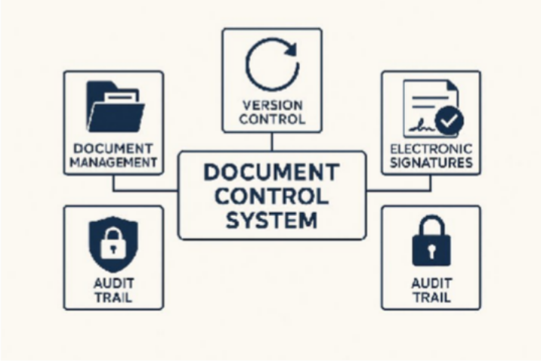

Document Management System:
Manage SOPs, Work Instructions (WI), forms, manuals, etc., with features such as version control and document status (draft / approved / obsolete).

Electronic Signatures:
Support compliance with 21 CFR Part 11 and ALCOA+ principles, including username/password authentication and audit trails.
  - Enterprise Quality Management System (eQMS)

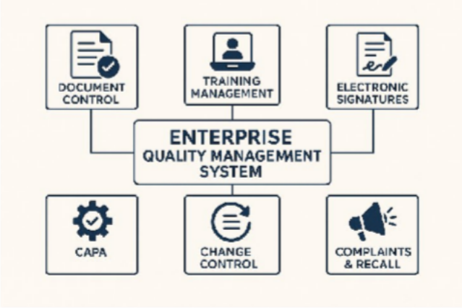

Training Management:
Link SOPs to employees, record training activities, manage tests, and track due dates.
Electronic signatures 21 CER Part 11
    - Electronic Records
    - Electronic Signatures
The goal is to ensure that electronic data is accurate, secure, reliable, and traceable, equivalent to paper-based documentation.

Key Principles of Part 11
    - Data Integrity – Ensuring correctness and completeness of data
    - Access Control – Controlling and restricting system access
    - Audit Trail – The system must record who did what, when, and how
    - System Validation – Demonstrating that the system works according to specifications
    - Electronic Signatures – Must be secure and legally equivalent to handwritten signatures

Deviation / Incident / OOS (Out of Specification)
Support reporting, investigation, and follow-up of deviations, incidents, and OOS results.

CAPA (Corrective & Preventive Action)
Manage corrective and preventive actions, including root cause analysis, action planning, and effectiveness checks.

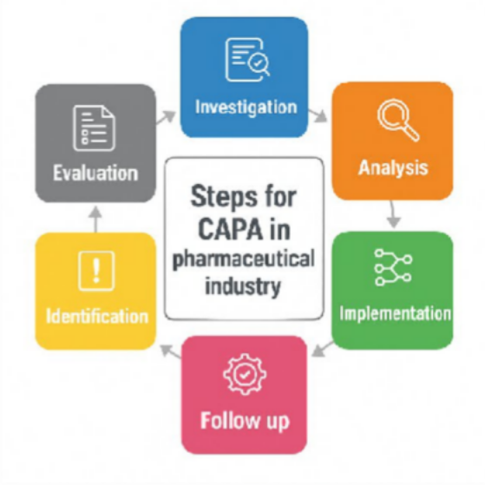

Change Control:
Control and track changes to processes, documents, and systems, with impact assessment and approval workflow.

Complaints & Recall Records:
Record, track, and investigate customer complaints, as well as manage product recall documentation
- Production / MES-lite + eBR (Electronic Batch Record)
Objective: To control herbal medicine manufacturing with full traceability across batches, lots, equipment, and raw materials.
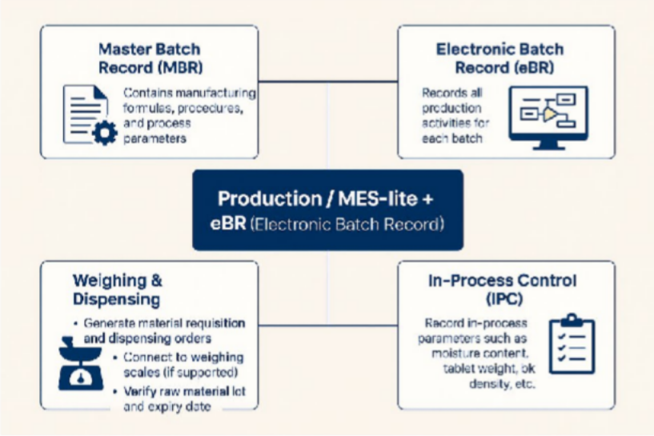
Core Functions

Master Batch Record (MBR):
Contains manufacturing formulas, procedures, and process parameters.

Electronic Batch Record (eBR):
Records all production activities for each batch.

Weighing & Dispensing:
- Generate material requisition and dispensing orders
- Connect to weighing scales (if supported)
- Verify raw material lot and expiry date

In-Process Control (IPC):
Record in-process parameters such as moisture content, tablet weight, bulk density, etc.

Equipment Logbook:
Record equipment usage, cleaning activities, and equipment status (in use / cleaned / maintenance)

Herbal Medicine–Specific Steps
For herbal products, additional process steps may be required, such as:

Extraction → Concentration → Drying → Milling → Sieving
These steps should be clearly defined in both MBR and eBR.

Warehouse & Traceability System

Objective:
Control stock and the status of raw materials, packaging materials, and finished goods, with the ability to answer traceability inquiries immediately.

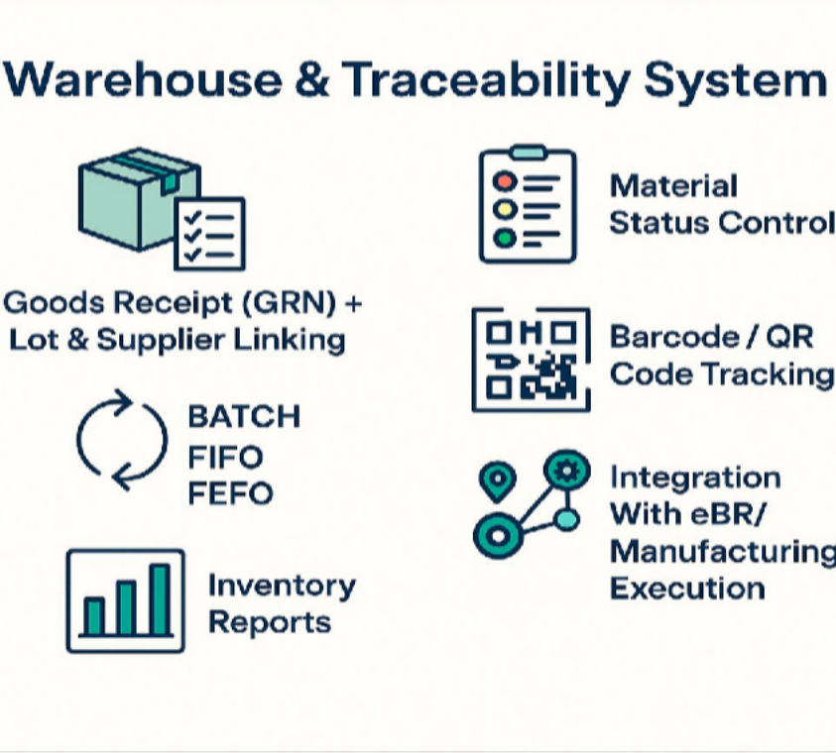
Key Functions
- Goods Receipt (GRN) for Raw Materials / Packaging / Finished Goods
  - Record incoming materials with linked lot numbers, suppliers, and
Certificates of Analysis (CoA).

- Material Status Management
  - Track and control statuses such as:
Quarantine / Released / Rejected / Returned / Hold

- Batch-Based Issuance
  - Issue materials to production based on FIFO or FEFO rules.

- Barcode / QR Code System

  - Apply barcodes or QR codes for raw materials, WIP, and finished products.

- Inventory Reports
  - Stock on hand
  - Expiry/aging report
  - Re-order point alerts

- Integration With eBR
  - Ability to trace which raw material lots were used in which production batches.

LIMS (Lab Information Management System) – QC Laboratory
Objective: To ensure transparency in analytical testing, enable easy traceability, and prevent unauthorized or improper result manipulation.
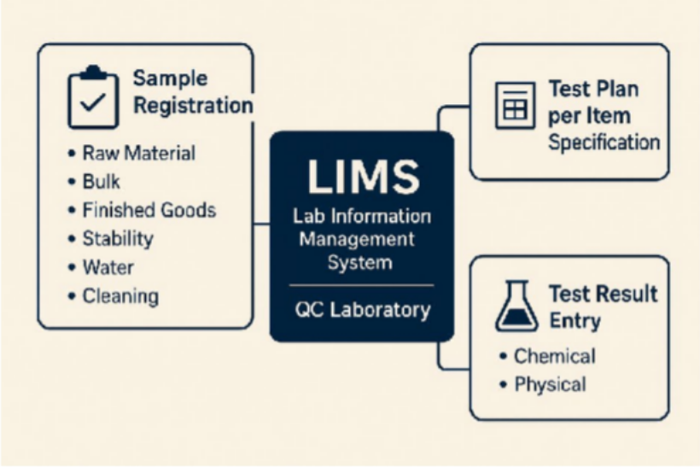

Functions
Sample Registration:
Register samples for testing, including:
- Raw Material
- Bulk
- Finished Goods
- Stability
- Water
- Cleaning (swab/rinse)

Test Plan Based on Item Specification:
Define and assign test plans according to the specification of each item.

Test Result Entry:
Record test results for:Physical tests

Maintenance & Calibration (CMMS)
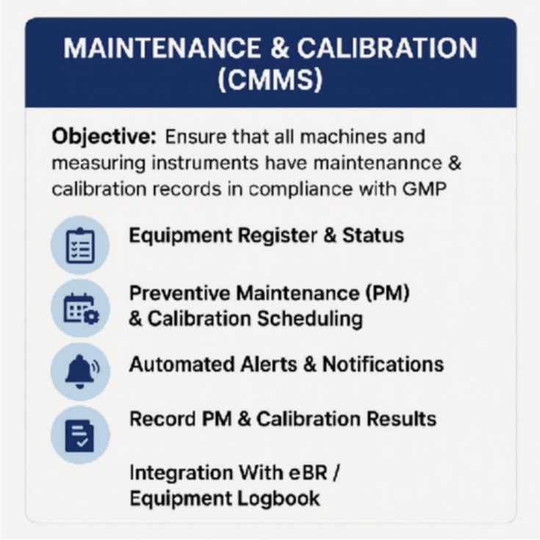
Objective:
Ensure that all machines and measuring instruments have proper maintenance and calibration records in compliance with GMP requirements.

Key Functions
- Equipment Register & Status
  - Centralized list of all equipment
  - Track equipment status (e.g., In Use, Under Maintenance, Out of Service)
- Preventive Maintenance (PM) & Calibration Scheduling
  - Define and manage PM plans
  - Create calibration schedules for each instrument or machine

Automated Alerts & Notifications
  - System alerts when PM or calibration is due
  - Overdue reminders for critical equipment
- Record PM & Calibration Results
  - Log maintenance activities and calibration outcomes
  - Attach calibration certificates and PM reports
- Integration With eBR / Equipment Logbook
  - The system ensures that equipment used in production is in
“calibrated” status
  - Real-time validation of equipment readiness before use
- Environment & Utility Monitoring
For herbal medicine manufacturing facilities with controlled production areas (even if not cleanrooms like sterile drug environments).
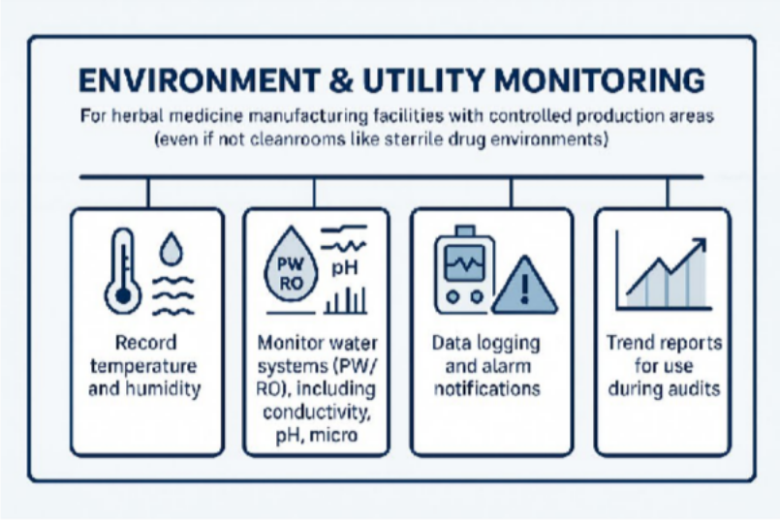

Functions
  - Record temperature and humidity in production areas, warehouses, and raw material storage rooms
  - Monitor water systems (PW / RO), including parameters such as conductivity, pH, and microbial count
  - Data logging and alarm notifications when values exceed specifications

  - Trend reports for use during audits

IT & Compliance System
This is not a single software, but a framework that must be applied across all systems mentioned above:
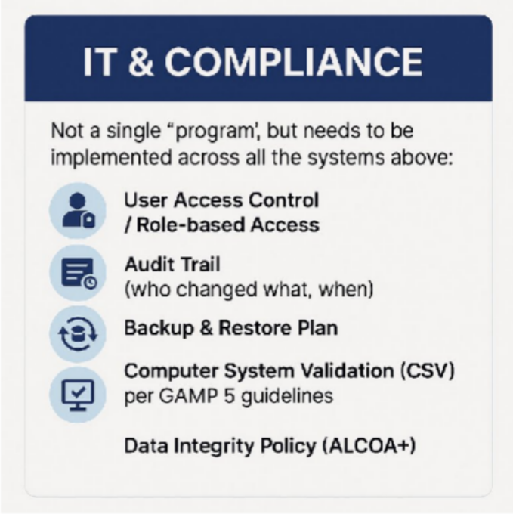

User Access Control / Role-Based Access
Ensure that each user can perform only the actions permitted for their role.

Audit Trail
Track who made changes, what was changed, and when it occurred.

Backup & Restore Plan
Maintain data protection and business continuity through scheduled backups and verified restoration procedures.
  - Computer System Validation (CSV) — based on GAMP 5 Validate computerized systems to ensure they are fit for intended use and compliant with regulatory requirements.
  - Incident

IT Support SLA (5×8) – Severity Levels
Severity Level Response Time On-site / Start Fix Time Resolution Target High (Critical) Within 1 hour Within 3 hours Same day Medium Within 4 hours Within 1 business day 1–2 business days Low Within 1 business day Within 1–3 business days 3–5 business days

  - Data Integrity Policy (ALCOA+)
Ensure data are Attributable, Legible, Contemporaneous, Original, Accurate, plus Complete, Consistent, Enduring, and Available.

Project หงส์ไทย Tracking – Software Development for Herbal GMP/PICS
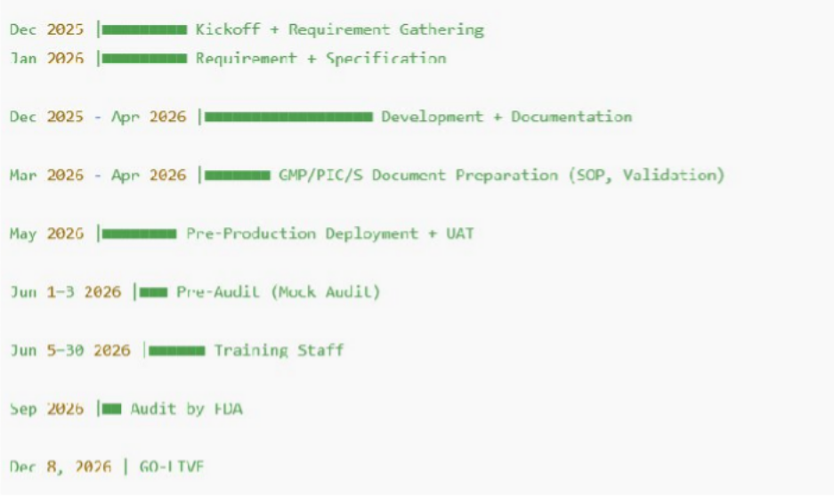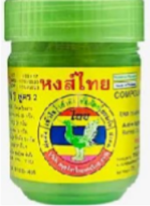

ลำ1ดับ ง1น / กิจกรรม วันที่เริ่ม วันที่สิ้นสุด ระยะเวล1 หม1ยเหตุ

Kickoff + เก็บ
1 Requirement & เขียน 15/12/2025 31/01/2026 ~1.5 เดือน
SRS FDD, UAT/
(Specification) Development +
เอกสารหลัก: SRS, FDD UAT, Data Flow, User Story

ทำาคู่ขนานกับข้อ 1

- Software
Documentation
ทำาเอกสารระบบ
15/12/2025 30/04/2026 ~4.5 เดือน
ในช่วงแรก

- GMP/PIC/S (SOP,
WI, Validation Plan)
01/03/2026 30/04/2026 2 เดือน รวม IQ/OQ/PQ Template

- Deployment Pre- production + UAT
05/05/2026 31/05/2026 ~1 เดือน ผู้ใช้ทดสอบและเก็บ
defect

ลำ1ดับ ง1น / กิจกรรม วันที่เริ่ม วันที่สิ้นสุด ระยะเวล1 หม1ยเหตุ

- Pre-Audit จาก อย.
(Mock Audit)
Training
01/06/2026 03/06/2026 3 วัน ตรวจเอกสาร +
ตรวจระบบ
อบรมการใช้งาน +

- พนักงานทั้งหมด 05/06/2026 30/06/2026 ~1 เดือน
บันทึกการอบรมตาม
GMP

7

Deploy

Audit จริงโดย อย.
กันย1ยน 2026 (09/2026)

กันย1ยน
2026

1 เดือน เตรียม CAR ถ้ามีข้อแก้ไข (รอคิวตรวจ)

ใช้จริง
(Go-
Live)
— 08/12/2026 — — เปิดใช้งานในระบบจริง

