Table of Contents
Herbal Manufacturing & Quality Management System 3
Project Proposal Document 3
1. Executive Summary 3
1.1 Project Overview 3
1.2 Business Objectives 3
2. System Architecture 4
2.1 Technology Stack 4
2.2 System Components 4
3. Feature Catalog 4
3.1 Feature Summary 4
3.2 Detailed Feature Breakdown 4
4. Key Features & Capabilities 9
4.1 Security Features 9
4.2 Logging & Monitoring 9
4.3 Document Generation 9
4.4 Traceability & QR Codes 10
4.5 Quality Control 10
4.6 Supply Chain Management 10
5. Database Schema Overview 10
5.1 Core Entities 10
6. API Structure 11
6.1 Base URL 11
6.2 Route Organization 11
6.3 Document Routes 11
7. System Requirements 12
7.1 Server Requirements 12
7.2 Development Requirements 12
8. Deployment Architecture 12
8.1 Supported Deployment Methods 12
8.2 Environment Configuration 12
9. Project Statistics 12
9.1 Code Metrics 12
9.2 Feature Count by Category 13
10. Future Enhancements 13
10.1 Potential Additions 13
11. Project Benefits 13
11.1 Operational Benefits 13
11.2 Business Benefits 14
12. Conclusion 14
Document Information 14

Herbal Manufacturing & Quality Management System

Project Proposal Document

1. Executive Summary
Project Name: Herbal Manufacturing API
Version: 1.0.0
Project Type: Manufacturing Execution System (MES) / Quality Management System (QMS)
Target Industry: Herbal/Pharmaceutical Manufacturing
Technology Stack: Node.js, Express.js, TypeScript, PostgreSQL, Sequelize ORM

1.1 Project Overview
The Herbal Manufacturing API is a comprehensive backend system designed to manage the complete lifecycle of herbal/pharmaceutical product manufacturing, from raw material procurement through quality control to finished product labeling and documentation. The system ensures compliance with manufacturing standards, provides full traceability through QR code integration, and automates document generation for production records.

1.2 Business Objectives
- Streamline Manufacturing Operations: Centralized management of products, materials, formulas, and production processes
- Ensure Quality Compliance: Comprehensive quality control system with inspection tracking and audit trails
- Enable Full Traceability: QR code-based tracking system for products and materials
- Automate Documentation: Automated generation of production documents and batch manufacturing records
- Optimize Supply Chain: Efficient vendor and order management with delivery tracking
- Maintain Regulatory Compliance: Audit status tracking and inspection result documentation

2. System Architecture

2.1 Technology Stack
Backend Framework: - Node.js with Express.js - TypeScript for type safety - RESTful API architecture
Database: - PostgreSQL (relational database) - Sequelize ORM for database operations - Database migrations support
Core Libraries: - Authentication: JWT (JSON Web Tokens), bcrypt for password hashing - Document Processing: docxtemplater, PizZip for Word document generation - Image Processing: Canvas, Jimp for image manipulation - QR Code Generation: qrcode library - File Upload: Multer for multipart/form-data handling - Logging: Custom logging system with transaction ID tracking
Infrastructure: - Docker containerization support - CORS-enabled for cross-origin requests - Static file serving for uploads, templates, and generated documents

2.2 System Components
- API Layer: RESTful endpoints organized by domain
- Business Logic Layer: Controllers handling business rules
- Data Access Layer: Sequelize models and database operations
- Middleware Layer: Authentication, validation, logging, transaction tracking
- File Management: Upload, storage, and retrieval of images and documents

3. Feature Catalog

3.1 Feature Summary
Total API Endpoints: 100+
Total Feature Modules: 11

3.2 Detailed Feature Breakdown
Module Overview Diagram
The following diagram provides a visual overview of all 11 modules organized by functional area:

Module 3
Category Management
Module 4
Product Management
Module 1
Authentication
Module 2
User Management
CORE SYSTEM MODULES
PRODUCT & MATERIAL MODULES
Module 5
Material Management
Module 6
Vendor & Payment
Module 7
Order Management
SUPPLY CHAIN MODULES
Module 9
Label & QR Codes
Module 10
Document Management
Module 8
Quality Control
QUALITY CONTROL MODULE
DOCUMENTATION & TRACEABILITY MODULES
Module 11
Image Management

Module 1: Authentication & Authorization
- User login with API key validation
- User logout
- JWT-based authentication
- Role-based access control (Admin/User)
- API key validation middleware
Module 2: User Management
- User Role:
  - Admin, management, normal user, etc.
- User Groups:
  - Create user group
  - Get all user groups
  - Update user group
- Users:
  - User registration
  - Get all users
  - Get user by ID
  - Update user profile
  - Delete user
  - Change password
  - User test endpoint
Module 3: Category Management
- Create category
- Get all categories
- Get category by ID
- Update category
- Delete category
Module 4: Product Management
- Products:
  - Create product
  - Get all products
  - Get product by ID
  - Update product
  - Delete product
- Product Formulas:
  - Create product formula
  - Get all formulas
  - Get formula by ID
  - Update formula
  - Delete formula
Module 5: Material Management
- Data Types:
  - Get material types
  - Get material units
  - Get user roles
- Materials:
  - Create material
  - Get all materials
  - Get material by ID
  - Update material
  - Delete material
Module 6: Vendor & Payment Management
- Vendors:
  - Create vendor
  - Get all vendors
  - Get vendor by ID
  - Update vendor
  - Delete vendor
- Payment Types:
  - Create payment type
  - Get all payment types
  - Get payment type by ID
  - Update payment type
  - Delete payment type
Module 7: Order Management
- Create order
- Get all orders
- Get order by ID
- Update order vendor information
- Add material to order
- Update order material
- Update order materials (bulk)
- Remove material from order
- Delete order
Module 8: Quality Control & Inspection
- Audit Status:
  - Create audit status
  - Get all audit statuses
  - Get audit status by ID
  - Update audit status
  - Delete audit status
- Quarantine Management:
  - Create quarantine entry
  - Get all quarantines
  - Get quarantine by ID
  - Update quarantine
  - Delete quarantine
- Inspection Topics:
  - Create inspection topic
  - Get all inspection topics
  - Get inspection topic by ID
  - Update inspection topic
  - Delete inspection topic
- Material Inspections:
  - Create material inspection
  - Get all material inspections
  - Get inspections by material ID
  - Get inspections by topic ID
  - Delete material inspection
- Inspection Results:
  - Update inspection results for quarantine
Module 9: Label Template & QR Code Management
- Label Templates:
  - Create label template with image upload
  - Get all templates
  - Get template by ID
  - Update label template
  - Approve template
- QR Codes:
  - Get QR codes for template
  - Get QR code statistics
  - Get QR code detail by ID
  - Search QR code (public API key access)
  - Update QR code
- Composite Sheets:
  - Generate composite label sheet
  - Get composite capacity
Module 10: Document Management
- Generate document from template
- Download generated document
- Download template file
- List available templates
- Upload template document
- Delete template
- Get template information
- Upload image for document
- Get image as base64
Module 11: Image Management
- List all images
- Get image information
- Upload image
- Serve image file (public access)
- Get image as base64
- Delete image
- Delete multiple images

4. Key Features & Capabilities

4.1 Security Features
- JWT Authentication: Secure token-based authentication
- API Key Validation: Additional layer of security for public endpoints
- Password Hashing: bcrypt encryption for user passwords
- Role-Based Access Control: Admin and regular user roles with permission checks
- Input Validation: Data validation middleware for all POST/PATCH requests
- CORS Support: Configurable cross-origin resource sharing

4.2 Logging & Monitoring
- Transaction ID Tracking: Unique UUID for each request for full traceability
- Comprehensive Logging: Request/response logging with transaction IDs
- File-Based Logging: Daily log rotation with automatic cleanup
- Log Levels: INFO, WARN, ERROR, DEBUG levels
- Request Tracking: Method, path, IP, user agent, response time tracking

4.3 Document Generation
- Template-Based Generation: Word document generation from templates
- Image Embedding: Support for embedding images in documents
- Template Management: Upload, download, list, and delete templates
- Batch Manufacturing Records: Support for BMR document generation
- Multi-language Support: English and Thai language support

4.4 Traceability & QR Codes
- QR Code Generation: Automatic QR code generation for labels
- QR Code Tracking: Search and statistics for QR codes
- Composite Label Sheets: Generate printable label sheets
- Public QR Search: API key-based public access for QR code lookup

4.5 Quality Control
- Quarantine System: Track materials in quarantine
- Inspection Management: Define and track inspection topics
- Result Recording: Record and update inspection results
- Audit Trail: Complete audit status tracking
- Material Inspection Mapping: Link materials to inspection requirements

4.6 Supply Chain Management
- Vendor Management: Complete vendor information management
- Order Processing: Create and manage purchase orders
- Material Tracking: Track materials in orders
- Delivery Management: Delivery days and scheduling
- Payment Type Management: Multiple payment method support

5. Database Schema Overview

5.1 Core Entities
- Users & User Groups: User management and role assignment
- Categories: Product and material categorization
- Products: Finished product information
- Materials: Raw material inventory
- Product Formulas: Product-to-material relationships
- Vendors: Supplier information
- Orders: Purchase order management
- Quarantines: Material quarantine tracking
- Inspection Topics: Quality inspection definitions
- Material Inspections: Material-to-inspection mappings
- Inspection Results: Quality test results
- Label Templates: Label design templates
- QR Codes: Traceability codes

6. API Structure

6.1 Base URL
/herbal/api

6.2 Route Organization
- /auth/* - Authentication endpoints
- /users/* - User management
- /user-groups/* - User group management
- /categories/* - Category management
- /products/* - Product management
- /product-formulas/* - Formula management
- /materials/* - Material management
- /material-type, /material-unit, /user-role - Data type endpoints
- /vendors/* - Vendor management
- /payment-types/* - Payment type management
- /orders/* - Order management
- /audit-status/* - Audit status management
- /quarantines/* - Quarantine management
- /inspection-topics/* - Inspection topic management
- /material-inspections/* - Material inspection management
- /order-detail-inspection-results/* - Inspection result management
- /label-templates/* - Label template management
- /upload/* - File upload endpoints
- /health - Health check

6.3 Document Routes
/herbal/api/documents/*
- Document generation and template management
- Image management

7. System Requirements

7.1 Server Requirements
- Node.js: Version 16 or higher
- PostgreSQL: Version 12 or higher
- RAM: Minimum 2GB, Recommended 4GB+
- Storage: Minimum 10GB for logs, uploads, and generated documents
- CPU: 2+ cores recommended

7.2 Development Requirements
- TypeScript 5.8+
- npm or yarn package manager
- Docker (optional, for containerized deployment)

8. Deployment Architecture

8.1 Supported Deployment Methods
- Docker: Docker Compose configuration included
- Traditional: Direct Node.js deployment
- Cloud: Compatible with AWS, Azure, GCP

8.2 Environment Configuration
- Environment variables for database connection
- JWT secret configuration
- API key management
- File storage paths configuration

9. Project Statistics

9.1 Code Metrics
- Total API Endpoints: 95+
- Route Modules: 11+
- Controllers: 25+
- Database Models: 20+
- Middleware Components: 5+

9.2 Feature Count by Category
Category | Endpoints | Features
Authentication | 2 | 2
User Management | 8 | 7
Category Management | 5 | 5
Product Management | 9 | 9
Material Management | 7 | 7
Vendor Management | 9 | 9
Order Management | 8 | 8
Quality Control | 20 | 20
Label & QR Codes | 10 | 10
Document Management | 9 | 9
Image Management | 7 | 7

10. Future Enhancements

10.1 Potential Additions
- Real-time notifications
- Advanced reporting and analytics
- Mobile application support
- Barcode scanning integration
- Inventory forecasting
- Automated reorder points
- Batch tracking enhancements
- Multi-warehouse support
- Advanced search and filtering
- Export to Excel/PDF functionality

11. Project Benefits

11.1 Operational Benefits
- Efficiency: Streamlined manufacturing processes
- Accuracy: Reduced manual errors through automation
- Compliance: Built-in quality control and audit trails
- Traceability: Complete product and material tracking
- Documentation: Automated document generation

11.2 Business Benefits
- Cost Reduction: Optimized inventory and order management
- Quality Assurance: Comprehensive inspection system
- Regulatory Compliance: Audit-ready documentation
- Scalability: Modular architecture for future growth
- Data Integrity: Centralized data management

12. Conclusion
The Herbal Manufacturing API is a comprehensive, production-ready system designed specifically for herbal/pharmaceutical manufacturing operations. With over 100 features across 12 major modules, the system provides end-to-end management of manufacturing processes, quality control, and compliance documentation.
The system’s modular architecture, robust security features, and comprehensive logging make it suitable for production deployment in regulated manufacturing environments. The integration of QR code tracking, automated document generation, and quality control systems ensures full traceability and regulatory compliance.

Document Information
Document Version: 1.0
Last Updated: December 2024
Prepared By: Development Team
Project Status: Production Ready

This document provides a comprehensive overview of the Herbal Manufacturing & Quality Management System. For detailed API documentation, please refer to the API endpoint specifications.

Hong Thai inhaler(Software GMP/pics)

Document Control System /eQMS
  - Document Control System
Key Functions
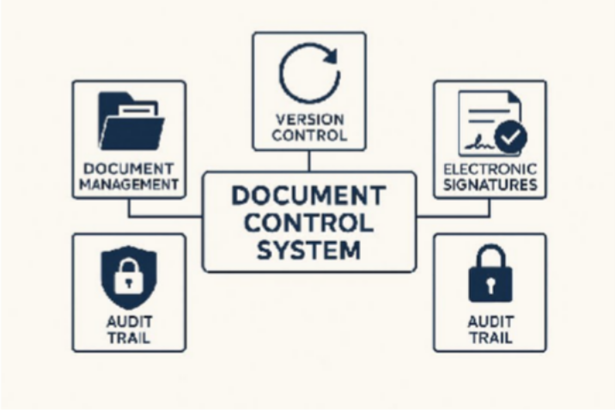

Document Management System:
Manage SOPs, Work Instructions (WI), forms, manuals, etc., with features such as version control and document status (draft / approved / obsolete).

Electronic Signatures:
Support compliance with 21 CFR Part 11 and ALCOA+ principles, including username/password authentication and audit trails.
  - Enterprise Quality Management System (eQMS)

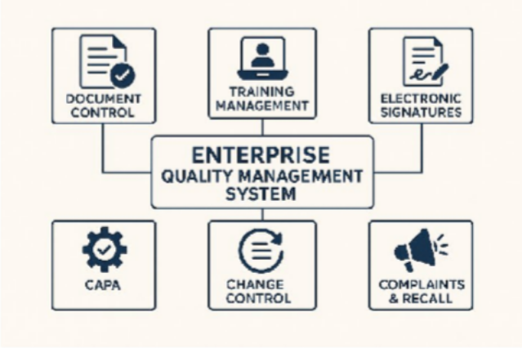

Training Management:
Link SOPs to employees, record training activities, manage tests, and track due dates.
Electronic signatures 21 CER Part 11
    - Electronic Records
    - Electronic Signatures
The goal is to ensure that electronic data is accurate, secure, reliable, and traceable, equivalent to paper-based documentation.

Key Principles of Part 11
    - Data Integrity – Ensuring correctness and completeness of data
    - Access Control – Controlling and restricting system access
    - Audit Trail – The system must record who did what, when, and how
    - System Validation – Demonstrating that the system works according to specifications
    - Electronic Signatures – Must be secure and legally equivalent to handwritten signatures

Deviation / Incident / OOS (Out of Specification)
Support reporting, investigation, and follow-up of deviations, incidents, and OOS results.

CAPA (Corrective & Preventive Action)
Manage corrective and preventive actions, including root cause analysis, action planning, and effectiveness checks.

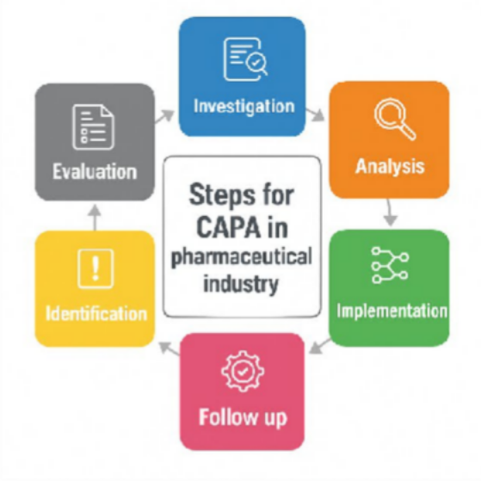

Change Control:
Control and track changes to processes, documents, and systems, with impact assessment and approval workflow.

Complaints & Recall Records:
Record, track, and investigate customer complaints, as well as manage product recall documentation
- Production / MES-lite + eBR (Electronic Batch Record)
Objective: To control herbal medicine manufacturing with full traceability across batches, lots, equipment, and raw materials.
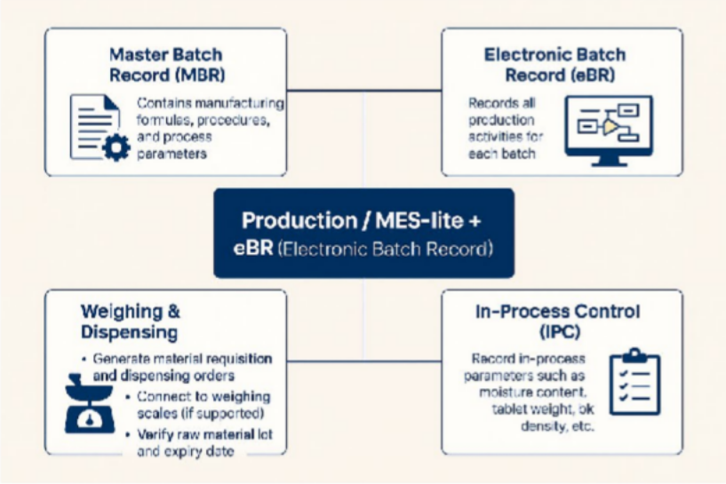
Core Functions

Master Batch Record (MBR):
Contains manufacturing formulas, procedures, and process parameters.

Electronic Batch Record (eBR):
Records all production activities for each batch.

Weighing & Dispensing:
- Generate material requisition and dispensing orders
- Connect to weighing scales (if supported)
- Verify raw material lot and expiry date

In-Process Control (IPC):
Record in-process parameters such as moisture content, tablet weight, bulk density, etc.

Equipment Logbook:
Record equipment usage, cleaning activities, and equipment status (in use / cleaned / maintenance)

Herbal Medicine–Specific Steps
For herbal products, additional process steps may be required, such as:

Extraction → Concentration → Drying → Milling → Sieving
These steps should be clearly defined in both MBR and eBR.

Warehouse & Traceability System

Objective:
Control stock and the status of raw materials, packaging materials, and finished goods, with the ability to answer traceability inquiries immediately.

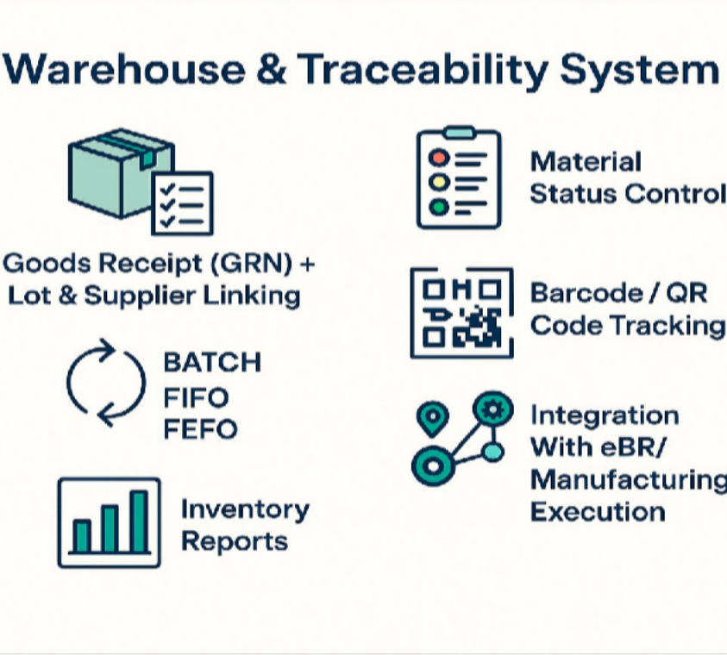
Key Functions
- Goods Receipt (GRN) for Raw Materials / Packaging / Finished Goods
  - Record incoming materials with linked lot numbers, suppliers, and
Certificates of Analysis (CoA).

- Material Status Management
  - Track and control statuses such as:
Quarantine / Released / Rejected / Returned / Hold

- Batch-Based Issuance
  - Issue materials to production based on FIFO or FEFO rules.

- Barcode / QR Code System

  - Apply barcodes or QR codes for raw materials, WIP, and finished products.

- Inventory Reports
  - Stock on hand
  - Expiry/aging report
  - Re-order point alerts

- Integration With eBR
  - Ability to trace which raw material lots were used in which production batches.

LIMS (Lab Information Management System) – QC Laboratory
Objective: To ensure transparency in analytical testing, enable easy traceability, and prevent unauthorized or improper result manipulation.
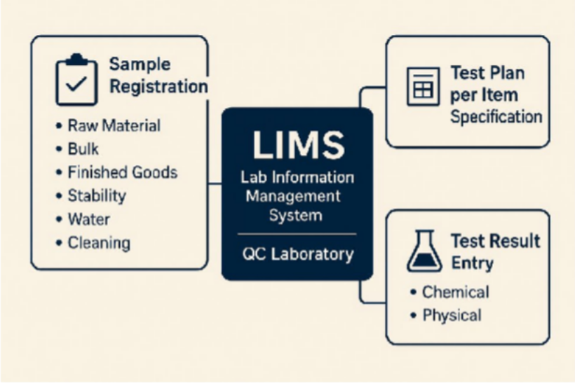

Functions
Sample Registration:
Register samples for testing, including:
- Raw Material
- Bulk
- Finished Goods
- Stability
- Water
- Cleaning (swab/rinse)

Test Plan Based on Item Specification:
Define and assign test plans according to the specification of each item.

Test Result Entry:
Record test results for:Physical tests

Maintenance & Calibration (CMMS)
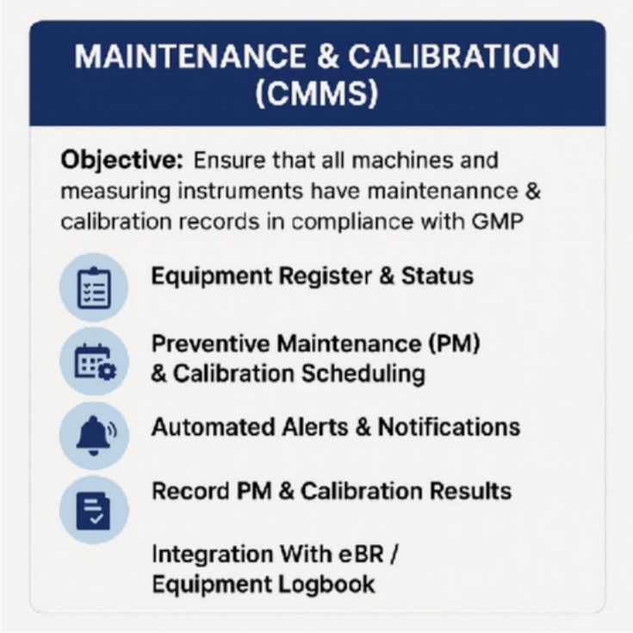
Objective:
Ensure that all machines and measuring instruments have proper maintenance and calibration records in compliance with GMP requirements.

Key Functions
- Equipment Register & Status
  - Centralized list of all equipment
  - Track equipment status (e.g., In Use, Under Maintenance, Out of Service)
- Preventive Maintenance (PM) & Calibration Scheduling
  - Define and manage PM plans
  - Create calibration schedules for each instrument or machine

Automated Alerts & Notifications
  - System alerts when PM or calibration is due
  - Overdue reminders for critical equipment
- Record PM & Calibration Results
  - Log maintenance activities and calibration outcomes
  - Attach calibration certificates and PM reports
- Integration With eBR / Equipment Logbook
  - The system ensures that equipment used in production is in
“calibrated” status
  - Real-time validation of equipment readiness before use
- Environment & Utility Monitoring
For herbal medicine manufacturing facilities with controlled production areas (even if not cleanrooms like sterile drug environments).
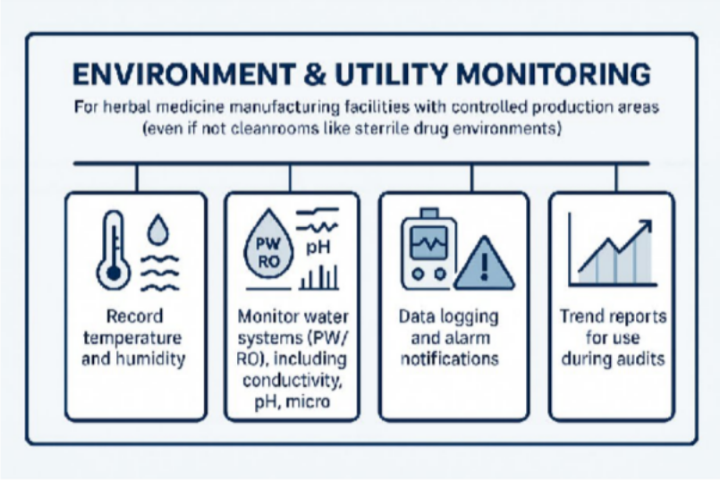

Functions
  - Record temperature and humidity in production areas, warehouses, and raw material storage rooms
  - Monitor water systems (PW / RO), including parameters such as conductivity, pH, and microbial count
  - Data logging and alarm notifications when values exceed specifications

  - Trend reports for use during audits

IT & Compliance System
This is not a single software, but a framework that must be applied across all systems mentioned above:
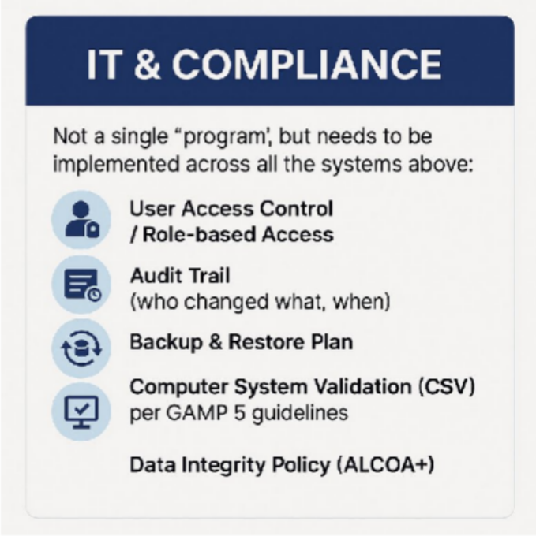

User Access Control / Role-Based Access
Ensure that each user can perform only the actions permitted for their role.

Audit Trail
Track who made changes, what was changed, and when it occurred.

Backup & Restore Plan
Maintain data protection and business continuity through scheduled backups and verified restoration procedures.
  - Computer System Validation (CSV) — based on GAMP 5 Validate computerized systems to ensure they are fit for intended use and compliant with regulatory requirements.
  - Incident

IT Support SLA (5×8) – Severity Levels
Severity Level Response Time On-site / Start Fix Time Resolution Target High (Critical) Within 1 hour Within 3 hours Same day Medium Within 4 hours Within 1 business day 1–2 business days Low Within 1 business day Within 1–3 business days 3–5 business days

  - Data Integrity Policy (ALCOA+)
Ensure data are Attributable, Legible, Contemporaneous, Original, Accurate, plus Complete, Consistent, Enduring, and Available.

Project หงส์ไทย Tracking – Software Development for Herbal GMP/PICS
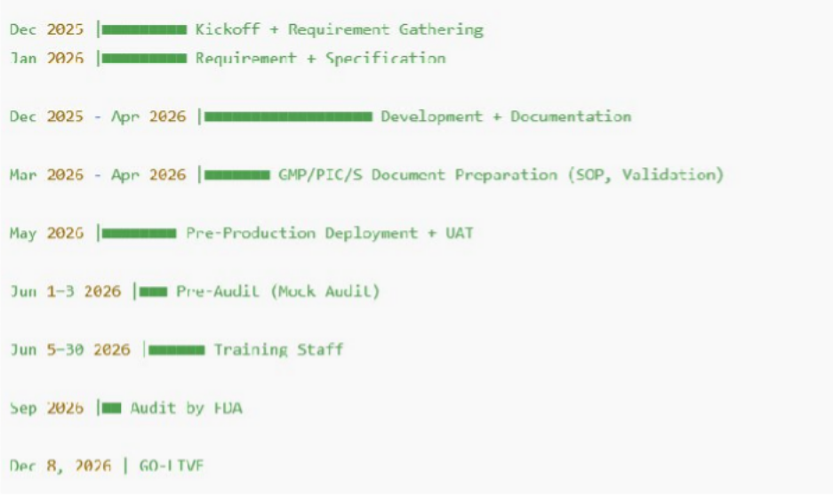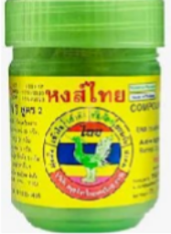

ลำ1ดับ ง1น / กิจกรรม วันที่เริ่ม วันที่สิ้นสุด ระยะเวล1 หม1ยเหตุ

Kickoff + เก็บ
1 Requirement & เขียน 15/12/2025 31/01/2026 ~1.5 เดือน
SRS FDD, UAT/
(Specification) Development +
เอกสารหลัก: SRS, FDD UAT, Data Flow, User Story

ทำาคู่ขนานกับข้อ 1

- Software
Documentation
ทำาเอกสารระบบ
15/12/2025 30/04/2026 ~4.5 เดือน
ในช่วงแรก

- GMP/PIC/S (SOP,
WI, Validation Plan)
01/03/2026 30/04/2026 2 เดือน รวม IQ/OQ/PQ Template

- Deployment Pre- production + UAT
05/05/2026 31/05/2026 ~1 เดือน ผู้ใช้ทดสอบและเก็บ
defect

ลำ1ดับ ง1น / กิจกรรม วันที่เริ่ม วันที่สิ้นสุด ระยะเวล1 หม1ยเหตุ

- Pre-Audit จาก อย.
(Mock Audit)
Training
01/06/2026 03/06/2026 3 วัน ตรวจเอกสาร +
ตรวจระบบ
อบรมการใช้งาน +

- พนักงานทั้งหมด 05/06/2026 30/06/2026 ~1 เดือน
บันทึกการอบรมตาม
GMP

7

Deploy

Audit จริงโดย อย.
กันย1ยน 2026 (09/2026)

กันย1ยน
2026

1 เดือน เตรียม CAR ถ้ามีข้อแก้ไข (รอคิวตรวจ)

ใช้จริง
(Go-
Live)
— 08/12/2026 — — เปิดใช้งานในระบบจริง

