1. GitLab (Prerequisite >> GitBash should be installed)
2. URL: <https://glcgitlab.southindia.cloudapp.azure.com/>
3. Credentials : Mindtree Credentials
4. Select SSH keys:

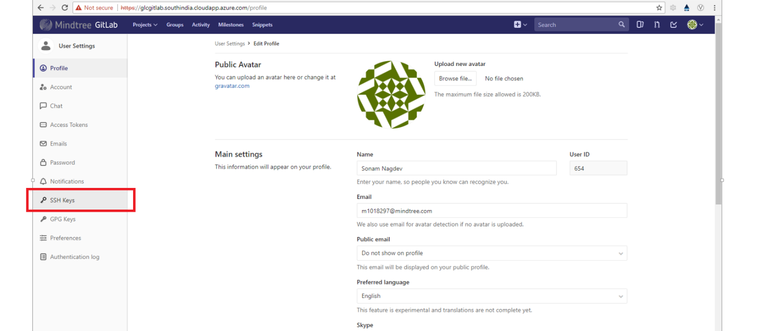

1. Generate the ssh key with the the below command from the below URL:

URL: <https://glcgitlab.southindia.cloudapp.azure.com/help/ssh/README>

Run the command highlighted below in blue with your email id as e.g.

ssh-keygen -t rsa -C "sonam.nagdev@mindtree.com" -b 4096

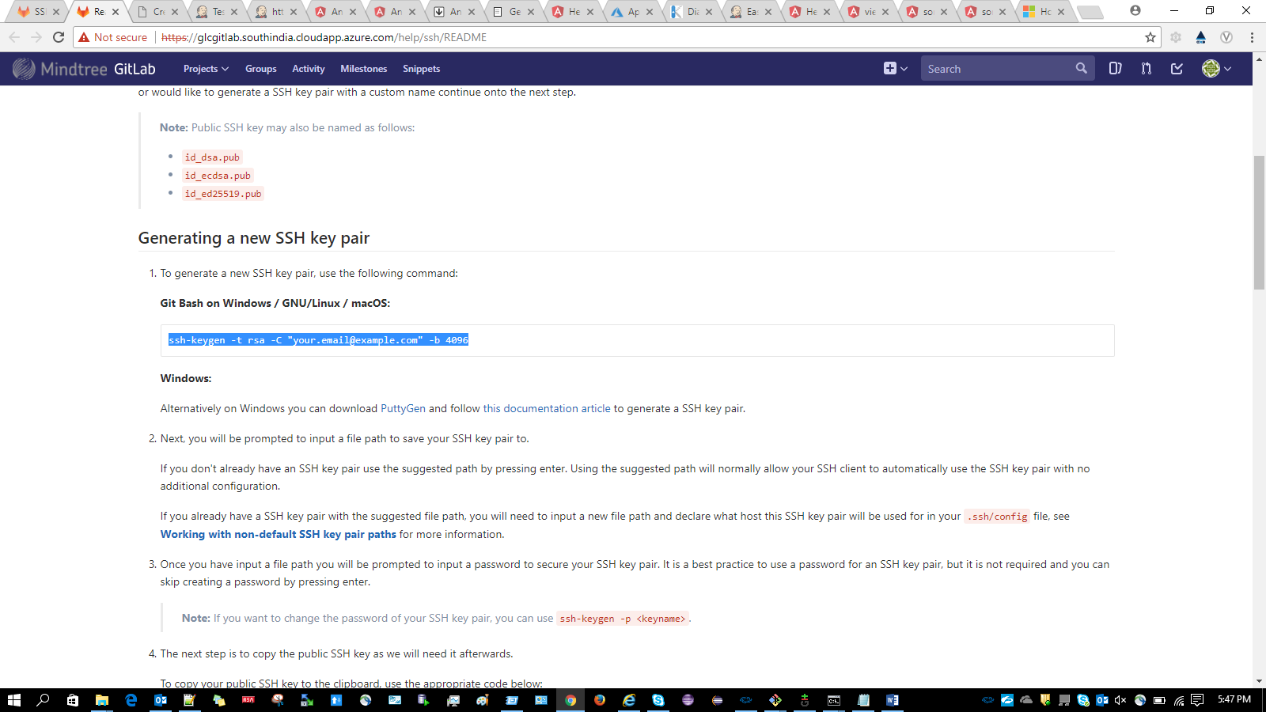

By running the above command the SSH key will be generated. By default it will be in the below folder

e.g. C:\Users\MXXXXXXX\.ssh folder

1. Execute the command highlighted below in git bash

cat ~/.ssh/id_rsa.pub | clip

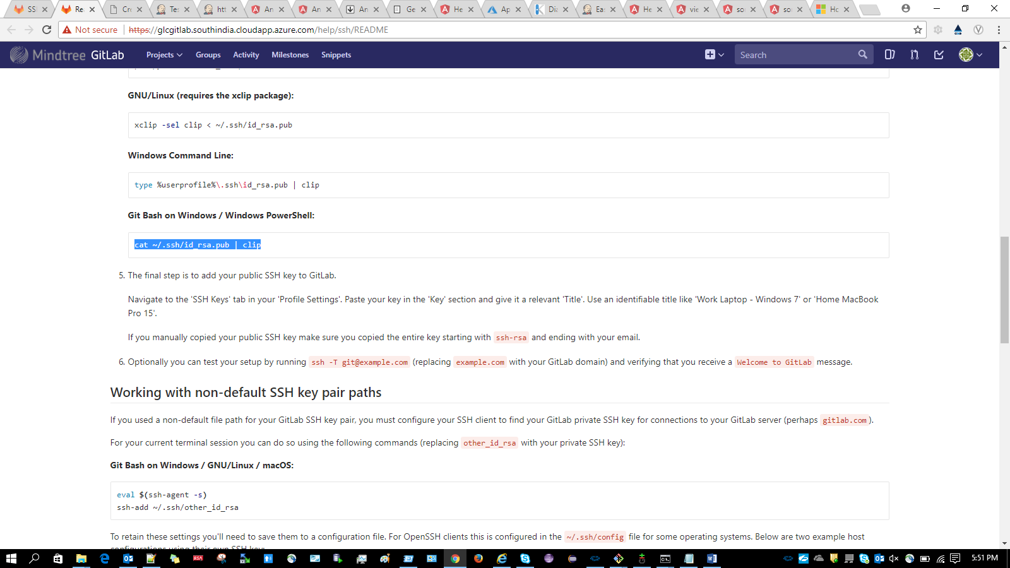

1. Paste the generated SSH key in the Key section as shown below:

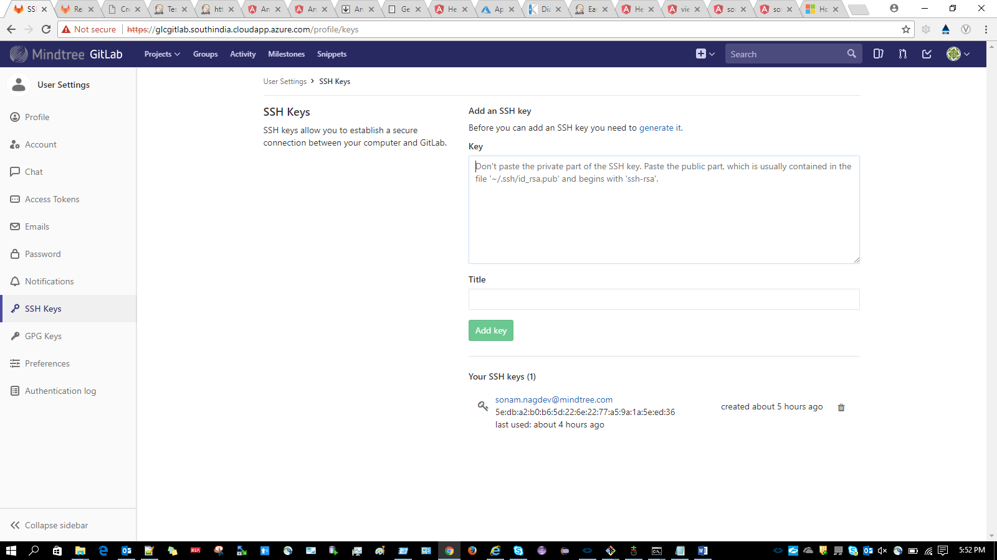

(Ctrl+v) in the Key text area and Click on Add Key button.

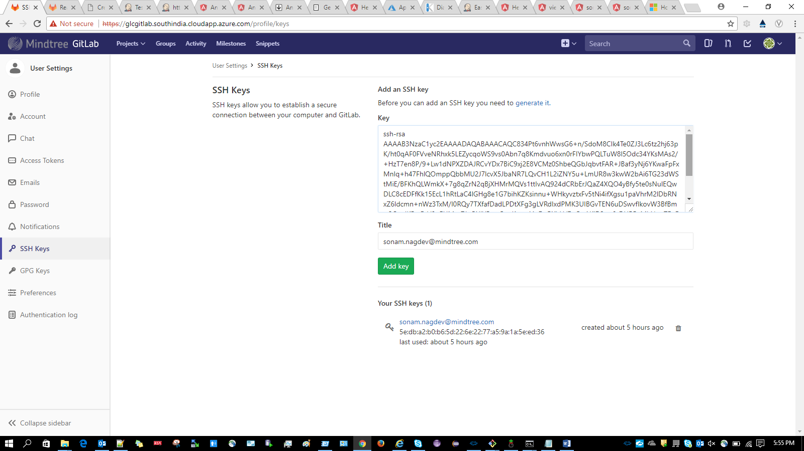

1. Create a group as shown below under the Groups section

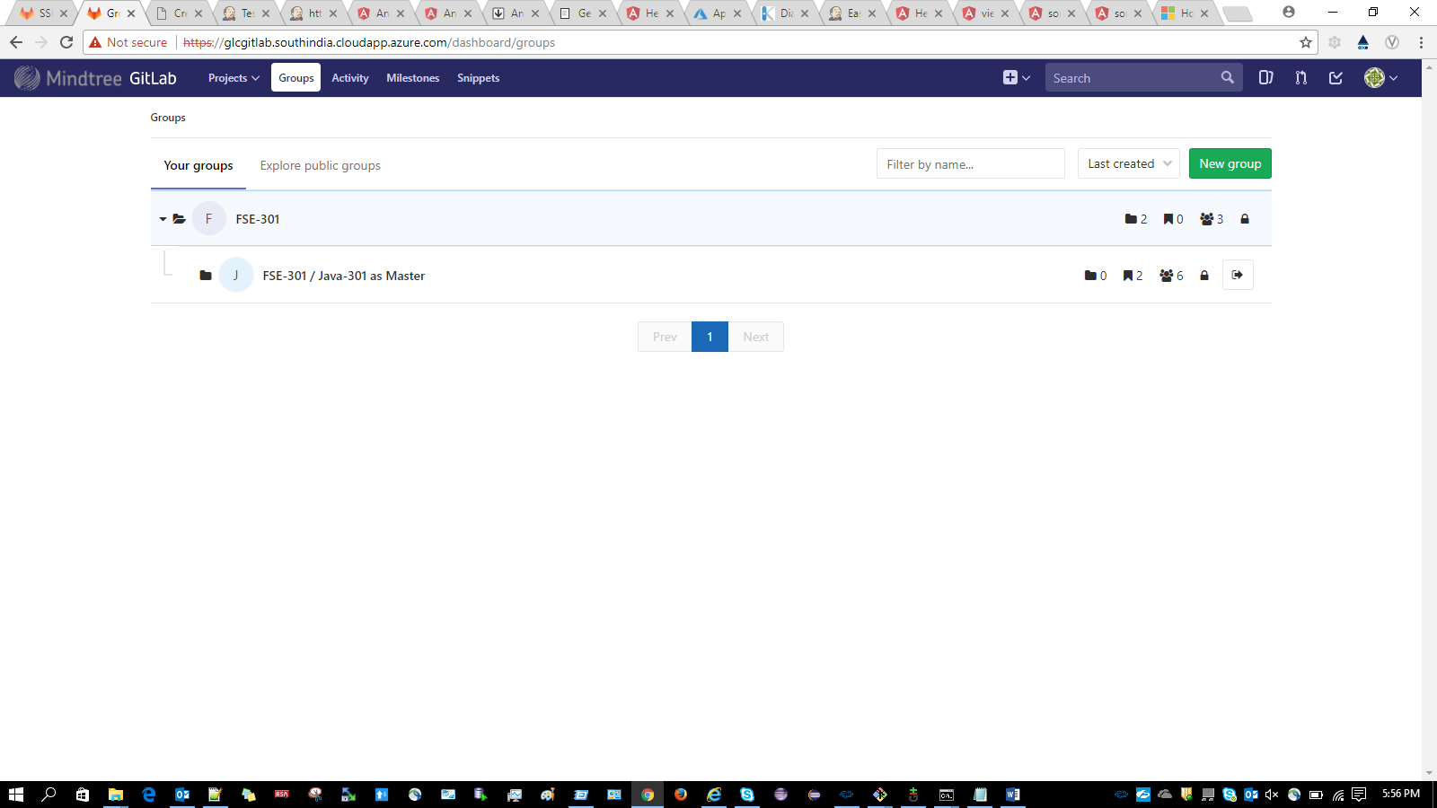

1. Navigate to the created group and create a new project by using “New Project” button as shown below:

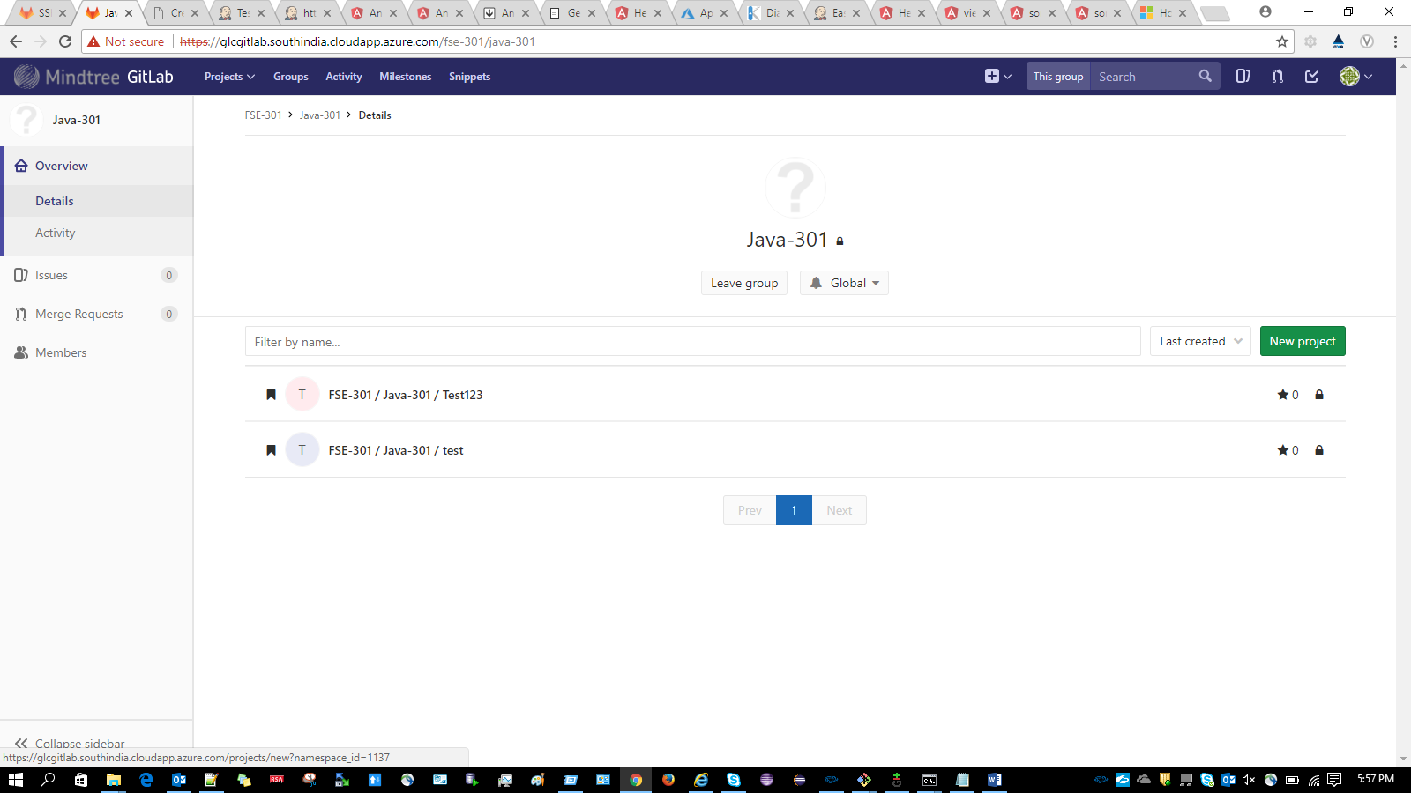

1. Give the project name and set the visibility level to Private(Selected by default)

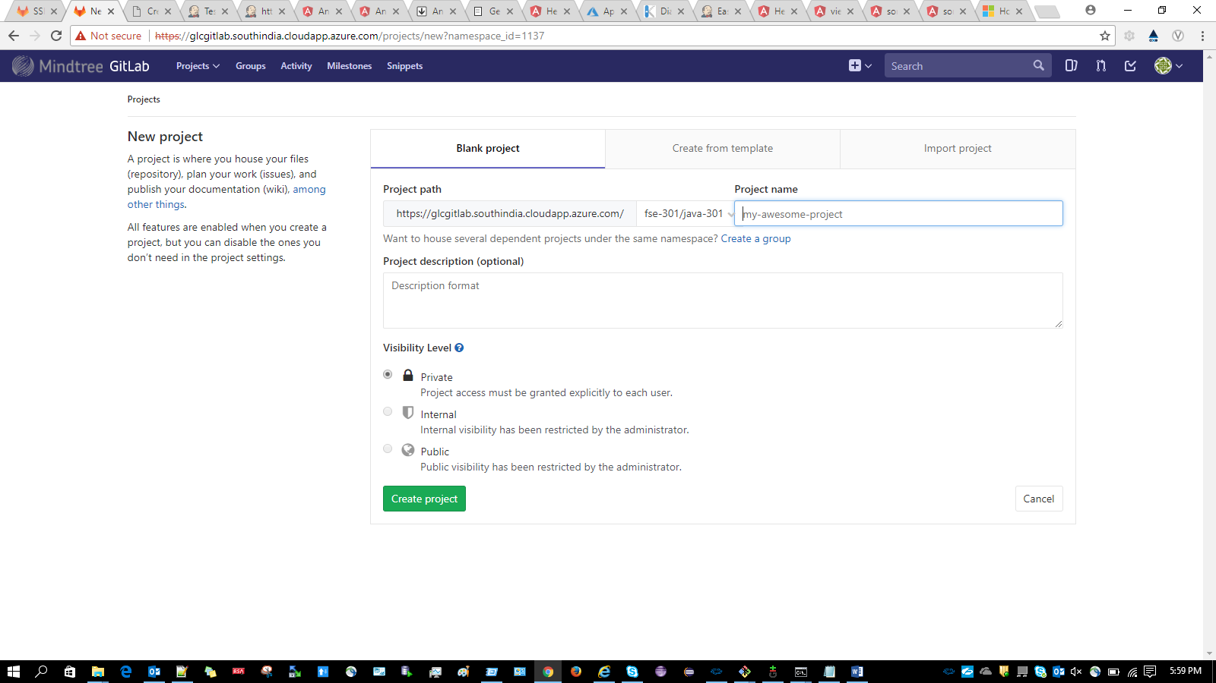

1. Give Project name as e.g. “DummyProject” and click on CreateProject button

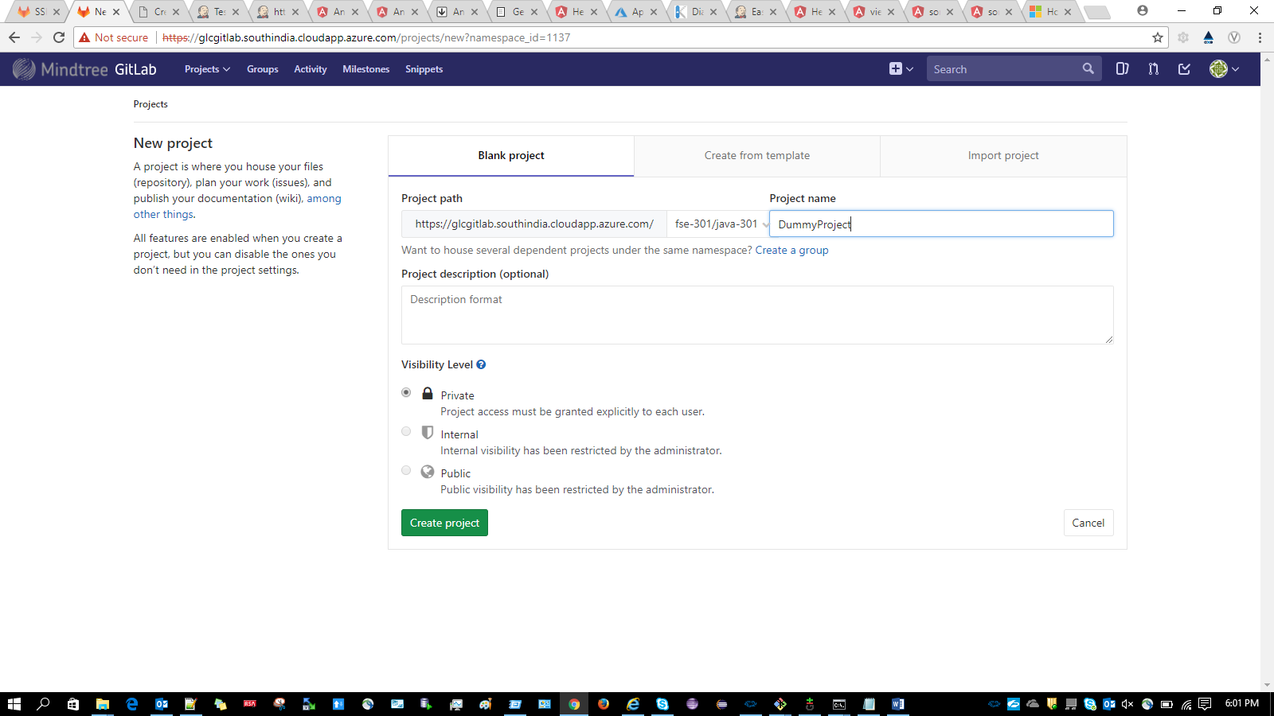

1. To set up a particular profile we need to execute the below two command in git bash:

git config --global user.name "Your UserName"

git config --global user.email "mXXXXXXX@mindtree.com"

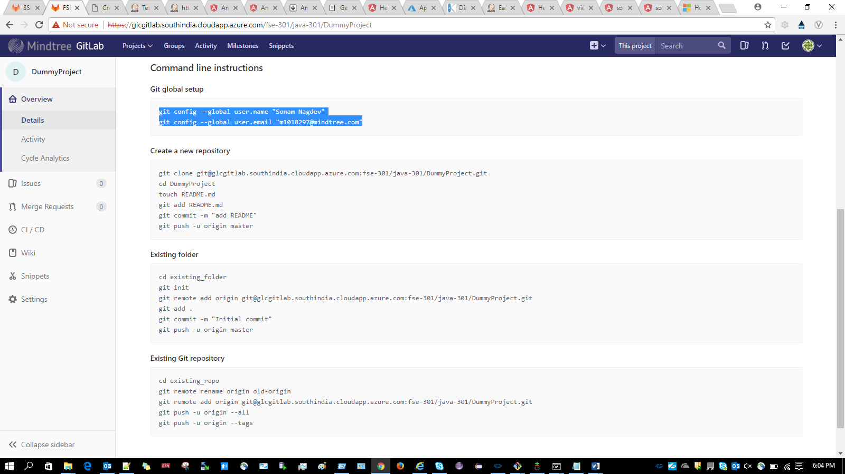

1. Create one dummy project in D: drive and add a text file as shown below:

D:\DummyProject\dummyFile.txt

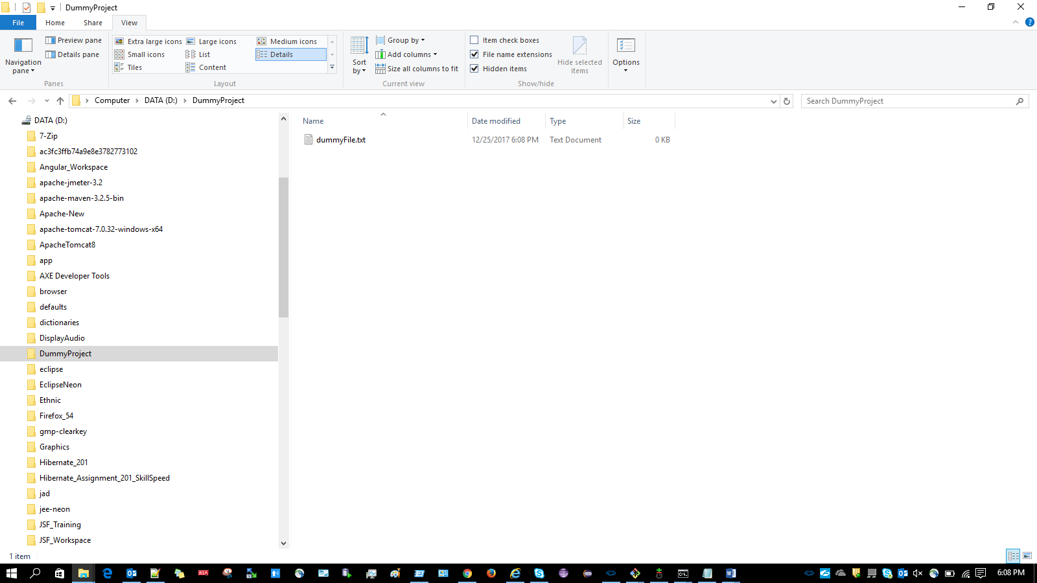

Add some text inside the file

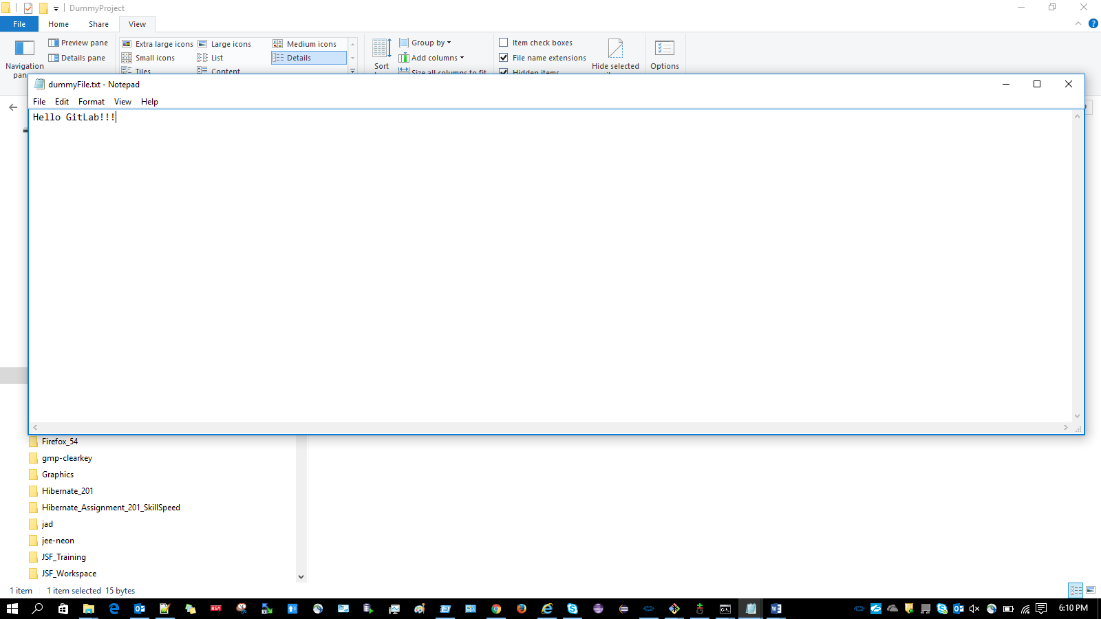

Right click on the below location and select “Git Bash here”

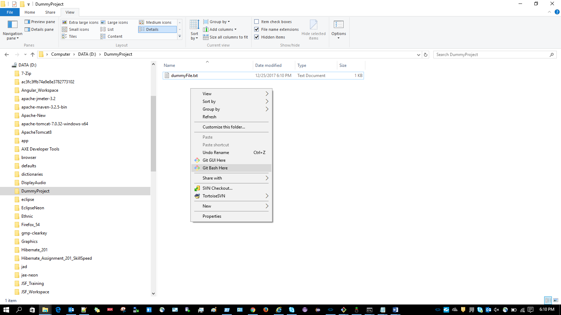

1. Execute the below commands in git bash to make your project a git project

git init

git remote add origin git@glcgitlab.southindia.cloudapp.azure.com:fse-301/java-301/DummyProject.git

git add .

git commit -m "Initial commit"

git push -u origin master

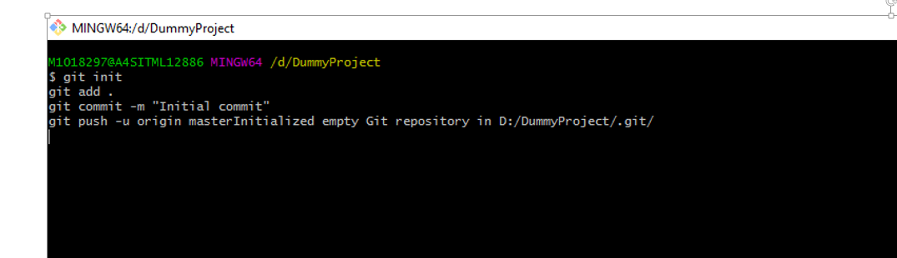

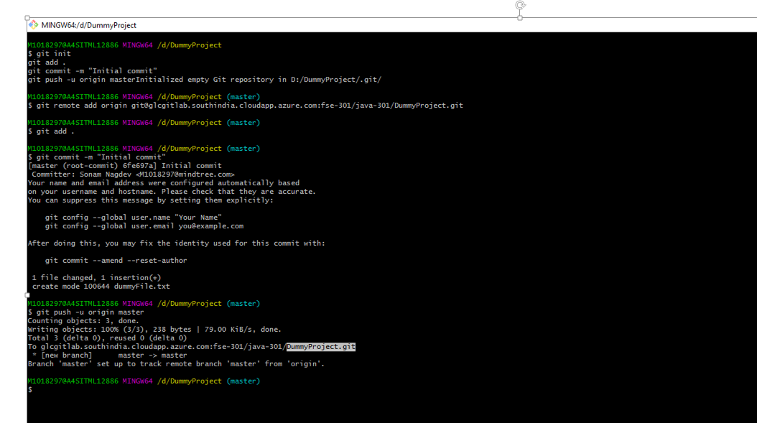

Now, a .git will be generated after executing the above commands inside your project:

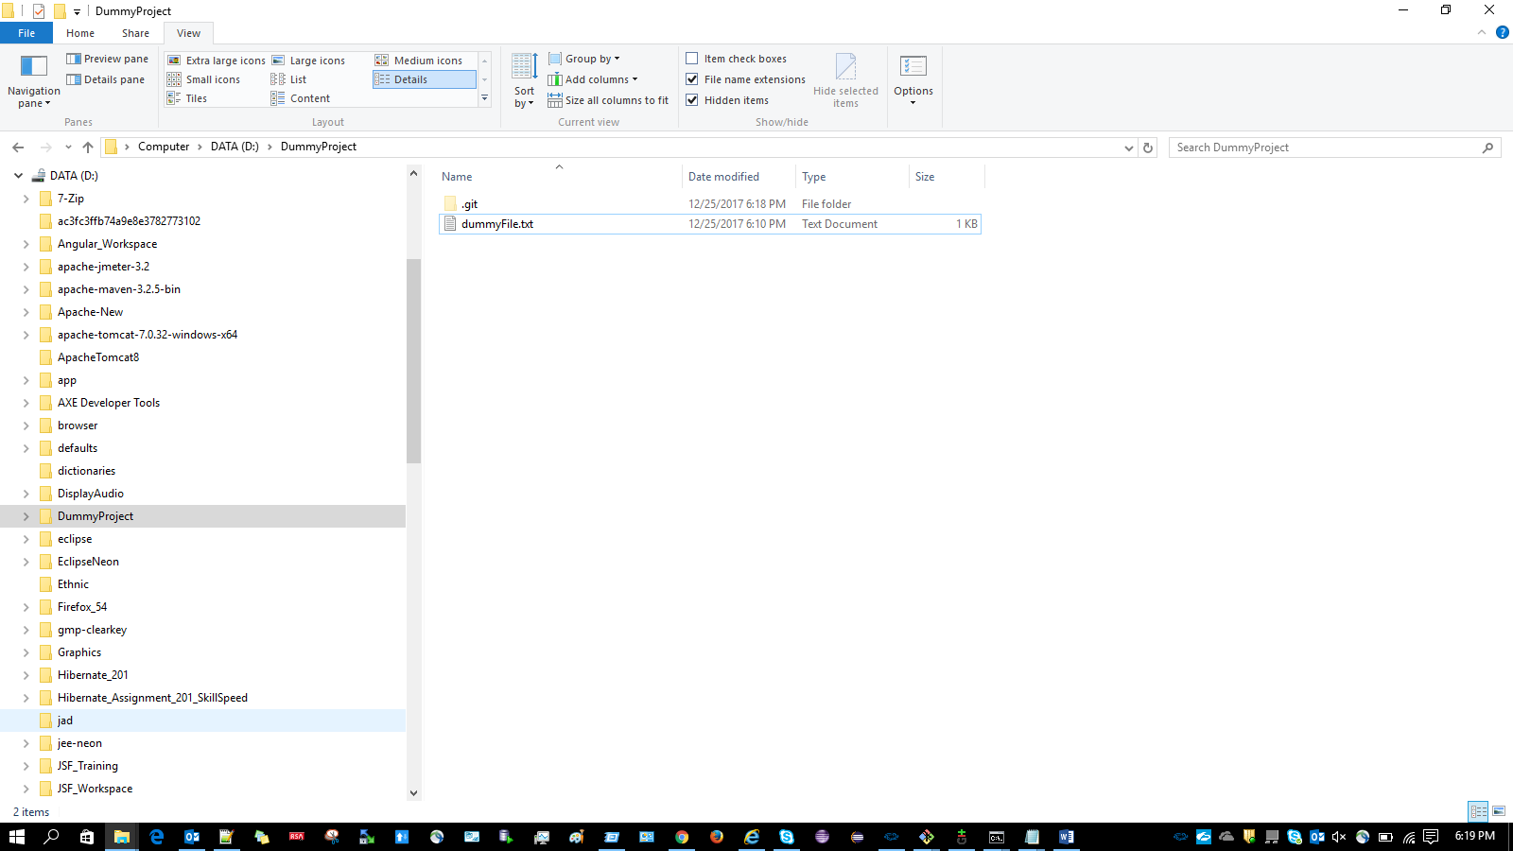

1. Basic Commands for using git:

git status -> It will tell whether your repository is up to date or not

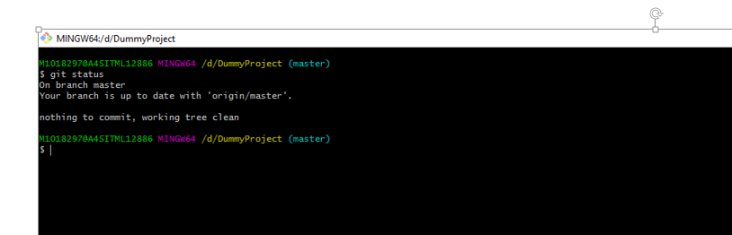

If you modify the file and do git status it will show as below

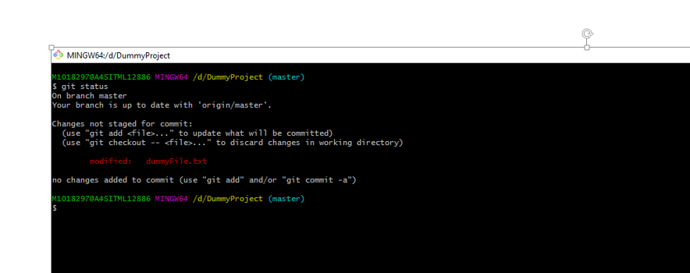

git add . -> The git add command adds a change in the working directory

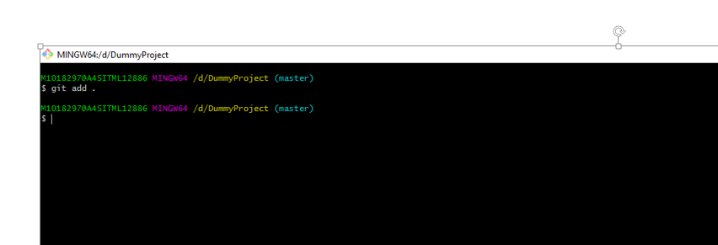

git commit –m “Commit Message” -> To commit the changed code into repository with the message using –m

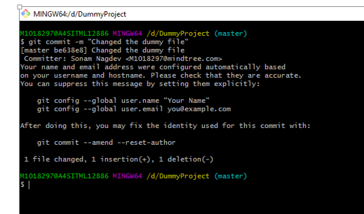

**Note**: To commit multiple files with the same commit message use the command below:

git commit –am “Commit Message”

git pull > It will fetch all the remote repository files to local and merge.

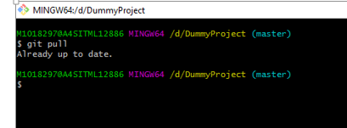

git push -> Pushing the code into GitLab

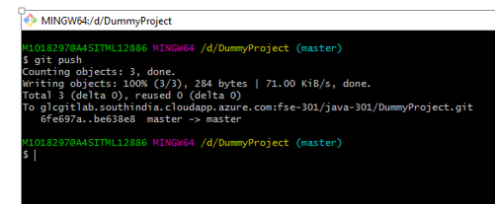

o) Branching in GitLab: A branch is an independent line of development. Create a branch to add your changes to the repository.

**Steps for creating a branch**

Click on Branch tab as shown below to create a branch

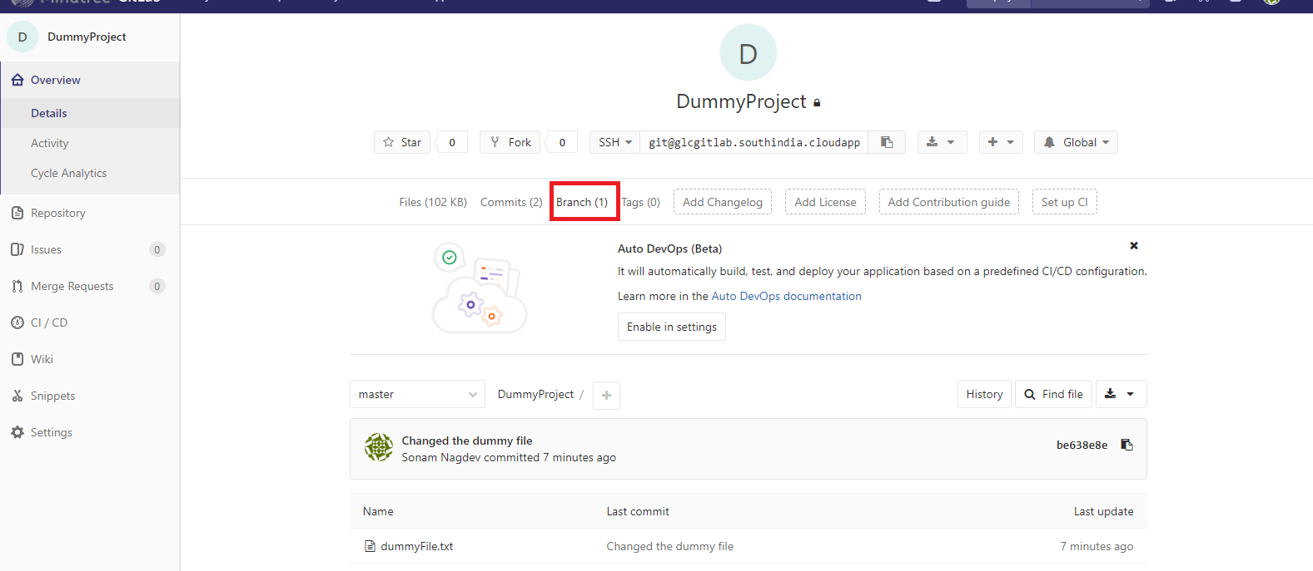

Click on the “New Branch” button

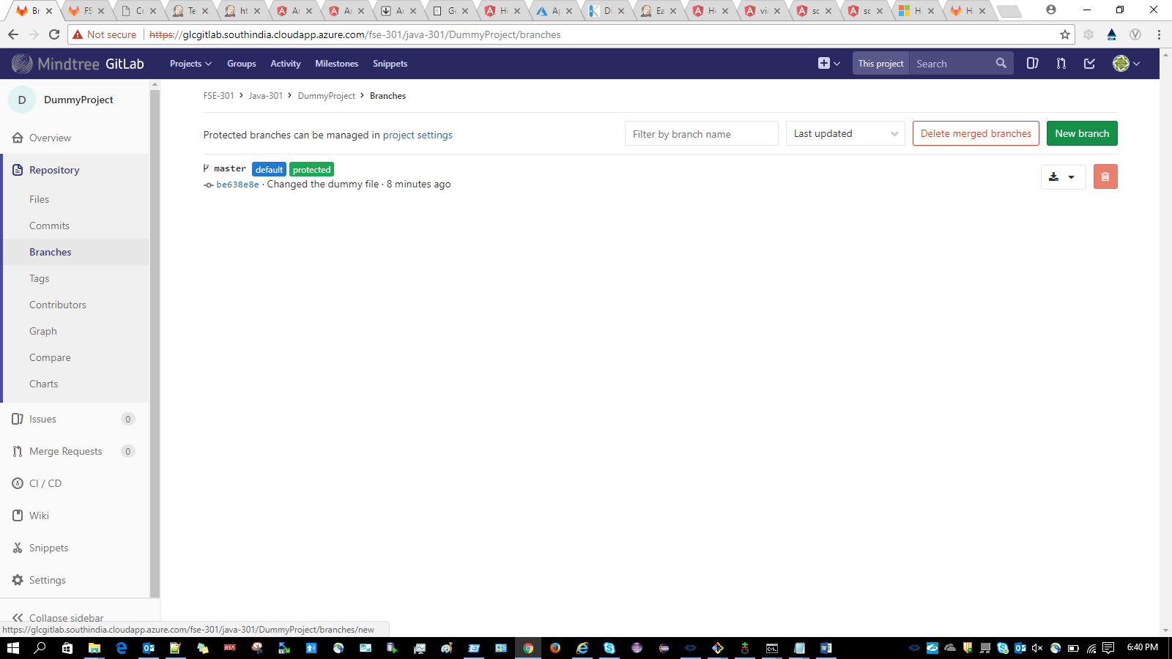

Give the Branch name e.g “dummyBranch “ and click on “Create Branch” button

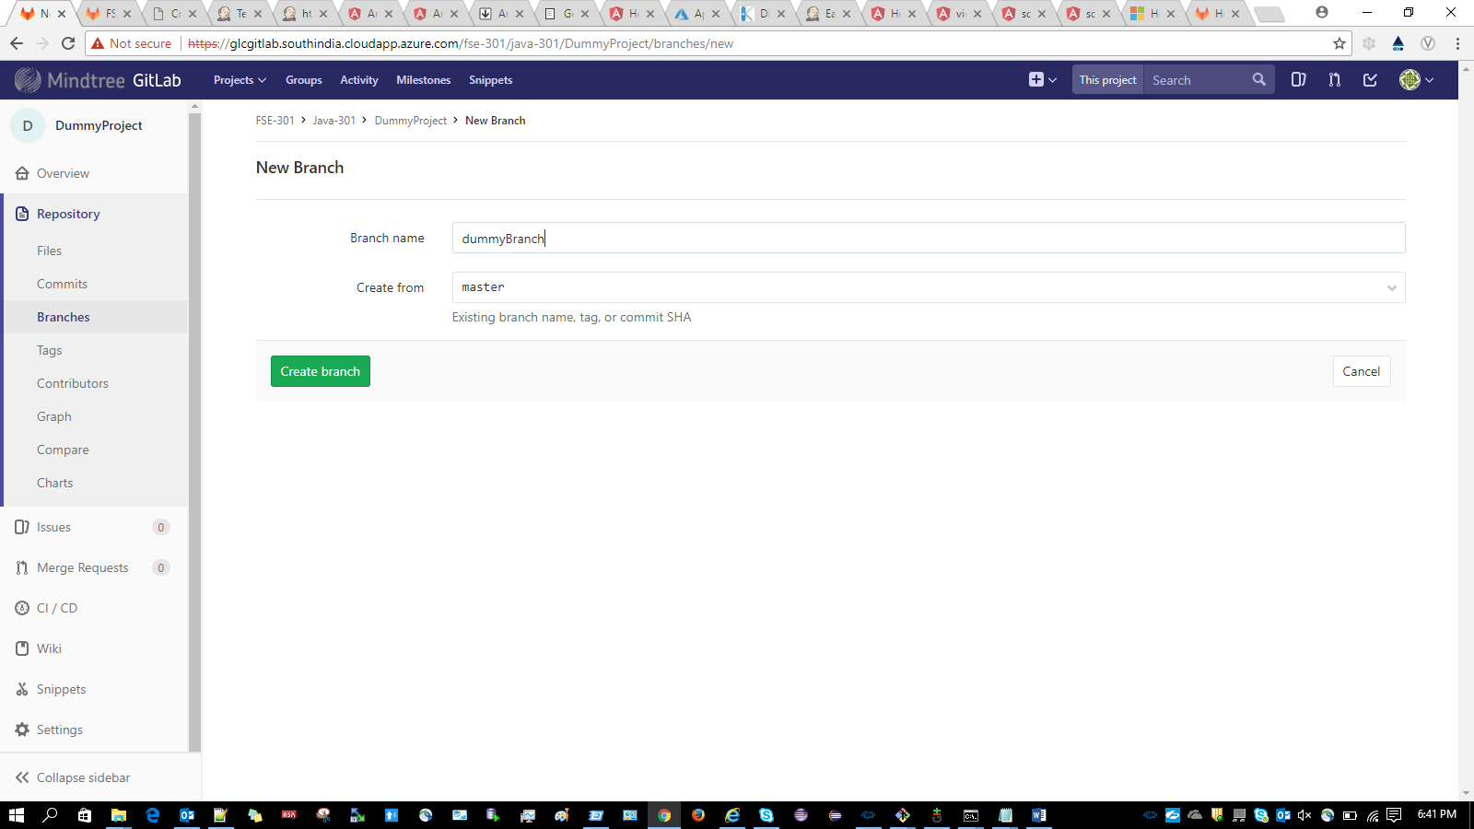

1. To copy the code from master to the created branch(dummyBranch) use the below command

Prerequisite: Create a branch folder say “dummyBranch” and then run the below command from the branch folder location

git clone -b dummyBranch --single-branch git@glcgitlab.southindia.cloudapp.azure.com:fse-

301/java-301/ DummyProject.git

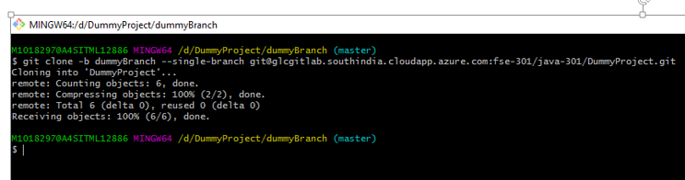

After executing the above command, the project will be cloned into the branch

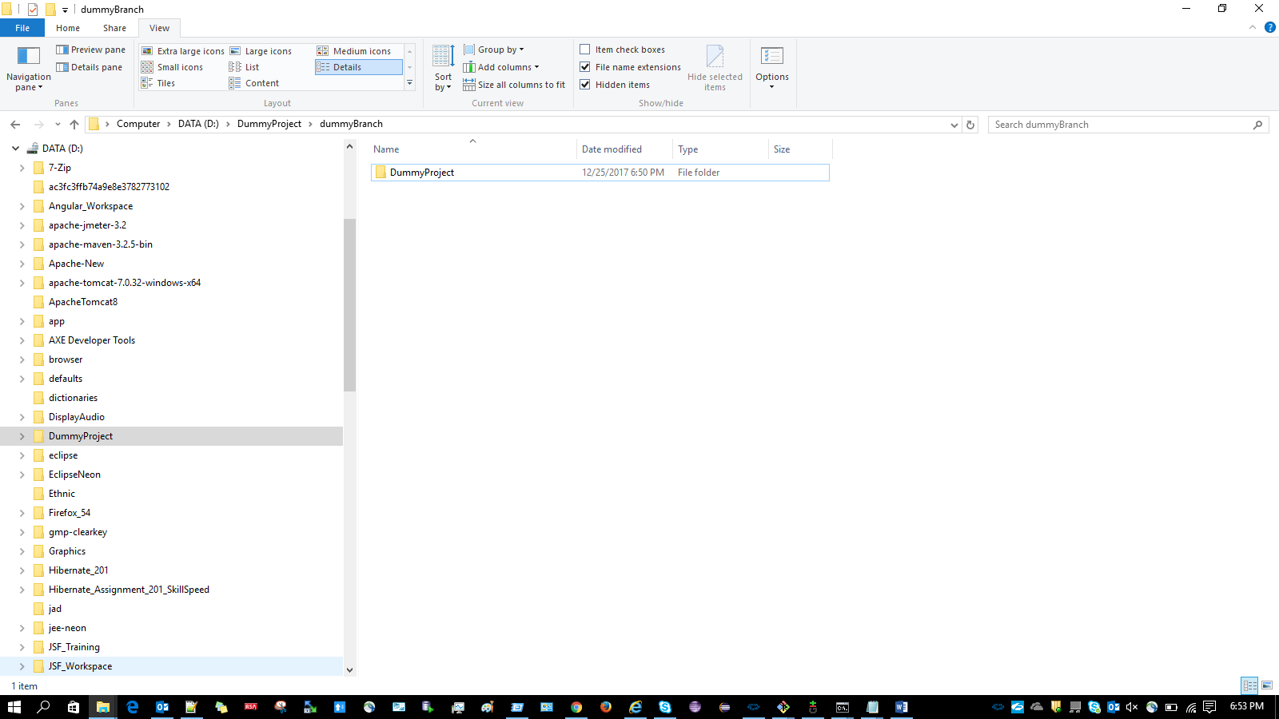

1. Create a master folder inside your project

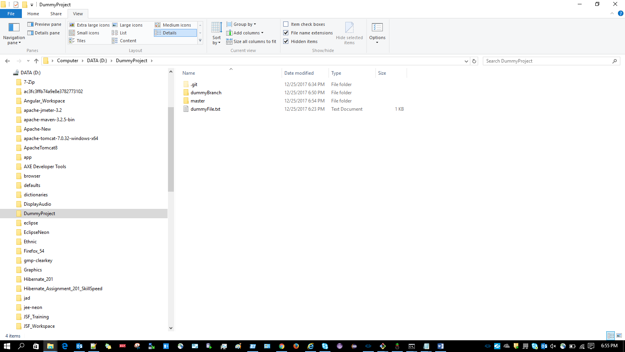

Inside the master folder select “Git Bash here” and execute the below command:

git clone git@glcgitlab.southindia.cloudapp.azure.com:fse-301/java-301/DummyProject.git

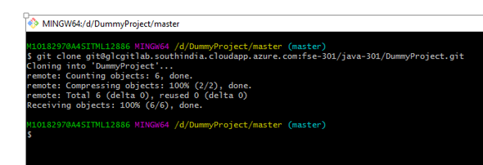

The project will be cloned inside master as shown below:

