**JENKINS: Continuous Integration Setup**

**Jenkins URL:** <https://glcdevops.southindia.cloudapp.azure.com:51001/>

**Credential:** Admin / Mindtree123

**Git URL:** https://glcgitlab.southindia.cloudapp.azure.com/

**CONFIGURATION:**

**Step 1:** Go to the Jenkins URL andClick “New Item”.

**Step 2:** Enter a name for your Jenkins project and select project type as “Freestyle project” and click OK.

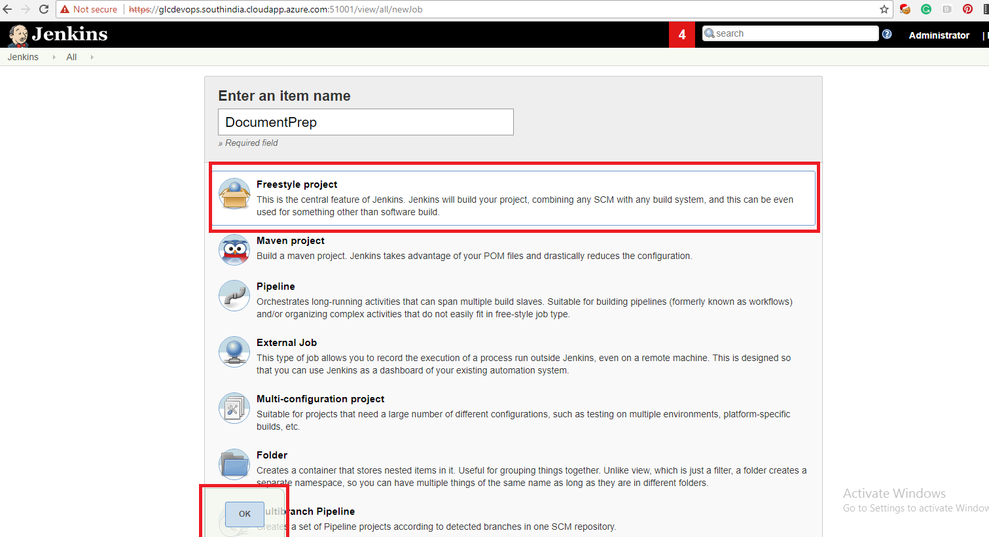

**Step 3:** Under Source code management, select git as source. Provide your Git lab’s repository URL and “M1027284 (SSH Key)” as credential.

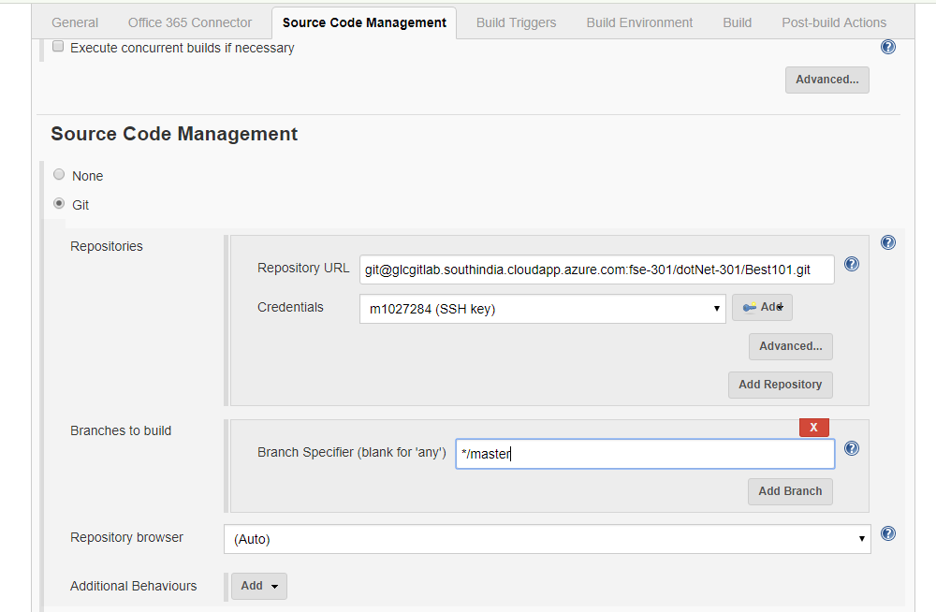

**Step 4:** Under Build Environment select “Provide Node & npm bin/ folder to PATH” option and select “npm” as NodeJS Installtion.

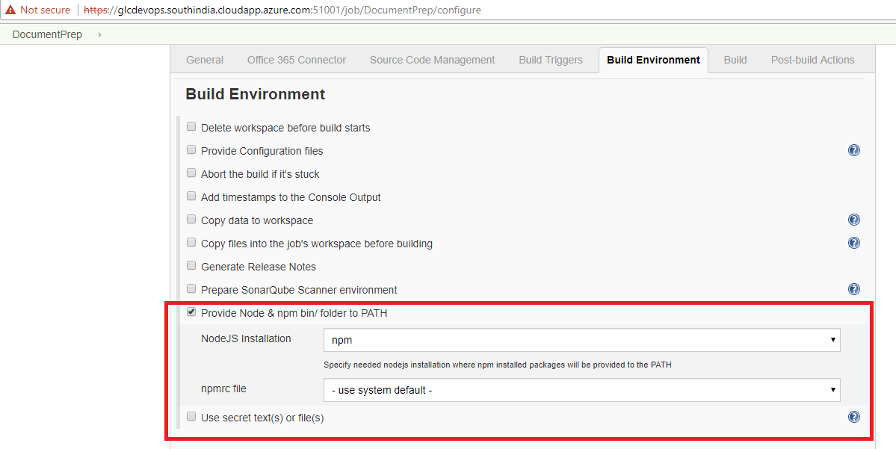

**LINKING JENKINS and GIT LAB:**

**Step 5:** Under Build triggers select “Build when a change is pushed to Git Lab”. Click advanced button and generate the secret token by clicking the Generate button.

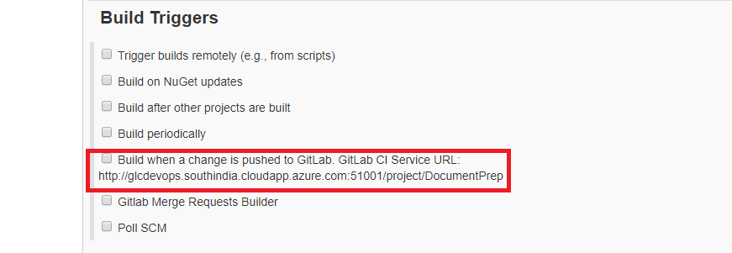

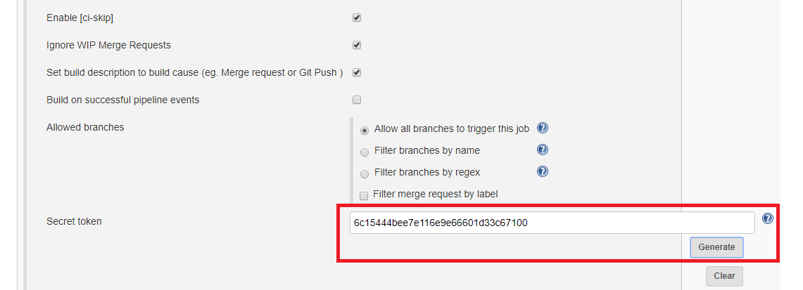

**Step 6:** Open your Git Lab project. Setup integration which is under settings. Use your Jenkins project URL as URL with word “job” replaced with “project” and your Jenkins generated token as Secret token, Uncheck “Enable SSL verification” and Click “Add Webhook”.

**Note:** You can test the push event by test option available after saving the same.

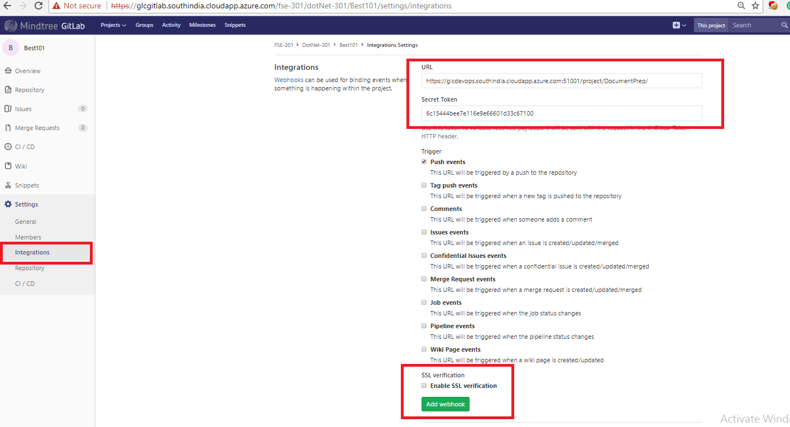

**PREREQUISITES SETUP:**

**Step 7:** Under Build select execute shell and enter the commands to be run before building your project.

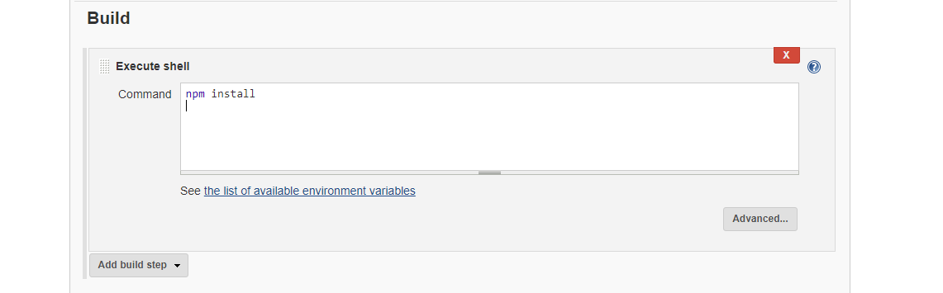

**Other Options available:**

* You can subscribe for email notifications too which is available under “Post-build Actions”.
* You can build your project by build option available in Jenkins or whenever you change and push your code to Git Lab, an automatic build will be triggered. You can check status of your build under console output.

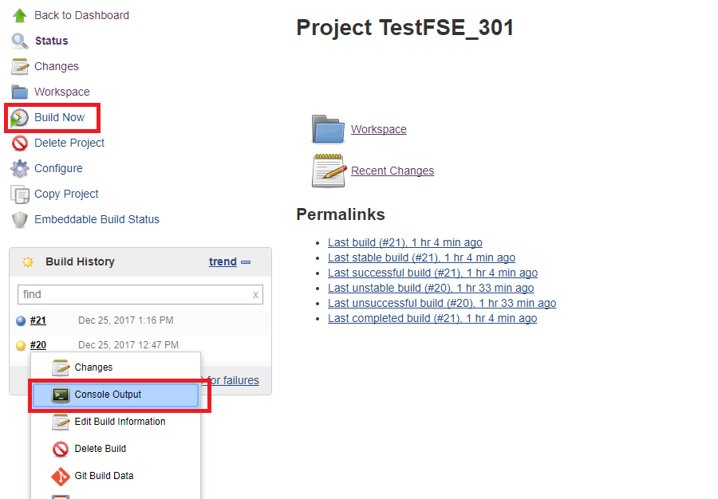

* You can restrict the number of build display on build history through option available under “Configure > General > Discard old builds >   
  Max # of builds to keep”.