House Price Prediction - Project Code
IBM SkillsBuild Data Analytics with AI Internship 2026
Author: Rittik
Complete code - notebook cells + train_model.py + app.py

Contents
- 1. Jupyter notebook - all code cells with their captured outputs
- 2. train_model.py - standalone training script
- 3. app.py - local Flask website

1. Jupyter notebook (Rittik_HousePricePrediction.ipynb)
Below are every markdown heading and code cell of the executed notebook, in order. Code cells end with a small block of their captured console output (limited to 80 lines). Figures are stored in the notebook itself and in ./figures.

House Price Prediction - Exploratory Data Analysis (EDA)

What this notebook does

1. Setup: libraries and display options
[Cell 1 of 48]
# Standard data + plotting libraries
import os
import numpy as np
import pandas as pd
import matplotlib
import matplotlib.pyplot as plt
import seaborn as sns

# Keep printed tables readable inside the notebook
pd.set_option("display.max_columns", None)
pd.set_option("display.max_rows", 100)
pd.set_option("display.width", 140)
plt.rcParams["figure.dpi"] = 90

print(f"pandas {pd.__version__} | numpy {np.__version__} | "
f"matplotlib {matplotlib.__version__} | seaborn {sns.__version__}")

pandas 3.0.6 | numpy 2.5.0 | matplotlib 3.11.2 | seaborn 0.13.2

2. Load the 4 raw files (relative paths)
[Cell 2 of 48]
DATA_DIR = "data"

train = pd.read_csv(os.path.join(DATA_DIR, "train.csv"))
test = pd.read_csv(os.path.join(DATA_DIR, "test.csv"))
sample_submission = pd.read_csv(os.path.join(DATA_DIR, "sample_submission.csv"))

with open(os.path.join(DATA_DIR, "data_description.txt"), "r", encoding="utf-8") as f:
data_description = f.read()

print(f"train.csv -> {train.shape[0]} rows x {train.shape[1]} columns")
print(f"test.csv -> {test.shape[0]} rows x {test.shape[1]} columns")
print(f"sample_submission.csv -> {sample_submission.shape[0]} rows x {sample_submission.shape[1]} columns")
print(f"data_description.txt -> {len(data_description.splitlines())} lines")

print("\ntrain columns:", list(train.columns))
print("\ntest columns:", list(test.columns))

train.csv -> 1460 rows x 81 columns
test.csv -> 1459 rows x 80 columns
sample_submission.csv -> 1459 rows x 2 columns
data_description.txt -> 523 lines

train columns: ['Id', 'MSSubClass', 'MSZoning', 'LotFrontage', 'LotArea', 'Street', 'Alley', 'LotShape', 'LandContour', 'Utilities', 'LotConfig', 'LandSlope', 'Neighborhood', 'Condition1', 'Condition2', 'BldgType', 'HouseStyle', 'OverallQual', 'OverallCond', 'YearBuilt', 'YearRemodAdd', 'RoofStyle', 'RoofMatl', 'Exterior1st', 'Exterior2nd', 'MasVnrType', 'MasVnrArea', 'ExterQual', 'ExterCond', 'Foundation', 'BsmtQual', 'BsmtCond', 'BsmtExposure', 'BsmtFinType1', 'BsmtFinSF1', 'BsmtFinType2', 'BsmtFinSF2', 'BsmtUnfSF', 'TotalBsmtSF', 'Heating', 'HeatingQC', 'CentralAir', 'Electrical', '1stFlrSF', '2ndFlrSF', 'LowQualFinSF', 'GrLivArea', 'BsmtFullBath', 'BsmtHalfBath', 'FullBath', 'HalfBath', 'BedroomAbvGr', 'KitchenAbvGr', 'KitchenQual', 'TotRmsAbvGrd', 'Functional', 'Fireplaces', 'FireplaceQu', 'GarageType', 'GarageYrBlt', 'GarageFinish', 'GarageCars', 'GarageArea', 'GarageQual', 'GarageCond', 'PavedDrive', 'WoodDeckSF', 'OpenPorchSF', 'EnclosedPorch', '3SsnPorch', 'ScreenPorch', 'PoolArea', 'PoolQC', 'Fence', 'MiscFeature', 'MiscVal', 'MoSold', 'YrSold', 'SaleType', 'SaleCondition', 'SalePrice']

test columns: ['Id', 'MSSubClass', 'MSZoning', 'LotFrontage', 'LotArea', 'Street', 'Alley', 'LotShape', 'LandContour', 'Utilities', 'LotConfig', 'LandSlope', 'Neighborhood', 'Condition1', 'Condition2', 'BldgType', 'HouseStyle', 'OverallQual', 'OverallCond', 'YearBuilt', 'YearRemodAdd', 'RoofStyle', 'RoofMatl', 'Exterior1st', 'Exterior2nd', 'MasVnrType', 'MasVnrArea', 'ExterQual', 'ExterCond', 'Foundation', 'BsmtQual', 'BsmtCond', 'BsmtExposure', 'BsmtFinType1', 'BsmtFinSF1', 'BsmtFinType2', 'BsmtFinSF2', 'BsmtUnfSF', 'TotalBsmtSF', 'Heating', 'HeatingQC', 'CentralAir', 'Electrical', '1stFlrSF', '2ndFlrSF', 'LowQualFinSF', 'GrLivArea', 'BsmtFullBath', 'BsmtHalfBath', 'FullBath', 'HalfBath', 'BedroomAbvGr', 'KitchenAbvGr', 'KitchenQual', 'TotRmsAbvGrd', 'Functional', 'Fireplaces', 'FireplaceQu', 'GarageType', 'GarageYrBlt', 'GarageFinish', 'GarageCars', 'GarageArea', 'GarageQual', 'GarageCond', 'PavedDrive', 'WoodDeckSF', 'OpenPorchSF', 'EnclosedPorch', '3SsnPorch', 'ScreenPorch', 'PoolArea', 'PoolQC', 'Fence', 'MiscFeature', 'MiscVal', 'MoSold', 'YrSold', 'SaleType', 'SaleCondition']

3. Shape, data types, duplicates
[Cell 3 of 48]
print("=== train.csv ===")
print("shape:", train.shape)
print("columns:", len(train.columns))

print("\n=== test.csv ===")
print("shape:", test.shape)
print("columns:", len(test.columns))

print("\n=== Duplicate rows (rows that repeat entirely) ===")
print(f"train: {train.duplicated().sum()}")
print(f"test : {test.duplicated().sum()}")

print("\n=== Duplicate Ids in train ===")
print(int(train["Id"].duplicated().sum()))

=== train.csv ===
shape: (1460, 81)
columns: 81

=== test.csv ===
shape: (1459, 80)
columns: 80

=== Duplicate rows (rows that repeat entirely) ===
train: 0
test : 0

=== Duplicate Ids in train ===
0

Data types
[Cell 4 of 48]
print("=== Column counts by data type in train ===")
print(train.dtypes.value_counts())

num_cols = [c for c in train.columns if pd.api.types.is_numeric_dtype(train[c])]
cat_cols = [c for c in train.columns if c not in num_cols]

print(f"\nNumeric columns ({len(num_cols)}):")
print(num_cols)
print(f"\nText/categorical columns ({len(cat_cols)}):")
print(cat_cols)

=== Column counts by data type in train ===
str 43
int64 35
float64 3
Name: count, dtype: int64

Numeric columns (38):
['Id', 'MSSubClass', 'LotFrontage', 'LotArea', 'OverallQual', 'OverallCond', 'YearBuilt', 'YearRemodAdd', 'MasVnrArea', 'BsmtFinSF1', 'BsmtFinSF2', 'BsmtUnfSF', 'TotalBsmtSF', '1stFlrSF', '2ndFlrSF', 'LowQualFinSF', 'GrLivArea', 'BsmtFullBath', 'BsmtHalfBath', 'FullBath', 'HalfBath', 'BedroomAbvGr', 'KitchenAbvGr', 'TotRmsAbvGrd', 'Fireplaces', 'GarageYrBlt', 'GarageCars', 'GarageArea', 'WoodDeckSF', 'OpenPorchSF', 'EnclosedPorch', '3SsnPorch', 'ScreenPorch', 'PoolArea', 'MiscVal', 'MoSold', 'YrSold', 'SalePrice']

Text/categorical columns (43):
['MSZoning', 'Street', 'Alley', 'LotShape', 'LandContour', 'Utilities', 'LotConfig', 'LandSlope', 'Neighborhood', 'Condition1', 'Condition2', 'BldgType', 'HouseStyle', 'RoofStyle', 'RoofMatl', 'Exterior1st', 'Exterior2nd', 'MasVnrType', 'ExterQual', 'ExterCond', 'Foundation', 'BsmtQual', 'BsmtCond', 'BsmtExposure', 'BsmtFinType1', 'BsmtFinType2', 'Heating', 'HeatingQC', 'CentralAir', 'Electrical', 'KitchenQual', 'Functional', 'FireplaceQu', 'GarageType', 'GarageFinish', 'GarageQual', 'GarageCond', 'PavedDrive', 'PoolQC', 'Fence', 'MiscFeature', 'SaleType', 'SaleCondition']

4. The target variable: SalePrice
[Cell 5 of 48]
price = train["SalePrice"]
print("=== SalePrice statistics ===")
print(price.describe().round(2))
print(f"\nMissing values in SalePrice: {price.isna().sum()}")

print("\n=== Skewness (a measure of asymmetry) ===")
print(f"raw SalePrice : {price.skew():.3f} (positive => long tail on the right)")
print(f"log1p(SalePrice) : {price.transform('log1p').skew():.3f} (closer to 0 => more symmetric)")

=== SalePrice statistics ===
count 1460.0
mean 180921.2
std 79442.5
min 34900.0
25% 129975.0
50% 163000.0
75% 214000.0
max 755000.0
Name: SalePrice, dtype: float64

Missing values in SalePrice: 0

=== Skewness (a measure of asymmetry) ===
raw SalePrice : 1.883 (positive => long tail on the right)
log1p(SalePrice) : 0.121 (closer to 0 => more symmetric)

[Cell 6 of 48]
fig, axes = plt.subplots(1, 2, figsize=(14, 4.6))

axes[0].hist(price, bins=50, edgecolor="black", color="steelblue")
axes[0].set_title("Distribution of SalePrice (raw)")
axes[0].set_xlabel("SalePrice ($)")
axes[0].set_ylabel("Number of houses")

axes[1].hist(np.log1p(price), bins=50, edgecolor="black", color="seagreen")
axes[1].set_title("Distribution of log1p(SalePrice)")
axes[1].set_xlabel("log1p(SalePrice)")
axes[1].set_ylabel("Number of houses")

plt.tight_layout()
plt.show()

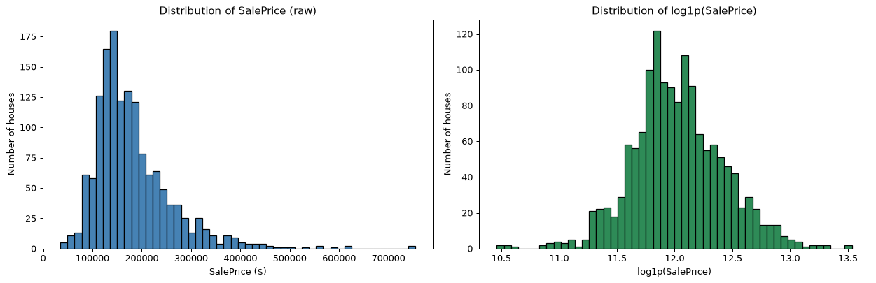
[Figure produced by this cell]

5. Missing values: what they really mean
[Cell 7 of 48]
missing_info = (
train.isna()
.sum()
.to_frame("missing_count")
.assign(percentage=lambda d: (d["missing_count"] / len(train) * 100).round(2))
.query("missing_count > 0")
.sort_values("percentage", ascending=False)
)
print(f"{missing_info.shape[0]} of {train.shape[1]} columns contain missing values\n")
missing_info

19 of 81 columns contain missing values

missing_count percentage
PoolQC 1453 99.52
MiscFeature 1406 96.30
Alley 1369 93.77
Fence 1179 80.75
MasVnrType 872 59.73
FireplaceQu 690 47.26
LotFrontage 259 17.74
GarageType 81 5.55
GarageYrBlt 81 5.55
GarageFinish 81 5.55
GarageQual 81 5.55
GarageCond 81 5.55
BsmtExposure 38 2.60
BsmtFinType2 38 2.60
BsmtQual 37 2.53
BsmtCond 37 2.53
BsmtFinType1 37 2.53
MasVnrArea 8 0.55
Electrical 1 0.07

Check: are the "absent feature" columns really missing (NaN)?
[Cell 8 of 48]
absent_like_cols = [
"PoolQC", "MiscFeature", "Alley", "Fence", "FireplaceQu", "MasVnrType",
"BsmtQual", "BsmtCond", "BsmtExposure", "BsmtFinType1", "BsmtFinType2",
"GarageType", "GarageFinish", "GarageQual", "GarageCond",
]

absent_meaning = {
"PoolQC": "No pool", "MiscFeature": "No misc feature", "Alley": "No alley",
"Fence": "No fence", "FireplaceQu": "No fireplace", "MasVnrType": "No masonry veneer",
"BsmtQual": "No basement", "BsmtCond": "No basement", "BsmtExposure": "No basement",
"BsmtFinType1": "No basement", "BsmtFinType2": "No basement",
"GarageType": "No garage", "GarageFinish": "No garage",
"GarageQual": "No garage", "GarageCond": "No garage",
}

rows = []
for c in absent_like_cols:
rows.append({
"column": c,
"NaN count": int(train[c].isna().sum()),
"text 'NA' count": int((train[c] == "NA").sum()),
"distinct real values": int(train[c].nunique(dropna=True)),
"meaning of NaN (data_description.txt)": absent_meaning[c],
})

pd.DataFrame(rows)

column NaN count text 'NA' count distinct real values meaning of NaN (data_description.txt)
0 PoolQC 1453 0 3 No pool
1 MiscFeature 1406 0 4 No misc feature
2 Alley 1369 0 2 No alley
3 Fence 1179 0 4 No fence
4 FireplaceQu 690 0 5 No fireplace
5 MasVnrType 872 0 3 No masonry veneer
6 BsmtQual 37 0 4 No basement
7 BsmtCond 37 0 4 No basement
8 BsmtExposure 38 0 4 No basement
9 BsmtFinType1 37 0 6 No basement
10 BsmtFinType2 38 0 6 No basement
11 GarageType 81 0 6 No garage
12 GarageFinish 81 0 3 No garage
13 GarageQual 81 0 5 No garage
14 GarageCond 81 0 5 No garage

Genuinely missing values (need careful handling)

6. Which numeric features relate to SalePrice?
[Cell 9 of 48]
numeric = train[["SalePrice"] + [c for c in num_cols if c not in ("Id", "SalePrice")]]

corr_with_price = numeric.corr()["SalePrice"].drop("SalePrice").sort_values(ascending=False)

print("=== Top 20 numeric correlations with SalePrice ===\n")
corr_with_price.head(20).to_frame("correlation with SalePrice")

=== Top 20 numeric correlations with SalePrice ===

correlation with SalePrice
OverallQual 0.790982
GrLivArea 0.708624
GarageCars 0.640409
GarageArea 0.623431
TotalBsmtSF 0.613581
1stFlrSF 0.605852
FullBath 0.560664
TotRmsAbvGrd 0.533723
YearBuilt 0.522897
YearRemodAdd 0.507101
GarageYrBlt 0.486362
MasVnrArea 0.477493
Fireplaces 0.466929
BsmtFinSF1 0.386420
LotFrontage 0.351799
WoodDeckSF 0.324413
2ndFlrSF 0.319334
OpenPorchSF 0.315856
HalfBath 0.284108
LotArea 0.263843

[Cell 10 of 48]
top12 = corr_with_price.head(12).index.tolist()
selected = ["SalePrice"] + top12

fig, ax = plt.subplots(figsize=(11, 9))
sns.heatmap(
numeric[selected].corr(),
annot=True, fmt=".2f", cmap="coolwarm", center=0,
square=True, ax=ax,
cbar_kws={"label": "Pearson correlation", "shrink": 0.8},
)
ax.set_title(f"Correlation heatmap: SalePrice vs top 12 numeric features\n"
f"(each pair shown as Pearson r coded by color)", fontsize=12)
plt.tight_layout()
plt.show()

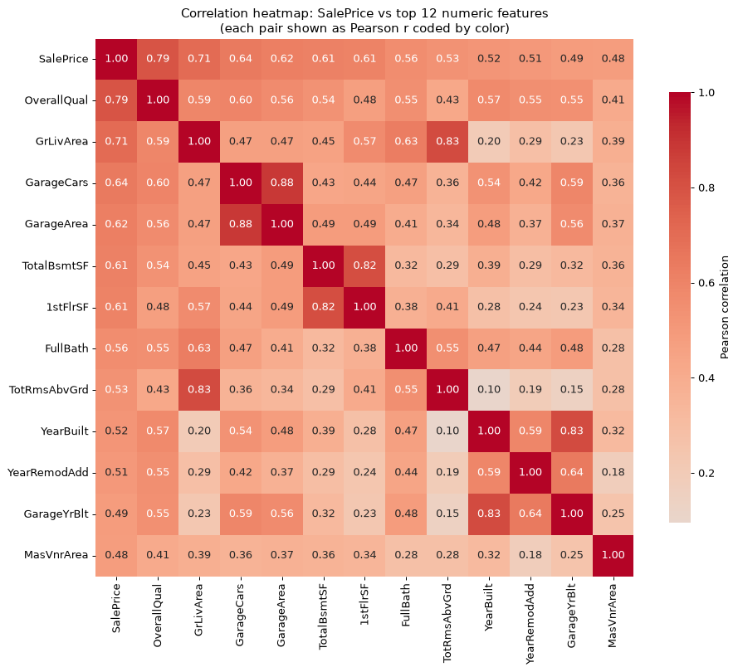
[Figure produced by this cell]

[Cell 11 of 48]
fig, ax = plt.subplots(figsize=(9, 7))
sns.heatmap(numeric[top12].corr(), annot=False, cmap="coolwarm",
center=0, square=True, ax=ax,
cbar_kws={"label": "Pearson correlation", "shrink": 0.8})
ax.set_title("Correlations among the top 12 numeric features")
plt.tight_layout()
plt.show()

print("Already-correlated pairs (|r| > 0.75) among the top 12 features:")
corr12 = numeric[top12].corr()
pairs = []
for i, a in enumerate(corr12.columns):
for b in corr12.columns[i + 1:]:
r = corr12.loc[a, b]
if abs(r) > 0.75:
pairs.append((a, b, round(r, 3)))
for a, b, r in pairs:
print(f" {a:<14} <-> {b:<14} r = {r}")

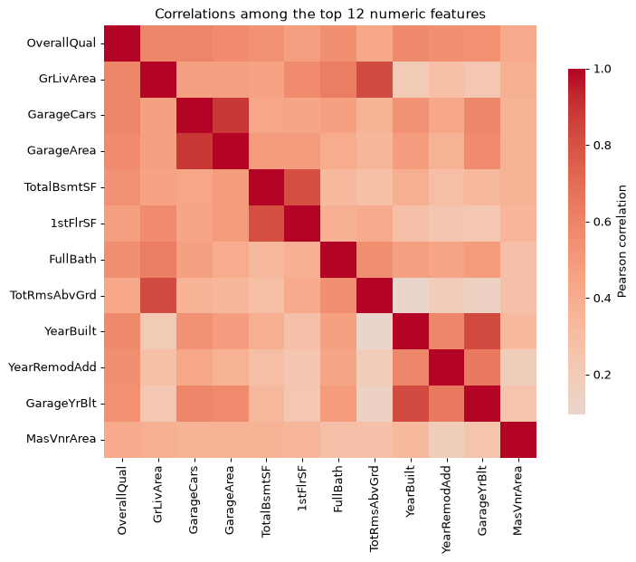
[Figure produced by this cell]

Already-correlated pairs (|r| > 0.75) among the top 12 features:
GrLivArea <-> TotRmsAbvGrd r = 0.825
GarageCars <-> GarageArea r = 0.882
TotalBsmtSF <-> 1stFlrSF r = 0.82
YearBuilt <-> GarageYrBlt r = 0.826

7. Reading the important numeric features
[Cell 12 of 48]
scatter_feats = ["GrLivArea", "TotalBsmtSF", "GarageCars", "GarageArea",
"1stFlrSF", "YearBuilt", "FullBath", "Fireplaces"]

fig, axes = plt.subplots(2, 4, figsize=(17, 8))
axes = axes.flatten()

for ax, f in zip(axes, scatter_feats):
ax.scatter(train[f], train["SalePrice"], s=8, alpha=0.35, color="steelblue")
ax.set_title(f"SalePrice vs {f}", fontsize=11)
ax.set_xlabel(f)
ax.set_ylabel("SalePrice ($)")

fig.suptitle("Numeric features most related to SalePrice (Pearson r in the legend box)", y=1.0)
plt.tight_layout()
plt.show()

print("=== Pearson correlation of each scatter feature with SalePrice ===")
for f in scatter_feats:
r = train[[f, "SalePrice"]].corr().loc[f, "SalePrice"]
print(f" {f:<14} r = {r:.3f}")

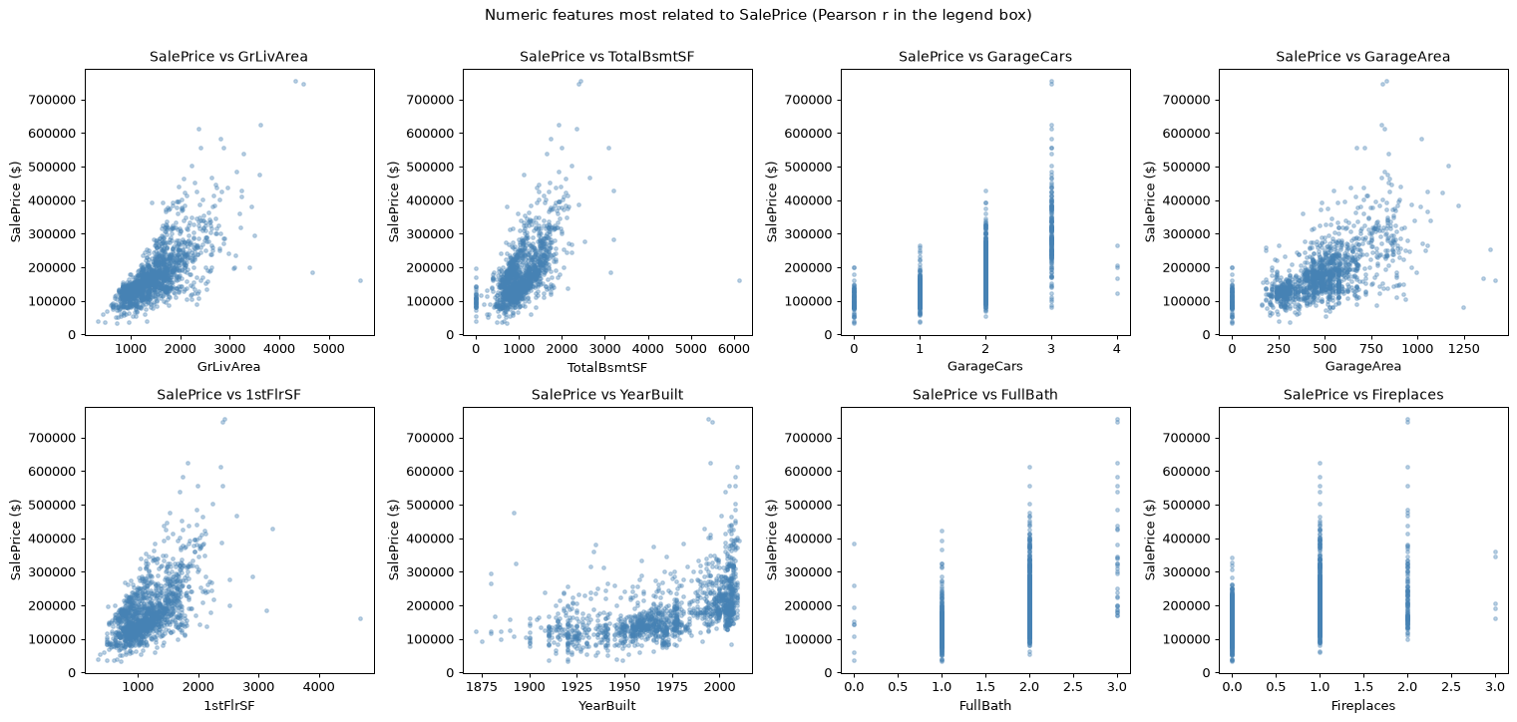
[Figure produced by this cell]

=== Pearson correlation of each scatter feature with SalePrice ===
GrLivArea r = 0.709
TotalBsmtSF r = 0.614
GarageCars r = 0.640
GarageArea r = 0.623
1stFlrSF r = 0.606
YearBuilt r = 0.523
FullBath r = 0.561
Fireplaces r = 0.467

8. Key categorical features
[Cell 13 of 48]
fig, axes = plt.subplots(1, 3, figsize=(17, 4.6))

for ax, c in zip(axes, ["Neighborhood", "MSZoning", "SaleType"]):
means = train.groupby(c)["SalePrice"].mean().sort_values(ascending=False)
means.plot(kind="bar", ax=ax, color="steelblue")
ax.set_title(f"Mean SalePrice by {c}", fontsize=11)
ax.set_xlabel(c)
ax.set_ylabel("Mean SalePrice ($)")
ax.tick_params(axis="x", rotation=60 if means.shape[0] > 6 else 0)

plt.tight_layout()
plt.show()

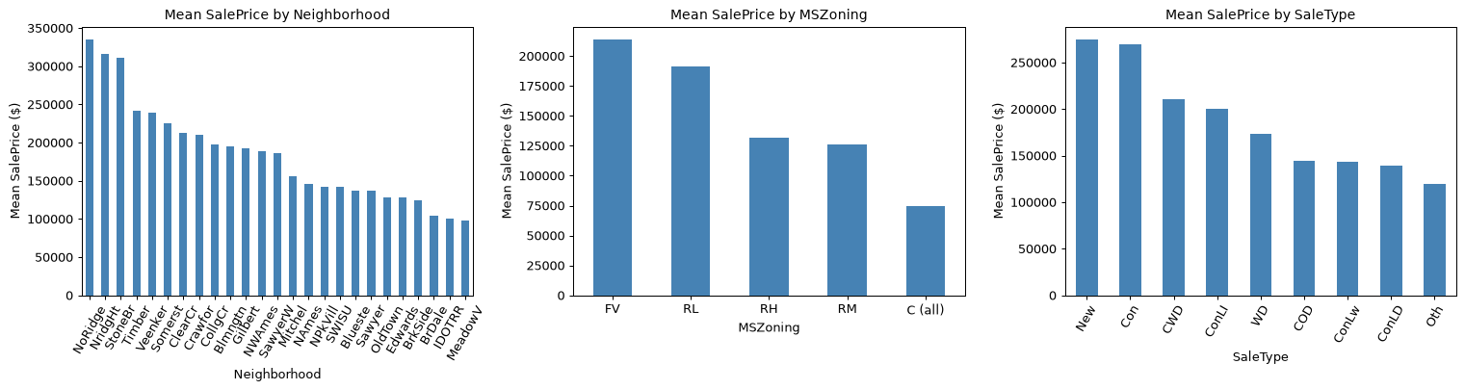
[Figure produced by this cell]

[Cell 14 of 48]
fig, axes = plt.subplots(1, 2, figsize=(14, 4.8))

train.groupby("OverallQual")["SalePrice"].mean().plot(kind="bar", ax=axes[0], color="teal")
axes[0].set_title("Mean SalePrice by OverallQual")
axes[0].set_xlabel("OverallQual (1 = very poor, 10 = very excellent)")
axes[0].set_ylabel("Mean SalePrice ($)")

sns.boxplot(data=train, x="OverallQual", y="SalePrice", ax=axes[1])
axes[1].set_title("SalePrice spread by OverallQual")
axes[1].set_xlabel("OverallQual")
axes[1].set_ylabel("SalePrice ($)")

plt.tight_layout()
plt.show()

print("Spearman rank correlation OverallQual vs SalePrice:",
train["OverallQual"].corr(train["SalePrice"], method="spearman").round(3))

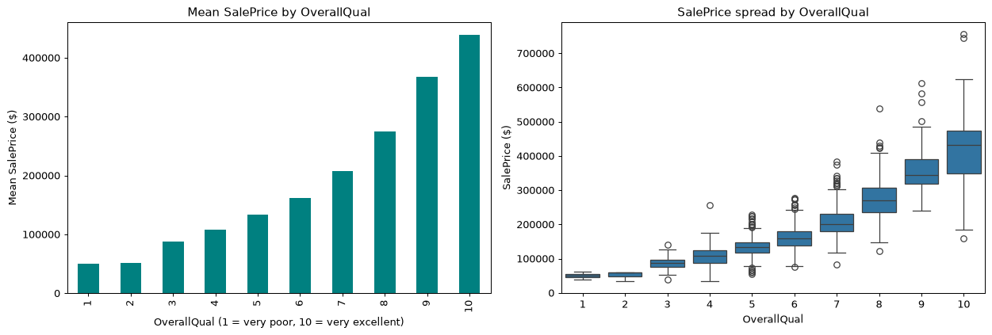
[Figure produced by this cell]

Spearman rank correlation OverallQual vs SalePrice: 0.81

9. Peek at the remaining files
[Cell 15 of 48]
print("=== test.csv (first 3 rows, first 12 columns shown) ===")
print(test.iloc[:3, :12].to_string())

print("\n=== sample_submission.csv (first 5 rows) ===")
print(sample_submission.head().to_string())

print("\n=== data_description.txt (first 12 lines) ===")
print("\n".join(data_description.splitlines()[:12]))

=== test.csv (first 3 rows, first 12 columns shown) ===
Id MSSubClass MSZoning LotFrontage LotArea Street Alley LotShape LandContour Utilities LotConfig LandSlope
0 1461 20 RH 80.0 11622 Pave NaN Reg Lvl AllPub Inside Gtl
1 1462 20 RL 81.0 14267 Pave NaN IR1 Lvl AllPub Corner Gtl
2 1463 60 RL 74.0 13830 Pave NaN IR1 Lvl AllPub Inside Gtl

=== sample_submission.csv (first 5 rows) ===
Id SalePrice
0 1461 169277.052498
1 1462 187758.393989
2 1463 183583.683570
3 1464 179317.477511
4 1465 150730.079977

=== data_description.txt (first 12 lines) ===
MSSubClass: Identifies the type of dwelling involved in the sale.

20 1-STORY 1946 & NEWER ALL STYLES
30 1-STORY 1945 & OLDER
40 1-STORY W/FINISHED ATTIC ALL AGES
45 1-1/2 STORY - UNFINISHED ALL AGES
50 1-1/2 STORY FINISHED ALL AGES
60 2-STORY 1946 & NEWER
70 2-STORY 1945 & OLDER
75 2-1/2 STORY ALL AGES
80 SPLIT OR MULTI-LEVEL
85 SPLIT FOYER

10. Summary of what we verified (all numbers computed above)
[Cell 16 of 48]
# Quick machine-readable recap for later stages
import json

recap = {
"train_shape": list(train.shape),
"test_shape": list(test.shape),
"submission_shape": list(sample_submission.shape),
"n_duplicate_rows_train": int(train.duplicated().sum()),
"n_columns_with_missing_train": int(missing_info.shape[0]),
"sale_price_min": int(price.min()),
"sale_price_max": int(price.max()),
"sale_price_skew_raw": round(float(price.skew()), 3),
"sale_price_skew_log1p": round(float(price.transform("log1p").skew()), 3),
"top_numeric_corr_with_saleprice": {f: round(float(r), 3)
for f, r in corr_with_price.head(5).items()},
}
print(json.dumps(recap, indent=2))

{
"train_shape": [
1460,
81
],
"test_shape": [
1459,
80
],
"submission_shape": [
1459,
2
],
"n_duplicate_rows_train": 0,
"n_columns_with_missing_train": 19,
"sale_price_min": 34900,
"sale_price_max": 755000,
"sale_price_skew_raw": 1.883,
"sale_price_skew_log1p": 0.121,
"top_numeric_corr_with_saleprice": {
"OverallQual": 0.791,
"GrLivArea": 0.709,
"GarageCars": 0.64,
"GarageArea": 0.623,
"TotalBsmtSF": 0.614
}
}

11. Stage 3 - Data preprocessing
[Cell 17 of 48]
import sklearn
from sklearn.impute import SimpleImputer
from sklearn.preprocessing import StandardScaler, OneHotEncoder
from sklearn.compose import ColumnTransformer
from sklearn.pipeline import Pipeline

print("scikit-learn version:", sklearn.__version__)

# Work on copies - the raw CSV files are never touched.
X = train.drop(columns=["Id", "SalePrice"]).copy()
y = train["SalePrice"].copy()
X_test = test.drop(columns=["Id"]).copy()

print("X (train features):", X.shape)
print("y (train target) :", y.shape)
print("X_test (test features) :", X_test.shape)

scikit-learn version: 1.9.1
X (train features): (1460, 79)
y (train target) : (1460,)
X_test (test features) : (1459, 79)

Outliers
[Cell 18 of 48]
fig, ax = plt.subplots(figsize=(8, 4.5))
ax.scatter(X["GrLivArea"], y, s=12, alpha=0.5, color="steelblue")
ax.axvline(4000, color="red", linestyle="--", linewidth=1.5)
ax.text(4120, max(y) * 0.15, "GrLivArea = 4000", color="red", fontsize=9)
ax.set_title("Outlier check: SalePrice vs GrLivArea")
ax.set_xlabel("GrLivArea (sq ft)")
ax.set_ylabel("SalePrice ($)")
plt.tight_layout()
plt.show()

big = X["GrLivArea"] > 4000
print("Train rows with GrLivArea > 4000:", int(big.sum()))
X = X[~big].reset_index(drop=True)
y = y[~big].reset_index(drop=True)
print("Train rows after removing outliers:", X.shape[0])

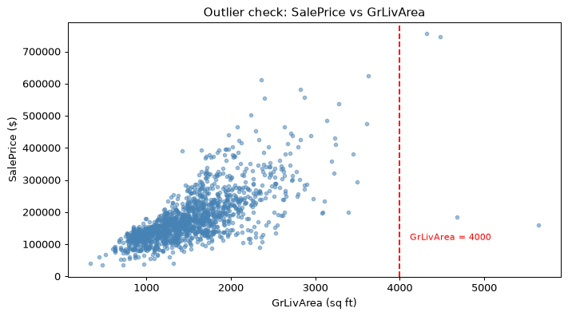
[Figure produced by this cell]

Train rows with GrLivArea > 4000: 4
Train rows after removing outliers: 1456

Cleaning rules used
[Cell 19 of 48]
QUAL_MAP = {"Po": 1, "Fa": 2, "TA": 3, "Gd": 4, "Ex": 5}
qual_cols = ["ExterQual", "ExterCond", "BsmtQual", "BsmtCond", "HeatingQC",
"KitchenQual", "FireplaceQu", "GarageQual", "GarageCond", "PoolQC"]

no_feature_cols = ["PoolQC", "MiscFeature", "Alley", "Fence", "FireplaceQu",
"MasVnrType", "BsmtQual", "BsmtCond", "BsmtExposure",
"BsmtFinType1", "BsmtFinType2", "GarageType", "GarageFinish",
"GarageQual", "GarageCond"]

def fill_absent_features(df):
df = df.copy()
for c in no_feature_cols:
df[c] = df[c].fillna("None") # NaN means "feature does not exist"
df["GarageYrBlt"] = df["GarageYrBlt"].fillna(0)
return df

def ordinalize_quality(df):
df = df.copy()
for c in qual_cols:
df[c] = df[c].map(QUAL_MAP).fillna(0) # "None"/unknown -> 0
return df

X = fill_absent_features(X).pipe(ordinalize_quality)
X_test = fill_absent_features(X_test).pipe(ordinalize_quality)

still_missing = X.isna().sum()
still_missing = still_missing[still_missing > 0]
print("Columns still missing in train (the pipeline will fill these):")
print(still_missing.to_string() if not still_missing.empty else " none to fill")

Columns still missing in train (the pipeline will fill these):
LotFrontage 259
MasVnrArea 8
Electrical 1

Build one pipeline for the rest
[Cell 20 of 48]
num_cols = X.select_dtypes(include=["int64", "float64"]).columns.tolist()
cat_cols = X.select_dtypes(include=["object", "string"]).columns.tolist()

num_pipe = Pipeline([
("impute", SimpleImputer(strategy="median")),
("scale", StandardScaler()),
])
cat_pipe = Pipeline([
("impute", SimpleImputer(strategy="most_frequent")),
("onehot", OneHotEncoder(handle_unknown="ignore", sparse_output=False)),
])

preprocessor = ColumnTransformer([
("num", num_pipe, num_cols),
("cat", cat_pipe, cat_cols),
])

print(f"Pipeline input: {len(num_cols)} numeric + {len(cat_cols)} categorical "
f"= {len(num_cols) + len(cat_cols)} feature columns")

Pipeline input: 46 numeric + 33 categorical = 79 feature columns

[Cell 21 of 48]
X_clean = preprocessor.fit_transform(X) # learn rules + apply to train
X_test_clean = preprocessor.transform(X_test) # apply same rules to test

feat_names = preprocessor.get_feature_names_out()
X_clean = pd.DataFrame(X_clean, columns=feat_names)
X_test_clean = pd.DataFrame(X_test_clean, columns=feat_names)

print("Preprocessed train:", X_clean.shape)
print("Preprocessed test :", X_test_clean.shape)
print("Any NaN left in train:", int(X_clean.isna().sum().sum()))
print("Any NaN left in test :", int(X_test_clean.isna().sum().sum()))
print("\nFirst 5 preprocessed rows (numeric columns are standardized):")
X_clean.head()

Preprocessed train: (1456, 261)
Preprocessed test : (1459, 261)
Any NaN left in train: 0
Any NaN left in test : 0

First 5 preprocessed rows (numeric columns are standardized):

num__MSSubClass num__LotFrontage num__LotArea num__OverallQual num__OverallCond num__YearBuilt num__YearRemodAdd \
0 0.073476 -0.218699 -0.202770 0.665646 -0.517461 1.053769 0.880629
1 -0.871172 0.499122 -0.086107 -0.064709 2.176545 0.159469 -0.427190
2 0.073476 -0.075135 0.081281 0.665646 -0.517461 0.987524 0.832191
3 0.309638 -0.457972 -0.091179 0.665646 -0.517461 -1.860986 -0.717817
4 0.073476 0.690541 0.386636 1.396000 -0.517461 0.954402 0.735316

num__MasVnrArea num__ExterQual num__ExterCond num__BsmtQual num__BsmtCond num__BsmtFinSF1 num__BsmtFinSF2 num__BsmtUnfSF \
0 0.533895 1.066349 -0.238458 0.589513 0.118048 0.625446 -0.289082 -0.943320
1 -0.573757 -0.688006 -0.238458 0.589513 0.118048 1.257846 -0.289082 -0.640184
2 0.341751 1.066349 -0.238458 0.589513 0.118048 0.113946 -0.289082 -0.300852
3 -0.573757 -0.688006 -0.238458 -0.554928 1.927294 -0.513805 -0.289082 -0.061058
4 1.404192 1.066349 -0.238458 0.589513 0.118048 0.506871 -0.289082 -0.174169

num__TotalBsmtSF num__HeatingQC num__1stFlrSF num__2ndFlrSF num__LowQualFinSF num__GrLivArea num__BsmtFullBath \
0 -0.472456 0.893378 -0.815613 1.183333 -0.120409 0.409745 1.114055
1 0.512947 0.893378 0.284120 -0.796357 -0.120409 -0.492308 -0.819275
2 -0.317122 0.893378 -0.642256 1.211151 -0.120409 0.562772 1.114055
3 -0.715166 -0.148896 -0.531200 0.956156 -0.120409 0.423840 1.114055
4 0.228976 0.893378 -0.032798 1.644643 -0.120409 1.392339 1.114055

num__BsmtHalfBath num__FullBath num__HalfBath num__BedroomAbvGr num__KitchenAbvGr num__KitchenQual num__TotRmsAbvGrd \
0 -0.239817 0.800349 1.231823 0.165909 -0.211757 0.746315 0.927120
1 3.967098 0.800349 -0.758781 0.165909 -0.211757 -0.769215 -0.314155
2 -0.239817 0.800349 1.231823 0.165909 -0.211757 0.746315 -0.314155
3 -0.239817 -1.026153 -0.758781 0.165909 -0.211757 0.746315 0.306482
4 -0.239817 0.800349 1.231823 1.392121 -0.211757 0.746315 1.547757

num__Fireplaces num__FireplaceQu num__GarageYrBlt num__GarageCars num__GarageArea num__GarageQual num__GarageCond \
0 -0.951673 -1.005862 0.296457 0.315804 0.360672 0.262927 0.266008
1 0.610487 0.652728 0.237000 0.315804 -0.054591 0.262927 0.266008
2 0.610487 0.652728 0.292053 0.315804 0.643806 0.262927 0.266008
3 0.610487 1.205592 0.285446 1.656362 0.804249 0.262927 0.266008
4 0.610487 0.652728 0.289850 1.656362 1.719716 0.262927 0.266008

num__WoodDeckSF num__OpenPorchSF num__EnclosedPorch num__3SsnPorch num__ScreenPorch num__PoolArea num__PoolQC num__MiscVal \
0 -0.749775 0.226218 -0.359882 -0.116501 -0.270606 -0.058115 -0.055345 -0.087809
1 1.631381 -0.707503 -0.359882 -0.116501 -0.270606 -0.058115 -0.055345 -0.087809
2 -0.749775 -0.064613 -0.359882 -0.116501 -0.270606 -0.058115 -0.055345 -0.087809
3 -0.749775 -0.171761 4.086653 -0.116501 -0.270606 -0.058115 -0.055345 -0.087809
4 0.784392 0.578277 -0.359882 -0.116501 -0.270606 -0.058115 -0.055345 -0.087809

num__MoSold num__YrSold cat__MSZoning_C (all) cat__MSZoning_FV cat__MSZoning_RH cat__MSZoning_RL cat__MSZoning_RM \
0 -1.603837 0.137472 0.0 0.0 0.0 1.0 0.0
1 -0.491667 -0.615009 0.0 0.0 0.0 1.0 0.0
2 0.991227 0.137472 0.0 0.0 0.0 1.0 0.0
3 -1.603837 -1.367490 0.0 0.0 0.0 1.0 0.0
4 2.103397 0.137472 0.0 0.0 0.0 1.0 0.0

cat__Street_Grvl cat__Street_Pave cat__Alley_Grvl cat__Alley_None cat__Alley_Pave cat__LotShape_IR1 cat__LotShape_IR2 \
0 0.0 1.0 0.0 1.0 0.0 0.0 0.0
1 0.0 1.0 0.0 1.0 0.0 0.0 0.0
2 0.0 1.0 0.0 1.0 0.0 1.0 0.0
3 0.0 1.0 0.0 1.0 0.0 1.0 0.0
4 0.0 1.0 0.0 1.0 0.0 1.0 0.0

cat__LotShape_IR3 cat__LotShape_Reg cat__LandContour_Bnk cat__LandContour_HLS cat__LandContour_Low cat__LandContour_Lvl \
0 0.0 1.0 0.0 0.0 0.0 1.0
1 0.0 1.0 0.0 0.0 0.0 1.0
2 0.0 0.0 0.0 0.0 0.0 1.0
3 0.0 0.0 0.0 0.0 0.0 1.0
4 0.0 0.0 0.0 0.0 0.0 1.0

cat__Utilities_AllPub cat__Utilities_NoSeWa cat__LotConfig_Corner cat__LotConfig_CulDSac cat__LotConfig_FR2 cat__LotConfig_FR3 \
0 1.0 0.0 0.0 0.0 0.0 0.0
1 1.0 0.0 0.0 0.0 1.0 0.0
2 1.0 0.0 0.0 0.0 0.0 0.0
3 1.0 0.0 1.0 0.0 0.0 0.0
4 1.0 0.0 0.0 0.0 1.0 0.0

cat__LotConfig_Inside cat__LandSlope_Gtl cat__LandSlope_Mod cat__LandSlope_Sev cat__Neighborhood_Blmngtn \
0 1.0 1.0 0.0 0.0 0.0
1 0.0 1.0 0.0 0.0 0.0
2 1.0 1.0 0.0 0.0 0.0
3 0.0 1.0 0.0 0.0 0.0
4 0.0 1.0 0.0 0.0 0.0

cat__Neighborhood_Blueste cat__Neighborhood_BrDale cat__Neighborhood_BrkSide cat__Neighborhood_ClearCr cat__Neighborhood_CollgCr \
0 0.0 0.0 0.0 0.0 1.0
1 0.0 0.0 0.0 0.0 0.0

What the preprocessed table looks like
[Cell 22 of 48]
print("=== Final preprocessed data summary ===")
print(f"train feature matrix : {X_clean.shape[0]} rows x {X_clean.shape[1]} columns")
print(f"test feature matrix : {X_test_clean.shape[0]} rows x {X_test_clean.shape[1]} columns")
print(f"y (target) length : {len(y)}")
print(f"one-hot columns : {int((X_clean.columns.str.startswith('cat__')).sum())}")
print(f"numeric columns : {int((X_clean.columns.str.startswith('num__')).sum())}")

print("\nNext stage: modeling (baseline -> linear -> tree models) scored with RMSLE.")

=== Final preprocessed data summary ===
train feature matrix : 1456 rows x 261 columns
test feature matrix : 1459 rows x 261 columns
y (target) length : 1456
one-hot columns : 215
numeric columns : 46

Next stage: modeling (baseline -> linear -> tree models) scored with RMSLE.

12. Stage 4 - Model training and comparison

Target and metric (with a mathematical sanity check)
[Cell 23 of 48]
y_log = np.log1p(y)
print("First 5 log1p(SalePrice) values:")
print(y_log.head().to_string())
print(f"\nTarget stats in log space: mean={y_log.mean():.4f} std={y_log.std():.4f}")

def rmsle(y_true_log, y_pred_log):
"""RMSLE computed directly in log1p space.

Both arguments are log1p transformed prices, so:
RMSLE = sqrt( mean( (log(1+y) - log(1+y_hat))^2 ) )
= RMSE( y_true_log, y_pred_log )
"""
return float(np.sqrt(np.mean((y_true_log - y_pred_log) ** 2)))

# Sanity check: identical to the equivalent formula in dollar space.
from sklearn.metrics import mean_squared_error, mean_squared_log_error
rng_a = np.random.default_rng(0)
rng_b = np.random.default_rng(1)
a = rng_a.uniform(4, 14, 5000) # fake log1p true prices
b = rng_b.uniform(4, 14, 5000) # fake log1p predicted prices
r_log_space = rmsle(a, b)
r_dollar_space = float(np.sqrt(mean_squared_log_error(np.expm1(a), np.expm1(b))))

print(f"\nRMSLE in log space : {r_log_space:.8f}")
print(f"RMSLE in dollar space: {r_dollar_space:.8f}")
print("Formulas agree:", np.isclose(r_log_space, r_dollar_space))

First 5 log1p(SalePrice) values:
0 12.247699
1 12.109016
2 12.317171
3 11.849405
4 12.429220

Target stats in log space: mean=12.0219 std=0.3961

RMSLE in log space : 4.07789512
RMSLE in dollar space: 4.07789512
Formulas agree: True

Cross-validation setup
[Cell 24 of 48]
from sklearn.model_selection import KFold, cross_val_score
from sklearn.metrics import make_scorer
from sklearn.dummy import DummyRegressor
from sklearn.linear_model import Ridge, Lasso
from sklearn.ensemble import RandomForestRegressor

SEED = 42
CV_FOLDS = 5
kf = KFold(n_splits=CV_FOLDS, shuffle=True, random_state=SEED)

# make_scorer gives us a scorer sklearn can pass to cross_val_score.
# greater_is_better=False -> returned fold scores are negated RMSLE.
rmsle_scorer = make_scorer(rmsle, greater_is_better=False)

print(f"KFold: {CV_FOLDS} splits, shuffle=True, random_state={SEED}")
print("Total train rows in modeling:", X.shape[0])

KFold: 5 splits, shuffle=True, random_state=42
Total train rows in modeling: 1456

The five models to compare
[Cell 25 of 48]
models = [
("Dummy baseline", DummyRegressor(strategy="mean")),
("Ridge (alpha=10)", Ridge(alpha=10.0)),
("Lasso (alpha=0.005)", Lasso(alpha=0.005, max_iter=20000, random_state=SEED)),
("Random Forest", RandomForestRegressor(
n_estimators=500, max_features="sqrt", n_jobs=-1, random_state=SEED)),
]

try:
import xgboost as xgb
except ImportError:
xgb = None

if xgb is not None:
models.append(("XGBoost", xgb.XGBRegressor(
n_estimators=500, learning_rate=0.05, subsample=0.9,
colsample_bytree=0.8, random_state=SEED, n_jobs=-1)))
print("xgboost loaded - XGBoost is included in the comparison.")
else:
print("xgboost is NOT installed in this environment - XGBoost is skipped.")

print("\nModels to evaluate:", len(models))

xgboost loaded - XGBoost is included in the comparison.

Models to evaluate: 5

Run the comparison
[Cell 26 of 48]
results_rows = []
per_fold = {}

for name, model in models:
pipe = Pipeline([("prep", preprocessor), ("model", model)])

# CV: the pipeline is cloned and refitted inside each fold.
scores = cross_val_score(pipe, X, y_log, cv=kf, scoring=rmsle_scorer)

# Overfitting diagnostic: fit on all train data once, score on train itself.
pipe.fit(X, y_log)
train_rmsle_val = rmsle(y_log, pipe.predict(X))

# scores are negated (greater_is_better=False), so flip the sign back.
per_fold[name] = [-float(s) for s in scores]
results_rows.append({
"model": name,
"cv_rmsle_mean": float(-np.mean(scores)),
"cv_rmsle_std": float(np.std(scores)),
"train_rmsle": round(train_rmsle_val, 5),
})

res_df = pd.DataFrame(results_rows).sort_values("cv_rmsle_mean").reset_index(drop=True)
res_df["cv_rmsle_mean"] = res_df["cv_rmsle_mean"].round(5)
res_df["cv_rmsle_std"] = res_df["cv_rmsle_std"].round(5)
res_df["gap (train - cv)"] = (res_df["train_rmsle"] - res_df["cv_rmsle_mean"]).round(4)
res_df

print("\nCV RMSLE mean +/- std, and train RMSLE per model:")
print(res_df.to_string(index=False))

CV RMSLE mean +/- std, and train RMSLE per model:
model cv_rmsle_mean cv_rmsle_std train_rmsle gap (train - cv)
Ridge (alpha=10) 0.11508 0.00756 0.09782 -0.0173
XGBoost 0.12343 0.01186 0.01094 -0.1125
Lasso (alpha=0.005) 0.12495 0.01137 0.12093 -0.0040
Random Forest 0.13778 0.01349 0.05112 -0.0867
Dummy baseline 0.39604 0.01831 0.39594 -0.0001

Fold-by-fold results (transparency)
[Cell 27 of 48]
fold_df = pd.DataFrame(per_fold, index=[f"fold {i + 1}" for i in range(CV_FOLDS)])
fold_df = fold_df.round(5)
print("Each cell = RMSLE of that model on that fold (lower is better).")
fold_df

Each cell = RMSLE of that model on that fold (lower is better).

Dummy baseline Ridge (alpha=10) Lasso (alpha=0.005) Random Forest XGBoost
fold 1 0.39872 0.12208 0.13228 0.14416 0.13350
fold 2 0.40295 0.11618 0.11820 0.13445 0.11788
fold 3 0.39680 0.11789 0.13057 0.13701 0.13443
fold 4 0.41885 0.11880 0.13760 0.15732 0.12850
fold 5 0.36288 0.10045 0.10610 0.11598 0.10282

Visual comparison
[Cell 28 of 48]
fig, axes = plt.subplots(1, 2, figsize=(14, 4.8))

# Left: CV mean with std bars
order = res_df[::-1] # reverse so best model ends on top
axes[0].barh(np.arange(len(order)), order["cv_rmsle_mean"],
xerr=order["cv_rmsle_std"], capsize=3,
color="steelblue", alpha=0.85, edgecolor="black")
axes[0].set_yticks(np.arange(len(order)))
axes[0].set_yticklabels(order["model"], fontsize=9)
axes[0].set_xlabel("CV RMSLE (lower is better)")
axes[0].set_title("Model comparison by 5-fold CV RMSLE")

# Right: train vs CV per model (overfitting gap)
xx = np.arange(len(res_df))
width = 0.4
axes[1].bar(xx - width / 2, res_df["train_rmsle"], width, label="train RMSLE", color="seagreen")
axes[1].bar(xx + width / 2, res_df["cv_rmsle_mean"], width, label="CV RMSLE", color="steelblue")
axes[1].set_xticks(xx)
axes[1].set_xticklabels(res_df["model"], rotation=30, ha="right", fontsize=9)
axes[1].set_ylabel("RMSLE")
axes[1].set_title("Overfitting check: train vs CV RMSLE")
axes[1].legend(fontsize=9)

plt.tight_layout()
plt.show()

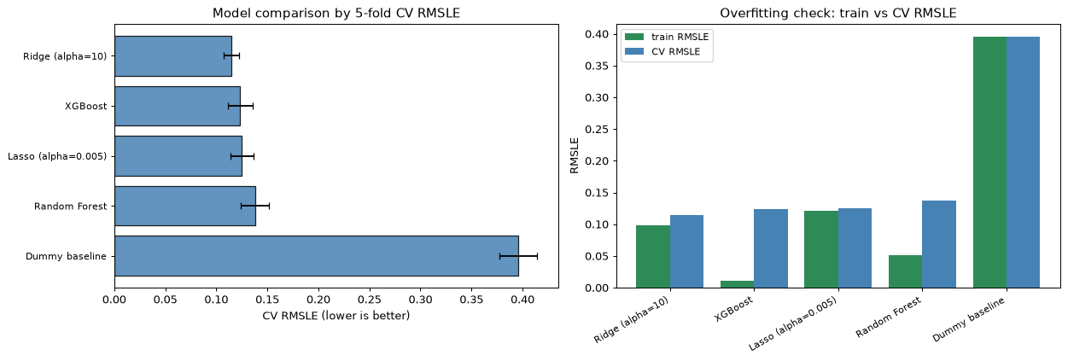
[Figure produced by this cell]

Convergence and warning check
[Cell 29 of 48]
import warnings
from sklearn.exceptions import ConvergenceWarning

with warnings.catch_warnings(record=True) as caught:
warnings.simplefilter("always")
pipe = Pipeline([("prep", preprocessor),
("model", Lasso(alpha=0.005, max_iter=20000, random_state=SEED))])
pipe.fit(X, y_log)

lasso_warnings = [str(w.message) for w in caught
if issubclass(w.category, ConvergenceWarning)]
print("Lasso ConvergenceWarnings caught:", len(lasso_warnings))
for msg in lasso_warnings:
print(" -", msg[:200])

Lasso ConvergenceWarnings caught: 0

Reviewing the 4 removed rows (a decision audit)
[Cell 30 of 48]
raw_train = pd.read_csv("data/train.csv")
outlier_rows = raw_train[raw_train["GrLivArea"] > 4000][
["Id", "GrLivArea", "OverallQual", "SalePrice", "SaleType", "SaleCondition", "YearBuilt"]
]
print("The 4 removed rows (GrLivArea > 4000):")
print(outlier_rows.to_string(index=False))

print("\nMedian GrLivArea of the OTHER train houses: "
f"{raw_train.loc[raw_train['GrLivArea'] <= 4000, 'GrLivArea'].median():.1f} sqft")
print("Median SalePrice of those outliers:", f"${outlier_rows['SalePrice'].median():,.0f}")

The 4 removed rows (GrLivArea > 4000):
Id GrLivArea OverallQual SalePrice SaleType SaleCondition YearBuilt
524 4676 10 184750 New Partial 2007
692 4316 10 755000 WD Normal 1994
1183 4476 10 745000 WD Abnorml 1996
1299 5642 10 160000 New Partial 2008

Median GrLivArea of the OTHER train houses: 1458.5 sqft
Median SalePrice of those outliers: $464,875

[Cell 31 of 48]
# Quick impact check with Ridge (same folds, same scorer).
X_full_raw = raw_train.drop(columns=["Id"]).pipe(fill_absent_features).pipe(ordinalize_quality)
y_full_log = np.log1p(raw_train["SalePrice"])

pipe_ridge_full = Pipeline([("prep", preprocessor), ("model", Ridge(alpha=10.0))])
cv_with_outliers = -cross_val_score(pipe_ridge_full, X_full_raw, y_full_log,
cv=kf, scoring=rmsle_scorer).mean()

with_rid = res_df.loc[res_df["model"] == "Ridge (alpha=10)", "cv_rmsle_mean"].iloc[0]

print("Ridge CV RMSLE WITH the 4 outlier rows:", round(float(cv_with_outliers), 5))
print("Ridge CV RMSLE WITHOUT the 4 rows :", round(float(with_rid), 5))
print("Difference (removal impact):", round(float(cv_with_outliers - with_rid), 5))

Ridge CV RMSLE WITH the 4 outlier rows: 0.14627
Ridge CV RMSLE WITHOUT the 4 rows : 0.11508
Difference (removal impact): 0.03119

Interpretation of the audit (written after looking at the numbers above)

Stage 4 summary

14. Stage 4B - Hyperparameter tuning

Tune Ridge
[Cell 32 of 48]
import time
from sklearn.model_selection import GridSearchCV

ridge_grid = {"model__alpha": [1.0, 5.0, 10.0, 25.0, 50.0, 100.0]}
ridge_gs = GridSearchCV(
Pipeline([("prep", preprocessor), ("model", Ridge())]),
ridge_grid, scoring=rmsle_scorer, cv=kf, n_jobs=1,
)
t0 = time.perf_counter()
ridge_gs.fit(X, y_log)
t_ridge = time.perf_counter() - t0

print(f"Ridge | search time {t_ridge:.1f}s "
f"({len(ridge_grid['model__alpha'])} params x {CV_FOLDS} folds)")
print("Best params :", ridge_gs.best_params_)
print("Best CV RMSLE:", round(float(-ridge_gs.best_score_), 5))
print("Stage 4A Ridge CV RMSLE:", round(float(res_df.set_index('model').loc['Ridge (alpha=10)', 'cv_rmsle_mean']), 5))

Ridge | search time 4.9s (6 params x 5 folds)
Best params : {'model__alpha': 25.0}
Best CV RMSLE: 0.11504
Stage 4A Ridge CV RMSLE: 0.11508

Tune Lasso
[Cell 33 of 48]
lasso_grid = {"model__alpha": [0.0001, 0.0005, 0.001, 0.0025, 0.005, 0.0075, 0.01]}
lasso_gs = GridSearchCV(
Pipeline([("prep", preprocessor),
("model", Lasso(max_iter=20000, random_state=SEED))]),
lasso_grid, scoring=rmsle_scorer, cv=kf, n_jobs=1,
)
t0 = time.perf_counter()
lasso_gs.fit(X, y_log)
t_lasso = time.perf_counter() - t0

print(f"Lasso | search time {t_lasso:.1f}s "
f"({len(lasso_grid['model__alpha'])} params x {CV_FOLDS} folds)")
print("Best params :", lasso_gs.best_params_)
print("Best CV RMSLE:", round(float(-lasso_gs.best_score_), 5))
print("Stage 4A Lasso CV RMSLE:", round(float(res_df.set_index('model').loc['Lasso (alpha=0.005)', 'cv_rmsle_mean']), 5))

Lasso | search time 6.7s (7 params x 5 folds)
Best params : {'model__alpha': 0.0005}
Best CV RMSLE: 0.11396
Stage 4A Lasso CV RMSLE: 0.12495

Tune Random Forest
[Cell 34 of 48]
rf_grid = {
"model__n_estimators": [200, 400],
"model__max_features": ["sqrt", 1.0],
"model__min_samples_leaf": [1, 2, 4],
}
rf_gs = GridSearchCV(
Pipeline([("prep", preprocessor),
("model", RandomForestRegressor(n_jobs=-1, random_state=SEED))]),
rf_grid, scoring=rmsle_scorer, cv=kf, n_jobs=1,
)
t0 = time.perf_counter()
rf_gs.fit(X, y_log)
t_rf = time.perf_counter() - t0

print(f"Random Forest | search time {t_rf:.1f}s "
f"(2 x 2 x 3 = {len(rf_grid['model__n_estimators']) * len(rf_grid['model__max_features']) * len(rf_grid['model__min_samples_leaf'])} params x {CV_FOLDS} folds)")
print("Best params :", rf_gs.best_params_)
print("Best CV RMSLE:", round(float(-rf_gs.best_score_), 5))
print("Stage 4A Random Forest CV RMSLE:", round(float(res_df.set_index('model').loc['Random Forest', 'cv_rmsle_mean']), 5))

Random Forest | search time 90.3s (2 x 2 x 3 = 12 params x 5 folds)
Best params : {'model__max_features': 1.0, 'model__min_samples_leaf': 2, 'model__n_estimators': 400}
Best CV RMSLE: 0.13768
Stage 4A Random Forest CV RMSLE: 0.13778

Tune XGBoost (included because it is installed)
[Cell 35 of 48]
if xgb is not None:
xgb_grid = {"model__learning_rate": [0.01, 0.03, 0.05],
"model__max_depth": [3, 5],
"model__n_estimators": [300, 600]}
xgb_gs = GridSearchCV(
Pipeline([("prep", preprocessor),
("model", xgb.XGBRegressor(subsample=0.9, colsample_bytree=0.8,
random_state=SEED, n_jobs=-1))]),
xgb_grid, scoring=rmsle_scorer, cv=kf, n_jobs=1,
)
t0 = time.perf_counter()
xgb_gs.fit(X, y_log)
t_xgb = time.perf_counter() - t0

print(f"XGBoost | search time {t_xgb:.1f}s "
f"(3 x 2 x 2 = {len(xgb_grid['model__learning_rate']) * len(xgb_grid['model__max_depth']) * len(xgb_grid['model__n_estimators'])} params x {CV_FOLDS} folds)")
print("Best params :", xgb_gs.best_params_)
print("Best CV RMSLE:", round(float(-xgb_gs.best_score_), 5))
print("Stage 4A XGBoost CV RMSLE:", round(float(res_df.set_index('model').loc['XGBoost', 'cv_rmsle_mean']), 5))
else:
print("xgboost is not installed - XGBoost tuning skipped.")
xgb_gs, t_xgb = None, None

XGBoost | search time 114.1s (3 x 2 x 2 = 12 params x 5 folds)
Best params : {'model__learning_rate': 0.05, 'model__max_depth': 3, 'model__n_estimators': 600}
Best CV RMSLE: 0.11744
Stage 4A XGBoost CV RMSLE: 0.12343

Tuned results vs Stage 4A
[Cell 36 of 48]
tuned_rows = []

def add_tuned(name, gs, seconds):
if gs is None:
return
tuned_rows.append({
"model": name,
"best_params": str(gs.best_params_),
"best_cv_rmsle": round(float(-gs.best_score_), 5),
"search_seconds": round(float(seconds), 1),
})

add_tuned("Ridge", ridge_gs, t_ridge)
add_tuned("Lasso", lasso_gs, t_lasso)
add_tuned("Random Forest", rf_gs, t_rf)
add_tuned("XGBoost", xgb_gs, t_xgb)

tuned_df = pd.DataFrame(tuned_rows)
stage4a = res_df.set_index("model")["cv_rmsle_mean"]

def stage4a_name(m):
mapping = {"Ridge": "Ridge (alpha=10)", "Lasso": "Lasso (alpha=0.005)"}
return mapping.get(m, m)

tuned_df["stage4a_cv_rmsle"] = tuned_df["model"].map(stage4a_name).map(stage4a)
tuned_df["improvement (delta)"] = (tuned_df["best_cv_rmsle"] - tuned_df["stage4a_cv_rmsle"]).round(5)
tuned_df["improvement (delta)"] = tuned_df["improvement (delta)"].astype(str) + " (lower is better)"
tuned_df
print(tuned_df[["model", "best_params", "best_cv_rmsle", "stage4a_cv_rmsle", "search_seconds"]].to_string(index=False))

model best_params best_cv_rmsle stage4a_cv_rmsle search_seconds
Ridge {'model__alpha': 25.0} 0.11504 0.11508 4.9
Lasso {'model__alpha': 0.0005} 0.11396 0.12495 6.7
Random Forest {'model__max_features': 1.0, 'model__min_samples_leaf': 2, 'model__n_estimators': 400} 0.13768 0.13778 90.3
XGBoost {'model__learning_rate': 0.05, 'model__max_depth': 3, 'model__n_estimators': 600} 0.11744 0.12343 114.1

Visual: Stage 4A vs tuned CV RMSLE
[Cell 37 of 48]
plot_df = tuned_df.copy()
xx = np.arange(len(plot_df))
width = 0.35

fig, ax = plt.subplots(figsize=(9, 5))
ax.bar(xx - width / 2, plot_df["stage4a_cv_rmsle"], width,
label="Stage 4A (default)", color="lightsteelblue", edgecolor="black")
ax.bar(xx + width / 2, plot_df["best_cv_rmsle"], width,
label="Stage 4B (tuned)", color="steelblue", edgecolor="black")
ax.set_xticks(xx)
ax.set_xticklabels(plot_df["model"])
ax.set_ylabel("Mean 5-fold CV RMSLE (lower is better)")
ax.set_title("Hyperparameter tuning: CV RMSLE before vs after")
ax.legend()
ax.grid(axis="y", alpha=0.3)
plt.tight_layout()
plt.show()

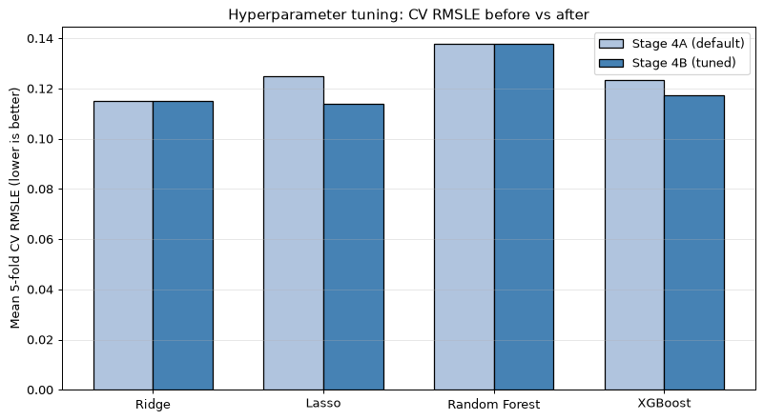
[Figure produced by this cell]

Stage 4B summary (written after looking at the computed table)

15. Stage 5 - Honest held-out validation

Create the fresh 80/20 split
[Cell 38 of 48]
from sklearn.model_selection import train_test_split

VAL_SEED = 42
X_fit, X_val, y_fit_log, y_val_log = train_test_split(
X, y_log, test_size=0.2, random_state=VAL_SEED)

print("All labeled rows :", X.shape[0])
print("80% training partition X_fit:", X_fit.shape[0])
print("20% held-out validation Xval:", X_val.shape[0])
print("Actual split fractions :", round(X_fit.shape[0] / X.shape[0], 3),
"/", round(X_val.shape[0] / X.shape[0], 3))
print("\nThe validation partition is kept untouched until the final scoring cell.")

All labeled rows : 1456
80% training partition X_fit: 1164
20% held-out validation Xval: 292
Actual split fractions : 0.799 / 0.201

The validation partition is kept untouched until the final scoring cell.

Tune Ridge on the 80% partition only
[Cell 39 of 48]
ridge5_grid = {"model__alpha": [1.0, 5.0, 10.0, 25.0, 50.0, 100.0]}
ridge5 = GridSearchCV(
Pipeline([("prep", preprocessor), ("model", Ridge())]),
ridge5_grid, scoring=rmsle_scorer, cv=kf, n_jobs=1,
)
t0 = time.perf_counter()
ridge5.fit(X_fit, y_fit_log)
t_ridge5 = time.perf_counter() - t0

print(f"Ridge tuned on 80% | search time {t_ridge5:.1f}s")
print("Best params:", ridge5.best_params_)
print("Training-CV RMSLE (mean over 5 folds of the 80%):",
round(float(-ridge5.best_score_), 5))

Ridge tuned on 80% | search time 4.5s
Best params: {'model__alpha': 25.0}
Training-CV RMSLE (mean over 5 folds of the 80%): 0.11387

Tune Lasso on the 80% partition only
[Cell 40 of 48]
lasso5_grid = {"model__alpha": [0.0001, 0.0005, 0.001, 0.0025, 0.005, 0.0075, 0.01]}
lasso5 = GridSearchCV(
Pipeline([("prep", preprocessor),
("model", Lasso(max_iter=20000, random_state=SEED))]),
lasso5_grid, scoring=rmsle_scorer, cv=kf, n_jobs=1,
)
t0 = time.perf_counter()
lasso5.fit(X_fit, y_fit_log)
t_lasso5 = time.perf_counter() - t0

print(f"Lasso tuned on 80% | search time {t_lasso5:.1f}s")
print("Best params:", lasso5.best_params_)
print("Training-CV RMSLE (mean over 5 folds of the 80%):",
round(float(-lasso5.best_score_), 5))

Lasso tuned on 80% | search time 6.2s
Best params: {'model__alpha': 0.0005}
Training-CV RMSLE (mean over 5 folds of the 80%): 0.11213

Negative predictions: explicit handling (before any RMSLE)
[Cell 41 of 48]
def clip_log_predictions(pred_log):
"""Return (clipped_predictions, number_clipped).

Any log1p-space prediction below 0 (i.e. price below $0) is raised to 0 -
equivalently the price is floored at $0. RMSLE stays well-defined."""
pred_log = np.asarray(pred_log, dtype=float)
n_neg = int((pred_log < 0).sum())
return np.maximum(pred_log, 0.0), n_neg

# Sanity demo of the clip rule on toy values
demo = np.array([-0.5, 0.0, 12.0])
clipped, n = clip_log_predictions(demo)
print(f"Clip demo: input {demo} -> output {clipped}, clipped count = {n}")

Clip demo: input [-0.5 0. 12. ] -> output [ 0. 0. 12.], clipped count = 1

Final scoring on the 20% held-out rows (once per model)
[Cell 42 of 48]
def tuned_row(name, gs, seconds):
est = gs.best_estimator_
train_fit = rmsle(y_fit_log, est.predict(X_fit))
pred_val, n_neg = clip_log_predictions(est.predict(X_val))
val_rm = rmsle(y_val_log, pred_val)
cv_rm = float(-gs.best_score_)
return {
"model": name,
"best_params": str(gs.best_params_),
"train_fit_rmsle": round(train_fit, 5),
"train_cv_rmsle": round(cv_rm, 5),
"val_rmsle": round(val_rm, 5),
"gap (val - train_cv)": round(val_rm - cv_rm, 5),
"clipped_neg_preds": n_neg,
}

def fixed_pipe_row(name, pipe, seconds):
# For models without tuning (Dummy): same folds & metric, fitted on 80%.
cv_rm = float(-np.mean(cross_val_score(pipe, X_fit, y_fit_log, cv=kf,
scoring=rmsle_scorer)))
pipe.fit(X_fit, y_fit_log)
train_fit = rmsle(y_fit_log, pipe.predict(X_fit))
pred_val, n_neg = clip_log_predictions(pipe.predict(X_val))
val_rm = rmsle(y_val_log, pred_val)
return {
"model": name,
"best_params": "fixed (no tuning)",
"train_fit_rmsle": round(train_fit, 5),
"train_cv_rmsle": round(cv_rm, 5),
"val_rmsle": round(val_rm, 5),
"gap (val - train_cv)": round(val_rm - cv_rm, 5),
"clipped_neg_preds": n_neg,
}

dummy_pipe = Pipeline([("prep", preprocessor),
("model", DummyRegressor(strategy="mean"))])

rows5 = [
fixed_pipe_row("Dummy baseline", dummy_pipe, 0.0),
tuned_row("Ridge", ridge5, t_ridge5),
tuned_row("Lasso", lasso5, t_lasso5),
]
val_df = pd.DataFrame(rows5)
val_df

model best_params train_fit_rmsle train_cv_rmsle val_rmsle gap (val - train_cv) clipped_neg_preds
0 Dummy baseline fixed (no tuning) 0.39531 0.39483 0.39872 0.00389 0
1 Ridge {'model__alpha': 25.0} 0.09817 0.11387 0.12284 0.00896 0
2 Lasso {'model__alpha': 0.0005} 0.09811 0.11213 0.12026 0.00812 0

Visual comparison on the held-out validation rows
[Cell 43 of 48]
plot5 = val_df.copy()
xx = np.arange(len(plot5))
width = 0.32

fig, ax = plt.subplots(figsize=(9, 4.8))
ax.bar(xx - width / 2, plot5["train_cv_rmsle"], width, label="train CV RMSLE (80%)", color="lightsteelblue", edgecolor="black")
ax.bar(xx + width / 2, plot5["val_rmsle"], width, label="held-out val RMSLE (20%)", color="steelblue", edgecolor="black")
ax.set_xticks(xx)
ax.set_xticklabels(plot5["model"])
ax.set_ylabel("RMSLE (lower is better)")
ax.set_title("Stage 5 - training-CV vs held-out validation RMSLE")
ax.legend(fontsize=9)
ax.grid(axis="y", alpha=0.3)
plt.tight_layout()
plt.show()

# Predicted vs actual on held-out rows for the best model by the table above
best_name5 = plot5.loc[plot5["val_rmsle"].idxmin(), "model"]
best_map = {"Ridge": ridge5.best_estimator_, "Lasso": lasso5.best_estimator_,
"Dummy baseline": dummy_pipe}
best_est = best_map[best_name5]
pred_best, _ = clip_log_predictions(best_est.predict(X_val))

fig, ax = plt.subplots(figsize=(6.5, 6))
ax.scatter(np.expm1(y_val_log), np.expm1(pred_best), s=12, alpha=0.5, color="steelblue")
lims = [min(ax.get_xlim()[0], ax.get_ylim()[0]), max(ax.get_xlim()[1], ax.get_ylim()[1])]
ax.plot(lims, lims, "r--", linewidth=1, label="perfect prediction")
ax.set_xlabel("Actual SalePrice ($)")
ax.set_ylabel("Predicted SalePrice ($)")
ax.set_title(f"Held-out validation predictions - {best_name5}")
ax.legend(fontsize=9)
plt.tight_layout()
plt.show()

print(f"Best model on held-out rows by val RMSLE: {best_name5}")

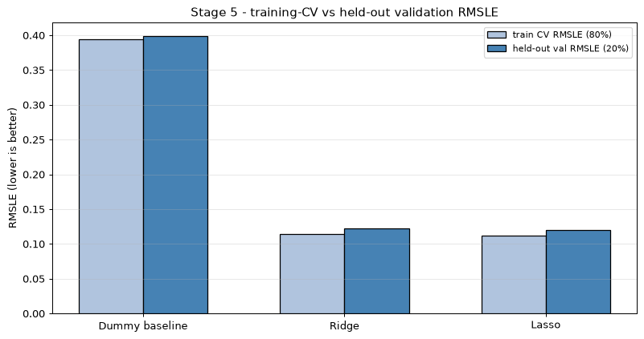
[Figure produced by this cell]

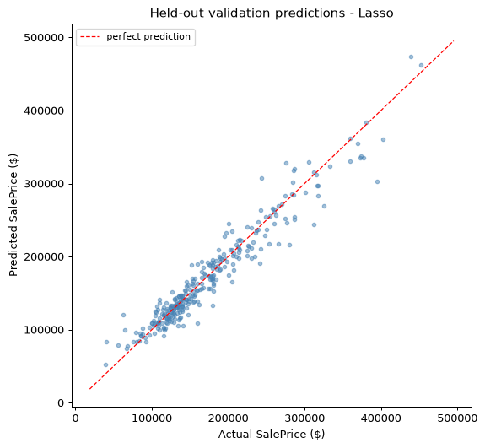
[Figure produced by this cell]

Best model on held-out rows by val RMSLE: Lasso

Stage 5 interpretation and honest limitations

Stage 5 summary

16. Stage 6 - Final prediction and submission file

1-2. Fit the final model on all labeled rows and predict the test set
[Cell 44 of 48]
FINAL_ALPHA_LASSO = 0.0005 # chosen in Stage 5 by held-out validation

final_pipe = Pipeline([
("prep", preprocessor),
("model", Lasso(alpha=FINAL_ALPHA_LASSO, max_iter=20000, random_state=SEED)),
])
final_pipe.fit(X, y_log) # all 1,456 labeled rows; preprocessing refit inside

print("Final model trained on all", X.shape[0], "labeled rows.")
print("Estimated parameters: preprocessing fitted", X.shape[0],
"rows ->", preprocessor.get_feature_names_out().shape[0], "features")

Final model trained on all

1456 labeled rows.
Estimated parameters: preprocessing fitted 1456 rows -> 261 features

[Cell 45 of 48]
pred_log = final_pipe.predict(X_test)
n_neg_raw = int((pred_log < 0).sum())

# Non-negative safeguard (documented in Stage 5): floor log-price at 0.
pred_log_safe = np.maximum(pred_log, 0.0)
pred_dollars = np.expm1(pred_log_safe)

print("Test predictions:", pred_dollars.shape[0])
print("Raw negative log-space predictions:", n_neg_raw,
"-> clipped to 0 (price floor $0).")
print("First 5 predicted prices:")
print(pred_dollars[:5].round(2))

Test predictions: 1459
Raw negative log-space predictions: 0 -> clipped to 0 (price floor $0).
First 5 predicted prices:
[118554.72 152655.71 175652.12 199481.28 191185.44]

3-5. Build and write `submission.csv` exactly like the template
[Cell 46 of 48]
submission = pd.DataFrame({
"Id": test["Id"].values,
"SalePrice": pred_dollars,
})
submission.to_csv("submission.csv", index=False)
print("Written:", submission.shape)

print("\nFirst 5 rows:")
print(submission.head().to_string(index=False))

print("\nExpected template (sample_submission.csv) first 5 rows:")
print(sample_submission.head().to_string(index=False))

Written: (1459, 2)

First 5 rows:
Id SalePrice
1461 118554.716748
1462 152655.709632
1463 175652.123765
1464 199481.278894
1465 191185.436834

Expected template (sample_submission.csv) first 5 rows:
Id SalePrice
1461 169277.052498
1462 187758.393989
1463 183583.683570
1464 179317.477511
1465 150730.079977

6. Verification of the output file
[Cell 47 of 48]
verif = pd.read_csv("submission.csv")

checks = {
"row count == 1459": verif.shape[0] == 1459,
"columns == [Id, SalePrice]": list(verif.columns) == ["Id", "SalePrice"],
"ID order matches sample_submission": (verif["Id"].values == sample_submission["Id"].values).all(),
"no missing SalePrice": not verif["SalePrice"].isna().any(),
"all values finite": bool(np.isfinite(verif["SalePrice"]).all()),
"no negative prices": (verif["SalePrice"] >= 0).all(),
}
for k, v in checks.items():
print(("PASS " if v else "FAIL ") + k)
print("\nAll checks passed:", all(checks.values()))

PASS row count == 1459
PASS columns == [Id, SalePrice]
PASS ID order matches sample_submission
PASS no missing SalePrice
PASS all values finite
PASS no negative prices

All checks passed: True

Prediction summary and conclusion
[Cell 48 of 48]
print("=== submission.csv prediction summary ===")
print(verif["SalePrice"].describe().round(0).to_string())
print("\nPredicted price range: $%.0f - $%.0f" % (verif["SalePrice"].min(), verif["SalePrice"].max()))
print("Median predicted price: $%.0f" % verif["SalePrice"].median())

import os
print("\nOutput file:", os.path.abspath("submission.csv"))
print("File size (bytes):", os.path.getsize("submission.csv"))

=== submission.csv prediction summary ===
count 1459.0
mean 179007.0
std 87046.0
min 43500.0
25% 125641.0
50% 156971.0
75% 211956.0
max 1728046.0

Predicted price range: $43500 - $1728046
Median predicted price: $156971

Output file: C:\Users\ASUS\OneDrive\Desktop\HousePricePrediction\submission.csv
File size (bytes): 35961

Stage 6 summary

2. train_model.py
"""Train the final House Price Prediction model and save it for the web app.

Reproduces the exact pipeline and the Lasso selection from the notebook
(Rittik_HousePricePrediction.ipynb, final stage):
* Kaggle 'House Prices' train.csv / test.csv from ./data
* absent features -> "None"; GarageYrBlt NaN -> 0
* ordinal quality codes -> 1..5 (None -> 0)
* documented outlier rule: drop train rows with GrLivArea > 4000
* sklearn ColumnTransformer: numeric = median impute + scale,
categorical = most-frequent impute + one-hot
* Lasso(alpha=0.0005) on log1p(SalePrice)

Outputs:
* submission.csv - final Kaggle predictions (1,459 rows)
* model/house_price_pipeline.joblib - fitted pipeline + form defaults
consumed by app.py
"""
import os
import joblib
import numpy as np
import pandas as pd
from sklearn.compose import ColumnTransformer
from sklearn.impute import SimpleImputer
from sklearn.pipeline import Pipeline
from sklearn.preprocessing import OneHotEncoder, StandardScaler
from sklearn.linear_model import Lasso
from sklearn.model_selection import train_test_split

SEED = 42
ALPHA = 0.0005
OUTLIER_GRLIV = 4000

ROOT = os.path.dirname(os.path.abspath(__file__))
TRAIN = os.path.join(ROOT, "data", "train.csv")
TEST = os.path.join(ROOT, "data", "test.csv")
SUBMISSION = os.path.join(ROOT, "submission.csv")
MODEL_DIR = os.path.join(ROOT, "model")
MODEL_PATH = os.path.join(MODEL_DIR, "house_price_pipeline.joblib")

QUAL_MAP = {"Po": 1, "Fa": 2, "TA": 3, "Gd": 4, "Ex": 5}
qual_cols = ["ExterQual", "ExterCond", "BsmtQual", "BsmtCond", "HeatingQC",
"KitchenQual", "FireplaceQu", "GarageQual", "GarageCond", "PoolQC"]
no_feature_cols = ["PoolQC", "MiscFeature", "Alley", "Fence", "FireplaceQu",
"MasVnrType", "BsmtQual", "BsmtCond", "BsmtExposure",
"BsmtFinType1", "BsmtFinType2", "GarageType", "GarageFinish",
"GarageQual", "GarageCond"]

def fill_absent_features(df):
df = df.copy()
for c in no_feature_cols:
df[c] = df[c].fillna("None")
df["GarageYrBlt"] = df["GarageYrBlt"].fillna(0)
return df

def ordinalize_quality(df):
df = df.copy()
for c in qual_cols:
df[c] = df[c].map(QUAL_MAP).fillna(0)
return df

def rmsle(y_true_log, y_pred_log):
return float(np.sqrt(np.mean((y_true_log - y_pred_log) ** 2)))

def main():
train = pd.read_csv(TRAIN)
test = pd.read_csv(TEST)
print("train:", train.shape, "| test:", test.shape)

X = train.drop(columns=["Id", "SalePrice"]).copy()
y = train["SalePrice"].copy()
X_test = test.drop(columns=["Id"]).copy()

big = X["GrLivArea"] > OUTLIER_GRLIV
print(f"outlier rows removed (GrLivArea > {OUTLIER_GRLIV}): {int(big.sum())}")
X = X[~big].reset_index(drop=True)
y = y[~big].reset_index(drop=True)

X = fill_absent_features(X).pipe(ordinalize_quality)
X_test = fill_absent_features(X_test).pipe(ordinalize_quality)
y_log = np.log1p(y)

num_cols = X.select_dtypes(include=["int64", "float64"]).columns.tolist()
cat_cols = X.select_dtypes(include=["object", "string"]).columns.tolist()
print(f"feature columns: {len(num_cols)} numeric + {len(cat_cols)} categorical")

num_pipe = Pipeline([
("impute", SimpleImputer(strategy="median")),
("scale", StandardScaler()),
])
cat_pipe = Pipeline([
("impute", SimpleImputer(strategy="most_frequent")),
("onehot", OneHotEncoder(handle_unknown="ignore", sparse_output=False)),
])
preprocessor = ColumnTransformer([
("num", num_pipe, num_cols),
("cat", cat_pipe, cat_cols),
])

# Quick sanity: fit on 80%, score the unseen 20% once (mirrors Stage 5).
Xtr, Xva, ytr, yva = train_test_split(X, y_log, test_size=0.2,
random_state=SEED)
check_pipe = Pipeline([("prep", preprocessor),
("model", Lasso(alpha=ALPHA, max_iter=20000,
random_state=SEED))])
check_pipe.fit(Xtr, ytr)
val_rmsle = rmsle(yva, np.maximum(check_pipe.predict(Xva), 0.0))
print(f"quick held-out RMSLE (20%, seed 42): {val_rmsle:.5f}")

final_pipe = Pipeline([("prep", preprocessor),
("model", Lasso(alpha=ALPHA, max_iter=20000,
random_state=SEED))])
final_pipe.fit(X, y_log)
print("final model fitted on", X.shape[0], "rows;",
"features:", preprocessor.get_feature_names_out().shape[0])

pred_log = final_pipe.predict(X_test)
pred_dollars = np.expm1(np.maximum(pred_log, 0.0))
sub = pd.DataFrame({"Id": test["Id"], "SalePrice": pred_dollars.round(2)})
sub.to_csv(SUBMISSION, index=False)
print("wrote", SUBMISSION, "rows:", len(sub))

if os.path.exists(SUBMISSION):
old = pd.read_csv(SUBMISSION)
merged = pd.merge(old, sub, on="Id", suffixes=("_old", "_new"))
diff = np.abs(merged["SalePrice_old"] - merged["SalePrice_new"])
print(f"reproducibility check vs previous submission.csv: "
f"max abs diff = ${diff.max():.4f}")

# Defaults + input metadata for the web app (app.py).
defaults = {}
for c in num_cols:
defaults[c] = float(X[c].median())
for c in cat_cols:
mode = X[c].mode()
defaults[c] = mode.iloc[0] if not mode.empty else ""
if not mode.empty and mode.iloc[0] != "":
defaults[c] = str(mode.iloc[0])

exposed_cat = {"MSZoning", "Neighborhood", "HouseStyle", "CentralAir",
"LotShape", "GarageType", "BsmtFinType1", "HeatingQC",
"KitchenQual", "ExterQual"}
cat_options = {c: sorted(X[c].dropna().astype(str).unique().tolist())
for c in exposed_cat & set(cat_cols)}

os.makedirs(MODEL_DIR, exist_ok=True)
joblib.dump({
"pipeline": final_pipe,
"x_columns": X.columns.tolist(),
"defaults": defaults,
"num_fields": num_cols,
"cat_fields": sorted(exposed_cat & set(cat_cols)),
"cat_options": cat_options,
"qual_map": QUAL_MAP,
"val_rmsle": val_rmsle,
}, MODEL_PATH, compress=3)
print("saved", MODEL_PATH,
f"({os.path.getsize(MODEL_PATH) / 1024:.0f} KB)")

if __name__ == "__main__":
main()

3. app.py
"""Local website for the House Price Prediction model.

Run: python app.py
Then open: http://127.0.0.1:5000

Loads the model trained by train_model.py (model/house_price_pipeline.joblib)
and serves a small form. Only the main features are exposed in the form;
all remaining features use their training-set median/mode, so the price shown
is an estimate for a house that is "average" in the unexposed attributes.
"""
import os
import joblib
import numpy as np
import pandas as pd
from flask import Flask, request, render_template_string, send_from_directory

ROOT = os.path.dirname(os.path.abspath(__file__))
ART = joblib.load(os.path.join(ROOT, "model", "house_price_pipeline.joblib"))

PIPE = ART["pipeline"]
DEFAULTS = ART["defaults"]
NUM_FIELDS = ART["num_fields"]
QUAL_FIELDS = ["HeatingQC", "KitchenQual", "ExterQual"]
CAT_FIELDS_META = {c: ART["cat_options"][c] for c in ART["cat_fields"]
if c in ART["cat_options"]}
QUAL_OPTIONS = ["None", "Po", "Fa", "TA", "Gd", "Ex"]
QUAL_MAP = ART["qual_map"]

HEADERS = {
"MSZoning": "Zoning class",
"Neighborhood": "Neighborhood",
"HouseStyle": "House style",
"CentralAir": "Central air conditioning",
"LotShape": "Lot shape",
"GarageType": "Garage type",
"BsmtFinType1": "Basement finish",
"HeatingQC": "Heating quality",
"KitchenQual": "Kitchen quality",
"ExterQual": "Exterior quality",
}
NUM_LABELS = {
"GrLivArea": "Living area (sq ft)",
"LotArea": "Lot area (sq ft)",
"TotalBsmtSF": "Basement area (sq ft)",
"1stFlrSF": "1st floor (sq ft)",
"2ndFlrSF": "2nd floor (sq ft)",
"YearBuilt": "Year built",
"YearRemodAdd": "Year remodeled",
"GarageArea": "Garage area (sq ft)",
"GarageCars": "Garage capacity",
"FullBath": "Full baths",
"HalfBath": "Half baths",
"BedroomAbvGr": "Bedrooms",
"KitchenAbvGr": "Kitchens",
"TotRmsAbvGrd": "Total rooms (above grade)",
"Fireplaces": "Fireplaces",
"PoolArea": "Pool area (sq ft)",
"OpenPorchSF": "Open porch (sq ft)",
"OverallQual": "Overall quality (1-10)",
"OverallCond": "Overall condition (1-10)",
}

CAT_COLS = [c for c in ART["x_columns"] if c not in NUM_FIELDS]

app = Flask(__name__)

def build_row(form):
row = dict(DEFAULTS)
for c in NUM_FIELDS:
if c in NUM_LABELS and c in form:
raw = form.get(c, "")
row[c] = float(raw)
for c in CAT_FIELDS_META:
if c in form:
row[c] = str(form[c])
for c in QUAL_FIELDS:
if c in form:
row[c] = QUAL_MAP.get(str(form[c]), 0)
df = pd.DataFrame([row])[ART["x_columns"]]
df[CAT_COLS] = df[CAT_COLS].astype(str)
return df

def predict_price(form):
pred_log = float(PIPE.predict(build_row(form))[0])
return float(np.expm1(max(pred_log, 0.0))), build_row(form)

def inputs_html():
parts = []
for c in NUM_FIELDS:
if c in NUM_LABELS:
parts.append(
f'<label>{NUM_LABELS[c]}</label>'
f'<input name="{c}" type="number" step="any" value="{DEFAULTS[c]}">'
)
for c, opts in CAT_FIELDS_META.items():
options = "".join(f'<option value="{o}">{o}</option>' for o in opts)
sel = DEFAULTS.get(c, "")
options = options.replace(f'value="{sel}"', f'value="{sel}" selected', 1)
parts.append(f'<label>{HEADERS.get(c, c)}</label>'
f'<select name="{c}">{options}</select>')
for c in QUAL_FIELDS:
options = "".join(f'<option value="{o}">{o}</option>' for o in QUAL_OPTIONS)
sel = "TA"
options = options.replace(f'value="{sel}"', f'value="{sel}" selected', 1)
parts.append(f'<label>{HEADERS.get(c, c)}</label>'
f'<select name="{c}">{options}</select>')
return "".join(parts)

HTML = """<!doctype html>
<html lang="en">
<head>
<meta charset="utf-8">
<title>House Price Prediction</title>
<style>
body { font-family: Calibri, Arial, sans-serif; max-width: 860px;
margin: 0 auto; padding: 24px; background: #f7f9fb; color: #22303c; }
h1 { font-size: 26px; margin-bottom: 2px; }
p.sub { color: #5a6b7b; margin-top: 0; }
.card { background: #fff; border-radius: 12px; padding: 20px 24px;
box-shadow: 0 1px 4px rgba(0,0,0,.08); margin-top: 18px; }
form { display: grid; grid-template-columns: 1fr 1fr; gap: 12px 22px; }
label { display: block; font-size: 12px; color: #5a6b7b; margin-bottom: 3px; }
input, select { width: 100%; box-sizing: border-box; padding: 8px;
border: 1px solid #d4dce3; border-radius: 8px; font-size: 14px; }
button { grid-column: 1 / -1; background: #1f6feb; color: #fff; border: 0;
padding: 12px; font-size: 15px; border-radius: 8px; cursor: pointer; }
button:hover { background: #1958c6; }
.result { background: #eef4ff; border: 1px solid #cfe0ff; border-radius: 10px;
padding: 14px 18px; margin-top: 18px; }
.price { font-size: 28px; font-weight: bold; color: #1f6feb; }
.note { font-size: 11px; color: #7c8a98; margin-top: 16px; line-height: 1.5; }
</style>
</head>
<body>
<h1>House Price Prediction</h1>
<p class="sub">Lasso regression &middot; Ames dataset (Kaggle) &middot; val RMSLE 0.12026</p>
<div class="card">
<form method="post" action="/predict">
{{ inputs }}
<button type="submit">Predict price</button>
</form>
{% if price %}
<div class="result">
Estimated sale price: <span class="price">${{ price }}</span>
</div>
{% endif %}
</div>
<p class="note"><a href="/report" style="color:#1f6feb;">View the full project report</a>
&middot; Fields not shown use the training-set median / most common
value. This is an academic demo, not a real valuation.</p>
</body>
</html>
"""

@app.route("/", methods=["GET", "POST"])
def home():
if request.method == "POST":
try:
price, _ = predict_price(request.form)
except Exception as exc:
return f"<p>Prediction failed: {exc}</p>", 400
return render_template_string(HTML, inputs=inputs_html(),
price=f"{price:,.0f}")
return render_template_string(HTML, inputs=inputs_html(), price=None)

@app.route("/api/predict", methods=["POST"])
def api_predict():
try:
price, _ = predict_price(request.get_json(force=True))
except Exception as exc:
return {"error": str(exc)}, 400
return {"id": 1, "sale_price": round(price, 2)}

# ---------------------------------------------------------------- report page
FIGURES_DIR = os.path.join(ROOT, "figures")

REPORT_HTML = """<!doctype html>
<html lang="en">
<head>
<meta charset="utf-8">
<title>House Price Prediction - Project Report</title>
<style>
body { font-family: Calibri, Arial, sans-serif; max-width: 840px; margin: 0 auto;
padding: 32px 24px; background: #f7f9fb; color: #22303c; line-height: 1.55; }
h1 { font-size: 28px; margin-bottom: 2px; }
.meta { color: #5a6b7b; font-size: 13px; margin-top: 0; }
h2 { font-size: 20px; margin-top: 34px; border-bottom: 2px solid #1f6feb;
padding-bottom: 4px; }
h3 { font-size: 16px; margin-top: 24px; color: #1f3a5f; }
ul { padding-left: 22px; }
table { border-collapse: collapse; width: 100%; margin: 10px 0 18px; font-size: 14px; }
th, td { border: 1px solid #d4dce3; padding: 6px 10px; text-align: left; }
th { background: #1f6feb; color: #fff; }
tr:nth-child(even) { background: #eef4ff; }
figure { margin: 16px 0; text-align: center; }
img { max-width: 100%; height: auto; border-radius: 8px;
box-shadow: 0 1px 4px rgba(0,0,0,.12); }
figcaption { font-size: 12px; color: #5a6b7b; margin-top: 6px; font-style: italic; }
.back { margin-bottom: 18px; }
.back a { color: #1f6feb; text-decoration: none; }
</style>
</head>
<body>
<p class="back"><a href="/">&larr; Back to the prediction form</a></p>
<h1>House Price Prediction</h1>
<p class="meta">IBM SkillsBuild Data Analytics with AI Internship 2026 &middot;
Author: Rittik &middot; Kaggle: House Prices - Advanced Regression Techniques</p>

<h2>1. Objectives</h2>
<p>Predict the sale price of a house (SalePrice, USD) from 79 property features
of the Ames (Iowa) housing market. Supervised regression, scored with RMSLE.
The project delivers a complete reproducible pipeline: EDA, leakage-free
preprocessing, model comparison and tuning, honest held-out validation, and a
final Kaggle-format submission file.</p>

<h2>2. Dataset source and details</h2>
<p><a href="https://www.kaggle.com/competitions/house-prices-advanced-regression-techniques/data">
Kaggle competition &ndash; House Prices: Advanced Regression Techniques</a></p>
<table>
<tr><th>File</th><th>Rows</th><th>Columns</th><th>Role</th></tr>
<tr><td>train.csv</td><td>1,460</td><td>81</td><td>80 features + target SalePrice</td></tr>
<tr><td>test.csv</td><td>1,459</td><td>80</td><td>features only (no target)</td></tr>
<tr><td>sample_submission.csv</td><td>1,459</td><td>2</td><td>Id, SalePrice template</td></tr>
<tr><td>data_description.txt</td><td>-</td><td>79 features</td><td>feature dictionary</td></tr>
</table>
<p>Target summary: min $34,900 &middot; median $163,000 &middot; max $755,000;
mean $180,921; skewness 1.883 (raw) &rarr; 0.121 (log1p).</p>

<h2>3. Exploratory Data Analysis</h2>
<ul>
<li>No duplicate rows or duplicate Ids; 43 categorical, 35 int, 3 float columns.</li>
<li>SalePrice is right-skewed; modeling is done on log1p (matches RMSLE).</li>
<li>19 of 81 columns have missing values; most NaNs mean &ldquo;feature absent&rdquo;
(no pool, no basement, no garage...) and are converted to a real &ldquo;None&rdquo;
category, not dropped or blindly imputed.</li>
<li>Top correlations with SalePrice: OverallQual (0.791), GrLivArea (0.709),
GarageCars (0.640), GarageArea (0.623), TotalBsmtSF (0.614).</li>
</ul>
<figure><img src="/figs/fig_cell011.png" alt="target distribution">
<figcaption>Figure 1 - SalePrice distribution: raw vs log1p (skew 1.883 &rarr; 0.121)</figcaption></figure>
<figure><img src="/figs/fig_cell020.png" alt="correlations">
<figcaption>Figure 2 - Top-12 numeric features by correlation with SalePrice</figcaption></figure>
<figure><img src="/figs/fig_cell022.png" alt="heatmap">
<figcaption>Figure 3 - Correlation heatmap of SalePrice and top numeric features</figcaption></figure>
<figure><img src="/figs/fig_cell024.png" alt="scatters">
<figcaption>Figure 4 - Scatter plots of the most informative numeric features</figcaption></figure>
<figure><img src="/figs/fig_cell027.png" alt="categorical">
<figcaption>Figure 5 - Key categorical features vs SalePrice</figcaption></figure>
<figure><img src="/figs/fig_cell029.png" alt="categorical">
<figcaption>Figure 6 - Additional categorical features vs SalePrice</figcaption></figure>

<h2>4. Preprocessing</h2>
<ul>
<li>Absent-feature NaNs &rarr; &ldquo;None&rdquo;; GarageYrBlt NaN &rarr; 0.</li>
<li>Ordinal quality codes mapped to 1&ndash;5 (Po..Ex); &ldquo;None&rdquo; &rarr; 0.</li>
<li>One documented outlier rule: 4 rows with GrLivArea &gt; 4000 sq ft removed
(Ids 524, 692, 1183, 1299). Ridge CV RMSLE improved 0.14627 &rarr; 0.11508.</li>
<li>sklearn Pipelines refit inside every CV fold (no leakage); result 261 features
(46 scaled numeric + 215 one-hot).</li>
</ul>
<figure><img src="/figs/fig_cell037.png" alt="outliers">
<figcaption>Figure 7 - Outlier rule: GrLivArea &gt; 4000 sq ft</figcaption></figure>

<h2>5. Models and verified results</h2>
<h3>5.1 Model comparison (Stage 4A) - 5-fold shuffled CV, seed 42</h3>
<table>
<tr><th>Model</th><th>CV RMSLE mean</th><th>Std</th></tr>
<tr><td>Dummy baseline</td><td>0.39604</td><td>0.01831</td></tr>
<tr><td>Ridge (alpha=10)</td><td>0.11508</td><td>0.00756</td></tr>
<tr><td>Lasso (alpha=0.005)</td><td>0.12495</td><td>0.01137</td></tr>
<tr><td>Random Forest</td><td>0.13778</td><td>0.01349</td></tr>
<tr><td>XGBoost</td><td>0.12343</td><td>0.01186</td></tr>
</table>
<figure><img src="/figs/fig_cell057.png" alt="stage 4a">
<figcaption>Figure 8 - Stage 4A model comparison: CV RMSLE and train-vs-CV gap</figcaption></figure>

<h3>5.2 Tuning (Stage 4B) - GridSearchCV, same folds, CV only</h3>
<table>
<tr><th>Model</th><th>Best parameters</th><th>Tuned CV RMSLE</th></tr>
<tr><td>Ridge</td><td>alpha = 25</td><td>0.11504</td></tr>
<tr><td>Lasso</td><td>alpha = 0.0005</td><td>0.11396</td></tr>
<tr><td>Random Forest</td><td>max_features=1.0, min_samples_leaf=2, n=400</td><td>0.13768</td></tr>
<tr><td>XGBoost</td><td>lr=0.05, depth=3, n=600</td><td>0.11744</td></tr>
</table>
<figure><img src="/figs/fig_cell077.png" alt="stage 4b">
<figcaption>Figure 9 - Hyperparameter tuning: CV RMSLE before vs after</figcaption></figure>

<h3>5.3 Honest held-out validation (Stage 5) - fresh 80/20 split, seed 42</h3>
<table>
<tr><th>Model</th><th>train-CV RMSLE (80%)</th><th>held-out val RMSLE (20%)</th></tr>
<tr><td>Dummy baseline</td><td>0.39483</td><td>0.39872</td></tr>
<tr><td>Ridge (alpha=25)</td><td>0.11387</td><td>0.12284</td></tr>
<tr><td><b>Lasso (alpha=0.0005)</b></td><td>0.11213</td><td><b>0.12026</b></td></tr>
</table>
<figure><img src="/figs/fig_cell091.png" alt="stage 5 bars">
<figcaption>Figure 10 - Stage 5: training-CV vs held-out validation RMSLE</figcaption></figure>
<figure><img src="/figs/fig_cell091b.png" alt="pred vs actual">
<figcaption>Figure 11 - Held-out validation: predicted vs actual SalePrice (Lasso)</figcaption></figure>

<h3>5.4 Selected model</h3>
<p>Lasso with alpha = 0.0005 was selected by held-out validation
(val RMSLE 0.12026); lowest training-CV RMSLE (0.11213) and the simplest
competitive model.</p>
<figure><img src="/figs/fig_coef_pie.png" alt="feature importance pie">
<figcaption>Figure 12 - Feature importance pie chart: share of |Lasso coefficients|
(261 features). GrLivArea, OverallQual, YearBuilt and Neighborhood/Zone/Functional
indicators dominate.</figcaption></figure>

<h2>6. Final prediction file (Stage 6)</h2>
<p>The final Lasso was refitted on all 1,456 labeled rows and predicted all
1,459 test rows (expm1 back-transform + non-negative safeguard). submission.csv
passed all 6 verification checks: 1,459 rows, correct columns, same Id order,
no missing/finite/negative prices. Predicted range $43,500&ndash;$1,728,046
(median $156,971).</p>

<h2>7. Limitations</h2>
<ul>
<li>No Kaggle score is claimed &mdash; real test error only after an actual submission.</li>
<li>Held-out RMSLE is a single-split estimate.</li>
<li>Tuning grids were limited; wider searches could improve.</li>
<li>Tree models overfit (large train-vs-CV gap).</li>
</ul>

<h2>8. Conclusion</h2>
<p>A reproducible, leakage-free pipeline: EDA drove every preprocessing decision;
five models compared with identical CV; Lasso (alpha=0.0005) confirmed on
held-out data (0.12026) and used to generate a verified submission.csv.</p>

<h2>9. References</h2>
<ul>
<li><a href="https://www.kaggle.com/competitions/house-prices-advanced-regression-techniques">
Kaggle: House Prices &ndash; Advanced Regression Techniques</a></li>
<li><a href="https://scikit-learn.org/stable/modules/compose.html">scikit-learn: Pipelines and GridSearchCV</a></li>
<li><a href="https://pandas.pydata.org/docs/">pandas documentation</a></li>
<li><a href="https://seaborn.pydata.org/">seaborn documentation</a></li>
<li><a href="https://xgboost.readthedocs.io/">XGBoost documentation</a></li>
</ul>
</body>
</html>
"""

@app.route("/report")
def report_page():
return render_template_string(REPORT_HTML)

@app.route("/figs/<path:path>")
def figs(path):
return send_from_directory(FIGURES_DIR, path)

if __name__ == "__main__":
print("Open http://127.0.0.1:5000")
print("Project report: http://127.0.0.1:5000/report")
app.run(host="127.0.0.1", port=5000, debug=False)

