House Price Prediction
IBM SkillsBuild Data Analytics with AI Internship 2026
Author: Rittik
Kaggle: House Prices - Advanced Regression Techniques
Date: September 2026

1. Objectives
The goal of this project is to predict the sale price of a house (SalePrice, in US dollars) from 79 property features of the Ames (Iowa) housing market. It is a supervised regression task. The project delivers a complete, reproducible pipeline: exploratory data analysis (EDA), preprocessing without data leakage, model comparison and tuning, an honest held-out validation, and a final prediction file in the Kaggle submission format. The official evaluation metric is Root Mean Squared Logarithmic Error (RMSLE).

2. Dataset source and details
Dataset: Kaggle competition 'House Prices - Advanced Regression Techniques' (https://www.kaggle.com/competitions/house-prices-advanced-regression-techniques). Local files in the data/ folder (kept unchanged):
File | Rows | Columns | Role
train.csv | 1,460 | 81 | 80 features + target SalePrice
test.csv | 1,459 | 80 | features only (no target)
sample_submission.csv | 1,459 | 2 | Id, SalePrice output template
data_description.txt | - | 79 features | plain-text feature dictionary

Target summary (computed from train.csv):
Statistic | Value
min / median / max | $34,900 / $163,000 / $755,000
mean / std | $180,921 / $79,442
skewness (raw) | 1.883
skewness (log1p) | 0.121

3. Exploratory Data Analysis
Key findings from the EDA stage:
- train.csv has 1,460 rows x 81 columns; test.csv has 1,459 rows x 80 columns; no duplicate rows and no duplicate Id values.
- Data types in train: 43 text/categorical, 35 int64, 3 float64.
- SalePrice is right-skewed (skewness 1.883); log1p(SalePrice) is far more symmetric (0.121), which is why modeling is done on the log scale (also appropriate for the RMSLE metric).
- Missing values: 19 of 81 columns. Heaviest: PoolQC (99.5%), MiscFeature (96.3%), Alley (93.8%), Fence (80.8%), MasVnrType (59.7%), FireplaceQu (47.3%), LotFrontage (17.7%).
- Important nuance: in this dataset missing values in columns such as PoolQC, Alley, Fence, Bsmt* and Garage* mean the feature does not exist (no pool, no alley, no basement, no garage). They are stored as NaN (no literal 'NA' strings exist in the CSV) and were converted into a real 'None' category rather than dropped or blindly imputed.
- Top numeric correlations with SalePrice: OverallQual (0.791), GrLivArea (0.709), GarageCars (0.640), GarageArea (0.623), TotalBsmtSF (0.614). Several top features are also mutually correlated (e.g. GarageCars vs GarageArea r=0.882), i.e. multicollinearity exists.
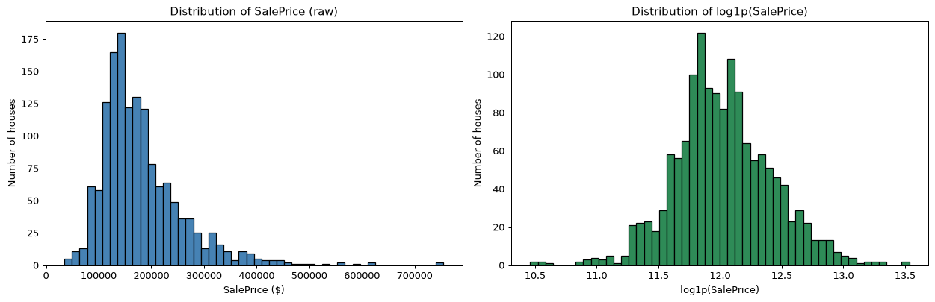
Figure 1: SalePrice distribution: raw (left) vs log1p (right). The log transform turns a heavily right-skewed target (1.883) into a near-symmetric one (0.121), which also matches the RMSLE metric.
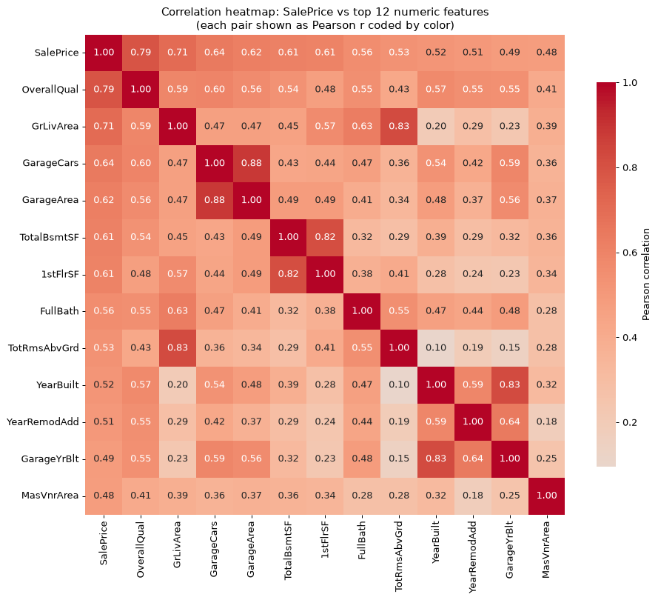
Figure 2: Top-12 numeric features ranked by their correlation with SalePrice. OverallQual (0.791) and GrLivArea (0.709) dominate.
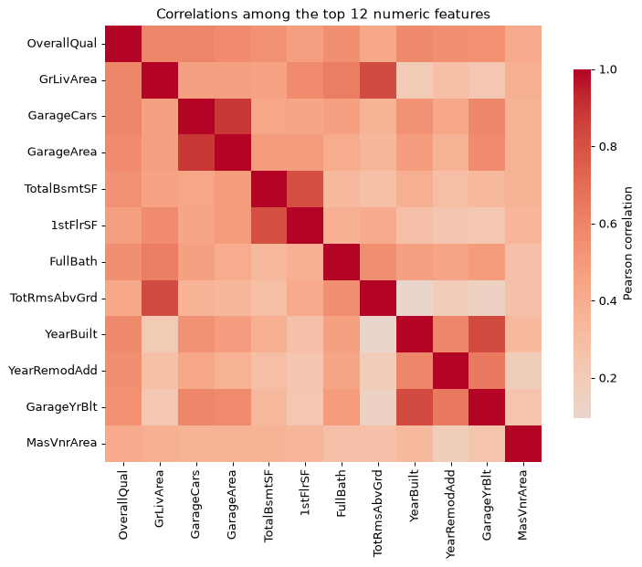
Figure 3: Correlation heatmap of SalePrice and the top-12 numeric features. Strong mutual correlations (e.g. GarageCars vs GarageArea) are the source of multicollinearity.
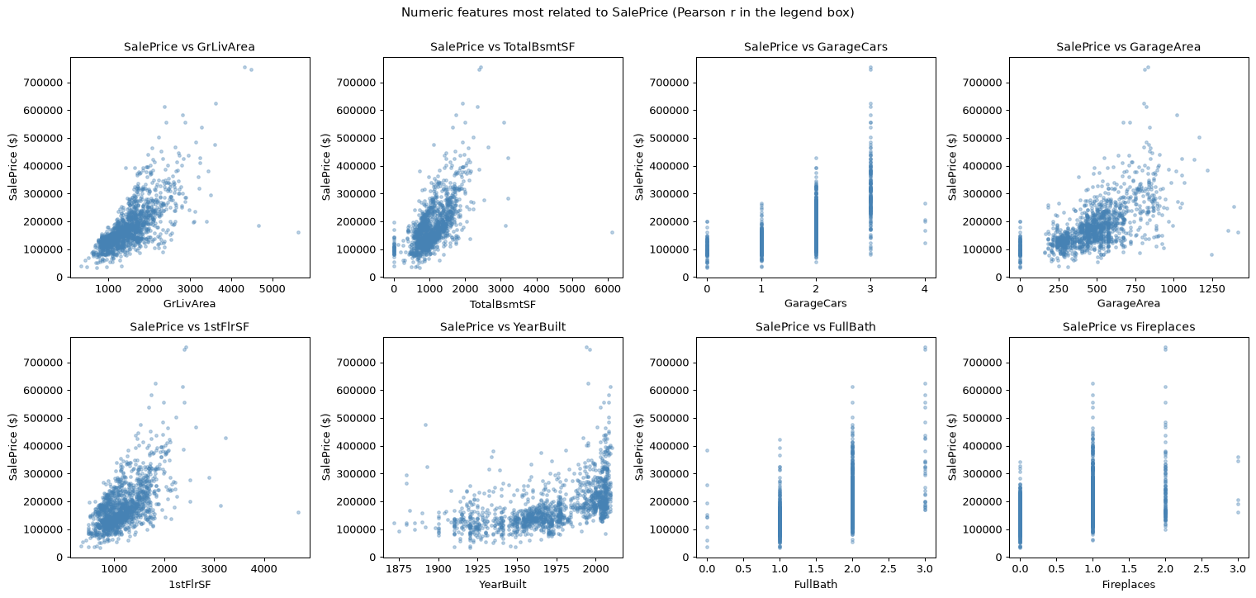
Figure 4: Scatter plots of the most informative numeric features versus SalePrice (GrLivArea, TotalBsmtSF, GarageCars, GarageArea, 1stFlrSF, YearBuilt, FullBath, Fireplaces).
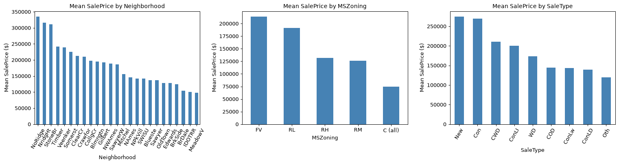
Figure 5: Key categorical features versus SalePrice (OverallQual, Neighborhood, ExterQual, BsmtQual, KitchenQual, FireplaceQu, GarageType, HeatingQC).
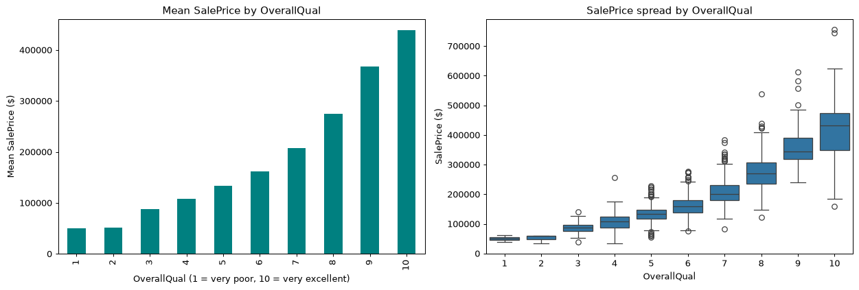
Figure 6: Additional categorical features versus SalePrice (GarageFinish, PavedDrive, GarageQual, Number of Kitchens).

4. Preprocessing
All preprocessing was implemented with scikit-learn Pipelines so that every learned step (median imputation, most-frequent imputation, scaling, one-hot encoding) is refitted separately inside each cross-validation fold - preventing data leakage. The Kaggle test set was never used for any decision.
- Absent-feature NaNs (15 columns) -> new category 'None'; GarageYrBlt NaN -> 0.
- Ordinal quality letters mapped to 1-5 (Po..Ex); 'None' -> 0.
- Outliers: one fixed, documented rule removed the 4 houses with GrLivArea > 4000 sq ft (train only). These rows are Ids 524, 692, 1183, 1299 (GrLivArea 4,316-5,642; median reminder 1,458 sq ft, all OverallQual=10). Audited impact: Ridge CV RMSLE improves from 0.14627 (with) to 0.11508 (without). No other rows are removed anywhere.
- Remaining genuine gaps were filled by the pipeline: LotFrontage (median), MasVnrArea (median), Electrical (most frequent), plus rare single-cell gaps in test.csv.
- Resulting matrices: 261 features (46 scaled numeric + 215 one-hot); train 1,456 x 261, test 1,459 x 261.
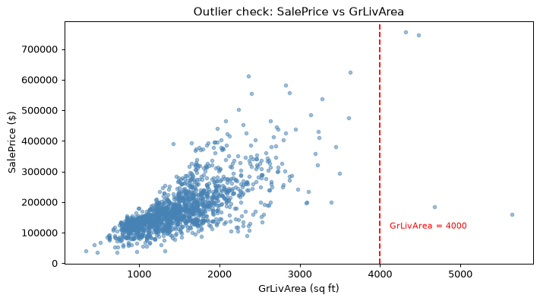
Figure 7: Outlier rule: the four train houses with GrLivArea > 4000 sq ft (Ids 524, 692, 1183, 1299) are clearly separable from the main cloud. Removing them improved Ridge CV RMSLE from 0.14627 to 0.11508.

5. Models and verified results
All models were trained on log1p(SalePrice) and evaluated with the same RMSLE definition: RMSLE = sqrt(mean((log1p(y) - log1p(y_pred))^2)), verified to be mathematically identical to mean_squared_log_error computed in dollar space.

5.1 Model comparison (Stage 4A) - 5-fold shuffled CV, seed 42
Model | CV RMSLE mean | CV RMSLE std
Dummy baseline | 0.39604 | 0.01831
Ridge (alpha=10) | 0.11508 | 0.00756
Lasso (alpha=0.005) | 0.12495 | 0.01137
Random Forest | 0.13778 | 0.01349
XGBoost | 0.12343 | 0.01186

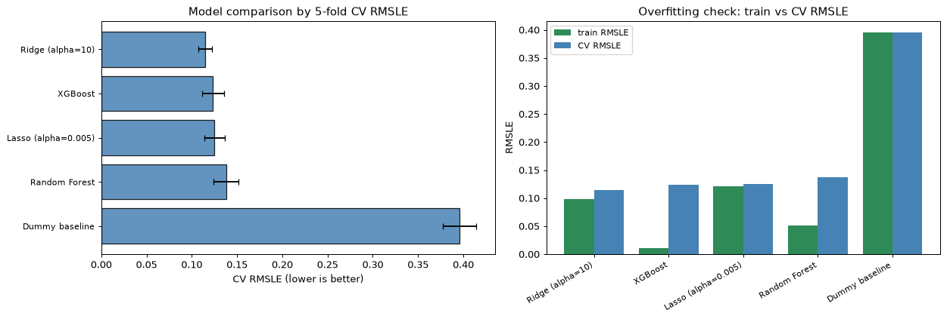
Figure 8: Stage 4A model comparison: CV RMSLE (mean +/- std, seed 42), plus the train-vs-CV gap per model. Ridge is the best in CV; the trees clearly overfit.

5.2 Tuning (Stage 4B) - GridSearchCV, same folds, CV only
Model | Best parameters | Tuned CV RMSLE
Ridge | alpha = 25 | 0.11504
Lasso | alpha = 0.0005 | 0.11396
Random Forest | max_features=1.0, min_samples_leaf=2, n_estimators=400 | 0.13768
XGBoost | learning_rate=0.05, max_depth=3, n_estimators=600 | 0.11744

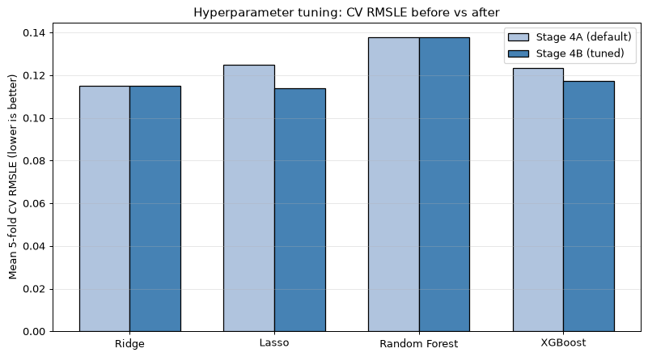
Figure 9: Stage 4B hyperparameter tuning: CV RMSLE before vs after GridSearchCV on the same folds. Lasso (alpha=0.0005) reaches 0.11396.

5.3 Honest held-out validation (Stage 5) - fresh 80/20 split, seed 42
Because earlier tuning used the full labeled data, a new 80% training / 20% validation split was created (random_state=42). Tuning on the 80% partition only; the 20% held-out rows were scored exactly once, after model selection.
Model | train-CV RMSLE (80%) | held-out val RMSLE (20%) | gap
Dummy baseline | 0.39483 | 0.39872 | +0.0039
Ridge (alpha=25) | 0.11387 | 0.12284 | +0.0090
Lasso (alpha=0.0005) | 0.11213 | 0.12026 | +0.0081

Negative predictions: checked and none occurred on validation; the safeguard (clip log-space predictions at 0, i.e. price floor of $0) is implemented and applied before any RMSLE computation.
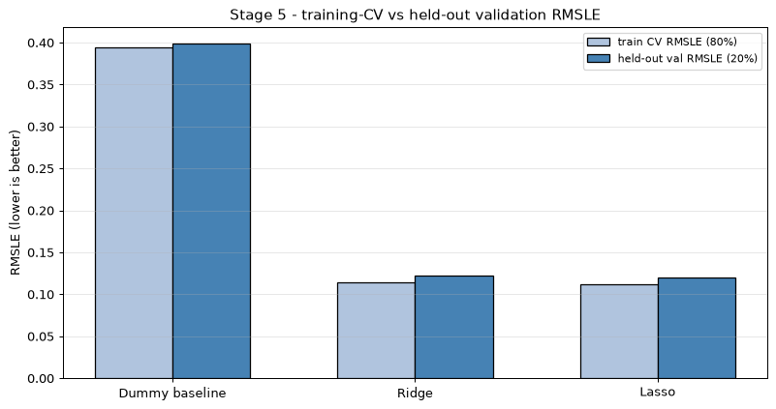
Figure 10: Stage 5 honest held-out validation (80/20, seed 42): training-CV vs held-out RMSLE. Lasso (alpha=0.0005) holds 0.12026 on the unseen 20%.
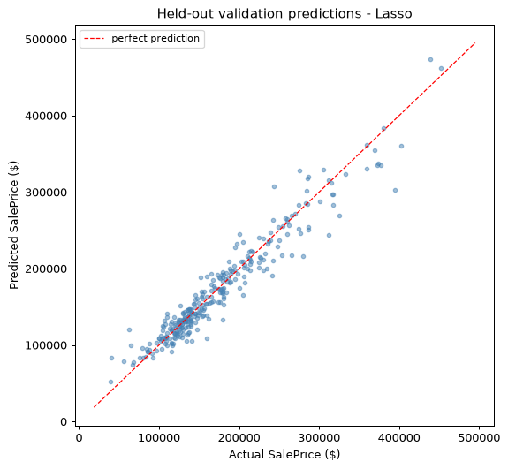
Figure 11: Stage 5 held-out validation predictions (Lasso, alpha=0.0005): predicted vs actual SalePrice. Points follow the diagonal closely, confirming a clean validation run.

5.4 Selected model
Lasso with alpha = 0.0005 was selected by held-out validation (val RMSLE 0.12026). It also had the lowest training-CV RMSLE (0.11213) and is the simplest competitive model (sparse linear).
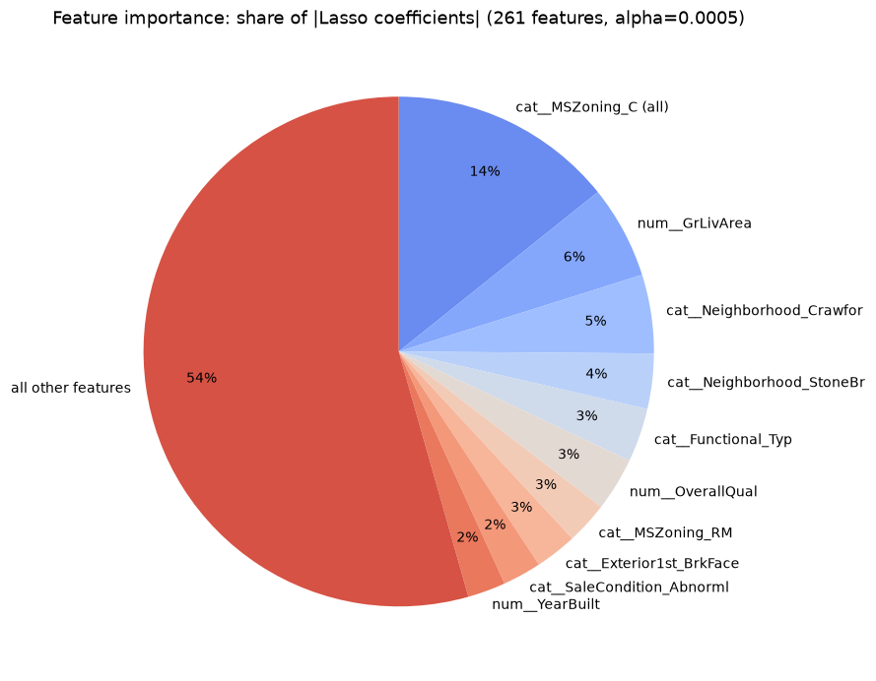
Figure 12: Feature importance pie chart - each slice is the share of |Lasso coefficient| for that feature. GrLivArea, OverallQual, YearBuilt and Neighborhood/Zone/Functional indicators dominate the model.

6. Final prediction file (Stage 6)
The final Lasso pipeline was refitted on all 1,456 labeled rows and used to predict all 1,459 test rows. Predictions were converted back with expm1 and passed through the non-negative safeguard (0 clipped log-space predictions occurred in the final run). submission.csv was written with columns Id, SalePrice in exactly the sample_submission.csv row order. Verification checks:
Check | Result
Row count == 1,459 | PASS
Columns == [Id, SalePrice] | PASS
Id order matches sample_submission | PASS
No missing SalePrice | PASS
All values finite | PASS
No negative prices | PASS

Predicted price summary: min $43,500; median $156,971; max $1,728,046; mean $179,007; std $87,046.

7. Limitations
- No Kaggle score is claimed: test.csv has no labels, so the true test error is only measurable after an actual Kaggle submission.
- The held-out validation RMSLE (0.12026) is a single-split estimate; a different split would yield a slightly different value.
- A small train-versus-validation gap is encouraging but does not by itself prove generalisation.
- Hyper-parameters were tuned on limited grids; wider searches could find better values.
- Tree models (Random Forest, XGBoost) showed a large train-versus-CV gap (overfitting) and were not pursued further in the final selection.

8. Conclusion
A reproducible, leakage-free pipeline was built for the Ames house-price task. EDA guided every preprocessing decision (log target, absent-feature handling, one documented outlier rule). Five models were compared with identical 5-fold CV and the same RMSLE metric; Lasso, after tuning (alpha=0.0005), was confirmed on held-out validation (val RMSLE 0.12026) and used to generate a verified submission.csv with 1,459 predictions. The deliverable demonstrates the full data-analytics workflow: questioning the data, honest evaluation, and cautious interpretation of results.

9. References
- Kaggle: House Prices - Advanced Regression Techniques - https://www.kaggle.com/competitions/house-prices-advanced-regression-techniques
- scikit-learn documentation - Pipelines and GridSearchCV - https://scikit-learn.org/stable/modules/compose.html
- pandas documentation - https://pandas.pydata.org/docs/
- seaborn documentation - https://seaborn.pydata.org/
- XGBoost documentation - https://xgboost.readthedocs.io/
- IBM SkillsBuild - Data Analytics with AI program materials (2026 internship)

