MongoDB Assignment 1

(PART 1)

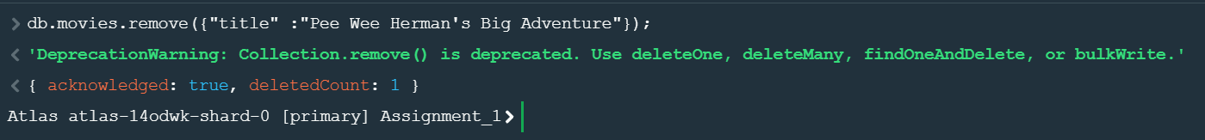

(PART 2)

MongoDB Assignment 2

MongoDB Assignment 3

