- After adding a transaction from the desktop view, the application currently navigates to Business Operations.
Expected behavior:
Once the transaction is successfully added, the user should be redirected to the Dashboard instead of Business Operations.

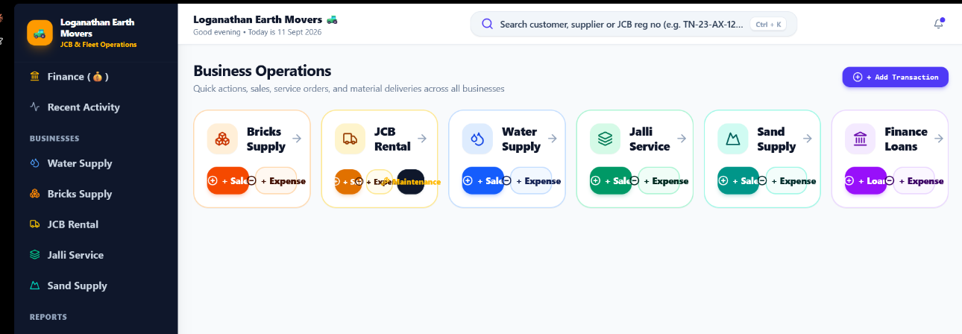

- Update the sand selection options as follows:
- Keep M Sand
- Keep P Sand
- Add an Add Custom Sand option so users can enter a custom sand type
- Remove the other two existing sand options

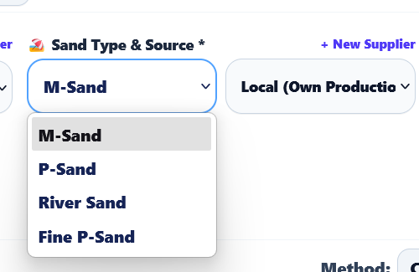
- Replace the Lorry option with Tractor throughout the application.
- Remove Lorry
- Add Tractor in its place
- Update all related labels, dropdowns, forms, and references accordingly

Update the Staff → Driver Profile section to include a complete Driving Hours Tracking feature.
For every driver, add a new “Driving Hours” tab alongside the existing All Activity, Salary & Bata Payouts, and Advance Transactions tabs.
• Automatically calculate the total driving duration from the start and end time.
• Save all driving-hour records permanently under that particular driver's profile.
• Add a month selector to filter the records by month.
• Display a monthly summary showing:
- Total days worked
- Total hours driven
- • Keep the existing salary/bata and advance transaction functionality unchanged.
- • The driving-hour data should be linked to the specific driver and should not mix with other staff members. And
- 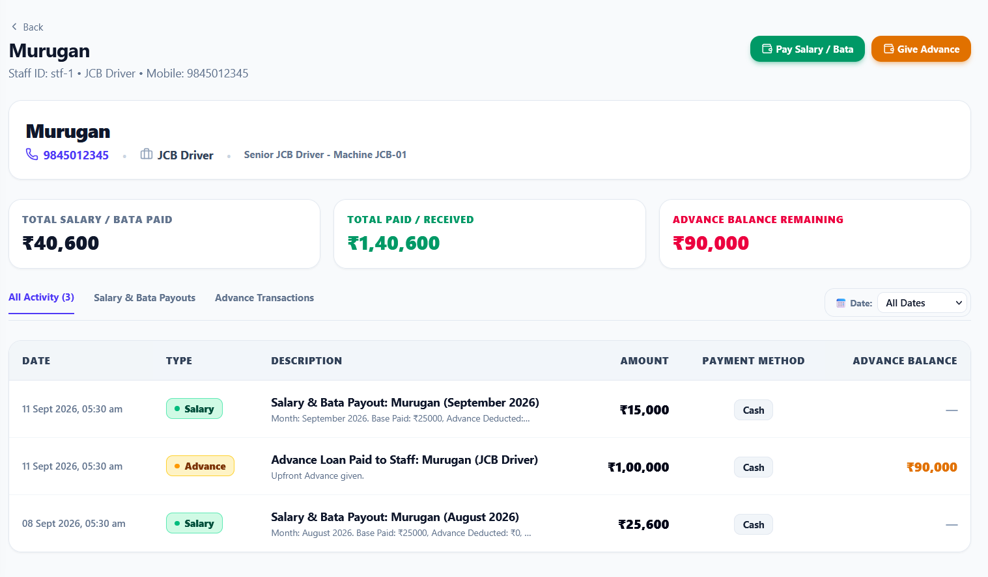
Update the Driver Bata Calculation section so that the “Fetch from JCB Log” button automatically fetches the driver's total hours worked/driven for the selected month from the JCB Log.
Requirements:
- Add a Month selector in the Driver Bata Calculation section.
- When the user selects a month and clicks “Fetch from JCB Log”, retrieve all JCB log entries for that specific driver and selected month.
- Calculate the total hours driven for that month by summing the recorded driving hours from the JCB Log.
- Automatically populate “Units (Per Hour)” with the fetched total hours.
  - Example: If the driver worked 138 hours in September 2026, Units should automatically become 138.
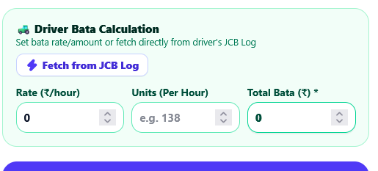
Update the Driver Bata Calculation section so that the “Fetch from JCB Log” button automatically fetches the driver's total hours worked/driven for the selected month from the JCB Log.
Requirements:
- Add a Month selector in the Driver Bata Calculation section.
- When the user selects a month and clicks “Fetch from JCB Log”, retrieve all JCB log entries for that specific driver and selected month.
- Calculate the total hours driven for that month by summing the recorded driving hours from the JCB Log.
- Automatically populate “Units (Per Hour)” with the fetched total hours.
  - Example: If the driver worked 138 hours in September 2026, Units should automatically become 138.

Prompt
Update the Supplier section to follow the same layout and functionality as the existing Customer section.
For Suppliers, replace the current simple supplier list with a table/card layout similar to the Customer screen.
Include these columns:
- SUPPLIER – Supplier name with avatar/initial
- MOBILE NUMBER – Phone number with phone icon
- TOTAL PURCHASE – Total business/purchase amount with the supplier
- PAID AMOUNT – Total amount paid to the supplier
- OUTSTANDING – Remaining amount payable to the supplier
- ACTION – Edit, View, and Delete icons
Supplier calculations
For each supplier:
Outstanding = Total Purchase − Paid Amount
Example:
Supplier | Total Purchase | Paid Amount | Outstanding
Siva Trader | ₹25,000 | ₹24,000 | ₹1,000
QQQQ | ₹30,000 | ₹28,000 | ₹2,000
Actions
Add the same three actions as Customer:
- ✏️ Edit – Edit supplier details
- 👁️ View – Open the supplier's detailed transaction/business history
- 🗑️ Delete – Delete the supplier with confirmation
Search
Keep the supplier search field at the top:
“Search supplier by name, phone or location...”
The search should filter suppliers by:
- Name
- Mobile number
- Location
Important
- Keep the same visual design, spacing, typography, colors, icons, and table structure as the Customer section.
- Supplier financial values should be calculated from the supplier's actual purchase and payment transactions.
- Clicking View should show the complete supplier transaction history, including purchases, payments, and outstanding balance.
- Remove the current simple supplier cards/list and use the Customer-style supplier table instead.
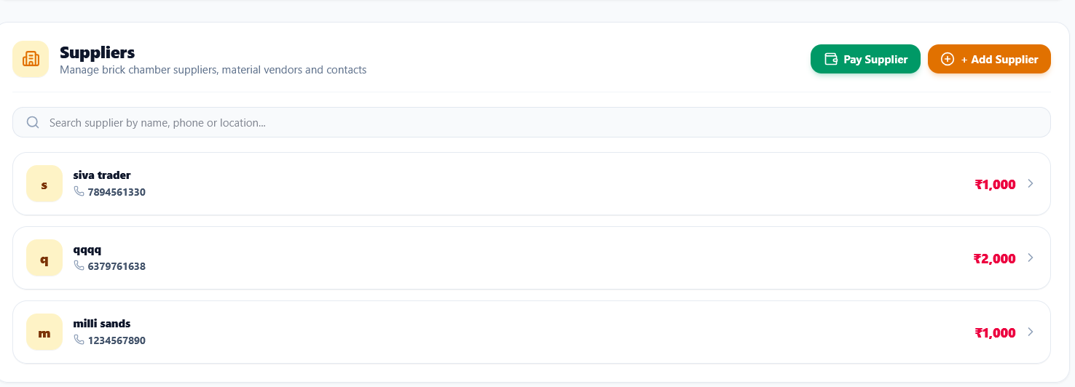

Prompt
Update the Supplier Ledger / Supplier Detail page to follow the same Customer Ledger design and functionality.
The current Supplier page has tabs like All Activity, Material Supplies, Payments Made, and Outstanding Items. Keep these business concepts, but redesign the ledger to match the Customer Ledger table structure.
Supplier Ledger Table
Use the following columns:
- DATE
- TYPE
- BUSINESS
- DESCRIPTION
- BILL AMOUNT
- AMOUNT PAID
- REMAINING DUE
- ACTION
Each supplier transaction should appear as a row in the ledger.
Example
Date | Type | Business | Description | Bill Amount | Amount Paid | Remaining Due | Action
08 Sept 2026 | Transaction | JCB Rental | JCB Earthmoving (5 Hours) | ₹500 | ₹0 | ₹500 | Edit / Delete
08 Sept 2026 | Transaction | Bricks Supply | Red Bricks (Tractor) | ₹2,500 | ₹1,000 | ₹1,500 | Edit / Delete
Supplier Ledger Behavior
- Bill Amount = total value of the supplier purchase/supply.
- Amount Paid = payments already made to that supplier.
- Remaining Due = Bill Amount − Amount Paid.
- Show unpaid/remaining amounts clearly.
- If the bill is fully paid, show ₹0 remaining.
- Every payment made to the supplier should update the Amount Paid and Remaining Due automatically.
- The ledger should maintain the complete transaction history for that supplier.
- Edit and Delete actions should work for each transaction.
- Add date filtering/month filtering similar to the Customer Ledger.
- Keep the existing supplier tabs, but make the All Activity view the main ledger view.
Important UI Requirement
Make the Supplier Ledger visually consistent with the Customer Ledger:
- Same table style
- Same spacing and typography
- Same action icons
- Same amount formatting
- Same colors for paid and outstanding amounts
- Same responsive behavior
The supplier ledger should behave like a proper accounting ledger, where every purchase/supply and payment is reflected in the supplier's total balance and outstanding amount.
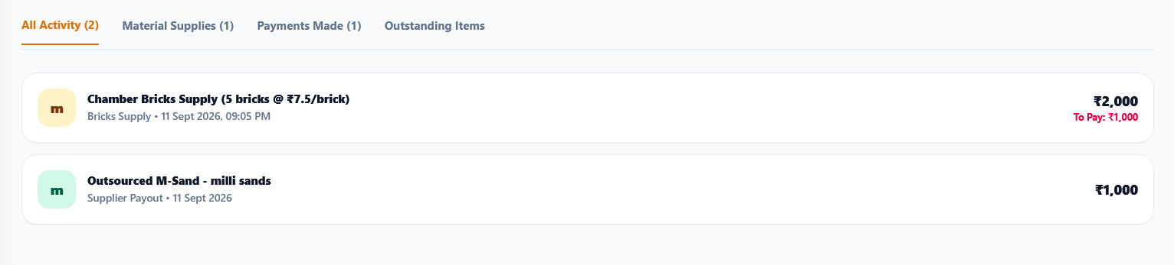

Fix the duplicate customer issue shown in the Customer list.
Currently, when entering/saving one customer, the same customer is appearing multiple times in the customer list with identical details.
Expected behavior
- Each customer should be created only once when the customer form is submitted.
- Prevent duplicate customer records from being created due to:
  - Multiple clicks on the Save/Add Customer button
  - Form submission being triggered more than once
  - Duplicate API/database requests
  - State refresh or re-render creating duplicate entries
- After successfully saving a customer, disable the submit button while the request is processing and show a loading state.
- Ensure the save operation is idempotent so the same customer cannot accidentally be inserted multiple times from one submission.
- Refreshing the page must not create another copy of the customer.
- If the same customer already exists, update/use the existing customer record instead of creating another duplicate, based on an appropriate unique identifier such as customer ID and/or validated mobile number.
- Do not delete legitimate different customers who happen to have similar names or phone numbers.
Important
The customer list should contain one row per unique customer.

Prompt
Update the Water Supply entry form based on the attached UI.
Supplier instead of Water Source
Remove the current “Water Source & Site” / water-source selection from the supplier-related section and use Supplier instead.
The field should be:
Supplier *
-- Choose Supplier ▼
Add a “+ New Supplier” option next to the Supplier label so users can quickly create a new supplier without leaving the form.
Supplier selection
The Supplier dropdown should contain:
- Existing suppliers
- + Add New Supplier / + New Supplier
When a supplier is selected, associate the transaction with that supplier so it appears correctly in the Supplier Ledger.
Supplier Payment & Cost
Keep/add these two fields directly below the supplier selection:
💳 PAID TO SUPPLIER (₹)
Input: 0
💰 SUPPLIER COST (₹)
Input: Cost
Behavior:
- Supplier Cost = total amount/cost of the material supplied by the supplier.
- Paid to Supplier = amount already paid to that supplier for this transaction.
- Calculate the outstanding amount automatically:
Outstanding = Supplier Cost − Paid to Supplier
Example:
Supplier Cost: ₹5,000
Paid to Supplier: ₹2,000
Outstanding: ₹3,000
- Allow the user to enter ₹0 if nothing has been paid yet.
- The supplier cost and payment must be recorded against the selected supplier.
- These values must flow into the Supplier Ledger and update the supplier's Total Purchase, Amount Paid, and Outstanding amounts.
- Do not treat the supplier as a water-source option. The supplier should be a proper supplier entity linked to the transaction.
Keep the existing UI styling, spacing, colors, dropdown design, and responsive layout unchanged.

Prompt
Fix the Receive Payment section so the customer's actual outstanding/due amount is shown correctly.
Currently, even when a customer has an outstanding balance, the customer dropdown displays “Due: ₹0”. This is incorrect.
Required behavior
- When opening the Receive Payment screen, fetch the customer's current outstanding balance from their actual ledger/transactions.
- In the Select Customer dropdown, display the correct amount:
Customer Name — Phone: XXXXXXXX (Due: ₹X,XXX)
Example:
rittu — Phone: 6379761638 (Due: ₹2,000)
- Do not always default the Due amount to ₹0.
- The due amount must be calculated from the customer's actual transactions:
Due = Total Business/Bills − Total Payments Received
- If the customer has fully paid, show Due: ₹0.
- If the customer has an outstanding balance, show the actual outstanding amount.
- When a customer is selected, the Payment Summary → Current Outstanding should also show the same correct balance.
- After entering a payment, dynamically update:
  - Payment Receiving
  - Remaining Balance
  - Customer's outstanding balance
- After saving the payment, update the customer's ledger immediately so the next time the Receive Payment screen is opened, the updated Due amount is displayed.
Important data consistency requirement
Use the same customer ledger/balance calculation everywhere in the application. Do not maintain a separate hardcoded or stale Due value specifically for the Receive Payment dropdown.
Also fix the duplicate customer records shown in the screenshot so the dropdown contains only one entry per unique customer.
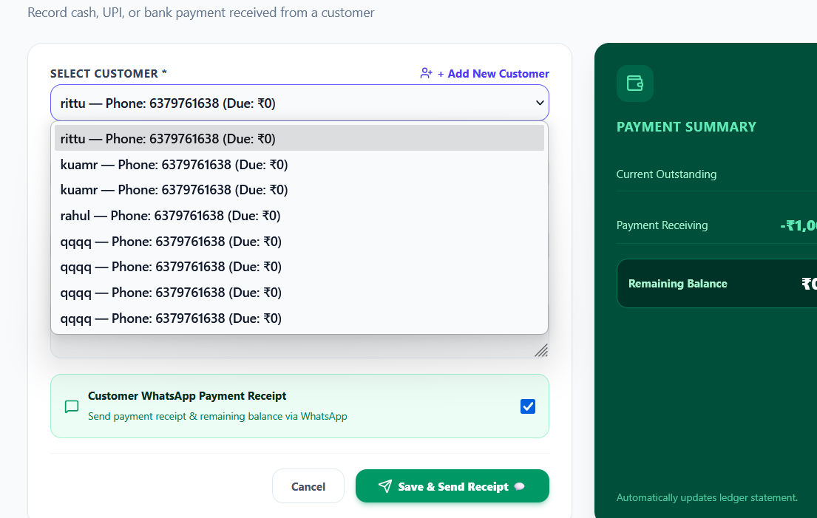

Prompt
Implement the Supplier selection dropdown exactly like the Customer dropdown shown in the reference image, but instead of “Due” owed by the customer, show the amount we need to pay the supplier.
Supplier Dropdown
When selecting a supplier, display:
Supplier Name — Phone: XXXXXXXX (Pay: ₹X,XXX)
Example:
- siva trader — Phone: 7894561330 (Pay: ₹19,000)
- qqqq — Phone: 6379761638 (Pay: ₹5,000)
Amount to Pay Calculation
The Pay amount must be calculated from the supplier's complete ledger:
Amount to Pay = Total Supplier Cost − Total Amount Already Paid
For example:
Total Supplier Cost = ₹25,000
Already Paid = ₹6,000
Pay = ₹19,000
If the supplier has already been fully paid:
siva trader — Phone: 7894561330 (Pay: ₹0)
Important
- Fetch the real-time/current supplier balance when loading the dropdown.
- Do not show ₹0 if the supplier actually has an outstanding amount.
- Use transactions from all supplier business types:
  - Jalli
  - Water
  - M Sand
  - P Sand
  - Bricks
  - Custom Materials
- Combine all unpaid supplier amounts into one Pay balance.
- When a supplier payment is recorded, immediately recalculate the amount.
- The updated amount should appear everywhere in the Supplier section and Pay Supplier screen.
- Show only one entry per unique supplier; do not display duplicate supplier records.
UI
Keep the supplier dropdown visually consistent with the Customer dropdown:
SELECT SUPPLIER *
siva trader — Phone: 7894561330 (Pay: ₹19,000) ▼
Dropdown:
siva trader — Phone: 7894561330 (Pay: ₹19,000)
qqqq — Phone: 6379761638 (Pay: ₹5,000)
another supplier — Phone: XXXXXXXX (Pay: ₹0)
The key requirement is: Customer shows “Due” (customer owes us), while Supplier should show “Pay” (we owe the supplier).
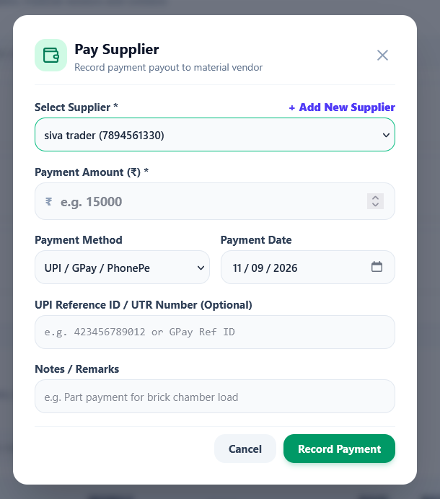

• Sort all business log entries by date and time in descending order.
• The most recently added/latest transaction must always appear at the top.
• Older transactions should appear below newer transactions.
• If two transactions have the same date, use the exact time to determine the order.
• Apply this sorting consistently across all business types, including:
- Water Supply
- Jalli
- M Sand
- P Sand
- Bricks
- JCB
- • The ordering should automatically update whenever a new transaction is added, edited, or its date/time is changed.
- • Do not rely only on the order in which records were created; sort using the actual transaction date + time.
