Trainee No- **TR126**

Name- **Rittwik Devdatta Das**

E-mail: [**rittwik.devdattadas@fractal.ai**](mailto:rittwik.devdattadas@fractal.ai)

**Power BI Assignment-2**

**Q.2 Answer**

We have created a Geography Hierarchy which can be seen in the Data section on the right. **Under the Geography Hierarchy, we have added the fields- Region, State and City in the hierarchical order.**

Also, different levels of hierarchy can be accessed from the options shown on selecting the bar graph using the **drill down/drill up** as well as **expand all down one level in the hierarchy option.**

From analyzing the graph, the following inferences are made:

**Region Analysis:**

* **Highest Sales value region:** **Northeast with a total sales value of $2.253M** followed by West, Southeast, South and Midwest respectively in the decreasing order of total sales value.
* **Lowest Sales value region:** **Midwest with a total sales value of $1.15M**

**State Analysis:**

* **Highest Sales value state:** **New York State (under Northeast region) with a total sales value of $582,675** and California comes very close total sales value of $582,400.
* **Lowest Sales value state:** **Nebraska (under Midwest region) with a total sales value of $54,380**

**City Analysis:**

* **Highest Sales value city:** **New York City (under New York state) with a total sales value of $391,767.50**
* **Lowest Sales value city:** **Omaha (under Nebraska state) with a total sales value of $54,380**

**Most upper level of hierarchy by Region:**

**Next level of hierarchy by State:**

**Lowest level of hierarchy by City:**

**Q.4 Answers**

1. The region with the highest operating margin is **South** and the operating margin is **40.62%**
2. The retailer with the highest total sales in Midwest region is **Walmart** and the total sales value is **$996.35K** ($996,347.50 to be precise)
3. The second most selling brand in Walmart in terms of no. of units sold is **Dasani Water** and the total units sold are **1.635M** (1,635,000 to be precise)
4. The brand which has the highest average price per unit in Walmart is **Powerade** and the price per unit is **$0.529** Also, Dasani Water comes very close as compared to Powerade with an average price per unit of $0.528 (approximately)
5. The delivery company which made the highest total sales is **USPS** and the total sales value is **$2.217M** ($2,217,072.50 to be precise)

**Q.3 Answer**

For this question, **we have created a new column Beverage Brand_new** which can be seen from the Beverages data sheet on the rightmost data and **replaced all the Coca-Cola values with Coke**.

For clarity, we have created a table which can be seen above with the columns- Beverage Brand and the new created column Beverage Brand_new with replaced values.

**Q1. Summary Page**

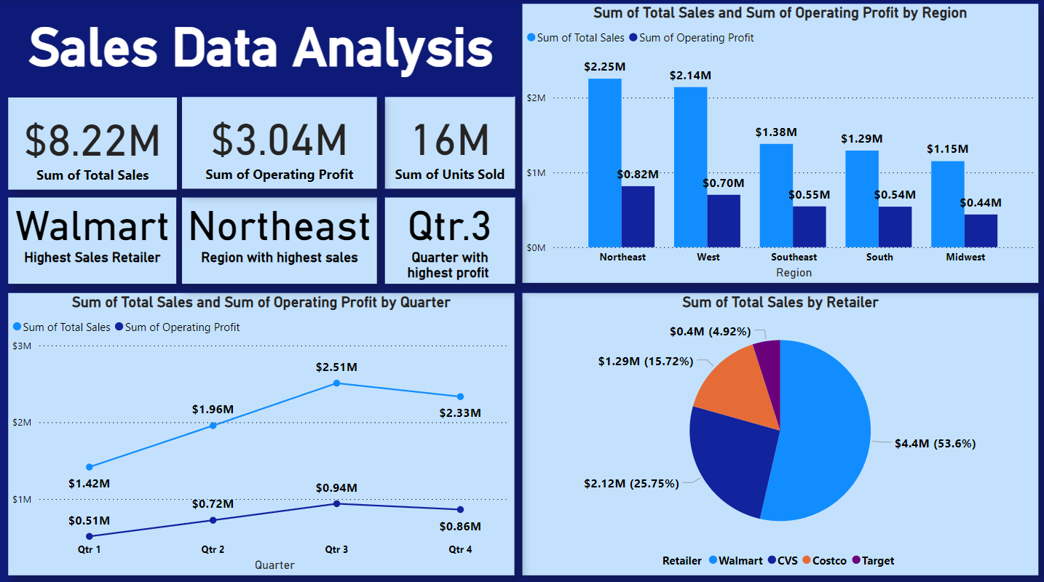

We have made an interactive summary page with necessary cards and different types of graphs showing relationships between various entities. The cards show various inferences about the data such as total sales, profit and units sold. The different types of graphs show various relationships between the retailers and sales and also the sales value comparison by different quarters.