**Name: RITTYMARIYA K R**

**Roll No:28**

**Batch:MCA -B**

**Date:23-05-2022**

**NETWORKING & SYSTEM ADMINISTRATION LAB**

**Experiment No.: 24**

**Aim**

Docker Installation.

**Procedure:**

**Step 1:**

1. Open the terminal on Ubuntu.

**Step 2:**

2. Remove any Docker Files that are running in the system, using the following command:

**$ sudo apt-get remove docker docker-engine docker.io**

After entering the above command, you will need to enter the password of the root and press enter.

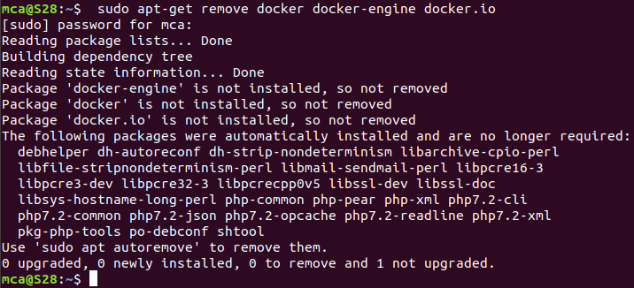

**Step 3:**

3. Check if the system is up-to-date using the following command:

**$ sudo apt-get update**

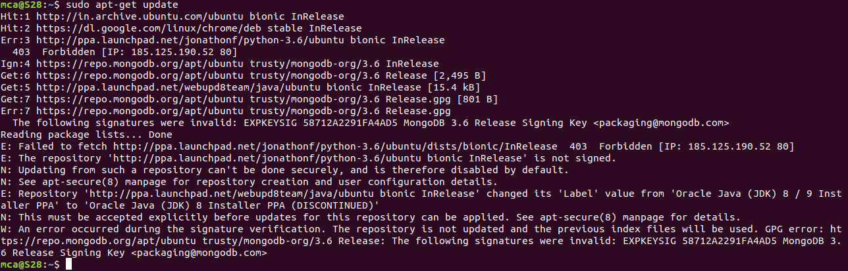

**Step 4:**

4. Install Docker using the following command:

**$ sudo apt install docker.io**

You’ll then get a prompt asking you to choose between y/n – choose *y*

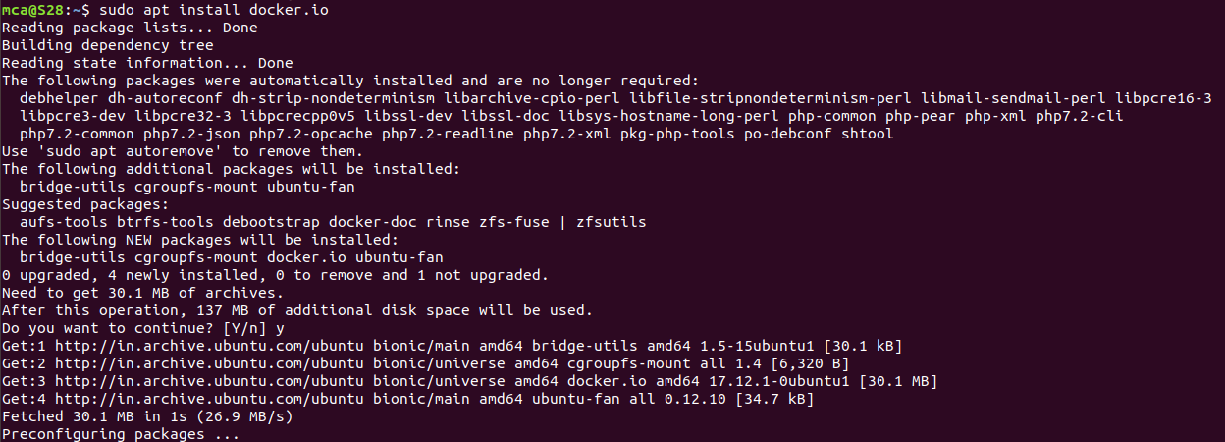

**Step 5:**

5. Install all the dependency packages using the following command:

**$ sudo snap install docker**



**Step 6:**

6. Before testing Docker, check the version installed using the following command:

**$ docker –version**



**Step 7:**

7. Pull an image from the Docker hub using the following command:

**$ sudo docker run hello-world**

Here, *hello-world* is the docker image present on the Docker hub.

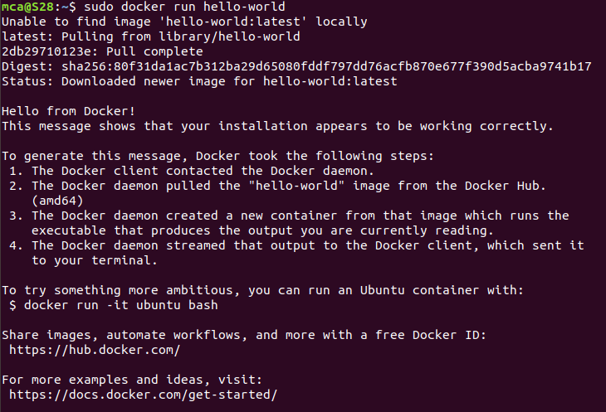

**Step 8:**

8. Check if the docker image has been pulled and is present in your system using the following command:

**$ sudo docker images**



**Step 9:**

9. To display all the containers pulled, use the following command:

**$ sudo docker ps -a**



**Step 10:**

10. To check for containers in a running state, use the following command:

**$ sudo docker ps**



You’ve just successfully installed Docker on Ubuntu!