Android Lab

1. How to implement drawable in android.(using gradient)

custom_button_background.xml

<?xml version="1.0" encoding="utf-8"?>

<selector xmlns:android="http://schemas.android.com/apk/res/android">

<item>

<shape android:shape="rectangle">

<solid android:color="#F4BFB1"></solid>

<stroke android:color="#9C2780"

android:width="30dp"

android:dashGap="10dp"

android:dashWidth="10dp">

</stroke>

<corners android:bottomLeftRadius="50dp"

android:topRightRadius="45dp"></corners>

<size android:width="200dp" android:height="200dp"></size>

<gradient android:startColor="#880E4F" android:endColor="#E040FB"

android:angle="360"

android:centerColor="#90F9BF"

android:type="radial"

android:gradientRadius="100dp"></gradient>

</shape>

</item>

</selector>

Activity_main.xml

<?xml version="1.0" encoding="utf-8"?>

<androidx.constraintlayout.widget.ConstraintLayout xmlns:android="http://schemas.android.com/apk/res/android"

xmlns:app="http://schemas.android.com/apk/res-auto"

xmlns:tools="http://schemas.android.com/tools"

android:layout_width="match_parent"

android:layout_height="match_parent"

tools:context=".MainActivity">

<TextView

android:layout_width="wrap_content"

android:layout_height="wrap_content"

android:text="Hello World!"

app:layout_constraintBottom_toBottomOf="parent"

app:layout_constraintEnd_toEndOf="parent"

app:layout_constraintStart_toStartOf="parent"

app:layout_constraintTop_toTopOf="parent" />

<ImageButton

android:layout_width="250dp"

android:layout_height="250dp"

android:background="@drawable/custom_button_background">

</ImageButton>

</androidx.constraintlayout.widget.ConstraintLayout>

**Output**

custom_button_background.xml

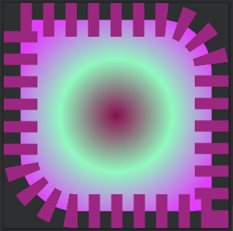

Activity_main.xml

