**Experiment No.: 7**

**Name: RITTYMARIYA K R**

**Roll No:28**

**Batch: MCA B**

**Date:17-10-2022**

**Aim**

Naïve Bayes

**Questions**

Naïve Bayes With CSV

**Program and Output**

1. #upload,read,print csv file

import pandas as pd

import io

from google.colab import files

uploaded = files.upload()

df1=pd.read_csv('/content/golf-dataset.csv')

print(df1)

**Output**

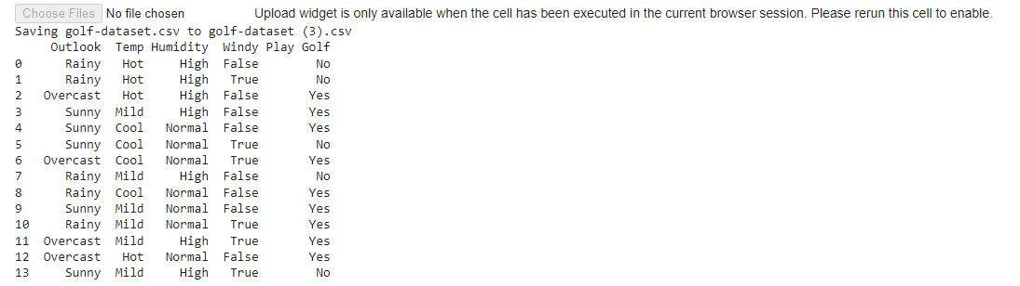

2. #replace attributes in csv

df1['Outlook'].replace(['Rainy'],[0], inplace=True)

df1['Outlook'].replace(['Overcast'],[1], inplace=True)

print(df1)

output

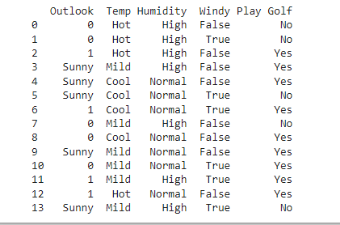

3.

import pandas as pd

import io

from sklearn.model_selection import train_test_split

df1.head(10)

X = df1.iloc[:, [0,1,2, 3]].values

y = df1.iloc[:, -1].values

print(X)

print(y)

X_train, X_test, y_train, y_test = train_test_split( X, y, test_size = 0.2, random_state=42)

print(X_test)

**Output**

