**NURS_6441_DiscussionWK4**

**Project Management Software Exercise:**

In this Discussion, you create your first sample project in ProjectLibre, post your file to the discussion board, and then reflect on your experience using this project management software.

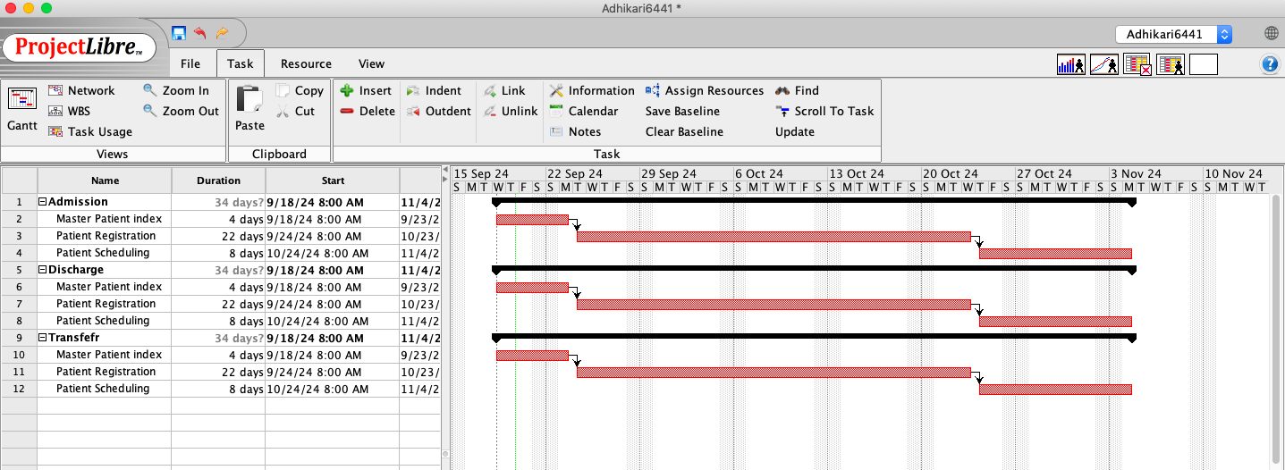

**Fig: Test project plan**

**Describe challenges you encountered when acquiring and working with this software.**

Difficulty in navigating features in the beginning was overwhelming.

While there are resources available, comprehensive tutorials and videos can be scattered making it difficult for new users like me to fully utilize the software. This is a challenge that requires patience and a willingness to explore the software’s capabilities and since I have that willingness to explore this software, I am more than happy to accept the challenge.

**Describe your comfort level building your test project.**

The training and tutorials provided significantly enhanced my comfort level. Practice and the right resources can make us proficient in using this software. Tasks such as Gantt chart, setting timelines, and assigning resources are relatively straightforward to build my confidence.

Overall, while there may be challenges in the initial phase, with some practice and exploration, beginners can gradually become comfortable using Project Libre.

**Explain the strengths and weaknesses of using project management software for a small project and for a large project.**

**Strengths of Project Libre (Small Projects)**

According to project libre.com, It is compatible with Microsoft Project files where we can simply open our projects in Linux, macOS, or Windows. Key features include Compatibility with Microsoft Project, Gantt Charts, Network Diagrams, WBS/RBS charts, Earned Value Costing, and Resource Histograms. It is free to use making it ideal for small projects with limited budgets.  Per Project Libre cloud, being a desktop application, it doesn’t require an internet connection, which can be convenient for small teams.

**Strength of Project Libre (Large Projects)**

It provides a tool for detailed scheduling and resource management that helps in organizing complex projects. Better Integration abilities allow better integration with a larger project ecosystem.  A project plan can be tailored to meet specific needs, making it adaptable for large projects with unique requirements.

**Weaknesses of project Libre (Small projects)**

It can be complex for simple projects that can overwhelm new users.

Being desktop-based limits real-time collaboration among team members can be a drawback for small teams.

**Weakness of Project Libre (Large Projects)**

Large projects can lead to slow performance and increased risk of crashes, making it challenging to manage extensive data effectively.

For larger projects with many moving parts, the complexity can be daunting, requiring more time for team members to become proficient.

**References:**

[ProjectLibre. (n.d.).Links to an external site.Links to an external site.](https://www.projectlibre.com/product/projectlibre-open-source) Retrieved December 3, 2019, from [https://www.projectlibre.com/product/projectlibre-open-sourceLinks to an external site.](https://www.projectlibre.com/product/projectlibre-open-source)

Remote Workers = ProjectLibre Cloud. Projectlibre. (2021, November 10).

[https://www.projectlibre.com/blog/remote-workers-projectlibre-cloudLinks to an external site.](https://www.projectlibre.com/blog/remote-workers-projectlibre-cloud)

**Response 1**

Hello Tari

I learned a lot from your post. I agree with you based on my personal experience that the more we spend time and work on something, the more comfortable we will be. You have mentioned the importance of staying up to speed with software applications as this is the downside of software and technology. Very well said, along with this, there is a potential risk for data to be assessed by third parties, and according to Galen data .com, it can be intentional or accidental, the data might go into the wrong hands.  Project libre.com asserts that In Project Libre, our data may be collected, transferred to, and stored in the United States or outside including places that may not provide the same protection. They have implemented safeguards to make sure that there is an adequate level of protection where our data is transferred but it is not 100% safe.

**References:**

Projectlibre Security Compliance Overview. Projectlibre. (n.d.).

[https://www.projectlibre.com/projectlibre-security-compliance-overviewLinks to an external site.](https://www.projectlibre.com/projectlibre-security-compliance-overview)

The disadvantages of technology in Healthcare. Galen Data. (2023, February 17).

[https://galendata.com/disadvantages-of-technology-in-healthcare/Links to an external site.](https://galendata.com/disadvantages-of-technology-in-healthcare/)

**Response 2**

Hello De-Havaland Levy

Thank you for the information. I knew that Project Libre is compatible with Microsoft, Linux, and MacOS operating systems but reading your post I got to know that it is incompatible with the iPad and iOS. According to Project Libre.com, project Libre is the number one alternative to Microsoft Project; free open-source project management software. It is an open-source project management tool that aims to be compatible with Microsoft Project. However, compatibility issues arise because of differences in file formats and features. Some common issues can be File Format Compatibility, Feature Discrepancies**,** and Version Differences. To mitigate these issues, the project can be simplified before importing/exporting and reviewed thoroughly after conversion to ensure everything is as expected.

**References:**

  Projectlibre. (n.d.-a). [https://www.projectlibre.com/product/1-alternative-microsoft-Links to an external site.](https://www.projectlibre.com/product/1-alternative-microsoft-)          project-free-project-management-software-open-source