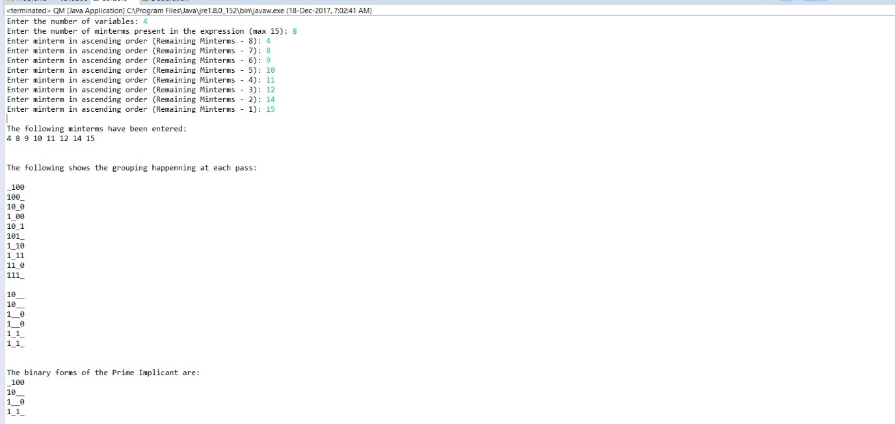

Fig. 2 Test Case 1; Pic 1

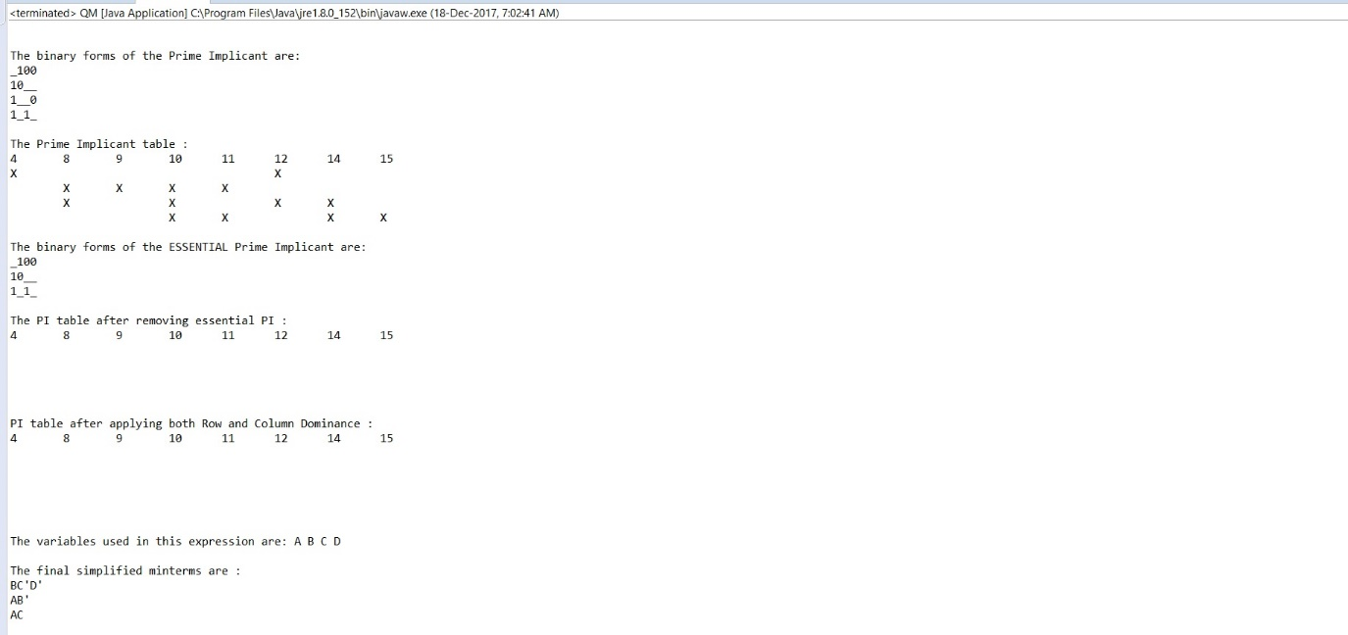

Fig. 3 Test Case 1; Pic 2

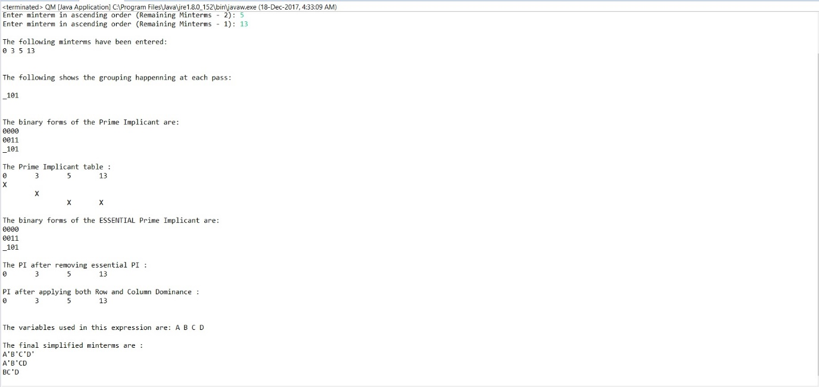

Fig. 4 Test Case 2

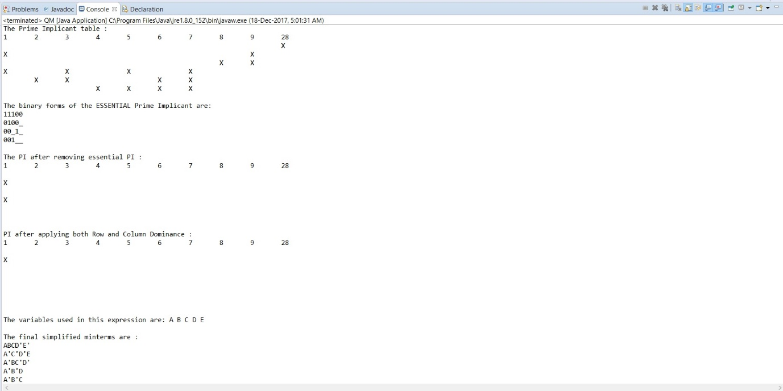

Fig. 5 Test Case 4;



Fig. 6 Test Case 3; Pic 1



Fig. 7 Test Case 3; Pic 2

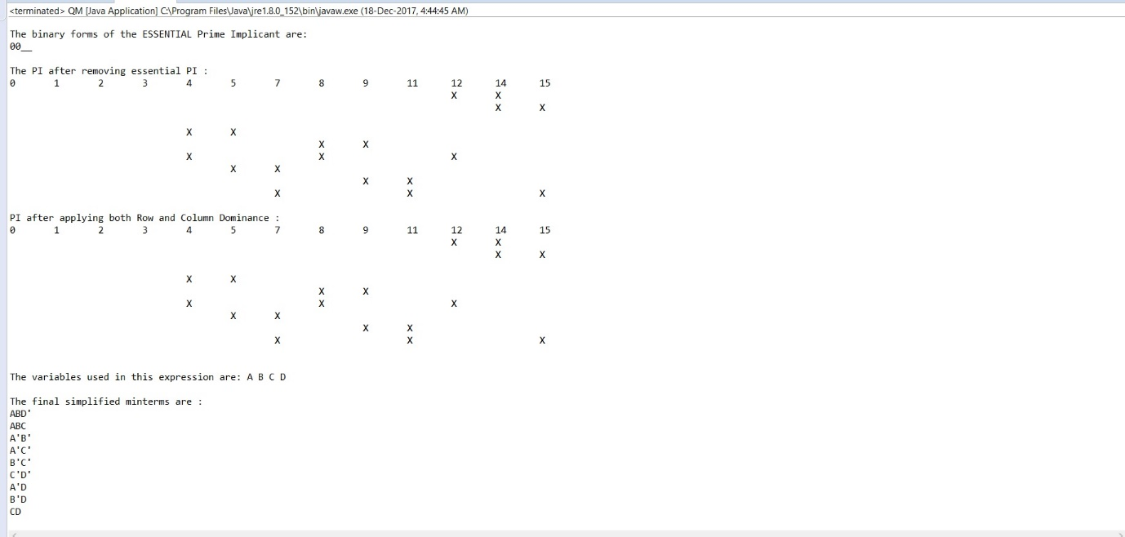

Fig. 8 Test Case 3; Pic 3

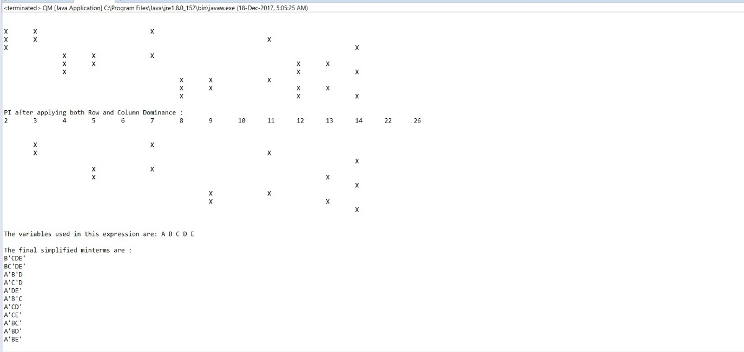

Fig. 9 Test Case 5;

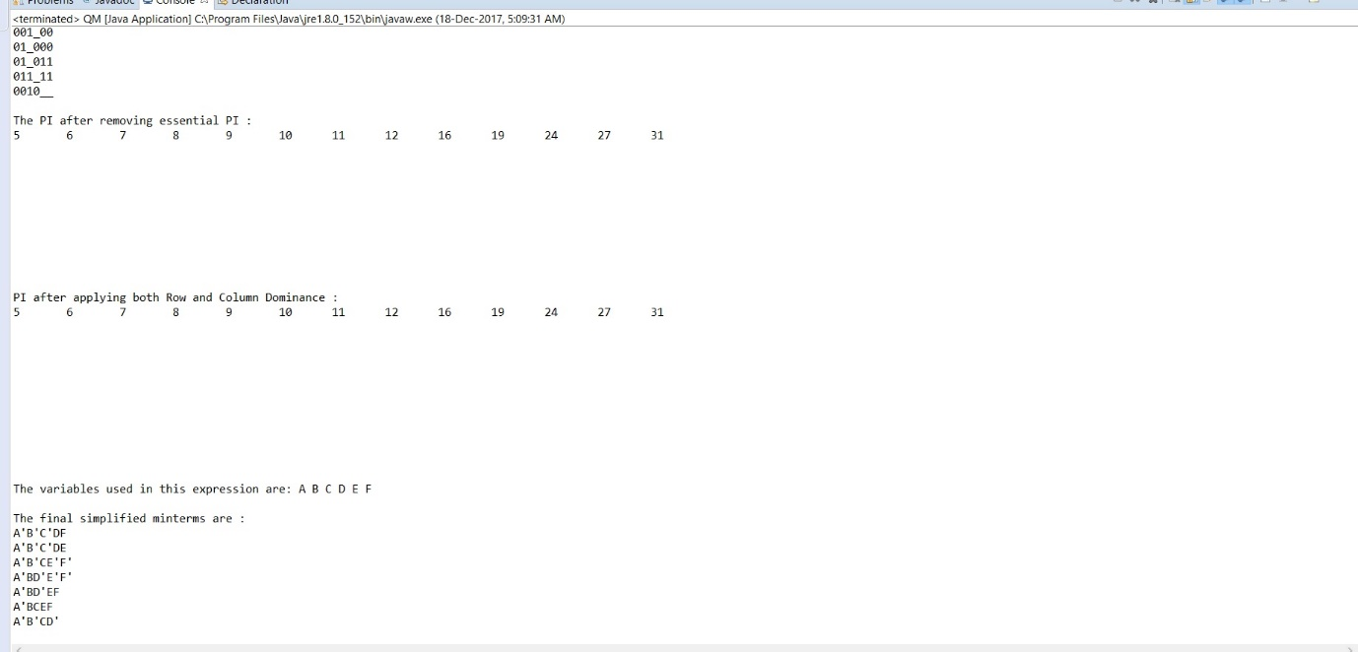

Fig. 10 Test Case 6;

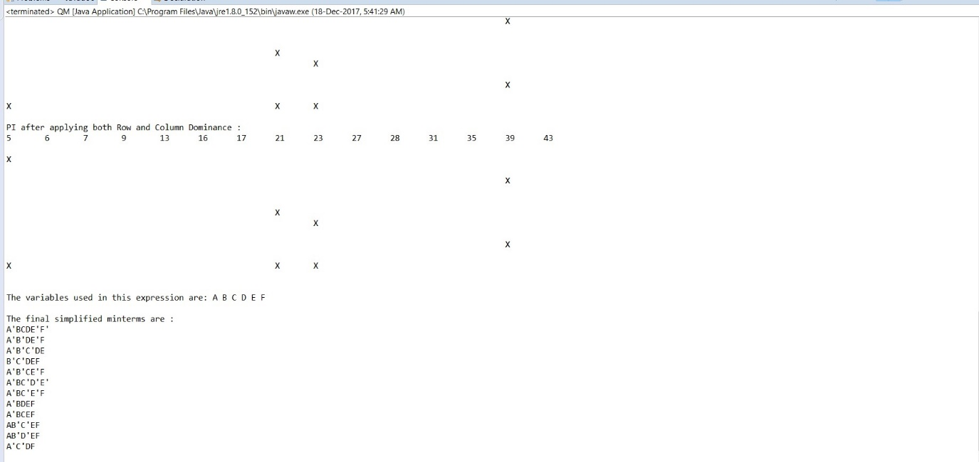

Fig. 11 Test Case 7;

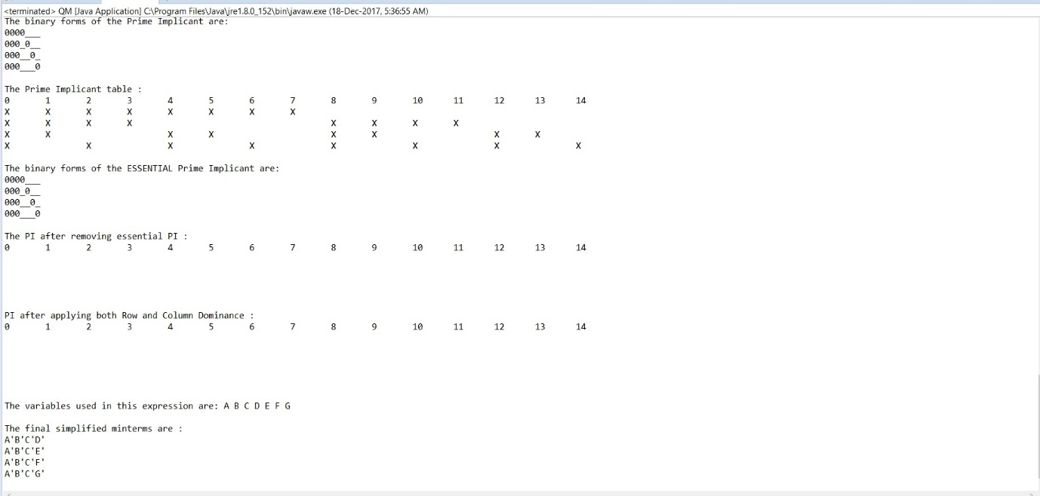

Fig. 12 Test Case 8;

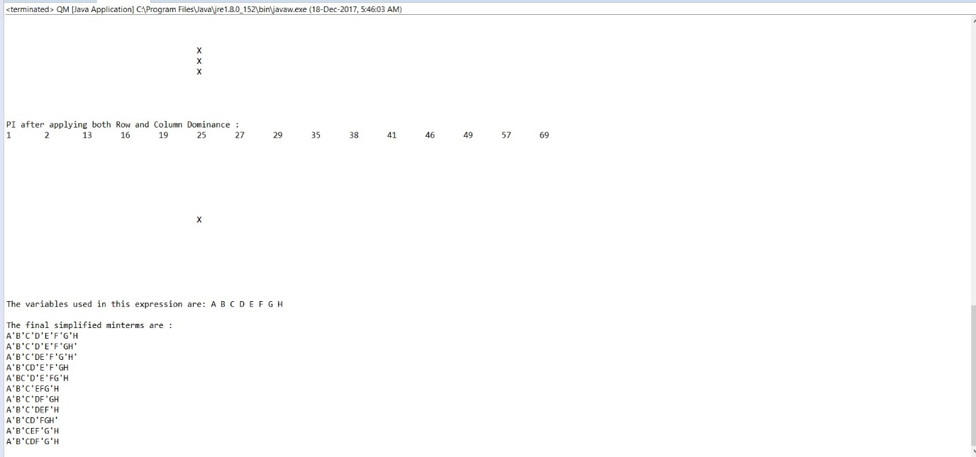

Fig. 13 Test Case 9;

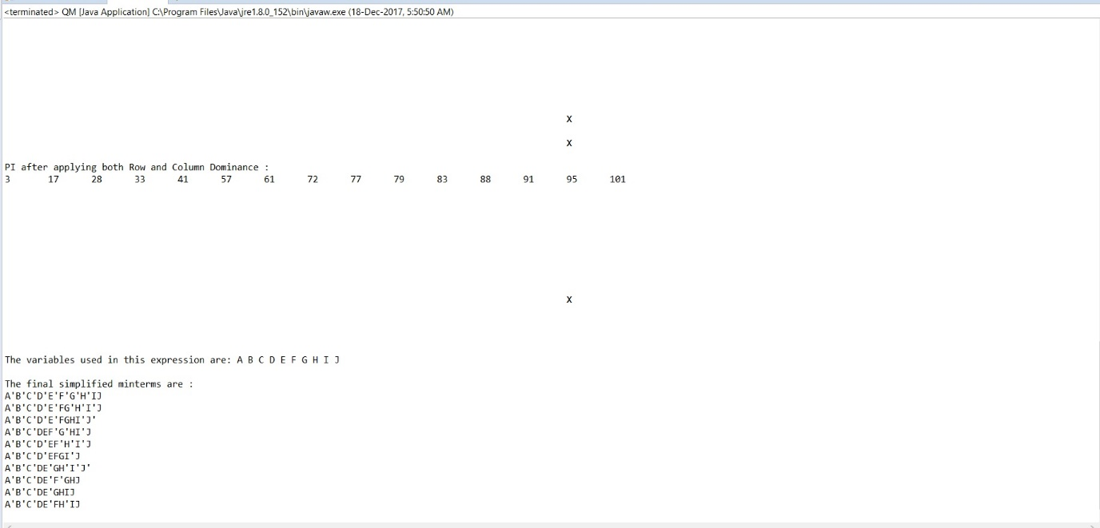

Fig. 14 Test Case 10;