**Annexure -3**

Software Requirements Specification

For Minor Project

Educational Portal



|  |  |
| --- | --- |
| **Prepared by:**  **Ritu Jain(PCE/15/IT/045)**  **Himani Gupta(PCE/15/IT/016)**  **Subham Sharma(PCE/15/IT066)** | **Guide:**  **Mr. Shirish Nagar**  **Assistant Professor** |
| **Department of Information Technology,**  **Poornima College of Engineering**  **August 10, 2018 Session – 2018-19** | |

**Table of Contents**

|  |  |
| --- | --- |
| **Table of Contents** | Page No. |
| **1. Introduction** |  |
| **1.1 Purpose** |  |
| **1.2 Feasibility** |  |
| **2. Functional /Nonfunctional Requirements** |  |
| **2.1 Functional Requirement** |  |
| **2.2 Nonfunctional Requirements** |  |
| **2.3 Technical Requirements ( Hardware /Software)** |  |
| **3. System Features** |  |
| **3.1 Module 1** |  |
| **3.1 Module 2** |  |
| **3.1 Module 3** |  |
| **3.1 Module 4** |  |
| **4. Analysis Diagrams** |  |
| **4.1 Use Case Diagram**  **4.2 Sequence Diagram**  **4.3 Component diagram**  **4.4 ER Diagram**  **4.5 Activity Diagram**  **4.6System Architecture Diagram** |  |
| **5. Other Requirements** |  |
| **6. Glossary** |  |
| **7. Appendices** |  |
| **8. References** |  |
| **9. Guide’s Comments** |  |

**Revision History**

|  |  |  |  |
| --- | --- | --- | --- |
| **Name** | **Date** | **Reason For Changes** | **Version** |
|  |  |  |  |
|  |  |  |  |
|  |  |  |  |
|  |  |  |  |

# 

# Introduction

## Purpose

The information described in this document is the features and requirements of the project to be developed for client. The objective of this “Education portal” is to launch an interactive and informative portal focused on education by developing, implementing and enriching a learning platform and content. The document is developed after consultation with the client and considering the complete requirement specifications of the given project

**1.2 Feasibility**

1. **Scalable**

The system is highly scalable as there is lots of modules which help Tutors, Parents, Principle do their work easy and effective manner.

## Functional /Non Functional Requirements

## Functional Requirements

* + 1. **Admin**
       - 1. Admin can edit and update the details of the users.
         2. Admin can delete the user’s details.
         3. Admin Shall be able to login to the system
         4. Admin shall be able to create user login for the student/teacher.
         5. Admin shall be able to add courses and other activity which are going to be organized.
         6. Admin shall be able to assign the courses and timetable to the teacher as per their profile
         7. Admin are able to manage the records of the alumni.
         8. Admin can monitor every activity which is performing by the system and improve the system by receiving feedback from the user.
    2. **Teacher**
       - 1. Teacher will be able to login to the system.
         2. Teacher can examine the student performance by uploading an assignment or test papers.
         3. Teacher will be able to upload the lecture notes which will be beneficial for the student
         4. Teacher can show the result and the attendance of the students.
         5. Teachers are able to understand the student record and to analyze the weaker section of the students.
         6. Teacher can arrange the list of the students participation in the event
    3. **Student**
       - 1. Student shall be able to login to the system.
         2. Student will be able to download the assignment and lectures from the system so as to prepare for the exam.
         3. Student can view the result of their exam as well as their attendance so that they can manage their performance.
         4. Student can give their name for the participation in different events organized by the organization.
         5. Student can post their queries and give their feedback too.

## 2.2 Nonfunctional Requirements

## Performance Requirements

This software should be able to handle the following task:

* At least 20 instructors/staff can login in on average of 4 hours a day for five days a week.
* At least 100 students can log into their accounts for 3 hours for 5 days of the week.
* It should be able to handle the SQLite xerial database of 100 instructors and 4000 students.

## Safety Requirements

This software will ease the process of student grading. At the end of every semester each student will receive a grade sheet generated by the administration using the data uploaded by the course instructor on this software. All important details should be maintained in hard copy as well.

## Security Requirements

This software will,

* Authenticate each user, who logs in ;
* When the user performs any action, authorize him/her to perform the actions allowed for the user and displays an error message if found to be unauthorized.

## Software Quality Attributes

* **Scalability:** We can increase the number of organization as required.
* **Manageability:** Activity status will show to the user whenever it will be updated.
* **Reliability:** The system must be backed up on a configurable schedule. Back up requirement will need to be determined. The system should be backed up with a frequency that ensures system and all data ease protected.
* **Extensibility:** System can be further extended to any level like it can include live tracking and it can be large scale project.
* **Usability:**  Student can check any activity schedule through this portal instead of wasting time to go to the admin person.
* **Availability:** The system should be available 24 hours a day, 7 days a week. Our website should be efficient enough to manage the load all the time.
* **Portability:** Our website should be portable and responsive enough so that every organization can easily manage the admin panel.

## 2.3 Technical Requirements (Hardware /Software)

## Operating Environment

Our Website could be operated on various browsers which include- Google Chrome, Mozilla Firefox, Internet Explorer, Mobile interface, and it also includes database servers which are deployed on BI interface. All this runs effectively with internet connectivity to update and manage activities.

## Hardware Interfaces

**Server side**

The web application will be hosted on one of the department’s window servers and connecting to one of the school/college database server. The web server is listening on the web standard port, port 80.

**Client side**

The system is web based application, client are requiring using a modern web browser such as Mozilla Firefox, Internet Explorer and enable cookies. The computer must have an internet connection in order to be able to access the system.

## Software Interfaces

**Server side**

The Django, a required framework to host a Django web application. An Apache server will accept all requests from the client. A development database will be hosted locally (using MySQL); the production database is hosted centrally using (using SQLite xerial).

**Client side**

An Os is capable of running a modern web browser which supports HTML version 5, CSS3, Bootstrap.

## Communications Interfaces

This will be a web application and as it will be communicating with a database server and so will be making use of network and HTTP to communicate

# System Features

## Module 1: User Login and Registration System

**Description and Priority**

The main purpose of this module is to provide Security by allowing access to only valid users. In order to access information about all the members of management (including students, teachers and all the staff) a registration page is maintained which feeds user information required to access education portal into the registration table in database so as to store all user personal information at one place. This way a valid user can easily get the details.

**Stimulus/Response Sequences**

1. The data is stored and manage by our database management system.
2. User can interact with other modules only after this module is verified.
3. As user gives input according to required fields, the data is send to secure records through database and during login the stored data is retrieved to verify the username and password.

## Module 2: Teachers

**Description and Priority**

The teacher will manage the time table of the different classes so that the student can view that timetable according to their respective classes. They will also import Exam result and details of different events which will be organized in respective year. They will update the details of attendance and import the assignment for the student practice.

**Stimulus/Response Sequences**

1. The details will be seen on the student login portal.
2. These details will be stored in the database.

## Module 3: Students

**Description and Priority**

The student have the alerts of the assignments so that they can do practice to enhance their knowledge. They will get the updation of an activity which will be organized in the organisation and can view their exam and attendance result. They will manage to see the details regarding their fees. They will update their assignment on this portal.

**Stimulus/ Response Sequences**

Student will be able to see the details of various activities.

## Module 4: Admin

**Description and Priority**

In main admin it can check the live report of the management of the organization and can also deactivate or block the misleading user. Admin can manage and get the details of the user who are using the website at the current time.

**Stimulus/ Response Sequences**

1. Admin can edit the details of the students and the staff.
2. Admin gets updated about the connected users.

# Analysis Diagrams

**4.1Use Case Diagram**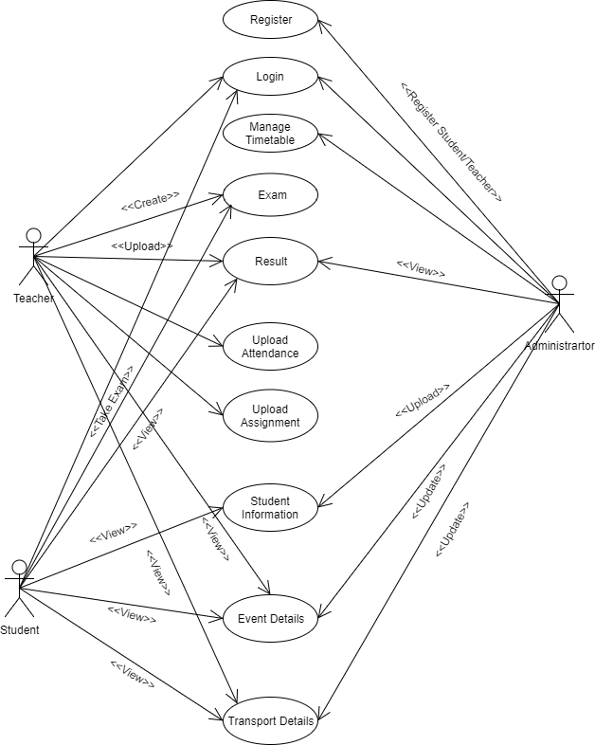

**4.2 Sequence Diagram**

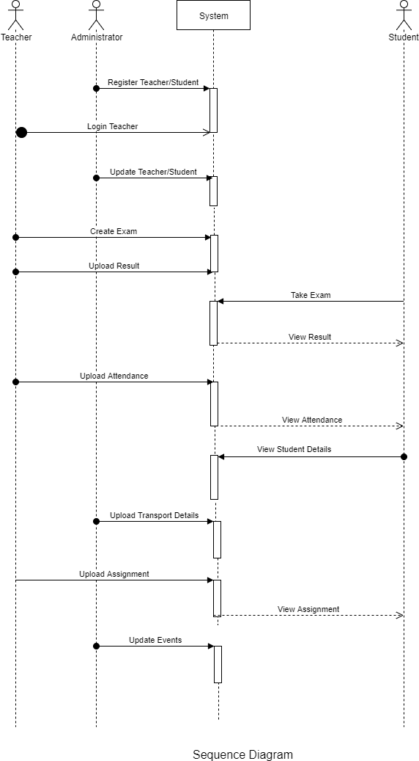

**4.3 Component diagram**

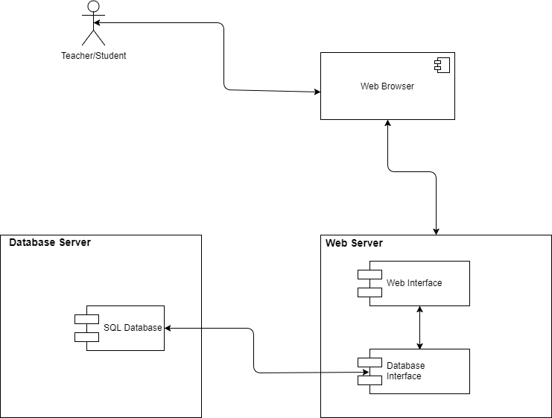

**4.4 ER Diagram**

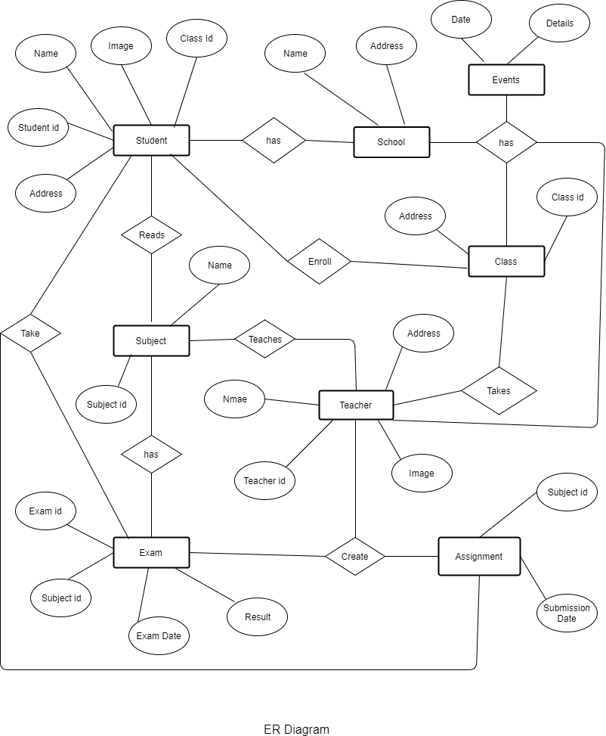

**4.5 Activity Diagram**

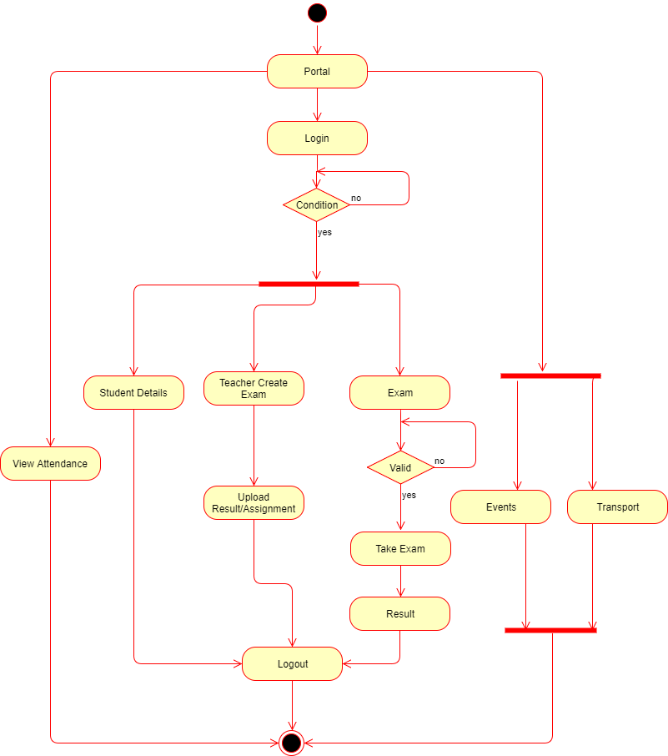

**4.6 Architecture Diagram**

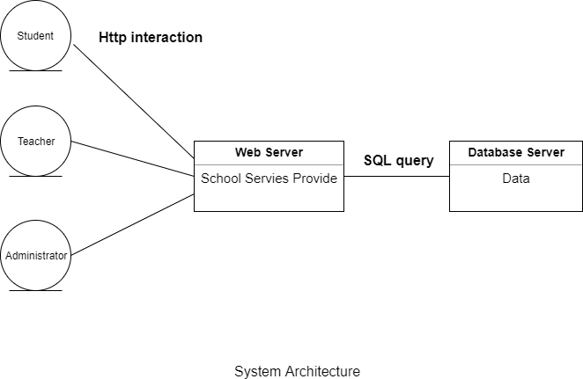

# Other Requirements

* Gmail and Facebook verification and login
* Chat support.

# Glossary

|  |  |  |
| --- | --- | --- |
| **S.No.** | **Abbreviations** | **Full Forms** |
| 1. | HTML | Hyper Text Markup Language |
| 2*.* | CSS | Cascading Style Sheet |
| 3. | JS | Java Script |
| 4. | SQL | Structured Query Language |
| 5. | ER Diagram | Entity Relationship Diagram |
| 6. | SRS | Software Requirement Specification |
| 7. | HTTP | Hyper Text Transfer Protocol |

# References

Following website visited were:

* [www.w3schools.com](http://www.w3schools.com)
* www.stackoverflow.com
* [www.idsPrime.com](http://www.idsprime.com)
* https //www.wikipedia.org/

# Guide’s Comments