ADD ROLE

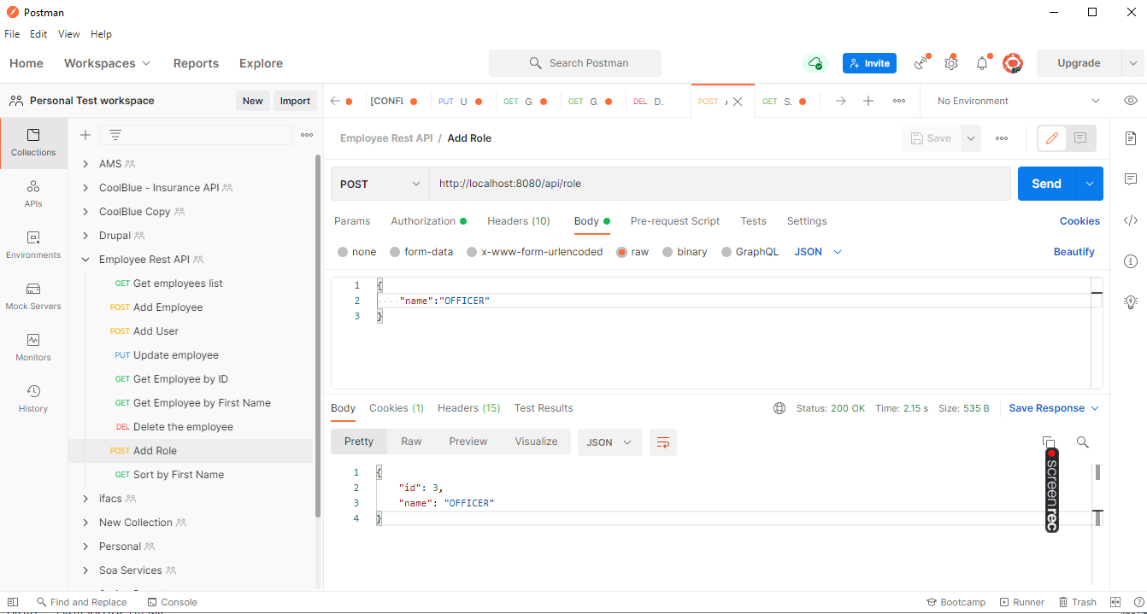

ADD USER

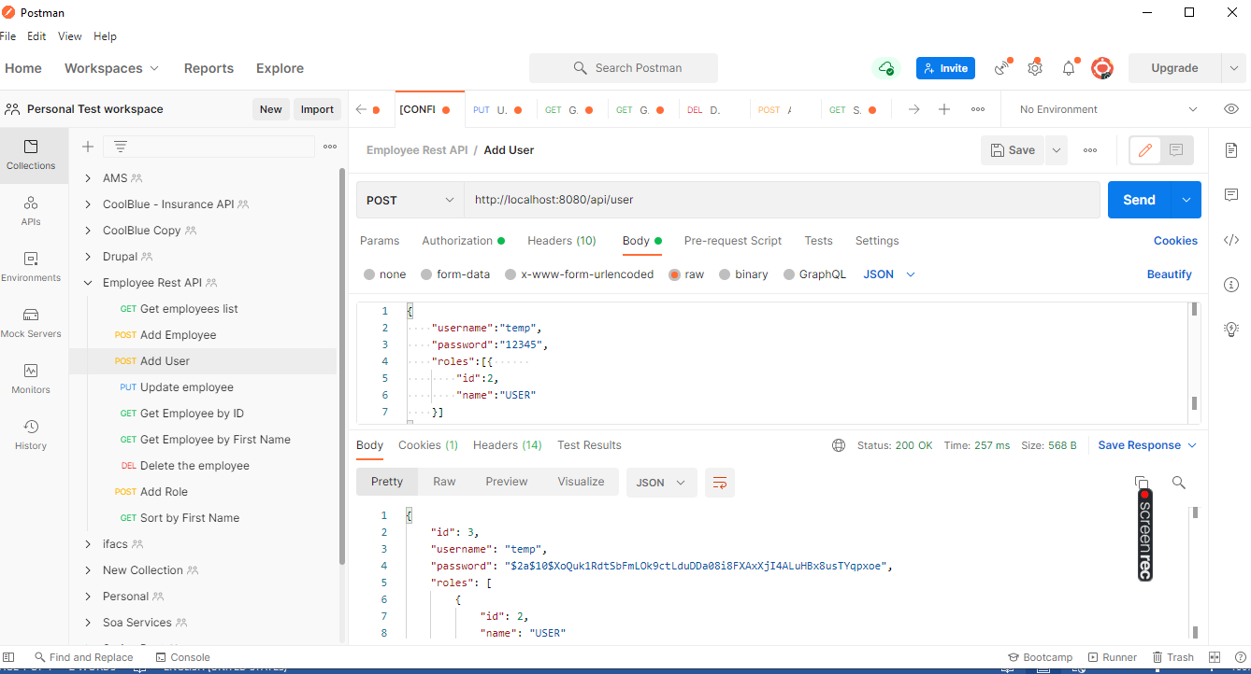

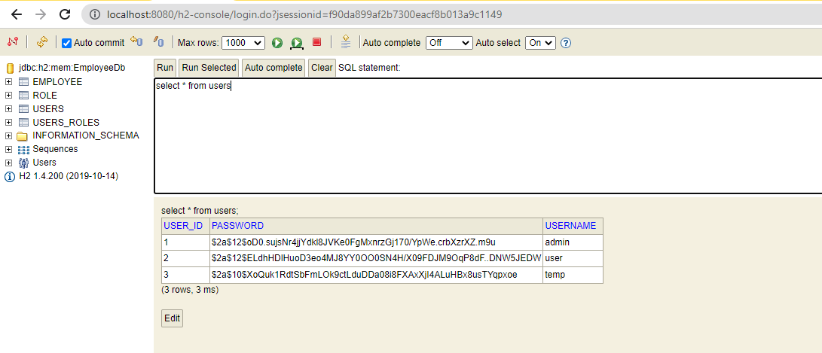

GET EMPLOYEE

1. INITIALLY NO EMPLOYEES

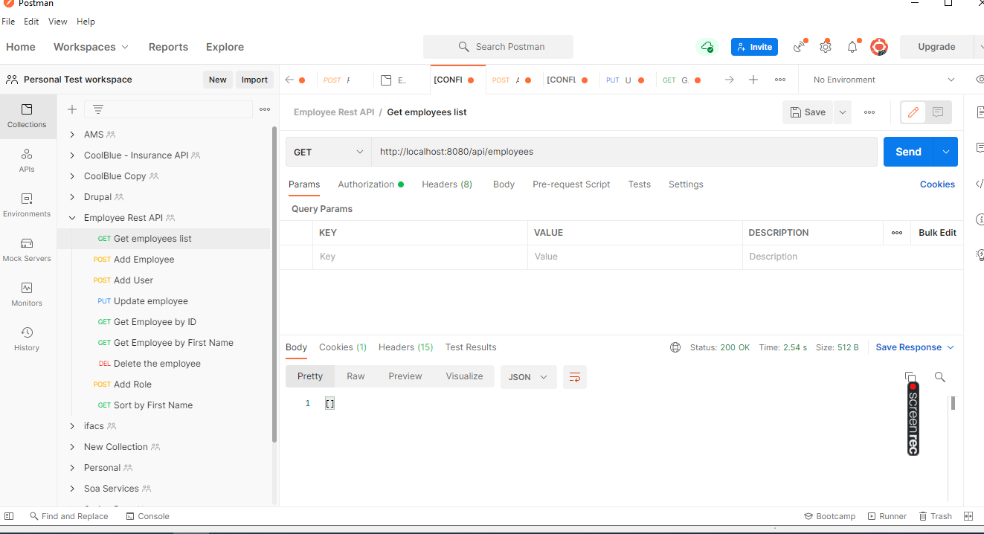

1. AFTER ADDING EMPLOYEES

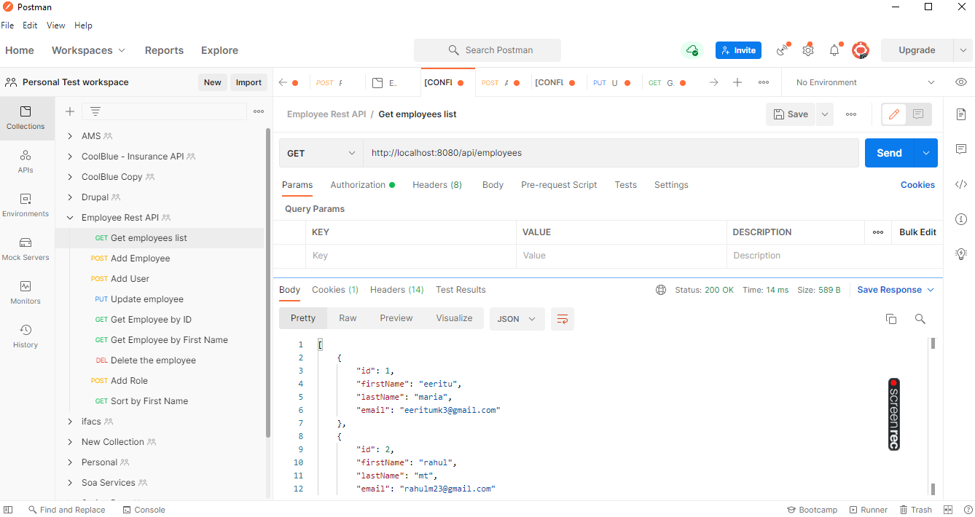

GET EMPLOYEE BY ID

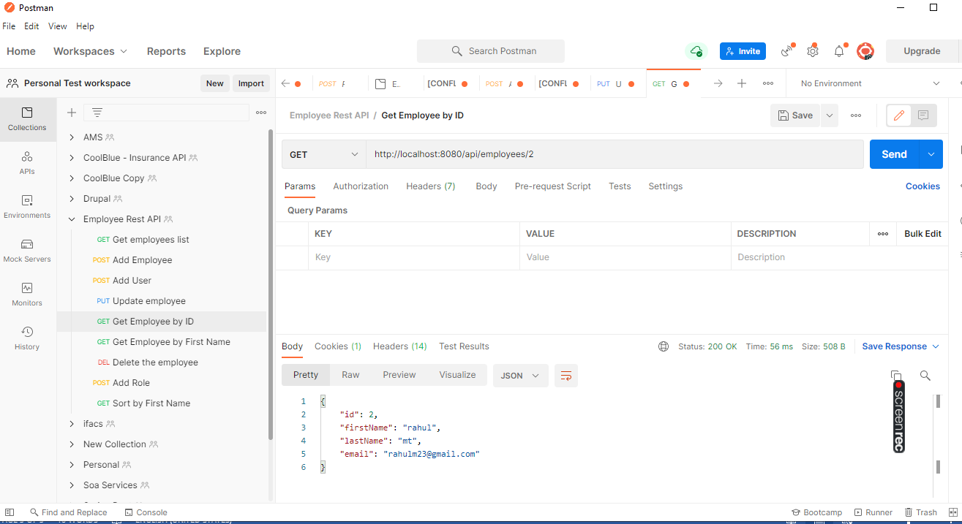

ADD EMPLOYEE

1. WHEN NORMAL USER TRIES TO ADD, forbidden

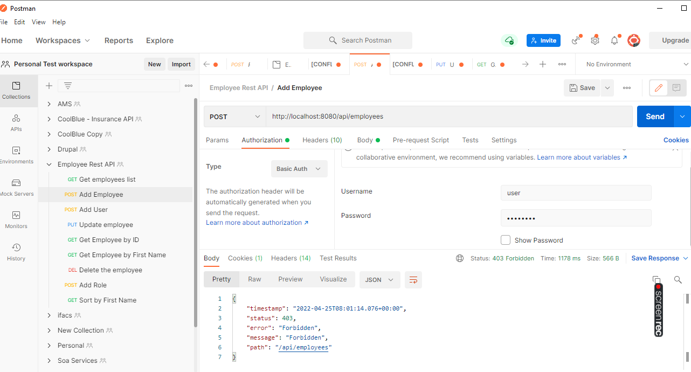

1. When admin tries to add

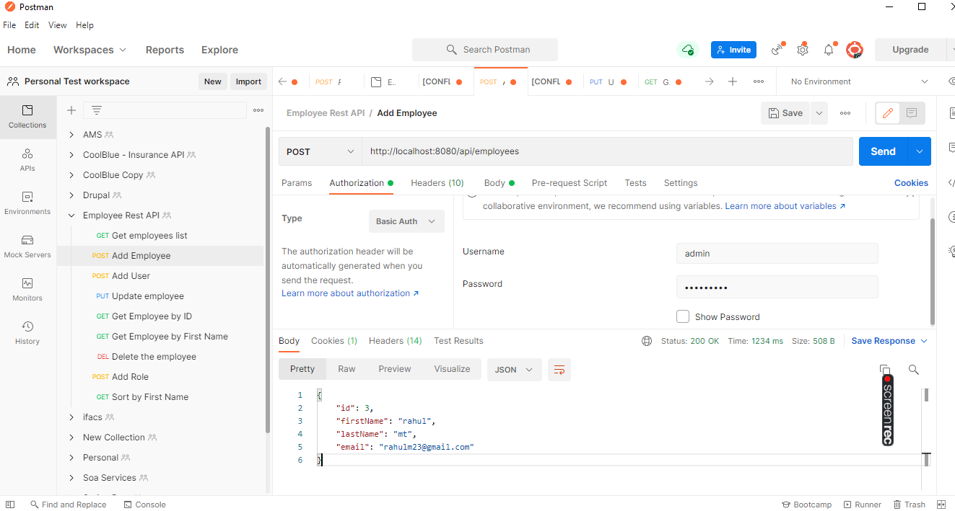

UPDATE EMPLOYEE DETAILS :-

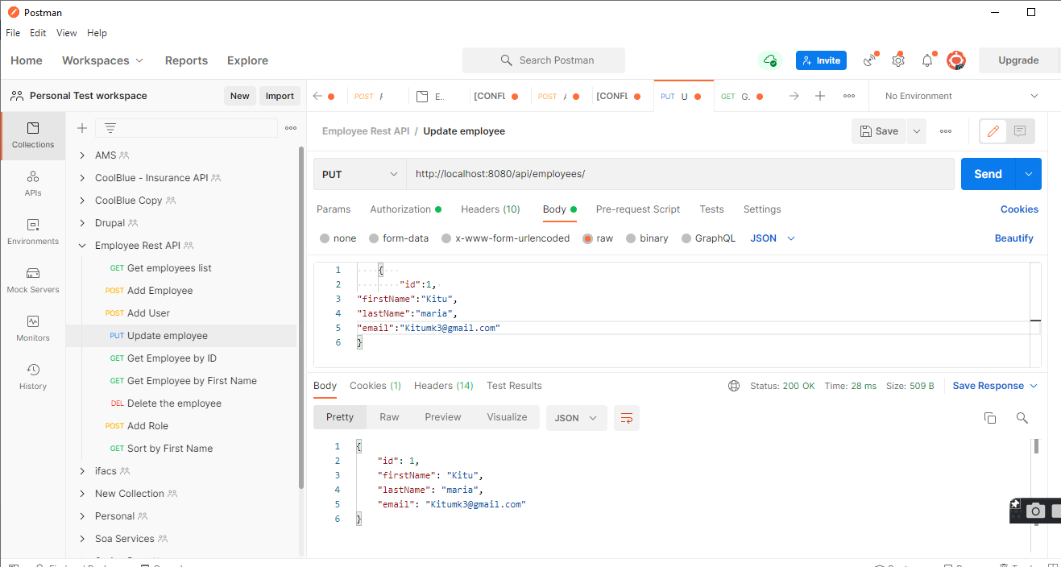

DELETE THE EMPLOYEE

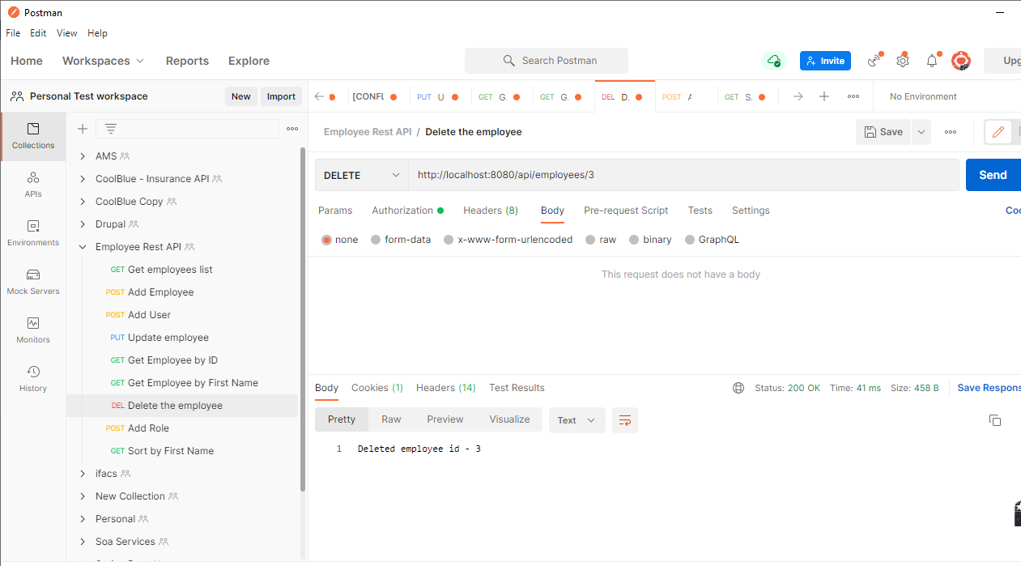

SEARCH FOR A EMPLOYEE

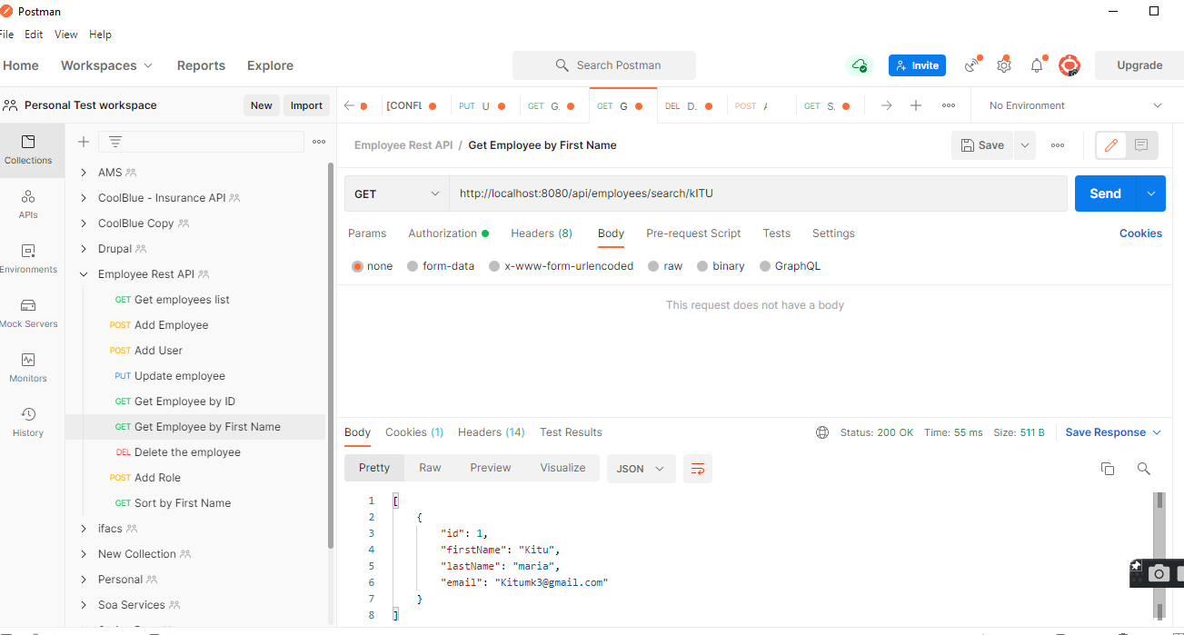

SORT THE EMPLOYEES

1. ASC

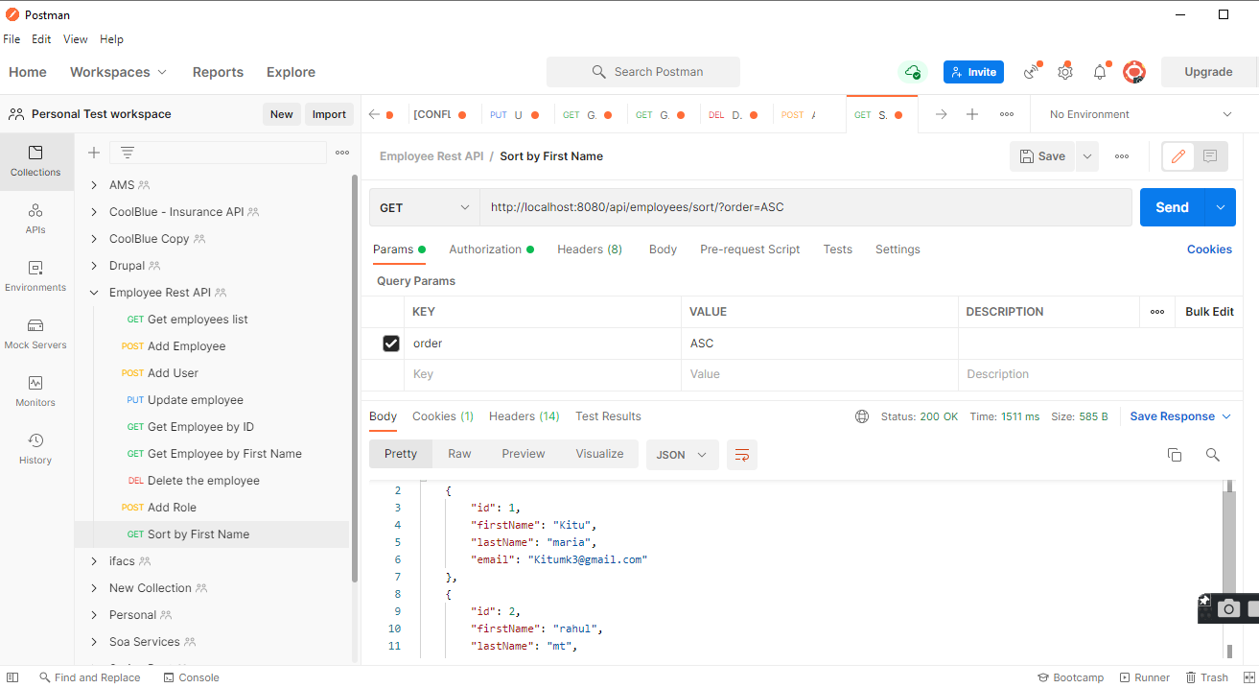

1. DESC

