**Assignment 3**

**Hacker’s Toolkit: Tools, Methods and Countermeasures**

**Chosen Cybercrime:** Phishing Attack

**Abstract**

Phishing remains one of the most effective and pervasive cyber threats because it targets human trust rather than (or in addition to) software vulnerabilities. This report examines phishing from both attacker and defender perspectives. Part 1 explains the attacker's toolkit, techniques, and a detailed fictional scenario that demonstrates the lifecycle of a phishing campaign. Part 2 provides a layered defence—detection, prevention, incident response, and user education—along with recommended tools and policies.

**Part 1: The Cybercriminal’s Perspective**

**1. Introduction**

Phishing attacks exploit social engineering principles to convince victims to reveal sensitive information or install malware. Successful campaigns take advantage of psychological triggers such as urgency, authority, scarcity, and familiarity. Attackers use automated tools and public information to craft convincing messages at scale, making phishing inexpensive and high yield.

**2. Tools & Techniques a Hacker Would Use**

**a. Campaign Frameworks & Automation**

* Tools like **Gophish**, **Social-Engineering Toolkit (SET)**, and custom SMTP scripts automate message personalization, sending, and tracking. Attackers use templates and variable fields (name, last transaction amount) to increase credibility.

**b. Email Header Forgery & Lookalike Domains**

* Techniques include altering email headers (From, Reply-To) and creating **typosquatting** or homograph domains (e.g., xхz-bank.com where х is Cyrillic) to bypass casual inspection.

**c. Website Cloning & Credential Harvesters**

* Utilities such as **HTTrack**, **ZPhisher**, or manual cloning copy login pages. Backend scripts (often PHP/Node.js) capture form inputs and forward victims to the real site to avoid suspicion.

**d. Malicious Attachments and Macro Exploits**

* Office documents with embedded macros or weaponized PDFs can drop malware (keyloggers, remote shells) when opened. Attackers obfuscate macros and host payloads on trusted platforms to evade detection.

**e. Alternative Vectors: Smishing & Vishing**

* SMS and voice phishing add credibility, especially when timed with a genuine service outage or known billing cycle. VoIP and spoofing services let attackers mimic legitimate numbers.

**f. Monetization & OpSec Tools**

* Once credentials are obtained, attackers monetize via direct transfers, gift-card purchases, reshipping scams, or selling data on dark web marketplaces. They use proxy networks, VPNs, and throwaway infrastructure to avoid tracing.

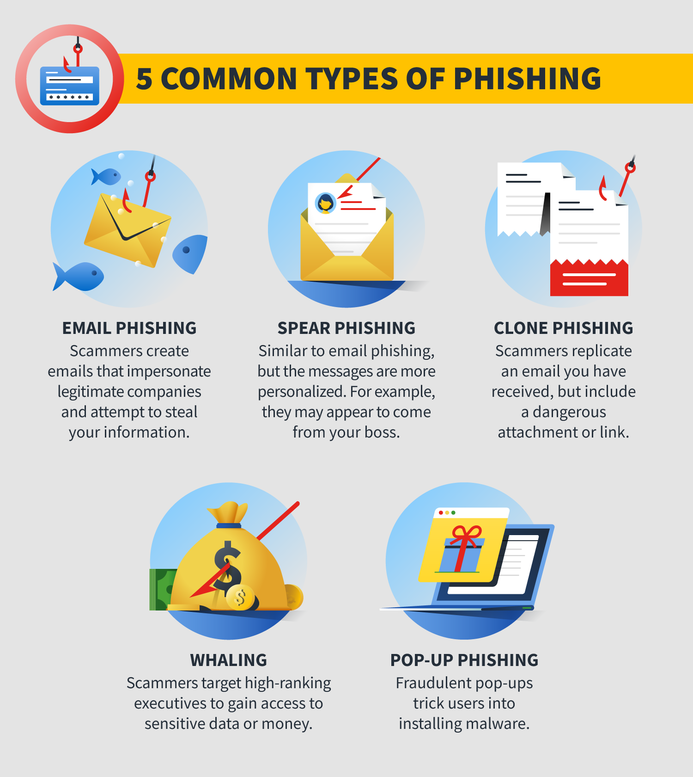

**3. Fictional Scenario — “ShadowFox and the Bank Verification Scam”**

**Actor:** ShadowFox — a motivated adversary with moderate technical skills.

**Target:** Customers of XYZ Bank.

**Objective:** Harvest online banking credentials and perform unauthorized transfers.

**Detailed Attack Steps:**

1. **Reconnaissance:** ShadowFox aggregates potential targets from a combination of data breaches, public forums, and social media. He also downloads the bank’s logos, email styles, and mobile app screenshots to increase realism.
2. **Crafting the Lure:** Using a Gophish template, ShadowFox crafts an email titled "Urgent: Verify Your XYZ Bank Account — Immediate Action Required." The message references a recent login from an unfamiliar location to induce fear and urgency.
3. **Setting Up Infrastructure:** He registers a domain with typosquatting strategy (xyzbank-secure[.]com) and hosts a cloned login page. To avoid immediate blacklisting, he deploys the site behind a CDN and uses HTTPS with a valid certificate.
4. **Deliverability Optimization:** To improve inbox rates, he rents a compromised SMTP relay and uses slight variations in sender names ("XYZ Bank Support" vs "XYZ Customer Care") to bypass filters.
5. **Execution:** The email is delivered to 10,000 recipients. Tracking shows open rates and click-through statistics so ShadowFox can prioritize likely victims.
6. **Deception & Capture:** Victims who click are presented with a login form. On submission, the credentials are recorded, and the user is redirected to the real bank site or to a confirmation page saying, "Your account has been secured," minimizing suspicion.
7. **Post-Exploitation:** ShadowFox tests credentials on low-risk accounts, then moves funds or creates a chain of secondary accounts (money mules) to launder proceeds. He may also use credentials to enrol in further social engineering attacks.

**Key Indicators of Compromise (IoCs):**

* Spike in password reset requests.
* Login attempts from anomalous IP ranges or countries.
* Known lookalike domains registered recently.
* Unusual device fingerprints and session geographic anomalies.

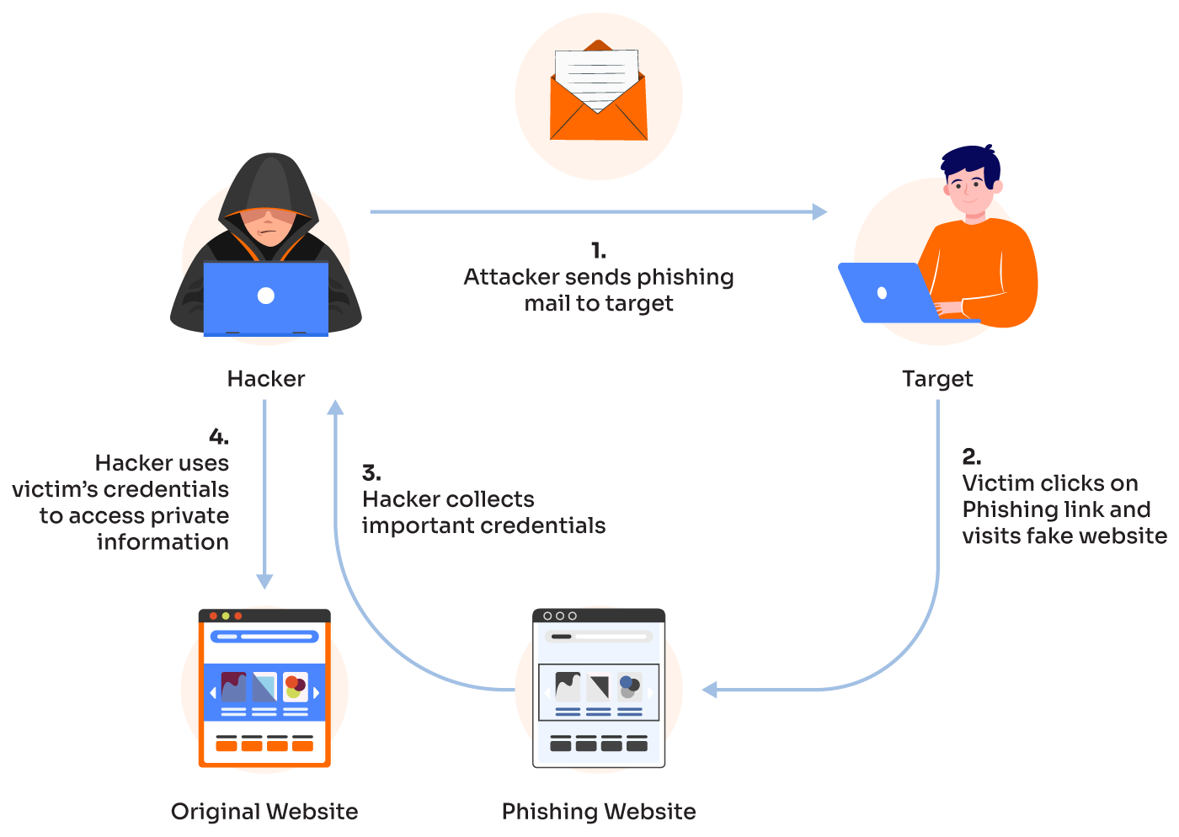

**Part 2: The Cybersecurity Defender’s Role**

**1. Detection Strategies**

**Email Authentication & Gateway Defenses**

* Enforce **SPF, DKIM, and DMARC** with a monitoring phase to identify abused sources and gradually move to strict rejection policies. Use advanced email gateways capable of sandboxing attachments and performing URL rewriting for tracking.

**Behavioral Analytics & Anomaly Detection**

* Implement UEBA to baseline normal user behavior. Correlate unusual login times, device changes, and geolocation shifts to generate high-confidence alerts.

**Threat Hunting & Domain Monitoring**

* Subscribe to threat intelligence feeds to detect newly registered domains and run automated takedown requests for sites used in active phishing campaigns.

**Endpoint & Network Telemetry**

* EDR agents can detect malicious attachments, macro execution, and lateral movement. Network logs may reveal exfiltration channels or unusual DNS queries to typosquatting domains.

**2. Prevention Measures**

**Multi-Factor Authentication (MFA)**

* Adopt strong second factors (hardware tokens or phishing-resistant FIDO2 keys) and avoid SMS-based OTP where possible due to SIM swap risks.

**Comprehensive Employee Training**

* Conduct role-specific training with periodic simulated phishing campaigns. Follow-up coaching for employees who fall for simulations and positive reinforcement for those who report.

**Zero Trust & Least Privilege**

* Apply zero-trust principles: verify every request, limit session durations, and enforce access checks even on internal networks. Privilege separation reduces blast radius.

**Secure Configuration & Hardening**

* Enforce browser hardening, disable unnecessary Office macros by default, deploy web proxies that block access to risky domains, and enable HSTS on corporate sites.

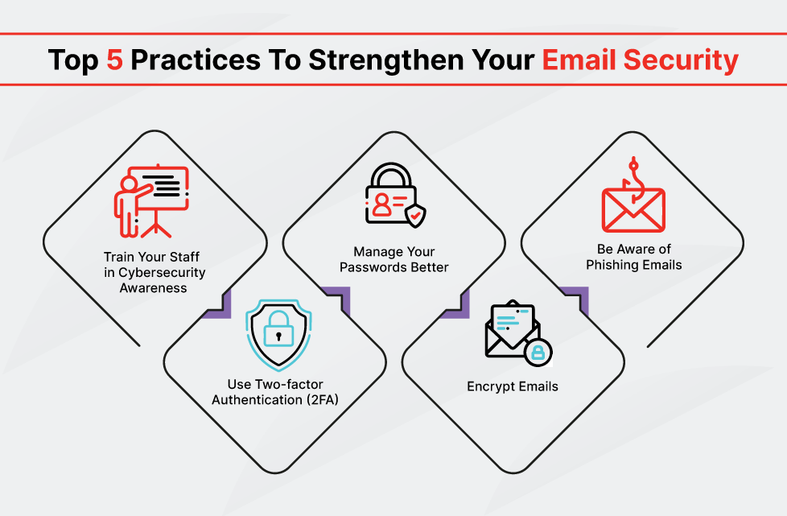

**3. Recommended Tools & Architecture**

* **Email Security:** Microsoft Defender for Office 365 or Proofpoint for URL and attachment sandboxing.
* **DNS Filtering:** Cisco Umbrella and Secure DNS to block malicious domains at resolution time.
* **Identity Protection:** Azure AD Identity Protection, YubiKey for phishing-resistant authentication.
* **EDR & SIEM:** CrowdStrike/Falcon for endpoints and Splunk/Sentinel for centralized logging and correlation.

**4. Incident Response Playbook**

1. **Preparation:** Maintain runbooks, contact lists, and pre-approved legal/takedown templates.
2. **Identification:** Triage user reports, sandbox suspicious attachments, and validate compromised domains.
3. **Containment:** Block malicious domains, push rules to mail servers to quarantine messages, and temporarily suspend affected accounts.
4. **Eradication:** Rotate credentials, remove persistence mechanisms, and restore systems from known-good backups.
5. **Recovery:** Re-enable services, monitor systems for recurrence, and provide affected users with remediation steps.
6. **Post-Incident:** Conduct root-cause analysis, revise training, and publish a lessons-learned report to relevant stakeholders.

**Conclusion**

Phishing combines low-cost automation with human psychology to produce disproportionately high returns for attackers. Defending against it requires a layered, adaptive strategy that mixes technology, process, and people. By enforcing technical controls like DMARC and phishing-resistant MFA, training users through realistic simulations, and maintaining a practiced incident response capability, organizations can reduce successful attacks and limit their impact. Interactive learning tools—posters, drills, and escape rooms—cement habits that technology alone cannot provide.