**PROJECT PROPOSAL**

**ON**

**AI FASHION STYLIST**

Submitted By:  
Helly Khambhatwala  
Enrollment No: 1AUA22BCS018

Ritu Pal  
Enrollment No: 1AUA23BCS906

Submitted To:  
Aarti Dadheech  
Professor

Department of Computer Science & Engineering (AI-ML)  
Adani University  
Ahmedabad, Gujarat - 382421

2025

# 1. Introduction

Fashion is a vital form of self-expression, yet many individuals struggle to coordinate clothing and accessories effectively. With the rapid growth of online shopping, users often face decision fatigue when selecting outfits without physical trials. This project, **AI Fashion Stylist – Outfit & Accessory Recommendation System**, aims to solve this challenge by using **computer vision and machine learning** to generate intelligent outfit suggestions.

The system works in a **bidirectional way**: if a user uploads a top, it recommends suitable bottoms and accessories; if a bottom is uploaded, it suggests tops and accessories; and if a full outfit is uploaded, it focuses on recommending accessories. It also incorporates **style and occasion awareness** (e.g., casual, formal, sporty, party) and **color harmony rules** for visually appealing suggestions.

Technically, the project applies **image classification, segmentation, feature extraction, similarity search, multi-label classification, and color analysis**. By combining these methods, the system can deliver personalized, stylish, and context-aware recommendations. With applications in **e-commerce, fashion retail, and personal styling**, this project has the potential to enhance user experience, reduce decision fatigue, and add value for businesses through intelligent fashion assistance.

# 2. Feasibility Study

The feasibility of this project is high due to the following reasons:

* **Need**: Fashion consumers often face decision fatigue when pairing clothes. An AI stylist reduces effort and increases confidence in outfit selection.
* **Significance**: This system can be integrated into e-commerce platforms, personal shopping assistants, and mobile apps, enhancing user satisfaction and driving sales.
* **Technical Feasibility**: Rich datasets like **Polyvore Outfits, DeepFashion2, and Fashion-Gen** are publicly available. Modern GPUs and open-source ML libraries enable efficient training and deployment.
* **Operational Feasibility**: The system can run on moderate hardware and be deployed as a web or mobile application.
* **Economic Feasibility**: Development can be completed using open-source frameworks, reducing costs. The potential ROI for businesses through improved personalization is high.

# 3. Objectives

The proposed project has several key objectives that are designed to ensure the system is comprehensive, practical, and user-friendly. These objectives are outlined as follows:

1. **Clothing Item Identification**: To build a robust recognition system that can accurately classify uploaded images as tops, bottoms, or complete outfits. This includes the detection of attributes such as color, fabric type, and pattern.
2. **Bidirectional Recommendation System**: To design a flexible recommendation engine that works in both directions. If a user uploads a top, the system should suggest compatible bottoms and accessories. Similarly, if a bottom is uploaded, it should suggest tops and accessories. For a full outfit, the system should focus on recommending appropriate accessories to complete the look.
3. **Style and Occasion Awareness**: To integrate contextual intelligence into the recommendation process by classifying items into categories such as casual, formal, sporty, or party wear. The system should adjust its suggestions depending on the selected or inferred occasion.
4. **Color Coordination Module**: To implement a module that can extract dominant colors from uploaded clothing images and recommend harmonious color combinations. This ensures that the recommended outfits not only fit stylistically but also appeal visually.
5. **Accessory Recommendation**: To build a dedicated component capable of suggesting multiple relevant accessories such as shoes, bags, belts, or jewelry using multi-label classification techniques.
6. **User-Centric Design**: To create a web-based interface that allows users to easily upload clothing images, view recommendations, and interact with the system. The interface should be intuitive and provide visual clarity in presenting recommended outfits and accessories.
7. **System Integration**: To integrate all modules – classification, feature extraction, recommendation engine, color matching, and accessory prediction – into a single seamless pipeline.
8. **Evaluation and Performance Metrics**: To evaluate the system using quantitative measures such as classification accuracy, retrieval precision, and top-k recommendation success rates, as well as qualitative feedback from users.

Through these objectives, the project aims not only to develop a technically sound system but also to ensure it addresses real-world challenges faced by fashion consumers and e-commerce platforms.

# 4. Literature Survey

* **Polyvore Outfits Dataset**: Provides curated outfit combinations, widely used in outfit compatibility research. Models like Bi-LSTMs and Siamese networks have been applied for outfit recommendation.
* **DeepFashion and DeepFashion2 Datasets**: Benchmarks for clothing recognition, attribute extraction, and landmark detection. Used extensively for fashion image analysis.
* **Fashion-Gen Dataset**: Offers multimodal (text + image) data, supporting style-aware and description-based recommendations.
* **Research by Han et al. (2017)**: Proposed bidirectional LSTMs for fashion compatibility prediction.
* **Recent Transformer Models**: Vision Transformers (ViT) and CLIP embeddings have been used for learning clothing similarity and generating recommendations.
* **Industry Implementations**: Amazon, Zalando, and Myntra have invested in AI-powered fashion tools for improving personalization.

The survey highlights that while research exists on outfit compatibility, fewer systems provide **bidirectional recommendations (top ↔ bottom)** with **style and occasion awareness**, leaving scope for innovation.

# 5. Proposed Methodology and Planning of Work

**5.1 Methodology**

The methodology for the AI Fashion Stylist project is structured into multiple stages:

1. **Dataset Preparation**: Collect Polyvore, DeepFashion2, and Fashion-Gen datasets; preprocess images; label attributes (type, color, style, occasion).
2. **Clothing Recognition**: Train models (CNN, ViT) to classify items as top, bottom, or outfit; use segmentation to isolate clothing.
3. **Feature Extraction & Embeddings**: Generate embeddings using pretrained networks (ResNet, EfficientNet, ViT) for similarity search.
4. **Bidirectional Recommendation**: Build recommendation engine that works both ways:
   * Top → suggest bottoms & accessories
   * Bottom → suggest tops & accessories
   * Outfit → suggest accessories
5. **Accessory Recommendation**: Multi-label classification for predicting shoes, bags, jewelry, etc.
6. **Color Matching Module**: Extract dominant colors (K-means clustering in RGB/HSV) and apply color harmony rules.
7. **Style & Occasion Awareness**: Classify items into casual, formal, sporty, party; filter recommendations accordingly.
8. **Integration & Deployment**: Combine modules into a single pipeline; deploy as a web app with user-friendly interface.

**5.2 Flowchart**

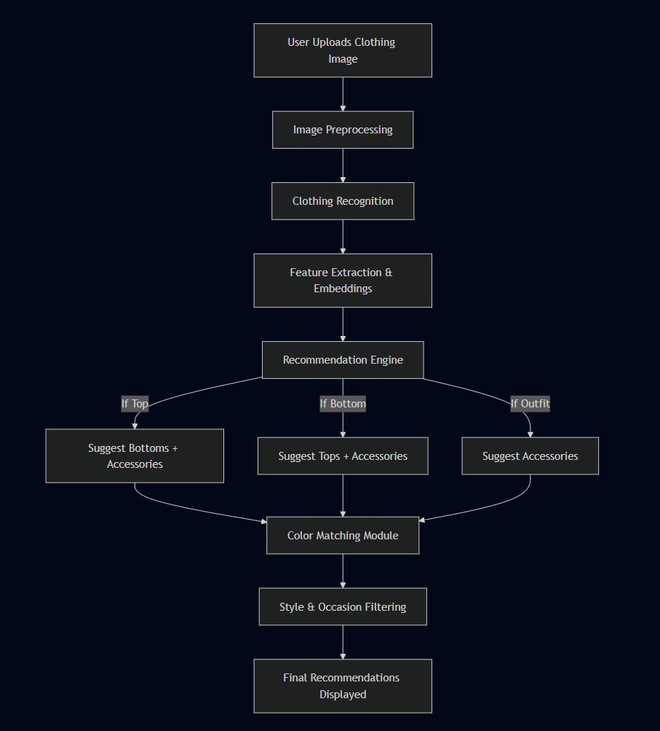

**5.3 Data Flow Diagram (DFD)**

**Level 0 DFD:**

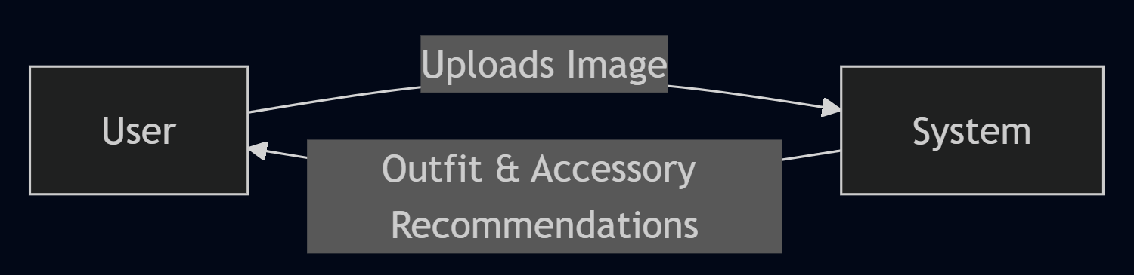

**Level 1 DFD:**

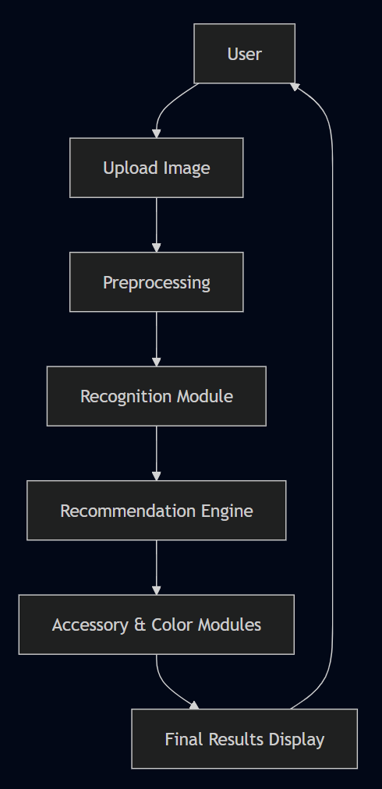

**5.4 Steps to Achieve Objectives**

1. Define scope and gather datasets
2. Preprocess and label data
3. Train classification and recognition models
4. Develop recommendation engine with embeddings
5. Implement accessory prediction module
6. Add color harmony and occasion-awareness modules
7. Integrate all components into one pipeline
8. Build frontend for image upload and result display
9. Test performance and refine system

**5.5 Interpretation of Results**

* **Classification Accuracy**: Measures recognition of clothing types
* **Top-K Recommendation Success**: Evaluates if expected items appear in top results
* **Accessory Precision**: Accuracy of predicted accessories
* **Color Harmony Satisfaction**: User feedback on suggested color combinations
* **User Evaluation**: Collect satisfaction scores and feedback for relevance

A successful system will demonstrate high classification accuracy, relevant top-k recommendations, correct accessory predictions, and positive user satisfaction, proving its real-world applicability in fashion personalization.

# 6. Hardware and Software Requirements

**Hardware Requirements:**

* GPU-enabled system (NVIDIA GTX/RTX recommended)
* 16 GB RAM minimum
* 500 GB+ storage
* Processor: Intel i7 / AMD Ryzen equivalent

**Software Requirements:**

* OS: Windows/Linux/MacOS
* Python 3.10+
* PyTorch or TensorFlow
* OpenCV, scikit-learn, FAISS
* Flask/React/Streamlit for frontend
* MongoDB/PostgreSQL for dataset storage

# 7. Bibliography / References

1. Han, Xintong, et al. "Learning fashion compatibility with bidirectional LSTMs." *Proceedings of the 2017 ACM on Multimedia Conference*, 2017.
2. Liu, Ziwei, et al. "DeepFashion2: A versatile benchmark for detection, pose estimation, segmentation and re-identification of clothing images." *IEEE/CVF Conference on Computer Vision and Pattern Recognition (CVPR)*, 2019.
3. Polyvore Outfits Dataset. Available at: <https://github.com/minhnhat93/Polyvore-Dataset>
4. DeepFashion2 Dataset. Available at: <https://github.com/switchablenorms/DeepFashion2>
5. Fashion-Gen Dataset. Available at: <https://fashion-gen.com/>
6. Radford, Alec, et al. "Learning transferable visual models from natural language supervision (CLIP)." *International Conference on Machine Learning (ICML)*, 2021.
7. Washington Post. "How designers used AI at New York Fashion Week." 2025. Available at: <https://www.washingtonpost.com/style/fashion/2025/09/20/artificial-intelligence-nyfw-ai/>
8. Vogue Business. "Gen Z is using ChatGPT as their stylist. What does it mean for brands?" 2025. Available at: <https://www.voguebusiness.com/story/technology/gen-z-is-using-chatgpt-as-their-stylist-what-does-it-mean-for-brands>