Created table and loaded data into it:

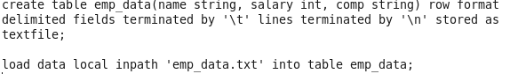

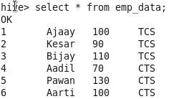

1. Get a list of employees who receive a salary less than 100, compared to their immediate employee with higher salary in the same unit.

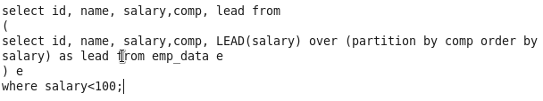

Output:



1. List of all employees who draw higher salary than the average salary of that department.

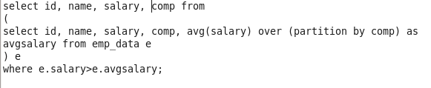

Output:

