Qs: Write a hive UDF that implements functionality of string concat_ws(string SEP, array<string>).

This UDF will accept two arguments, one string and one array of string.

It will return a single string where all the elements of the array are separated by the SEP.

UDF:

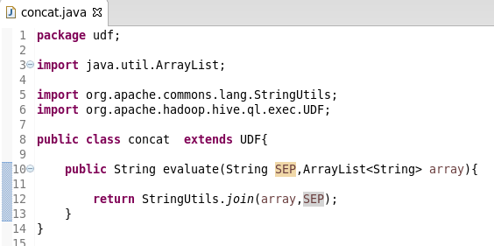

Creating & loading table:

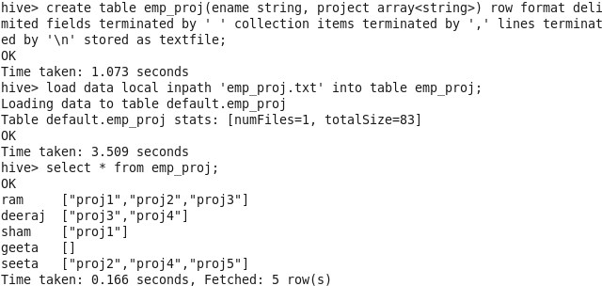

Concat the project arrays by “|” but it separated by the “SEP”:

