Hoe to change react port and DB port

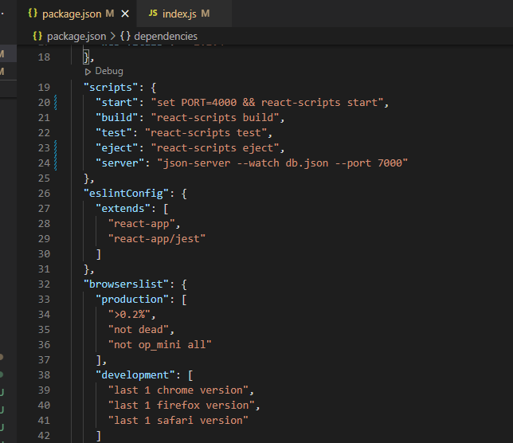

How to install particular version of react package

<https://stackoverflow.com/questions/49828493/upgrading-react-version-and-its-dependencies-by-reading-package-json>

