IIT JAMMU SUMMER SCHOOL 2026
IoT & Embedded Systems Program

ASSIGNMENT QUESTION BANK
IoT Programming, GitHub Integration &
Hands-On Project Challenges

Course | Internet of Things – Hands-On Learning
Total Assignments | 5 Modules | 50 Questions | 100 Marks
Submission Mode | GitHub Repository + PDF Report

Note to Students: Upload ALL code to GitHub. Submissions without a GitHub link will NOT be evaluated.
Make sure to attach a screenshot of your TInkerCad / Wokwi diagram and Serial Monitor Output with each question.
Get a chance to work with us at Techible and gain hands-on exposure and a letter of recommendation for your future. Additional support will be provided to overachievers

Table of Contents

Module 1 | GitHub Setup & Version Control | 3
Module 2 | IoT Fundamentals & Arduino Programming | 5
Module 3 | Sensors, Actuators & Data Acquisition | 8
Module 4 | Wireless Communication & Protocols | 11
Module 5 | Advanced IoT Projects & Problem Statements | 14
Appendix A | GitHub Submission Checklist | 18
Appendix B | Grading Rubric | 19

Module 1: GitHub Setup & Version Control
Weightage: 20 Marks | Questions: Q1–Q10

Learning Objectives
- Master GitHub repository management for IoT
- Implement Git version control for embedded C++ code
- Create professional project documentation

Section A: Short Answer Questions (2 marks each)

Q1. GitHub Repository Creation
Create a GitHub account and set up a new public repository named iot-summer-school-2026. Your repository must include:
- A README.md with your name, roll number, and a 3-line project description
- A folder structure: /week1, /week2, /week3, /final-project
- A .gitignore file configured for Arduino/C++ projects
- An appropriate open-source license (e.g., MIT)
Deliverable: Paste your GitHub repository URL in the submission form.
GitHub Repo Link: https://github.com/rituraj-64/iot-summer-school-2026
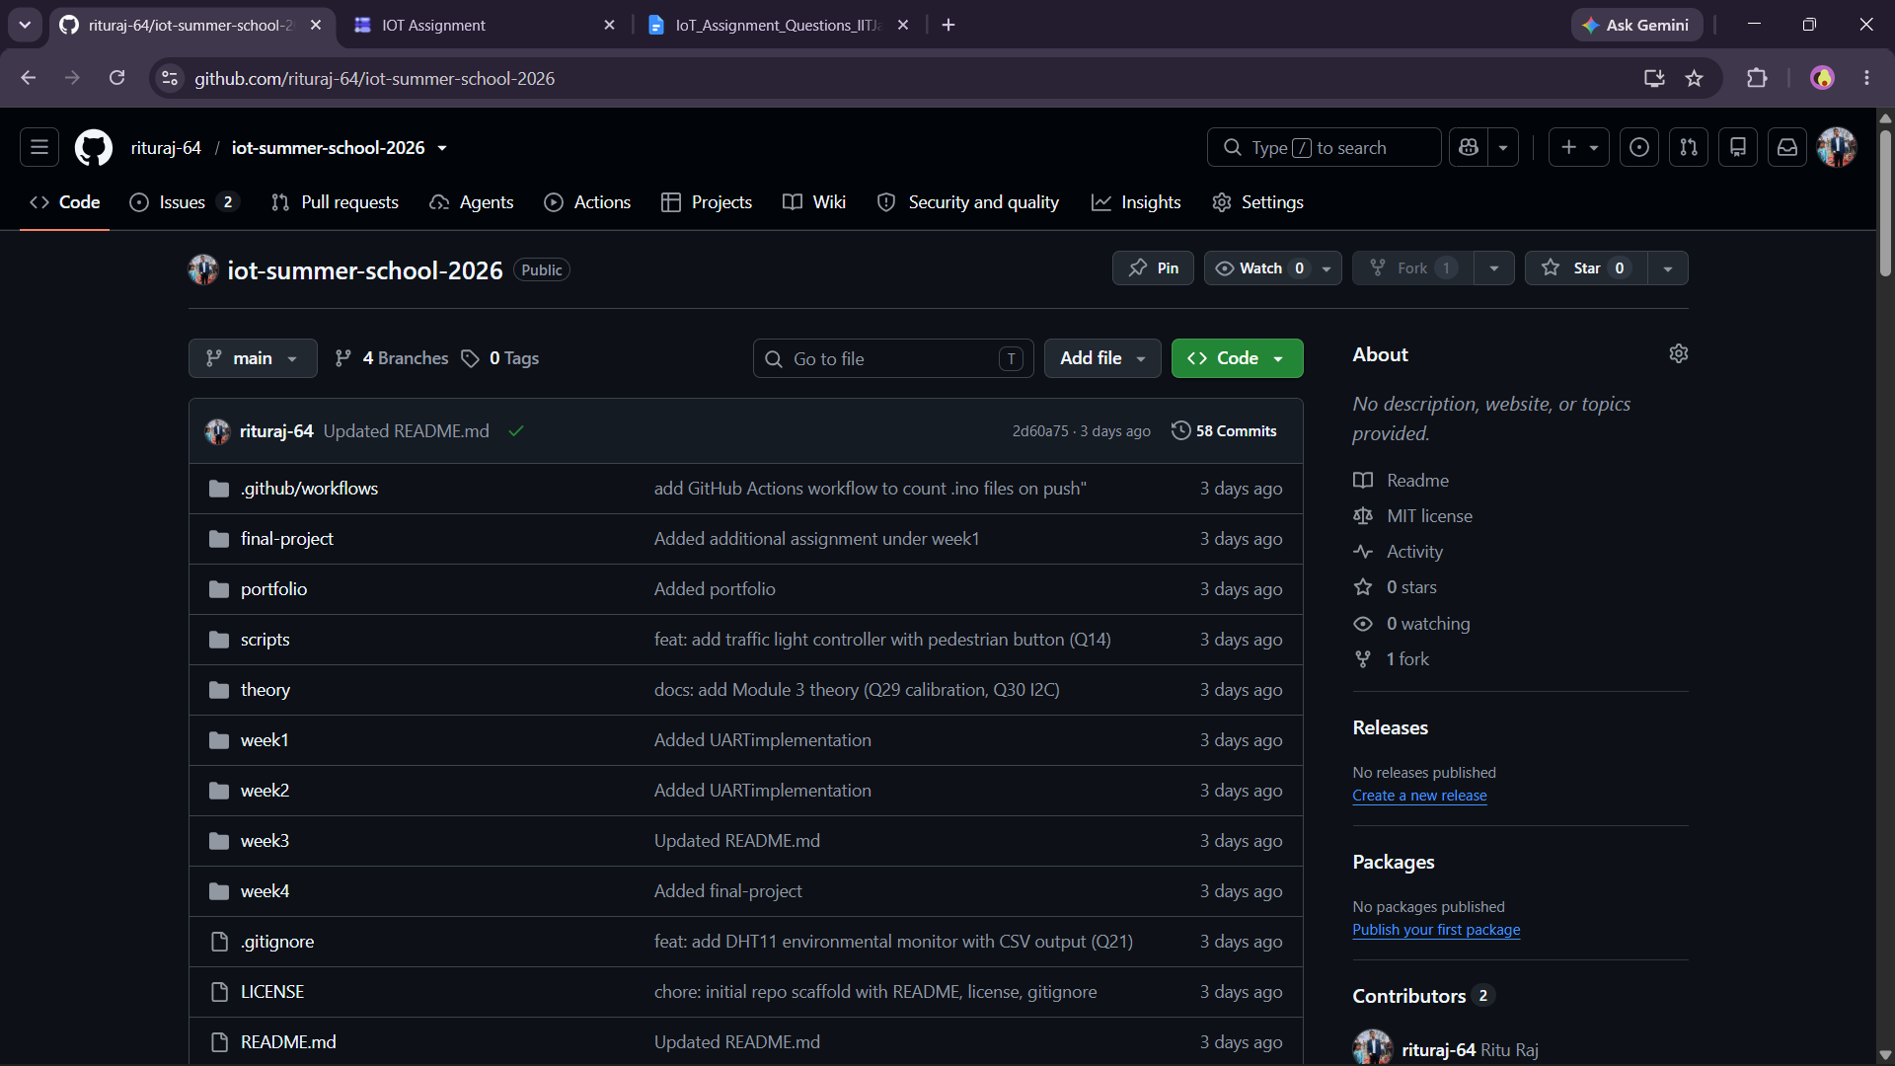

Q2. Git Workflow – Push Your First Code
Upload the following LED blink sketch to your repository under /week1/led_blink/:

void setup() {
pinMode(13, OUTPUT);
}
void loop() {
digitalWrite(13, HIGH);
delay(1000);
digitalWrite(13, LOW);
delay(1000);
}
Commit this file with a meaningful commit message (e.g., feat: add LED blink starter code). Screenshot your commit history and upload it.

Commit History: https://github.com/rituraj-64/iot-summer-school-2026/commit/98045bd6ca6d3e9fe88f8a181c662b89827d1dae
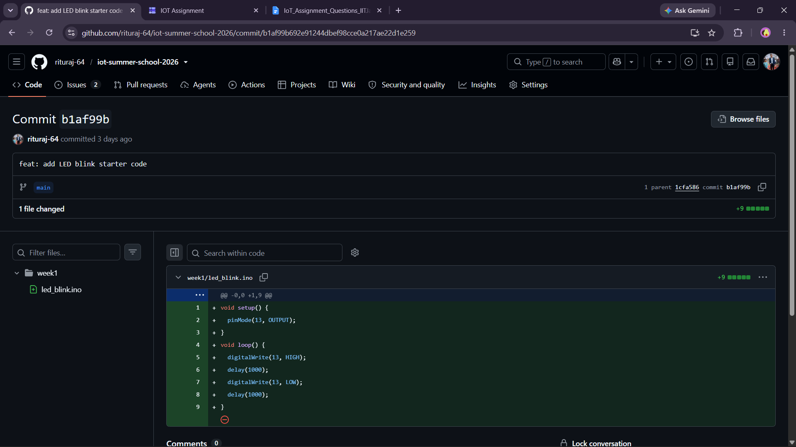

Q3. Branching Strategy
In your repository, create three branches named: dev, sensor-module, and wireless-module. In the dev branch, add a file notes.md describing what each branch will contain. Merge dev into main and show the merge commit in your submission.
Merge commit link: https://github.com/rituraj-64/iot-summer-school-2026/commit/15c81a373f9293ba3ba894469bf960c496a372e3
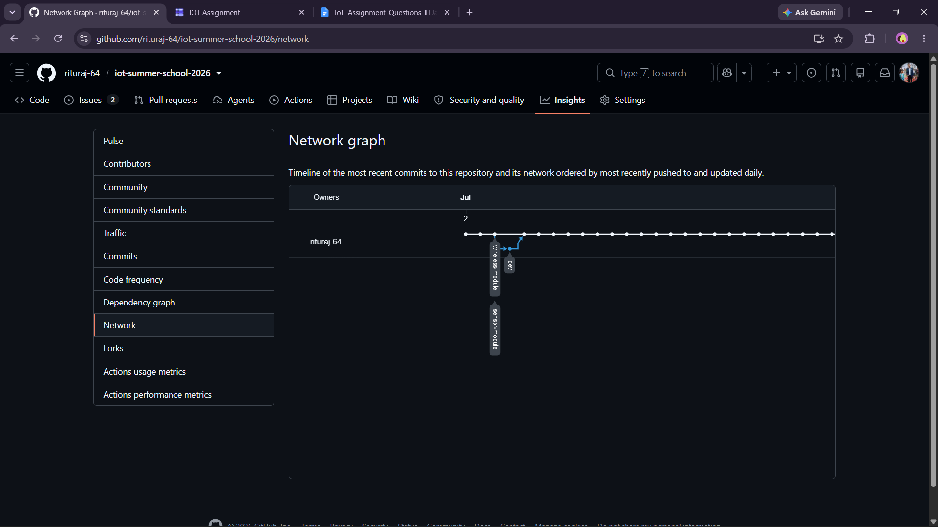
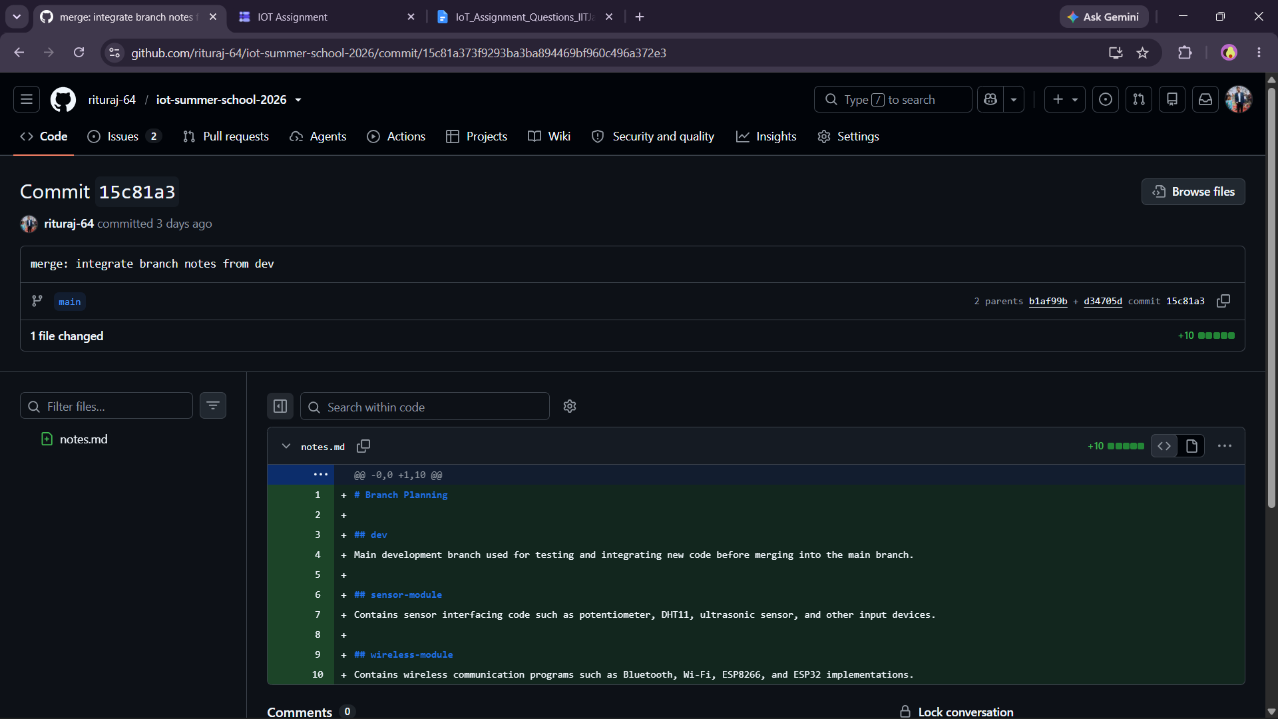

Section B: Practical Tasks (4 marks each)

Q4. Versioned Code – Multiple Commits
Starting from your LED blink code (Q2), progressively improve it across 4 Git commits:
- v1.0 – Basic LED blink (500ms interval)
- v1.1 – Add serial print: Blink count: X
- v1.2 – Read a potentiometer to control blink speed
- v1.3 – Add a comment header block with author name, date, and description
Each commit must have a descriptive message following the conventional commits format (feat:, fix:, docs:, chore:).

Commit History: https://github.com/rituraj-64/iot-summer-school-2026/commits/main/week1/led_blink/led_blink.ino
Code:
/*
* Project: LED Blink - Potentiometer Controlled (non-blocking)
* File: led_blink.ino
* Author: Ritu Raj (Roll: 25BEC064)
* Date: 2026-07-02
* Description: Blinks the on-board LED (pin 13). A potentiometer on A0 sets the
* blink interval (100-1000 ms), sampled every loop so the speed
* responds instantly. Blink count printed to the Serial Monitor.
* Board: Arduino UNO
*/
const uint8_t LED_PIN = 13; // on-board LED
const uint8_t POT_PIN = A0; // potentiometer wiper
unsigned long blinkCount = 0;
unsigned long previousMillis = 0; // last time the LED toggled
int ledState = LOW;
void setup() {
pinMode(LED_PIN, OUTPUT);
Serial.begin(9600);
}
void loop() {
// Sample the pot on EVERY pass so a change is felt immediately.
int potValue = analogRead(POT_PIN);
int interval = map(potValue, 0, 1023, 100, 1000);
unsigned long currentMillis = millis();
if (currentMillis - previousMillis >= (unsigned long)interval) {
previousMillis = currentMillis;
ledState = (ledState == LOW) ? HIGH : LOW; // flip the LED
digitalWrite(LED_PIN, ledState);
if (ledState == HIGH) { // one full blink per ON transition
blinkCount++;
Serial.print("Blink count: ");
Serial.println(blinkCount);
}
}
}
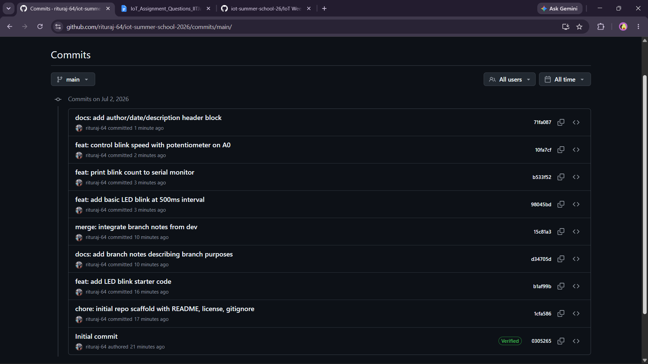
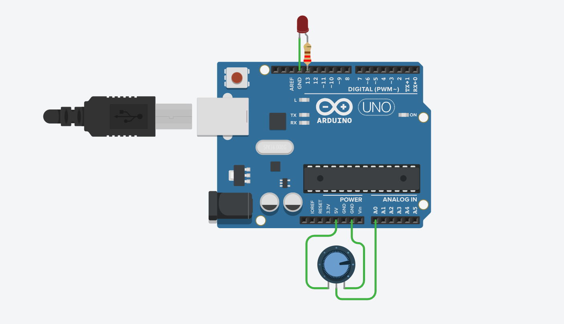

Q5. README Documentation
Write a professional README.md for your /week1/led_blink/ project. The README must include: Project Title, Hardware Required (list of components), Circuit Diagram Description (text-based), How to Upload Code (step-by-step), Expected Output, and Troubleshooting Tips (minimum 3 points).

REAME.md: https://github.com/rituraj-64/iot-summer-school-2026/blob/main/week1/led_blink/README.md
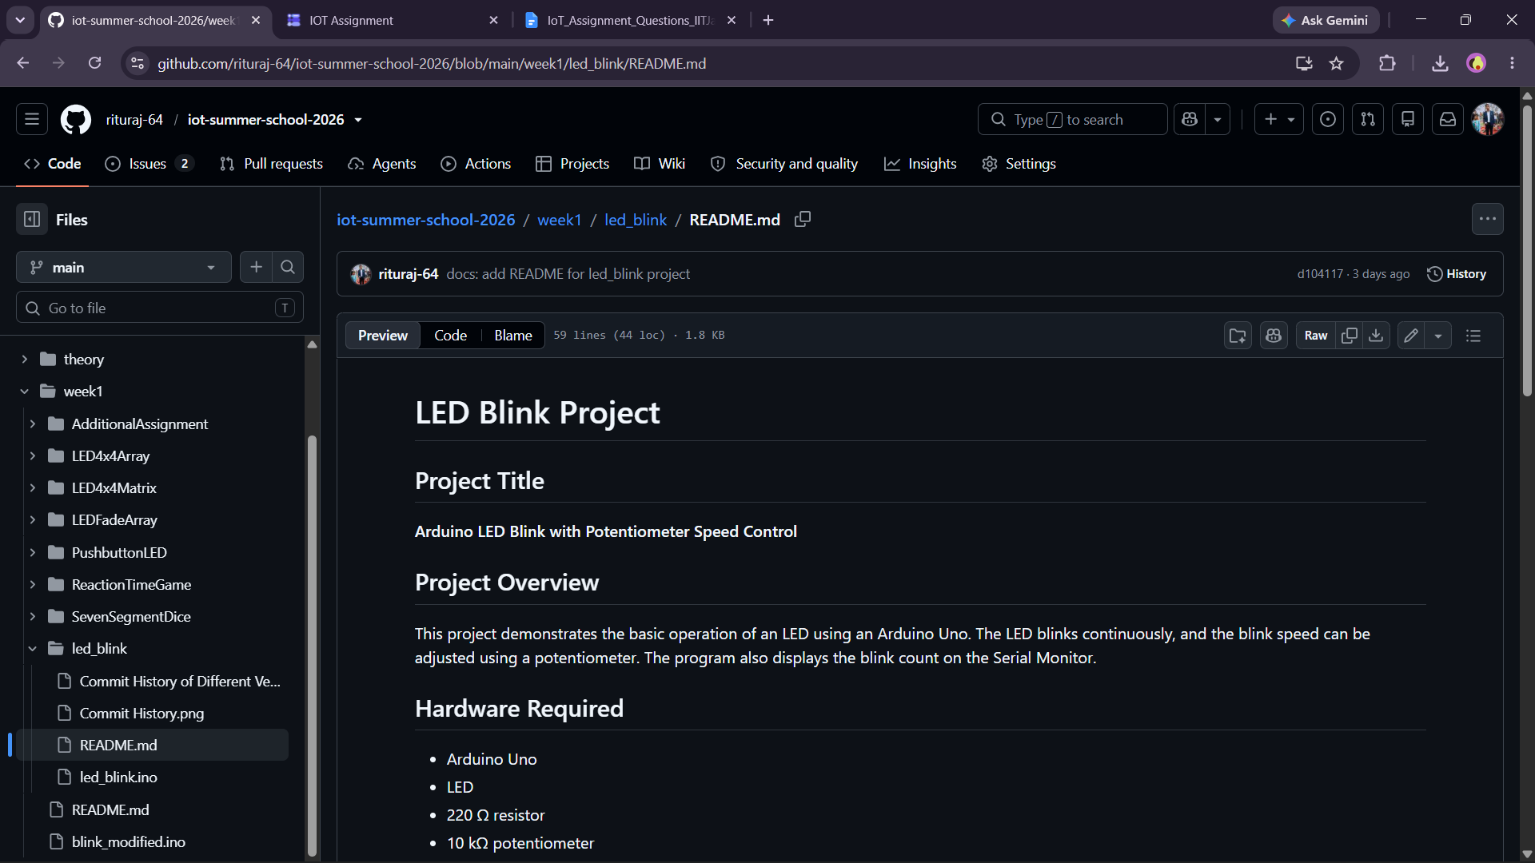

Q6. Issue Tracking & Milestones
Create 3 GitHub Issues in your repository describing hypothetical bugs or features:
- Bug: Blink interval not changing when potentiometer is at maximum
- Feature: Add RGB LED support
- Enhancement: Log data to Serial Monitor in CSV format
Assign each issue to yourself, add appropriate labels, and create a milestone called 'Week 1 Completion'. Close at least one issue with a commit reference (Fixes #1).

Closed issue: https://github.com/rituraj-64/iot-summer-school-2026/issues/1
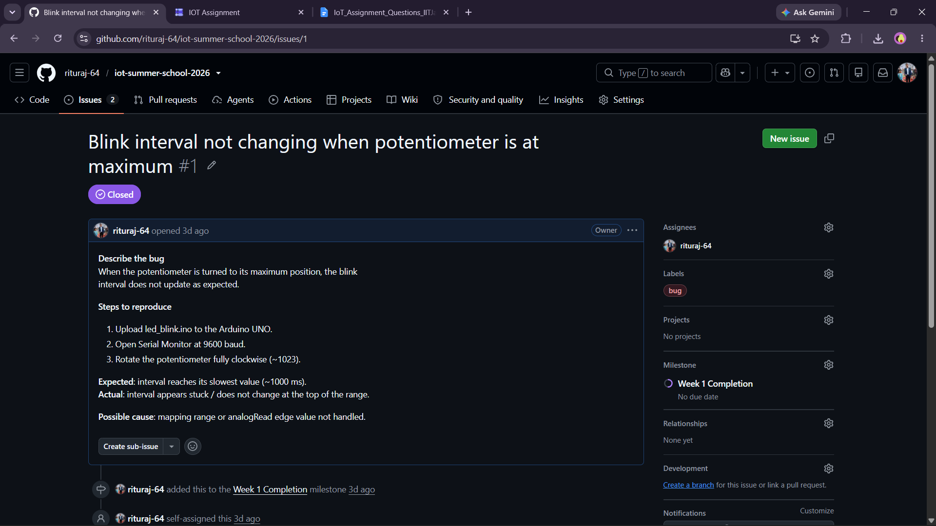
Open issue1: https://github.com/rituraj-64/iot-summer-school-2026/issues/2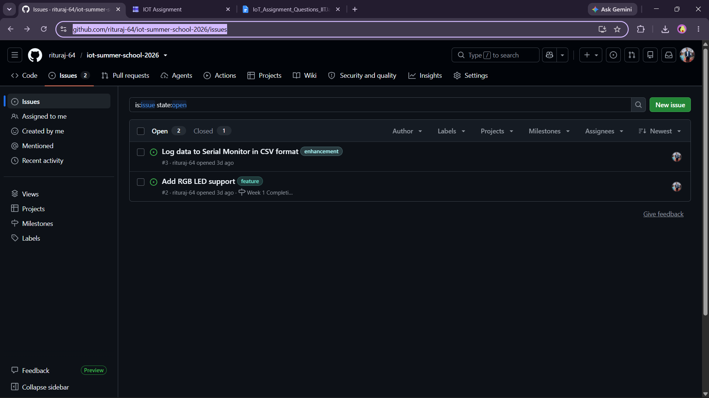

Open issue2: https://github.com/rituraj-64/iot-summer-school-2026/issues/2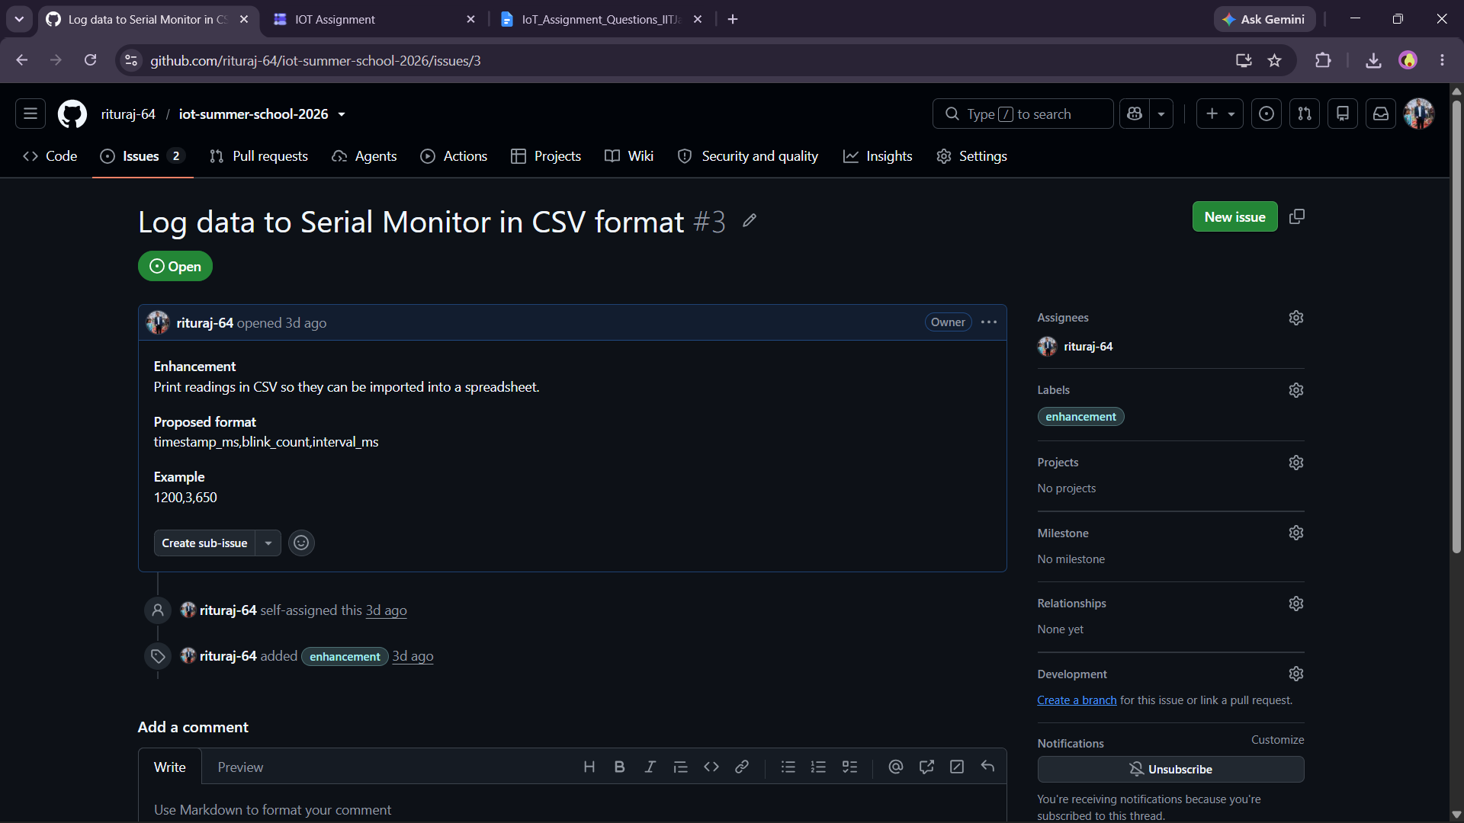

Q7. Collaborative Fork & Pull Request
Fork a partner's iot-summer-school-2026 repository. Add a new file /week1/blink_modified.ino that blinks the LED 3 times fast, then pauses for 2 seconds. Submit a Pull Request to your partner's repository with a proper title and description. Your partner must review and merge your PR.
Deliverable: URL of your Pull Request.

Merged another’s pull request: https://github.com/rituraj-64/iot-summer-school-2026/pull/4
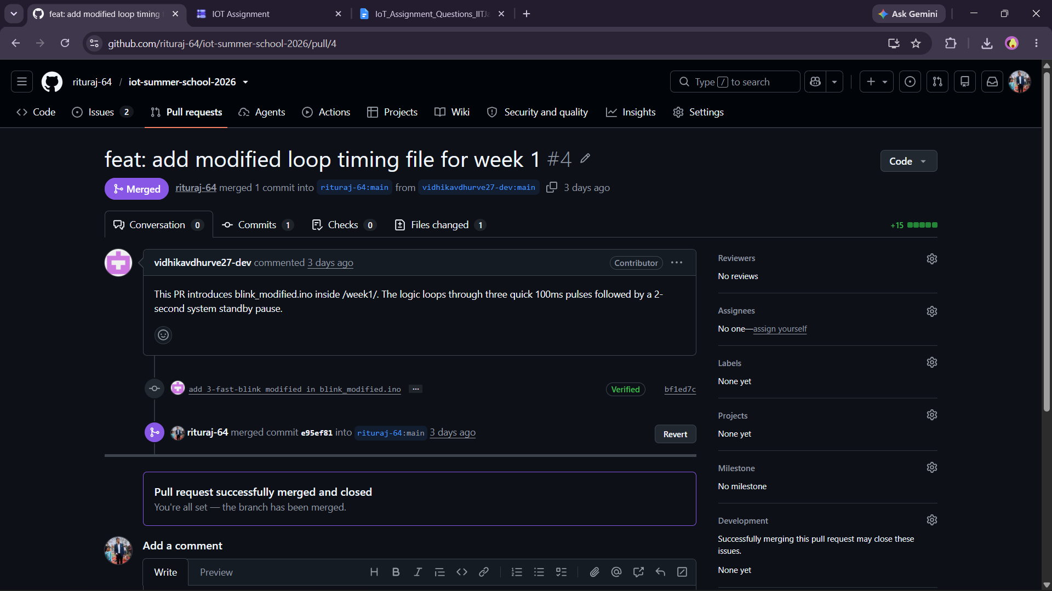

My Pull Request Merged: https://github.com/vidhikavdhurve27-dev/iot-summer-school-2026/pull/5
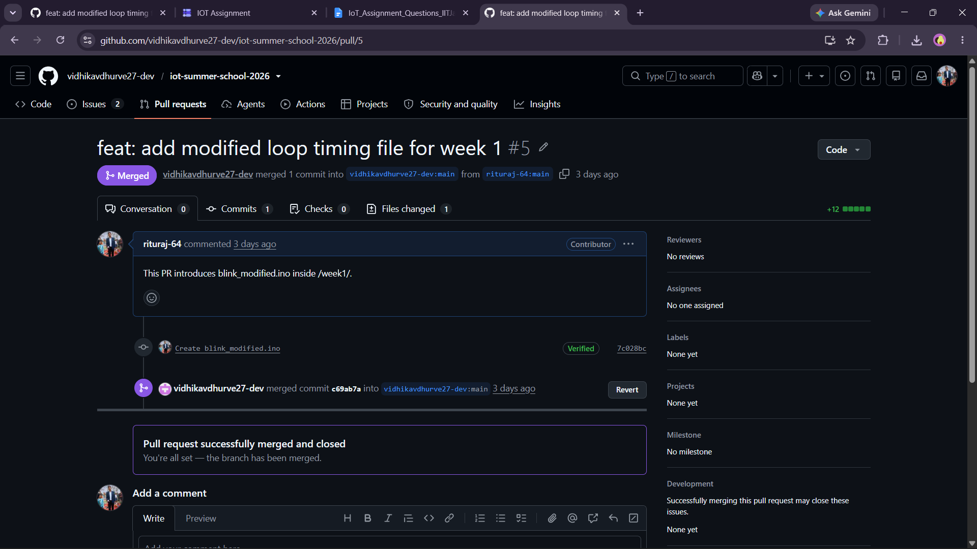

Q8. CI/CD with GitHub Actions (Challenge Question)
Set up a basic GitHub Actions workflow (.github/workflows/lint.yml) that runs a Python script to count the number of .ino files in your repository and prints the count whenever code is pushed. This tests your ability to automate tasks using GitHub Actions.

GitHub Actions workflow: https://github.com/rituraj-64/iot-summer-school-2026/blob/main/.github/workflows/lint.yml
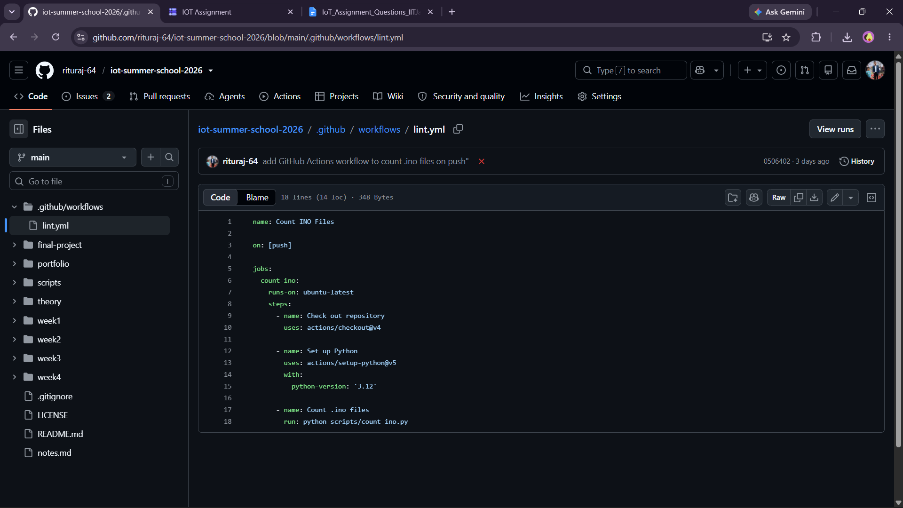

Count_ino.py: https://github.com/rituraj-64/iot-summer-school-2026/blob/main/scripts/count_ino.py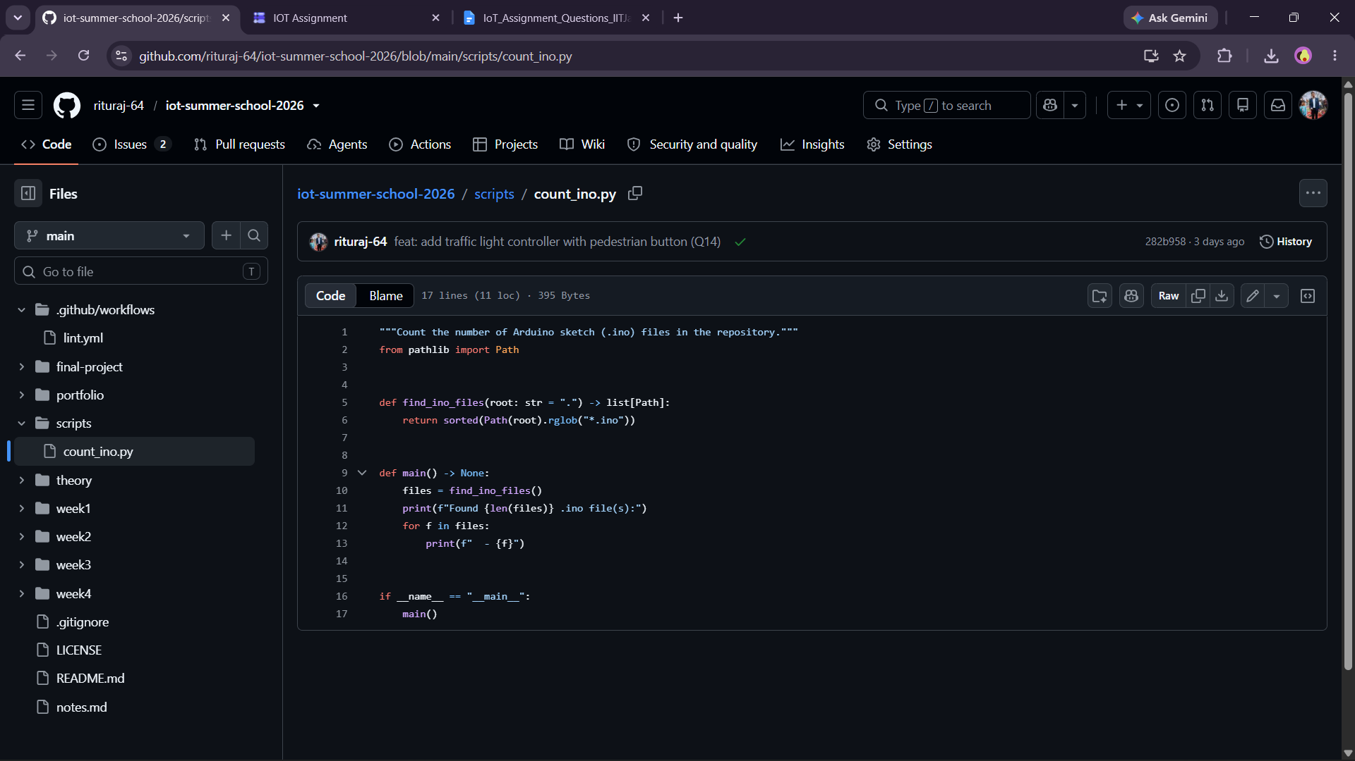
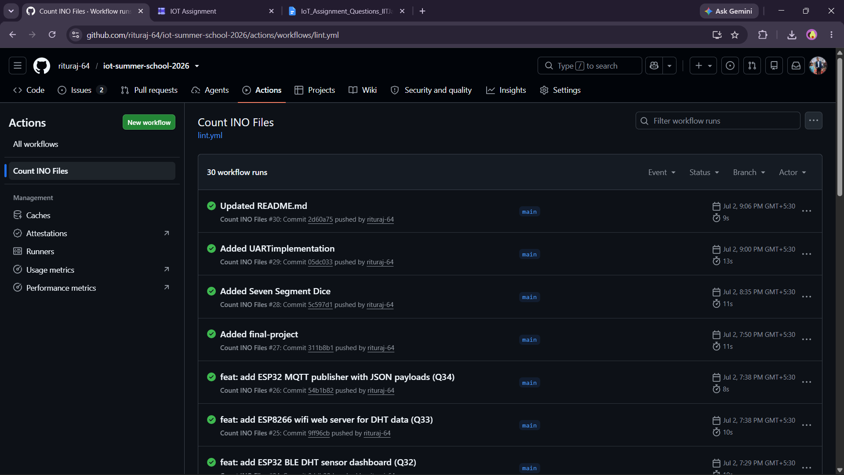

Q9. (Theory) Explain the difference between git pull, git fetch, and git clone. When would you use each? (2 marks)
Answer:
1. git clone
• Creates a complete local copy of a remote Git repository.
• It is used when working with a repository for the first time.
2. git fetch
• Downloads the latest changes from the remote repository without merging them into the current branch.
• It is used when you want to review updates before applying them.
3. git pull
• Downloads the latest changes from the remote repository and automatically merges them into the current branch.
• It is used to keep your local repository up to date with the remote repository.
Summary
• git clone → Copy a repository for the first time.
• git fetch → Check for new changes without merging.
• git pull → Download and merge the latest changes.
Q10. (Theory) What is a .gitignore file? Write a .gitignore for an Arduino project that excludes compiled output files (.hex, .elf), OS-specific files (.DS_Store, Thumbs.db), and IDE config folders (.vscode/, build/). (2 marks)

Answer:
A .gitignore file is a text file used by Git to specify which files and folders should not be tracked or committed to a repository.

It is useful because it prevents unnecessary files (such as compiled binaries, temporary files, OS-generated files, and IDE settings) from being stored in version control.
.gitignore for an Arduino Project
# Compiled output files
*.hex
*.elf

# Build folder
build/

# VS Code configuration
.vscode/

# macOS system files
.DS_Store

# Windows system files
Thumbs.db

Module 2: IoT Fundamentals & Arduino Programming
Marks: 20 | Questions: Q11–Q20 | Type: Code + Explanation

📌 Hardware Required for This Module
- Arduino UNO / Nano / Mega (any one)
- LEDs (Red, Green, Blue), 220Ω resistors, Buzzer
- Push buttons, 10kΩ pull-down resistors
- Breadboard, jumper wires, USB cable

Section A: Conceptual Questions (2 marks each)

Q11. IoT Architecture
Draw and label a 4-layer IoT architecture diagram: Perception Layer, Network Layer, Processing Layer, and Application Layer. Give one example device/technology for each layer. (Hand-drawn photo accepted; upload to GitHub under /theory/)
GitHub link: https://github.com/rituraj-64/iot-summer-school-2026/blob/main/theory/Q11.png
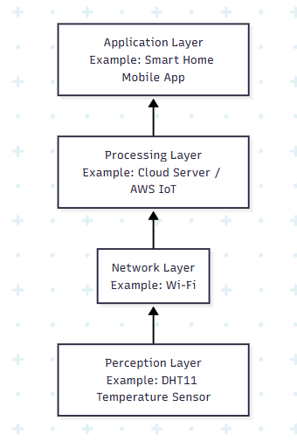

Q12. Microcontroller vs Microprocessor
Fill in the following comparisontable and upload a photo/scan to your GitHub repository:
Parameter | Microcontroller (Arduino UNO) | Microprocessor (Raspberry Pi)
CPU Speed | 16 MHz | 1–2+ GHz (depends on Raspberry Pi model)
On-chip RAM | 2 KB SRAM | Typically 1 GB–8 GB external RAM
On-chip Flash | 32 KB Flash Memory | No on-chip flash; uses a microSD card for storage
Operating System | No operating system  (runs a single program directly) | Runs an operating system such as Raspberry Pi OS (Linux)
Typical Use Case | Embedded systems, sensor interfacing, robotics, IoT control | General-purpose computing, multimedia, AI, IoT gateway, web server
Power Consumption | Low (typically around 50–70 mA at 5 V) | Higher (typically 2–7 W depending on the model and workload)

GitHub link: https://github.com/rituraj-64/iot-summer-school-2026/blob/main/theory/Q12.md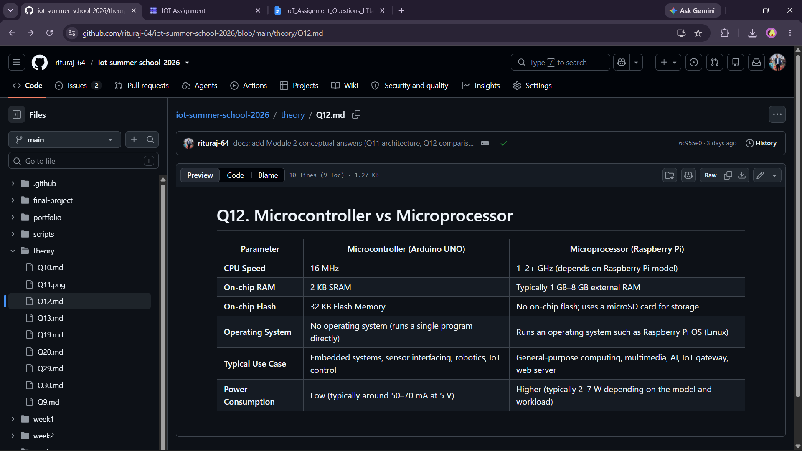

Q13. Arduino Pin Types
List and explain with examples: Digital Input, Digital Output, Analog Input, PWM Output, and I2C/SPI pins available on Arduino UNO. For each, give one real IoT use case.

GitHub link: https://github.com/rituraj-64/iot-summer-school-2026/blob/main/theory/Q13.md
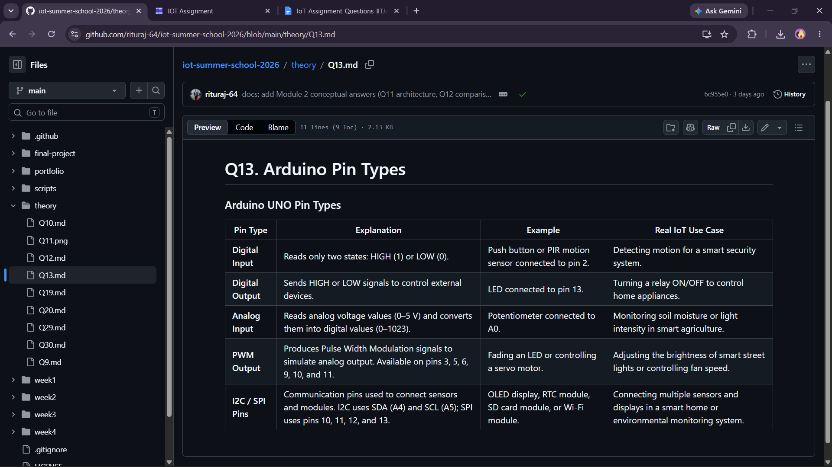

Section B: Programming Tasks (4 marks each)

Q14. Traffic Light Controller
Write an Arduino program that simulates a traffic light system using 3 LEDs (Red, Yellow, Green):
- RED ON for 5 seconds → YELLOW ON for 2 seconds → GREEN ON for 4 seconds
- Add a pedestrian button (push button on pin 7): when pressed, force RED immediately and hold for 8 seconds
- Print the current light state to Serial Monitor with timestamp (millis())
Code must be uploaded to: /week2/traffic_light/traffic_light.ino

Code:
/*
* Author : Ritu Raj
* Date : 2 July 2026
*/
const int rled = 2;
const int yled = 3;
const int gled = 4;
const int button = 7;

void setup() {
pinMode(rled, OUTPUT);
pinMode(yled, OUTPUT);
pinMode(gled, OUTPUT);

pinMode(button, INPUT_PULLUP);

Serial.begin(9600);}

void showred() {
digitalWrite(rled, HIGH);
digitalWrite(yled, LOW);
digitalWrite(gled, LOW);

Serial.print(millis());
Serial.println(" ms : RED");}

void showyellow() {
digitalWrite(rled, LOW);
digitalWrite(yled, HIGH);
digitalWrite(gled, LOW);

Serial.print(millis());
Serial.println(" ms : YELLOW");}

void showgreen() {
digitalWrite(rled, LOW);
digitalWrite(yled, LOW);
digitalWrite(gled, HIGH);

Serial.print(millis());
Serial.println(" ms : GREEN");}

void pedestrian() {
showred();
Serial.print(millis());
Serial.println(" ms : Pedestrian Button Pressed");
delay(8000);}

void loop() {

// Check if pedestrian button is pressed
if (digitalRead(button) == LOW) {
pedestrian();
return;}

showred();
delay(5000);

if (digitalRead(button) == LOW) {
pedestrian();
return;}

showyellow();
delay(2000);

if (digitalRead(button) == LOW) {
pedestrian();
return;}

showgreen();
delay(4000);}

Project link: https://www.tinkercad.com/things/dt57upmj5H9-traffic-light?sharecode=Lo5feR9iaAdC0YGlRLHckKyzdxmTe5LRssfjkGRhLQw
GitHub link: https://github.com/rituraj-64/iot-summer-school-2026/tree/main/week2/traffics_light
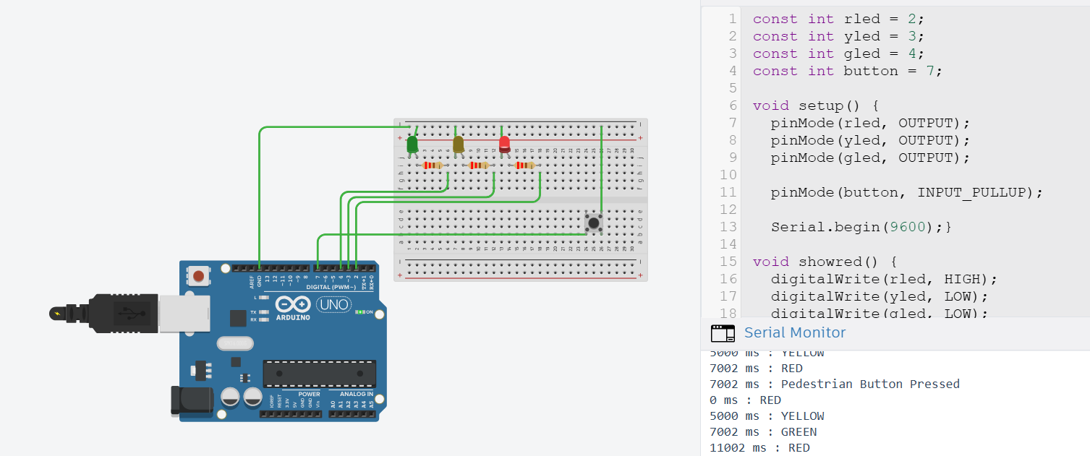

Q15. Digital Piano using Buzzer
Build a 4-key musical instrument using push buttons and a passive buzzer:
- 4 buttons mapped to notes: Do (262Hz), Re (294Hz), Mi (330Hz), Fa (349Hz)
- Button press plays the note; button release silences the buzzer
- If two buttons are pressed together: play Sol (392Hz) as a chord substitute
- Add a mode toggle (5th button): switch between Major and Minor scale
Commit separately for each feature using Git.

Code:
/*
* Author : Ritu Raj
* Date : 2 July 2026
*/

const int mode = 6;
bool major = true;
bool prev = HIGH;

const int buzzer = 8;
const int dobtn = 2;
const int rebtn = 3;
const int mibtn = 4;
const int fabtn = 5;

void setup() {
pinMode(dobtn, INPUT_PULLUP);
pinMode(rebtn, INPUT_PULLUP);
pinMode(mibtn, INPUT_PULLUP);
pinMode(fabtn, INPUT_PULLUP);
pinMode(mode, INPUT_PULLUP);}

void loop() {
bool current = digitalRead(mode);
if(prev==HIGH && current==LOW){
major=!major;
delay(200);}

prev=current;

bool d=digitalRead(dobtn)==LOW;
bool r=digitalRead(rebtn)==LOW;
bool m=digitalRead(mibtn)==LOW;
bool f=digitalRead(fabtn)==LOW;

int pressed=d+r+m+f;

if(pressed>=2){
tone(buzzer,392);}

else if(d){
tone(buzzer,262);}

else if(r){
tone(buzzer,294);}

else if(m){
if(major)
tone(buzzer,330);
else
tone(buzzer,311);}

else if(f){
if(major)
tone(buzzer,349);
else
tone(buzzer,330);}

else{
noTone(buzzer);}}

Project Link (Tinkercad): https://www.tinkercad.com/things/bWWskKHjrw5-digital-piano?sharecode=vmyoRVGX25s9OvqVBp5kOVfYS0ejrRDLcsMlRzjAVrE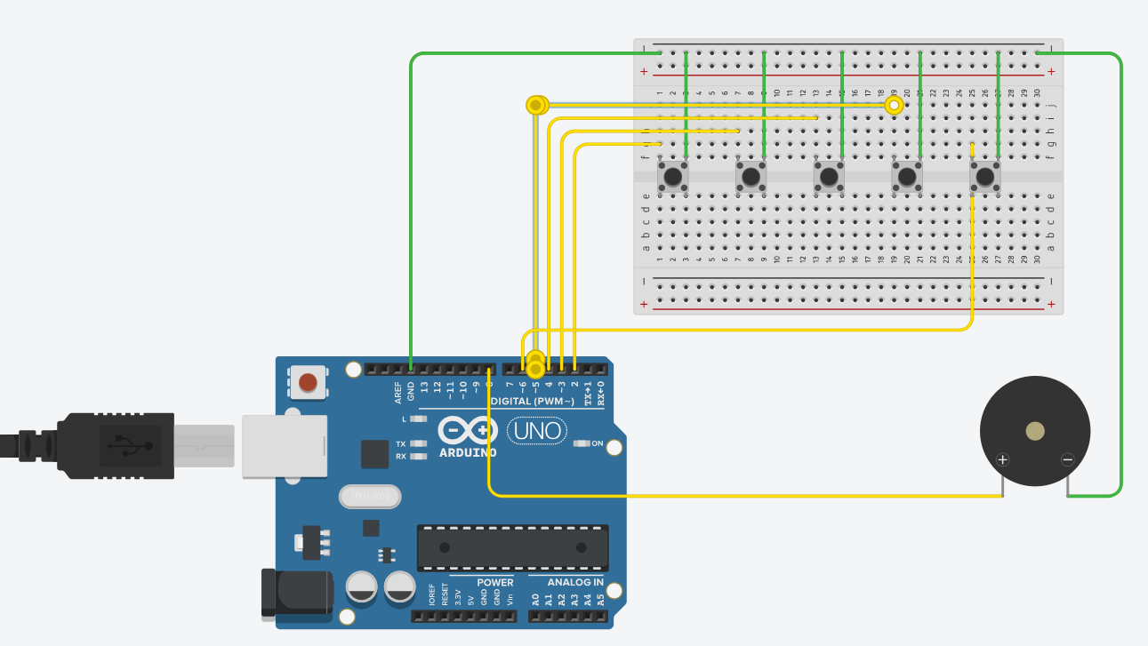
Commit History: 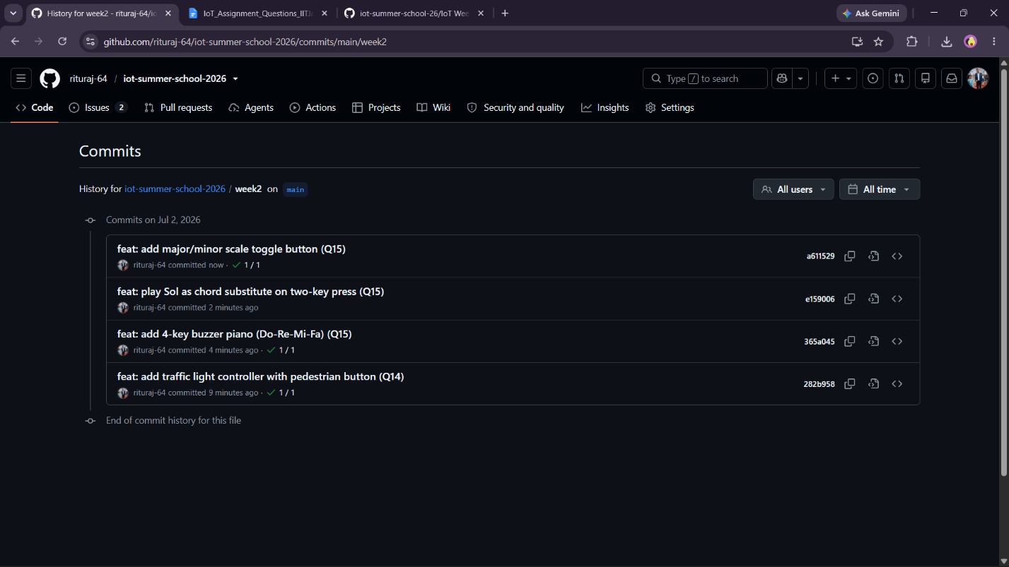

GitHub Link: https://github.com/rituraj-64/iot-summer-school-2026/tree/main/week2/digital_piano

Q16. Serial Command Interface
Write a program that receives commands over Serial Monitor and controls hardware:
LED_ON → Turn built-in LED on
LED_OFF → Turn built-in LED off
BLINK_X → Blink LED X times (X is 1–9)
STATUS → Print pin states
RESET → Restart blink counter
Implement input validation: unknown commands should print 'ERROR: Unknown command'.

Code:

/*
* Author : Ritu Raj
* Date : 2 July 2026
*/

const int led = LED_BUILTIN;
int blink = 0;

void setup() {
pinMode(led, OUTPUT);
Serial.begin(9600);
Serial.println("Serial Command Interface Ready");}

void loop() {
if (Serial.available()) {
String command = Serial.readStringUntil('\n');
command.trim();
if (command == "LED_ON") {
digitalWrite(led, HIGH);
Serial.println("LED ON");}

else if (command == "LED_OFF") {
digitalWrite(led, LOW);
Serial.println("LED OFF");}

else if (command.startsWith("BLINK_")) {
int times = command.substring(6).toInt();
if (times >= 1 && times <= 9) {
for (int i = 0; i < times; i++) {
digitalWrite(led, HIGH);
delay(500);
digitalWrite(led, LOW);
delay(500);}

blink += times;
Serial.print("Blink Count = ");
Serial.println(blink);}

else {
Serial.println("ERROR: Invalid blink count");}}

else if (command == "STATUS") {

Serial.print("LED State: ");
if (digitalRead(led))
Serial.println("ON");
else
Serial.println("OFF");
Serial.print("Blink Counter: ");
Serial.println(blink);}

else if (command == "RESET") {

blink = 0;
Serial.println("Blink counter reset");}

else {
Serial.println("ERROR: Unknown command");}}}

Project Link (Tinkercad): https://www.tinkercad.com/things/i7anwHcCFcV-serial-command-interface?sharecode=lIgQbBk1Y3fAAzKai5oTYgpqqaOXkZB-czZVC4LmWPU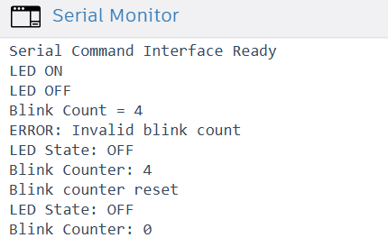
GitHub Link: https://github.com/rituraj-64/iot-summer-school-2026/tree/main/week2/serial_command

Q17. PWM Fading Night Light
Create an automatic night light that fades an LED in and out (breathing effect) continuously. Implement three modes switchable via a button: (1) Slow breathing (3-second cycle), (2) Fast pulse (0.5-second cycle), (3) SOS pattern (... --- ...). Display current mode on Serial Monitor.

Code:

/*
* Author : Ritu Raj
* Date : 2 July 2026
*/

const int ledPin = 9;
const int buttonPin = 2;
const int ldrPin = A0;

int mode = 1;
int threshold = 500; // Adjust if required

bool lastButtonState = HIGH;
bool currentButtonState;

void setup() {
pinMode(ledPin, OUTPUT);
pinMode(buttonPin, INPUT_PULLUP);
Serial.begin(9600);
Serial.println("Automatic PWM Night Light");
Serial.println("Mode 1 : Slow Breathing");}

void loop() {

// ---------- Button ----------
currentButtonState = digitalRead(buttonPin);

if (lastButtonState == HIGH && currentButtonState == LOW) {
mode++;
if (mode > 3)
mode = 1;
printMode();
delay(250);}
lastButtonState = currentButtonState;

// ---------- LDR ----------
int light = analogRead(ldrPin);

// Bright -> LED OFF
if (light > threshold) {
analogWrite(ledPin, 0);
return;}

// Dark -> Run Selected Mode
if (mode == 1)
slowBreathing();
else if (mode == 2)
fastPulse();
else
sosPattern();}

void printMode() {
if (mode == 1)
Serial.println("Mode 1 : Slow Breathing");
else if (mode == 2)
Serial.println("Mode 2 : Fast Pulse");
else
Serial.println("Mode 3 : SOS Pattern");}

void slowBreathing() {
for (int i = 0; i <= 255; i++) {
analogWrite(ledPin, i);
delay(6);
if (modeChanged()) return;}
for (int i = 255; i >= 0; i--) {
analogWrite(ledPin, i);
delay(6);
if (modeChanged()) return;}}

void fastPulse() {
for (int i = 0; i <= 255; i++) {
analogWrite(ledPin, i);
delay(1);
if (modeChanged()) return;}
for (int i = 255; i >= 0; i--) {
analogWrite(ledPin, i);
delay(1);
if (modeChanged()) return;}}

// ===============================
// SOS Pattern
// ===============================
void sosPattern() {
dot();
dot();
dot();

dash();
dash();
dash();

dot();
dot();
dot();

delay(1000);}

// ===============================
// Dot
// ===============================
void dot() {
analogWrite(ledPin, 255);
delay(200);
analogWrite(ledPin, 0);
delay(200);
modeChanged();}

// ===============================
// Dash
// ===============================
void dash() {
analogWrite(ledPin, 255);
delay(600);
analogWrite(ledPin, 0);
delay(200);
modeChanged();}

// ===============================
// Check Button During Animation
// ===============================
bool modeChanged() {
currentButtonState = digitalRead(buttonPin);
if (lastButtonState == HIGH && currentButtonState == LOW) {
mode++;
if (mode > 3)
mode = 1;
printMode();
delay(250);
lastButtonState = currentButtonState;
analogWrite(ledPin, 0);
return true;}
lastButtonState = currentButtonState;
return false;}
Project Link (Tinkercad): https://www.tinkercad.com/things/keq8zvcWao6-pwm-fading-night-light?sharecode=I_YABz1WQQKjgUi3qKs6Vp7bkR0OK3ywHawZ1DUkmZI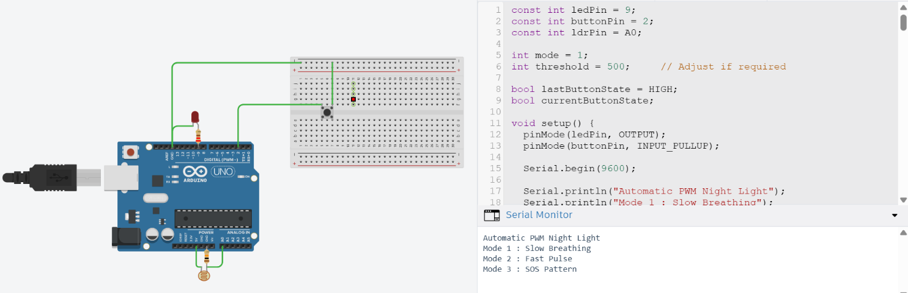
GitHub Link: https://github.com/rituraj-64/iot-summer-school-2026/tree/main/week2/PWM_night_light

Q18. State Machine Implementation
Implement a simple vending machine state machine with 4 states: IDLE, COIN_INSERTED, ITEM_SELECTED, DISPENSING. Use 3 buttons as inputs (Insert Coin, Select Item, Cancel). Use 3 LEDs to show the current state. Print all state transitions to Serial Monitor. Code must include a comment block documenting the state transition diagram.

Code:

/*
* Author : Ritu Raj
* Date : 2 July 2026
*/

/*

enum State
{
IDLE,
COIN_INSERTED,
ITEM_SELECTED,
DISPENSING
};

State currentState = IDLE;

// Function Prototypes
void updateLEDs();
void changeState(State newState);

// Button Pins
const int coinBtn = 2;
const int selectBtn = 3;
const int cancelBtn = 4;

// LED Pins
const int idleLED = 8;
const int coinLED = 9;
const int stateLED = 10;

void setup()
{
Serial.begin(9600);

pinMode(coinBtn, INPUT_PULLUP);
pinMode(selectBtn, INPUT_PULLUP);
pinMode(cancelBtn, INPUT_PULLUP);

pinMode(idleLED, OUTPUT);
pinMode(coinLED, OUTPUT);
pinMode(stateLED, OUTPUT);

updateLEDs();

Serial.println("Vending Machine Started");
Serial.println("Current State: IDLE");
}

void loop()
{
bool coin = (digitalRead(coinBtn) == LOW);
bool select = (digitalRead(selectBtn) == LOW);
bool cancel = (digitalRead(cancelBtn) == LOW);

switch (currentState)
{
case IDLE:

if (coin)
{
changeState(COIN_INSERTED);
delay(250);
}

break;

case COIN_INSERTED:

if (select)
{
changeState(ITEM_SELECTED);
delay(250);
}
else if (cancel)
{
changeState(IDLE);
delay(250);
}

break;

case ITEM_SELECTED:

Serial.println("Dispensing Item...");
delay(1000);

changeState(DISPENSING);

delay(1500);

Serial.println("Item Dispensed.");
changeState(IDLE);
break;

case DISPENSING:
// Automatic transition handled above
break;
}
}

void changeState(State newState)
{
currentState = newState;
updateLEDs();
Serial.print("Current State -> ");
switch (currentState)
{
case IDLE:
Serial.println("IDLE");
break;

case COIN_INSERTED:
Serial.println("COIN_INSERTED");
break;

case ITEM_SELECTED:
Serial.println("ITEM_SELECTED");
break;

case DISPENSING:
Serial.println("DISPENSING");
break;
}
}

void updateLEDs()
{
digitalWrite(idleLED, LOW);
digitalWrite(coinLED, LOW);
digitalWrite(stateLED, LOW);

switch (currentState)
{
case IDLE:
digitalWrite(idleLED, HIGH);
break;

case COIN_INSERTED:
digitalWrite(coinLED, HIGH);
break;

case ITEM_SELECTED:
digitalWrite(stateLED, HIGH);
break;

case DISPENSING:
digitalWrite(stateLED, HIGH);
break;
}
}

Project Link (Tinkercad): https://www.tinkercad.com/things/1doZOSI9VuU-vending-machine?sharecode=BH3we6ZOgoR2nc4tRKQjJVg_MbjY9svvY2SeEG7Sf7o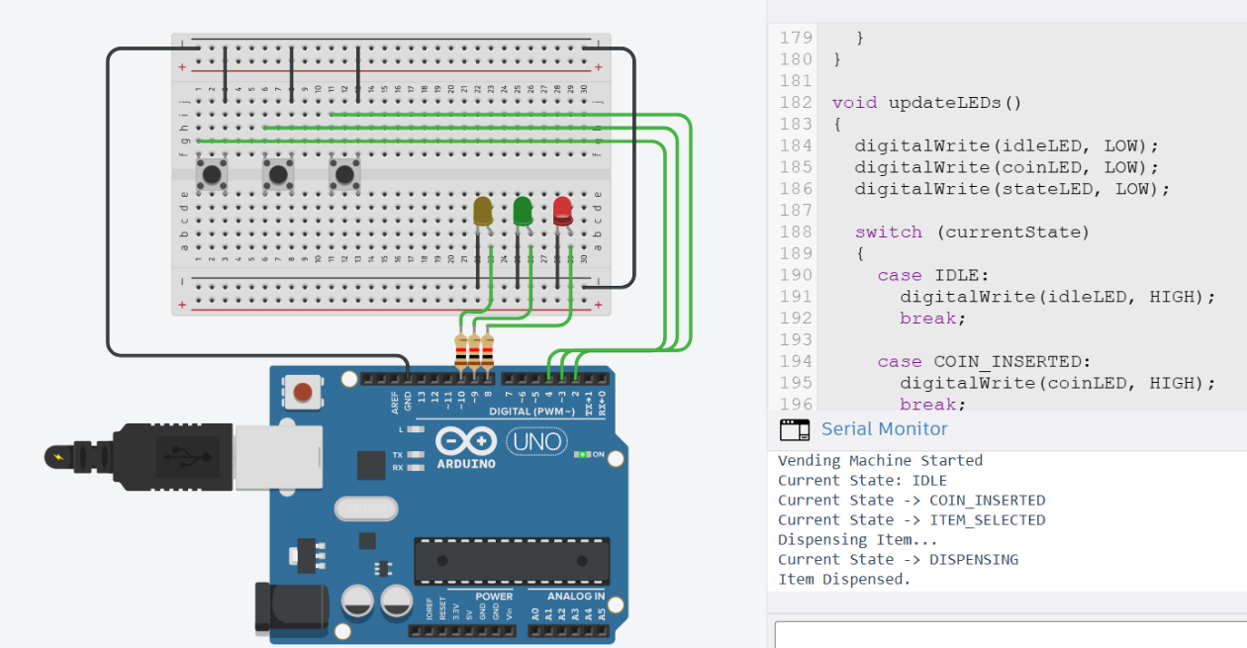
GitHub Link: https://github.com/rituraj-64/iot-summer-school-2026/tree/main/week2/vending_machine
Q19. (Theory) What is the difference between analogWrite() and analogRead() in Arduino? What is PWM and why is it used? Give a practical IoT example for each. (2 marks)

Answer:
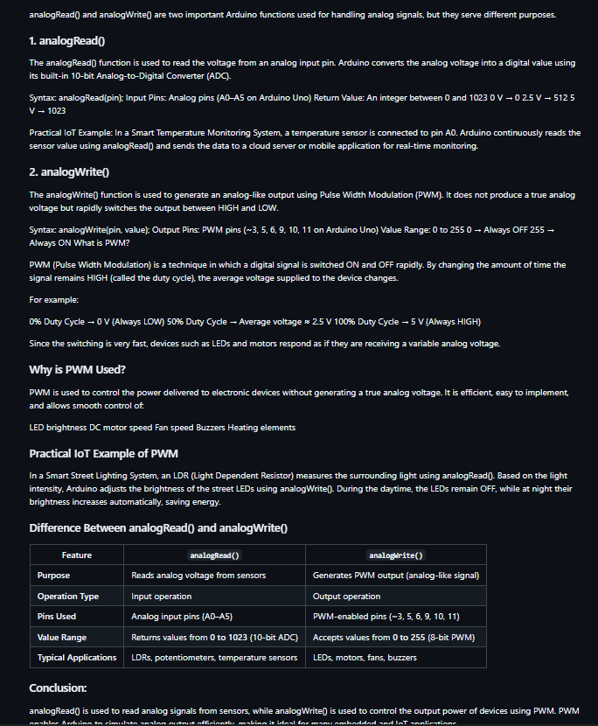
GitHub Link: https://github.com/rituraj-64/iot-summer-school-2026/blob/main/theory/Q19.md

Q20. (Theory) Explain the setup() and loop() functions in Arduino. What happens if you put a long delay() inside loop()? How does this affect sensor reading responsiveness? What is the non-blocking alternative? (2 marks)

Answer:
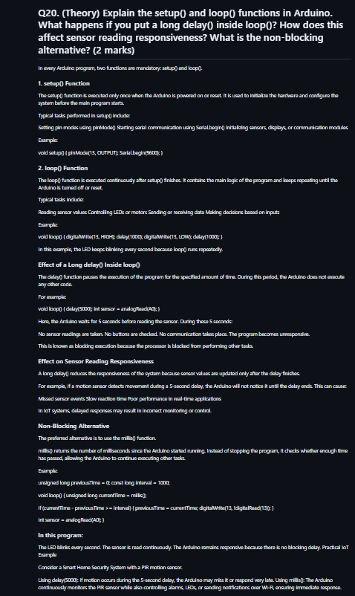
GitHub Link: https://github.com/rituraj-64/iot-summer-school-2026/blob/main/theory/Q20.md

Module 3: Sensors, Actuators & Data Acquisition
Marks: 20 | Questions: Q21–Q30 | Type: Hands-On Experiments

🔬 Sensors Covered in This Module
- DHT11/DHT22 – Temperature & Humidity
- HC-SR04 – Ultrasonic Distance
- LDR – Light Dependent Resistor
- PIR – Passive Infrared Motion Sensor
- Soil Moisture Sensor, MQ-2 Gas Sensor (optional)

Section A: Sensor Experiments (4 marks each)

Q21. Environmental Monitoring Station (DHT11)
Build a mini weather station using DHT11 sensor:
- Read temperature (°C and °F) and humidity every 2 seconds
- Display readings on Serial Monitor in CSV format: timestamp,temp_C,temp_F,humidity
- Trigger a Red LED if temperature > 35°C or humidity > 80%
- Trigger a Green LED if conditions are normal
- Save 5 sample CSV readings in a file /week3/data/sample_readings.csv in your GitHub repo
Library: DHTesp or DHT by Adafruit. Include library version in README.

GitHub Link: https://github.com/rituraj-64/iot-summer-school-2026/tree/main/week3/env_monitor
Project Link: https://wokwi.com/projects/468441225781705729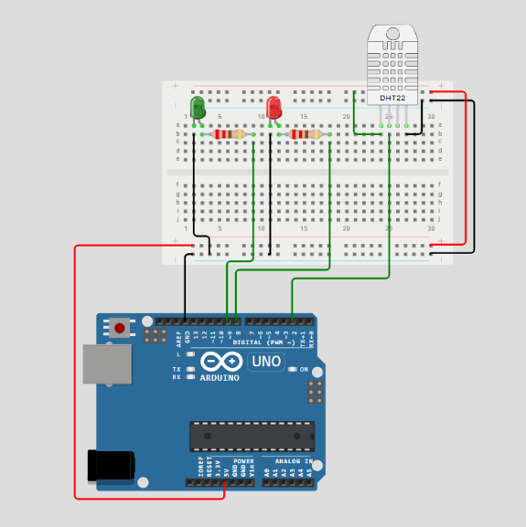

Q22. Ultrasonic Parking Sensor
Using HC-SR04, build a parking distance alert system:
- Distance > 50cm: No alert, Serial prints SAFE
- Distance 20–50cm: Yellow LED ON, buzzer beeps every 500ms
- Distance 10–20cm: Red LED ON, buzzer beeps every 200ms
- Distance < 10cm: All LEDs flash rapidly, buzzer continuous
- Calculate and display distance in cm using the formula: distance = (duration * 0.034) / 2
Advanced: Use millis() for non-blocking timing (no delay()). +1 bonus mark.

GitHub Link: https://github.com/rituraj-64/iot-summer-school-2026/tree/main/week3/parking_sensor
Project Link: https://wokwi.com/projects/468441343245304833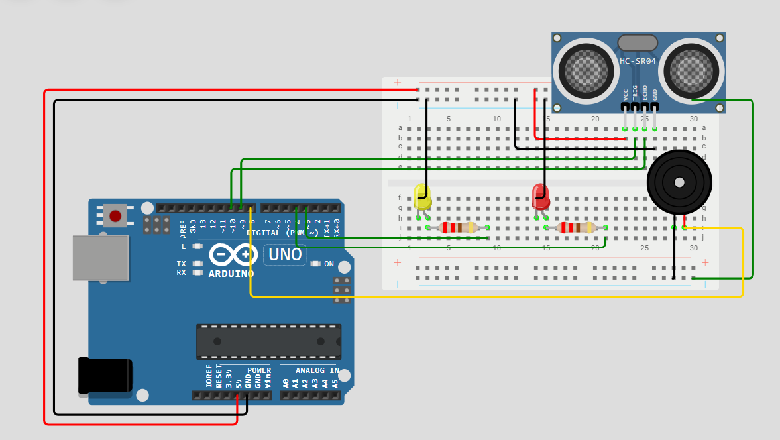

Q23. Smart Street Light (LDR + PIR)
Implement an intelligent street light controller:
- LDR below threshold (dark): Enable motion detection mode
- PIR detects motion at night: Turn LED on at full brightness for 30 seconds
- No motion after 30 sec: Dim LED to 20% using PWM
- LDR above threshold (daylight): Turn LED completely OFF
- Log every event to Serial: [HH:MM:SS] EVENT: description
Submit a circuit diagram sketch (hand-drawn or Tinkercad screenshot) in /week3/schematics/.

GitHub Link: https://github.com/rituraj-64/iot-summer-school-2026/tree/main/week3/smart_street_light
Project Link: https://www.tinkercad.com/things/iUMWnN7ZPa5-smart-street-light?sharecode=R5lvUFjr0l1T3rANZzkBMuhQVyzthTZC9YKclfpxz48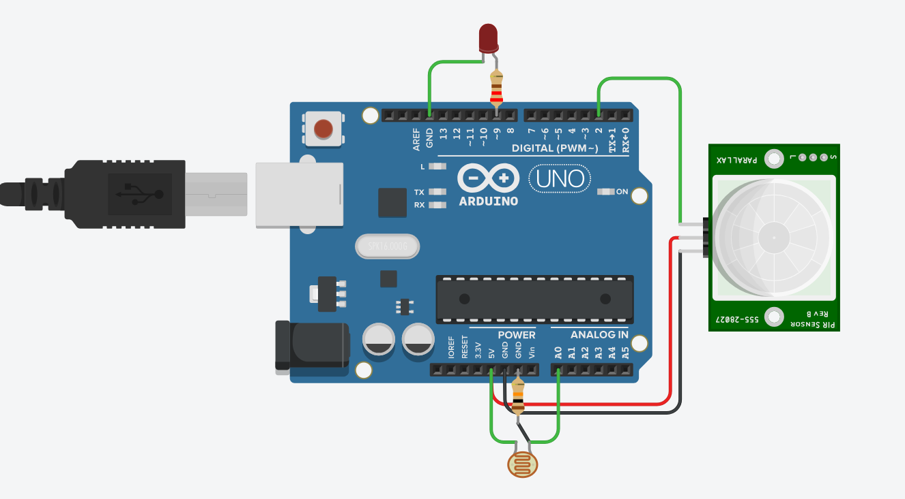

Q24. Multi-Sensor Data Logger
Build a system that reads 3 sensors simultaneously and logs structured data:
- DHT11: Temperature, Humidity
- LDR: Light level (0–1023 raw, converted to percentage)
- HC-SR04: Distance in cm
Output format every 5 seconds:
=== SENSOR LOG ===
Time : 12345 ms
Temp : 28.5 C | Humidity: 65%
Light : 73% (Bright)
Distance : 42 cm
==================
Upload 20 lines of captured Serial Monitor output as /week3/data/sensor_log.txt.

GitHub Link: https://github.com/rituraj-64/iot-summer-school-2026/tree/main/week3/data_logger
Project Link: https://wokwi.com/projects/468441378805678081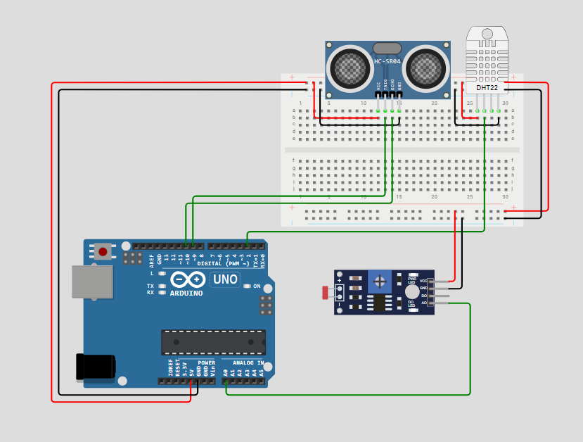
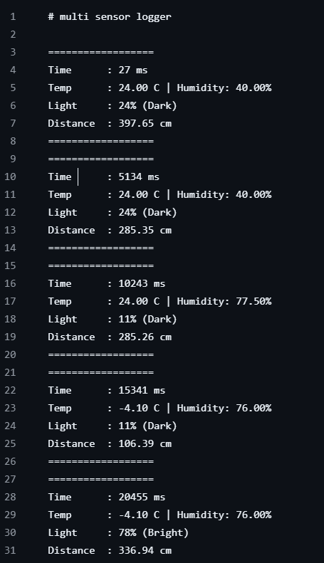

Section B: Actuator Control (2 marks each)

Q25. Servo Motor Sweep
Control a SG90 servo motor with a potentiometer. Potentiometer position (0–1023) maps to servo angle (0°–180°). Display angle in Serial Monitor. Add a button that makes the servo do one full sweep (0→180→0) when pressed. Code: /week3/servo_control/

GitHub Link: https://github.com/rituraj-64/iot-summer-school-2026/tree/main/week3/servo_control
Project Link: https://www.tinkercad.com/things/7gyStqv5tqT-servo-motor-sweep?sharecode=A-0JzaNqEo2-itlMNAI3xn3ZXAlHaADIpK6wZ6IkiEo
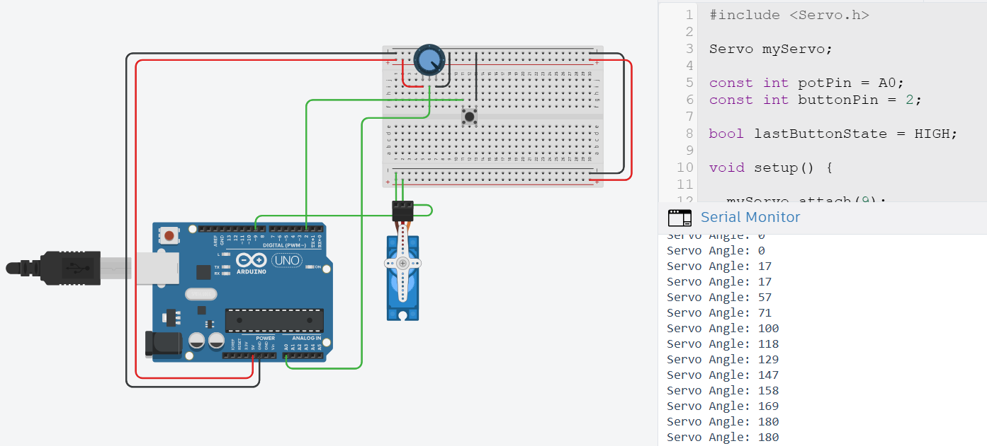

Q26. DC Motor Speed Control with L298N
Control a DC motor through L298N driver: potentiometer sets speed (0–255 PWM), one button changes direction (Forward/Reverse), another button stops/starts the motor. Display Direction, Speed (0–100%), and State on Serial Monitor.

GitHub Link: https://github.com/rituraj-64/iot-summer-school-2026/tree/main/week3/speed_control
Project Link: https://www.tinkercad.com/things/cQwmxBud23W-potentiometer-speed-control?sharecode=5ZQMfzL_NfQd_VAiUvg-EpjG_Tvj52IA00ghCBnXgIo
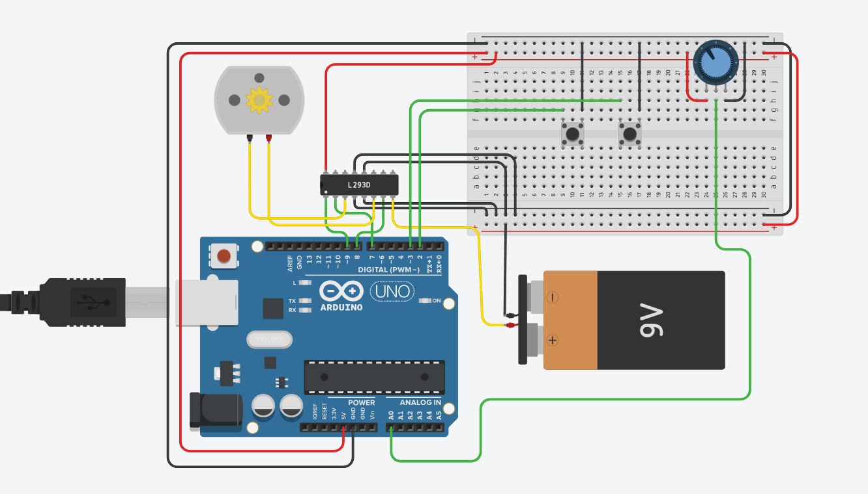

Q27. Relay-Controlled AC Device Simulation
Simulate a relay controlling an AC appliance (use LED as a safe simulation). DHT11 triggers relay ON when temperature > 32°C (AC turns on). Relay OFF when temp drops below 28°C (hysteresis). Add a manual override button. Log all relay state changes with temperature readings.

GitHub Link: https://github.com/rituraj-64/iot-summer-school-2026/tree/main/week3/relay_control
Project Link: https://wokwi.com/projects/468441541296209921
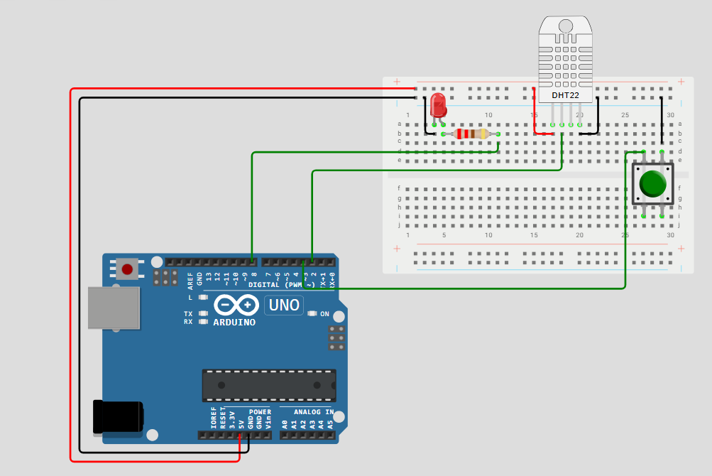

Q28. Keypad + LCD Display
Using a 4x4 membrane keypad and 16x2 LCD, build a password-protected access system: Display 'ENTER PIN:' on LCD, user enters 4-digit PIN, correct PIN (set in code) shows 'ACCESS GRANTED' + Green LED, wrong PIN shows 'ACCESS DENIED' + Red LED + buzzer. After 3 wrong attempts, lock for 10 seconds.

GitHub Link: https://github.com/rituraj-64/iot-summer-school-2026/tree/main/week3/keypad_lock
Project Link: https://www.tinkercad.com/things/2jLqHJRFS70-password-lock?sharecode=oJ75jCrTSI84zsEgoB93WMwxtXrpo-4tA-Q_CmgMHYM
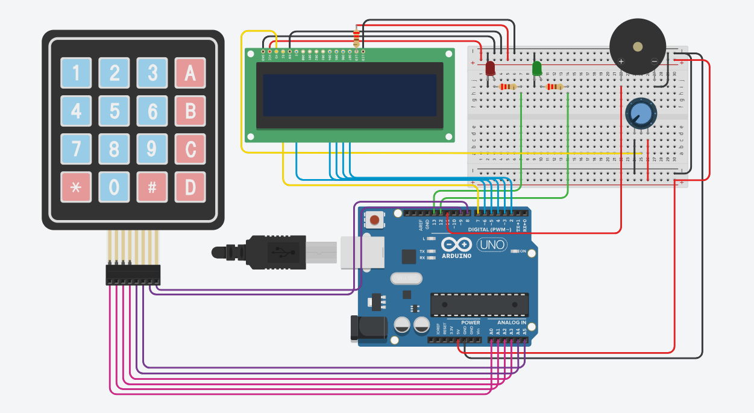

Q29. (Theory) What is sensor calibration and why is it important in IoT systems? How would you calibrate an analog soil moisture sensor to give accurate percentage readings? Describe the two-point calibration method. (2 marks)

Answer:
Sensor calibration is the process of adjusting or mapping a sensor's output so that it accurately represents the actual physical quantity being measured. Sensors often produce different readings due to manufacturing variations, aging, temperature changes, and environmental conditions. Calibration helps eliminate these errors and improves measurement accuracy.

Importance of Sensor Calibration in IoT Systems
Improves the accuracy and reliability of sensor data. Reduces measurement errors caused by sensor variations. Ensures consistent readings across multiple devices. Improves decision-making in automated IoT systems. Prevents false alarms and incorrect actions.

For example, in a smart irrigation system, an uncalibrated soil moisture sensor may indicate that the soil is dry even when it has enough moisture, causing unnecessary watering and wasting water.

Calibration of an Analog Soil Moisture Sensor
An analog soil moisture sensor produces an analog value (typically 0–1023 on an Arduino Uno) that varies with the moisture content of the soil. Since different sensors and soil types produce different values, calibration is required before converting the readings into moisture percentages. Two-Point Calibration Method

The two-point calibration method is the simplest and most commonly used method.

It uses two reference conditions:
Point 1: Dry Soil (0% Moisture)
Keep the sensor completely dry or in air. Read the sensor value several times. Record the average value.
Example:
Dry Reading = 850
This represents 0% moisture.

Point 2: Wet Soil (100% Moisture)
Insert the sensor into fully saturated soil or water. Record the sensor value.
Example:
Wet Reading = 350
This represents 100% moisture.

Converting Sensor Reading to Percentage
Now, any reading between the dry and wet values can be converted into a moisture percentage.

For example:
Dry Value = 850 Wet Value = 350 Current Reading = 600

Using Arduino, this can be done with the map() function:
int sensorValue = analogRead(A0);
int moisture = map(sensorValue, 850, 350, 0, 100); moisture = constrain(moisture, 0, 100);

Here:
850 → 0% moisture (dry) 350 → 100% moisture (wet) Any value in between is converted proportionally into a percentage. constrain() ensures the value stays between 0% and 100%. Practical IoT Example

Consider a Smart Irrigation System.
The soil moisture sensor continuously measures soil moisture. The Arduino reads the value using analogRead(). The reading is converted into a calibrated percentage using the two-point calibration values. If the moisture level falls below 30%, the Arduino automatically turns on a water pump. When the moisture reaches 70%, the pump is turned off. The moisture percentage is also uploaded to a cloud dashboard or mobile application for remote monitoring.

This ensures efficient water usage and healthy plant growth.

Advantages of Two-Point Calibration
Simple and easy to perform. Improves measurement accuracy. Compensates for differences between sensors. Provides meaningful percentage values (0–100%). Widely used in IoT applications such as smart farming and automated irrigation.

Q30. (Theory) Explain I2C protocol with respect to IoT sensor communication. What are SDA and SCL lines? How does I2C addressing work? Name 3 common IoT sensors that use I2C. (2 marks)

Answer:
I2C (Inter-Integrated Circuit) is a synchronous serial communication protocol used for communication between a microcontroller (master) and multiple peripheral devices (slaves), such as sensors, displays, and memory modules. In IoT systems, I2C is widely used because it requires only two communication wires, making the circuit simple and reducing the number of pins required.
How I2C Works
I2C follows a Master-Slave architecture.
Master Device: Initiates communication and controls the clock signal (e.g., Arduino, ESP32). Slave Device: Responds only when its unique address is called (e.g., sensors). Multiple slave devices can be connected to the same two communication lines. SDA and SCL Lines
I2C uses only two wires:
SDA (Serial Data Line) Used to transfer data between the master and slave devices. It is a bidirectional line, meaning data can flow in both directions. SCL (Serial Clock Line) Carries the clock signal generated by the master. Synchronizes the data transfer between devices.
Both SDA and SCL require pull-up resistors because they use open-drain/open-collector outputs.
How I2C Addressing Works
Each I2C slave device has a unique 7-bit (or sometimes 10-bit) address.
The communication process is as follows:
The master sends a START condition. The master transmits the address of the slave device. Every slave checks the transmitted address. Only the slave whose address matches responds with an ACK (Acknowledgement) signal. The master then reads data from or writes data to that slave. After communication is complete, the master sends a STOP condition.
For example:
Temperature Sensor Address → 0x48 OLED Display Address → 0x3C Pressure Sensor Address → 0x76
Since each device has a different address, many sensors can share the same SDA and SCL lines without interference.
Advantages of I2C in IoT Requires only two communication wires. Supports multiple devices on the same bus. Saves microcontroller pins. Easy to expand by adding more sensors. Suitable for low-speed sensor communication in IoT systems. Common IoT Sensors That Use I2C
Some commonly used I2C sensors are:
BMP280 – Measures temperature and atmospheric pressure. MPU6050 – Measures acceleration and angular velocity (accelerometer + gyroscope). BH1750 – Measures ambient light intensity.
Other popular I2C devices include BME280 (temperature, humidity, pressure), OLED displays, and RTC modules.
Practical IoT Example
Consider a Weather Monitoring Station.
An Arduino or ESP32 acts as the master. A BMP280 sensor measures temperature and pressure. A BH1750 sensor measures light intensity. An OLED display shows the measured values.
All these devices communicate over the same SDA and SCL lines using different I2C addresses, reducing wiring complexity and saving GPIO pins.

