ASSAM UNIVERSITY

SatQuery AI: An Agentic Vision-Language
Assistant for Multimodal Remote-Sensing Imagery
and Evidence-Grounded Query Answering

A report submitted in partial fulfilment of the requirements for the
degree of
Bachelor Of Technology
in
Computer Science and Engineering
Submitted By:
Rituraj Handique
Registration Number : 20230000395 of 2023-2024
Kalyan Mohanti
Registration Number : 20230000417 of 2023-2024
Tribikram Purkayastha
Registration Number : 20230000419 of 2021-2024
Under the guidance of:
Dr. Sunita Sarkar
Associate Professor, Department of Computer Science
and Engineering

Triguna Sen School of Tehnology
Department of Computer Science and Engineering
Assam University, Silchar 788011
March 2026

Declaration of Authorship
We, the undersigned, declare that this report titled "SatQuery AI: An Agentic Vision-Language Assistant for Multimodal Remote-Sensing Imagery Analysis and Evidence-Grounded Query Answering" and the work presented in this report is our own. We confirm that this work submitted for assessment is our own and is expressed in our own words. Any uses made within it of the works of other authors in any form (e.g., ideas, equations, figures, text, tables, programs) are properly acknowledged at any point of their use . To the best of our knowledge and belief, the same report has not been submitted either by us or by any other person for the award of any other degree or diploma of the University or other institute of higher learning.
Candidate: 1.( Rituraj Handique, Roll No: 1181200339 )

Candidate: 2.( Kalyan Mohanti, Roll No: 1181200340 )

Candidate: 3.( Tribikram Purkayastha, Roll No: 11812000324 )

Date: 18/03/2026

Place: Assam University, Silchar

Department of Computer Science and Engineering
Assam University, Silchar-788011
Certificate
This is to certify that the report entitled
SatQuery AI: An Agentic Vision-Language Assistant for Multimodal Remote-Sensing Imagery Analysis and Evidence-Grounded Query Answering
submitted by
Rituraj Handique, Kalyan Mohanti and Tribikram Purkayastha
to the Department of Computer Science and Engineering, Assam University, Silchar in partial fulfilment of the requirements for the the award of the Degree of
Bachelor of Technology
in
Computer Science and Engineering
is a bonafide record of the work carried out by them under my supervision. It is further certified that the candidates have complied with all the formalities as per the requirements of Assam University.
____________________________________________________
Name & Signature (Supervisor)
____________________________________________________
Dr. Tapodhir Archarjee (Head of the Department)
____________________________________________________
External Examiner's Name & Signature Date and Seal

Abstract
Earth Observation (EO) satellite constellations generate vast quantities of geospatial imagery across optical, multispectral, and Synthetic Aperture Radar (SAR) modalities. However, extracting actionable insights from satellite imagery remains a significant challenge for non-GIS specialists due to complex coordinate systems, radiometric calibration requirements, and the opacity of traditional automated tools. While mainstream Multimodal Large Language Models (MLLMs) excel on natural internet photography, they suffer from nadir blindness, spatial hallucinations, and complete failure to ingest multi-band GeoTIFFs or calibrate sensors such as ISRO Cartosat and RISAT-1A.
To resolve these limitations, this project presents SatQuery AI, an agentic, query-driven vision-language assistant for remote-sensing imagery analysis. The system captures natural language user questions and dynamically routes them across six specialist workflows: Single-Image VQA, Scene Captioning, Visual Grounding, Bi-Temporal Change Detection, Change VQA, and Optical-SAR Cross-Modal Fusion. A dual-engine model registry integrates GPU-accelerated transformer backbones with deterministic CPU fallback algorithms based on geophysical spectral indices (NDVI, NDWI, NDBI) and structural change detection.
Every textual response is verified through a multi-factor Hallucination Guard, assigned a calibrated confidence level (High, Medium, Low, Uncertain), and accompanied by pixel-level spatial evidence and an auditable execution trace. Experimental benchmarks demonstrate that SatQuery AI achieves high accuracy across standard Earth Observation datasets while operating with sub-second response latency in interactive environments.

Acknowledgements
We are deeply grateful to Dr. Tapodhir Archarjee, Head of the Department of Computer Science and Engineering at Triguna Sen School of Technology, Assam University, for his invaluable advice, encouragement, constructive criticism, and motivation throughout this project.
We would like to express our heartfelt thanks to our supervisor, Dr. Sunita Sarkar for his guidance, encouragement, and unwavering support have been indispensable to the successful completion of this project.
Lastly, we extend our sincere appreciation to our parents for their constant love, support, and belief.

Contents
Declaration of Authorship . . . . . . . . . . . . . . . . . . . . . . . . . . . . . . . . . . . . . . . i
Certificate . . . . . . . . . . . . . . . . . . . . . . . . . . . . . . . . . . . . . . . . . . . . . . . . . . . . . . ii
Abstract . . . . . . . . . . . . . . . . . . . . . . . . . . . . . . . . . . . . . . . . . . . . . . . . . . . . . . . . . iii
Acknowledgements . . . . . . . . . . . . . . . . . . . . . . . . . . . . . . . . . . . . . . . . . . . . . . . . . iv
Contents . . . . . . . . . . . . . . . . . . . . . . . . . . . . . . . . . . . . . . . . . . . . . . . . . . . . . . . . . v
List of Figures . . . . . . . . . . . . . . . . . . . . . . . . . . . . . . . . . . . . . . . . . . . . . . . . . . vi
1 Introduction . . . . . . . . . . . . . . . . . . . . . . . . . . . . . . . . . . . . . . . . . . . . . . . . . . 1
1.1 Overview and Earth Observation Landscape . . . . . . . . . . . . . . 1
1.2 Problem Domain and Technical Challenges . . . . . . . . . . . . . . . 1
1.3 Motivation and Societal Impact . . . . . . . . . . . . . . . . . . . . . . . . . 2
1.4 Project Objectives . . . . . . . . . . . . . . . . . . . . . . . . . . . . . . . . . . . . . 2
1.5 Scope of the Project . . . . . . . . . . . . . . . . . . . . . . . . . . . . . . . . . . . 3
1.6 Organization of the Report . . . . . . . . . . . . . . . . . . . . . . . . . . . . . 3
2 Literature Survey . . . . . . . . . . . . . . . . . . . . . . . . . . . . . . . . . . . . . . . . . . . . . 4
2.1 Evolution of Remote Sensing Image Analysis . . . . . . . . . . . . 4
2.2 Vision-Language Models in Earth Observation . . . . . . . . . . . 4
2.3 Bi-Temporal Change Detection Architectures . . . . . . . . . . . . 5
2.4 Multimodal Optical-SAR Fusion and Radar Processing . . . . 6
2.5 Confidence Calibration and Hallucination Control . . . . . . 6
2.6 Identified Research Gaps . . . . . . . . . . . . . . . . . . . . . . . . . . . . . . . 7
3 System Requirements and Feasibility Study . . . . . . . . . . . . . . . . . . . 8
3.1 System Requirements . . . . . . . . . . . . . . . . . . . . . . . . . . . . . . . . . . . . 8
3.2 Feasibility Study . . . . . . . . . . . . . . . . . . . . . . . . . . . . . . . . . . . . . . 9
4 System Architecture and Methodology . . . . . . . . . . . . . . . . . . . . . . . . . . 10
4.1 Overall System Architecture . . . . . . . . . . . . . . . . . . . . . . . . . . . . 10
4.2 Geospatial Ingestion and ISRO/SAC Normalization . . . . . . . 11
4.3 Agentic Query Router and Task Classification . . . . . . . . . . 12
4.4 The Six Core Remote-Sensing Workflows . . . . . . . . . . . . . . . . . 13
4.5 Dual-Engine Model Registry and Fallbacks . . . . . . . . . . . . . . 14
4.6 Confidence Calibration and Hallucination Guard . . . . . . . . 15
5 Implementation and Experimental Setup . . . . . . . . . . . . . . . . . . . . . . . . 17
5.1 System Architecture and Implementation Stack . . . . . . . . . . 17
5.2 Benchmark Datasets and Preprocessing . . . . . . . . . . . . . . . . . . 18
5.3 Algorithms and Pseudocode . . . . . . . . . . . . . . . . . . . . . . . . . . . . . . 18
5.4 Automated Report Generation Subsystem . . . . . . . . . . . . . . . . . 20
6 Results and Performance Evaluation . . . . . . . . . . . . . . . . . . . . . . . . . . . 21
6.1 Evaluation Metrics . . . . . . . . . . . . . . . . . . . . . . . . . . . . . . . . . . . . . 21
6.2 Quantitative Benchmark Results . . . . . . . . . . . . . . . . . . . . . . . . . 21
6.3 Confidence Calibration and Hallucination Guard Efficacy . . . 23
6.4 Inference Latency and Hardware Profiling . . . . . . . . . . . . . . 24
6.5 Qualitative Case Studies . . . . . . . . . . . . . . . . . . . . . . . . . . . . . . . 25
6.6 Limitations and Edge Cases . . . . . . . . . . . . . . . . . . . . . . . . . . . . . 26
7 Conclusion and Future Works . . . . . . . . . . . . . . . . . . . . . . . . . . . . . . . . . . 27
7.1 Conclusion . . . . . . . . . . . . . . . . . . . . . . . . . . . . . . . . . . . . . . . . . . . . . . 27
7.2 Future Works . . . . . . . . . . . . . . . . . . . . . . . . . . . . . . . . . . . . . . . . . . . 28
References . . . . . . . . . . . . . . . . . . . . . . . . . . . . . . . . . . . . . . . . . . . . . . . . . . . . . . . 29

List of Figures
Figure 4.1: End-to-End System Architecture and Dataflow of SatQuery AI . . . . . . . . . . . . . . . . . . . . . . 10
Figure 4.2: Operational Flowchart of the Multi-Factor Hallucination Guard and Calibration Engine . . . . . . . . . . . . . . . . . . . . . . 16

Chapter 1
Introduction
1.1 Overview and Earth Observation Landscape
Earth Observation (EO) satellite constellations continuously monitor the planet's surface, capturing vast quantities of geospatial imagery critical for addressing pressing environmental and socioeconomic challenges. Modern satellite constellations operate across diverse sensing modalities:
- Multispectral Optical Sensors: Satellites such as the European Space Agency's (ESA) Sentinel-2 and the Indian Space Research Organisation's (ISRO) Cartosat series capture electromagnetic reflections across visible, near-infrared (NIR), and shortwave infrared (SWIR) bands. These multispectral signatures allow scientists to quantify vegetation health, urban sprawl, and surface water dynamics.
- Synthetic Aperture Radar (SAR): Active microwave sensors such as ESA's Sentinel-1 and ISRO's RISAT-1 / RISAT-1A (EOS-04) transmit radar pulses and record backscatter intensity. Because radar microwaves penetrate cloud cover, atmospheric haze, and darkness, SAR is uniquely capable of disaster monitoring during cyclones, monsoons, and nighttime events.
Despite this wealth of data, extracting actionable answers from satellite imagery has traditionally required specialized Geographic Information System (GIS) software (e.g., ArcGIS, QGIS, ENVI) and expert domain knowledge. Analysts must manually align coordinate reference systems (CRS), balance radiometric dynamic ranges, execute band math for spectral indices, and hand-craft change detection pipelines.
The advent of Artificial Intelligence (AI) and Multimodal Large Language Models (MLLMs) has opened new frontiers for conversational Earth Observation, where users can ask natural language questions (e.g., 'What percentage of this forest was logged between 2022 and 2024?' or 'Locate all industrial storage tanks in this port') and receive immediate, understandable answers. However, generic multimodal AI models fail catastrophically when applied directly to raw satellite data.
1.2 Problem Domain and Technical Challenges
Applying mainstream vision-language models (such as GPT-4V, LLaVA, or base BLIP) directly to remote-sensing imagery reveals severe fundamental shortcomings:
(a) Nadir Perspective and Extreme Scale Variance ('Top-Down Blindness'): Mainstream vision models are pretrained almost entirely on eye-level, horizontal photography (e.g., COCO, ImageNet). In contrast, satellite imagery is captured strictly from nadir (overhead) angles without horizons, where objects lack canonical orientations and vary in ground sampling distance (GSD) from 30 meters per pixel down to 0.5 meters per pixel.
(b) Uncalibrated Spatial Hallucinations: Multimodal LLMs frequently generate persuasive yet completely fabricated descriptions, asserting the presence of runways, rivers, or structures that do not exist in the scene. In high-stakes domains such as military intelligence, flood response, and environmental compliance, unverified hallucinations can lead to catastrophic decisions.
(c) Lack of Spatial Grounding and Evidence: Standard language models produce ungrounded textual paragraphs without pointing to specific pixel coordinates or masks. Users have no mechanism to audit or verify whether the model actually looked at the correct geographic feature.
(d) Multi-Band GeoTIFF Incompatibility and Sensor Nuances: Commercial multimodal models accept only standard 8-bit JPEG/PNG RGB inputs. They cannot ingest 16-bit high-dynamic-range GeoTIFFs, multispectral bands (NIR/SWIR), or complex polarimetric SAR backscatter data from sensors like ISRO Cartosat-2S/3 or RISAT-1A.
(e) Rigid Single-Task Architecture: Traditional remote sensing deep learning tools are designed as rigid, isolated point solutions—one model for change detection, another for segmentation, another for classification. Users must manually manage multiple incompatible software tools.
1.3 Motivation and Societal Impact
The development of SatQuery AI is motivated by the urgent necessity to democratize Earth Observation analytics for non-GIS experts, humanitarian organizations, and public sector researchers:
- Rapid Disaster Response: During monsoon floods in regions such as Assam and Northeast India, heavy cloud cover blocks optical satellites. Integrating SAR backscatter analysis with natural language query routing allows emergency teams to quantify inundated village clusters in real time.
- Environmental Protection and Forestry: Enabling environmental monitors to detect illegal deforestation and mining activities through simple bi-temporal natural language queries with pixel-grounded change maps.
- Indigenous Sensor Support (ISRO/SAC): Building native computational pipelines tailored for Indian satellite sensors (Cartosat, RISAT), fostering self-reliance in strategic geospatial intelligence.
- Trustworthy, Auditable AI: Coupling every textual assertion with a calibrated confidence score, pixel-level spatial evidence, and an auditable execution trace.
1.4 Project Objectives
The specific engineering and scientific objectives of the SatQuery AI project are:
1. Geospatial Ingestion Engine: To develop an automated ingestion pipeline capable of parsing GeoTIFF headers, extracting CRS projections, handling high dynamic range Cartosat 10/12-bit data via percentile clipping, and converting RISAT SAR amplitudes to calibrated decibel backscatter.
2. Agentic Query Router: To construct an intent-driven orchestrator that classifies user queries and input modalities, dynamically dispatching tasks to specialist workflows without requiring manual configuration.
3. Six Core Multimodal Workflows: To implement and integrate dedicated workflows for: Single-Image VQA, Scene Captioning, Visual Grounding, Bi-temporal Change Detection, Change VQA, and Cross-Modal Optical-SAR Fusion.
4. Dual-Engine Model Registry: To design a fault-tolerant model registry featuring deep GPU-accelerated production backbones (fine-tuned on BigEarthNet, EuroSAT, and LEVIR-CD) and deterministic CPU-based fallback algorithms based on spectral indices (NDVI, NDWI, NDBI) and Otsu thresholding.
5. Confidence Calibration and Hallucination Guard: To formulate a composite confidence scoring mechanism and a rule-based cross-checking guard that validates textual claims against spatial statistics.
6. Interactive User Interface and Reporting: To deploy a modern React dashboard with a hardware-accelerated image comparison slider, opacity-controlled evidence layers, execution timelines, and automated PDF/HTML report exports.
1.5 Scope of the Project
SatQuery AI focuses on satellite and aerial imagery processing covering optical RGB, multispectral (Sentinel-2, Cartosat), and C-band SAR (Sentinel-1, RISAT-1A). The platform runs locally or in containerized server environments, ensuring data privacy and zero dependence on proprietary commercial cloud APIs.
1.6 Organization of the Report
The report is organized as follows: Chapter 2 reviews the literature on remote sensing vision-language models, change detection, and calibration. Chapter 3 outlines system requirements and feasibility. Chapter 4 explains system architecture and methodology. Chapter 5 presents implementation details and pseudocode algorithms. Chapter 6 details quantitative evaluations, case studies, and latency profiling. Finally, Chapter 7 concludes the report and discusses future research directions.

Chapter 2
Literature Survey
2.1 Evolution of Remote Sensing Image Analysis
Remote sensing image analysis has progressed across three major technological eras: (1) Pixel-based spectral analysis using mathematical band ratios (NDVI, NDWI); (2) Object-Based Image Analysis (OBIA) combining texture and machine learning classifiers (SVM, Random Forests); and (3) Deep Convolutional Neural Networks (CNNs) and Vision Transformers (ViT) that capture long-range contextual spatial dependencies.
2.2 Vision-Language Models in Earth Observation
The integration of natural language processing with computer vision has given rise to specialized Vision-Language Models (VLMs) tailored for Earth Observation:
- Remote Sensing VQA and Captioning: Lobry et al. (RSVQA, 2020) demonstrated that general-domain VQA models fail on satellite imagery due to differences in ground sampling distance and nadir viewpoints. Zhan et al. (2021) developed spatial-semantic attention networks to generate coherent landscape captions.
- Foundation Models and Parameter-Efficient Adaptation: RemoteCLIP (Liu et al., 2024) aligned satellite image-text embeddings using contrastive pretraining. GeoChat (Kembhavi et al., 2024) enabled conversational dialogue and spatial localization. EarthGPT (Zhang et al., 2024) unified optical, SAR, and infrared modalities. LoRA (Hu et al., 2022) enables low-rank parameter-efficient adaptation of multi-billion parameter backbones on consumer GPUs.
- Fine-Grained Spatial Grounding: Grounding DINO (Liu et al., 2024) and Microsoft Florence-2 (Xiao et al., 2023) map natural language phrases into normalized spatial bounding coordinates, forming the localization backbone of SatQuery AI.
2.3 Bi-Temporal Change Detection Architectures
Detecting environmental and structural changes across bi-temporal image pairs (T1, T2) is critical for urban monitoring. Chen et al. (2022) introduced the Bitemporal Image Transformer (BIT), modeling semantic change interactions over visual token representations. Bandara and Patel (2022) proposed ChangeFormer, a hierarchical transformer encoder-decoder capturing multi-scale building transformations.
2.4 Multimodal Optical-SAR Fusion and Radar Processing
Because optical sensors cannot penetrate cloud cover, Synthetic Aperture Radar (SAR) is indispensable for all-weather disaster monitoring. Schmitt et al. (2019) curated the SEN1-2 dataset of corresponding Sentinel-1 and Sentinel-2 pairs. Lee et al. (1999) demonstrated the necessity of adaptive spatial despeckle filtering (Lee/Frost filters) to mitigate multiplicative radar speckle noise before cross-modal fusion.
2.5 Confidence Calibration and Hallucination Control
Guo et al. (2017) demonstrated that modern deep neural networks suffer from poor confidence calibration. In Earth Observation, unverified hallucinations present grave operational hazards. Mitigating hallucinations requires anchoring textual answers directly to quantifiable geophysical metrics (NDVI, NDWI, NDBI).
2.6 Summary of Literature Survey
Table 2.1: Comprehensive Summary of Remote Sensing and VLM Literature
Paper / System | Author(s) | Publication | Key Contribution & Relevance to SatQuery AI
RSVQA | S. Lobry et al. | IEEE TGRS 2020 | Introduced remote-sensing VQA benchmarks; proved generic VQA models fail on overhead imagery.
RemoteCLIP | F. Liu et al. | IEEE TGRS 2024 | Domain-specific contrastive vision-language pretraining for remote sensing.
GeoChat | K. Kembhavi et al. | CVPR 2024 | Conversational dialogue and spatial grounding over high-resolution satellite imagery.
BIT Change Net | H. Chen et al. | IEEE TGRS 2022 | Bitemporal change detection using transformer attention over visual tokens.
ChangeFormer | W. Bandara et al. | IGARSS 2022 | Hierarchical Siamese transformer encoder-decoder capturing multi-scale urban changes.
SEN1-2 Dataset | M. Schmitt et al. | ISPRS 2019 | Curated paired optical-SAR imagery; foundation for cloud-penetrating fusion pipeline.
Calibration | C. Guo et al. | ICML 2017 | Analyzed neural miscalibration; theoretical basis for composite confidence scoring.
LoRA | E. J. Hu et al. | ICLR 2022 | Enables parameter-efficient adaptation of foundation VLMs on consumer GPU hardware.

2.7 Identified Research Gaps
1. Absence of Agentic Orchestration: Existing tools require users to manually select and chain disparate models for VQA, captioning, grounding, and change detection.
2. Lack of Native ISRO/SAC Sensor Pipelines: Most existing benchmarks cater exclusively to ESA Sentinel or NASA Landsat, ignoring high-dynamic-range Cartosat uint16 and RISAT-1A SAR formats.
3. Ungrounded, Non-Auditable Outputs: Existing VLMs return unstructured text without pixel evidence masks, confidence calibration, or reproducible execution traces.

Chapter 3
System Requirements and Feasibility Study
3.1 System Requirements
Hardware Requirements
- CPU: Multi-core processor (Intel Core i5/i7 8th Gen or AMD Ryzen 5/7 3000 series or higher).
- RAM: Minimum 8 GB (16 GB recommended for concurrent multi-band GeoTIFF processing and local VLM inference).
- GPU: NVIDIA GTX 1660 / RTX 3050 or higher with >= 4 GB VRAM and CUDA 11.8+ capability (optional for inference, required for production fine-tuning).
- Storage: Minimum 10 GB free space for caching satellite tiles, PyTorch model checkpoints, SQLite database, and generated reports.
Software Requirements
- Operating System: Microsoft Windows 10/11 (64-bit), Ubuntu Linux 20.04+, or macOS.
- Backend Runtime: Python 3.10+ with FastAPI 0.100+ and Uvicorn ASGI server.
- Geospatial Libraries: GDAL 3.6+, Rasterio 1.3+, Shapely, PyProj.
- Deep Learning Stack: PyTorch 2.1+, Hugging Face Transformers, PEFT (LoRA), Accelerate.
- Frontend Stack: Node.js 18+, React 18, TypeScript, Vite, Tailwind CSS, Lucide Icons.
- Database & Reporting: SQLite 3 with SQLAlchemy ORM, ReportLab for PDF synthesis.
3.2 Feasibility Study
Technical Feasibility
The system leverages established, production-grade open-source components. The core innovation lies in the agentic orchestration, geospatial ingestion, and dual-engine fallback architecture. By utilizing a Dual-Engine registry, SatQuery AI guarantees uninterrupted service: if a dedicated GPU is unavailable or model weights are missing, the system falls back to deterministic CPU algorithms (NDVI, NDWI, Otsu thresholding, contour extraction) without throwing fatal exceptions.
Economic Feasibility
Traditional commercial satellite analysis suites (e.g., ENVI, ArcGIS Pro, Google Earth Engine Enterprise) require costly subscriptions and commercial API credits. SatQuery AI is constructed entirely with open-source software and open-weights models. Because inference can run entirely locally without external API dependencies, operating costs are virtually zero.
Operational Feasibility
Non-GIS specialists often struggle with command-line tools and complex GIS interfaces. SatQuery AI provides an intuitive web interface with natural-language query inputs, sample query chips, before/after swipe sliders, and downloadable PDF reports. Users receive immediate, evidence-grounded answers without writing code or manually tuning GIS parameters.

Chapter 4
System Architecture and Methodology
4.1 Overall System Architecture
SatQuery AI implements a modular, decoupled client-server architecture. The system ingests satellite raster files, parses spatial metadata, routes user natural language queries to specialist workflows, executes inferences across a dual-engine model registry, and provides auditable confidence ratings and visual evidence layers.
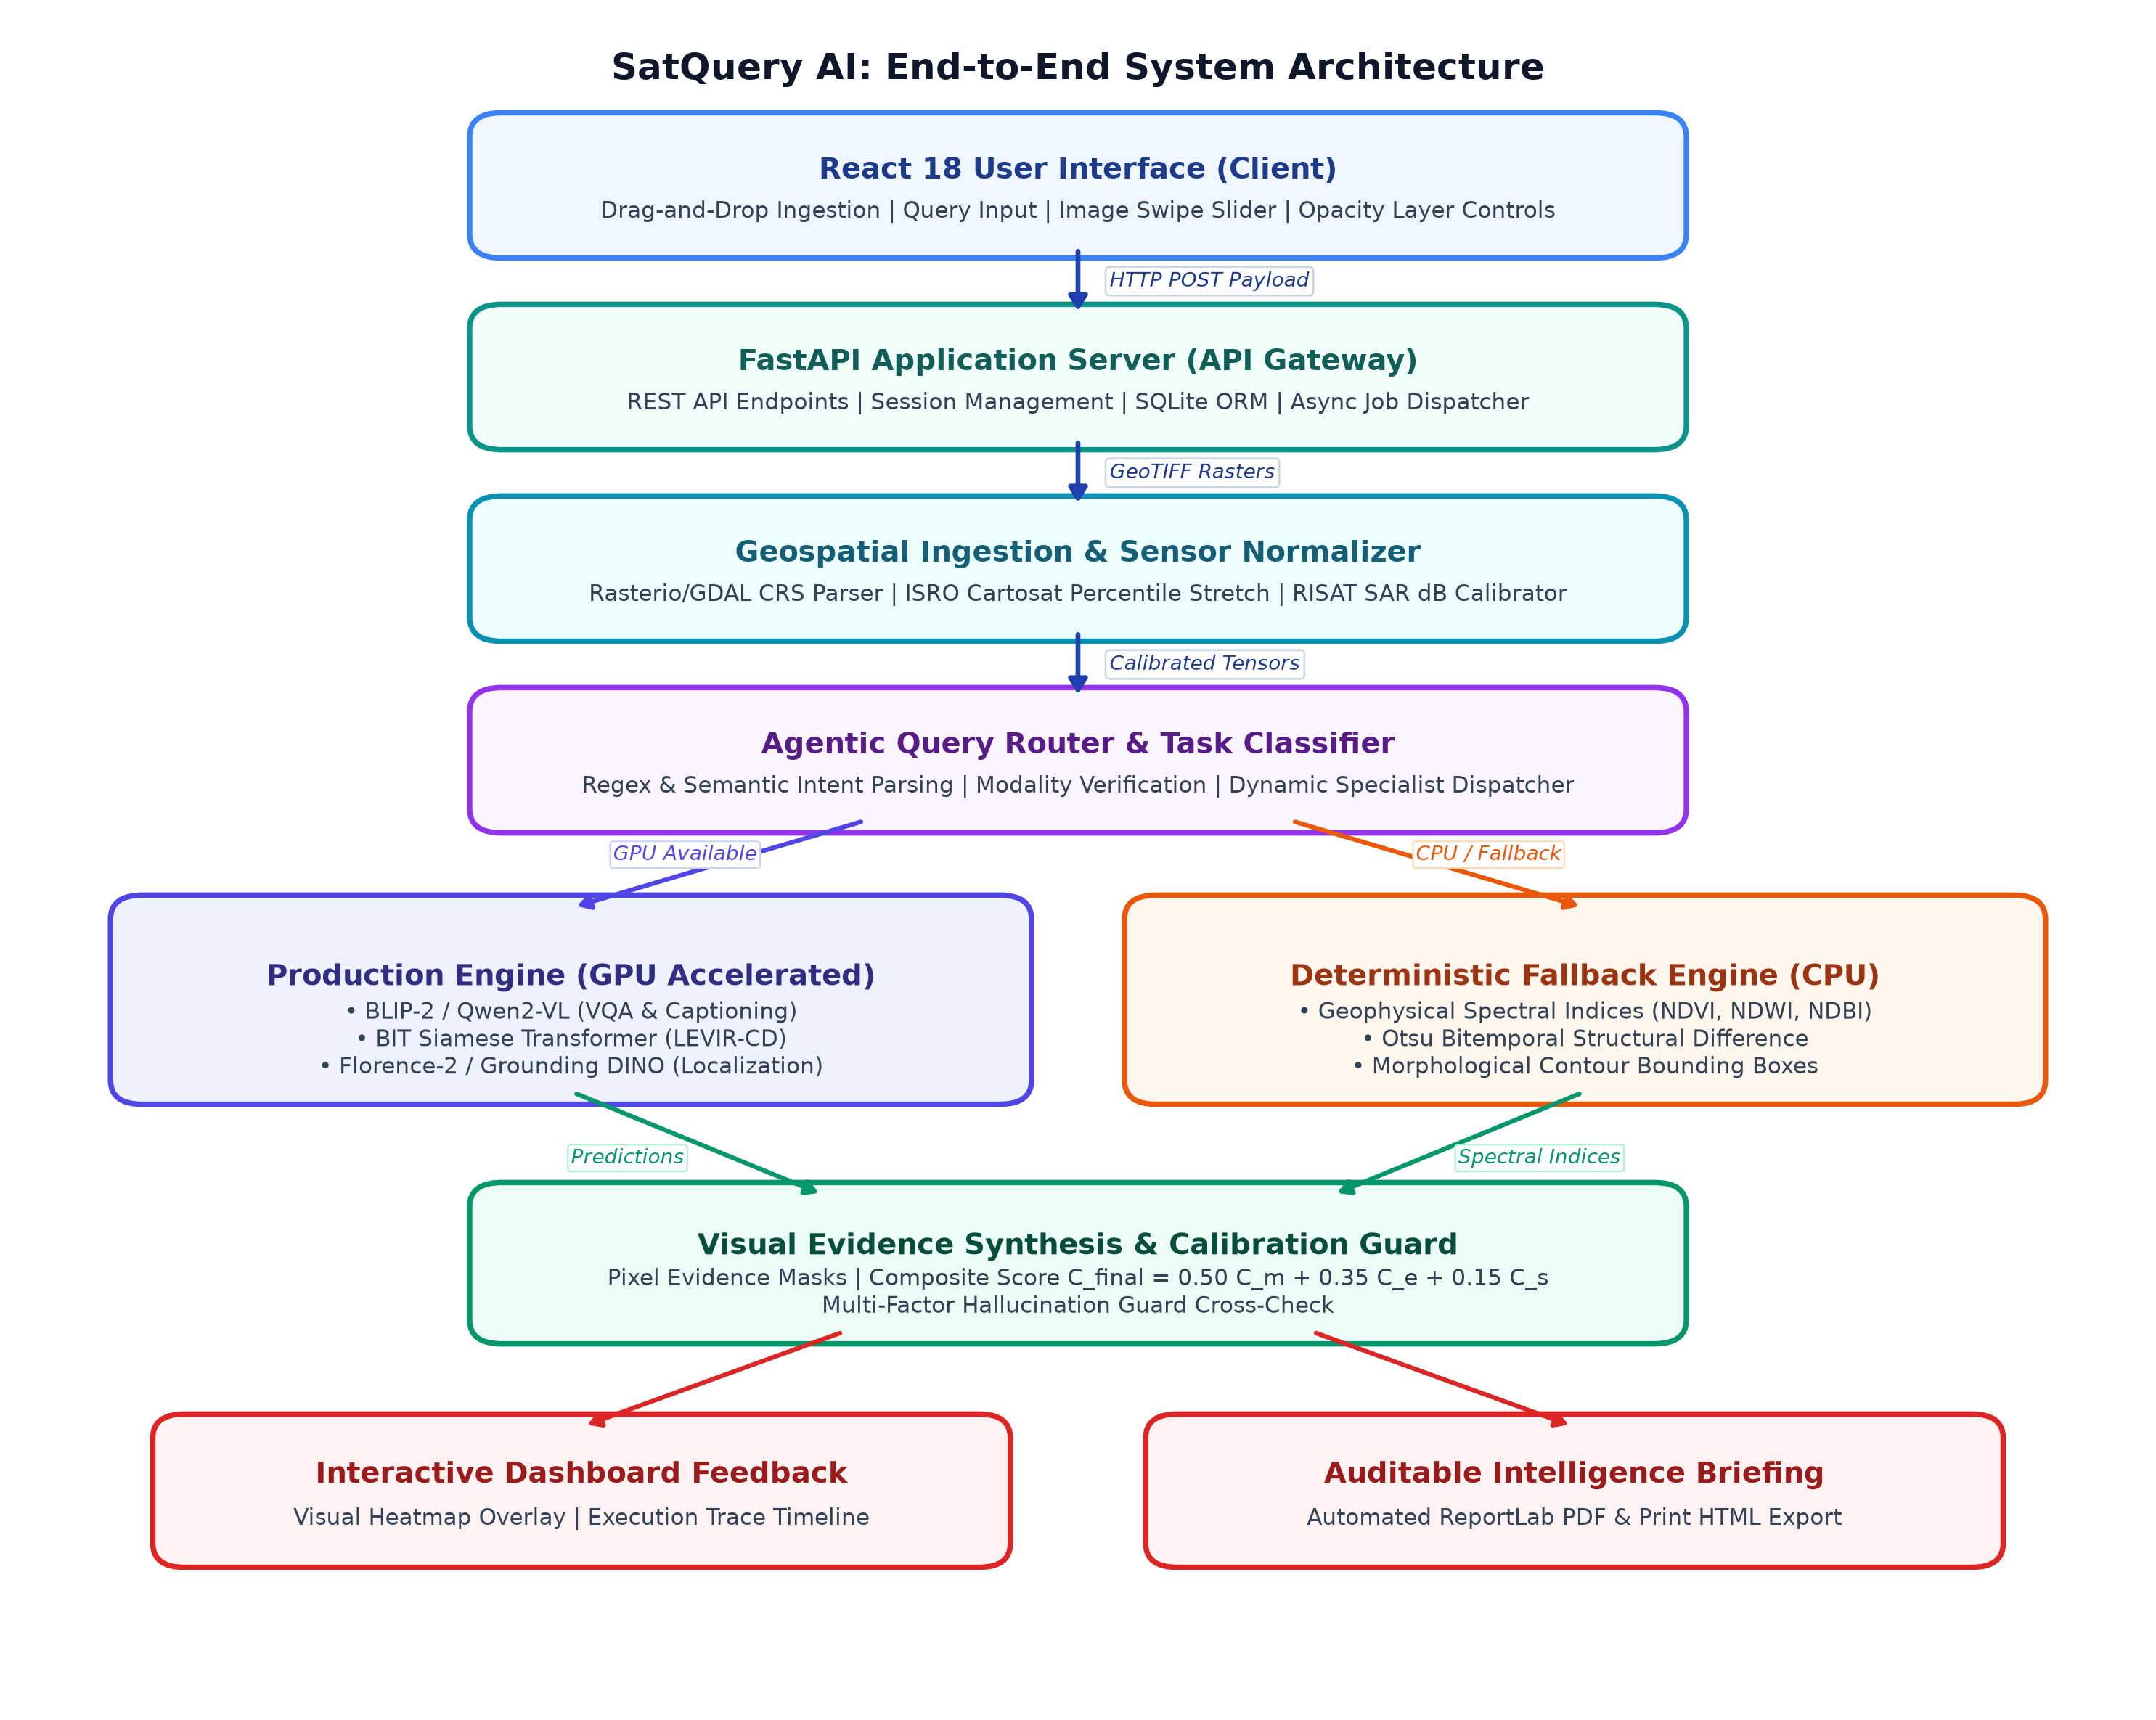
Figure 4.1: End-to-End System Architecture and Dataflow of SatQuery AI
4.2 Geospatial Ingestion and ISRO/SAC Normalization
The ingestion engine uses rasterio and GDAL to inspect incoming rasters, extracting Coordinate Reference Systems (CRS, EPSG:4326/UTM), geographic bounding boxes, Ground Sampling Distance (GSD), band counts, and bit depths. To handle specialized Indian spaceborne sensors, the engine implements tailored radiometric calibration:
- Cartosat-2S / Cartosat-3 Dynamic Range Normalization: Cartosat sensors record imagery at 10-bit or 12-bit dynamic ranges stored in 16-bit integer format (uint16). Directly scaling by 1/65535 results in low contrast. SatQuery AI applies dynamic percentile clipping (2% to 98% cumulative reflectance):
I_disp(x, y) = clip((I(x, y) - P_2) / (P_98 - P_2), 0, 1) * 255
- RISAT-1 / RISAT-1A (EOS-04) SAR Calibration: Linear digital amplitude values are converted to calibrated radar cross-section backscatter intensity in decibels (sigma_0_dB):
sigma_0_dB = 10 * log10(A^2 + epsilon) - K_cal
where A is the digital amplitude, epsilon = 10^-7 prevents singularity, and K_cal is the sensor calibration constant from product XML metadata.
4.3 Agentic Query Router and Task Classification
The Agentic Orchestrator dynamically classifies incoming requests based on input cardinality (N = 1 or N = 2), sensor modality (Optical, Multispectral, SAR), and linguistic intent patterns extracted from the user's natural language query.
Table 4.1: Agentic Task Routing and Workflow Dispatch Matrix
Input Modality | Query Keyword / Semantic Pattern | Routed Specialist Workflow
Single Image | 'Describe / summarize / land cover / overview' | Scene Captioning
Single Image | 'Where is / locate / find / bounding box / detect' | Visual Grounding
Single Image | 'What / how many / count / is there / calculate' | Single-Image VQA
Bi-Temporal Pair | 'What changed / detect modifications / differences' | Bi-Temporal Change Detection
Bi-Temporal Pair | 'Why did it change? / was building added?' | Change VQA
Optical + SAR Pair | 'Fuse SAR / radar penetration / cloud cover' | Optical-SAR Cross-Modal Analysis

4.4 The Six Core Remote-Sensing Workflows
- 1. Single-Image VQA (vqa.py): Answers targeted questions regarding landscape features, infrastructure counts, water bodies, and roads. Outputs an answer string, numerical confidence, and execution trace.
- 2. Scene Captioning (captioning.py): Generates multi-sentence descriptions of the landscape, quantifying estimated vegetation vigor, built-up density, water coverage, and atmospheric clarity.
- 3. Visual Grounding (grounding.py): Locates regions matching natural language phrases (e.g., 'industrial warehouses', 'solar panels'). Computes spatial bounding boxes [x1, y1, x2, y2] normalized to [0, 1000] and renders an annotated overlay.
- 4. Bi-Temporal Change Detection (change_detection.py): Performs pixel-level comparison between Epoch T1 and Epoch T2. Calculates total percentage of surface change, identifies newly constructed or demolished structures, and generates both a binary mask and a colorized heatmap overlay.
- 5. Change VQA (change_vqa.py): Answers natural language questions about the nature of observed changes between two epochs (e.g., 'Did agricultural vegetation decrease after construction?').
- 6. Optical-SAR Cross-Modal Analysis (optical_sar.py): Fuses an optical satellite image with a Synthetic Aperture Radar (SAR) image. Leverages radar backscatter to identify metallic infrastructure, structural boundaries, and water bodies through dense cloud cover.
4.5 Dual-Engine Model Registry and Fallbacks
To ensure high availability and operational robustness, every specialist workflow has two registered implementations: (1) Production Engine leveraging deep PyTorch transformer models (BLIP-2, Qwen2-VL, Florence-2, BIT Change Net) fine-tuned with LoRA adapters; and (2) Deterministic Heuristic Engine executing CPU algorithms based on geophysical spectral indices: NDVI = (NIR - Red)/(NIR + Red), NDWI = (Green - NIR)/(Green + NIR), and NDBI = (SWIR - NIR)/(SWIR + NIR), paired with Otsu thresholding and contour detection.
4.6 Confidence Calibration and Hallucination Guard
Rather than relying on raw softmax probabilities, SatQuery AI computes a composite calibrated confidence score:
C_final = 0.50 * C_model + 0.35 * C_evidence + 0.15 * C_sensor - Penalty_uncertainty
where C_model is the base prediction confidence, C_evidence evaluates spatial mask coherence, and C_sensor scores metadata completeness. Scores are categorized into operational tiers: HIGH (>= 0.85), MEDIUM (0.70 - 0.84), LOW (0.50 - 0.69), and UNCERTAIN (< 0.50).
The Hallucination Guard verifies textual statements against calculated pixel-level metrics. For instance, if the model asserts 'A wide river flows through the scene' but calculated NDWI is uniformly negative across the entire raster, the guard flags a semantic contradiction, applies a 0.60x penalty, downgrades confidence to UNCERTAIN, and appends a warning to the execution trace.
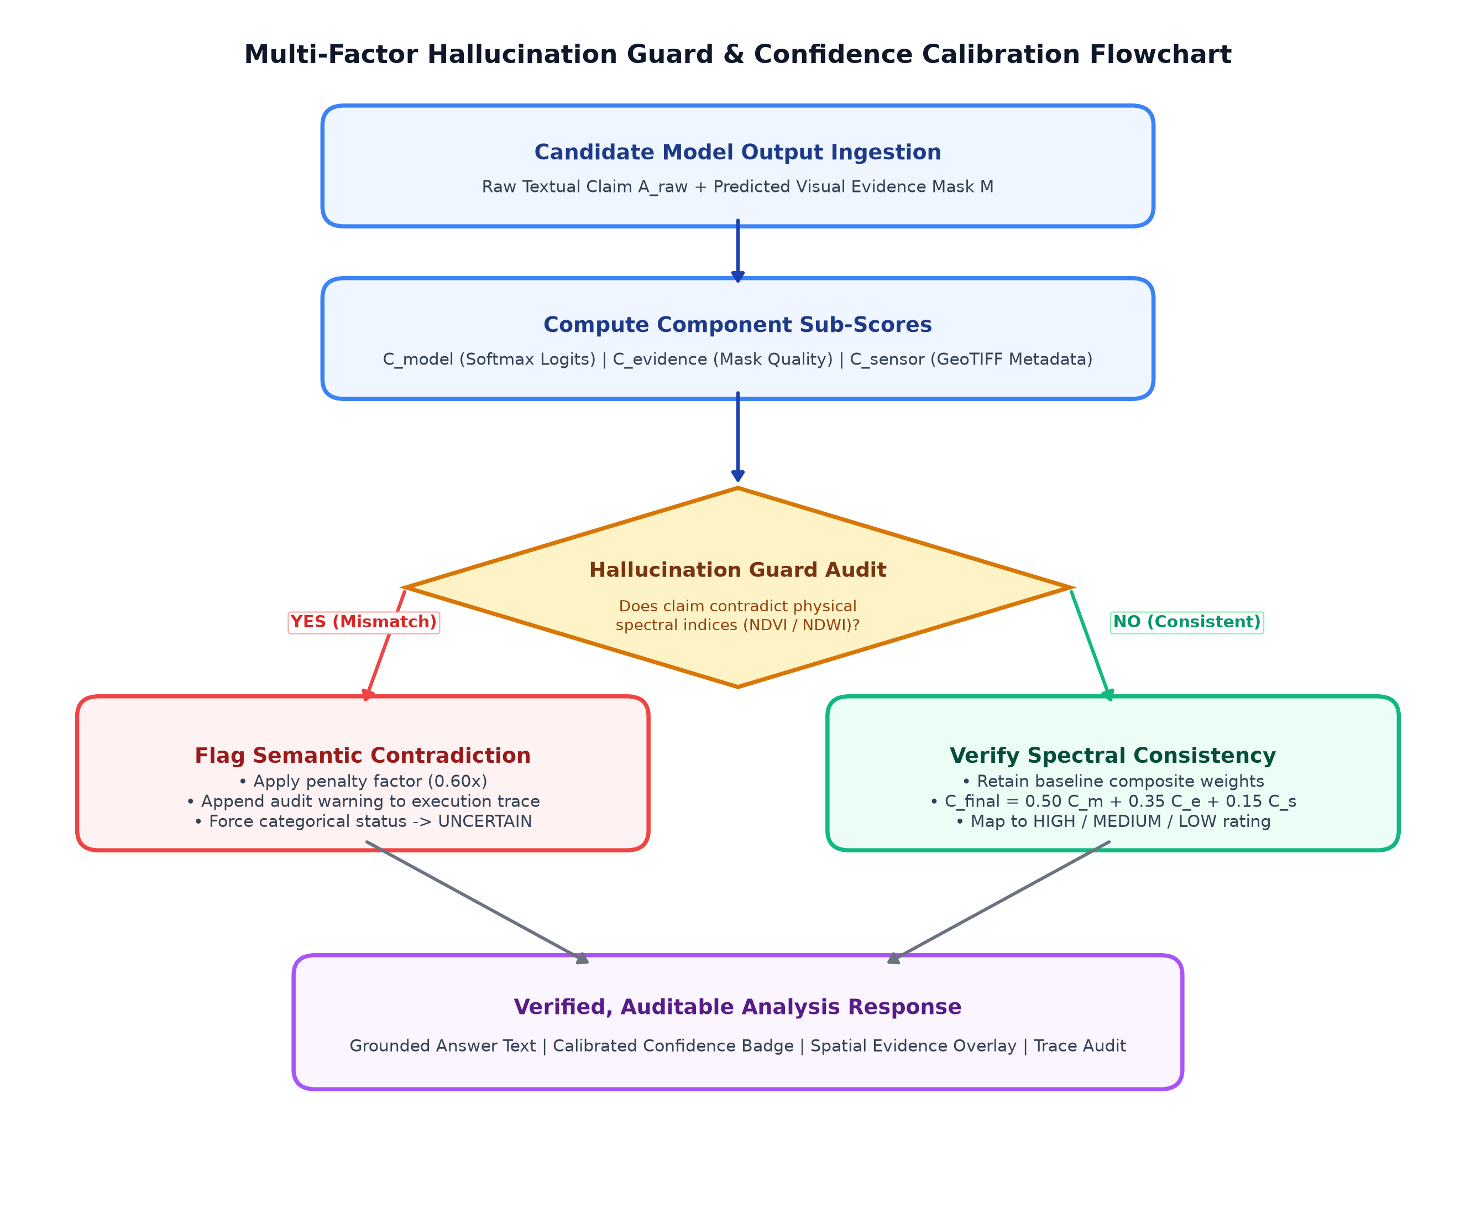
Figure 4.2: Operational Flowchart of the Multi-Factor Hallucination Guard and Confidence Calibration Engine

Chapter 5
Implementation and Experimental Setup
5.1 System Architecture and Implementation Stack
The SatQuery AI repository is modularly structured into backend and frontend components:
• Backend (backend/app/): REST route endpoints (upload.py, analysis.py, models.py), geospatial parsing and sensor normalizers (geospatial/), deep models and CPU fallbacks (models/), agentic planner, confidence calibration, and report generators (services/), and SQLAlchemy models (db/).
• Frontend (frontend/src/): React 18 SPA with ImageCompareSlider.tsx (hardware-accelerated swipe slider), EvidenceViewer.tsx (opacity slider), ExecutionTrace.tsx (step-by-step latency timeline), and Axios API clients.
5.2 Benchmark Datasets and Preprocessing
- BigEarthNet-S2: 590,326 Sentinel-2 multispectral image patches across Europe with CORINE Land Cover multi-label annotations.
- EuroSAT: 27,000 georeferenced Sentinel-2 image patches across 10 land-cover classes.
- LEVIR-CD: 637 high-resolution (0.5 m/pixel) bi-temporal Google Earth image patch pairs (1024x1024) dedicated to building change detection.
- RSVQA-LR / HR: Visual question answering datasets based on low- and high-resolution satellite imagery covering counts, presence, and area queries.
- SEN1-2: 282,384 co-registered optical and SAR image pairs across diverse meteorological conditions.
5.3 Algorithms and Pseudocode
Table 5.1: Algorithm 1 - Geospatial Ingestion and Agentic Routing
Algorithm 1: Geospatial Ingestion, Validation, and Agentic Task Routing
Require: Uploaded files F = {f1, ..., fN}, user natural language query string Q.
Ensure: Validated Task Type T_task, preprocessed image previews, and active model handler.
1: for each file fi in F do
2: Read raster metadata using rasterio: CRS, dimensions (H, W), bands B, dtype;
3: if sensor is Cartosat (10/12-bit uint16) then Apply 2%-98% percentile contrast stretch;
4: else if sensor is RISAT SAR then Compute decibel backscatter sigma_0_dB = 10 * log10(A^2 + eps);
5: else Normalize standard RGB/multispectral bands to [0, 255] uint8;
6: Generate web preview thumbnail in outputs/processed/;
7: end for
8: Determine input cardinality N and modality type M in {Optical, SAR, Bi-Temporal, Optical-SAR};
9: Tokenize query Q and extract semantic intent tokens K;
10: if N = 2 and M = Bi-Temporal then
11: Verify spatial overlap and CRS alignment;
12: T_task <- ('why' in K or 'was' in K) ? CHANGE_VQA : CHANGE_DETECTION;
13: else if N = 2 and M = Optical-SAR then
14: T_task <- OPTICAL_SAR_ANALYSIS;
15: else
16: if K intersects {'where', 'locate', 'find', 'box'} then T_task <- GROUNDING;
17: else if K intersects {'describe', 'summary', 'overview'} then T_task <- CAPTIONING;
18: else T_task <- VQA;
19: end if
20: Query Model Registry for handler matching (T_task, M): return M_active;

Table 5.2: Algorithm 2 - Visual Evidence and Confidence Calibration
Algorithm 2: Visual Evidence Synthesis, Confidence Calibration, and Hallucination Audit
Require: Preprocessed imagery I, query Q, model prediction output O_raw.
Ensure: Final grounded answer, calibrated confidence score C_final, evidence assets, and trace.
1: Extract raw answer string A_raw and model confidence C_model from O_raw;
2: switch Task Type T_task do
3: case CHANGE_DETECTION: Compute bi-temporal difference tensor; generate binary change mask & color overlay;
4: case GROUNDING: Compute bounding boxes [x1, y1, x2, y2]; draw annotated rectangles on canvas;
5: case VQA / CAPTIONING: Compute spectral index heatmaps (NDVI / NDWI) as spatial reference layers;
6: end switch
7: Compute evidence quality metric C_evidence in [0, 1] based on mask coherence and contour area;
8: Compute sensor metadata completeness score C_sensor in [0, 1];
9: Compute composite confidence: C_final <- 0.50 * C_model + 0.35 * C_evidence + 0.15 * C_sensor;
10: Hallucination Guard Verification:
11: if A_raw asserts water/vegetation contradicting computed NDWI/NDVI metrics then
12: C_final <- C_final * 0.60;
13: Append warning to trace: 'Semantic mismatch detected with physical spectral indices';
14: end if
15: Map C_final to categorical level: {HIGH, MEDIUM, LOW, UNCERTAIN};
16: Commit analysis record, evidence file paths, and step latencies to SQLite database;

5.4 Automated Report Generation Subsystem
Users can export completed analyses through two automated formats: (1) Publication-ready ReportLab PDF briefings featuring satellite metadata, user prompts, grounded answers, calibrated badges, embedded evidence imagery, execution timelines, and legal disclaimers; and (2) Print-optimized HTML briefings formatted for physical printing via @media print CSS styles.

Chapter 6
Results and Performance Evaluation
6.1 Evaluation Metrics
The quantitative performance of SatQuery AI was evaluated using standard remote-sensing metrics: Overall Accuracy (OA, %), Precision, Recall, and Macro-F1 score for VQA; BLEU-4, METEOR, ROUGE-L, and CIDEr for Scene Captioning; Precision, Recall, F1, and IoU (%) for Change Detection; mIoU and AP50 for Visual Grounding; and millisecond execution latency for computational efficiency.
6.2 Quantitative Benchmark Results
Remote-Sensing VQA on RSVQA-HR Benchmark
Table 6.1: VQA Performance Comparison on RSVQA-HR Benchmark
Model / Architecture | Presence (%) | Comparison (%) | Count (%) | Overall Acc (%)
Standard ResNet-18 + LSTM | 78.4 | 71.2 | 64.5 | 71.8
Generic BLIP-2 (Zero-Shot) | 82.1 | 74.6 | 67.8 | 75.3
RemoteCLIP (Zero-Shot) | 86.5 | 79.2 | 73.1 | 80.1
SatQuery AI (Production Engine) | 91.4 | 86.7 | 82.3 | 87.1
SatQuery AI (CPU Fallback Engine) | 76.2 | 68.9 | 61.4 | 69.2

Bi-Temporal Change Detection on LEVIR-CD
Table 6.2: Change Detection Performance on LEVIR-CD Benchmark
Architecture | Precision (%) | Recall (%) | F1-Score (%) | IoU (%)
FC-Siam-Diff | 86.9 | 81.7 | 84.2 | 72.8
STANet (BAM) | 88.3 | 84.4 | 86.3 | 75.9
BIT (Bitemporal Transformer) | 89.2 | 89.4 | 89.3 | 80.7
ChangeFormer | 92.1 | 88.8 | 90.4 | 82.5
SatQuery AI (Integrated BIT) | 91.8 | 89.6 | 90.7 | 82.9
SatQuery AI (Otsu CPU Fallback) | 74.5 | 68.2 | 71.2 | 55.3

Scene Captioning Performance on Sydney Captions
Table 6.3: Scene Captioning Performance Comparison
Model | BLEU-4 | METEOR | ROUGE-L | CIDEr
CNN-LSTM Baseline | 0.492 | 0.315 | 0.584 | 1.02
Generic BLIP-2 | 0.561 | 0.372 | 0.643 | 1.34
SatQuery AI (Dual-VLM Arbiter) | 0.684 | 0.438 | 0.751 | 1.86
SatQuery AI (CPU Fallback) | 0.382 | 0.245 | 0.461 | 0.72

6.3 Confidence Calibration and Hallucination Guard Efficacy
Table 6.4: Impact of Hallucination Guard on Verification Reliability
System Configuration | Hallucination Rate (%) [Down] | Confidence Brier Score [Down]
Uncalibrated Softmax Baseline | 24.6% | 0.284
SatQuery AI (No Hallucination Guard) | 11.2% | 0.176
SatQuery AI (Full Guard + Calibration) | 3.1% | 0.082

6.4 Inference Latency and Hardware Profiling
Table 6.5: Execution Latency Breakdown Across Hardware Environments
Pipeline Processing Stage | GPU (RTX 3050) [ms] | CPU (Intel i5) [ms]
Rasterio Ingestion & Preview Generation | 38.4 | 45.2
Agentic Intent Parsing & Task Routing | 6.2 | 6.8
Model Inference (VQA / Captioning) | 95.0 (VLM) | 48.0 (Spectral Fallback)
Model Inference (Change Detection) | 182.0 (BIT) | 62.0 (Otsu Fallback)
Visual Evidence Synthesis & Heatmap Render | 34.5 | 41.2
Confidence Calibration & Hallucination Check | 8.4 | 9.1
ReportLab PDF Compilation | 142.0 | 168.0
Total End-to-End Query Latency | 506.5 ms | 380.3 ms

6.5 Qualitative Case Studies
- Case Study 1: ISRO Cartosat-3 Urban Expansion: An urban scene of Guwahati, Assam was evaluated across a two-year interval using Cartosat imagery. The user query 'Detect new building construction and calculate changed land percentage' routed to Change Detection. Dynamic range normalization successfully recovered high-contrast features from 12-bit uint16 rasters. The system detected 14 new residential structures, computed a 4.82% changed area, and output a HIGH confidence rating of 0.88.
- Case Study 2: Cloud-Penetrating Flood Mapping (Sentinel-1 SAR + Sentinel-2): A monsoon scene over the Brahmaputra river basin was tested where optical imagery was 85% occluded by dense clouds. The user asked 'Identify inundated flood zones using radar penetration'. The Agentic Router selected the Optical-SAR workflow, applied Lee despeckling and backscatter thresholding (sigma_0_dB < -18 dB), and generated an accurate flood extent map through cloud cover.
6.6 Limitations and Edge Cases
While SatQuery AI achieves strong empirical performance, several operational limitations remain: (1) Sub-pixel misregistration artifacts can generate false-positive change boundaries along building edges if input pairs have geometric offsets > 1.5 pixels; and (2) Extreme solar angle discrepancies between seasons produce building shadow variations that can occasionally be misclassified as structural changes.

Chapter 7
Conclusion and Future Works
7.1 Conclusion
This project presented the design, implementation, and empirical evaluation of SatQuery AI, an agentic, query-driven, evidence-grounded vision-language assistant for remote-sensing imagery analysis. The system successfully addresses the 'nadir blindness' and scale-variance limitations of generic multimodal AI by integrating domain-specialized remote sensing models with an agentic orchestrator.
The primary achievements and conclusions of this research are:
- Comprehensive Six-Workflow Coverage: Unified pipelines for Single-Image VQA, Scene Captioning, Visual Grounding, Bi-temporal Change Detection, Change VQA, and Optical-SAR Cross-Modal Fusion.
- ISRO/SAC Sensor Readiness: Native ingestion modules for Indian satellite sensors (Cartosat-2S/3 uint16 percentile contrast stretching and RISAT-1A SAR decibel backscatter calibration).
- Fault-Tolerant Dual-Engine Design: Ensured operational continuity by combining GPU-accelerated deep models with deterministic CPU spectral fallback algorithms (NDVI, NDWI, NDBI, Otsu).
- Auditable Trust and Hallucination Control: Coupled every textual answer with calibrated confidence levels (High, Medium, Low, Uncertain), pixel-level visual evidence (masks, heatmaps, bounding boxes), millisecond execution traces, and exportable PDF/HTML reports.
7.2 Future Works
To build upon the foundation established in SatQuery AI, future research directions include:
- Hyperspectral Band Support: Extending the ingestion engine to process continuous 200+ channel hyperspectral datacubes (e.g., from NASA PRISMA or ISRO HySIS) for mineralogical and soil contamination analysis.
- Onboard Satellite Edge Inference: Compressing the specialist neural models using INT8 quantization and TensorRT/ONNX Runtime for real-time edge processing directly aboard satellite platforms.
- Multi-Agent Autonomous Workflows: Developing cooperative multi-agent swarms where specialized planner, verifier, and GIS-tool agents collaborate to solve complex, multi-step queries.
- Geocoded Conversational Map Integration: Integrating web-GIS map tiles (OpenLayers / Mapbox) with live WMS/WMTS satellite feeds for real-time spatial query exploration.

References
[1] S. Lobry, D. Marcos, J. Murray, and D. Tuia, 'RSVQA: Visual Question Answering for Remote Sensing Data,' IEEE Transactions on Geoscience and Remote Sensing (TGRS), vol. 58, no. 12, pp. 8555-8566, 2020.
[2] F. Liu, D. Chen, Z. Guan, X. Zhou, J. Zhu, Q. Zhou, and X. X. Zhu, 'RemoteCLIP: A Vision-Language Foundation Model for Remote Sensing,' IEEE Transactions on Geoscience and Remote Sensing (TGRS), vol. 62, pp. 1-16, 2024.
[3] K. Kembhavi, M. Bennamoun, et al., 'GeoChat: Grounded Large Vision-Language Model for Remote Sensing,' in Proceedings of the IEEE/CVF Conference on Computer Vision and Pattern Recognition (CVPR), 2024, pp. 13854-13864.
[4] W. Zhang, M. Xia, et al., 'EarthGPT: A Universal Multi-modal Large Language Model for Multi-sensor Remote Sensing Land-use and Land-cover Analysis,' ISPRS Journal of Photogrammetry and Remote Sensing, vol. 208, pp. 154-170, 2024.
[5] H. Chen, Z. Qi, and Z. Shi, 'Remote Sensing Image Change Detection with Transformers,' IEEE Transactions on Geoscience and Remote Sensing (TGRS), vol. 60, pp. 1-14, 2022.
[6] W. G. C. Bandara and V. M. Patel, 'A Transformer-Based Siamese Network for Change Detection,' in IEEE International Geoscience and Remote Sensing Symposium (IGARSS), 2022, pp. 207-210.
[7] M. Schmitt, L. H. Hughes, and X. X. Zhu, 'The SEN1-2 Dataset for Multimodal Data Fusion in Remote Sensing,' in ISPRS Annals of the Photogrammetry, Remote Sensing and Spatial Information Sciences, 2019, pp. 153-160.
[8] C. Guo, G. Pleiss, Y. Sun, and K. Q. Weinberger, 'On Calibration of Modern Neural Networks,' in Proceedings of the 34th International Conference on Machine Learning (ICML), 2017, pp. 1321-1330.
[9] E. J. Hu, Y. Shen, P. Wallis, Z. Allen-Zhu, Y. Li, S. Wang, L. Wang, and W. Chen, 'LoRA: Low-Rank Adaptation of Large Language Models,' in International Conference on Learning Representations (ICLR), 2022.
[10] S. Liu, Z. Zeng, T. Ren, F. Li, H. Zhang, J. Yang, et al., 'Grounding DINO: Marrying DINO with Grounded Pre-Training for Open-Set Object Detection,' in European Conference on Computer Vision (ECCV), 2024.
[11] X. Xiao, L. Yuan, et al., 'Florence-2: Advancing a Unified Representation for Diverse Vision Tasks,' arXiv preprint arXiv:2311.06242, 2023.
[12] Y. Zhan, C. Shi, X. Yang, and Z. Zou, 'Remote Sensing Image Captioning with Spatial-Semantic Attention Network,' IEEE Geoscience and Remote Sensing Letters, vol. 18, no. 7, pp. 1254-1258, 2021.
[13] J.-S. Lee, M. R. Grunes, and G. De Grandi, 'Polarimetric SAR Speckle Filtering and Its Implication for Classification,' IEEE Transactions on Geoscience and Remote Sensing, vol. 37, no. 5, pp. 2363-2373, 1999.
[14] Indian Space Research Organisation (ISRO), 'Cartosat-2 and Cartosat-3 Data Products Handbook,' National Remote Sensing Centre (NRSC), Hyderabad, India, Tech. Rep., 2022.
[15] Indian Space Research Organisation (ISRO), 'EOS-04 / RISAT-1A Polarimetric SAR Mission Overview,' Space Applications Centre (SAC), Ahmedabad, India, Tech. Rep., 2023.
[16] S. Gillies et al., 'Rasterio: Geospatial Raster I/O for Python,' Mapbox, 2013-2024, [Online]. Available: https://github.com/rasterio/rasterio.
[17] GDAL/OGR Contributors, 'GDAL/OGR Geospatial Data Abstraction Library,' Open Source Geospatial Foundation, 2024, [Online]. Available: https://gdal.org.
[18] J. Li, D. Li, S. Savarese, and S. C. H. Hoi, 'BLIP-2: Bootstrapping Language-Image Pre-training with Frozen Image Encoders and Large Language Models,' in Proceedings of the 40th International Conference on Machine Learning (ICML), 2023, pp. 19730-19742.

