Facebook Social Circles Network Analysis
Graph Analysis Using Gephi

1. Dataset and Methodology
The dataset analysed in this report is the SNAP Facebook Social Circles network. It is a combined ego-network drawn from a survey of Facebook users, where each node represents a user and each undirected edge represents a friendship.
The combined graph aggregates the ego-networks of ten survey participants into a single connected social graph.
After import into Gephi as an undirected graph, the network was confirmed to contain 4,039 nodes and 88,234 edges, forming a single connected component.
The Yifan Hu layout algorithm was chosen for the initial spatial arrangement because of its efficiency on large graphs.
Statistics for degree, betweenness centrality, and Louvain modularity were computed using Gephi's built-in algorithms.

Network Overview
Nodes | 4,039
Edges | 88,234
Connected components | 1
Density | 0.011
Average degree | 43.69
Average clustering coefficient | 0.61
Communities (Louvain) | 15
Modularity | 0.835

2. Network Visualisation
Facebook network rendered in Gephi's Preview mode after applying the Yifan Hu layout and colouring nodes by their detected community. The visualisation immediately reveals the network's most striking property: a small number of densely connected social circles, each anchored by one or more high-degree hub users, loosely interconnected through bridging relationships. The community structure detected by the modularity algorithm corresponds visibly to these clusters.
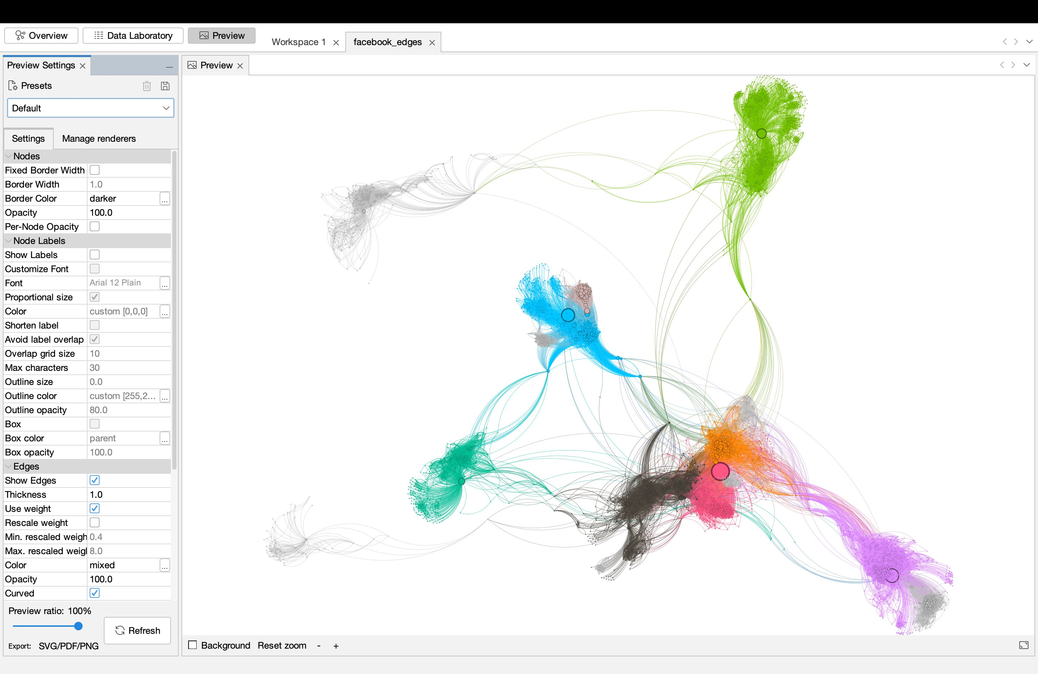

3. Degree Analysis
Degree counts the number of direct friendships each user has. The five most connected users in this network are listed below.
Rank | User ID | Degree
1 | 107 | 1,045
2 | 1684 | 792
3 | 1912 | 755
4 | 3437 | 547
5 | 0 | 347
User 107 is the dominant hub of this network, with 1,045 friends — over a quarter of the entire user base. The top five users all have degrees in the hundreds, far above the network-wide average of 43.7.
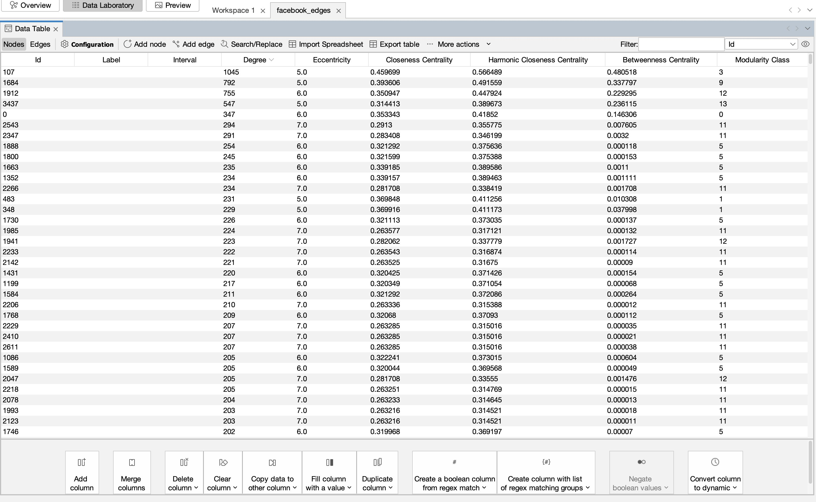

4. Betweenness Centrality and Bridge Nodes
Betweenness centrality measures how often a node lies on the shortest path between other pairs of nodes. In a friendship network, users with high betweenness act as bridges — they connect otherwise separated social groups, and information flowing across the network passes disproportionately through them.
Rank | User ID | Betweenness | Also top-5 by degree?
1 | 107 | 0.481 | Yes
2 | 1684 | 0.338 | Yes
3 | 3437 | 0.236 | Yes
4 | 1912 | 0.229 | Yes
5 | 1085 | 0.149 | No — bridge node
The most analytically interesting result is user 1085. They rank fifth in betweenness centrality despite not appearing in the top five by degree. This is the textbook profile of a bridge node — a moderately connected user who is positioned strategically between communities, so a disproportionate share of social paths run through them. Conversely, user 0 has the fifth-highest degree but does not appear in the top-five by betweenness; they are popular within their immediate community but do not serve as a connector to other groups.

5. Community Detection
The Louvain modularity algorithm was applied with default parameters (resolution = 1.0). It produced 15 communities with a modularity score of 0.835. Modularity values above 0.4 indicate well-defined community structure, and a value above 0.7 is considered very strong; 0.835 is exceptionally high, meaning the network partitions almost perfectly into distinct social circles with dense internal friendships and sparse cross-group connections.
The five largest communities together account for over 60% of the network. This corresponds directly to the dataset's construction — each large community represents one of the original ego-networks (a user and their close friends) that were combined to form the graph.

6. Degree Filter and Network Comparison
A degree filter of Degree ≥ 5 was applied using Gephi's Topology filter, removing users with very few friendships from the visualisation. The filter retained 3,581 nodes (88.7% of the network) and 86,935 edges (98.5% of the original), removing 458 low-degree peripheral users while preserving virtually all of the social structure.
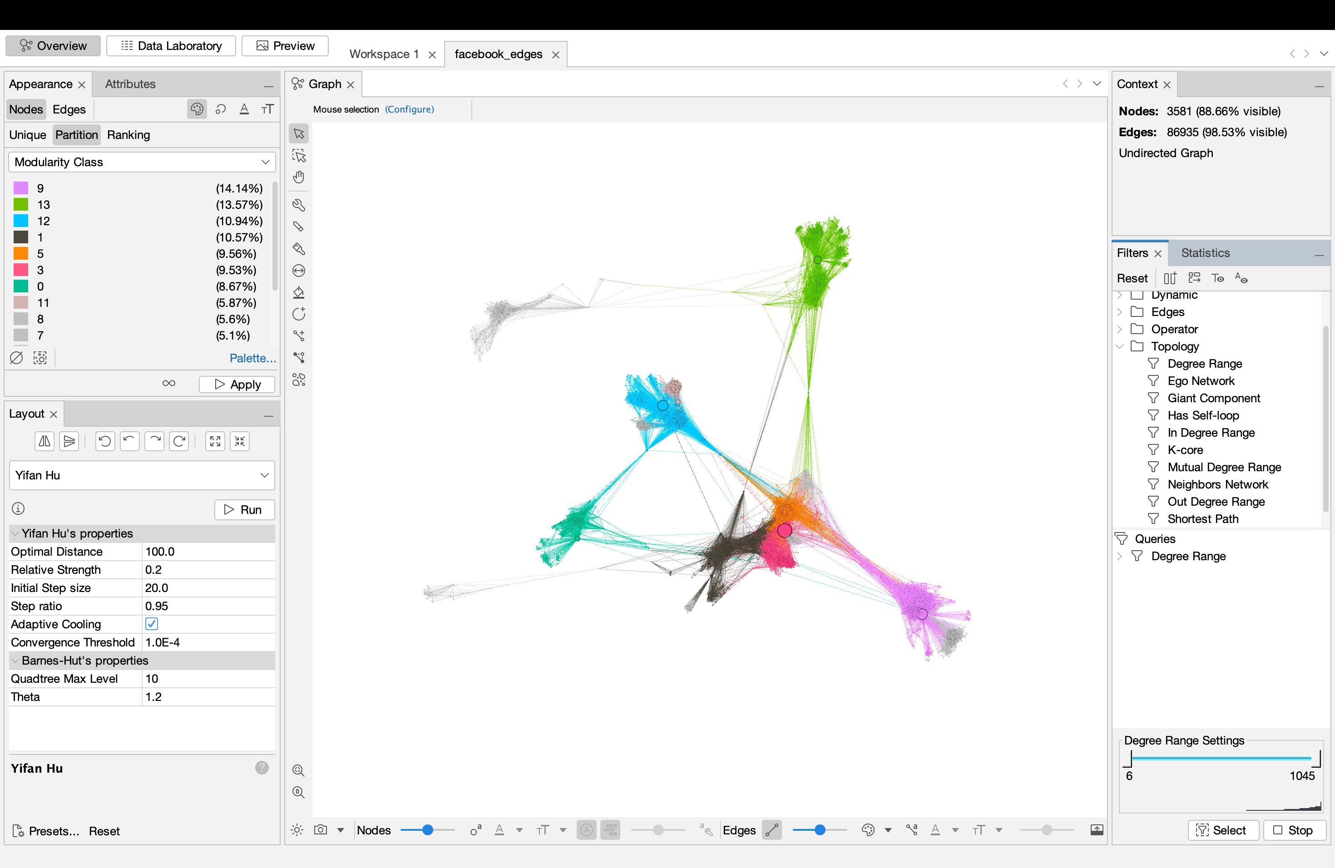

The comparison between the original and filtered networks reveals an important property: Removing all users with fewer than five friends:
- Eliminates 458 peripheral users (11.3% of nodes)
- Preserves 98.5% of the edges
- Does not break the network into disconnected components
- Leaves the visible community structure essentially unchanged
This indicates that the periphery contributes almost nothing to the structural backbone of the graph. The information in this network — which user belongs to which community, which users are bridges, where the hubs sit — is entirely contained in the core of well-connected users.

7. Key Insights
1. A single dominant user (User 107). User 107 is the most central figure across all measures: highest degree (1,045) and highest betweenness (0.481). They are simultaneously the most popular user and the most important structural connector in this network.
2. Bridges are not always hubs. User 1085 ranks fifth in betweenness despite not appearing in the top five by degree. This is a true bridge — fewer friends, but their friendships cross community boundaries. In a social network, bridges are critical for information diffusion across groups; identifying them requires looking beyond raw connection counts.
3. Strong, recoverable community structure (Q = 0.835). Louvain found 15 distinct communities with extremely high modularity, cleanly recovering the ego-network structure baked into the dataset. The five largest communities account for over 60% of users — these are the major social circles.
4. High clustering reflects real social behaviour. An average clustering coefficient of 0.61 confirms the small-world property typical of social networks: a user's friends are very likely to be friends with each other, forming triangle-rich neighbourhoods. This is the fingerprint of genuine human social organisation.
5. Structure lives in the core, not the periphery. Filtering out users with fewer than five friends removed 11% of users but only 1.5% of edges, with no impact on the visible community structure. Social cohesion in this graph is carried entirely by the well-connected core; the long tail of low-connection accounts is structurally irrelevant.

