**21/12/2023**

**Installation of PySpark (Windows)**

**Windows Installation**

The installation which is going to be shown is for the Windows Operating System. It consists of the installation of Java with the environment variable and Apache Spark with the environment variable.

**Java installation**

**Jdk**

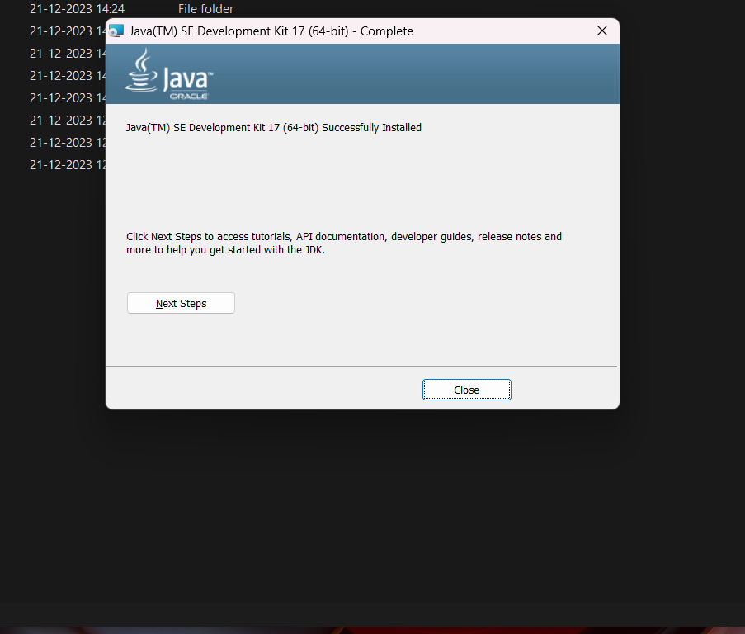

**Environmental setup:-**

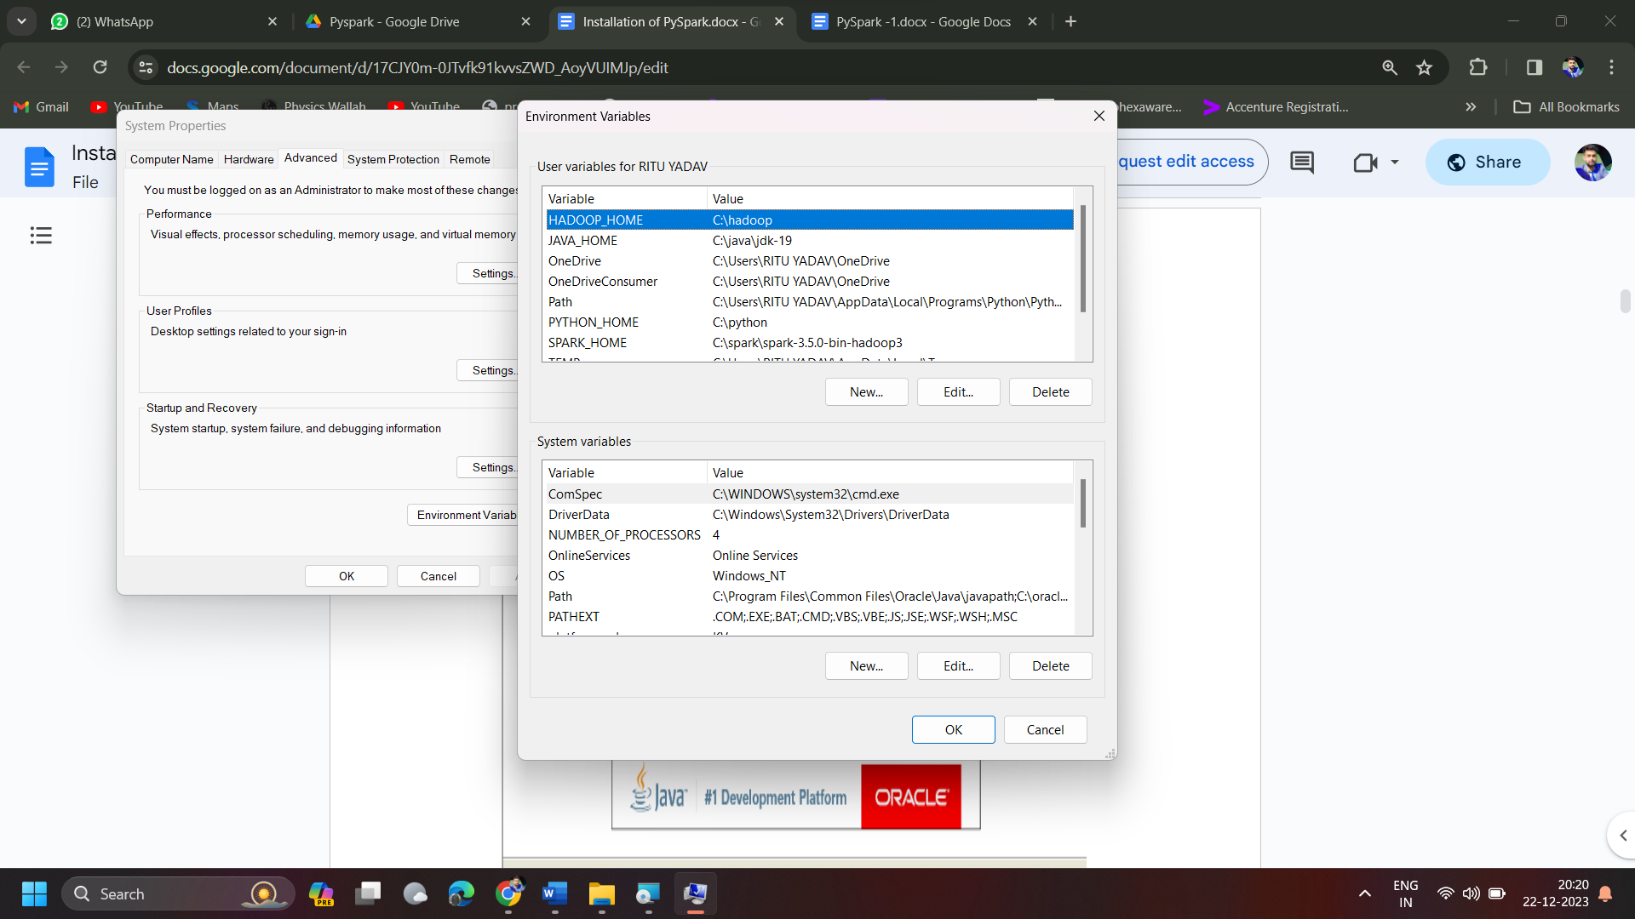

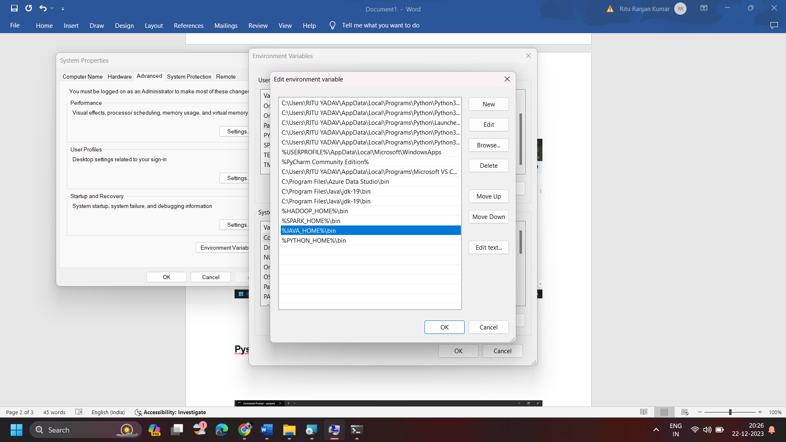

**Download Apache spark**



**Finalizing Pyspark Installation**

