**PYTHON ASSESSMENT**

**Date: -20/12/2023**

**Q1>Answer: -**

**Python module:** A Python module is a file containing Python definitions and statements. A module can define functions, classes, and variables. A module can also include runnable code. Grouping related code into a module makes the code easier to understand and use. It also makes the code logically organized.

**NumPy: -** NumPy is a Python library used for working with arrays.

It also has functions for working in domain of linear algebra, Fourier transform, and matrices.

NumPy was created in 2005 by Travis Oliphant. It is an open-source project and you can use it freely.

* **Pandas:-** It has a DataFrame object that is quick and effective, with both standard and custom indexing.
* Utilized for reshaping and turning of the informational indexes.
* For aggregations and transformations, group by data.
* It is used to align the data and integrate the data that is missing.
* Provide Time Series functionality.
* Process a variety of data sets in various formats, such as matrix data, heterogeneous tabular data, and time series.
* Manage the data sets' multiple operations, including sub setting, slicing, filtering, group By, reordering, and **reshaping.**

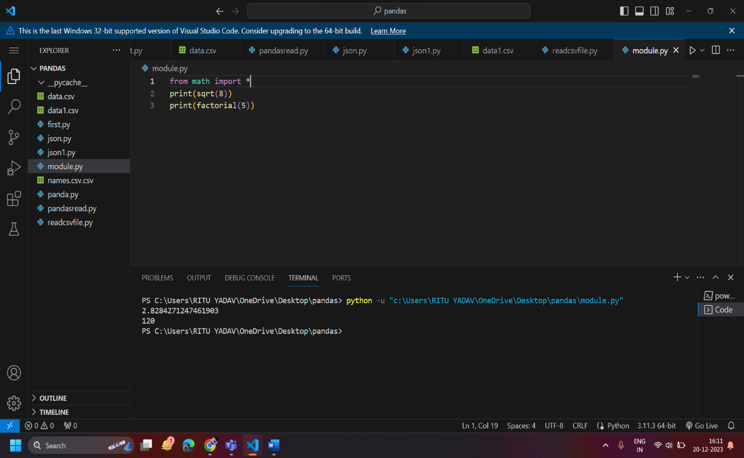

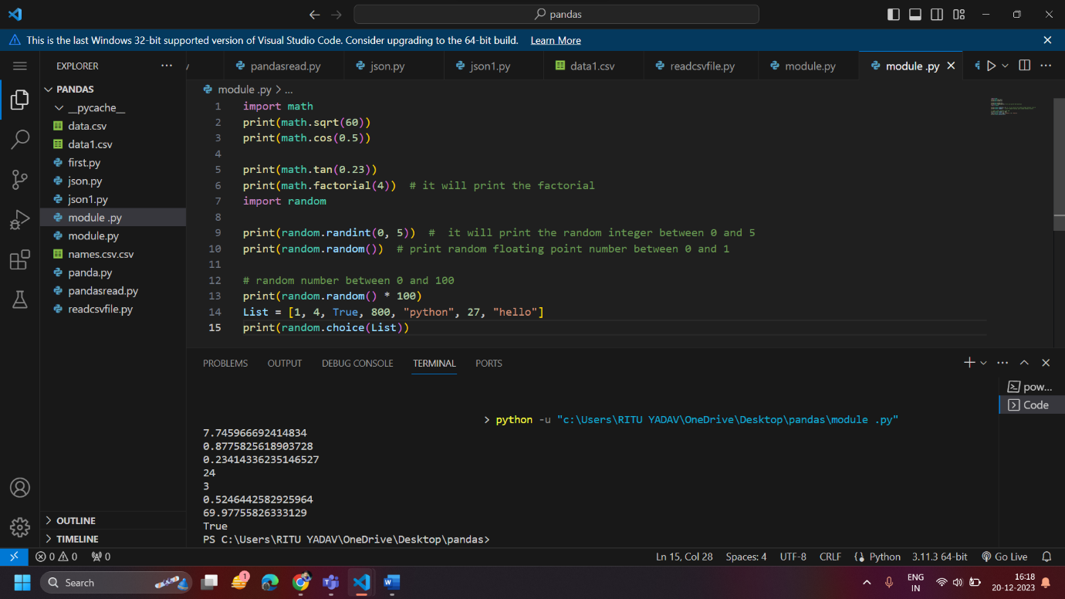

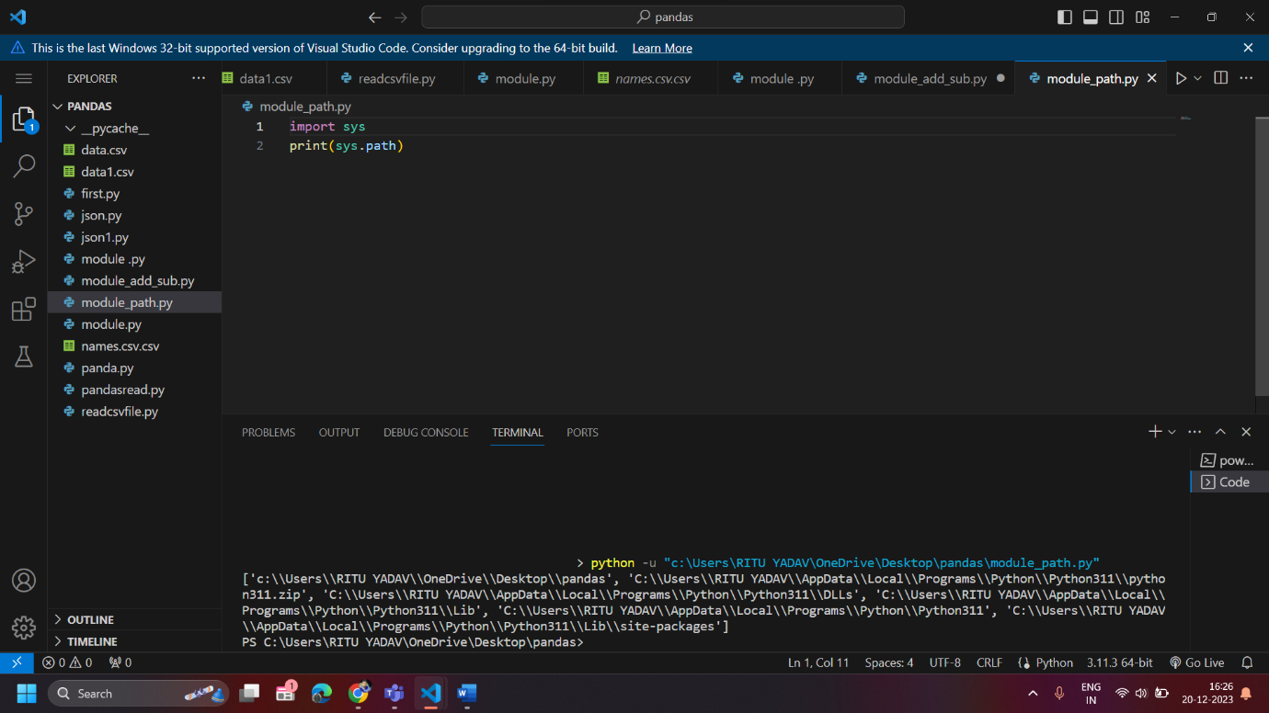

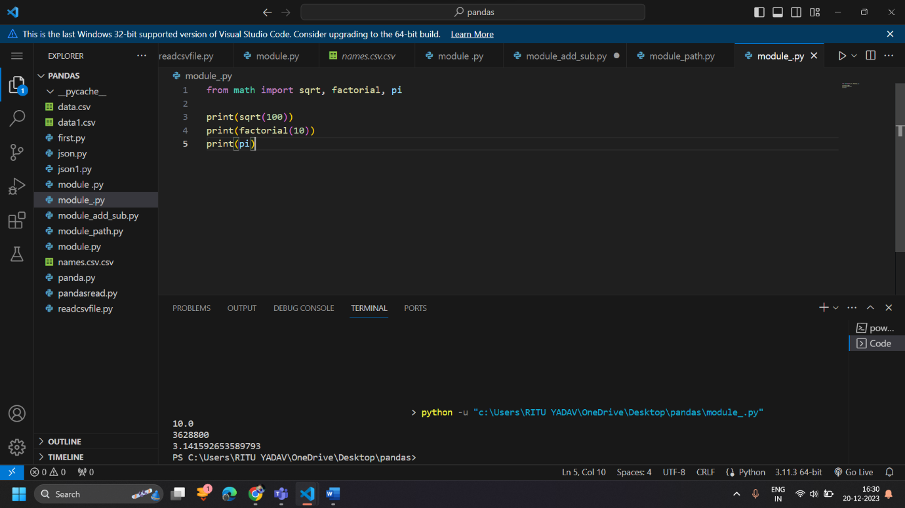

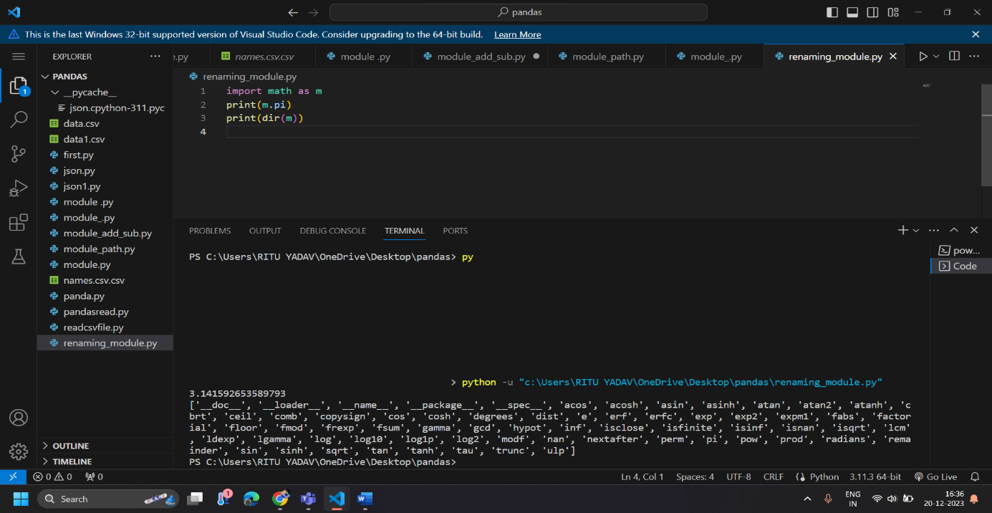

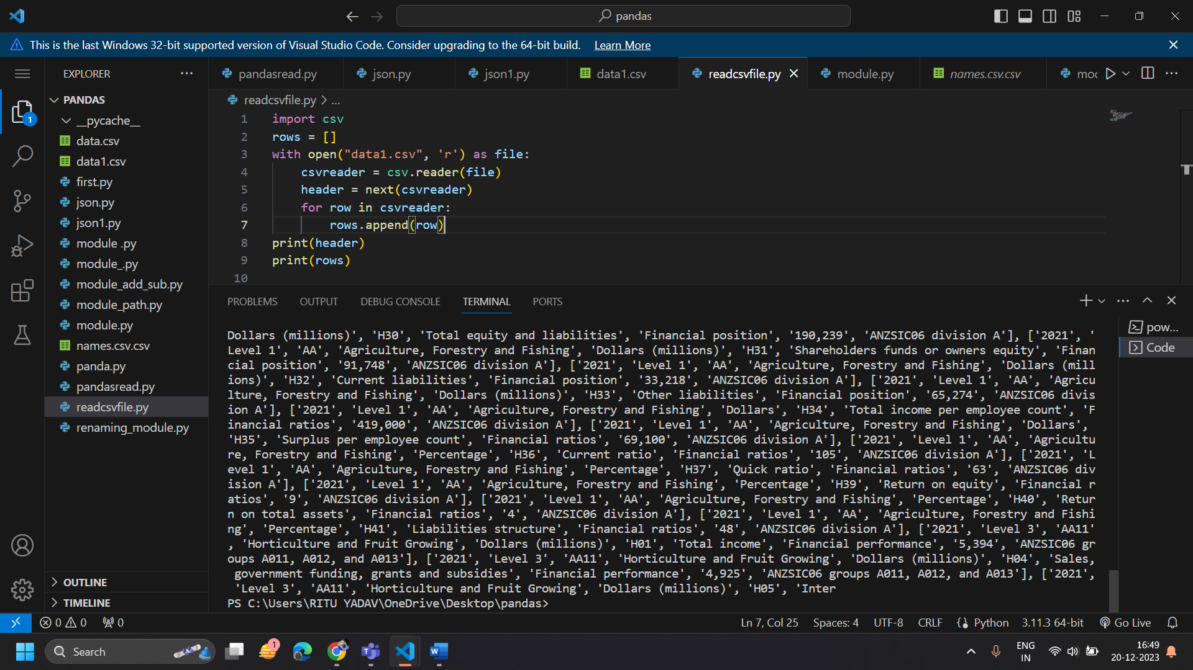

**Q2>ANSWER – Pandas And NumPy**

