Date:-9/12/2023

Schema, Rollup function, add extra subtotal,

Grouping function, Sub total, Grand total

procedure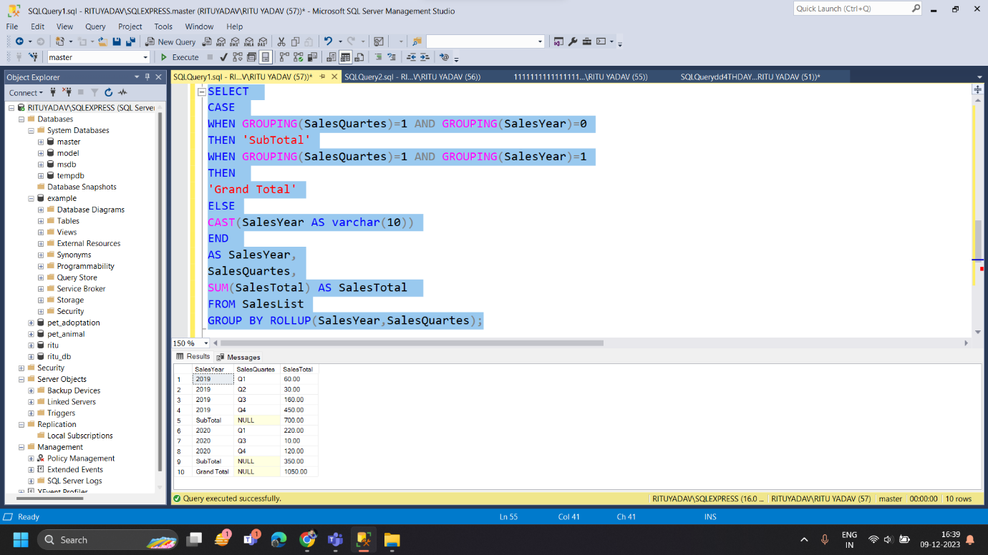

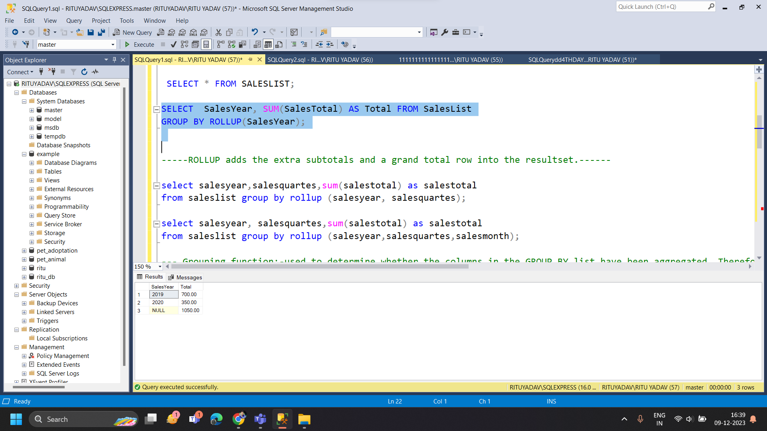

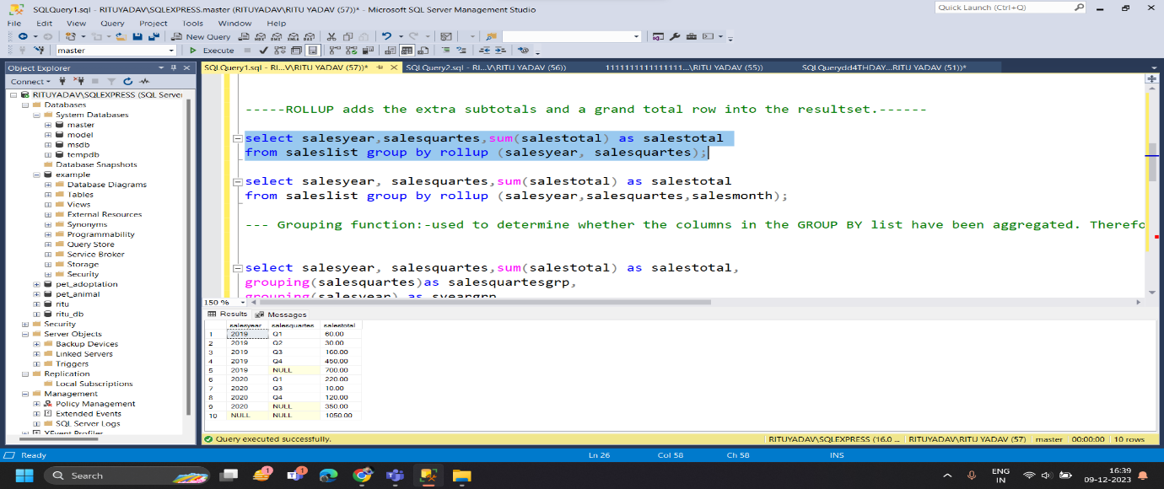

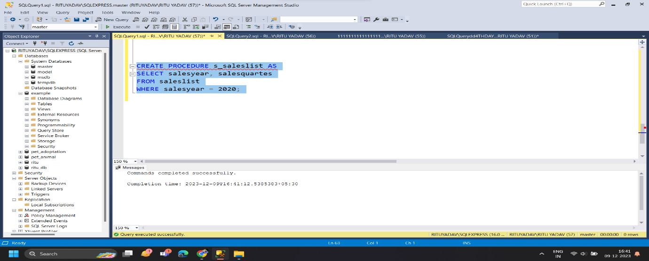

Schema

In a SQL database, a schema is a list of logical structures of data. A database user owns the schema, which has the same name as the database manager.

Database

It is to store information. It can store the simplest data, such as a list of people as well as the most complex data. The database stores the information in a well-structured format.

Type of schema:-

1. **Logical Schema**
2. **Physical Schema**
3. **View Schema**