CAR WASH POS & CUSTOMER PORTAL
Current State Sequence Diagrams
Technical Architecture & Component Interaction Documentation
Document Generated: October 3, 2026
Version: Current Production Implementation · Status: 100% Implemented (9 Workflows)

Table of Contents
Workflow 1: Customer Registration & Welcome Promo Dispatch [IMPLEMENTED]
Workflow 2: Customer Authentication & Session Recovery [IMPLEMENTED]
Workflow 3: POS Express Wash Checkout & Receipt Generation [IMPLEMENTED]
Workflow 4: Welcome Discount Code Redemption [IMPLEMENTED]
Workflow 5: Wash Club Membership Subscription [IMPLEMENTED]
Workflow 6: In-Lane Membership Wash Redemption [IMPLEMENTED]
Workflow 7: Staff Administration & Role-Based Authorization [IMPLEMENTED]
Workflow 8: Transaction Ledger Audit, Filtering & Voiding [IMPLEMENTED]
Workflow 9: Customer Contact & Webhook Enquiry Dispatch [IMPLEMENTED]

Workflow 1: Customer Registration & Welcome Promo Dispatch
Implementation Status: IMPLEMENTED IN CURRENT CODEBASE · Code Reference: Customer SignUp Workflow
Purpose:
Allows a new guest customer to register an account on the public portal, validates uniqueness, generates customer CRM and user account credentials, issues a 15% First-Signup welcome coupon, and triggers an email dispatch webhook.
Sequence Diagram (Visual Flow):
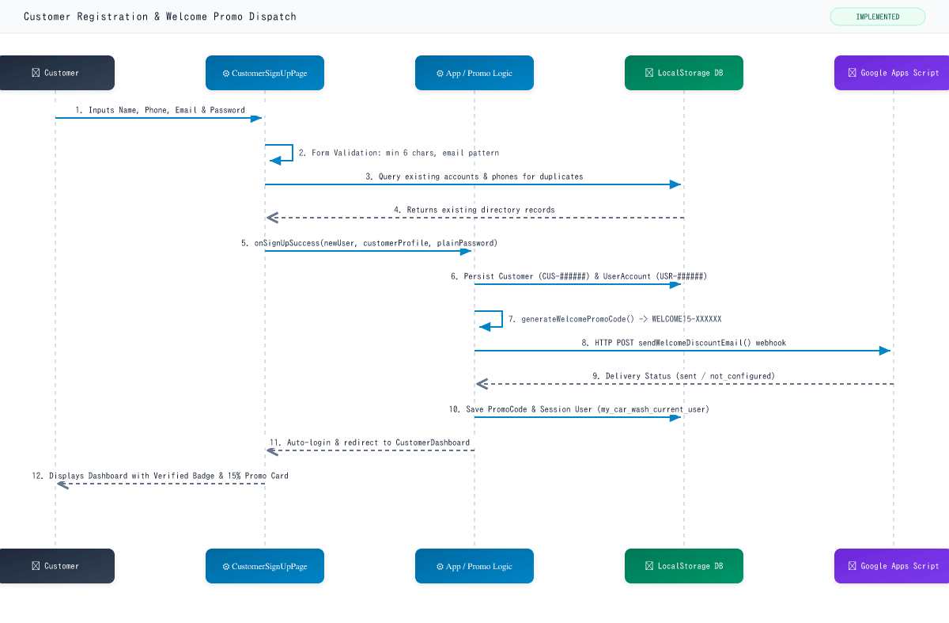
Detailed Step-by-Step Flow Description:
Step 1: Customer fills first name, last name, phone, email, password, and confirm-password fields on the public signup page.
Step 2: The client component validates field presence, matching passwords, and normalized phone digits.
Step 3: A duplicate lookup queries localStorage to ensure the email and phone do not already belong to an active customer. If duplicate, a direct "Sign in here" link appears.
Step 4: Upon submission, App.tsx generates a sequential customer profile (CUS-######) and salted user account hash.
Step 5: The PromoService automatically creates a 15% discount code valid for 3 months and dispatches an asynchronous HTTP POST webhook to Google Apps Script.
Step 6: The application commits all entities to localStorage, persists active user session, and immediately navigates to CustomerDashboardPage.
Components Involved:
- Customer (Actor)
- CustomerSignUpPage (UI)
- App.tsx / Auth & Promo Logic (Application Logic)
- LocalStorage (Client Storage: customers, accounts, promo_codes)
- Google Apps Script Web App (External Email Webhook)
Business Rules & Validations Enforced:
- Password must be at least 6 characters.
- Phone numbers are normalized via non-digit regex to prevent duplicate entries.
- Welcome discount is strictly set to 15% with a 3-month expiration window.
- All newly registered users are enforced with role = "customer" (never Admin or Cashier).
Error / Failure Handling:
- Duplicate email/phone -> Inline alert with error message and pre-filled sign-in shortcut.
- Unconfigured Google Apps Script webhook -> Graceful fallback: promo code is saved locally with "not_configured" delivery status so the user still receives their discount.

Workflow 2: Customer Authentication & Session Recovery
Implementation Status: IMPLEMENTED IN CURRENT CODEBASE · Code Reference: Customer Login Workflow
Purpose:
Authenticates registered customers via email, customer ID, or phone number, verifies salted password credentials, executes self-healing for demo accounts, and restores user session.
Sequence Diagram (Visual Flow):
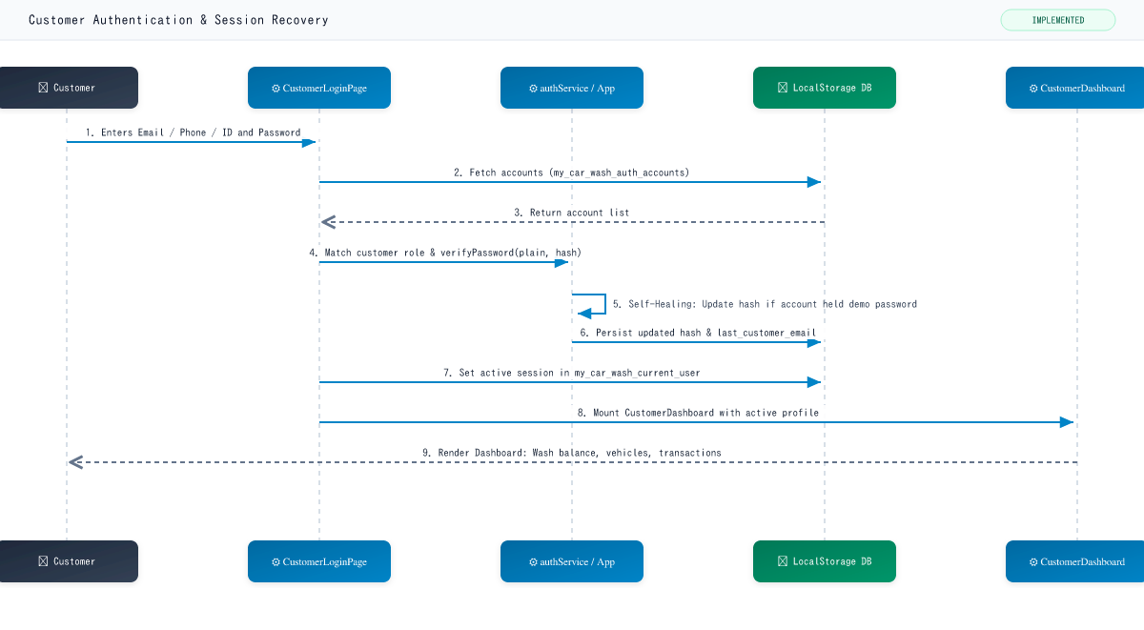
Detailed Step-by-Step Flow Description:
Step 1: Customer enters identifier and password on CustomerLoginPage (or uses Quick Demo button).
Step 2: The component normalizes the input, matching against email, internal ID, customer ID, or phone.
Step 3: authService validates the password hash against the stored record.
Step 4: A self-healing mechanism automatically updates the stored hash if the user previously had the demo password but entered their newly chosen password.
Step 5: The last used email is stored in localStorage for pre-filling next time.
Step 6: Active session is established and the customer dashboard view is rendered.
Components Involved:
- Customer (Actor)
- CustomerLoginPage (UI)
- authService.ts (Auth Logic)
- LocalStorage (Client Storage: accounts, customers, current_user)
- CustomerDashboardPage (UI Destination)
Business Rules & Validations Enforced:
- Only accounts with role = "customer" are allowed to authenticate on this portal.
- Invalid password or unknown account immediately displays localized error.
- Session persists across browser tab refreshes via localStorage.
Error / Failure Handling:
- Account not found -> "Invalid credentials" notification.
- Incorrect password -> "Invalid credentials" notification with form preserved.

Workflow 3: POS Express Wash Checkout & Receipt Generation
Implementation Status: IMPLEMENTED IN CURRENT CODEBASE · Code Reference: New Wash / POS Transaction Workflow
Purpose:
Handles the in-lane cashier point-of-sale transaction: vehicle category selection, wash package selection, à la carte add-ons, sales tax calculation, payment processing, and printed receipt modal.
Sequence Diagram (Visual Flow):
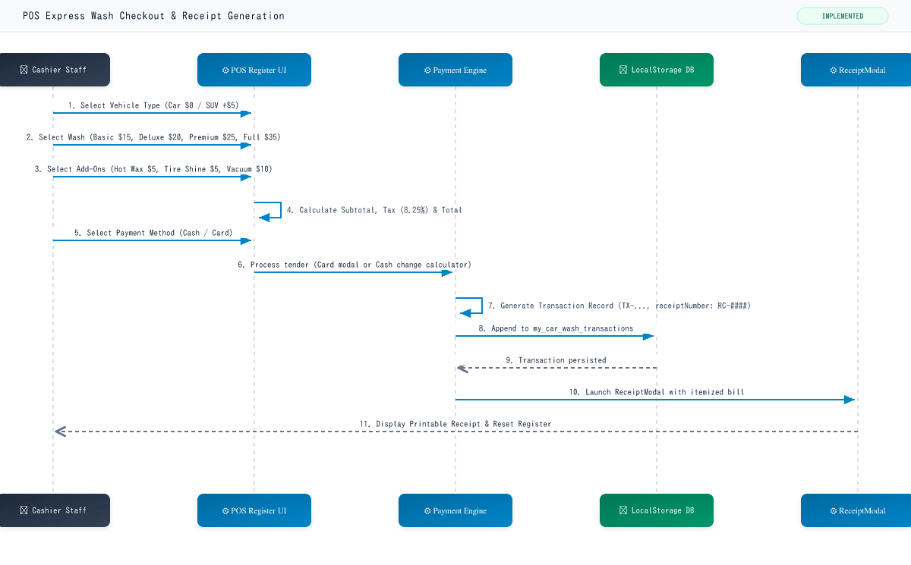
Detailed Step-by-Step Flow Description:
Step 1: Cashier selects vehicle tier (Car or SUV/Truck), wash tier, and optional add-ons in lane.
Step 2: OrderSummary computes real-time subtotal, 8.25% sales tax, and total amount due.
Step 3: Cashier selects payment method. If credit/debit card, CardPaymentPanel processes test authorization and returns masked card ref (**** 1234). If cash, change due is computed.
Step 4: App.tsx constructs a complete Transaction entity with status = "completed".
Step 5: The transaction is committed to localStorage.
Step 6: ReceiptModal opens displaying business details, itemized breakdown, tax details, barcode, and print action.
Components Involved:
- Cashier / Staff (Actor)
- POS Register UI (UI)
- Payment Engine (Logic: Card / Cash Calculator)
- LocalStorage (Client Storage: transactions)
- ReceiptModal (UI Destination)
Business Rules & Validations Enforced:
- SUV/Truck category incurs configured vehicle surcharge (default +$5.00).
- Sales tax is computed as subtotal * taxRate (default 8.25%).
- Receipt numbers are sequentially incremented for customer auditing.
Error / Failure Handling:
- No wash service selected -> Payment button remains disabled.
- Cash tendered is less than order total -> Error prompt to enter full payment amount.

Workflow 4: Welcome Discount Code Redemption
Implementation Status: IMPLEMENTED IN CURRENT CODEBASE · Code Reference: 15% Promo Code Redemption Workflow
Purpose:
Validates and applies the First-Signup 15% discount coupon at checkout, deducts discount from wash subtotal, links transaction record, and flags the coupon as redeemed.
Sequence Diagram (Visual Flow):
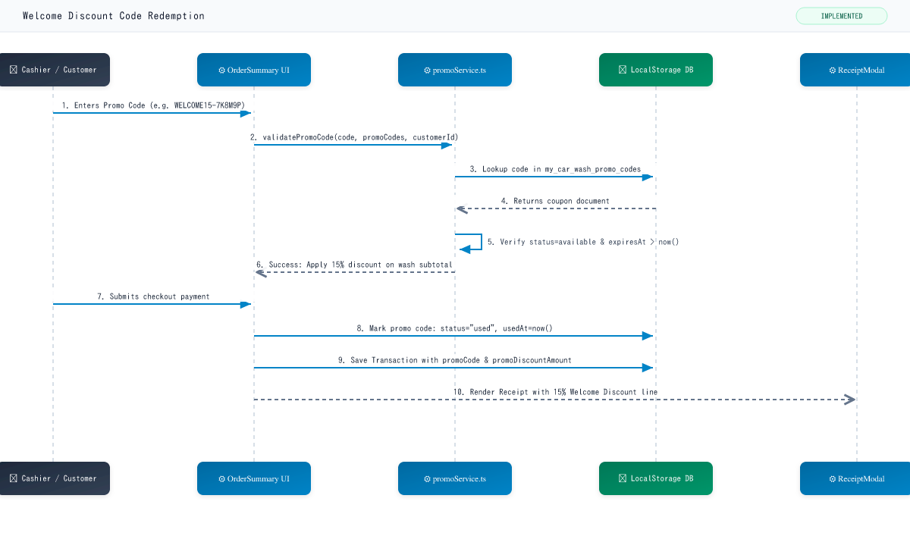
Detailed Step-by-Step Flow Description:
Step 1: Cashier or customer enters coupon code into the OrderSummary promo input field.
Step 2: promoService checks that the code exists, belongs to eligible customer, is unused, and has not passed its 3-month expiration date.
Step 3: The cart subtotal is reduced by 15% and sales tax is recalculated.
Step 4: When transaction completes, promo code is updated to status = "used" with timestamp and receipt number.
Step 5: Printed receipt displays original subtotal, welcome discount reduction, and final total.
Components Involved:
- Cashier / Customer (Actor)
- OrderSummary (UI)
- promoService.ts (Validation & Calculation Logic)
- LocalStorage (Client Storage: promo_codes, transactions)
- ReceiptModal (UI Destination)
Business Rules & Validations Enforced:
- Promo code is strictly single-use; subsequent attempts are rejected.
- Expired codes (> 3 months from creation) cannot be redeemed.
- Discount applies to the wash service subtotal.
Error / Failure Handling:
- Non-existent code -> "Invalid promo code" message.
- Already used code -> "This promo code has already been redeemed".
- Expired code -> "This promo code expired on [date]".

Workflow 5: Wash Club Membership Subscription
Implementation Status: IMPLEMENTED IN CURRENT CODEBASE · Code Reference: Membership Purchase Workflow
Purpose:
Enables customers to enroll in monthly or annual wash pass clubs, captures recurring plan terms, initiates payment, records active membership document, and registers initial wash credits.
Sequence Diagram (Visual Flow):
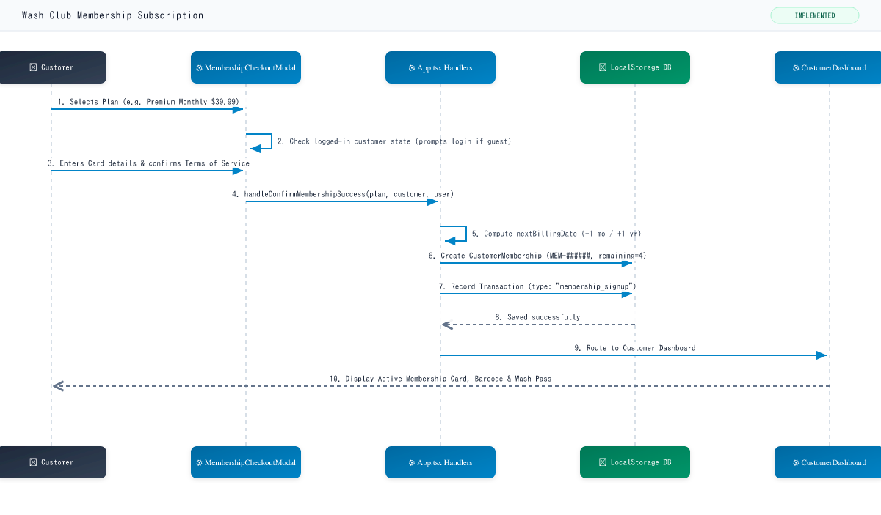
Detailed Step-by-Step Flow Description:
Step 1: Customer navigates to Memberships page, reviews wash plans, and clicks "Join Wash Pass".
Step 2: If guest, modal prompts customer to log in or create an account. If authenticated, checkout modal opens.
Step 3: Customer enters payment method and approves subscription terms.
Step 4: System calculates billing frequency, expiration date, and allocates 4 included washes.
Step 5: A new CustomerMembership record (MEM-######) and financial transaction record are saved to localStorage.
Step 6: Customer dashboard refreshes with active member badge, remaining wash meter, and digital member ID.
Components Involved:
- Customer (Actor)
- MembershipsPage / Modal (UI)
- App.tsx Membership Logic (Application Logic)
- LocalStorage (Client Storage: memberships, transactions)
- CustomerDashboardPage (UI Destination)
Business Rules & Validations Enforced:
- Customer can maintain an active subscription per customer ID.
- Initial allocation grants 4 washes for the billing period.
- Next billing date is computed based on billingFrequency (monthly vs yearly).
Error / Failure Handling:
- Unauthenticated user -> Redirects to login prompt with pre-selected plan preserved.
- Declined card payment -> Modal displays retry message without saving membership.

Workflow 6: In-Lane Membership Wash Redemption
Implementation Status: IMPLEMENTED IN CURRENT CODEBASE · Code Reference: Membership Usage During POS Workflow
Purpose:
Identifies active club members during checkout, validates wash entitlement balance, debits 1 wash from remaining allocation, records audit log, and issues zero-dollar wash transaction.
Sequence Diagram (Visual Flow):
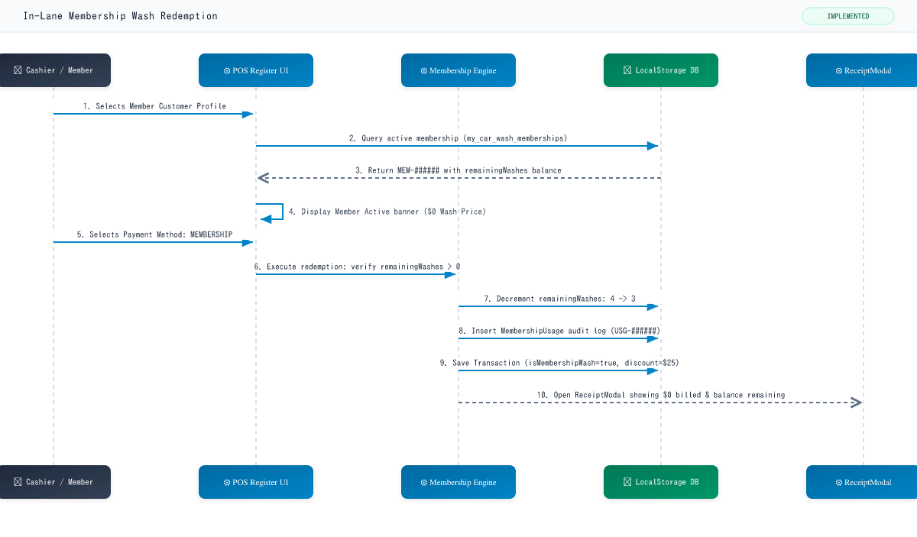
Detailed Step-by-Step Flow Description:
Step 1: Customer arrives at wash register. Cashier selects customer profile or scans member barcode.
Step 2: System detects active subscription with positive remaining wash balance.
Step 3: The eligible plan service displays as $0 Included With Membership.
Step 4: Cashier selects MEMBERSHIP payment method and confirms checkout.
Step 5: System decrements customer membership balance, generates a MembershipUsage log (USG-######), and creates a completed transaction.
Step 6: Receipt prints indicating 100% membership credit and balance remaining.
Components Involved:
- Cashier / Member (Actor)
- POS Register (UI)
- Membership Engine (Application Logic)
- LocalStorage (Client Storage: memberships, usages, transactions)
- ReceiptModal (UI Destination)
Business Rules & Validations Enforced:
- Customer must have status = "active" and remainingWashes > 0.
- Redeemed wash service must match plan includedServiceId.
- Optional add-ons are billed separately or receive plan add-on discount.
Error / Failure Handling:
- Zero remaining washes -> UI warns balance exhausted; prompts cashier to bill retail or renew.
- Expired/cancelled membership -> System prevents $0 redemption and reverts to retail pricing.

Workflow 7: Staff Administration & Role-Based Authorization
Implementation Status: IMPLEMENTED IN CURRENT CODEBASE · Code Reference: Staff & Admin Login Workflow
Purpose:
Authenticates store managers and cashier staff members, verifies password hashes, establishes staff session, and provisions role-based navigation tabs (Admin vs Cashier).
Sequence Diagram (Visual Flow):
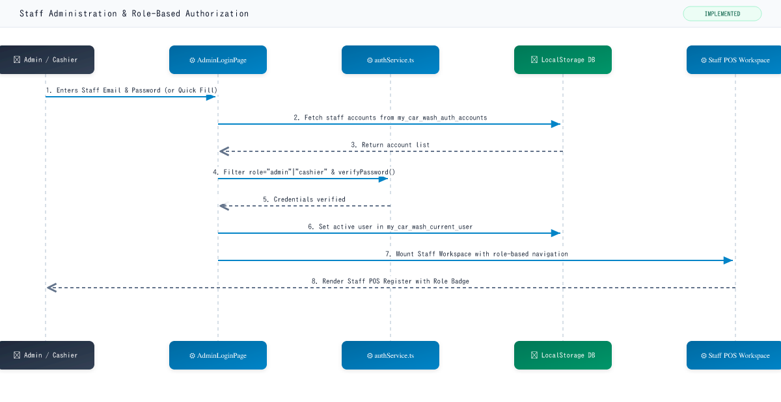
Detailed Step-by-Step Flow Description:
Step 1: Staff member navigates to AdminLoginPage and submits credentials (or clicks Admin/Cashier Quick Fill buttons).
Step 2: authService queries account directory and verifies password hash.
Step 3: User role is evaluated: "admin" receives POS, Customers, Memberships, Transactions, and Settings tabs; "cashier" receives POS, Customers, and Transactions.
Step 4: Session is persisted in localStorage.
Step 5: Application mounts Staff Header showing live register lane, clock, tax rate, and active role badge.
Components Involved:
- Admin / Cashier (Actor)
- AdminLoginPage (UI)
- authService.ts (Auth Logic)
- LocalStorage (Client Storage: accounts, current_user)
- Staff Header / POS Register (UI Destination)
Business Rules & Validations Enforced:
- Customer accounts are blocked from accessing Admin Login.
- Admin role has exclusive access to modify services, vehicle surcharges, and tax rates in Settings.
- Password hash is verified using constant-time string comparison.
Error / Failure Handling:
- Invalid password -> "Invalid credentials" error alert.
- Customer account entered on Staff Login -> "Invalid credentials" error alert.

Workflow 8: Transaction Ledger Audit, Filtering & Voiding
Implementation Status: IMPLEMENTED IN CURRENT CODEBASE · Code Reference: Transaction Management Workflow
Purpose:
Provides store managers and cashiers with full transaction auditing, real-time receipt filtering, customer history lookup, receipt reprints, and transaction voiding.
Sequence Diagram (Visual Flow):
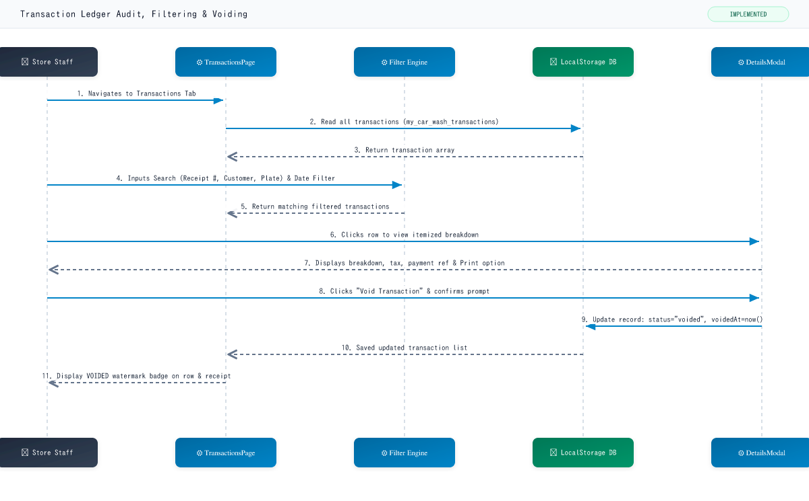
Detailed Step-by-Step Flow Description:
Step 1: Staff views chronological transaction ledger displaying receipt number, timestamp, customer name, vehicle, payment method, and amount.
Step 2: Filter engine performs multi-criteria filtering by text search, status (Completed vs Voided), and payment type.
Step 3: Clicking any record opens TransactionDetailsModal with full line items, discount records, and receipt reprint option.
Step 4: Staff clicks "Void Transaction" and confirms the modal dialog.
Step 5: Transaction entity is updated to status = "voided" with an audit timestamp and persisted to localStorage.
Step 6: Table updates row with red "VOIDED" badge and prevents duplicate voiding.
Components Involved:
- Staff / Manager (Actor)
- TransactionsPage / Table (UI)
- TransactionFilters (UI Filter Engine)
- LocalStorage (Client Storage: transactions)
- TransactionDetailsModal (UI Modal)
Business Rules & Validations Enforced:
- Already voided transactions cannot be voided again.
- Voiding retains the original financial record for audit trail integrity.
- Receipt modal dynamically renders "VOIDED" watermark across reprinted receipt.
Error / Failure Handling:
- User cancels void prompt -> Transaction remains active and completed.

Workflow 9: Customer Contact & Webhook Enquiry Dispatch
Implementation Status: IMPLEMENTED IN CURRENT CODEBASE · Code Reference: Enquiry Submission Workflow
Purpose:
Enables website visitors to submit questions or service quotes, verifies honeypot spam protection, enforces 30-second rate limits, and forwards structured inquiries to a Google Apps Script webhook.
Sequence Diagram (Visual Flow):
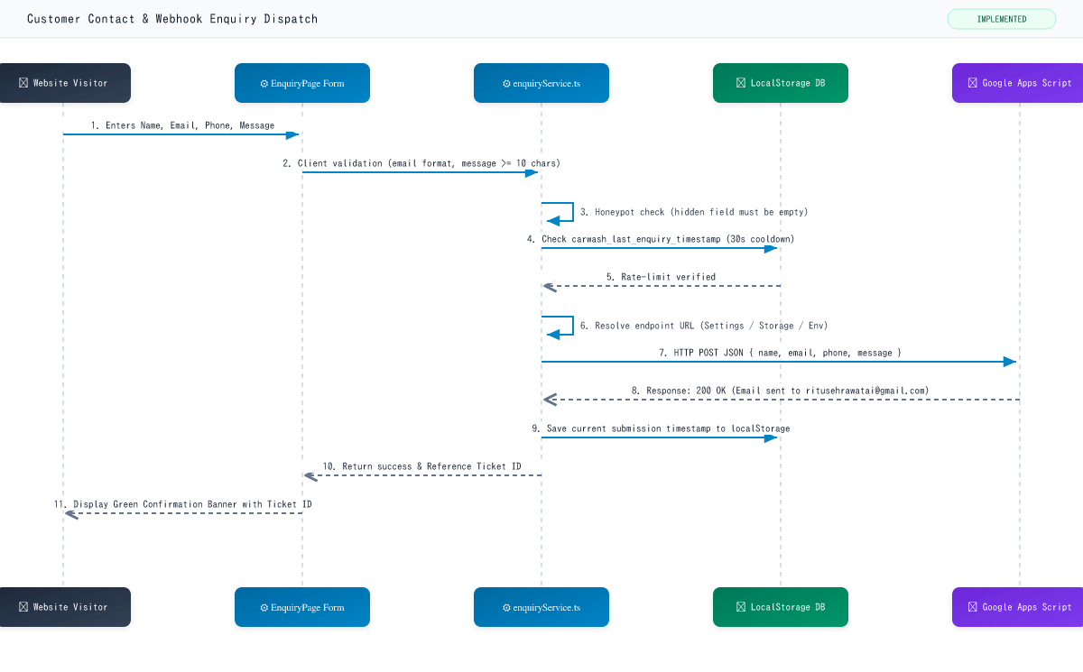
Detailed Step-by-Step Flow Description:
Step 1: Website visitor fills contact form on EnquiryPage with name, email, phone, and inquiry details.
Step 2: enquiryService checks honeypot field to block automated spam bots.
Step 3: A 30-second rate-limiting rule checks localStorage to prevent rapid duplicate submissions.
Step 4: The service resolves the active Google Apps Script Web App URL from Settings, localStorage, or environment variable.
Step 5: Payload is submitted via HTTP POST to Google Apps Script which delivers the notification email to ritusehrawatai@gmail.com.
Step 6: EnquiryPage presents a green confirmation card with a generated ticket reference number and resets form.
Components Involved:
- Website Visitor (Actor)
- EnquiryPage Form (UI)
- enquiryService.ts (Validation & Rate Limiting)
- LocalStorage (Client Storage: timestamp, endpoint)
- Google Apps Script Web App (External Webhook: ritusehrawatai@gmail.com)
Business Rules & Validations Enforced:
- Anti-spam honeypot field must remain empty.
- Enforces 30-second cooldown period between submissions per browser.
- Graceful error handling displays configuration guidance if webhook URL is unset.
Error / Failure Handling:
- Honeypot filled -> Silently rejected to prevent spam.
- Submission within 30 seconds -> Displays rate-limit warning with countdown.
- Webhook endpoint unreachable -> Displays offline setup modal with instructions for station administrator.

