By Rituparna Sengupta, 27/10/2021

**Technical test**

**Automation –Selenium**

Task:

Write a short automated test of the following using Selenium and NUnit/JUnit in an OO language (e.g. C#/Java/Python).

* Go to <https://www.google.com/maps>
* Enter Dublin in the search box
* Search
* Verify left panel has “Dublin” as a headline text
* Click Directions icon
* Verify destination field is “Dublin”

Use element locator methods as necessary.

Implement as many assertions as you deem applicable.

**The Test is done in the Eclipse IDE  with Java, Cucumber, Junit, Extent Report.**

IDE Tools:

* Eclipse IDE for Eclipse Committers Version: 2020-06 (4.16.0)
* Cucumber for the Feature file

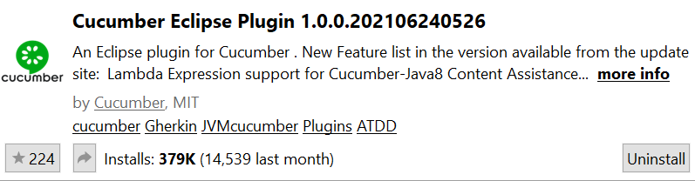

Make sure that Cucumber Extension is installed in the Eclipse

* Dependencies added in pom.xml

Assumptions:

The business rules to enter the **valid** destination name in the search field of <https://www.google.com/maps> and validate on clicking the search button destination name appears on the

Left panel of the page and on clicking direction buttom, destination name is populated on destination field.

On entering invalid destination name in the search field of <https://www.google.com/maps>, “Google Maps can't find” text is displayed.

Configuration:



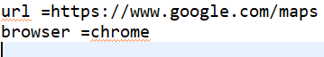

Set appropriate browser in the config file before running the tests.

Note: This solution is tested in Chrome only but not tested in other browser(due to an environment issue in my development environment) though my code contains the solution for Firefox too.

How to Run Tests:

Run Test in Eclipse IDE:

Reference README.txt

Known Issue:

1.      There is no known issue in the scenarios created to cover the requirements mentioned in the assignments.

2.      Negative scenario (invalid location) is added in addition to the assignment requirements.

The Test with invalid data sometimes fails when run as a suite, but passes mostly. If it is executed alone or if the first scenario is executed alone it pass.

.

When executed alone:

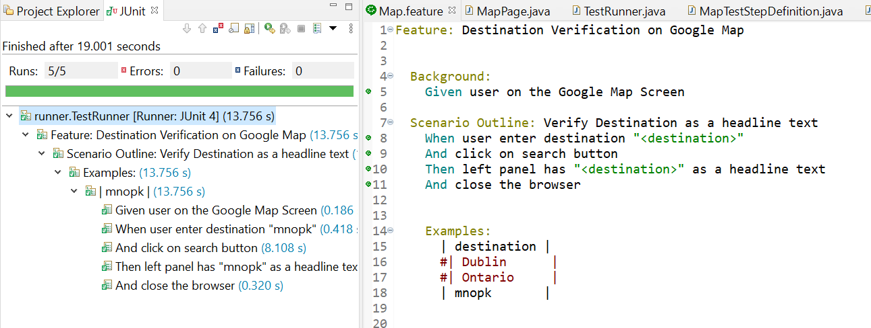

First scenario executed with all data:

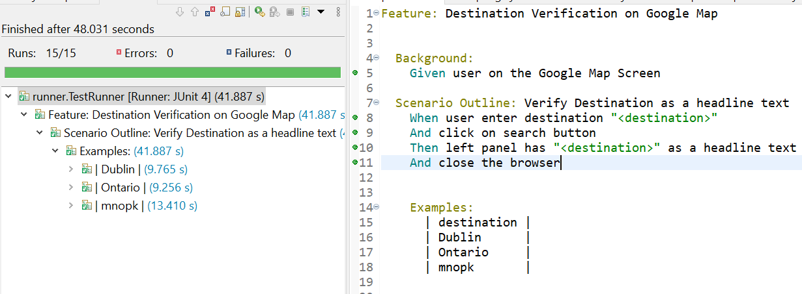

Both the scenarios passed :

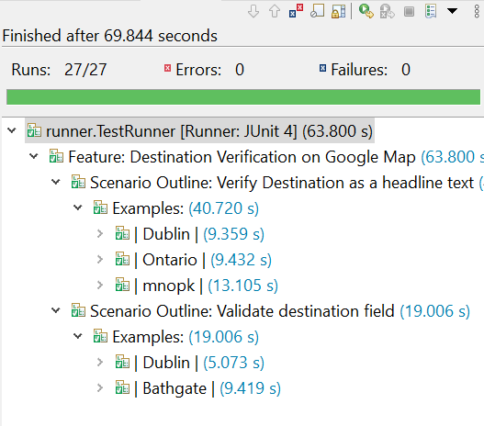

Report:

Report will be generated under /TechicalTest_Map_Automation/target/reports/extentReport.html

1. Right click on extentReport.html
2. Click on Open With - > Web Browser
3. Copy the location of the report

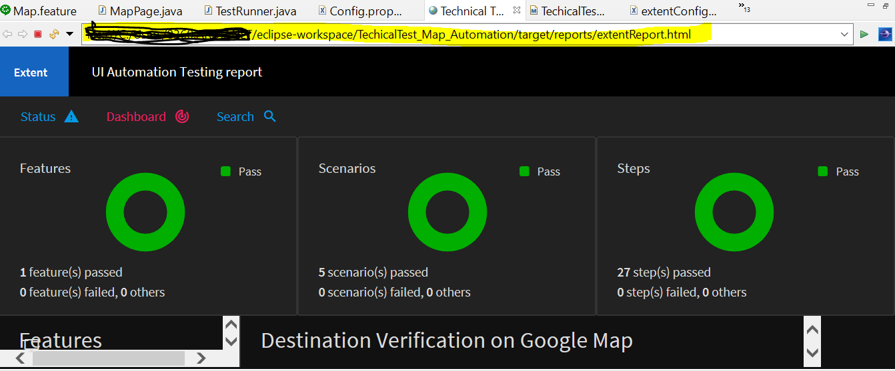

1. Paste on browser to get clearview of the report.