AI Finance Agent
Data Analysis Report

Prepared by: Ritu Verma
AI & Finance Professional
April 2026

Tools Used: Python | Excel | Power BI | SQL | PowerPoint

Executive Summary
This report presents a comprehensive data analysis of the AI Finance Agent
project, covering invoice reconciliation, insurance claims, and budget
forecasting. The analysis was performed using Python, Excel Power Query,
Power BI, and SQL across five datasets containing invoices, payments,
claims, settlements, and budget records.

Key findings reveal that 40% of invoices remain unpaid (Rs. 7,700
outstanding), 2 insurance claims worth Rs. 1,20,000 are pending settlement,
and the average monthly expense ratio stands at 83.8% — above the
recommended 80% threshold. Immediate action is recommended for vendor
follow-up and claims escalation.

1.Invoice Analysis
A total of 5 invoices were processed with a combined value of Rs. 26,700.
The reconciliation process identified 3 matched invoices (Rs. 19,000) and
2 unmatched invoices (Rs. 7,700) requiring immediate follow-up.

Key Findings
- Total Invoices: 5
- Total Amount: Rs. 26,700
- Paid: 3 invoices — Rs. 19,000 (71.2%)
- Unpaid: 2 invoices — Rs. 7,700 (28.8%)
- Highest Invoice: PQR Inc — Rs. 7,800
- Unpaid Vendors: XYZ Ltd (Rs. 3,200), LMN Co (Rs. 4,500)

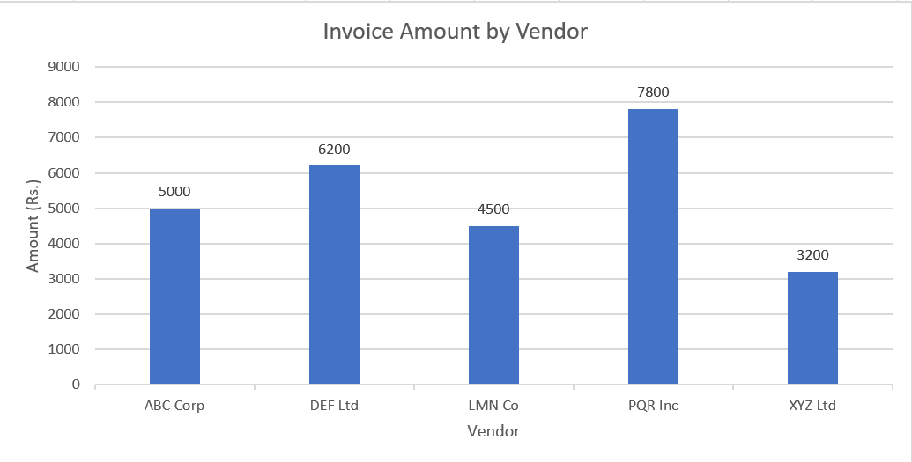

2. Insurance Claims Analysis
A total of 5 insurance claims were analyzed with a combined claimed
value of Rs. 1,93,000. Of these, 3 claims were settled (Rs. 67,000)
and 2 remain pending (Rs. 1,20,000), representing significant
financial exposure.

Key Findings
- Total Claims: 5
- Total Claimed: Rs. 1,93,000
- Settled: 3 claims — Rs. 67,000 ✅
- Pending: 2 claims — Rs. 1,20,000 ❌
- Highest Risk: Sunita Rao (ICICI Lombard) — Rs. 72,000
- Top Insurer by Volume: HDFC Ergo — 41.97%

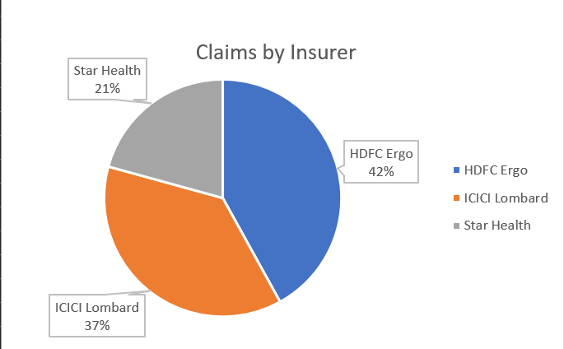

3.Budget Analysis
Six months of budget data (September 2023 to February 2024) was analyzed
to identify income trends, expense patterns, and net surplus. The data
reveals a consistently positive net surplus, though expense ratios
remain above the recommended 80% threshold in most months.

Key Findings
- Period: Sep 2023 — Feb 2024 (6 months)
- Average Monthly Income: Rs. 88,833
- Average Monthly Expenses: Rs. 74,667
- Average Net Surplus: Rs. 14,167
- Highest Expense Ratio: Nov 2023 — 91.5% ⚠️
- Lowest Expense Ratio: Sep 2023 — 80.0% ✅
- Best Net Surplus: Dec 2023 — Rs. 13,000
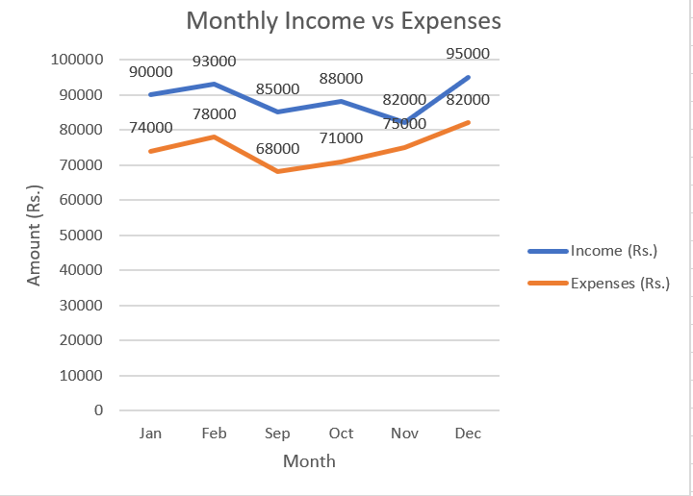

4.SQL Data Analysis
SQL queries were executed using SQLite (DB Browser) on five imported
tables to perform deeper analysis including vendor ranking, payment
status identification, claims variance calculation, and expense ratio
computation.

Query Results Summary
- Query 1 — Vendor Ranking: PQR Inc highest at Rs. 7,800
- Query 2 — Payment Status: 3 Paid, 2 Unpaid (LEFT JOIN)
- Query 3 — Claims Variance: Sunita Rao highest at Rs. 72,000
- Query 4 — Expense Ratio: Nov 2023 highest at 91.5%

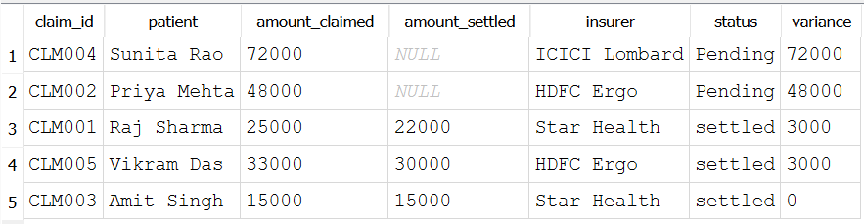

5.Recommendations
Based on the data analysis across invoices, insurance claims, and budget
forecasting, the following actions are recommended to improve financial
operations and reduce risk exposure.

Immediate Actions
- Contact XYZ Ltd and LMN Co to recover Rs. 7,700 in unpaid invoices
- Escalate Sunita Rao (Rs. 72,000) and Priya Mehta (Rs. 48,000) claims
- Investigate November 2023 expense spike — ratio reached 91.5%

Process Improvements
- Set up automated alerts for invoices unpaid beyond 30 days
- Target expense ratio below 80% from March 2024 onwards
- Implement monthly claims review with insurers
- Automate reconciliation reports using AI Finance Agent

