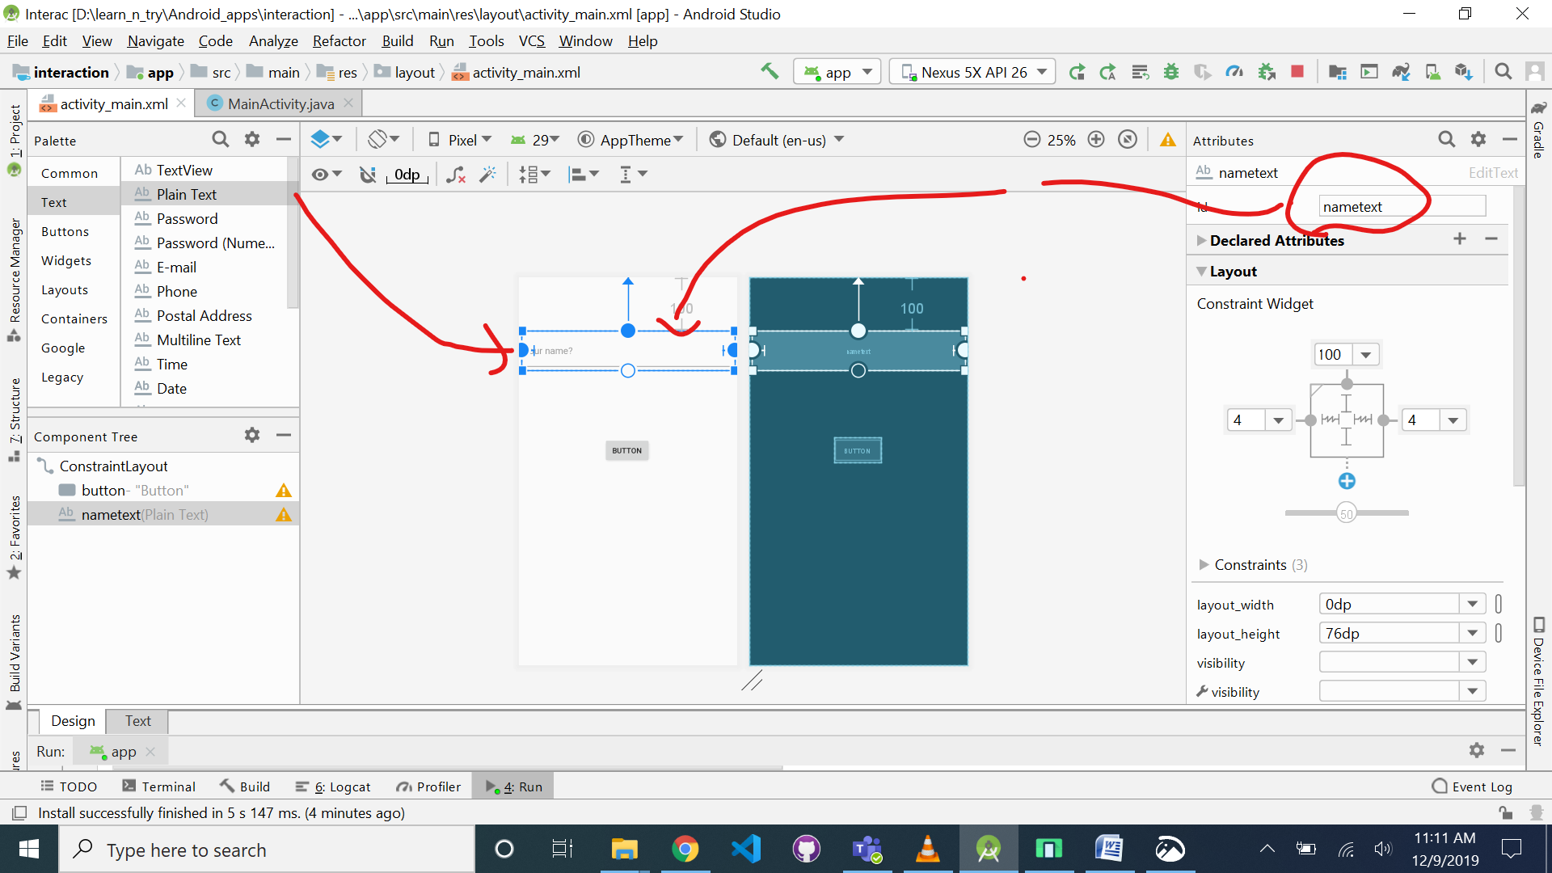

**In main activity add click function which is the onClick function for our button.**

**public void** click(View view)  
{  
 EditText nameEditText = (EditText) findViewById(R.id.***nametext***);  
 Log.*i*(**"Holaaa"**,**"Welcome"**);  
 Log.*i*(**"text"**, nameEditText.getText().toString());  
}

To give alternate chance to players and not letting overwrite each other’s move, follow this code.

Use imageView.getDrawable()!=null

If resource name is required follow this link -<https://stackoverflow.com/questions/23357706/how-to-check-which-current-image-resource-is-attached-to-imageview-in-android-xm>