React – A javascript library for building User interfaces which run on **Browser.**

**Uses Components , so code updation is easy, code reusability is enhanced and total manageability also shoots up.**

**PreRequisites:**

1. **JavaScript**
2. **Let** (for variables) **and const**(for constant variables)
3. **Arrow functions:**

Const functionName=() =>{ … }

1. **Import and Export:**

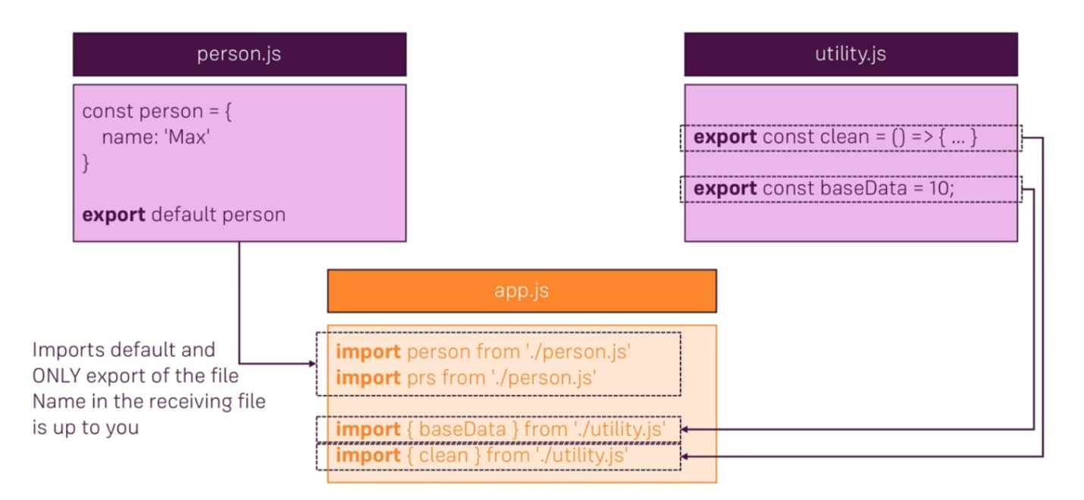

Default export – Use any name of your choice while importing.

Named export – Use the exact name for importing back or can use an alias like:

Import {clean as cln} from ‘./utility.js’.

1. **Classes** : contains variables and functions, can have constructor and supports inheritance.
2. **Spread and Rest operator :**

**Spread:**  use of ‘…’ in props and objects for splitting array props or spreading/copying stuff for properties or objects . eg

**const NewArray = […oldArray,5,6,8]**

**and const NewObj= {…oldObject, name=”Ram”}**

now if there isn’t a property called “name” in oldObject then it will be added. Otherwise it will be updated.

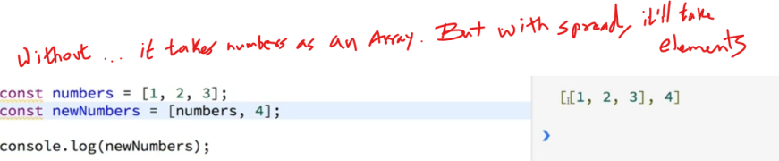

**Rest : use of “…” in functions**

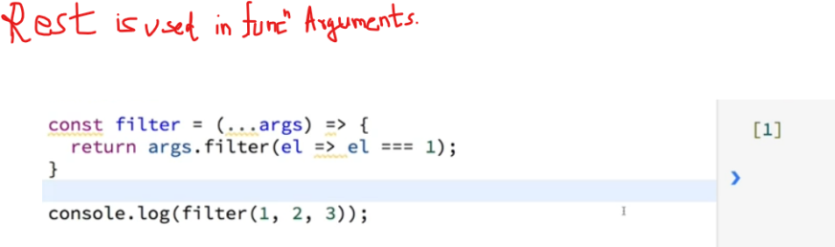

1. **Destructuring** : copying specific contents of an array or object.

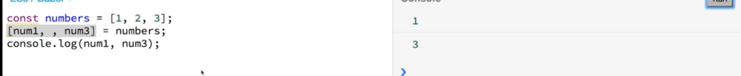

1. **References**:

Primitive data types actually copy the contents but when we try to use = for array or objects, they doesn’t copy the contents instead they just point it to the same memory location.

For true copying, we have to use spread operator .

1. **Inbuilt functions like Array functions** ( map, filter

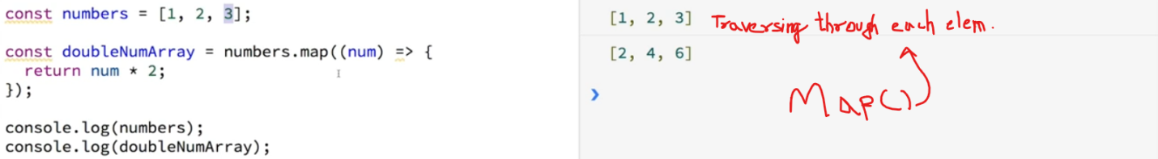

Installing React :

npm install create-react-app –g

Making a new Component (first go to the respective folder):

create-react-app one

Starting the server:

npm start inside the folder

**File Structure:**

index.html has div with id “root”

index.js file renderes App.js into the #root div.

App.js sends html by returning JSX via class which extends component.

Other components can be made and imported in the App.js which can use the components as tags.

**Why components and not just a single component?**

* To avoid re-rendering of whole site, we split it into components and hence only re-render the component which needs to be re-rendered.
* To improve code reusability.
* Code collaboration becomes easier , since less conflicts will happen if they work on separate files.
* Testing becomes easier

**Components:**

* Make new folder and put js file in it
* Import react and make a function which returns some JSX and export it with a name which can be imported in App.js eg:
* import React from 'react';
* const person =(props) =>{
* return (
* // <p> This is a person and that person is {Math.floor(Math.random()*30)}  </p>
* <p>This is {props.name}, who is {props.age} years old.</p>
* )
* };
* export default person;
* “props” is basically the collection of properties sent to this file by App.js which looks like this:
* import React, { Component } from 'react';
* import Person from './Person/Person.js' ;
* import './App.css';
* class App extends Component {
* render() {
* return (
* <div className="App">
* <h1>This is React App</h1>
* <p>This part is main app section</p>
* <Person name ="Max" age ="12">"Yo I am an engineer"</Person>
* <Person name ="Mark" age ="23">"I love Badminton"</Person>
* <Person name ="Marshall" age ="32">"I am done with hobbies"</Person>
* </div>
* );
* }
* }
* export default App;
* To use the content written between the opening and closing tags, we can use {props.children}
* Using State to keep values inside component:
* class App extends Component {
* state = {
* persons:[
* { name:'Max', age:12 },
* { name :'Mark', age:23 },
* { name :'Marshall', age:32}
* ]
* }
* render() {
* return (
* <div className="App">
* <h1>This is React App</h1>
* <p>This part is main app section</p>
* <Person name ={this.state.persons[0].name} age ={this.state.persons[0].age}>"Yo I am an engineer"</Person>
* <Person name ={this.state.persons[1].name} age ={this.state.persons[1].age}>"I love Badminton"</Person>
* <Person name ={this.state.persons[2].name} age ={this.state.persons[2].age}>"I am done with hobbies"</Person>
* </div>
* );
* }
* }
* Jsx
* JSX actually uses it’s own tags, although they define <div> as <div> internally, they do have differences like className instead of class and onClick instead of the usual onclick.
* We can change state values by using this.setstate(), it basically updates the contents which are being subjected to change.
* For calling a function on occurrence of an event, we shouldn’t use parenthesis, coz if we use parenthesis, the function will be called while compilation itself.
* <button onClick={this.switchName}>Switch Name</button>
  + To send in parameters we can use something like this:
* <button onClick={this.switchName.bind(this,"New Name!")}>Switch Name</button>
  + Or we can use : (using arrow function allows us to use parenthesis and avoids execution of the function during compilation)
* <button onClick={() => this.switchName("New Name!")}>Switch Name</button>
* We can also pass functions from components as props……
* <Person name ={this.state.persons[0].name} age ={this.state.persons[0].age} click={this.switchName}>"Yo I am an engineer"</Person>
* And using it in presentation file like:
* <p onClick = {props.click}  >This is {props.name}, who is {props.age} years old.</p>

**React Hooks:**

let you use state and other React features without writing a class.

Key concept – use functions instead of classes, and it also reduces the hassle of writing functions for eg, setState is eased into useState ie. Use of below istead of the one above…. :

 const App = props =>{

    const [personsState, setPersonsState] = useState({

    persons:[

      { name:'Max', age:12 },

      { name :'Mark', age:23 },

      { name :'Marshall', age:32}

    ]

  });

    const switchName=() =>{

    setPersonsState({

      persons:[

        { name:'Max 2.0', age:12 },

      { name :'Mark 2.0', age:23 },

      { name :'Marshall 2.0', age:32}

      ]

    })

    personsState.persons[0].name = "Max 2.0";

  }

    return (

      <div className="App">

        <h1>This is React App</h1>

        <p>This part is main app section</p>

        <button onClick={switchName}>Switch Name</button>

        <Person name ={personsState.persons[0].name} age ={personsState.persons[0].age}>"Yo I am an engineer"</Person>

        <Person name ={personsState.persons[1].name} age ={personsState.persons[1].age}>"I love Badminton"</Person>

        <Person name ={personsState.persons[2].name} age ={personsState.persons[2].age}>"I am done with hobbies"</Person>

      </div>

    );

  }

The issue with hooks is that the update function doesn’t merge the updated part with the previously defined function, instead it replaces it.

Two Way binding:

    <input type="text" onChange={props.changed } value={props.name} ></input>

props has ‘changed’ as a property defined in App.js

<Person name ={this.state.persons[0].name} age ={this.state.persons[0].age} changed={this.nameChange}></Person>

nameChange is a function, which focuses on changing the value of the first element of array according to the typed content which is being sent in for of an event triggered by onchange :

nameChange=(event)=>{

    this.setState(

      {

        persons:[

          {name : event.target.value , age:29 },

          { name :'Mark 2.0', age:23 },

          { name :'Marshall 2.0', age:32}

        ]

      }

    )

  }

**Styling:**

***Import css file in js file like this:***

Person.css

.Person {

    width:60%;

    margin:16px auto;

    text-align: center;

    border:1px solid black;

    padding:20px;

}

App.js

import './Person.css';

***or define css inline inside render function:***

 render() {

        const style ={

          backgroundColor : 'white',

          font: 'inherit',

          border: '1px solid blue',

          padding:'8px'

        };

        return (

          <div className="App" >

            <h1>This is React App</h1>

            <p>This part is main app section</p>

            <button style={style} onClick={() => this.switchName("New Name!")}>Switch Name</button>

            <Person name ={this.state.persons[0].name} age ={this.state.persons[0].age} click={this.switchName} changed={this.nameChange}>"Yo I am an engineer"</Person>

            <Person name ={this.state.persons[1].name} age ={this.state.persons[1].age}   >"I love Badminton"</Person>

            <Person name ={this.state.persons[2].name} age ={this.state.persons[2].age}  >"I am done with hobbies"</Person>

          </div>

        );

      }

To put on conditions inside a react component, we have to add {} inside which we can use ternary statements… for example for toggling the visibility of a block we can write something like this:

<button style={style} onClick={this.togglePersons}>Switch Name</button>

            { this.state.showPersons ?

              <div >

              <Person name ={this.state.persons[0].name} age ={this.state.persons[0].age} click={this.switchName} changed={this.nameChange}>"Yo I am an engineer"</Person>

              <Person name ={this.state.persons[1].name} age ={this.state.persons[1].age}   >"I love Badminton"</Person>

              <Person name ={this.state.persons[2].name} age ={this.state.persons[2].age}  >"I am done with hobbies"</Person>

            </div> : null

            }

The function :

togglePersons=()=>{

    const show= this.state.showPersons;

    this.setState({showPersons:!show});

  }

Where showPersons is defined in the App component:

class App extends Component {

  state = {

    persons:[

      { name:'Max', age:12 },

      { name :'Mark', age:23 },

      { name :'Marshall', age:32}

    ],

    showPersons:false

  }

Another approach:

Use this instead of the “ternary {}”:

let contnt = null;

        if(this.state.showPersons)

        {

          contnt = (

            <div >

              <Person name ={this.state.persons[0].name} age ={this.state.persons[0].age} click={this.switchName} changed={this.nameChange}>"Yo I am an engineer"</Person>

              <Person name ={this.state.persons[1].name} age ={this.state.persons[1].age}   >"I love Badminton"</Person>

              <Person name ={this.state.persons[2].name} age ={this.state.persons[2].age}  >"I am done with hobbies"</Person>

            </div>

          )}

This is kept inside the render function which is called every time some event happens.

We still have the toggle function and the button, only the div content is replaced by {contnt}

The good thing about this approach is that, we can write things directly in JavaScript.

Using map() to output lists, hence removed the manual typing of 3 <Person> tags:

let contnt = null;

        if(this.state.showPersons)

        {

          contnt = (

            <div >

              {this.state.persons.map(ppl=>{

                return <Person name={ppl.name}

                                age={ppl.age}

                                changed={this.nameChange}></Person>

              }) }

            </div>

          )

        }

Map basically goes through all the array elements and performs the command typed inside the paranthesis.

The command that we had was that of a function which returns tags of Person with respective values.

Hence the command over all returns an array, we are able to write the js command coz, we have written it inside {}.

**Delete card on click:**

 deletePerson=(index)=>{

    const people = this.state.persons;

    people.splice(index,1);

    this.setState({persons:people})

  }

Here we are only giving a reference to the person, so, it is automatically updating the array, instead of this, we should actually make a copy like below:

deletePerson=(index)=>{

    const people = this.state.persons.slice();

    //or use spread operator like this:

    //const people = [...this.state.persons]

    people.splice(index,1);

    this.setState({persons:people})

  }

Inside render ():

let contnt = null;

        if(this.state.showPersons)

        {

          contnt = (

            <div >

              {this.state.persons.map((ppl,index)=>{

                return <Person name={ppl.name}

                                age={ppl.age}

                                changed={this.nameChange}

                                click={()=>this.deletePerson(index)}></Person>

              }) }

            </div>

          )

        }

Map lets us see index, sending in index so that only the tag which is being clicked gets deleted alone.

**Individual nameChange binding:**

Passing event and index to the function:

<Person name={ppl.name}

              age={ppl.age}

**changed={(event)=>this.nameChange(event, index)}**

**click={()=>this.deletePerson(index)}**

              key={index}></Person>

passing event in first parenthesis of the arrow function.

The nameChange function:

  nameChange=(event,index)=>{

    let people = this.state.persons;

    people[index].name= event.target.value;

    console.log(people[index].name);

    this.setState(

      {

        persons:people

      }

    )

  }

**Const cannot be reassigned or re declared but When you're adding to an array or object you're not re-assigning or re-declaring the constant, it's already declared and assigned, you're just adding to the "list" that the constant points to.**

So this works fine (for dynamically changing class of elements based on the number of elements in the persons array:

const classes=[];

        if(this.state.persons.length<=2){

          classes.push('red');//just red

        }

        if(this.state.persons.length<=1){

          classes.push('bold'); //red and bold

        }

        return (

          <div className="App" >

            <h1>This is React App</h1>

            <p className={classes.join(' ')}>This part is main app section</p>

            <button style={style} onClick={this.togglePersons}>Toggle</button>

          {contnt}

         </div>

        );

      }

  }

**On every event, the whole content is re-rendered ie, render method is called!!!**

Radium(external library) is used in React to implement inline CSS in a better and easier fashion.