Scavenger Hunt

The time-series data consists of Linear Acceleration(LA), Rotational Velocity(RV) and Rotational Acceleration(RA) with 80 linear and 101 rotational timestamps respectively. The LA, RV and RA for all the 65 instances were plotted against a timescale and these plots could be used to compare and arrive at the 5 uncommon instances. The range of the data was considered a factor to select the three features (PLA, PRV and PRA) out of the nine since the peak values represent a range that segregates outliers that are far from reach from the usual data points which helps distinguish the 5 “distinct” instances.

The maximum values of the peak LA, RV and RA were sorted in the array and their respective indices printed, to deduce the instances which had the 5 largest peak values.

| **Feature** | **Instance Number of Top 5 largest feature values** |
| --- | --- |
| Peak Linear Acceleration | [8, 9, 11, 19, 20] |
| Peak Rotational Velocity | [8, 9, 11, 34, 60] |
| Peak Rotational Acceleration | [8, 9, 11, 19, 20] |

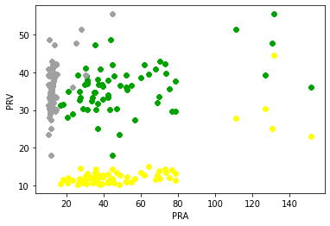

The Figure 1 here shows all the features plotted against each other in a single plot. The 5 farthest points from the origin are considered to be the instances that are different from the rest which can be visually detected. The best outliers can be found using the PLA vs PRA since the plot is uniformly scattered across both axes and outliers are far from the usual data.

Figure 1. This figure shows the plots of PLA, PRV and PRA against each other (PLA vs PRV

- green, PLA vs PRA - yellow and PRV vs PRA - gray)

The figures below show 2 instances of varying linear acceleration with time where one plot is normal and the other deviates from the usual 60 instances. The peak values differ from each other which help distinguish the unusual instances from the usual ones.

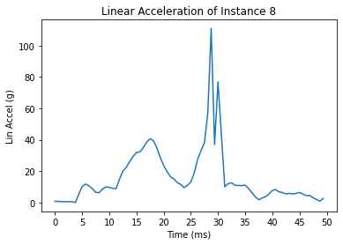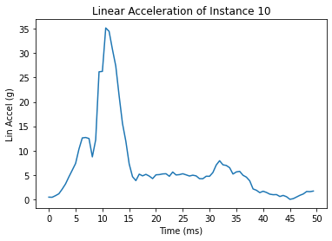

Figure 2. Linear acceleration for instance Figure 3. Linear acceleration for instance 8 which is dissimilar to the other 60 10 which is similar to the other 60 instances - abnormal behavior instances - normal behavior