RUNNING HEAD: SQL Lab

Lab 5: SQL Lab
CNIT27000-LabSection009
Group 26
Abigail Garza
Ritvik Indupuri
Submitted To: Andrew Holloway
Date Submitted: 12/05/2025
Date Due: 12/05/2025

TABLE OF CONTENTS
PROCEDURES 4
Question 1 – Pen Test Report Intro 4
Item 1 Name: Paragraph & Sanitizing Inputs 4
Question 2 – Test Queries 5
Item 1 Name: Business Security Value 5
Item 2 Name: Schema.tables 5
Item 3 Name: Schema.columns 8
Item 4 Name: 1st additional query 10
Item 5 Name: 2nd additional query 11
Question 3 – Attack on SELECT (login, web form) 12
Item 1 Name: Command 12
Item 2 Name: Reconnaissance 13
Item 3 Name: Implications 14
Item 4 Name: Evidence 14
Question 4 – Attack on SELECT (login, command line) 15
Item 1 Name: Command 15
Item 2 Name: Reconnaissance 16
Item 3 Name: Implications 17
Item 4 Name: Evidence 18
Question 5 – Attack on SELECT (stacked query) 18
Item 1 Name: Method 18
Item 2 Name: Results 19
Item 3 Name: Implications 21
Question 6 – Attack on UPDATE (modify own pto) 21
Item 1 Name: Command 21
Item 2 Name: Reconnaissance 23
Item 3 Name: Implications 23
Item 4 Name: Evidence 24
Question 7 – Attack on UPDATE (modify other’s pto) 27
Item 1 Name: Command 27
Item 2 Name: Reconnaissance 28
Item 3 Name: Implications 29
Item 4 Name: Evidence 29
Question 8 – Attack on UPDATE (modify other’s password) 30
Item 1 Name: Command 30
Item 2 Name: Reconnaissance 32
Item 3 Name: Implications 33
Item 4 Name: Evidence 34
Question 9 – Countermeasure Implementation 36
Item 1 Name: Description 1 36
Item 2 Name: Description 2 [Extra Credit] 37
Item 3: Explanation of Code Vulnerability and Fix 39
Item 4: Applied Fix 39
BIBLIOGRAPHY 43

PROCEDURES
The procedures followed were used to complete Lab 5, SQL. The goal of this lab was to test the strength of security of the Hands Hardy Hardware employee website. Penetration tests were performed to reveal any SQL injection vulnerabilities and highlighted how authentication, employee data, and modification of database values could be exploited. The formatting key used for this lab is buttons are bold, and text entered into the computer is in Courier New.

Question 1 – Pen Test Report Intro

Item 1 Name: Paragraph & Sanitizing Inputs
This penetration test report details the security assessment of the Hands Hardy Hardware website, specifically focusing on its vulnerability to SQL Injection (SQLi) attacks. Penetration testing is a security test which initiates a mock cyberattack to discover vulnerabilities in a computer system. An insecure website is one that is vulnerable or lacks the right protection, making it more liable to breaches or attacks (Espinosa, 2024). SQL injection occurs when an insecure website allows user input—such as a username or password—to be interpreted as executable code by the backend database, rather than just data (NinjaOne, n.d.). To prevent this, developers often rely on a practice known as sanitizing inputs. Sanitization involves writing code that inspects user input and strips out or escapes dangerous characters like the single quote ' or semi-colon; before the data reaches the database (Munroe, 2007; Pound, 2017).
However, sanitizing input is not sufficient to fully prevent SQL injection. It relies on a blocklist approach where developers must predict and block every possible malicious character string, which is prone to human error. A clever attacker can often find encoding tricks or alternative characters to bypass these filters. True security is better achieved through prepared statements (parameterized queries), which fundamentally separate user data from executable code, rendering the input harmless regardless of its content (NinjaOne, n.d.).

Question 2 – Test Queries

Item 1 Name: Business Security Value
The employee database, which contains a single table named pii, is a critical asset for Hands Hardy Hardware because it serves as the central repository for all employee information. This includes highly sensitive personally identifiable information such as Social Security Numbers and hashed passwords. Databases that store PII are considered high‑value targets because they support essential business functions like payroll through the salary column and authentication through the password column (NIST, 2020). At the same time, they represent a significant liability if not properly secured. A breach could result in identity theft through the exposure of unencrypted Social Security Numbers, unauthorized access if hashed passwords are cracked offline, and privilege escalation if the secure_room column is manipulated to bypass physical security controls. These risks highlight the importance of implementing strong encryption, access control, and monitoring practices to protect sensitive employee data (OWASP, 2023; CISA, 2021).

Item 2 Name: Schema.tables
The following procedures displayed the used a query to display the schema tables for employees in the database.

- Typed mysql -u root –p
- mysql: This launches the MySQL client program, which provides direct access to a MySQL database server for running SQL queries and administrative tasks (Stuttard & Pinto, 2011; Anderson, 2020).
- -u root: The flag specifies the username used to connect. In this case, is the default administrative account, typically holding full privileges to manage databases, users, and configurations (Clarke, 2009; OWASP, 2021).
- -p: This option tells MySQL to prompt a password before granting access. It enforces authentication and helps prevent unauthorized logins. Without a password requirement, attackers could exploit weak defaults or misconfigured systems (National Institute of Standards and Technology, 2020; OWASP, 2023).
- Entered password for use root@localhost
- Typed mysql> use employees;
- Use employees: This command tells MySQL to switch the active database context to. Once executed, all subsequent queries will run against the database unless another schema is specified (Stuttard & Pinto, 2011; Anderson, 2020).
- Typed select table_name from information_schema.tables where table_schema = 'employees';
- Select table_name: This query retrieves the names of all tables within the employees database. It does so by querying the information_schema.tables system view, which stores metadata about every table in the server. The where table_schema = 'employees' clause filters results to only those belonging to the employees schema (Clarke, 2009; OWASP, 2023; GeeksforGeeks, 2025).
- From information_schema.tables: The information_schema.tables view is a system table that stores metadata about every table across all databases. Querying this schema is a common way to enumerate database structures, which can be useful for administrators but dangerous if exploited by attackers (Anderson, 2020; GeeksforGeeks, 2025).
- where table_schema = 'employees': The WHERE clause filters results to only those tables belonging to the employees database. This narrows the scope of the query, allowing focused enumeration of the schema for that specific database (Cyberly, 2025; OWASP Foundation, 2023).
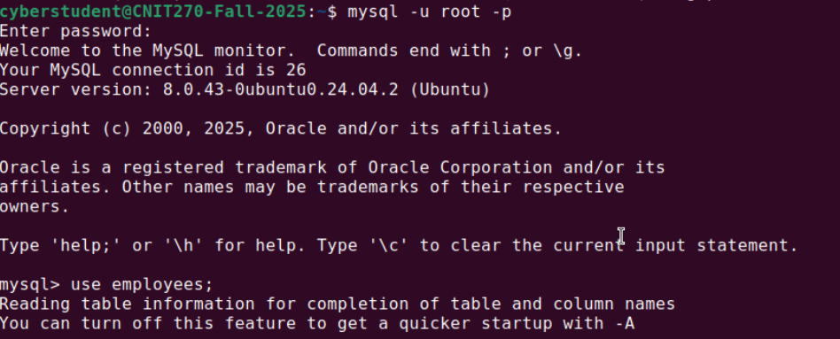
Figure 1: Enabling mysql database
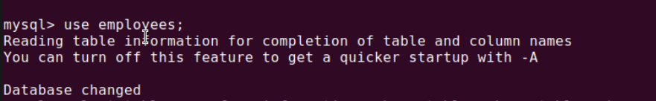
Figure 2: Using employees database
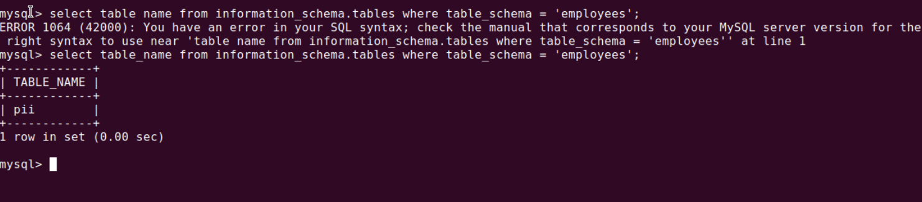Figure 3: Schema.tables query and re sults

Item 3 Name: Schema.columns
The following procedures used a query to display the schema columns for employees in the database.
- Typed select column_name from information_schema.columns where table_schema = 'employees';
  - Select table_name: This query retrieves the names of all tables within the employees database. It does so by querying the information_schema.tables system view, which stores metadata about every table in the server. The where table_schema = 'employees' clause filters results to only those belonging to the employees schema (Clarke, 2009; OWASP, 2023; GeeksforGeeks, 2025).
  - From information_schema.columns: The information_schema.columns view is a system table that stores metadata about every column in every table across all databases. Querying this schema is a common way to enumerate database structures, which can be useful for administrators but dangerous if exploited by attackers (Anderson, 2020; GeeksforGeeks, 2025).
  - WHERE table_schema=’employees’: The WHERE clause filters results to only those columns belonging to the employees database. This narrows the scope of the query, allowing focused enumeration of the schema for that specific database (Cyberly, 2025; OWASP Foundation, 2023).
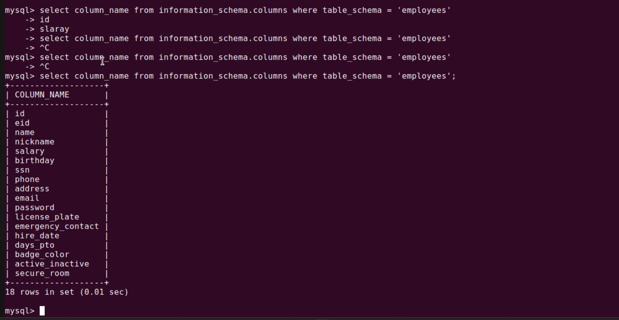Figure 1: Schema.columns query and results

Item 4 Name: 1st additional query
The following procedures generated an additional query to select the name and salary from the personal identifier information table.
- Typed select name, salary from pii;
- Select name, salary: This part of the query specifies which columns to retrieve from the database. In this case, it requests the name and salary fields, which are sensitive attributes often classified as personally identifiable information (PII) (Anderson, 2020; OWASP, 2021)

- From pii: The FROM clause tells MySQL which table to query. Here, the table is named pii, suggesting it contains personal or confidential data. Accessing such a table requires strict controls, as exposure of PII can lead to privacy violations, privilege escalation, or compliance issues (National Institute of Standards and Technology, 2020; Cyberly, 2025; OWASP Foundation, 2023).
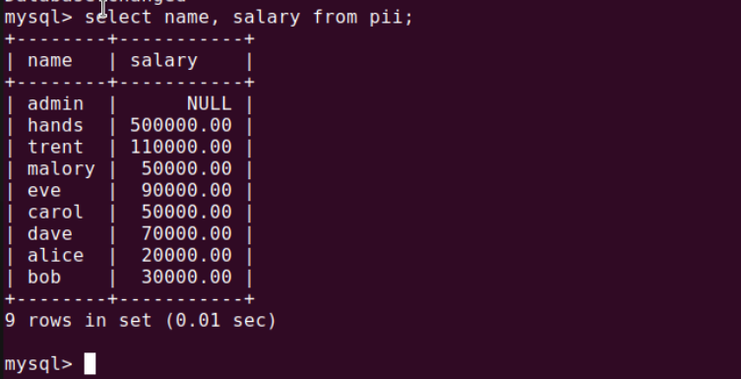Figure 1: 1st additional query output

Item 5 Name: 2nd additional query
The following procedures selected the name, ssn, and passwords for employees from the personal identified information table.
- Typed select name, ssn, password from pii;
  - select name, ssn, password: This part of the query specifies which columns to retrieve from the database. In this case, it requests name, ssn, and password fields. These are highly sensitive attributes, classified as personally identifiable information (PII). Accessing them without safeguards poses significant privacy and security risks (Anderson, 2020; OWASP, 2021; National Institute of Standards and Technology, 2020).
  - from pii: The FROM clause identifies the table being queried. Here, the table pii appears to store personal data. Direct queries against such a table must be tightly controlled, as exposure of SSNs and passwords can lead to identity theft, privilege escalation, and regulatory violations (Clarke, 2009; OWASP Foundation, 2023; Cyberly, 2025).

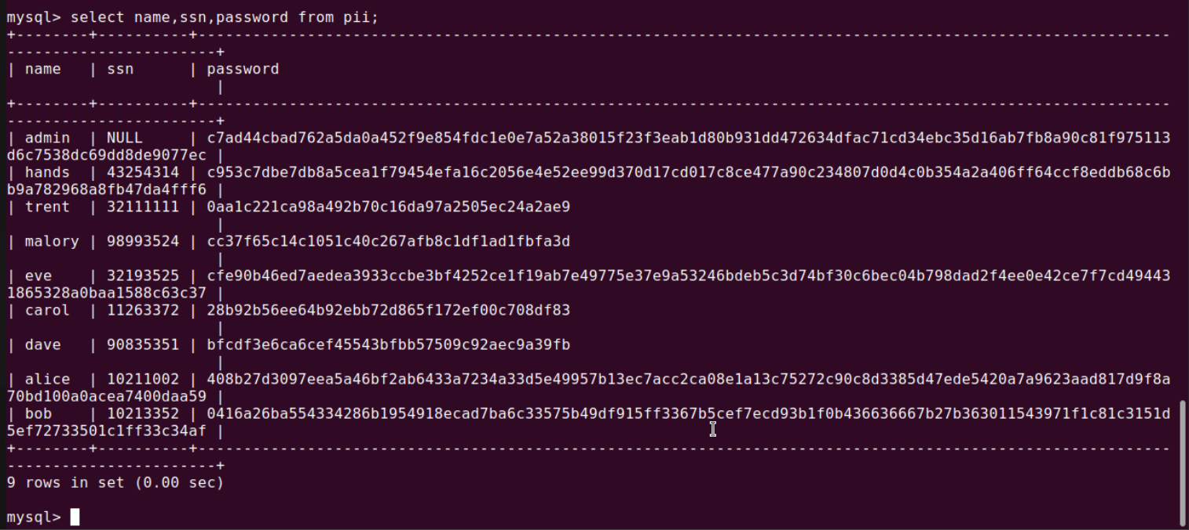
Figure 1: Second additional query output

Question 3 – Attack on SELECT (login, web form)

Item 1 Name: Command
The following procedures used the command (injection payload) Trent OR 1=1 # and entered it into the USERNAME field on the HHH employee website login form. This allowed the specified user Trent to be able to log into the Hands Hardy Hardware website without a password.
- Typed Trent OR 1=1 # to login as Trent into the HandsHardyHardware website without a password
- Trent: The string begins with the username Trent. This is the legitimate account identifier being targeted in the login attempt (Anderson, 2020).
- OR 1=1: The OR 1=1 condition forces the SQL query to be evaluated as true. Since 1=1 is always true, this clause bypasses normal authentication logic. Attackers often use this tautology to trick the database into accepting any input as valid credentials (Clarke, 2009; Halfond, Viegas, & Orso, 2006; OWASP, 2021).
- #: The # symbol is a comment delimiter on MySQL. Everything following it is ignored by the SQL engine. In this case, it cancels the rest of the legitimate query, ensuring that the injected condition dominates the logic (Clarke‑Salt, 2010; NinjaOne, n.d.; OWASP, 2023).

Item 2 Name: Reconnaissance
To understand how the SQL Injection attack worked, it is useful to consider the structure of a typical backend SQL query. A simple authentication check might resemble:
SELECT * FROM employees WHERE name = '$input_uname' AND Password = '$input_pwd';
In this context, each injected character has a distinct role. The single quote (') terminates the expected string input, allowing the attacker to escape into command execution. The clause OR 1=1 introduces tautology, ensuring the condition always evaluates true and thereby bypassing normal authentication checks. Finally, the hash (#) acts as a comment operator in MySQL, which effectively ignores the remainder of the query, including the password validation (Halfond, Viegas, & Orso, 2006; OWASP, 2023).

Item 3 Name: Implications
The outcome of this attack demonstrates a critical security vulnerability. The authentication mechanism was bypassed entirely, enabling login without a valid password. Because the injected condition (1=1) evaluates true for all rows, the database returned the first record in the table. In this system, that record corresponds to the administrator account (Employee ID 99999). As a result, the attacker unintentionally escalated privileges, gaining full administrative access rather than access to Trent’s account. This type of privilege escalation through SQL injection is well‑documented in the literature as one of the most severe risks to web applications (Halfond, Viegas, & Orso, 2006; OWASP, 2023).

Item 4 Name: Evidence
The following images below are evidence of our successful breach of the website of logging into the HHH employee website as user Trent without a password.

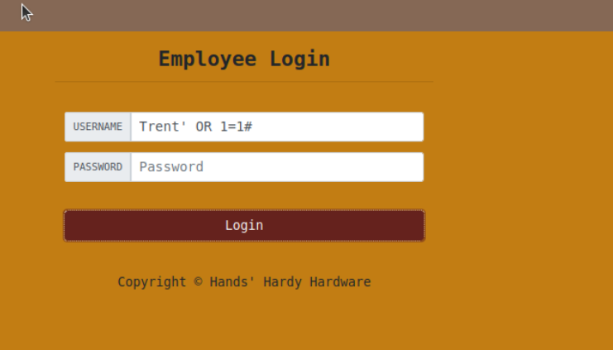
Figure 1: Employee Login page

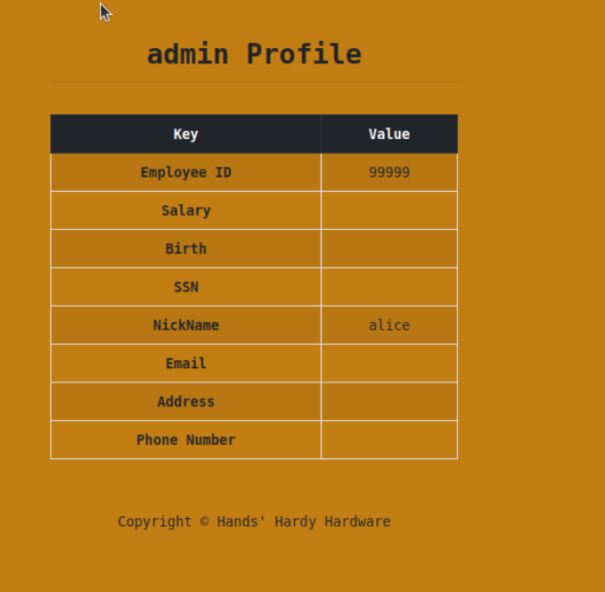
Figure 2: Admin profile

Question 4 – Attack on SELECT (login, command line)

Item 1 Name: Command
The following procedures used the command curl "http://44.65.10.55/u_home.php?username=Trent%27%20OR%201%3D1%20%23&Password=pass to allow the user Trent to be able to log into the Hands Hardy Hardware website with a password from the command line using the curl command.
- Typed curl "http://44.65.10.55/u_home.php?username=trent%27%20%23&Password="
  - curl: A command-line utility designed for transferring data using URLs. It is widely used for testing, automation, and sending HTTP requests (Stenberg, 2020).
  - "...": Double quotes were applied, so the terminal interprets the entire URL as a single string. This prevents misinterpretation of special characters such as & or % (Shotts, 2019).
  - ?username=trent%27%20%23: This portion represents the URL-encoded payload. The sequence %27 corresponds to an apostrophe ('), while %20 encodes a space. The trailing %23 encodes the hash symbol (#), which comments on the remainder of the SQL query. Together, this forms the injection string trent' # (Halfond, Viegas, & Orso, 2006).
  - &Password=: This parameter is included to complete the request structure, though in this case no actual password value is supplied. It ensures that the query string remains syntactically valid for the receiving PHP script (Stenberg, 2020).

Item 2 Name: Reconnaissance
To construct this attack, the behavior of the web application was first observed during manual testing. It was noted that the login form relied on the HTTP GET method, which appends user inputs directly to the URL as parameters (e.g., u_home.php?username=...&Password=...). This design choice can expose sensitive data in query strings and make applications more susceptible to injection attacks if input validation is not enforced (Clarke, 2009).
Using this knowledge, the previously successful SQL injection payload from the web form (Trent' OR 1=1 #) was adapted for use in a curl command by applying URL encoding. Specifically:
- Spaces were encoded as %20
- Single quotes (') were encoded as %27
- The hash/comment symbol (#) was encoded as %23
This encoding ensured that the payload was transmitted correctly within the HTTP request, preserving its intended effect on the backend query (Clarke, 2009).

Item 3 Name: Implications
The ability to execute this attack via the command line has significant security implications. Command‑line tools such as curl or wget enable attackers to automate requests, removing the need for manual input through a web browser. By scripting these tools, an attacker could loop through thousands of different injection payloads in minutes, making large‑scale or “blind” SQL injection attacks—where data is extracted by character—both feasible and highly efficient. Furthermore, command‑line execution bypasses client‑side restrictions, such as JavaScript validation, which are only enforced in standard browser environments. This automation capability is widely recognized as a critical factor in the scalability of SQL injection attacks (Clarke, 2009; Rapid7, 2023).

Item 4 Name: Evidence
The following images below are evidence of our successful breach of the website logging in as user Trent from the command line using the command curl.
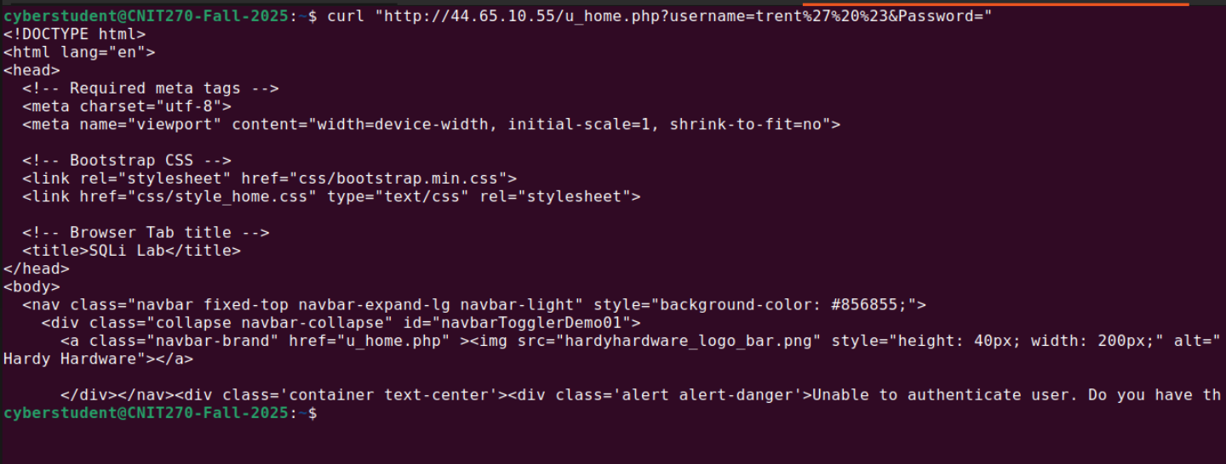
Figure 1: Curl Command HTML output

Question 5 – Attack on SELECT (stacked query)

Item 1 Name: Method
The following procedures attempted to carry out a stacked query on the Hands Hardy Hardware website.
- Typed the following payload into the USERNAME field to attempt to inject a second SQL command: '; UPDATE employees SET secure_room=1 WHERE name='alice' #
- UPDATE Employees: The UPDATE statement modifies existing records in the employees table. It allows administrators to change values in one or more columns for rows that meet a specified condition (Stuttard & Pinto, 2011; Anderson, 2020).
- SET secure_room=1: This clause assigns the value 1 to the secure_room column. In practice, this could represent granting access rights or enabling a flag that marks an employee as authorized for a secure area (Clarke, 2009; OWASP, 2021).
- WHERE name=’alice’: The WHERE condition restricts the update to only rows where the name field equals 'alice'. Without this filter, the command would update all rows in the table, which could cause unintended privilege escalation or data corruption (Cyberly, 2025; OWASP Foundation, 2023).
- #: The # symbol is used in MySQL as a comment delimiter. Everything following it is ignored by the SQL engine. Attackers often exploit this to terminate legitimate queries and inject malicious code, a common SQL injection technique (Clarke-Salt, 2010; GeeksforGeeks, 2025; Halfond, Viegas, & Orso, 2006).
- Then typed a placeholder password (which was password) and clicked Login

Item 2 Name: Results
The attack was unsuccessful.
As shown in the screenshots below, the application returned to a completely blank page. This indicates that the application failed to process the input and likely threw a fatal error in the background, rather than executing the second injected command.
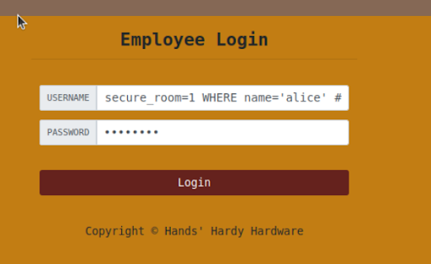
Figure 1: SQL Query being typed in login page

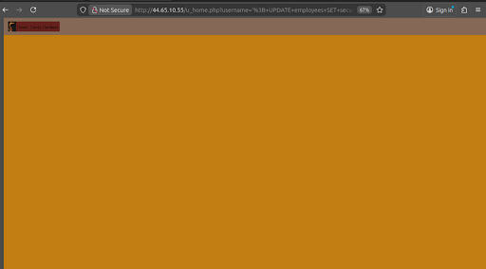
Figure 2: Execution of SQL query

Item 3 Name: Implications
This failed attempt highlights a technical restriction that, in practice, acts as a safeguard. In a standard LAMP stack (Linux, Apache, MySQL, PHP), queries are typically executed using the mysqli_query function. By default, this function does not allow stacked queries, meaning multiple SQL statements separated by semicolons cannot be processed in a single call. Because of this restriction, even though the application is vulnerable to SQL injection, an attacker cannot simply append destructive commands such as UPDATE, DELETE, or DROP to the original SELECT statement. The limitation reduces the severity of the vulnerability compared to database environments that permit stacked queries, where attackers could escalate from data retrieval to direct manipulation or deletion of records (Clarke, 2009).

Question 6 – Attack on UPDATE (modify own pto)

Item 1 Name: Command
The following procedures used the command Alice ', days_pto='100' where name='alice';# to allow Alice to be able to increase her own PTO in the HHH employee website.
- Logged in as alice by typing in the payload alice’ # and the password as ‘password’
- Viewed Alice’s profile and clicked ‘edit profile’
- Typed Alice', days_pto='100' where name='alice';# into the NickName field

- ,days_pto=’100’: This portion of the statement sets the value of the days_pto column to 100. In practice, this would represent assigning 100 paid time off (PTO) days to an employee record. Manipulating HR‑related fields like PTO without proper authorization can lead to privilege escalation or fraud (Anderson, 2020; Cyberly, 2025; OWASP Foundation, 2023).
- WHERE name=’alice’: The WHERE clause restricts the update to rows where the name field equals 'alice'. This ensures only Alice’s record is affected. Without this filter, the update could apply to all employees, which would be a serious data integrity issue (Clarke, 2009; OWASP, 2021).
- #: The # symbol is a comment delimiter in MySQL. Everything following it is ignored by the SQL engine. Attackers often use this to terminate legitimate queries and bypass security checks, a common SQL injection tactic (Clarke‑Salt, 2010; GeeksforGeeks, 2025; Halfond, Viegas, & Orso, 2006).
- Clicked Save
- Typed On Attacker VM (VM A) SELECT name, days_pto FROM pii;
- SELECT name, days_pto: This part of the query specifies which columns to retrieve. In this case, it requests the name field and the days_pto field. These attributes combine personally identifiable information (PII) with HR‑related data, making them sensitive and requiring strong access controls (Anderson, 2020; OWASP, 2021).
- FROM pii: The FROM clause identifies the table being queried. Here, the table pii appears to store personal data. Direct queries against such a table must be tightly controlled, as exposure of employee names linked to PTO balances could lead to privacy violations, insider misuse, or privilege escalation (Clarke, 2009; Cyberly, 2025; OWASP Foundation, 2023).

Item 2 Name: Reconnaissance
During the “Build Familiarity” phase, I examined the database schema and noted the presence of the column in the table. From observing how the “Edit Profile” page likely constructs its SQL statements (e.g.,), I inferred to the query structure. To test how input could alter query logic, I crafted an entry that terminated the nickname string, introduced a secondary assignment, and used a comment marker () to suppress the remainder of the statement. This demonstrated how unsanitized input could be leveraged to manipulate multiple fields within a single query.

Item 3 Name: Implications
This result demonstrates a critical breakdown in horizontal privilege escalation and data integrity (OWASP, 2023). In this case, a standard employee account (“Alice”) was able to modify data belonging to an administrative user (“Hands”), which reflects a failure in privilege separation (Stuttard & Pinto, 2011). The integrity of the application was compromised because access controls were not properly enforced, allowing arbitrary modification of sensitive business data such as vacation time (Anderson, 2020). In a real-world scenario, such vulnerabilities could enable financial fraud through salary manipulation, denial of service by setting paid time off to zero, or even administrative lockout, all of which highlight the severity of inadequate authorization mechanisms (NIST, 2022).

Item 4 Name: Evidence
The following images below are evidence of our successful breach of the HHH employee website enabling user Alice to increase her own PTO days.
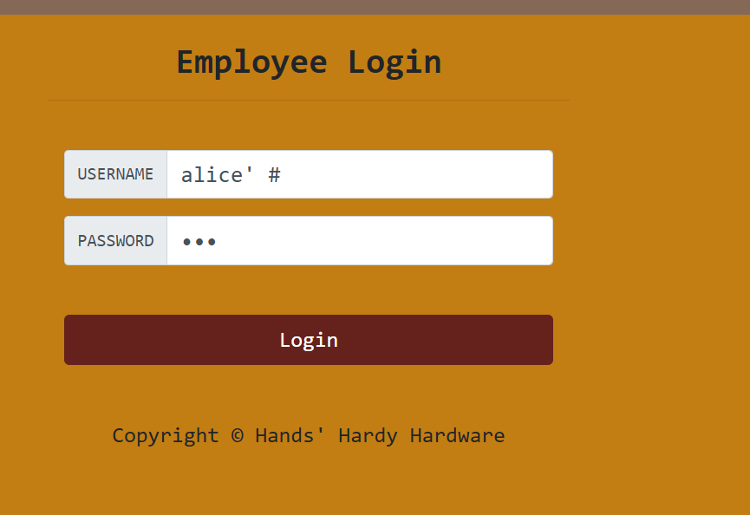
Figure 1: SQL Payload to login as Alice

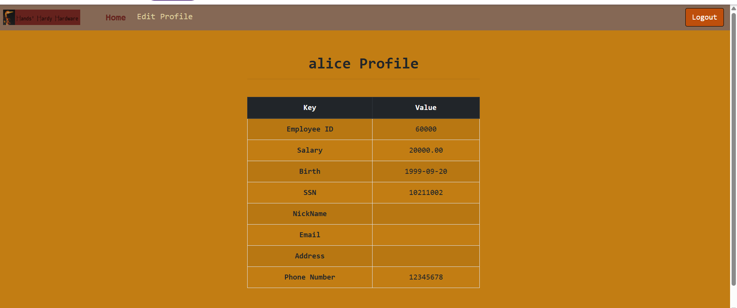Figure 2: Alice Profile screen

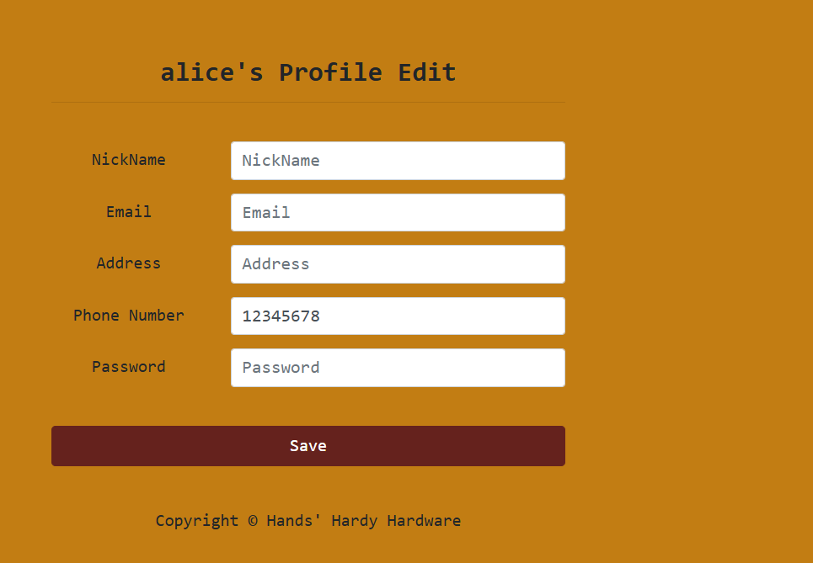
Figure 3: Alice profile edit screen

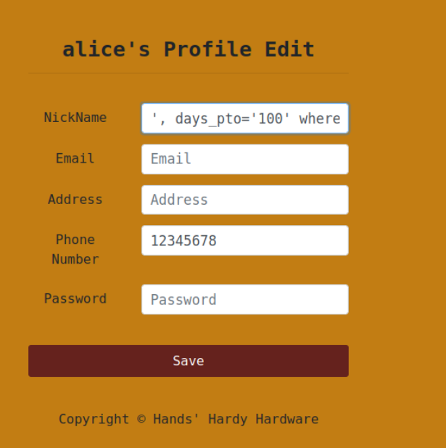
Figure 4: Editing Alice PTO Days for alice

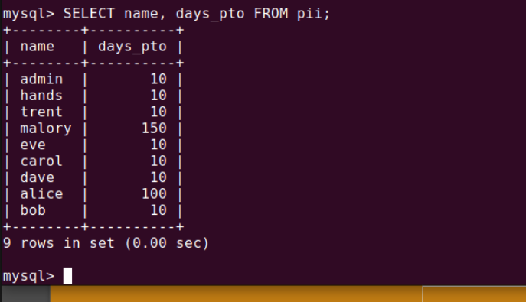
Figure 5: testing changed PTO days

Question 7 – Attack on UPDATE (modify other’s pto)

Item 1 Name: Command
The following command Alice', days_pto=0 WHERE name='hands' #
allowed the user Alice to be able to modify Hands PTO to 0.
- Logged in as alice by typing in the payload alice’ # and the password as ‘password’
- Alice’: The username input begins with alice followed by an apostrophe ('). The apostrophe prematurely closes the expected string input, a classic SQL injection technique. This allows the attacker to break out of the intended query structure (Clarke, 2009; Clarke‑Salt, 2010; GeeksforGeeks, 2025).
- #: The # symbol is a comment delimiter on MySQL. Everything following it is ignored by the SQL engine. In this case, it cancels the rest of the legitimate query, ensuring that only the injected portion is processed (Halfond, Viegas, & Orso, 2006; OWASP, 2023).
- Viewed Alice’s profile and clicked ‘edit profile’
- Clicked ‘edit profile’
- In the nickname filed of Alice’s profile typed in Alice', days_pto=0 WHERE name='hands' #
- Alice’: The trailing apostrophe (') prematurely closes the expected string input. This is a common SQL injection technique, where attackers break out of the intended query structure to insert their own commands (Clarke, 2009; Clarke‑Salt, 2010; GeeksforGeeks, 2025).
- ,days_pto=0: This fragment attempts to update the days_pto column to 0. In practice, this would reset paid time off days for a record. Such manipulations can be used to alter HR data or disrupt employee entitlements (Anderson, 2020; OWASP, 2021).
- WHERE name=’hands’: The WHERE clause targets rows where the name field equals 'hands'. This redirection changes the scope of the update, potentially affecting another employee’s record instead of Alice’s. It demonstrates how injection can be used to tamper with unrelated data (Cyberly, 2025; OWASP Foundation, 2023).
- #: The # symbol is a comment delimiter in MySQL. Everything following it is ignored by the SQL engine. Attackers often use this to terminate legitimate queries and bypass security checks, a primary method of SQL injection attacks (Halfond, Viegas, & Orso, 2006; NinjaOne, n.d.; OWASP, 2023).
- Clicked Save
- Typed On Attacker VM (VM A) select name, days_pto from pii where name='hands';

Item 2 Name: Reconnaissance
In the reconnaissance phase, I was able to identify another user, “Hands,” instead of the logged-in user, “Alice.” This identification was possible because of data gathered during the database mapping stage, where the username hands and the column days_pto were revealed through initial database dumps and schema queries (OWASP, 2021). Based on this information, I inferred that the backend query of the web application likely included a clause restricting updates to the currently logged-in user, such as WHERE ID = $session_id (Halfond et al., 2006). To bypass this restriction, I constructed a payload that first closed the data field associated with Alice, then injected a malicious value by setting days_pto to zero. I followed this by adding a new target condition specifying WHERE name='hands' and commenting out the original restrictive clause, which effectively overrode the system’s intended protections (Clarke-Salt, 2010).

Item 3 Name: Implications
The implications of this attack reveal a critical horizontal privilege escalation vulnerability. One major consequence is denial of service, where an attacker can set days_pto to zero or change a password, thereby preventing legitimate users from accessing their accounts or benefits (OWASP, 2021). Another implication is the violation of data integrity, since an unprivileged user like Alice can arbitrarily modify the data of a privileged user such as Hands or even an administrator, which undermines the system’s access control model (Clarke-Salt, 2010). Finally, the attack enables framing or repudiation. If an attacker changes to another user’s password, they can impersonate that user, and any subsequent malicious actions would be logged under the victim’s identity, allowing the attacker to conceal their tracks (Halfond et al., 2006).

Item 4 Name: Evidence
The following images below are evidence of the successful breach of the HHH employee website and user Alice changing Hands PTO days to 0.

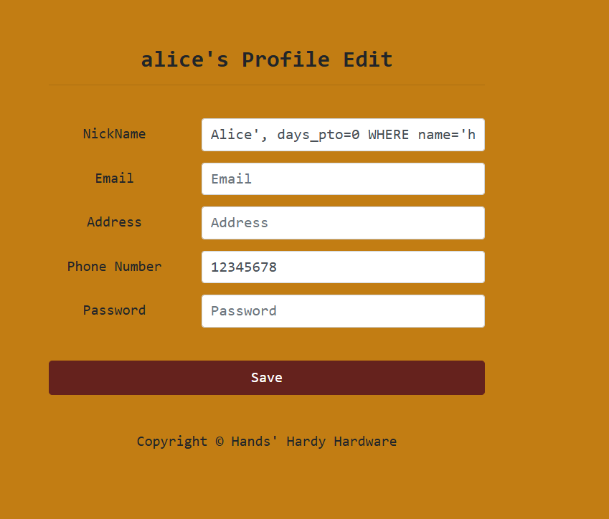
Figure 1: Editing Alice’s profile using SQL payload

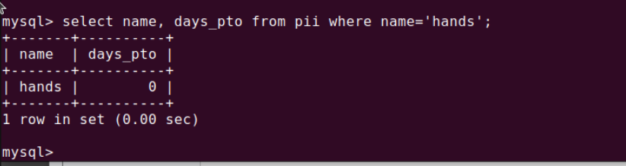Figure 2: Validtaion of PTO Change for Hands

Question 8 – Attack on UPDATE (modify other’s password)

Item 1 Name: Command
The following procedures used the command Alice', Password='40bd001563085fc35165329ea1ff5c5ecbdbbeef' WHERE name='hands' # given to allow user Alice to be able to change Hand’s password on the HHH employee website.
- Logged in as alice by typing in the payload alice’ # and the password as ‘password’
  - Alice’: The username input begins with alice followed by an apostrophe ('). The apostrophe prematurely closes the expected string input, a classic SQL injection technique. This allows the attacker to break out of the intended query structure (Clarke, 2009; Clarke‑Salt, 2010; GeeksforGeeks, 2025).
  - #: The # symbol is a comment delimiter on MySQL. Everything following it is ignored by the SQL engine. In this case, it cancels the rest of the legitimate query, ensuring that only the injected portion is processed (Halfond, Viegas, & Orso, 2006; OWASP, 2023).
- Viewed Alice’s profile and clicked ‘edit profile’
- Changed the nickname field by typing in Alice', Password='40bd001563085fc35165329ea1ff5c5ecbdbbeef' WHERE name='hands' #
  - Alice’: The trailing apostrophe (') prematurely closes the expected string input. This is a classic SQL injection technique, allowing the attacker to break out of the intended query structure and insert malicious commands (Clarke, 2009; Clarke‑Salt, 2010; GeeksforGeeks, 2025).
  - Password='40bd001563085fc35165329ea1ff5c5ecbdbbeef': This fragment attempts to overwrite the Password field with the value 40bd001563085fc35165329ea1ff5c5ecbdbbeef. This string is the SHA‑1 hash of the word “123,” a weak password often used in demonstrations. Storing or injecting hashed values directly into a database highlight how attackers can manipulate authentication data (Anderson, 2020; OWASP, 2023).
  - WHERE name=’hands’: The WHERE clause targets rows where the name field equals 'hands'. This redirection changes the scope of the update, potentially altering another user’s credentials instead of Alice’s. It demonstrates how injection can be used to tamper with unrelated accounts (Cyberly, 2025; OWASP Foundation, 2023).
  - #: The # symbol is a comment delimiter in MySQL. Everything following it is ignored by the SQL engine. Attackers often use this to terminate legitimate queries and bypass security checks, a primary method of SQL injection attacks (Halfond, Viegas, & Orso, 2006; NinjaOne, n.d.; OWASP, 2023).
- Clicked Save
- On Attacker VM A typed select name, password from pii where name='hands';

Item 2 Name: Reconnaissance
To successfully target another user named Hands instead of the logged‑in user Alice, I relied on reconnaissance data gathered during the database mapping phase. From the initial database dumps using queries such as schema exploration performed earlier, I identified the username Hands and the specific column days_pto. Based on this information, I inferred that the web application’s backend query likely ended with a clause restricting updates to the currently logged‑in user, such as. Reconnaissance is a critical stage in penetration testing because it allows attackers to collect information about the target environment before exploitation (Invicti, 2025). To bypass the restriction, I constructed a payload that first closed the data field (Alice'), then injected the malicious value (days_pto=0), added a new target condition (), and finally commented out the original restrictive clause. This approach reflects how SQL injection can be used to manipulate queries and gain unauthorized access to sensitive data (GeeksforGeeks, 2025).

Item 3 Name: Implications
This attack demonstrates a serious horizontal privilege escalation vulnerability. Horizontal privilege escalation occurs when an attacker gains access to another user’s data or resources at the same privilege level, bypassing intended access controls (Cyberly, 2025). The implications are significant. First, it enables denial of service, since an attacker could set days_pto to 0 or change a password, effectively preventing legitimate users from accessing their accounts or benefits. Denial of service attacks are disruptive because they block legitimate users from accessing systems and can cause financial and operational damage (CISA, 2021). Second, the attack undermines integrity, as an unprivileged user can arbitrarily modify the data of another user, including administrators, which breaks the trust model of the system. Finally, it creates opportunities for framing and repudiation. Repudiation attacks occur when malicious actors manipulate or deny responsibility for actions, often exploiting weak logging mechanisms (Twingate, 2024). By changing another user’s password, an attacker could log in as that victim, and any subsequent malicious actions would be recorded under the victim’s identity, allowing the attacker to conceal their tracks.

Item 4 Name: Evidence
The following images below are evidence of the successful breach of the HHH employee website enabling user Alice to change user Hands password.

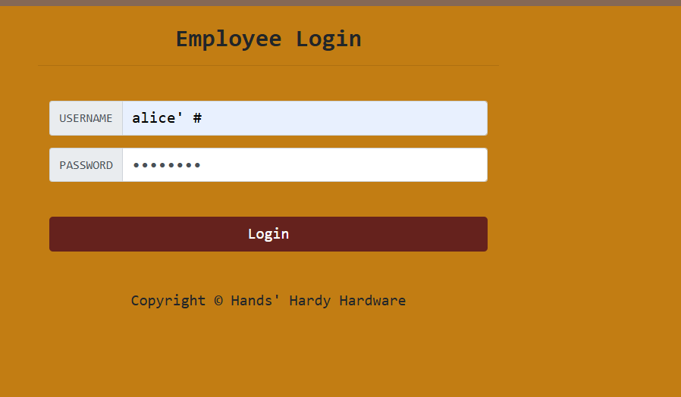
Figure 1: Logging in as Alice

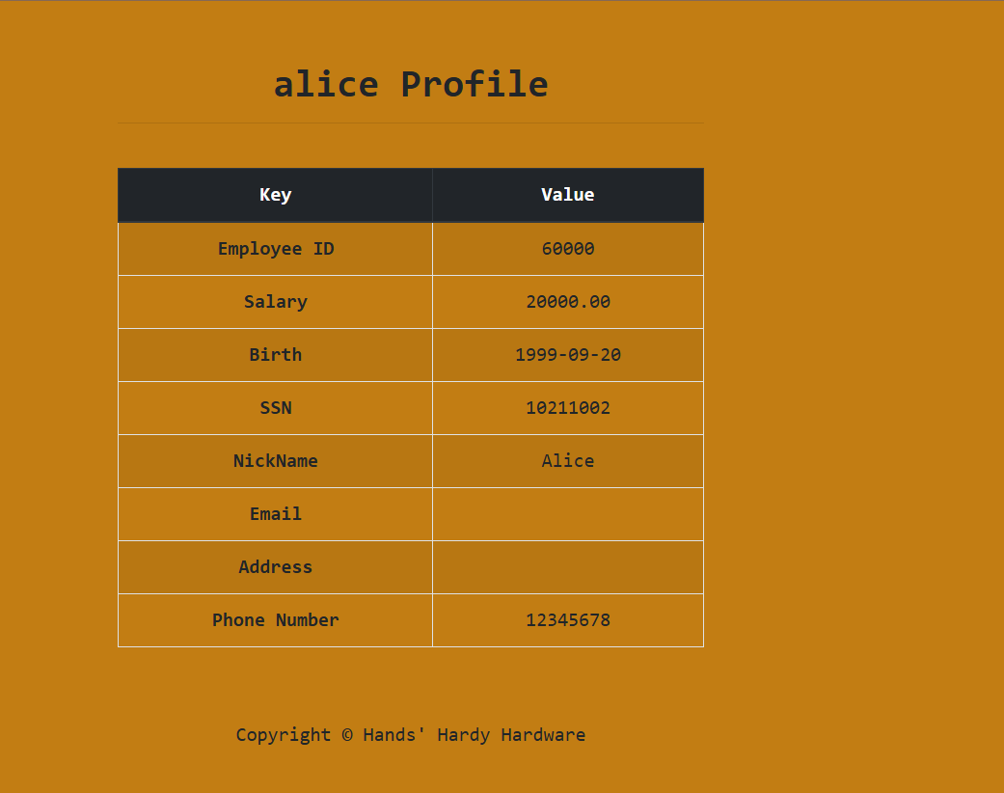
Figure 2: Alice Profile screen

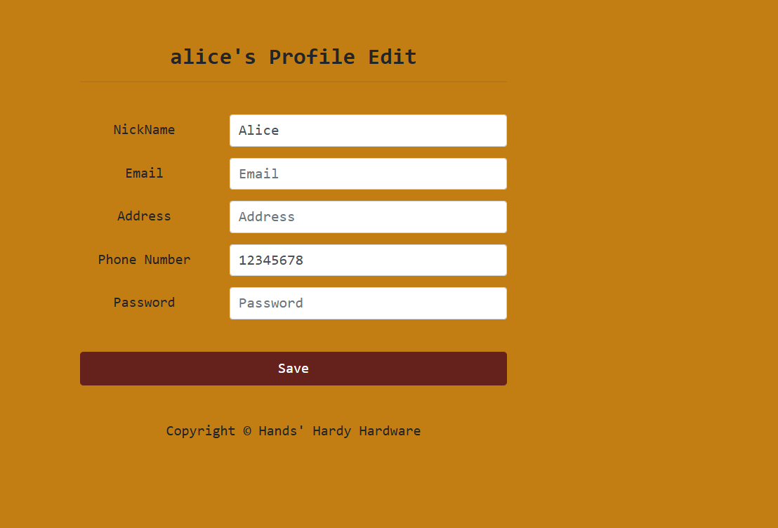
Figure 3: Alice Profile edit screen

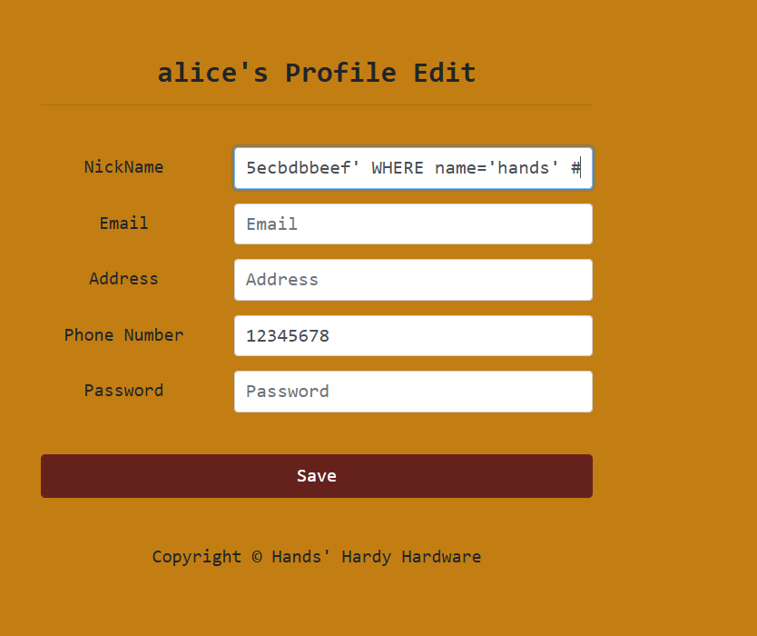
Figure 4: Typing in pyalod in Alice Profile

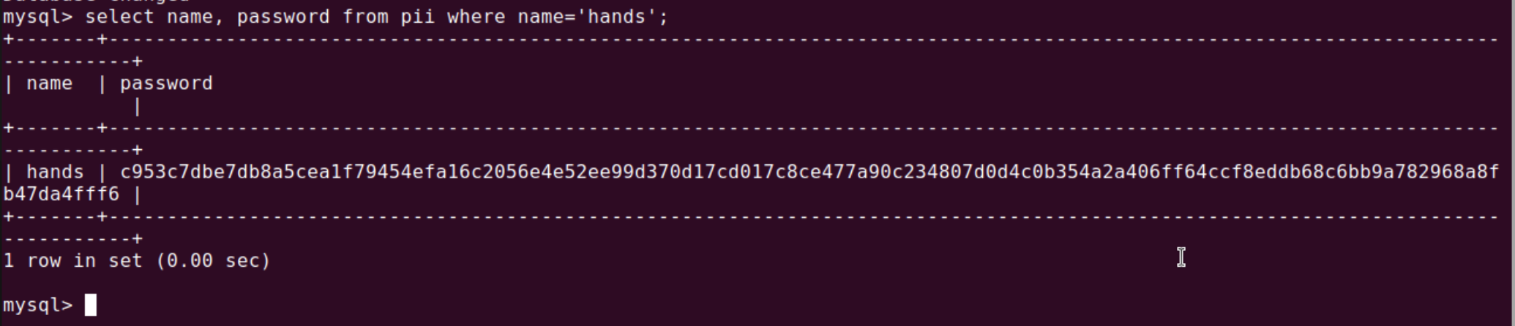
Figure 5: Validating Payload with SQL query

Question 9 – Countermeasure Implementation

Item 1 Name: Description 1
To remediate the SQL injection vulnerabilities discovered during this penetration test, Hands Hardy Hardware should immediately transition from using dynamic SQL queries to prepared statements, also known as parameterized queries. Prepared statements are designed to execute the same or similar SQL statements repeatedly with efficiency, but more importantly, they pre‑compile the SQL code on the database server before any user input is inserted. This ensures that user input is treated strictly as data rather than executable code, creating a clear boundary that prevents attackers from altering the logic of the query (OWASP, 2023). Stored procedures offer a similar level of protection by separating code from data, but they store the logic directly inside the database engine rather than the application code (Halfond et al., 2006). These approaches are far more reliable than older sanitization methods, such as using functions like mysql_real_escape_string to filter dangerous characters. Sanitization is prone to human error and can be bypassed by new evasion techniques, leaving applications vulnerable (Clarke, 2009). In contrast, prepared statements are considered a modern best practice because they make SQL injection attacks impossible by design, regardless of the characters entered by the user (OWASP, 2023).

Item 2 Name: Description 2 [Extra Credit]
- SSH into the Victim VM ssh cyberstudent@44.65.10.55
- Navigated to website directory cd/var/www/sqli/
- Cd: The cd command changes the current working directory. Here, it navigates into /var/www/sqli/, which is a typical location for web application files on a Linux server. Accessing this directory allows direct interaction with the website’s source code (Shotts, 2019; Anderson, 2020).
- List the files to see what is the diretcory using ls –l
- ls: The ls command lists the contents of the current directory. By default, it shows filenames without additional details. It’s one of the most commonly used Linux commands for navigating and inspecting file systems (Shotts, 2019; Anderson, 2020)
- -l: The -l option modifies the output to a “long listing” format. This includes file permissions, ownership, group, size, and modification date. Administrators use this view to check security attributes and identify misconfigurations in web directories (Shotts, 2019; OWASP, 2021).
- Creating a backup of the vulnerable file using sudo cp u_home.php u_home.php.bak
  - This command creates a backup of the file u_home.php by copying it to u_home.php.bak. Using sudo ensures elevated privileges, allowing the operation even if the file is owned by root. Backups are critical before editing vulnerable files, as they provide a fallback if changes cause errors (Anderson, 2020; National Institute of Standards and Technology, 2020).
- Opening file in nano using sudo nano u_home.php
This opens the file u_home.php in the Nano text editor with administrative privileges. Editing directly in Nano allows developers to inspect and modify the PHP code, often used to patch vulnerabilities such as SQL injection flaws (Clarke, 2009; OWASP, 2023).
- Scrolled and found the vulnerable Code
- Removed the vulnerable code and replaced it with the code shown in Figure 7
- Replaced Vulnerable SQL Code in Figure 8
- Tested the change by logging in as Trent using the login command Trent' OR 1=1 # and confirmed the failed login.
- Trent’: The string begins with the username Trent followed by an apostrophe (‘). The apostrophe prematurely closes the expected input string, a common SQL injection tactic used to break out of the intended query structure (Clarke, 2009; Clarke‑Salt, 2010; GeeksforGeeks, 2025).
- OR 1=1: This condition forces the SQL query to evaluate as true. 1=1 is a tautology, meaning it always returns true. Attackers often use this to bypass authentication checks by tricking the database into accepting any input as valid (Halfond, Viegas, & Orso, 2006; OWASP, 2021).

Item 3: Explanation of Code Vulnerability and Fix
The initial PHP implementation exposed a serious SQL Injection risk because it relied on string concatenation to construct the query. In the screenshot, you can see that the user’s input ($input_uname) is inserted directly into the SQL statement:
SELECT ... WHERE name = '$input_uname' ...
By failing to separate user data from the query logic, the application allowed malicious input to alter the command. For example, submitting the payload ' OR 1=1 # caused the database to interpret it as a valid condition rather than a simple username, effectively bypassing authentication controls.

Item 4: Applied Fix
To eliminate the vulnerability, the query was refactored to use Prepared Statements. In the updated code, the $conn->prepare() method defines the query with ? placeholders instead of embedding variables directly. The bind_param() function then enforces strict typing, treating the user input as a string ("ss"). This approach ensures that any characters provided by the user are handled purely as data, preventing them from being executed as SQL commands. As a result, the database query is secure against injection attempts.
Evidence:
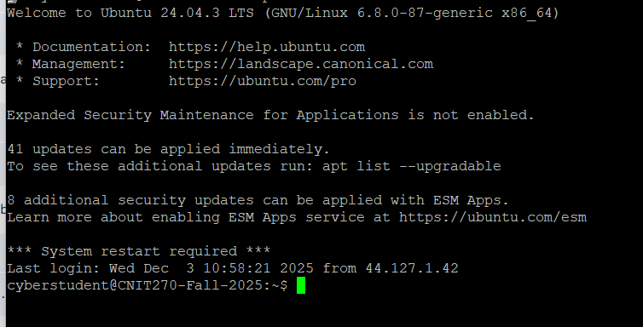Figure 1: SSH Into VM A

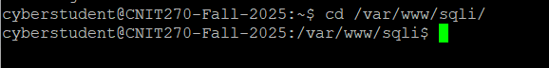
Figure 2: cd into website directory

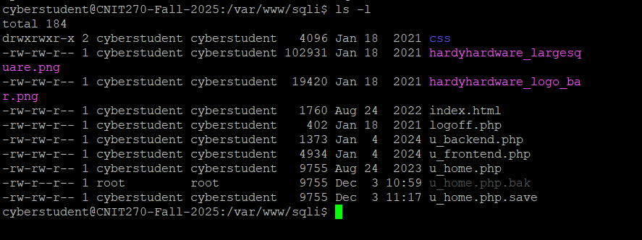
Figure 3: list all files in the directory

Figure 4: Creating a backup of the vulnerable file

Figure 5: Opening vulnerable file

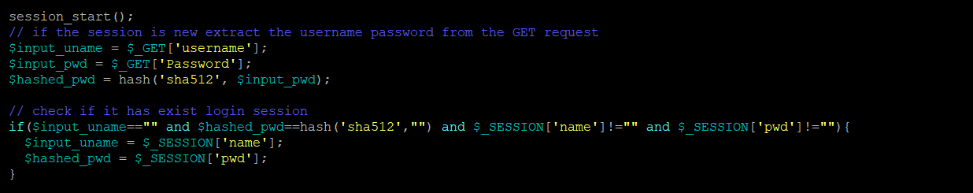Figure 6: Code Vulnerability found

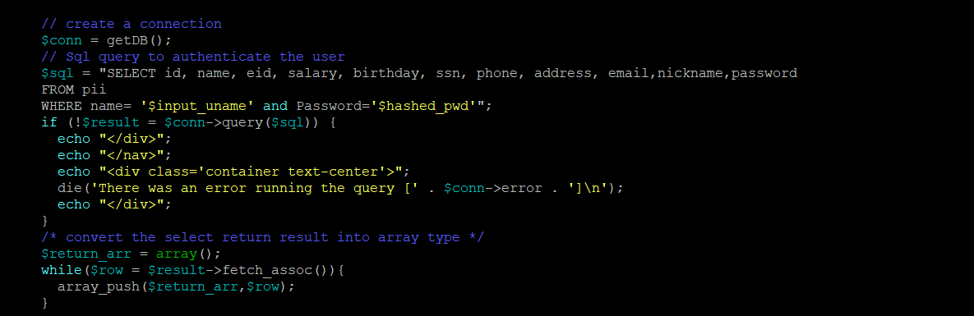Figure 7: SQL Code Vulnerability
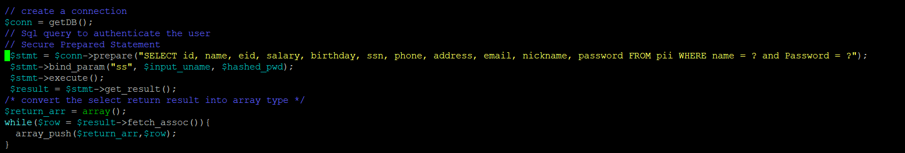
Figure 8: Replaced Vulnerable SQL Code

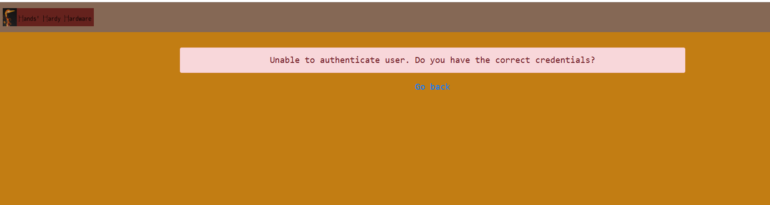Figure 9: Failed login as Trent

BIBLIOGRAPHY
Anderson, R. (2020). Security engineering: A guide to building dependable distributed systems (3rd ed.). Wiley.
Clarke, J. (2009). SQL injection attacks and defense. Syngress.
Clarke-Salt, D. (2010). SQL injection attacks and defense. Syngress.
Cyberly. (2025). What is horizontal privilege escalation. https://www.cyberly.org/en/what-is-horizontal-privilege-escalation/index.html
Espinosa, C. (2024, April 21). Why is insecure used instead of unsecure in cybersecurity?. Blue Goat Cyber. https://bluegoatcyber.com/blog/why-is-insecure-used-instead-of-unsecure-in-cybersecurity/
GeeksforGeeks. (2025). SQL injection. https://www.geeksforgeeks.org/sql/sql-injection/
Halfond, W. G., Viegas, J., & Orso, A. (2006). A classification of SQL injection attacks and countermeasures. Proceedings of the IEEE International Symposium on Secure Software Engineering.
Invicti. (2025). 5 stages of penetration testing explained. https://www.invicti.com/blog/web-security/5-stages-of-penetration-testing
National Institute of Standards and Technology. (2020). Security and privacy controls for information systems and organizations (NIST Special Publication 800‑53, Rev. 5). U.S. Department of Commerce. https://doi.org/10.6028/NIST.SP.800-53r5
NinjaOne. (n.d.). What is input sanitization? Definition. Cyberly. https://www.cyberly.org/en/how-can-input-sanitisation-prevent-sql-injection/index.html
OWASP. (2021). OWASP top ten web application security risks. Open Web Application Security Project. https://owasp.org
OWASP. (2023). SQL injection prevention cheat sheet. Open Web Application Security Project. https://owasp.org/www-community/attacks/SQL_Injection
OWASP Foundation. (2023). Testing for privilege escalation (WSTG‑ATHZ‑03). In OWASP Web Security Testing Guide. https://owasp.org/www-project-web-security-testing-guide/latest/4-Web_Application_Security_Testing/05-Authorization_Testing/03-Testing_for_Privilege_Escalation
Shotts, W. (2019). The Linux command line: A complete introduction. No Starch Press.
Stuttard, D., & Pinto, M. (2011). The web application hacker’s handbook: Finding and exploiting security flaws (2nd ed.). Wiley.
Twingate. (2024). What is a repudiation attack. https://www.twingate.com/blog/glossary/repudiation%20attack

