SOFTWARE REQUIREMENTS SPECIFICATION
NeuroForge Enterprise SDLC Platform
An AI-Powered Platform for Managing the Complete Software Development Life Cycle

1. Introduction

1.1 Purpose
This document specifies the software requirements for the NeuroForge Enterprise SDLC Platform, an AI-powered platform that automates and manages the complete Software Development Life Cycle — from requirement gathering through planning, design, coding, testing, deployment, monitoring and maintenance — inside a single integrated workspace. It defines the functional behaviour the system shall provide, the non-functional qualities it shall satisfy, the interfaces it shall expose, the business rules that govern its use and the risks its design shall mitigate. Its purpose is to establish one unambiguous and agreed description of the system before design and implementation begin, so that what is built can be verified against what was asked for.

1.2 Intended Audience
This specification is written for the development team who will design and implement the platform, the project manager responsible for planning and tracking delivery, and the reviewers and evaluators who will assess whether the delivered system satisfies its requirements. Readers are assumed to have a basic understanding of software development concepts such as requirements, version control, testing and deployment. No prior familiarity with the NeuroForge platform itself is assumed, and each functional requirement is therefore stated in plain language and accompanied by a worked example.

1.3 Intended Use
This document is intended to be used in three ways. As a design input, it guides design and development by stating what the system shall do before any code is written. As a verification baseline, it provides the checklist against which the delivered system is verified, requirement by requirement. As a review reference, it serves as the reference during testing, review and evaluation, and as the baseline against which any later change is assessed.

1.4 Product Scope
The NeuroForge Enterprise SDLC Platform supports project teams from requirement gathering through implementation, testing, deployment and maintenance. It replaces the disconnected tool-chain that most engineering teams use today — separate tools for requirements, tasks, source code, testing and releases — with one centralized workspace built on a shared data model, in which AI assists at each stage.
Within scope are user authentication and role-based access control, requirement capture and project planning, task assignment and sprint management, AI-assisted code generation and documentation, Git integration and version control, automated testing and bug tracking, CI/CD build and deployment, real-time dashboards and analytics, and performance monitoring for maintenance. The goal is to reduce manual effort and shorten delivery time while keeping the process structured, auditable and traceable from a requirement to the code and tests that satisfy it. Out of scope for this release are on-premise deployment of the AI model, native mobile applications and two-way synchronisation with third-party application lifecycle management tools; these are recorded as planned future enhancements.

2. Overall Description

2.1 User Needs
The platform serves nine distinct user roles, each with a different reason for using the system and therefore a different view of it: a Business Analyst captures and refines requirements, a Developer needs assigned tasks and code assistance, a Tester needs generated test cases and a defect log, and a Client or Stakeholder needs progress visible without understanding the underlying tooling. The system shall present each user only the modules and data that their assigned role permits.
Table 1: User Roles and Responsibilities
# | Role | Responsibility
1 | System Administrator | Creates accounts, assigns roles and permissions, configures system settings and monitors system health.
2 | Project Manager | Plans and manages projects, creates schedules, assigns tasks, tracks progress and manages resources.
3 | Business Analyst | Collects and analyses requirements from clients and stakeholders and prepares requirement documents.
4 | Product Owner | Defines the product vision, prioritises the backlog and approves requirements.
5 | Software Architect | Designs the system architecture, selects technologies and defines coding standards.
6 | Developer | Develops features, writes and reviews code, fixes bugs and integrates APIs with AI assistance.
7 | QA / Test Engineer | Creates test cases, performs manual and automated testing and verifies bug fixes.
8 | DevOps Engineer | Manages CI/CD pipelines, automates builds and deployments and monitors infrastructure.
9 | Client / Stakeholder | Reviews progress via dashboards, approves deliverables and confirms business requirements are met.

2.2 Assumptions and Dependencies
The following assumptions and dependencies apply to this specification. A change in any of them may require the requirements to be revisited.
- Users have a stable internet connection and access the platform through a current version of a modern web browser such as Chrome, Edge, Firefox or Safari.
- The platform depends on an external AI service accessed over an API to generate user stories, design suggestions, code suggestions and test cases; if it is unavailable, the affected features degrade to manual entry rather than failing outright.
- The backend is built with Java and the Spring Boot framework and stores its data in a relational database.
- A Git hosting service such as GitHub or GitLab is reachable from the platform for version-control features.
- Every user holds a valid account created by an Administrator; the platform does not support anonymous or self-registered access to project data.

3. System Features and Requirements

3.1 Functional Requirements
Each requirement below is written in “shall” form, assigned to the actor who performs it, given a priority of High or Medium, and accompanied by a worked example illustrating the expected behaviour.
Table 2: Functional Requirements
ID | Actor | Requirement | Priority
FR-1 | Any user | The system shall allow a user to create a new project by entering a project name and description, and shall allow that user to view, rename or archive any project to which they have access. Example: a Project Manager creates the project “Mobile Banking App” and archives it once the release has shipped. | High
FR-2 | Any user | The system shall allow a user to enter requirements as plain everyday text, typed or pasted, with no special format or code required, and shall save that text so it can be re-opened and edited later. Example: a Business Analyst pastes a paragraph describing a new checkout flow and returns to edit it the following day. | High
FR-3 | Any user | After requirement text is submitted, the system shall use AI to produce user stories in the form “As a [type of user], I want [goal], so that [reason]”, and shall allow each generated story to be edited or deleted. Example: “users need to reset forgotten passwords” becomes “As a customer, I want to reset my password by email, so that I can regain access to my account.” | Medium
FR-4 | Tester | For a selected feature, the system shall generate a set of test cases using AI, each listing the steps to follow and the expected result, and shall allow the user to review and edit them before they are run. Example: for “password reset” the system generates a test case for “user enters an unregistered email” with the expected result “system shows an error and does not send an email”. | High
FR-5 | Any user | The system shall allow a user to report a problem by entering a title, description and severity (Low, Medium or High), assign the issue to a team member, and change its status between Open, In Progress and Closed until it is resolved. Example: a Tester logs “Login button unresponsive on Safari” as High severity and assigns it to a Developer. | High
FR-6 | Developer / Project Manager | Based on the saved requirements, the system shall suggest a starting design or architecture using AI, presented as a list of the major components and how they connect. Example: for an e-commerce project the system suggests separate Catalog, Cart and Payment components with a note on how they communicate. | Medium
FR-7 | Developer | For an assigned task, the system shall suggest sample code relevant to that task, and the developer shall be able to accept, edit or dismiss the suggestion. No suggested code shall be applied automatically. Example: for the task “add email validation” the system suggests a code snippet that validates an email address format. | Medium
FR-8 | Any user / notified stakeholders | When a new version is deployed, the system shall display the current deployment status (In Progress, Successful or Failed) on screen and shall automatically notify the relevant stakeholders on completion or failure. Example: on failure the assigned Project Manager receives an email stating that the deployment failed, with a link to the error log. | High
FR-9 | Administrator / Any user | The system shall authenticate every user before granting access and shall restrict each user to the modules and data permitted by their assigned role. Only an Administrator shall create accounts and assign roles. Example: a Developer who opens the administration menu is shown a “not authorised” message instead of the user list. | High
FR-10 | Any user | The system shall present a project dashboard showing sprint progress, open issues by severity, the most recent test-run result and the status of the latest deployment. Example: a Project Manager sees that 12 of 18 sprint tasks are complete and that three high-severity issues remain open. | Medium

3.2 Non-Functional Requirements

3.2.1 Performance
- Ninety-five per cent of standard page and report requests shall return a response in under two seconds under normal operating load.
- AI-assisted requests, including user-story generation and test-case generation, shall complete within ten seconds under normal operating load.
- The user interface shall load within three seconds on a standard broadband connection.

3.2.2 Security
- Only authenticated users shall be granted access to the platform.
- Only users holding the Administrator role shall access account management and system settings.
- Project data shall be visible only to the users assigned to that project.
- All traffic between the browser and the server shall be transmitted over HTTPS.
- Passwords shall be stored using industry-standard hashing and shall never be stored as plain text.

3.2.3 Usability, Reliability and Compliance
- A new user shall be able to create a project and use the core features without formal training.
- Where an AI-assisted request fails, the system shall display a clear error message explaining what failed, and the surrounding features shall remain usable.
- Personal data shall be handled in accordance with standard privacy practices, and no personal data shall be collected beyond what account access requires.

3.2.4 Scalability
- The system shall support at least five hundred concurrent users and two hundred active projects without measurable degradation in response time.
- The architecture shall allow additional application server instances to be added without changes to application code.

3.2.5 Availability and Recovery
- The platform shall achieve 99.5 per cent uptime in any calendar month, excluding scheduled maintenance.
- The system shall take automated daily backups and shall meet a recovery point objective of twenty-four hours.
- Where the database connection is lost, unsaved user input shall be preserved locally and restored when the connection is re-established.

3.3 External Interface Requirements
This section states the requirements governing the interfaces between the platform and its users, the software services it depends on, and the networks over which it communicates.

3.3.1 Performance Requirements
- The REST API shall respond to a standard read request within one second, measured at the server.
- Result sets shall be paginated, and no single API response shall return more than fifty records by default.

3.3.2 Safety Requirements
The system controls no physical equipment, so it presents no risk of physical harm. The primary safety concern is the integrity of project data. Accordingly:
- The system shall confirm with the user before any irreversible action, such as deleting a project.
- Projects shall be archived rather than permanently deleted by default, so that an accidental removal can be reversed.

3.3.3 Security Requirements
- Authentication shall use signed tokens that expire after a defined period of inactivity, after which the user shall re-authenticate.
- Role-based access control shall be enforced on the server for every request, and not by hiding controls in the user interface alone.

3.3.4 Software Quality Attributes
- Maintainability — The backend shall follow standard Spring Boot conventions and a layered package structure, so that a developer new to the project can locate and change behaviour without reading the whole codebase.
- Portability — The platform shall function consistently across major browsers and operating systems, and shall not depend on any browser-specific feature.
- Interoperability — The platform shall publish API documentation generated directly from the backend using Swagger / OpenAPI.

3.3.5 Business Rules
- Only a Project Manager or an Administrator shall add or remove team members from a project.
- Only the assignee of an issue or the Project Manager shall close that issue.
- An archived project shall be read-only until it is restored.
- No AI-generated artefact — user story, design, code or test case — shall be applied automatically; each shall require explicit acceptance by a user.

3.4 System Features
The functional requirements above group into six user-visible features, each delivered end to end rather than as an isolated screen, and each contributing to the traceability chain that runs from a captured requirement to the deployed code and the tests that verify it.
Table 3: System Features
Feature | Summary
Requirement Capture | Requirements are entered as plain text, saved against a project and converted by AI into editable user stories, giving every downstream artefact a single traceable origin.
Design Assistance | AI proposes a starting architecture for the saved requirements as a list of major components and their connections, which the architect refines rather than authors from scratch.
Implementation Support | Developers receive AI code suggestions for assigned tasks and work against connected Git repositories with branching, pull requests and code review.
Automated Testing | Test cases are generated for a selected feature, reviewed and edited by the tester, then executed automatically with results reported against the originating requirement.
Deployment Tracking | CI/CD pipelines build, test and deploy each version, and the current status is shown on screen with automatic notification of the relevant stakeholders.
Issue Tracking | Defects are logged with a title, description and severity, assigned to a team member and tracked through Open, In Progress and Closed until resolved.

4. Other Requirements

4.1 Database Requirements
Project, user, requirement, test case and issue data shall be stored in a relational database. The schema shall support one project having many users, many requirements, many test cases and many issues, and shall maintain referential integrity between them so that a requirement cannot exist without the project that owns it. Every record shall carry its creation and last-modified date and the identity of the user responsible, and records shall be archived rather than physically deleted.

4.2 Legal and Regulatory Requirements
Data shall be handled in accordance with standard privacy practices, and no personal data shall be collected beyond what account access requires — a name, an email address and an assigned role. Requirement text and source code shall be treated as confidential to the organization that owns the project, and shall not be shared with any third party except the external AI service used to fulfil an explicit user request.

4.3 Internationalization and Localization
The initial release shall be published in English only. All interface text shall nevertheless be held in external resource files rather than embedded in the source code, so that additional languages can be added later without a major redesign. Text shall be stored in a Unicode encoding and dates displayed according to the user's locale.

4.4 Risk Management
The following failure modes have been identified, together with their effect on users, an assessment of severity and the mitigation the design shall provide.
Table 4: Risk Management — Failure Modes and Mitigations
Failure Mode | Effect | Severity | Mitigation
AI service unavailable | User-story, design, code and test-case generation cannot run; teams fall back to manual authoring and delivery slows. | High | Display a clear error rather than failing silently; allow affected artefacts to be entered manually; retry with backoff and alert the Administrator.
Database connection lost | Users cannot save or read project data; unsaved work is at risk of loss. | High | Preserve unsaved input locally and restore it on reconnection; retry through a pooled connection; take daily backups with a 24-hour recovery point objective.
Deployment pipeline failure | The new version is not released and the deployment is reported as Failed. | Medium | Notify the assigned Project Manager by email with a link to the error log; retain the last successful build for rollback; block deployment automatically when tests fail.
Unauthorized access attempt | Project data, source code or requirements could be exposed to a user without the necessary rights. | High | Enforce role-based access control on the server rather than the interface alone; expire session tokens; transmit over HTTPS; hash passwords; log every privileged action.
Performance degradation under peak load | Response times rise, requests time out and users lose confidence in the platform. | Medium | Scale application instances horizontally; index and paginate large result sets; alert on threshold breaches through Prometheus and Grafana.

5. Design and Diagrams

5.1 System Architecture
The platform follows a modular, microservices-inspired architecture composed of five core components: the Frontend, the API Layer, the Service Layer, the Data Layer and the ML/AI Engine. A request originates in a React frontend that holds no business logic of its own and communicates only through a REST API, which validates it, applies authentication and role-based access control, and passes it to the Spring Boot service layer where the business logic resides.
The service layer is the single point through which data is read and written, so no client reaches the database directly. It delegates generative work — user stories, design suggestions, code suggestions and test cases — to the AI engine, which calls an external large language model and returns structured results for a user to accept or reject. Security is applied as a cross-cutting concern across the service layer through Spring Security, signed tokens and role-based access control rather than separately in each module, and separating the layers this way allows any one of them to be replaced or scaled independently.
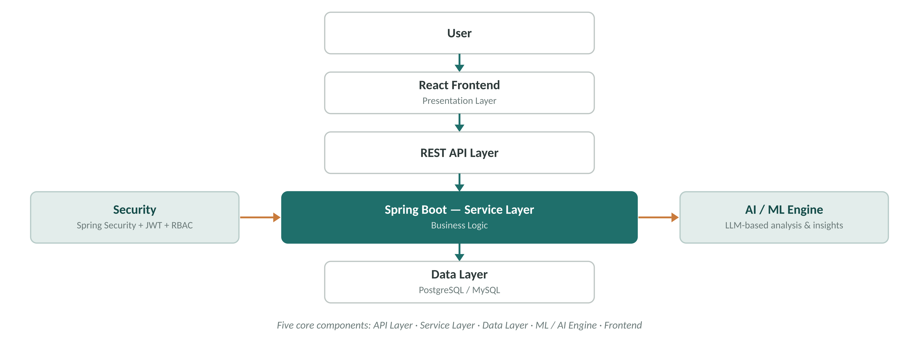
Figure 1: NeuroForge System Architecture

5.2 Use Cases and Diagrams
The diagram below shows the four primary actors and the use cases each of them drives.
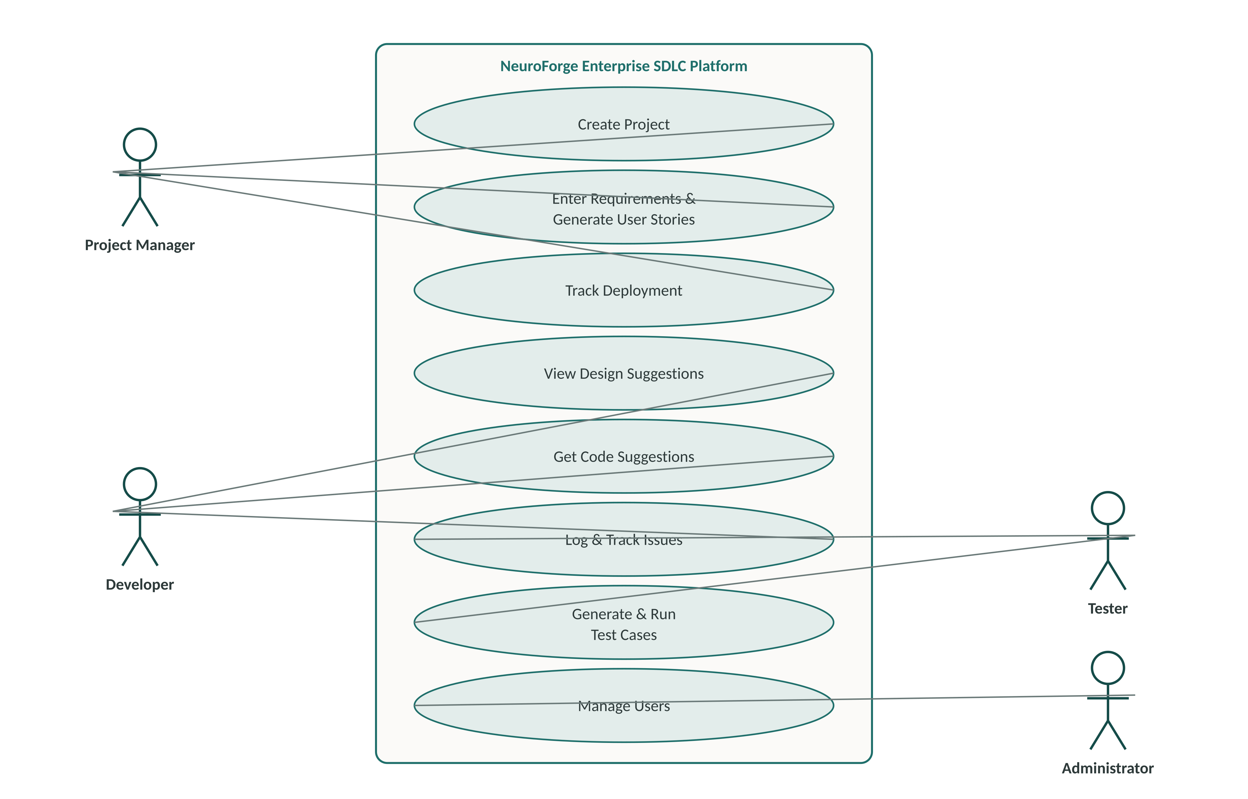
Figure 2: NeuroForge Use Case Diagram
The primary flow runs as follows. A Project Manager creates a project and adds the team. Requirements are entered as plain text and converted into editable user stories, which are prioritised into sprints. Developers implement the resulting tasks with AI design and code suggestions, committing to the connected Git repository. Testers generate, edit and run test cases and log defects as issues assigned back to a developer. Once those issues close, the build is deployed through the CI/CD pipeline and stakeholders are notified automatically. Throughout, the Administrator manages accounts and permissions, and every artefact remains traceable to its originating requirement.

