BUSINESS REQUIREMENTS DOCUMENT

Order Management System (OMS)
Star Convenience Store (SCS)

Prepared For: Star Convenience Store Management
Prepared By: Business Analyst
Date: August 15, 2026
Document Version: v4.0

- Document Control & Metadata
Metadata Field | Description
Project Name | Star Convenience Store (SCS) Order Management System (OMS).
Document Title | Business Requirements Document (BRD)
Version | v4.0
Date | August 15, 2026
Prepared By | Business Analyst
Reviewed/Approved By | SCS Store Owner / Business Owner

  - Document Change History:

Version | Date | Author | Change Description
v1.0 | August 7, 2026 | Business Analyst | Initial Draft (Elicitation Baseline): Compiled raw findings, stakeholders, and scope constraints from initial owner/associate interviews.
v2.0 | August 11, 2026 | Business Analyst | Process Modeling Update: Embedded L1 Current State Flow and Appendix A (AS-IS BPMN Swimlane Diagram). Added high-level business requirement blocks (HLR-01 to HLR-05).
v3.0 | August 13, 2026 | Business Analyst | Replenishment & Rules Expansion: Integrated L1 Future State Flow, Appendix B (TO-BE Swimlane) , automated PO business rules (BR-01 to BR-03), and replenishment specs.
v4.0 | August 15, 2026 | Business Analyst | Final Sign-Off Draft: Consolidated all feedback, finalized project exclusions (Out-of-Scope boundaries), added Cover Page, and formatted for Stakeholder Sign-off.

- Executive Summary & Business Problem Context:
  - The Problem: Surging daily footfall (1,000–1,200 up from 200–250) has not translated to expected revenue growth due to manual, paper-based inventory tracking.
  - The Financial Impact: Q3 revenue grew by only 4% against a forecasted 15%, driven by frequent out-of-stock situations on high-demand items.
  - The Operational Drain: Store associates waste approximately 6 hours per week on manual, error-prone inventory reconciliation across three paper registers.
- Project Objectives & Success Criteria:
  - Project Objectives
    - Eliminate Revenue Leakage: Stop ongoing financial loss by implementing real-time inventory tracking to prevent critical stock-outs on high-demand items.
    - Minimize Administrative Overhead: Eliminate the time and manual effort store staff currently waste on tedious, highly repetitive physical inventory tracking tasks.
    - Optimize Daily Store Operations: Provide the Store Owner and Retail Associates with the real-time digital visibility needed to manage inventory, sales, and replenishment more efficiently.
  - Success Criteria & Measurable Business Outcomes:
    - Financial Growth: Enable Star Convenience Store to achieve its targeted 15% revenue growth or more in the immediate quarter following the system's deployment.
    - Reconciliation Time Reduction: Reduce the current 6 hours per week spent on manual inventory matching across paper registers and delivery challans to under 30 minutes.
    - Operational Efficiency: Successfully replace the paper-based Sales, Distributor, and Credit registers with a single, unified Order Management System (OMS) POS interface.
- Project Scope:
  - In-scope:
    - Point of Sale (POS) Checkout: Barcode scanning, automated product master lookup, and integrated scale weighing for loose items.
    - Real-Time Inventory Management: Automatic real-time inventory deduction upon checkout.
    - Automated Replenishment: Real-time stock threshold monitoring, automated Draft PO generation grouped by distributor, and direct PO transmission via WhatsApp, Email, or SMS.
    - Resiliency & Exception Flows: Support for logging credit orders, handling partial distributor deliveries, and managing damaged goods.
  - Out-Scope:
    - Active Credit (Udhaar) Management: The system will support marking orders as "Credit" to ensure real-time inventory levels are decremented accurately. However, any tracking of customer balances, limits, or collection workflows is strictly excluded from this release per the owner's request.
    - Deferred to the Next Release:
      - Reporting and Sales Analytics.
      - Distributor Payment Tracking.
    - Deferred to Future Releases:
      - Staff Payroll and HR Management.
      - Multi-location or Multi-store Capabilities.
      - Advanced Business Intelligence (BI) Reporting.
  - Assumptions & Constraints
    - Assumptions
      - Internet assumption: Store will maintain a minimum internet connection of 2 Mbps bandwidth with 99% uptime during business hours (8 AM – 10 PM daily).
      - POS device assumption: Store will provide a laptop/desktop device running Windows 10 or later with minimum 4GB RAM and 20GB available storage.
      - Training assumption: Store staff members (3 Retail Associates and 1 Store Owner) will be available for a maximum 4-hour hands-on training session prior to system go-live.
      - Authentication System: The OMS will require role-based login authentication for Store Owner and Retail Associate access. Authentication mechanism is a technical implementation concern outside BA scope.
    - Constraints:
      - Downtime constraint: System uptime SLA: 99.5% during business hours (max 18 minutes downtime per week). Planned maintenance windows limited to 2 hours per month, scheduled outside business hours.
      - Training constraint: Initial training must be completed within 48 hours of system go-live. All store staff must pass a system competency checklist before independent POS operation is authorized.
- Stakeholder Matrix & Primary Actors:
Actor | Role | Impact | Key System Touchpoint
Store Owner | Business Sponsor | High | Approves POs; monitors overall store revenue, inventory dashboards, and low-stock alerts to drive the 15% growth target
Retail Associates | Operational Users | Medium-High | Operates the POS daily; scans barcodes, weighs loose items, and performs physical stock verification
Distributors | External Actors | Low | Receives automated POs via WhatsApp/Email; delivers physical inventory with paper challans
Customers | External Actors | Low | Experiences faster checkout times; completes digital/cash payments and receives automated system receipts

- Current State ("AS-IS") Process Analysis:
  - High-Level Current State Flow & Pain Points: The vertical diagram below outlines the sequential flow of a typical customer transaction and the subsequent inventory replenishment cycle under the current manual model: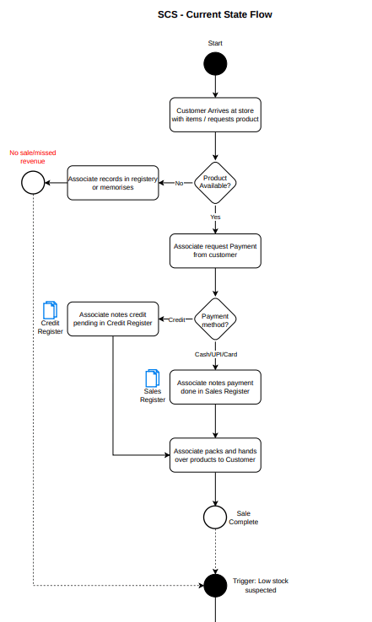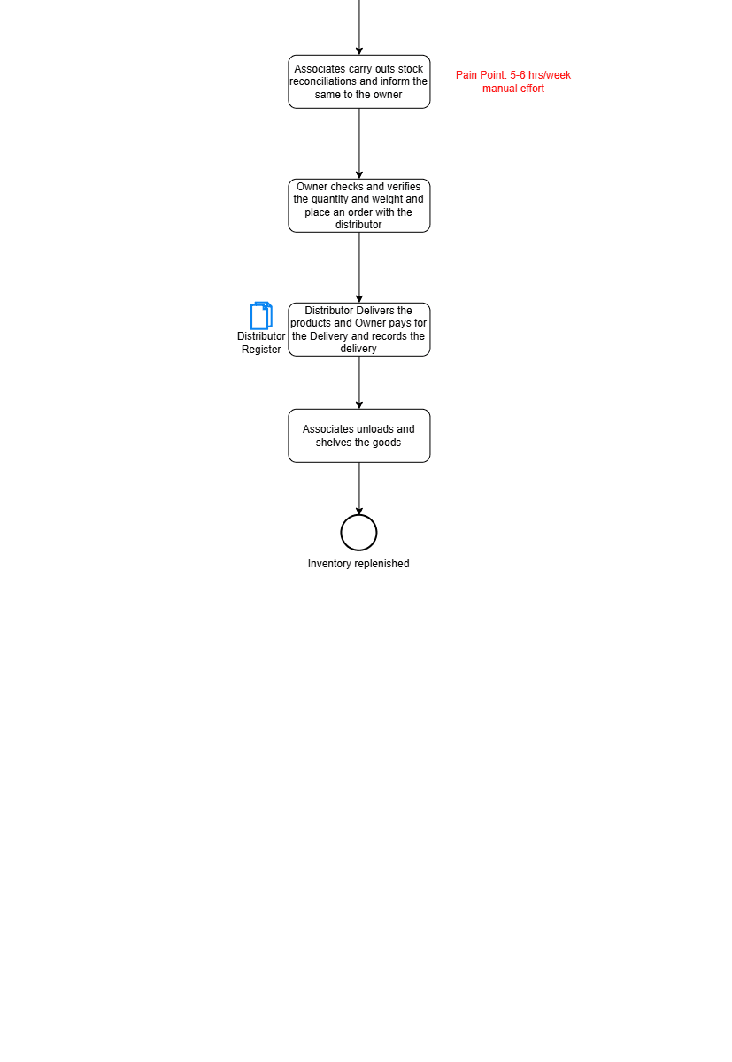
  - Key Operational Bottlenecks
    - Manual Transaction Logging: Retail Associates must handwrite every product and price in a paper Sales Register. This creates severe checkout bottlenecks, especially during peak hours as daily footfall has surged from 200–250 to 1,000–1,200 customers.
    - Fragmented Financial Records: Sales, customer credit, and distributor invoices are siloed across three separate physical notebooks. This prevents any real-time tracking of profits or revenue leakage.
    - High Administrative Drain: Staff must spend approximately 6 hours per week physically auditing shelves against handwritten paper logs to identify stock-outs.
    - Frequent Stock-outs & Stalled Revenue: Because inventory levels are not updated in real-time, fast-moving items frequently run out of stock before anyone notices. This inventory blindness limited recent revenue growth to only 4% against a forecasted 15%.
  - Detailed Lane-by-Lane Mapping Reference: For a highly detailed, lane-by-lane operational view displaying exact stakeholder hand-offs, please refer to Appendix A: Detailed AS-IS Swimlane Diagram (Horizontal BPMN).
- Future State ("TO-BE") Process Analysis
The future-state operating model transitions Star Convenience Store (SCS) from manual, paper-based tracking to a centralized, data-driven Order Management System (OMS).
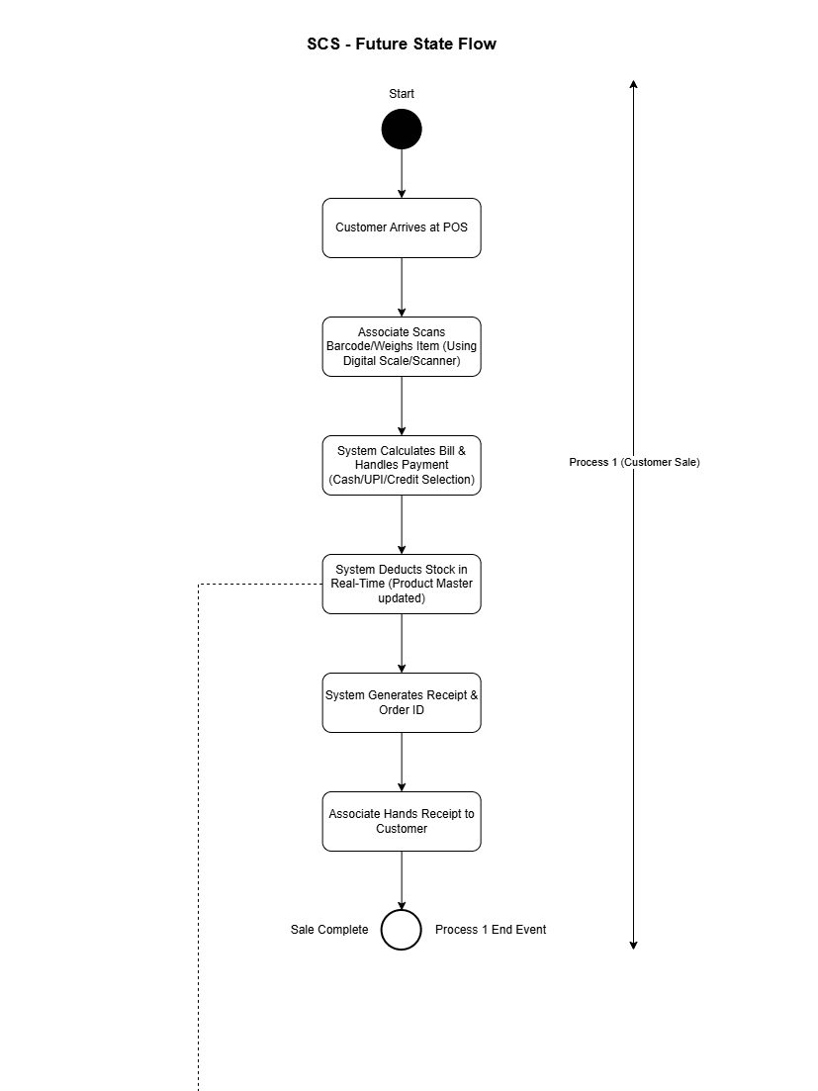
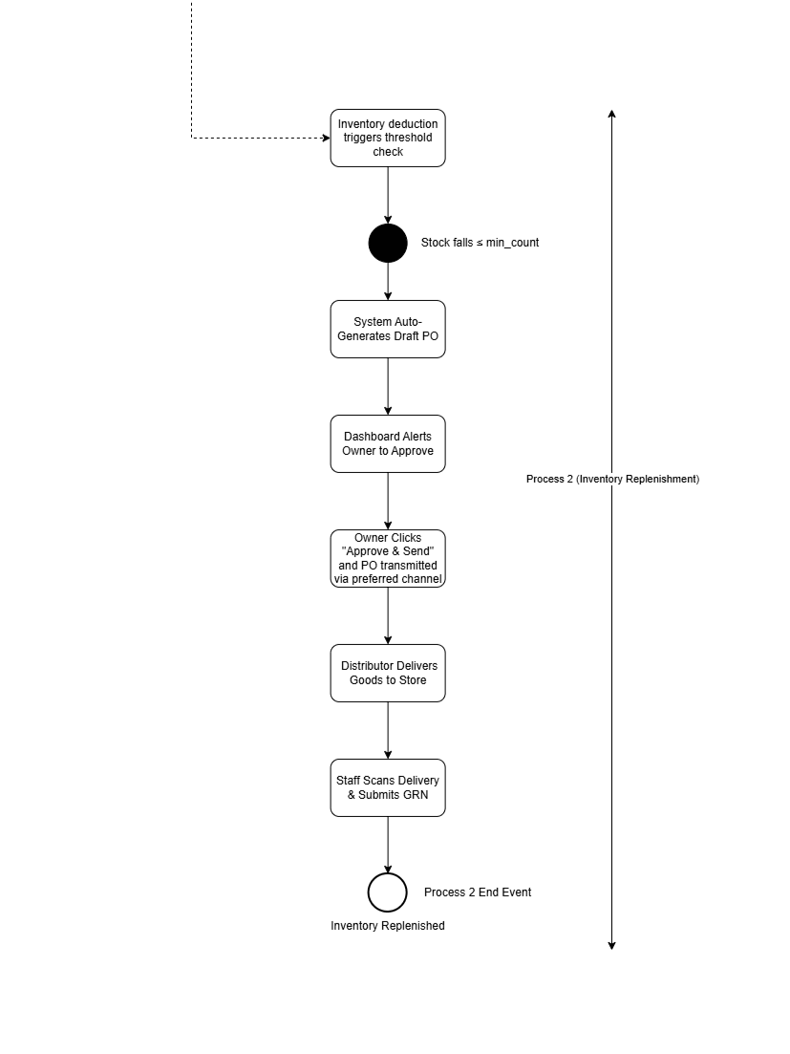
  - High-Level Future State Flow: The newly designed system architecture automates core operations across checkout sales and distributor replenishment to ensure seamless coordination between store staff, the owner, and external vendors:
    - POS Checkout Integration: The POS terminal automatically processes scannable items via barcode reading and calculates pricing for loose items using an integrated digital weight scale.
    - Automated Real-Time Deductions: Every transaction automatically updates the Product Master in real-time upon successful payment (Cash, Digital, or Credit).
    - Closed-Loop Replenishment: When stock levels fall to or below the minimum threshold, the system automatically flags a draft PO on the Store Owner's dashboard. Once approved, the PO is transmitted directly to the distributor.
    - Verified Receiving (GRN): Goods received are scanned and verified against the original PO before the system automatically updates stock levels and clears active low-stock alerts.
  - Detailed Lane-by-Lane Mapping Reference: For a detailed, lane-by-lane operational view of the future-state workflows, including alternative paths for unreadable barcodes and partial distributor deliveries, please refer to Appendix B: Detailed TO-BE Swimlane Diagram (Horizontal BPMN)
- High-Level Business Requirements:
  - Point of Sale (POS) Checkout Capabilities:
    - HLR-01: Barcode Scanning Integration: The system must utilize barcode scanning to automatically decode and retrieve product names, pricing, and tax details for packaged items from the Product Master database.
    - HLR-02: Variable-Weight Scale Support: The system must integrate with a digital weight scale at the checkout counter to dynamically read weights and calculate pricing for loose, non-barcoded goods (e.g., loose bread, fresh items) based on unit-weight rates.
    - HLR-03: Manual Product Lookup: The system must provide an alternate search mechanism (by product name or barcode manual entry) to process items when barcodes are unreadable, dirty, or torn.
    - HLR-04: Multi-Payment Type Logging: The system must allow associates to log different payment methods for transactions—specifically Cash, UPI (digital gateways), Debit/Credit Cards, and Credit (Udhaar).
    - HLR-05: Receipt Generation: The system must generate an official transaction receipt containing a unique Order ID, timestamp, itemized list, subtotal, taxes, and final total.
  - Real-Time Inventory & Low-Stock Management
    - HLR-06: Real-Time Stock Auto-Deductions: The system must automatically deduct purchased quantities from the Product Master database immediately upon transaction settlement to maintain an accurate real-time inventory count.
    - HLR-07: Automated Low-Stock Notifications: The system must continuously monitor stock levels and instantly trigger a dashboard alert and notification (via Whatsapp, email or SMS) to the Store Owner when any product's inventory falls to or below its minimum defined threshold.
  - Closed-Loop Distributor Replenishment
    - HLR-08: Automated Draft PO Generation: When a low-stock threshold is breached, the system must automatically generate a Draft Purchase Order (PO) with a unique PO ID, pulling in the maximum stock target configuration and grouping items by their designated distributor.
    - HLR-09: Digital PO Transmission: The system must allow the Store Owner to review, edit, and transmit finalized POs directly to distributors via modern communication channels, including the WhatsApp API, SMS, or Email.
    - HLR-10: Goods Receipt Note (GRN) Verification: The system must provide a delivery verification interface where associates can scan incoming inventory against open POs and the Store Owner can submit a GRN to automatically update stock levels and clear active alerts.
- Business Rules
These core operational policies enforce store and inventory data integrity, ensuring that the system aligns with Star Convenience Store's (SCS) business policies.
  - BR-01 (Low-Stock Thresholds):
    - Standard items flag at single-digit unit count. Fast-moving items (e.g., milk, bread, eggs, soft drinks, cigarettes, Lays, Kurkure, Parle-G) are configured with higher thresholds in the Product Master to account for daily velocity — specific thresholds are set per product during system configuration.
    - Fast-moving, high-demand items (e.g., milk, bread, eggs, soft drinks, specific snacks like Lays, Kurkure, Parle-G) must have higher reorder thresholds configured to account for daily velocity and prevent stockouts during pending PO fulfillment.
  - BR-02 (Order Processing & Settlement):
    - All transactions must be logged with item-level pricing before physical goods are handed over to the customer.
    - Payments must be verified and settled via cash, UPI, card, or authorized store credit.
    - For Credit (Udhaar) orders, the system will support marking the transaction type as "Credit" to process inventory deductions. However, active customer balance ledger tracking, limits, and collection workflows are managed manually by the owner outside the OMS.
  - BR-03 (Distributor Communication & Purchase Order Status):
    - A PO must remain in "Pending Approval" status in the Draft PO table until the Store Owner clicks "Approve & Send".
    - Approved POs must be transmitted directly to the distributor with a standard data payload, including: PO Order ID, item list with quantities, delivery location, and total estimated cost.
    - Distributor payment settlements and invoice collections remain 100% manual and are tracked outside the OMS boundaries.
- Sign-off & Approvals Block
By signing below, the key project stakeholders formally agree that this Business Requirements Document (BRD) accurately captures the operational problems, scope, requirements, and business policies for the Star Convenience Store (SCS) Order Management System (OMS) project. This signature grants formal approval to transition the project from the requirements analysis phase into design and development.

Stakeholder Name | Project Role | Signature | Date
SCS Store Owner | Project Sponsor & Business Owner
Business Analyst | Requirements Author

Appendices
The appendices contain the exhaustive, lane-by-lane operational swimlane process maps designed to guide developers, database administrators, and QA testers through system implementation.
Appendix A: Detailed AS-IS Swimlane Diagram (Horizontal BPMN)
- Document Reference: AS-IS.drawio (Editable XML Source File)
- Description: This detailed 4-swimlane diagram maps the existing manual operations across the Customer, Retail Associate, Store Owner, and Distributor lanes. It details the specific points where manual paper logging occurs, showing how fragmented financial tracking and stockouts manifest across physical notebooks.
- Usage Instruction: To view, interact with, or edit this process flow, import the source file (AS-IS.drawio) directly into the Draw.io Web App.

Appendix B: Detailed TO-BE Swimlane Diagram (Horizontal BPMN)
- Document Reference: To-BE.drawio (Editable XML Source File)
- Description: This blueprint serves as the future-state architectural reference for system development. It illustrates the complete automated sequence, including specific system decision gateways (e.g., barcode found vs. alternative manual entry paths), integrated scale interactions, background database updates, and exception flows (such as partial distributor delivery handling and order cancellations).
- Usage Instruction: To view, interact with, or edit this system blueprint, import the source file (To-BE.drawio) directly into the Draw.io Web App.

