YOLO-Based Detection of Floating Waste in Water Bodies Using Image Processing
[Author Name(s)]
[Department / School], [Institution], [City], [Country]
E-mail: [Author e-mail address(es)]
Abstract
Floating litter in rivers, lakes, and canals is an environmental monitoring concern because visual surveys are labor-intensive and provide limited temporal coverage. This study implements a single-class YOLOv8n object detector that localizes visible floating litter and outputs confidence scores, an image-level count, and an annotated image. The pilot uses the TUD-GV detection dataset, whose published record contains 1,501 RGB images and 8,181 boxes for the single class “litter.” A group-separated subset of 54 training, 20 validation, and 20 test images was used; whole filename experiment groups were kept disjoint. The model was fine-tuned for 3 epochs at 320px on cpu hardware. The confidence threshold (0.975) and NMS IoU (0.50) were selected on the validation subset. One-to-one matching at IoU 0.50 on the pilot test subset gave precision 0.588, recall 0.807, F1 0.680, mAP@0.50 0.636, mAP@0.50:0.95 0.286, and count MAE 1.550 objects per image. These preliminary results demonstrate that the end-to-end software pipeline runs; they are not a full-dataset benchmark or evidence of generalization to other waterways. No material-specific plastic classification is performed.
Keywords: Image processing, floating litter, water-body monitoring, object detection, YOLOv8, environmental monitoring
1. Introduction
1.1 Background
Plastic and other persistent waste can accumulate in freshwater and coastal environments, where transport by rivers contributes to the movement of debris through connected aquatic systems. Monitoring visible litter at the water surface can support cleanup planning and environmental assessment, but manual inspection is slow, spatially limited, and difficult to repeat consistently. Image-based sensing offers a way to screen larger image collections and direct human attention to locations that may require inspection. Deep learning has been applied to floating macroplastic monitoring, but the literature emphasizes the limited availability of representative labeled data and the difficulty of detecting small, visually ambiguous objects against changing water backgrounds [1].
Object detection is appropriate when a monitoring system needs both localization and enumeration. Unlike image-level classification, a detector returns a position for each visible candidate, enabling bounding-box overlays and per-image counts. YOLO models formulate detection as a one-stage prediction task and are widely used where inference speed and a compact deployment pipeline are desirable [9]–[11]. YOLOv8 is selected here as the baseline implementation; it is not presented as a proven best-performing architecture for floating litter.
1.2 Problem Statement
Floating litter is often small relative to the image, partly occluded, or visually similar to natural surface patterns. Reflections, ripples, shadows, glare, changing camera distance, and water color can produce false detections or missed objects. A model trained on a narrow set of views may also fail when applied to another waterway, camera, or season. Moreover, a single-class system must distinguish the target concept “visible floating litter” from plants, foam, reflections, and other non-target objects. The research problem is therefore to develop and evaluate a reproducible single-class YOLOv8 pipeline that localizes visible litter and counts detections without claiming material-specific identification or unmeasured performance.
1.3 Research Objectives
The objectives of the proposed study are: (i) to define a single-class detection task for visible floating litter; (ii) to prepare a documented image and annotation pipeline; (iii) to fine-tune a YOLOv8 baseline and generate bounding-box detections; (iv) to convert retained detections into per-image object counts and annotated outputs; and (v) to evaluate detection quality, counting error, inference cost, and limitations using a held-out test set. The study also aims to identify the effect of small-object visibility, reflections, lighting, and background variation on model behavior.
1.4 Motivation and Scope
The intended application is decision support for environmental monitoring, such as triaging images for review or summarizing visible litter counts over a monitored site. The proposed system does not autonomously remove waste, determine pollution mass, infer the chemical composition of an object, or identify specific plastic products. The detector will use one label, “litter,” and its output count will mean the number of retained visible detections in an image, not the number or mass of all items in the water body. The primary dataset is the TUD-GV object-detection subset [5]. The IWHR floater dataset is considered as a secondary source only after its class definitions are reconciled with the litter-only target [4].
2. Related Works
Research on image-based floating-waste monitoring spans reviews of deep-learning methods, water-specific datasets, marine debris detection, and general-purpose object detectors. The following works motivate the proposed design and clarify the limits of existing evidence.
Jia et al. reviewed deep-learning methods for detecting macroplastic litter in water bodies and summarized data and deployment challenges, including the lack of sufficiently varied labeled observations [1]. Their review supports treating data coverage and generalization as central evaluation concerns rather than assuming that a detector trained on one site will transfer to another.
Jia et al. introduced the TU Delft–Green Village dataset and evaluated several deep-learning architectures for floating-litter image classification, studying transfer learning, augmentation, and generalization to changed viewpoints and devices [2]. The original large dataset is useful for context, but image classification does not itself produce object boxes or counts. It should not be confused with the later 1,501-image object-detection subset used here.
In a subsequent study, Jia et al. investigated semi-supervised deep learning for floating litter in freshwater bodies [3]. The associated TUD-GV detection subset contains 1,501 RGB images and 8,181 bounding-box annotations, with a single “litter” class [5]. This labeling structure aligns directly with the scope of the present single-class detector. The paper motivates careful use of unlabeled data, but the present proposal starts with a supervised YOLOv8 baseline so that the experimental question remains bounded and reproducible.
Qiao et al. published an annotated dataset and benchmark for floating debris in inland waters, reporting 3,000 images collected in real water scenarios and baseline detection experiments [4]. The dataset includes household litter as well as natural floating matter such as aquatic plants and algae. It is therefore a valuable source for testing detector behavior in realistic scenes, but its label taxonomy should not be collapsed into “litter” without defining which annotated categories qualify as litter and verifying the remapped boxes.
de Vries et al. studied quantification of floating plastic debris at sea using vessel-based optical images and artificial intelligence [6]. Their work demonstrates the relevance of image-based counting beyond controlled laboratory scenes and emphasizes that camera geometry and observation conditions affect what can be detected. The present paper adopts the localization-and-counting goal while restricting claims to visible, labeled objects in still images.
Deng et al. proposed an embeddable automatic garbage-detection algorithm for complex marine environments [7]. This line of work is directly relevant to practical detection under cluttered water backgrounds. It also highlights the importance of evaluating false positives in complex scenes, a requirement retained in the proposed protocol rather than relying only on a single aggregate accuracy figure.
Bajaj et al. examined sea-debris detection using deep learning [8]. Their study reflects the broader use of visual recognition for marine debris and provides motivation for automated screening. Differences in imagery, object scale, and label definitions mean that reported results from sea imagery cannot be assumed to predict freshwater performance.
Redmon et al. introduced YOLO as a unified, real-time object-detection approach [9]. Its single-stage formulation underpins the family of models used in this proposal. Subsequent detector designs have sought improved speed–accuracy trade-offs: YOLOv4 combined architectural and training refinements [10], while YOLOv7 introduced trainable bag-of-freebies strategies for real-time detection [11]. These general object-detection studies inform the choice of a YOLO baseline, but they do not establish performance on floating litter.
Taken together, the literature supports a practical gap: floating-litter datasets and detection studies exist, but visible targets remain difficult under small-object, reflection, and domain-shift conditions, and published scores are tied to their specific datasets and protocols [1]–[8]. This proposal therefore prioritizes a clearly defined one-class target, dataset-level separation, count evaluation, and transparent reporting. No direct comparison with published benchmark scores is made because training settings, splits, and label policies differ.
3. Proposed Model: Architecture and Workflow
The implemented prototype receives water-body images and produces a per-image set of litter boxes, confidence values, a count, and an annotated image. Figure 3.1 shows the workflow implemented in the prototype. The measured pilot results are reported separately in Section 4.
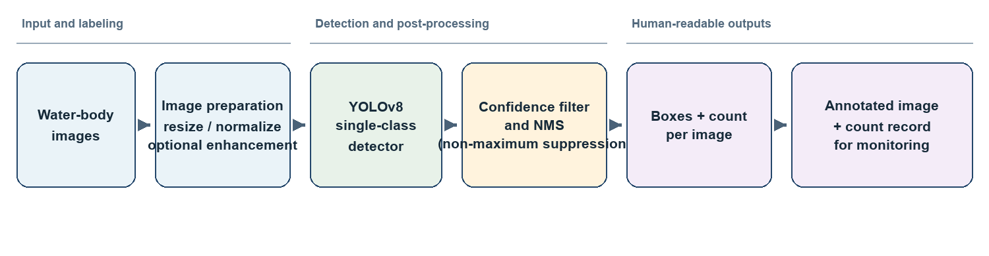
Figure 3.1: Proposed YOLOv8 workflow for single-class floating-litter detection
3.1 Input Images and Dataset Preparation
The primary dataset is the TUD-GV object-detection subset [5]. Its public metadata reports 1,501 RGB images, 8,181 bounding boxes, and a single annotation class named “litter.” Images and labels should be downloaded from the record, checked for missing files and invalid coordinates, and converted or validated in the format expected by the selected YOLOv8 implementation. A data manifest should preserve image identifiers, source video or capture session where available, image dimensions, and annotation counts.
The IWHR dataset contains 3,000 annotated images from real inland-water scenarios [4]. Because the reported annotation policy includes both waste and natural floating matter, it is not treated as an interchangeable litter-only dataset. If used for external testing or training, a written mapping must retain anthropogenic litter targets and exclude natural matter according to the source categories; ambiguous or mixed boxes should be reviewed. Dataset provenance and any relabeling must be recorded.
For the pilot, the 54 training images (220 boxes) are from the disjoint filename group(s) exp14; 20 validation images are sampled from exp16; and 20 test images (83 annotations) are sampled from exp23. Groups do not cross splits. This deliberately small pilot split verifies the pipeline but is not a substitute for group-balanced evaluation over the complete 1,501-image dataset.
3.2 Image Pre-processing and Augmentation
Images are resized with aspect ratio preserved by letterboxing to the input dimensions required by the chosen YOLOv8 variant. Pixel values are normalized as required by the framework. This standard path is the reference preprocessing condition. Denoising and contrast enhancement, such as a mild local-contrast operation, are optional experimental branches rather than mandatory transformations: smoothing can erase small litter edges, while aggressive enhancement can amplify water texture and reflections. Each optional operation should be evaluated on validation data against the unmodified baseline, then either retained or omitted according to measured benefit.
Training-time augmentation may include horizontal or vertical flips only when they preserve plausible scene interpretation, along with restrained scale, crop, brightness, and color variation. Augmentation must not create labels outside the image or distort boxes. All transformations applied to an image must be applied consistently to its boxes, and the final transformation recipe should be fixed and reported.
3.3 YOLOv8 Baseline Detector
The implemented baseline is Ultralytics YOLOv8n [12], initialized from the published pretrained yolov8n.pt detection checkpoint and fine-tuned on the single target class “litter.” The run used 3 epochs, an input size of 320 pixels, batch size 4, random seed 2026, and cpu execution with PyTorch 2.14.1+cpu and Ultralytics 8.4.199. The full run record is saved with the prototype. This is a small feasibility run on a selected subset, not a fully tuned benchmark.
For each image, the model predicts candidate box coordinates and confidence scores. The box coordinates locate visible instances; the confidence score expresses the model’s estimated certainty for a candidate and is not a calibrated probability unless calibration is separately assessed. Since the task is single-class detection, no output label should claim bottle, bag, wrapper, or polymer identity.
3.4 Confidence Filtering and Duplicate Suppression
Candidate detections below a confidence threshold selected on validation data are discarded. Non-maximum suppression (NMS) then removes highly overlapping boxes predicted for the same object, using an intersection-over-union threshold selected before final testing. The confidence and NMS thresholds must be reported because they affect both false positives and counts. Where objects overlap closely, suppression can remove a real instance; threshold sensitivity should therefore be examined on the validation set and discussed in the final analysis.
3.5 Bounding Boxes, Counting, and Annotated Output
After post-processing, every retained detection is drawn as a bounding box with the “litter” label and confidence value. The per-image count is the number of retained boxes. The system should save an annotated image and a structured record containing the source image identifier, predicted boxes, confidence values, count, model version, and inference settings. This record supports traceability and later review. The count is a visual detection count for the captured frame; it is not an estimate of litter mass, submerged debris, or total environmental abundance.
3.6 Evaluation Protocol
The confidence threshold (0.975) and NMS IoU (0.50) were selected by F1 on the validation subset, then fixed for the held-out test group. Predicted boxes were matched one-to-one to annotations at IoU 0.50, with each ground-truth box used at most once. Precision, recall, and F1 are micro-aggregated over matched instances; count MAE is the mean absolute difference between predicted and annotated object counts per image. Mean inference time was measured after a model warm-up on the CPU. Average precision was computed on this test subset using the standard confidence sweep with a confidence floor of 0.001 and NMS IoU of 0.70.
4. Results and Analysis
A working YOLOv8n prototype was trained and evaluated on a small, disjoint-group TUD-GV subset. The following results are measurements from that run, not projected values. Because only 54 training images and 20 test images were used, the results are preliminary and should not be read as a publication-quality estimate of performance across the full dataset.
4.1 Dataset Profile
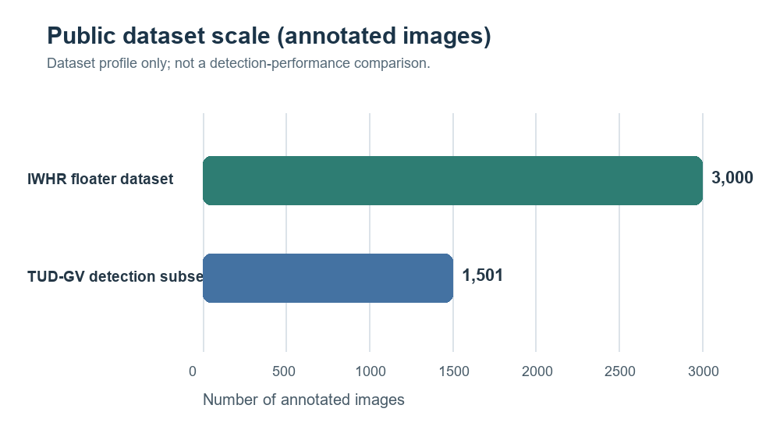
Figure 4.1: Annotated image counts reported for the two candidate datasets [4], [5]
The TUD-GV detection subset provides a smaller, directly aligned single-class resource: its metadata reports 1,501 images and 8,181 boxes for “litter” [5]. The IWHR dataset reports 3,000 annotated images [4], but its broader floating-object scope requires label review before it can support a litter-only experiment. Image count alone does not establish suitability: annotation consistency, scene diversity, object-size distribution, and capture-source separation must also be assessed. For these reasons, TUD-GV is proposed as the primary training/evaluation source and IWHR as a possible separately analyzed external dataset, subject to label mapping.
Dataset | Published image count | Annotation/task information | Role in this proposal
TUD-GV detection subset [5] | 1,501 | 8,181 boxes; single class “litter” | Primary dataset; task matches scope
IWHR floater dataset [4] | 3,000 | Floating-object annotations include litter and natural floaters | Secondary benchmark only after litter-specific label review

Table 4.1: Candidate dataset characteristics from their published records
4.2 Pilot training and evaluation results
The run used 54 training images, 20 validation images, and 20 test images, with no experiment group shared across these splits. The training images contained 220 annotated boxes and the test images contained 83. YOLOv8n was initialized from pretrained weights and fine-tuned for 3 epochs at 320px with batch size 4 on cpu. Validation selected confidence 0.975 and NMS IoU 0.50; test detections were matched to annotations at IoU >= 0.50. Average precision was also computed on the held-out test subset. Figure 4.2 summarizes the resulting precision, recall, F1, and counting error. The run produced TP=67, FP=47, and FN=16 across the test images.
4.3 Interpretation and limitations of the pilot
At the selected operating point, precision was 58.8%, recall was 80.7%, and F1 was 68.0%. The image-level count MAE was 1.55 objects per image. Mean per-image prediction-and-annotation time after warm-up was 0.0469 s/image (21.3 images/s) on the CPU; this excludes file decoding, application startup, and UI overhead. Test-set mAP@0.50 was 0.636, and mAP@0.50:0.95 was 0.286. Figure 4.3 shows annotated examples with predicted and ground-truth counts. The small test sample makes these values sensitive to individual images; no confidence intervals are reported.
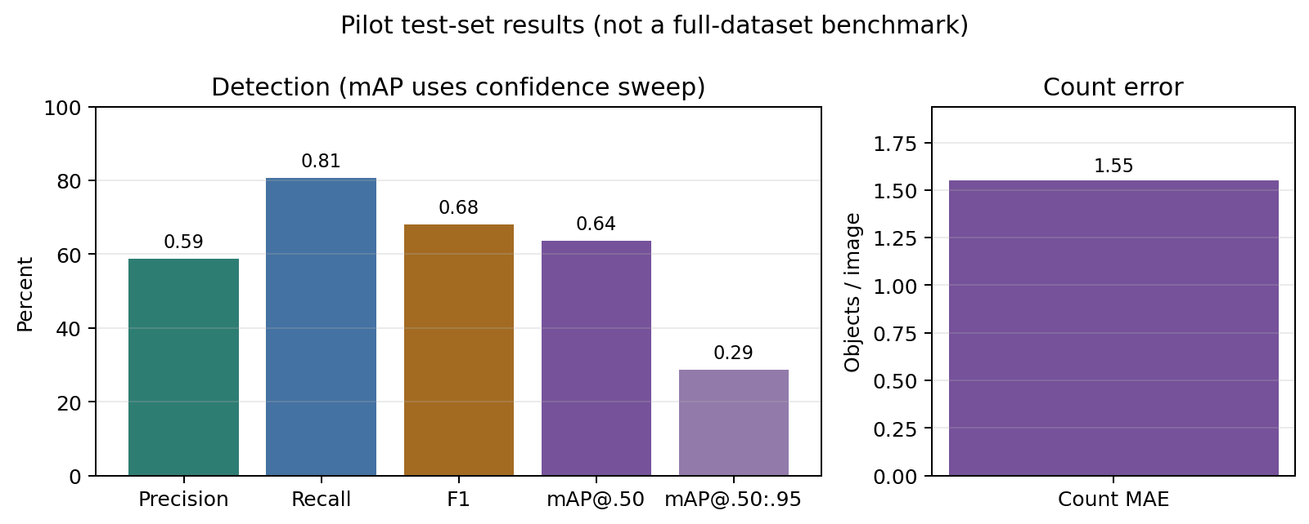
Figure 4.2: Pilot test metrics; mAP is computed over the confidence sweep
Measure | Pilot result | Protocol / scope
Precision | 0.588 (58.8%) | TP / (TP + FP), confidence >= 0.975
Recall | 0.807 (80.7%) | TP / (TP + FN), IoU matching threshold 0.50
F1 score | 0.680 (68.0%) | Harmonic mean of micro-averaged precision and recall
mAP@0.50 | 0.636 | Test split; confidence sweep; NMS IoU 0.70
mAP@0.50:0.95 | 0.286 | Test split; IoU thresholds 0.50 through 0.95
TP / FP / FN | 67 / 47 / 16 | Across 20 held-out test images
Count MAE | 1.550 objects/image | Mean absolute predicted-vs-annotated count difference
Operating point | Confidence 0.975; NMS IoU 0.50 | Chosen on validation; F1=0.539
Prediction + annotation time | 0.0469 s/image | CPU; after warm-up; excludes image decoding
Training set | 54 images; 220 boxes | 3 epochs, 320px, batch 4
Test set | 20 images; 83 boxes | Disjoint group exp23; thresholds fixed from validation

Table 4.2: Quantitative results from the small pilot run
4.4 Analysis of Anticipated Error Sources
The measurements establish that the implemented system can train, infer, draw boxes, and produce per-image counts on the selected dataset subset. They do not establish reliable performance in different waterways or camera conditions. With only 20 test images from one held-out experiment group, false positives and misses can substantially change the reported precision and recall. The prototype should therefore be treated as a software and methodology demonstration. A larger group-wise evaluation on all available images is needed to assess small targets, reflections, illumination changes, and domain shift.
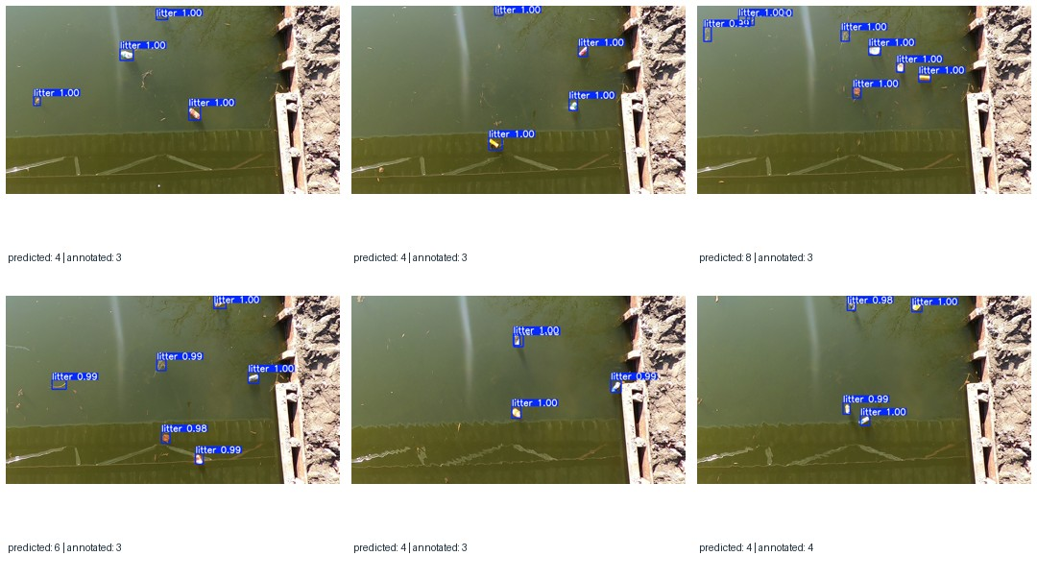
Figure 4.3: Annotated pilot test images; each panel reports predicted and annotated counts
The annotated examples are qualitative illustrations and should not be interpreted as a complete error analysis. The current model predicts one generic “litter” class and cannot distinguish bottles, bags, wrappers, natural debris, or polymer composition beyond what the dataset labels support.
5. Conclusion
This study implemented a working single-class YOLOv8n prototype for visible floating-litter detection. It prepares a leakage-aware pilot split from the TUD-GV dataset, fine-tunes pretrained weights, filters detections, writes bounding boxes and counts, and supplies both a command-line predictor and an image-upload application. On the 20-image pilot test subset, the fixed-threshold evaluation measured precision 0.588, recall 0.807, F1 0.680, mAP@0.50 0.636, mAP@0.50:0.95 0.286, and count MAE 1.550. The experiment confirms the prototype workflow operates end to end; the small test set does not establish general performance.
The measured values are preliminary because the model was trained on only 54 images and evaluated on 20 images from a single held-out experiment group. Further work should train and evaluate across the complete dataset with multiple group-wise splits, report full-dataset mAP and uncertainty, inspect errors by object size and scene condition, and test on an independent waterway. The model is a monitoring aid for visible detections, not an estimate of total pollution and not a classifier of material type.
References
[1] T. Jia, Z. Kapelan, R. de Vries, P. Vriend, E. C. Peereboom, I. Okkerman, and R. Taormina, “Deep learning for detecting macroplastic litter in water bodies: A review,” Water Research, vol. 231, art. 119632, 2023. https://doi.org/10.1016/j.watres.2023.119632.
[2] T. Jia, A. J. Vallendar, R. de Vries, Z. Kapelan, and R. Taormina, “Advancing deep learning-based detection of floating litter using a novel open dataset,” Frontiers in Water, vol. 5, art. 1298465, 2023. https://doi.org/10.3389/frwa.2023.1298465.
[3] T. Jia, R. de Vries, Z. Kapelan, T. H. M. van Emmerik, and R. Taormina, “Detecting floating litter in freshwater bodies with semi-supervised deep learning,” Water Research, vol. 266, art. 122405, 2024. https://doi.org/10.1016/j.watres.2024.122405.
[4] G. Qiao, M. Yang, and H. Wang, “An annotated dataset and benchmark for detecting floating debris in inland waters,” Scientific Data, vol. 12, art. 385, 2025. https://doi.org/10.1038/s41597-025-04594-9.
[5] T. Jia, A. J. Vallendar, R. de Vries, Z. Kapelan, and R. Taormina, “TUD-GV Dataset for Floating Litter Detection (object detection task),” Zenodo, 2024. https://doi.org/10.5281/zenodo.13730228.
[6] R. de Vries et al., “Quantifying floating plastic debris at sea using vessel-based optical data and artificial intelligence,” Remote Sensing, vol. 13, no. 17, art. 3401, 2021. https://doi.org/10.3390/rs13173401.
[7] X. Deng et al., “An embeddable algorithm for automatic garbage detection based on complex marine environment,” Sensors, vol. 21, no. 19, art. 6391, 2021. https://doi.org/10.3390/s21196391.
[8] R. Bajaj, S. Garg, N. Kulkarni, and R. Raut, “Sea debris detection using deep learning: Diving deep into the sea,” in Proc. 2021 IEEE 4th International Conference on Computing, Power and Communication Technologies (GUCON), 2021, pp. 1–6. https://doi.org/10.1109/GUCON50781.2021.9573722.
[9] J. Redmon, S. Divvala, R. Girshick, and A. Farhadi, “You only look once: Unified, real-time object detection,” in Proc. IEEE Conference on Computer Vision and Pattern Recognition (CVPR), 2016, pp. 779–788. https://doi.org/10.1109/CVPR.2016.91.
[10] A. Bochkovskiy, C.-Y. Wang, and H.-Y. M. Liao, “YOLOv4: Optimal speed and accuracy of object detection,” arXiv:2004.10934, 2020. https://doi.org/10.48550/arXiv.2004.10934.
[11] C.-Y. Wang, A. Bochkovskiy, and H.-Y. M. Liao, “YOLOv7: Trainable bag-of-freebies sets new state-of-the-art for real-time object detectors,” in Proc. IEEE/CVF Conference on Computer Vision and Pattern Recognition (CVPR), 2023, pp. 7464–7475. https://doi.org/10.1109/CVPR52729.2023.00721.
[12] Ultralytics, “YOLOv8,” Ultralytics documentation and source code, 2023. https://docs.ultralytics.com/models/yolov8/. Accessed: 3 Nov. 2026.

