RITWICK MONDAL
Abstract
This document presents the analytical queries used to explore the curated Gold-layer datasets of the YouTube Trending Data Engineering Pipeline. The queries demonstrate regional, channel, category, temporal, and engagement-focused analysis using Amazon Athena. Each query is accompanied by its purpose and supporting Athena execution evidence, providing a clear link between the analytical logic and the resulting output.
Analytics & Athena Query Evidence

Analytics
The Gold layer supports three main analytical grains: regional daily summaries, channel performance, and category performance.

1. Regional Total Views
SELECT region,
SUM(total_views) AS total_views
FROM trending_analytics
GROUP BY region
ORDER BY total_views DESC;

Measures total recorded trending-video views by region.
Evidence:
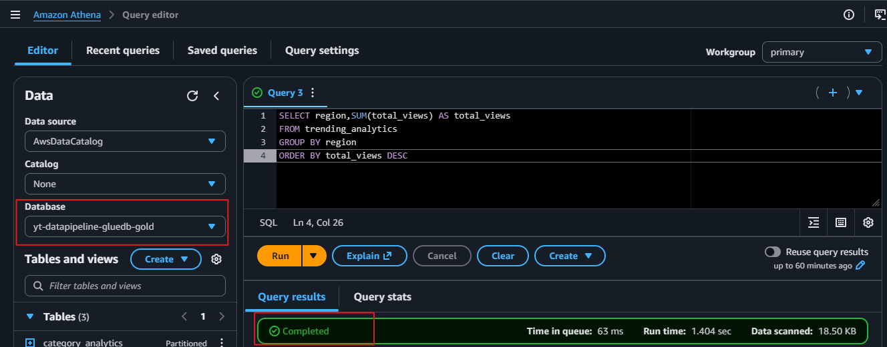
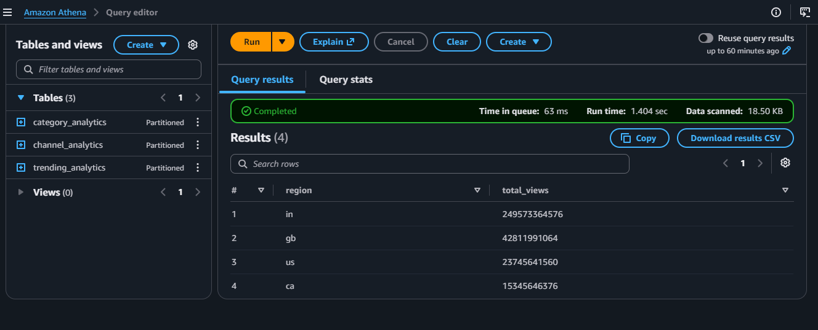
2. Highest-Viewed Channels by Region
SELECT
region, channel_title, total_views, times_trending, rank_in_region
FROM channel_analytics
WHERE region = 'us'
ORDER BY total_views DESC
LIMIT 10;

Shows the leading channels in a selected region based on aggregate views.
Evidence
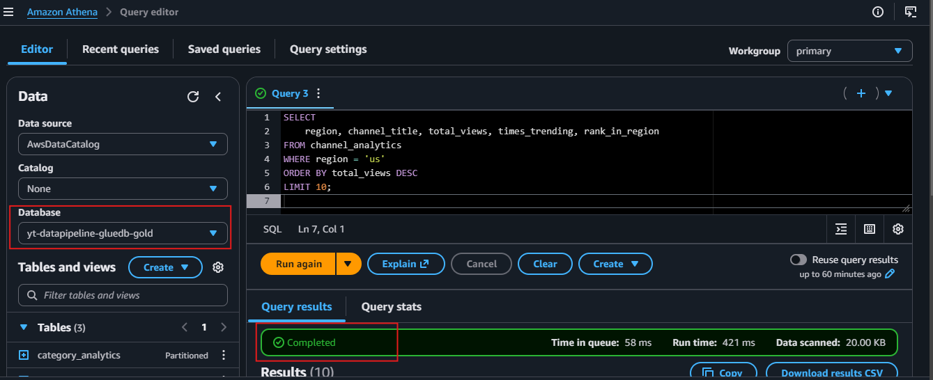
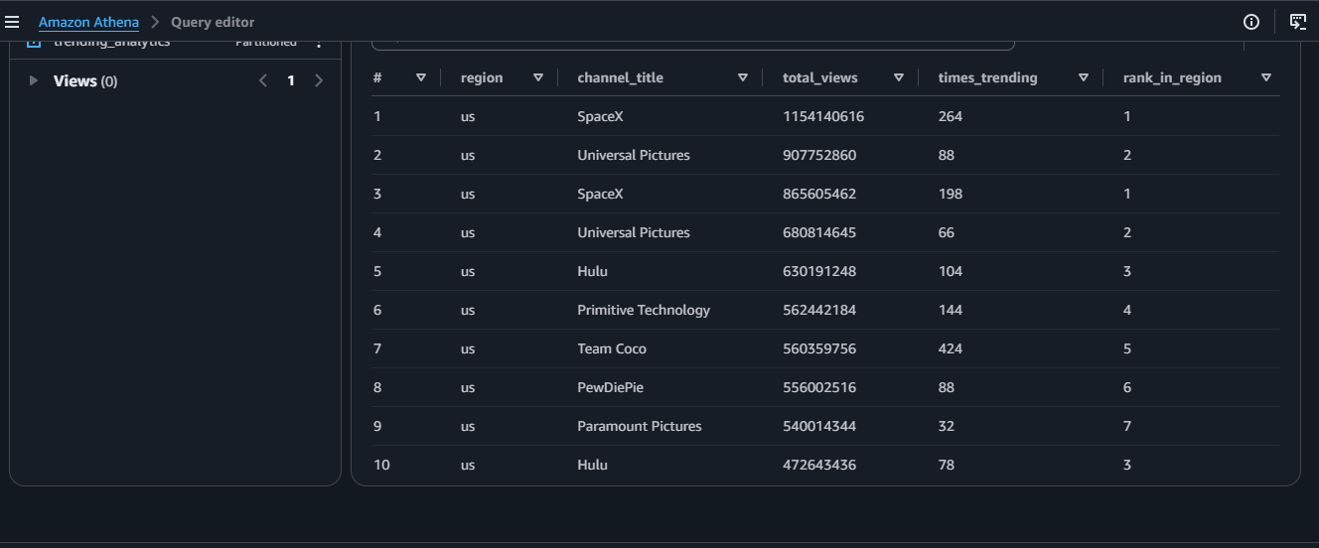

3. Category View Share Within a Region/Date
SELECT
region, trending_date_parsed, category_name, total_views, view_share_pct
FROM category_analytics
WHERE region = 'in'
ORDER BY trending_date_parsed, total_views DESC;

Uses the Gold-derived view_share_pct to compare category contribution within region/day.
Evidence:
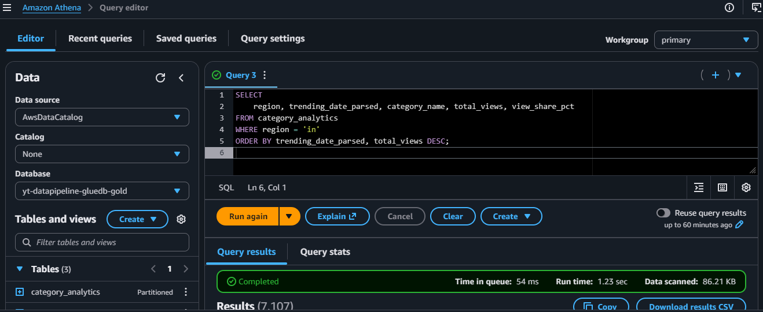
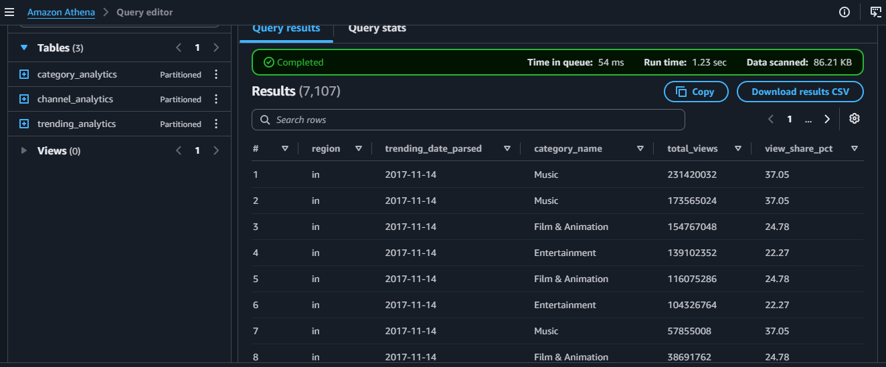

4. Top Categories by Average Engagement
SELECT
category_name,
AVG(avg_engagement_rate) AS avg_engagement_rate
FROM category_analytics
GROUP BY category_name
ORDER BY avg_engagement_rate DESC
LIMIT 10;

Compares category-level engagement rates.
Evidence:
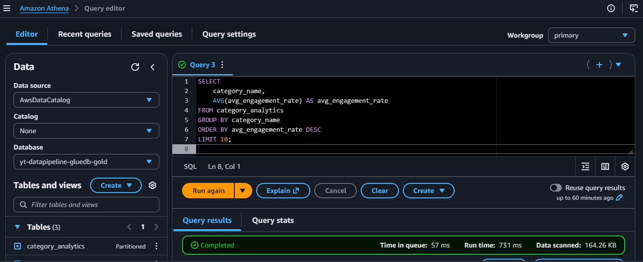
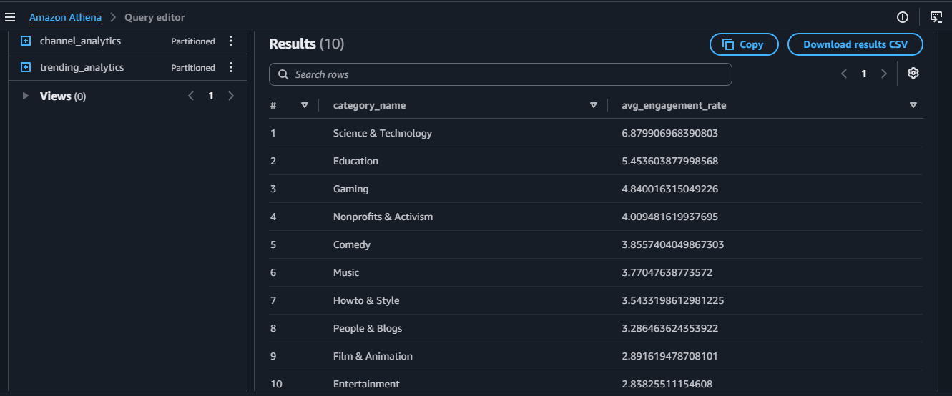

5. Channels Appearing in Multiple Regions
SELECT
channel_title,
COUNT(DISTINCT region) AS regions_active,
SUM(total_views) AS total_views
FROM channel_analytics
GROUP BY channel_title
HAVING COUNT(DISTINCT region) > 1
ORDER BY regions_active DESC, total_views DESC
LIMIT 10;

Identifies channels with cross-region presence.
Evidence:
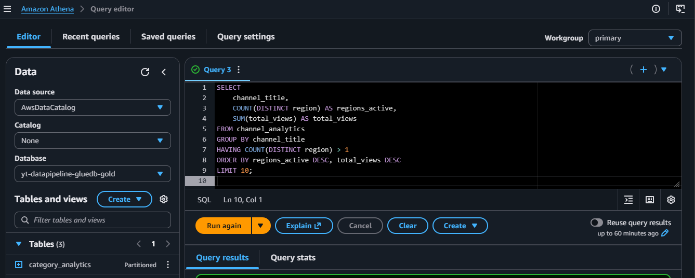
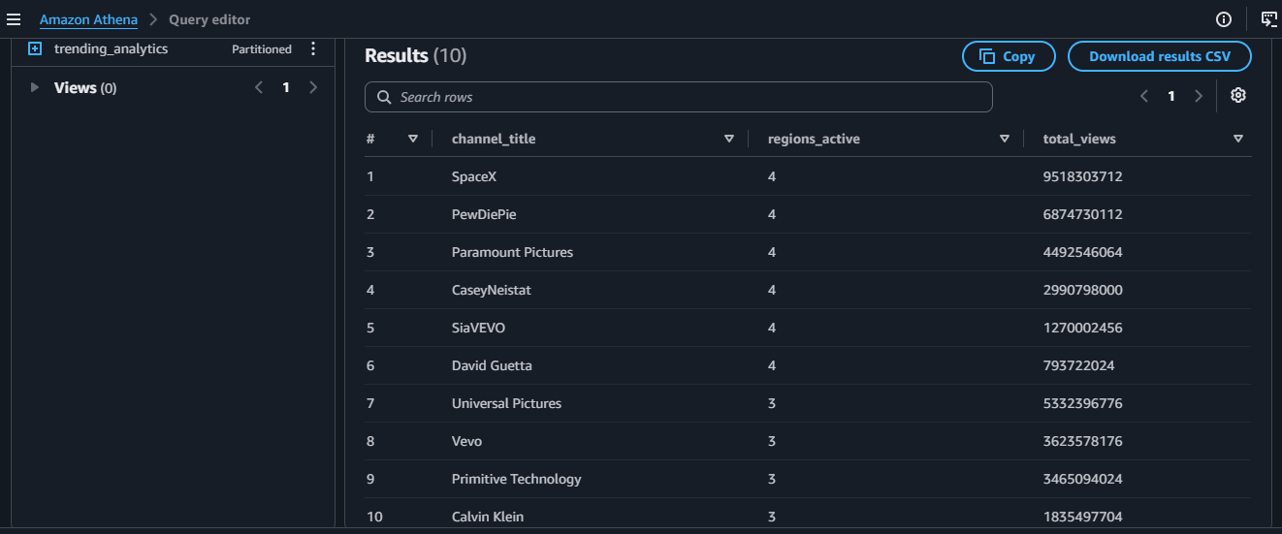

6. Daily Volume of Trending Videos
SELECT
trending_date_parsed,
SUM(total_videos) AS trending_videos
FROM trending_analytics
GROUP BY trending_date_parsed
ORDER BY trending_date_parsed;

Shows how the number of recorded trending videos changes over time.
Evidence:
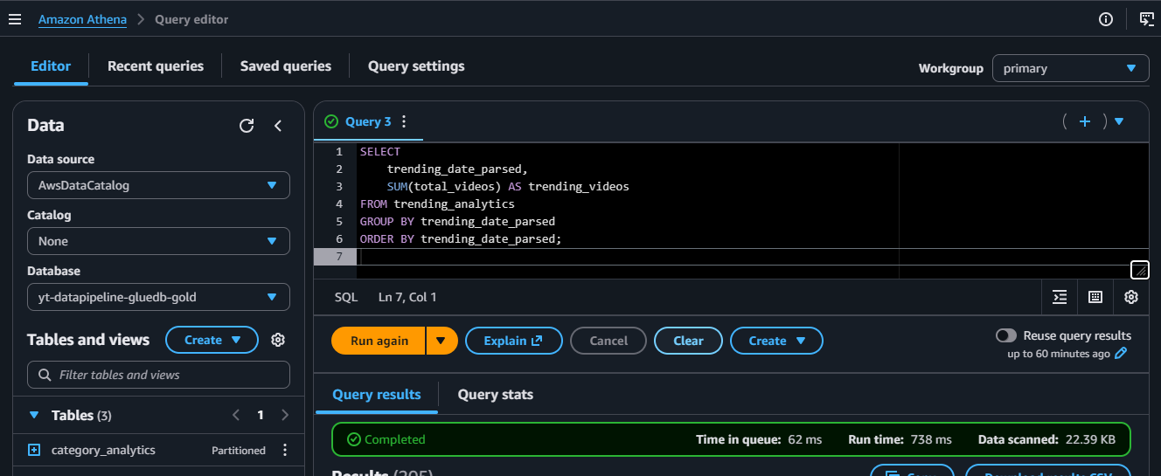
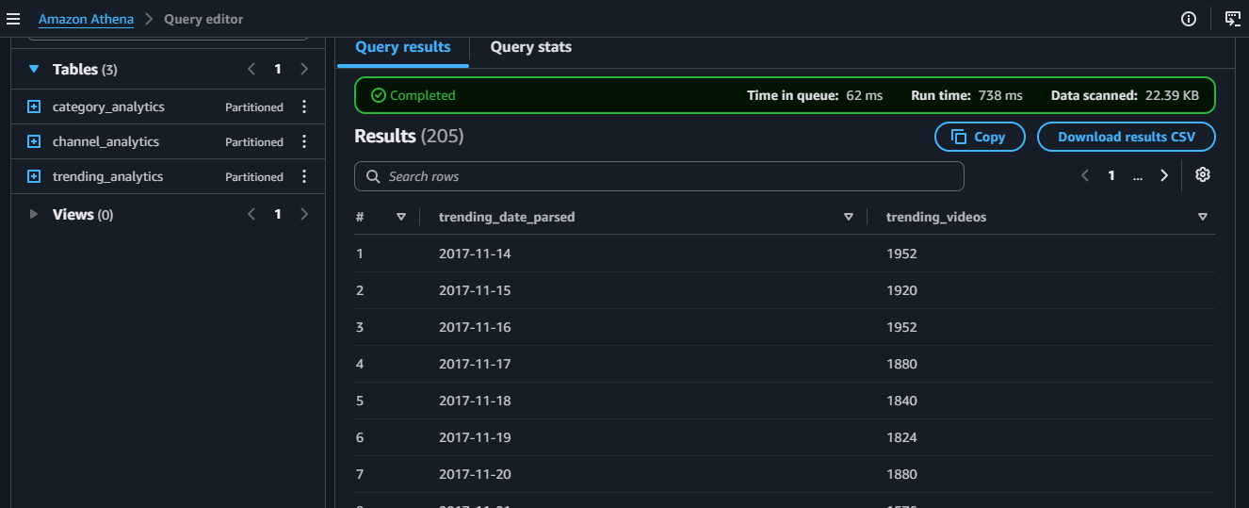

7. Views vs Engagement Correlation
SELECT
corr(total_views, avg_engagement_rate) AS views_engagement_correlation
FROM channel_analytics;

Provides a compact measure of linear association between aggregate channel views and average engagement rate.
Evidence:
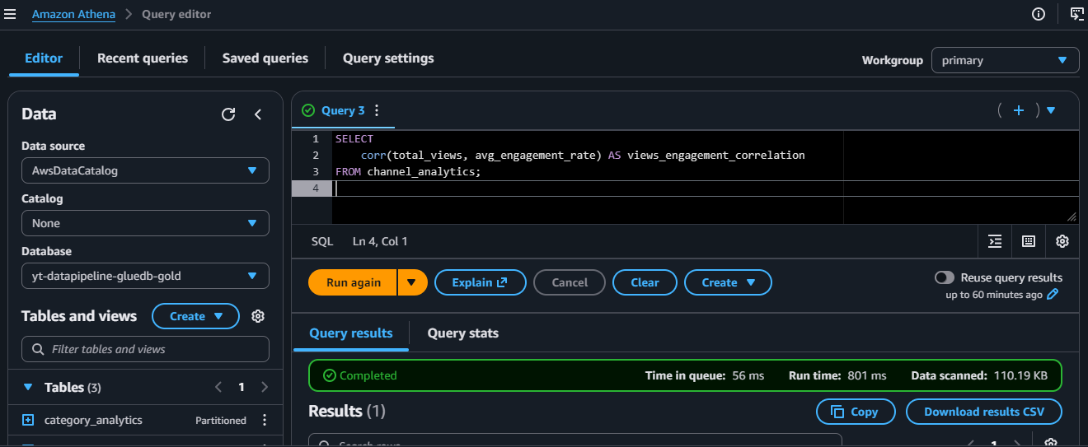
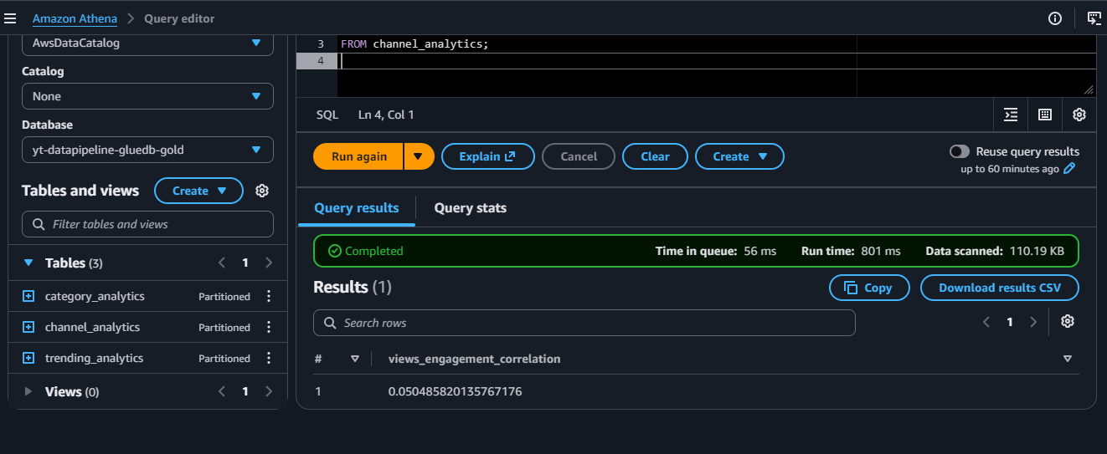

Evidence
Athena screenshots are provided as supporting evidence for the analytical queries documented above. Each screenshot demonstrates the corresponding SQL query execution and its resulting dataset.

