**Name of the Project:** Phase-1 Project [LockedMe.com]

**Problem Statement:** To digitize the products of Company Lockers Pvt. Ltd through an application

**Objective:** To develop a user interface to be able to provide user operations in two levels: Main menu and business level operations.

**Product capabilities:**

Main Menu User Interface Option list:

1. Retrieving file names in ascending order.
2. Business level operations
   1. Option to add user specific file to application.
   2. Option to delete user specific file to application.
   3. Option to search a user specific file from the application.
   4. Navigation option to close current execution and return to main context.
3. Option to close application.

**Appearance and User Interactions:**

The application UI looks as below->

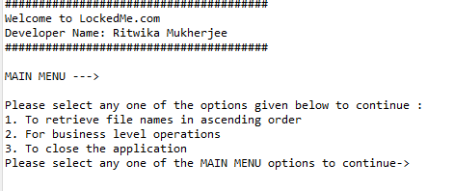

This is the first page of the application. The user can navigate to different options named as ‘1’,’2’,’3’etc. to use various functionalities. When the user presses ‘2’ and presses “enter” the user is taken to the business level operation menu as shown below->

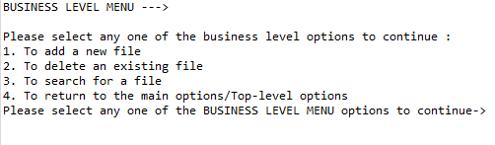

By pressing the various numbers for various operations, the functionalities can be utilized. To navigate back to the main menu ‘4’ needs to be selected and then “enter” needs to be pressed.

**Outputs of the Application:**

Showing all the features through UI interactions:

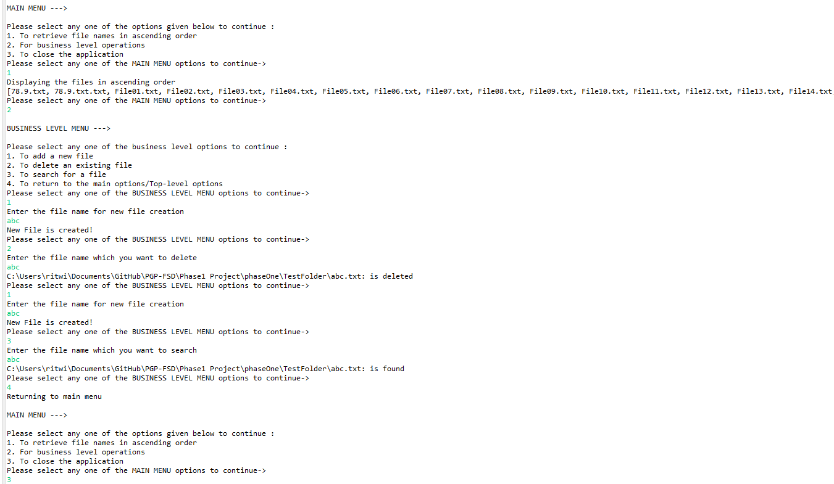

Closing the application:

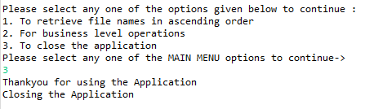

Exception handling:

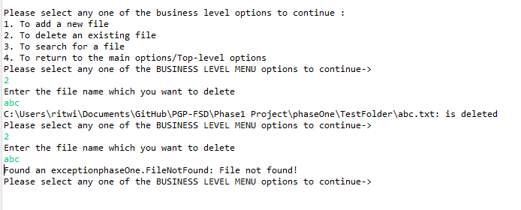

**Sprint Planning Details:**

No of Sprints: 2

No of User Stories: 3

No of tasks: 6

Tasks are as follows:

1. Retrieving file names in ascending order.
2. Adding a file to a given folder, Handling error while adding.
3. Deleting user specific file from a given folder, handling custom file not found error.
4. Searching user specific file from a given folder, handling custom file not found error.
5. Adding navigation option to go back to main menu.
6. Adding functionality to exit from the whole application.

**Flow Chart of the application:**

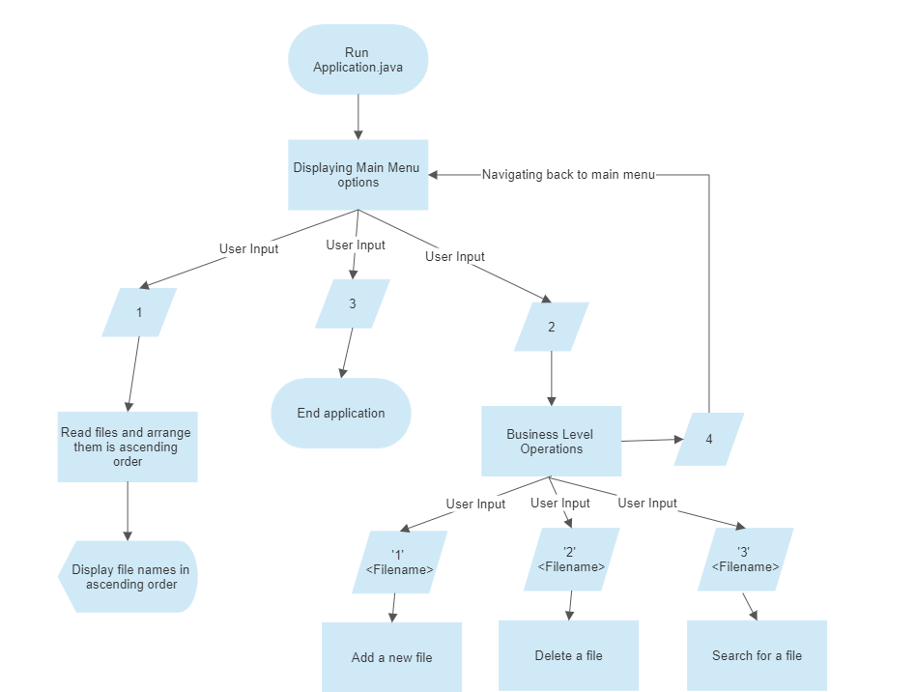

**List of the core concepts used are as follows:**

1. File handling
2. Data structures
3. Exception handling
4. Polymorphism
5. Collections.

**GitHub Link for the course code:** <https://github.com/ritwikam2020/Phase1Project>

**Conclusion:**

1. Currently the project is in the prototype version so the total user interface is on the form of command prompt. The next phase can have a more interactive UI that could take mouse click instead of number options.
2. Also, the menu options can come up as pages and navigation between the pages can happen through button clicks.
3. There could ne no security added to file search and addition and the whole process can be made password protected for security of the users.