# ABSTRACT

# INTRODUCTION

# PAST WORK

# PROJECT DESIGN

The main goal for this project was to extract some sort of meaning from a network of collaboration at a conference. At each stage of the project, there was a smaller sub-goal. A chronology of these sub-goals and an explanation for each follows.

1. The first sub-goal was to determine if there was any meaningful information about the communities about co-authorship that could be obtained via network analysis. Ultimately, this proved to be inconclusive because while raw collaboration data showed the structure of the conference and communities, there was nothing showing why the structure was the way it was. This sub-goal was then dropped as the primary focus of the project.
2. The next sub-goal was to measure “success” of someone in a conference, using general and specific properties of the network itself and the nodes in it. The main issue with this goal was that defining “success” solely in terms of collaborative values proved to be difficult and not entirely accurate. Several conjectures were formed about a definition of success using purely these properties, but they remained as conjectures. This sub-goal was also then dropped as the main focus of the project.
3. The next-sub goal was measuring “fairness” in the network. While the concepts “co-authorship communities” and “success” were not possible to determine by using solely collaboration data, fairness was something that was verifiable using network properties. The model used for determining fairness comprises analysis of collaborative data, but focuses on the inter-level communication of multi-leveled collaboration.

The sub goal of “fairness” was ultimately the goal that was chosen for the final project because it proved to be the only concept among the three that could be analyzed in a network using only collaborative data with meaningful results. The first analysis performed on all networks was manual, where numerical properties of the network were examined in parallel with its visual properties. Ultimately, the latter proved to be more useful in manual analysis. After conclusions were drawn based on manual analysis, a new sub-goal was developed.

1. The last sub-goal was to find numerical properties that could be combined to create a numerical value for “fairness” so that conferences could be rated for fairness without the need for manual analysis. This value would have to be size-agnostic, so that values would have consistent meaning across all conferences, large or small.

This goal of automatically determining fairness from numerical properties of a conference was the final step in the project design. With the goals completely set in stone, the implementation was the next big step.

# METHODOLOGY & IMPLEMENTATION

Before any methodology following the steps of project design, there was the step of data procurement. Several different conferences were selected (DAC, ICCAD, NOCS, CODES, EMSOFT) for analysis over a time period of five years (2010 to 2014). The original plan for data procurement was to use the IEEE Xplore API to automatically download all the citations for each conference over this time frame. However, due to API limitations the data had to be gathered by manually using the command search feature to narrow data to a subset for each year of each conference and using the CSV export feature. After this, the information about technical program committee (hereafter TPC) members was obtained from the website of each individual conference and manually inserted into these CSV files.

This data was then run through a Python program that created a node for each person, automatically tagged it with a role (TPC or author), institution (university or company) and name. Then, the program created edges between nodes connected via either co-authorship, institution, or even social groups (the last being when people from different institutions co-authored).

During the process of analysis and the work on the project, various different visualization methods were utilized to see and understand the network better. The network itself was analyzed and visualized in Gephi, an open-source graph visualization platform. The nodes and edges in the network were colored according to their tag with a script.



*An edge between two co-authors from different institutions*

*An edge between two nodes from the same institution*

*An edge between two co-authors (from the same institution)*

*An author whose paper was accepted to the conference*

*A member of the conference’s technical program committee*

*Someone who serves as both a TPC member and an author*

Figure 1: A key for the graph's color coding

These colors served to help understand the network more easily at-a-glance. However, simply coloring the network was not enough to clarify its meaning, as the issue of its layout still remained.

At first, the default layout algorithms present in Gephi were used for force-directed layout of the graph. However, this did not lead to good results because the layout did not show a clear visualization of the connections and relationships in the graph. The nodes in the graph were far too compressed to allow any information to be gleaned from visual inspection. The default algorithms used for layout were the ForceAtlas and Yifan Hu algorithms. Although neither ended up satisfying the requirements in the end, the former turned out to be better for our network than the latter. Figure 2 is a sample layout using the ForceAtlas algorithm on the NOCS 2010 network.

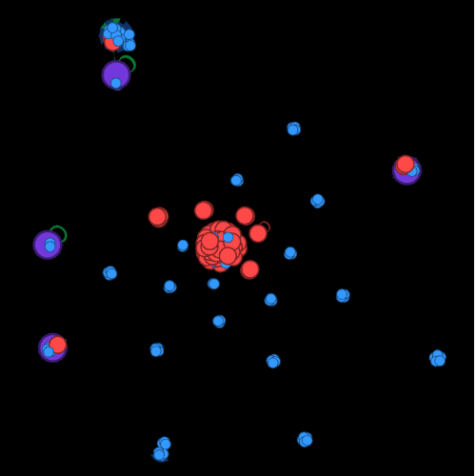

Figure 2: The ForceAtlas algorithm

After finding these algorithms unsuitable, a potential candidate was found on the internet – the OpenOrd algorithm, available as a plug-in for Gephi. It uses a five-stage simulated annealing process and an edge-cutting technique to generate layouts that scale to large and complex networks. Despite being better than the default algorithms, the OpenOrd algorithm still did not quite meet the requirements due to its visual clutter. Figure 3 is a sample layout using the OpenOrd algorithm on the NOCS 2010 network.

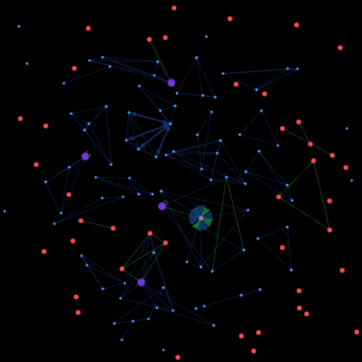

Figure 3: The OpenOrd algorithm

In terms of the layout, the OpenOrd algorithm provided almost everything we wanted. Aside from its visual clutter, it provided a good visualization about the connections in the network and how “central” and “important” nodes were. One of the other default algorithms in Gephi was the Fruchterman-Reingold algorithm, one of the first algorithms for force directed drawing. Unfortunately, it did not satisfy our requirements when acting alone. It created layouts that were visually easy to understand, but the important factor of understanding node relationships was missing. Fortunately, when applied to the graph after the OpenOrd algorithm, it pulled the clutter into an easily understood layout that still retained the important properties. Figure 4 is a sample layout using the Fruchterman-Reingold algorithm on the NOCS 2010 OpenOrd layout seen in Figure 3.

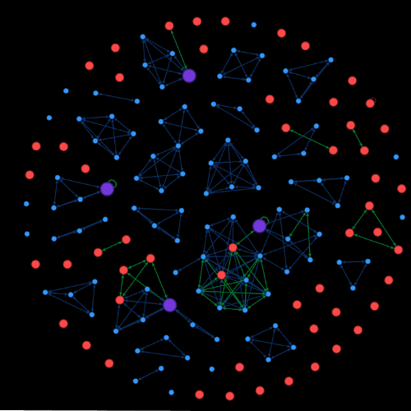

Figure 4: The Fruchterman-Reingold algorithm applied to the OpenOrd algorithm

The layout using these algorithms in sequence was almost perfect. However, it was missing one key component – multi-level visualization. While this network showed connections between nodes very easily, it did not show connections between the different *layers* of nodes (*e.g.* authors, committee members, TPC-authors). The solution to this was however quite simple. A layout algorithm called Network Splitter 3D was found that allowed the network to be split into levels via a tag with a z-level for each node and then rotated on the *x*-axis to visualize the levels. When this splitter was applied to the network after the Fruchterman-Reingold and OpenOrd algorithms, it produced an easy-to-understand, multilevel visualization of the network that showcased all the relevant properties and met all the requirements. Figure 5 is a sample layout showing the Network Splitter 3D algorithm on the NOCS 2010 Fruchterman-Reingold and OpenOrd layout seen in Figure 4.

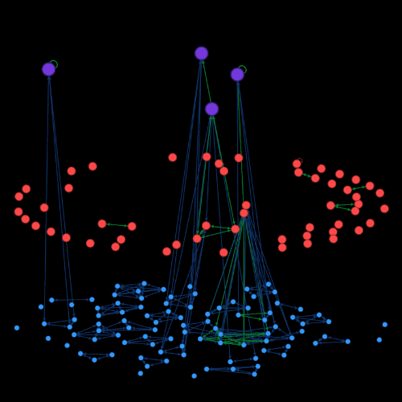

Figure 5: The Network Splitter 3D multilevel visualization applied to the Fruchterman-Reingold and OpenOrd algorithms

# This last layout provided everything required for network analysis, and no further work was performed in terms of new layouts. The next step in work was to perform different types of analysis on the networks using these visualizations to understand what information could be obtained. Each following step corresponds to the equally numbered step in the PROJECT DESIGN section.

1. When looking to find relationships between the authors in terms of communities and co-authorship, the primary focus is on the co-authorship “edges” of the graph. The “communities” in the graph were manually analyzed at first, but there was not enough information in the data to extrapolate any kind of meaningful result.
2. Measuring success in the network started with finding a “definition” for success, and therein lied the problem. Defining success in terms of co-authorship is not a functional procedure – depending on the goals of the author and the personal ideals of success, the definition can vary. Since it would not be possible to determine the author’s end goal from the data, trying to determine “success” of authors proved inconclusive.
3. The concept of “fairness” in a network was more easily defined than success. This was the first sub-goal during which technical program committee members played a large part in the methodology of analysis. In order to find a numerical explanation for this “fairness” metric in relation to the TPC-authors, all the relevant properties of the network and sub-networks were analyzed (e.g. average degree of authors, average degree of TPC members, # of communities, average path length, etc.). These values alone did not function as indicators of fairness in themselves, but when applied to different segments of the network, could be converted to a discrete fairness value.

After the properties above were extracted from the network, the focus shifted to trying to determine how they could be used to represent the fairness of the conference. Before this, however, a clear definition of fairness was needed. After consulting a variety of networks, it was determined that an “unfair” conference would be one where relationships that were conflicts-of-interest either gave some authors advantages, or others disadvantages, in areas such as paper acceptance likelihood and co-authorship desirability.

The idea developed following this definition was that there was an undeniable likelihood that TPC members were indeed more likely to be accepted due to the fact that by the very virtue of being included in the committee itself, they were already classed as more “elite” than other paper writers. If a TPC member were to write a paper like any other author, their paper would probably be accepted.

From this, the idea of comparing the authorship groups of TPC members tended to have larger authorship group than other authors. If not, then there was most likely nothing going on because the TPC-authors had submitted papers as normal. If so, however, than there was likely something going on, because if the papers written with TPC members mysteriously had an average of ten co-authors versus an average of 3 for other papers, it would signify that they were most likely included due to the “stamp” of their name and level rather than due to their contributions to the paper itself.

Four different values were extracted from the network that were then combined to create a “total fairness value”. The first two were related to the communities in the network. The first was the “TPC-author community size mean”, referred to as $c_{tpc-a}$, which was the average size of the communities which TPC-authors were part of. The second was the “Author community size mean”, referred to as $c_{a}$, which was the average size of the communities that the normal conference authors were part of. These values were combined to form “TPC to author community ratio”, referred to as ${ r}_{c}$, or the ratio between the average size of TPC-author communities and the average size of normal author communities.

The next two values used dealt with the degree property of the nodes in the network. The first was “TPC-author degree mean”, referred to as $d_{tpc-a}$, which was the average degree of TPC-authors in the graph. This is different from community size, because community size does not take into account connections reaching outside of communities. Connections like these are frequently found inside the network, frequently as institutional connections, and sometimes as cross-community authorship communities. The second was “Author degree mean”, referred to as $d_{a},$ which was the average degree of all authors in the graph. These values were combined to form “TPC to author degree ratio”, referred to as ${ r}_{d}$, or the ratio between the average degree of TPC-authors and general conference authors. These two were then combined into the final “total-fairness-value”, hereafter referred to as $v_{f}$. The formula is written below.

$$r_{c}=10 ×\frac{c_{tpc-a}}{c_{a}} r_{d}=\frac{d_{tpc-a}}{d_{a}}$$

NB: The initial value of ${ r}_{c}$ was multiplied by 10 to normalize it to the same level as ${ r}_{d}$

$$v_{f}=10× \frac{r_{c}+ r_{d}}{2}$$

*or*

$$v_{f}=10×\frac{\frac{c_{tpc-a}}{c_{a}}+ \frac{d_{tpc-a}}{d_{a}}}{2}$$

This formula was then applied to two different conferences (NOCS and ICCAD) over a five year period (from 2010 and 2014), to determine fairness values of the conferences in each year. After the numbers had been determined, they were compared with the “fairness” determined from manual visual analysis of the same conferences.

# RESULTS

After $v_{f}$ had been computed for each year of the two selected conferences, the results were tabulated and mapped over time to provide a variety of data to observe.

|  |  |  |
| --- | --- | --- |
| *Conference* | *Year* | $$v_{f}$$ |
| NOCS | 2010 | 3.2 |
|  | 2011 | 38.7 |
|  | 2012 | 33.2 |
|  | 2013 | 1.9 |
|  | 2014 | 2.2 |
| ICCAD | 2010 | 4.1 |
|  | 2011 | 5.7 |
|  | 2012 | 6.1 |
|  | 2013 | 2.3 |
|  | 2014 | 6.5 |

*fff*

From the data in the table, it can be assumed that the “fairness” of conferences can vary quite wildly over time. Noticeably, the 2011 and 2012 NOCS conference have very high $v_{f}$ values of 38.7 and 33.2 respectively. At first glance, this may seem like an error in the data or the calculation, but the NOCS 2011 and 2012 conferences have such high scores because they had neither TPC-author collaboration nor institutional connections between the TPC members and the authors. Therefore, they were “perfectly fair” according to our definition of fairness, resulting in these high scores of fairness.

In order to determine the correctness of this method of measuring fairness in the conference years, manual analysis was performed to determine “fairness” compared to the previously mentioned definition. For the NOCS conferences, $v_{f}$ was an excellent measure of the fairness of the conference. However, there was a problem in determining the general fairness of the conferences.

When computed using all the years of conferences, ${\overline{ v}}_{f-total}= 10.39$. When looking at the table, however, this value seems to be off-base from the true “average fairness” of the conferences. The two perfectly fair years of the NOCS conference greatly influenced the average. Thus, the average fairness was computed for NOCS separately, disregarding the years of 2011 and 2012, referred to as ${\overline{ v}}_{f-nocs-subset}$. The average fairness was also computed for ICCAD separately, referred to as ${\overline{ v}}_{f-iccad}$. The average fairness of both NOCS and ICCAD was also computed separately from the two perfectly fair years, referred to as ${\overline{ v}}_{f-total-subset}$. A table of these computations is shown below.

|  |  |
| --- | --- |
| $${\overline{ v}}_{f-total}$$ | 10.39 |
| $${\overline{ v}}_{f-total-subset}$$ | 4.00 |
| $${\overline{ v}}_{f-nocs}$$ | 15.84 |
| $${\overline{ v}}_{f-nocs-subset}$$ | 2.43 |
| $${\overline{ v}}_{f-iccad}$$ | 4.94 |

These values show that ${\overline{ v}}_{f}$ was greatly skewed by the two perfect years of NOCS. The value 4.00, the average with those years excluded, is far more fitting to the rest of the graph. However, averaging a value across both conferences yields a meaningless overall average. Comparing ${\overline{ v}}_{f}$ across different conferences is of actual importance, as it means that differences in fairness can be interpreted via values on the same scale. Since the fairness was computed using two ratios of metrics on a particular subset versus the entire network, the value retains a consistent meaning despite any size of the conference. Looking at differences in the average fairness of NOCS and ICCAD would yield more meaning than a total average.

When dealing with the average fairness of NOCS, ${\overline{ v}}_{f-nocs-subset}$ will be used rather than ${\overline{ v}}_{f-nocs}$ so that the “perfect” years do not influence the fairness of the other years. It could be argued that the two perfect years should increase the average fairness of the conference as a whole – and it does, from 2.43 to 15.84. However, this implies that most years, the conference has fairness ranging from somewhere around 10.00 to 20.00, whereas in reality for two   
“perfect” years, $v_{f}$ ranged from 30 to 40, but for the rest the $v_{f}$ was actually more closer to 2 or 3. The two years may have been temporary bursts of fairness, but it is not logical to assume that other years not sampled would have similar values due to the fact that during the majority of the time $v_{f}$ was actually far lower.

Now, assuming that the average fairness of NOCS is then represented by $v_{f-nocs-subset}$, we can assume that the fairness of NOCS in most years should be close to 2.43. ICCAD’s fairness computation requires no exclusion due to the fact that there are no abnormally fair or unfair years in the time range, and we can assume that the conference’s fairness in most years should be close to 4.94. At first glance, this makes it seem like ICCAD is generally 103% more fair than NOCS, but remembering that the $v_{f}$ for two of the years was near 30 or 40, it can be concluded, more interestingly, that NOCS had massive swings in fairness between 2010 and 2011 and between 2012 and 2013.

$\overline{∆_{f}}$ represents the average amount of fairness change in the conference, and ${ s}_{f}$ could be used to define the “stability” of the conference.

${ s}_{f}=100{\overline{∆_{f}}}^{-1}=100×\frac{1}{\overline{∆_{f}}}$

NB: ${ s}_{f}$ was scaled by 100 to normalize its scale to the other variables such as ${ v}_{f}$

${ s}_{f-nocs-perfect}$, computed as stability across 2010 and 2011 and 2012 and 2013, was equal to 2.99. When computed using $∆_{f}$ across the other time periods, ${ s}_{f-nocs-regular}$ was equal to 34.48. During the time period of 2010 to 2013, ${ s}_{f-nocs-perfect}$ approached 3, signifying massive fairness instability. For the regular time periods, ${ s}_{f-nocs-regular}$ approached 35, signifying a time period of relative stability, but not one completely devoid of tremors. When computed across the entirety of NOCS, ${ s}_{f-nocs}$ was equal to 18.15. Despite not being as protean across the five years as it was during the first three, the conference as a whole remained rather unstable.

In the ICCAD conference, there were no large changes in fairness necessitating analysis of subsections of the five year span, so a single ${ s}_{f}$ value sufficed for representing the stability of the entire conference from 2010 to 2014. In the time period, ${ s}_{f-iccad}$ was 40.00. Even during the most stable period of NOCS, ${ s}_{f-nocs-regular}$ was equal to 34.48, and less than ${ s}_{f-iccad}$. Especially when considering that the total stability of NOCS, ${ s}_{f-nocs}$ was 18.15, it can be said that ICCAD as a conference was far more stable than NOCS. A table of these values is given below.

|  |  |  |
| --- | --- | --- |
| *Conference* | *Time Period* | $$s_{f}$$ |
| NOCS | 2010 - 2014 | 18.15 |
|  | 2010 - 2012 | 34.48 |
|  | 2012 - 2014 | 2.99 |
| ICCAD | 2010 - 2014 | 40.00 |

# CONCLUSIONS

# ACKNOWLEDGEMENTS

# REFERENCES