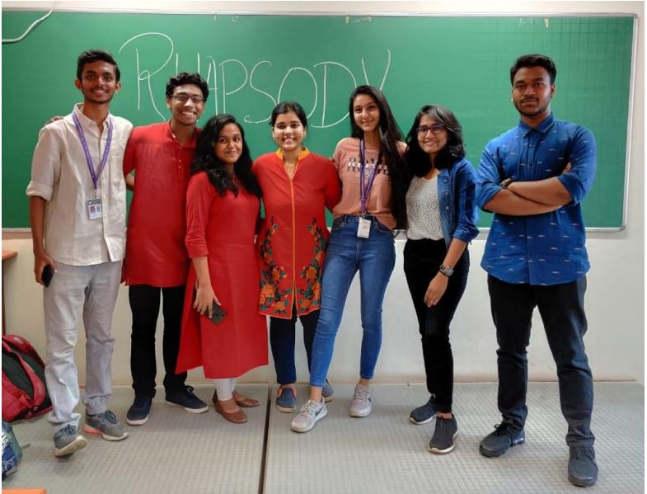

**“The two most important days in your life are the day you are born and the day you find out why.”**

**-Mark Twain**

Multitudes struggle to find the one thing that they are meant for. For some the path is clear. One thing is certain, a path exists and has to be found. To qualify as Ikigai it should be something you love to do, something you are good at, something that you can earn from and something that the world needs. Music for centuries has served the very purpose of livening up lives. It helps a person feel, express and achieve. Many find their inner self leaning into music, they find their peace in music. Here at F.C.R.I.T a plethora of students share their love for music. And Rhythm helps them search for their Ikigai. Rhythm, the official Music Club, which is a part of the Literary Arts section of F.C.R.I.T. is one of the newest and most awaited clubs in Angel's. Formed by a group of music enthusiasts, this club comprises a total of 114 registered members and is still counting. The core committee comprises students from across different departments and streams. Council members: Club heads: Aldric Pinto (Comps Sem 4)

Dany Poly (Comps Sem 4)

Secretary: Ananya Rajesh (IT Sem 4)

Treasurer: Anshuta Kakuste (Comps Sem 4)

Creative directors: Jennifer James (Comps Sem 4)

Joel Chacko (Mech Sem 4)

Event heads: Catherine Sarah Sunil (IT Sem 2), Elisha Gras (Comps Sem 2)

Rhythm aims to facilitate the students with exciting opportunities to showcase and develop their musical talents. It focuses mainly on 3 attributes; Vocals, Instruments and Production. The club owns pages across social media platforms to voice out the talents of these energetic and soulful young people. Frequent initiatives are carried out wherein students are encouraged to send in their video covers and original compositions to widen the reach. As a result, it has been receiving many incentives from various Promotional Pages in the social media accounts. As their first event, in the very first week of its genesis, the club set up a Jam session. Free for all, the jam session saw a variety of students, ranging throughout semesters and departments. Each student was allocated groups after which they sang songs based on various genres and moods. The session was a huge success and the club witnessed a soaring rise in the number of registrations thereafter. In addition to sessions like these, the club looks forward to arrange workshops and classes to teach students instruments (like guitar & keyboard), Hindustani and Carnatic vocals and navigation of music production software like FL Studio, Ableton Live etc. There have been speculations regarding a Talent Showcase Evening, a choir event, in the upcoming semesters. The club has won many hearts and is supported by the entire F.C.R.I.T. family including the staff! Looking forward to this beautiful musical journey!