Prestige Blue Chip Software Park, Block-1, Level-4, No.9, Hosur Road, Bangalore 560029, Karnataka, India.

**USER MANUAL for TASK TRACKER TOOL**

**Revision: 1.0**

**Date: 13th July 2018**

|  |  |  |
| --- | --- | --- |
| Prepared by:  Ritwik Shanker, Rahul Singh Chouhan | Reviewed by:  Kiran Kumar | Approved by:  Vadivel M |
| Date: 9th July 2018 | Date: 13th July 2018 | Date: 13th July 2018 |
|  | | |
| Disclaimer  The official controlled copy of this procedure is the signed PDF document on the Esterline Technologies India network server, and is available to all authorized users. All other printed or electronic copies and versions are considered uncontrolled copies used for reference only.  This document contains no controlled technical data or technology. | | |

**Revision History**

|  |  |  |
| --- | --- | --- |
| **Revision** | **Release Date** | **Description** |
| 1.0 | 13th July | Initial release |
|  |  |  |
|  |  |  |

**Table of Contents**

1 Purpose 4

2 Scope 4

3 Abbreviations, Terms and Definitions 4

4 Responsibility and Authority 5

5 Functional Requirements Description 5

6 Tool Description 5

6.1 Login Page 5

6.2 Home Page 6

6.3 Add Project Page 6

6.4 Editing Project 7

6.5 Creation WO 8

6.6 PM-Add Edit Comments 9

6.7 View-WO 9

6.8 Start WIP 10

6.9 Author – Add/Edit Comments 10

6.10 Raising Illustration 11

6.11 SFCK- WO 12

6.12 Reviewer – QA 13

6.13 Draft Delivery 15

6.14 Shop Verification 15

6.15 V&V Update 15

6.16 Final Delivery 16

6.17 Associated Illustration 16

6.17.1 Start-WIP 17

6.17.2 Illustrator-Add/Edit Comments 17

6.17.3 SFCK- IO 17

6.17.4 Reviewer-QA 18

6.17.5 Author – QA 19

6.17.6 Send to Author 19

6.17.7 V&V 20

6.18 Report 20

7 References 21

8 Requirements 21

# Purpose

This document explains the usage of the task tracker tool which is primary developed for Technical Publications team of Esterline India.

# Scope

This Scope of the task tracker tool is to address the following requirement from technical publication team.

Cover the tracking of all tasks or work orders ranging from total work load received by Esterline, scheduling/planning, work allocation, current status, deliverable quantity and quality with all the KPI’s/Metrics.

This task tracker tool provides complete business growth of the organization with more efficiency and realistic way.

* Get the complete work load and monitor the status.
* Total deliverable quantities with quality.
* Generation of all KPI’s/Metrics for the project.
* SOP will be followed in linier motion.
* Elimination of using/tracking multiple excels related to the various ongoing as well as closed work order at the same time.
* Elimination of human error in excels and saves production time.

# Abbreviations, Terms and Definitions

|  |  |
| --- | --- |
| Abbreviation/Term | Definition |
| CMNTS | Comments |
| CSTMR | Customer |
| ILLU | Illustration |
| IO | Illustration Order |
| IR | Internal Review |
| OWNR | Owner |
| PR | Peer Review |
| QA | Quality Assurance |
| REVWR | Reviewer |
| SFCK | Self-Check |
| TTT | Task Tracker Tool |
| V&V | Verification and Validation |
| WIP | Work In Progress |
| WO | Work Order |

# Responsibility and Authority

|  |  |
| --- | --- |
| **Technical Manager** | The Technical Manager will update the tracker for received work order details, responsible Owner’s name, required SFCK date and planned delivery date to the customer. |
| **Technical Writer** | Technical Writer will accept the WO in TTT with date and will update the required parameters in all the phase of work with date till the work submits for review. |
| **Technical Illustrator** | Technical Illustrator will accept the WO with illustration details (raised by the Technical Writer) in TTT with date and will update the required parameters in all the phase of work with date till the work submits for review. |
| **Peer Reviewer** | Once OWNR (Technical Writer) submits the work in TTT, the WO will come to the Peer Reviewer’s bucket. Peer Reviewer will update the V&V tab with error code and description, if any. Then Peer Reviewer will send the work to the next level (for Internal Review) with date once it is ready. |
| **Technical Lead / Internal Reviewer** | Technical Lead / Internal Reviewer will update the V&V tab with error code and description, if any. Then Technical Lead / Internal Reviewer will send the work to the next level (External Review / Customer) with actual delivery date once it is ready. |

# Functional Requirements Description

The requirements for the TTT are decomposed into five major pages as given below. The detailed requirements pertaining to each of these functions will be described in the respective sections.

Functions:

1. Unique Credentials
2. Editing Project
3. Associated WO
4. Associated ILLU
5. Generate Report

# Tool Description

## Login Page

Like any web based software, the tool has a login page which allows the manager/author/ illustrator/reviewer to login into the Task Tracker tool by entering the username (Employee ID) and password.

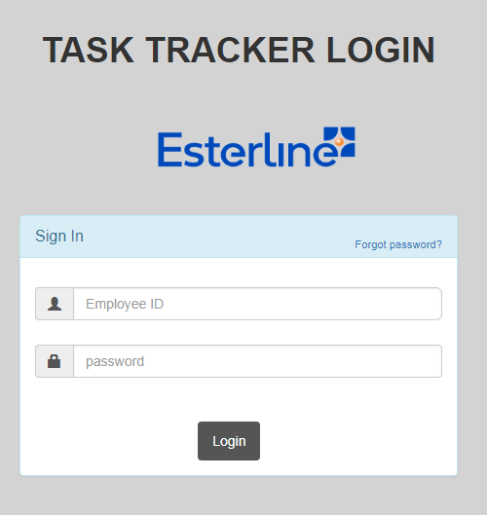

* The first time password for all users is “password” which takes the control to password changing page upon first login where the user has to enter the new password.
* There is an option of “Forgot Password?” which helps the user to reset the password via an e-mail password recovery mechanism.

## Home Page

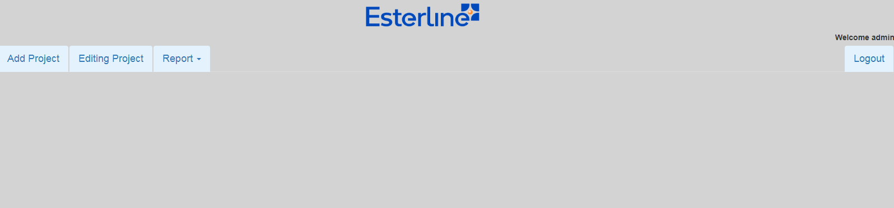

The home page has the following buttons:

C:\Users\ritwik.shanker\Desktop\Images Task Tracker\HomePageButtons.PNG

* **Add Project:** It provides the option to add Project for Tracking.
* **Editing Project**: Provides the list of all the projects that were added using Add Project button which can be edited for any changes.
* **Report**
  + **Individual Summary-** Itwill generate consolidated report for the individual who has logged in.
  + **Team Report -** This tab will generate a complete consolidate report of a team irrespective of all the Projects.
* **Logout -** It will logout the user from the tool.

## Add Project Page

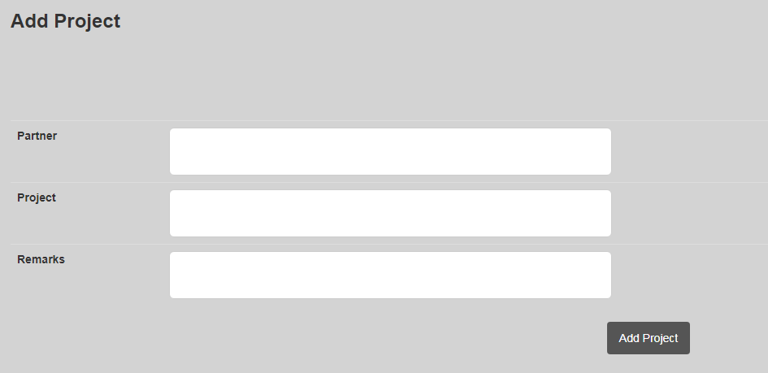

The objective of this page is to add Project details which include Partner, Project, and Remarks to the Database. All the details that added here are visible in the editing project button. Only **Manager and Admin** will have access to this Tab.

## Editing Project

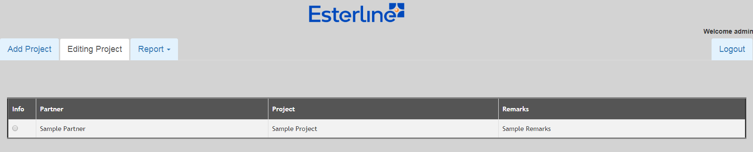

This tab will show all the projects which are added through add project button. There is a radio button on the left of the table which can be used to access further deep into projects. Selecting the Radio Button will open up new buttons.

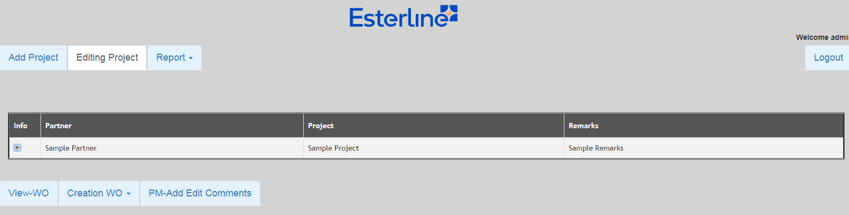

Creation of WO is explained first so that the work order is created and then viewing of the WO is mentioned.

## Creation WO

This button will have a drop-down menu which has the option to add and edit a work order. Only Manager will have access to this button.

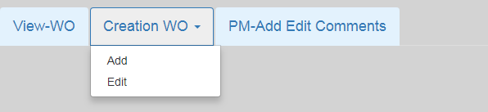

**Add -** Clicking the add button will open up to add WO details fields. (All fields below contains Sample Data)

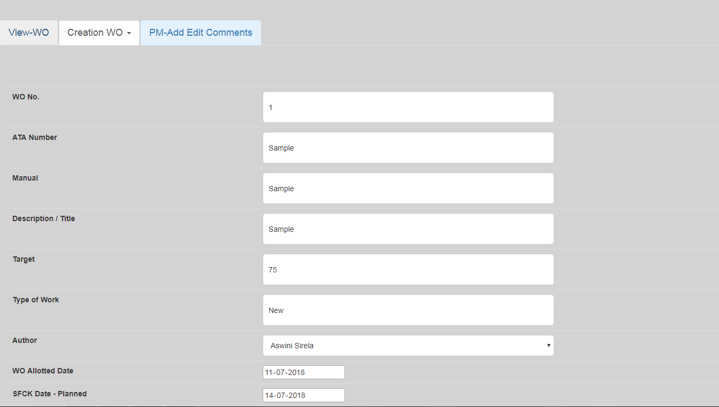

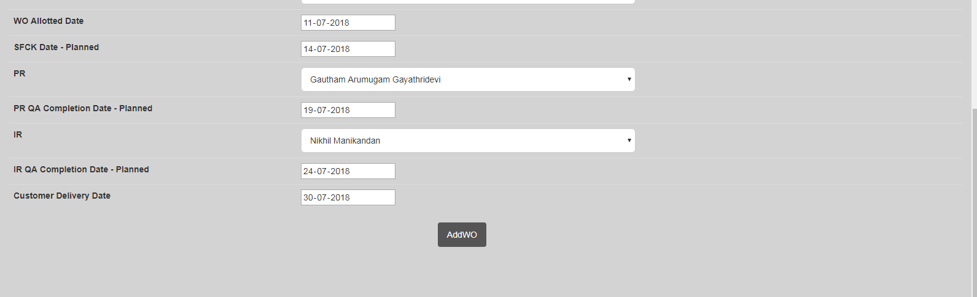

Author, Peer Reviewer and Internal Reviewer input boxes contain dropdown Menu which contains the name of employees.

If new employee needs to be added, please contact the tool administrator. Once the **“ADDWO”** button is clicked the respective WO details will be added and visible under **View WO** button.

**Edit –** This button will allow the manager to edit any preset WO Details. Clicking this button will open up all the WO in that Project and selecting the radio button against the respective Work Order will open up the Edit fields of that Work Order.

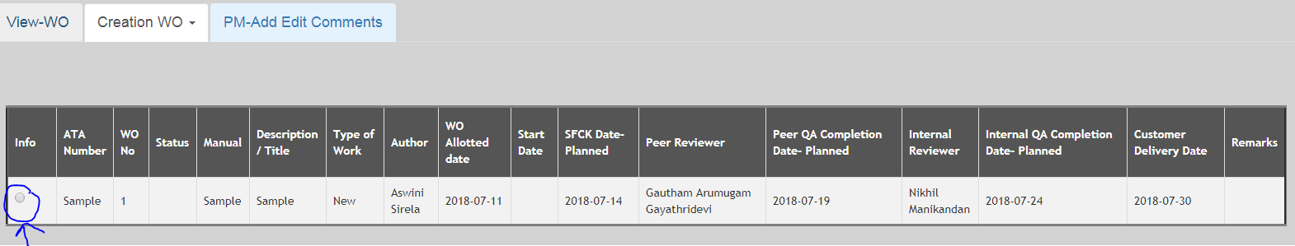

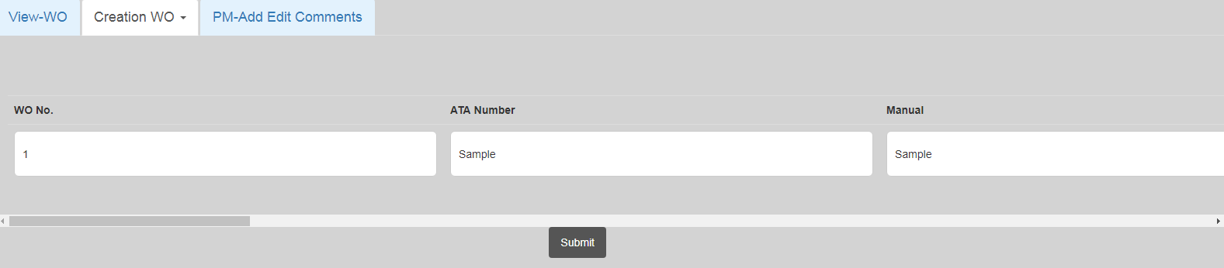

## PM-Add Edit Comments

Only Manager will have access to this tab. Once the tab is clicked the modify attribute dialog box will appear with all the parameters of the current Project.

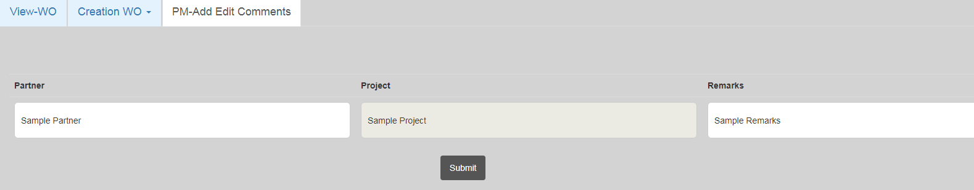

## View-WO

As we saw three buttons will open up when we click the radio button. This button will display all the Work Orders associated with the user’s Employee ID. Everyone will have access to this button but user will only be able to see his Work Orders only i.e. according to his/her allocation.

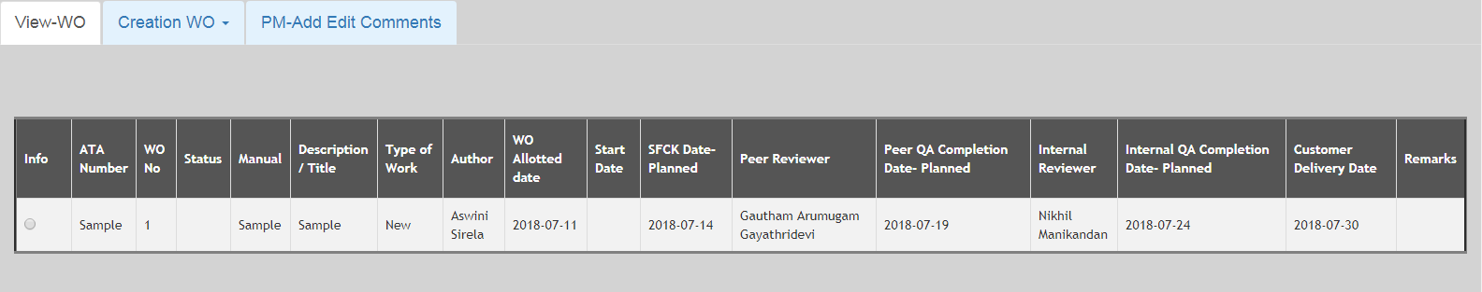

Selecting the Radio Button of the respective Work Order will open all the buttons and also display all the Associated Illustration.

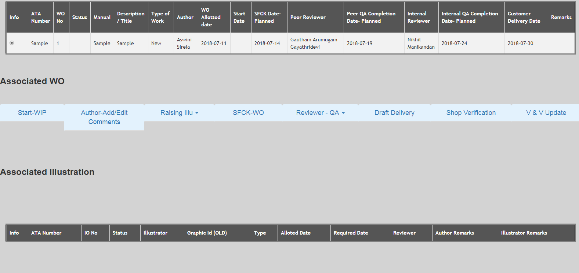

## Start WIP

Clicking the Start-WIP Button will open a button “**Accept WO”**

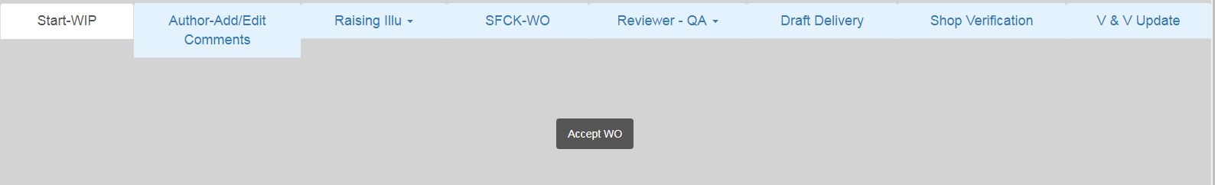

Clicking this button will update the Start Date of the Work Order and its status to “**WO ACCEPTED”**. The date will be taken automatically from the System. Input Date option is not given due to obvious reasons. This button will only start the order if the Author is trying to start the order. Internal reviewer, Peer reviewer and Manager can’t start the order. An alert message will also be displayed on starting the Order.

## Author – Add/Edit Comments

Clicking this button will open a textbox with the functionality to add multiple paragraphs.

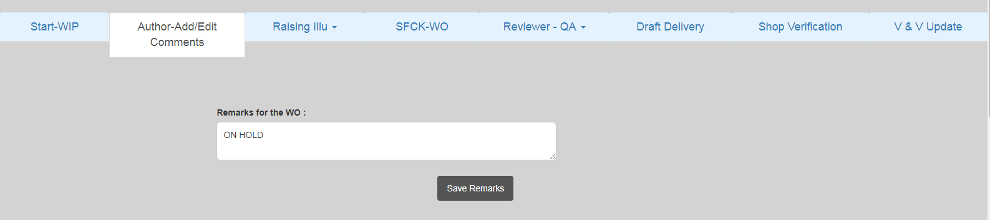

The author can input his/her remarks here. The remarks will be visible to everyone but only Author will be able to change it.

## Raising Illustration

This is also a dropdown menu. It will contain option to Add, Edit, and Delete Illustration.

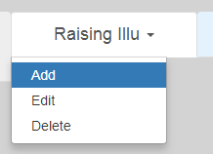

* **Add-** This button will open the Add Illustration Page where only the Author can add the Illustration for a Specific Work Order. This tab will be visible to everyone but only Author will be able to add the illustration.

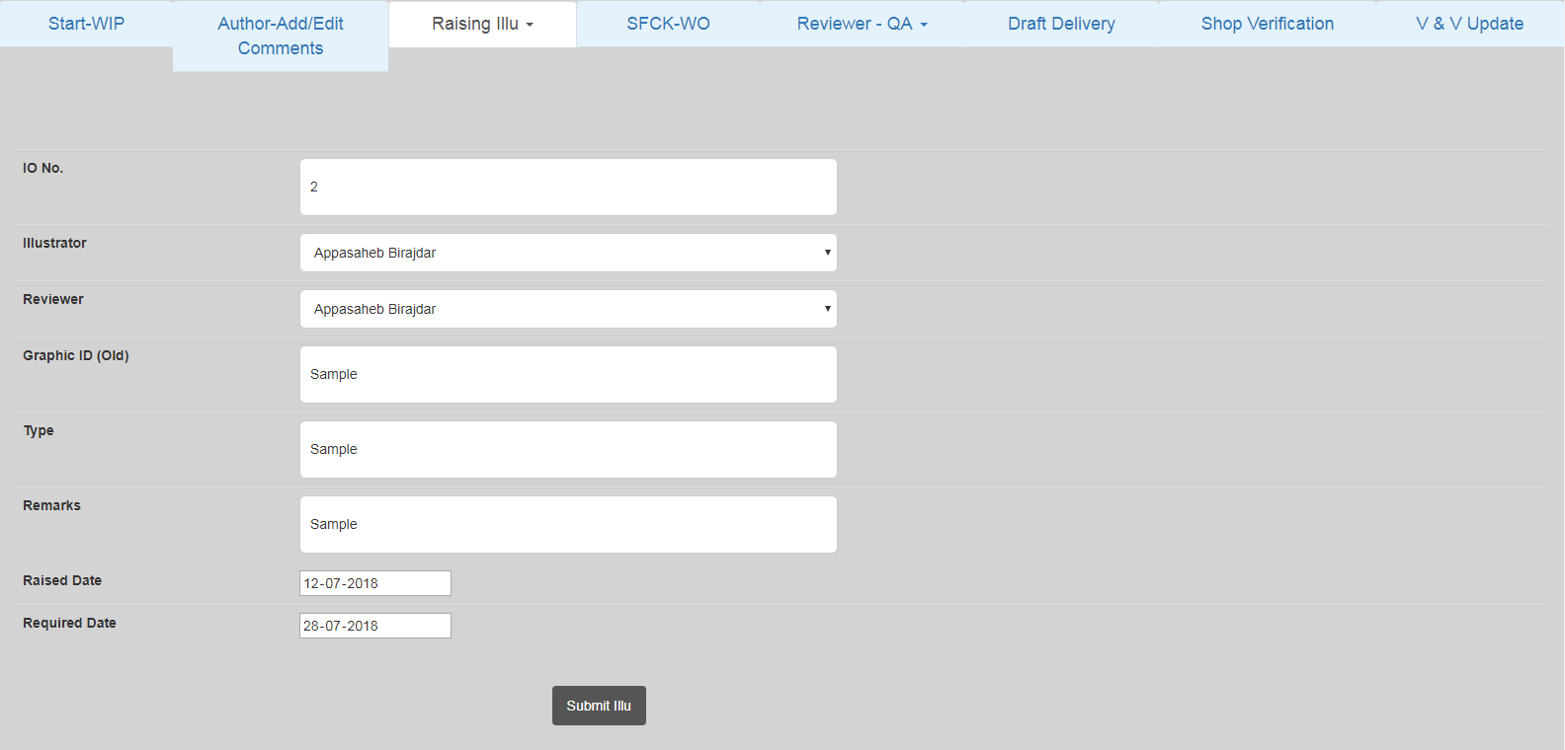

* **Edit –** Selecting the Edit Option the Author will be able to edit the Selected Illustration. Selecting this will first open up all the list of all the Illustration for the respective Work Order.   
  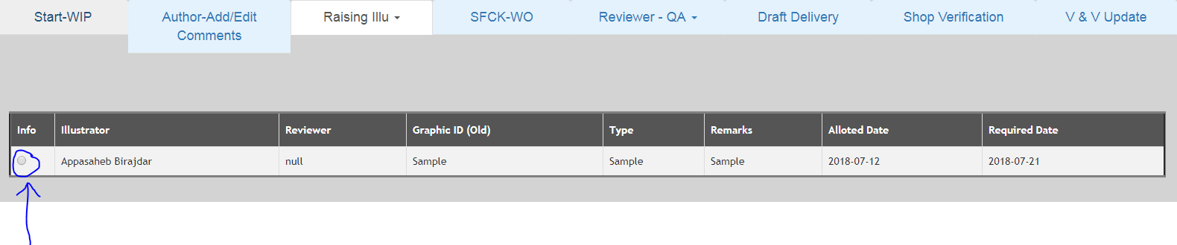

Then the user needs to select the radio button for the respective Illustration to edit the respective Illustration.

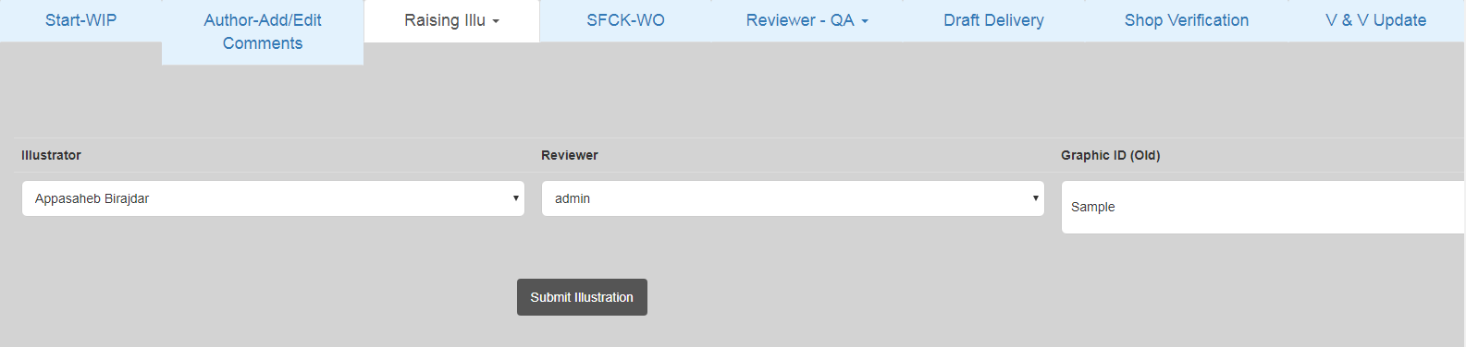

All fields will be editable with a scroll-bar option. Clicking the Submit Illustration Button will submit the Illustration.

**NOTE- AS OF NOW THERE IS ONLY PROVISION OF ADDING A SINGLE ILLUSTRATOR IN A SINGLE WORK ORDER BUT IF A SINGLE WORK ORDER WILL CONTAIN MULTIPLE ILLUSTRATORS, PLEASE CONTACT ADMIN.**

* **Delete –** Selecting this will first open up all the list of all the Illustration for the respective Work Order. The author can select any illustration and select delete to delete it. An alert message will be displayed.

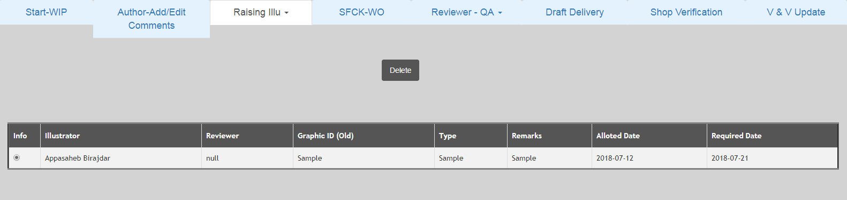

## SFCK- WO

Once again this tab will only be accessible by Author. The author can do SFCK here and Work Order status will get updated accordingly.

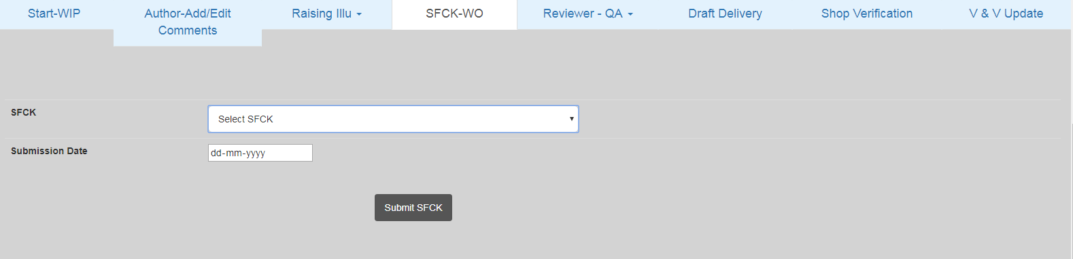

The user can select the type of SFCK he wants to perform the respective WO from the dropdown menu.

## Reviewer – QA

This tab will only be accessible to the Reviewer i.e. either Peer or Internal Reviewer. The Reviewer from here can Add, Edit, Delete, Calculate Score, and Submit a Review. All these option will be accessible through a dropdown menu.

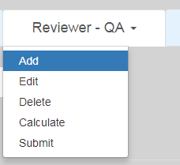

* **Add –** Peer/Internal Reviewer will click thisto fill the Error Code, Error Description, Quantity, Review Start Date and Review Completion Date.

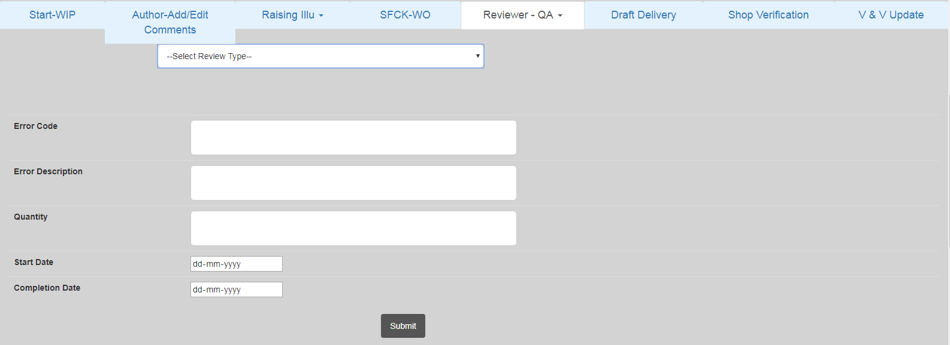

* **Edit –** Clicking this will display all the Error Code along with their respective Review Type.The reviewer can select the respective radio Button and the Error will be editable.

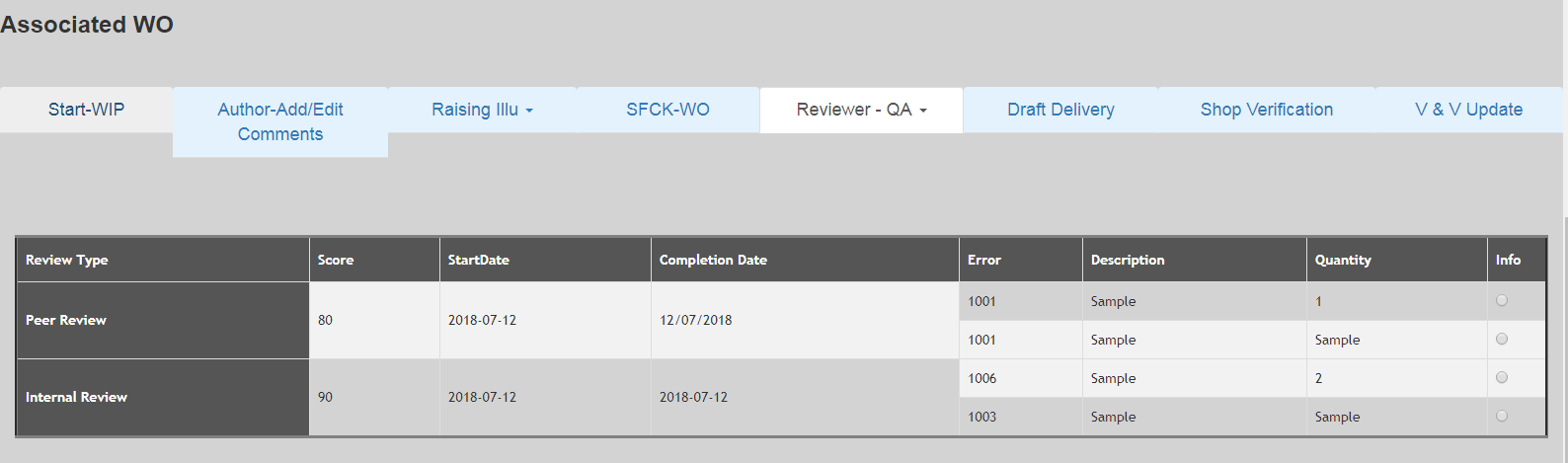

* **Delete –** The reviewer can use this button to delete a Wrongly Entered Error Code. The display will be same as Edit Button and reviewer will select the Radio Button corresponding to the Error Code and select delete to delete that respective Error Code.
* **Calculate –** Any-one can use this button. This will allow the user to calculate the score of a particular Review.

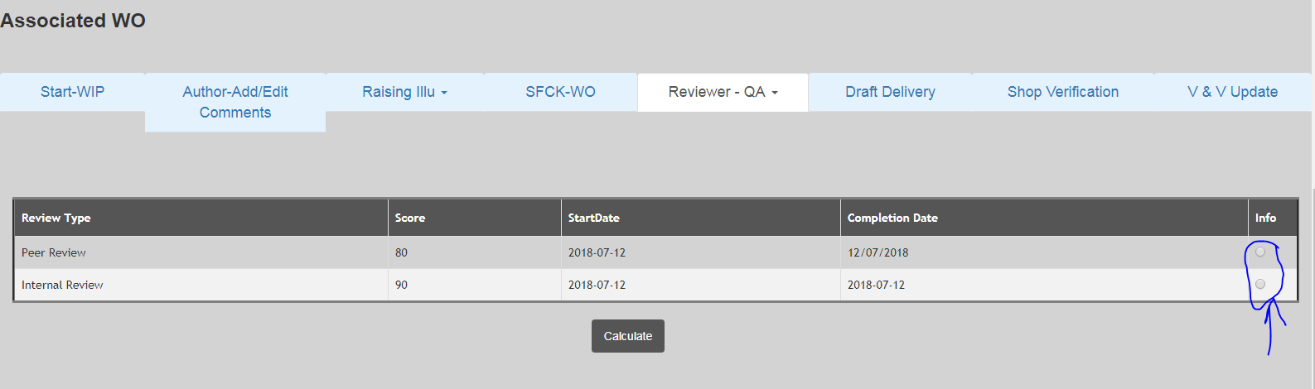

The user needs to select the respective Review Type for the respective WO and the click the calculate button to Calculate the score.

* **Submit –** This will allow the Reviewer to close the review or submit the review. The Reviewer will select the review type for a Work Order and then click the Submit button to submit it. This will automatically add the current system date to the review Completion Date.

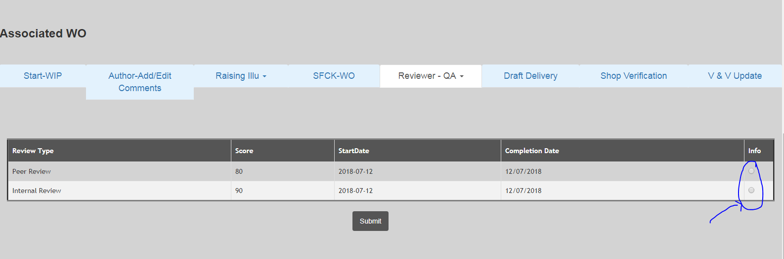

## Draft Delivery

Manager will only have access to this tab. Manager will be able to deliver the Draft Once the Reviews are closed. He can select the date and click the submit Button and receive an alert message.

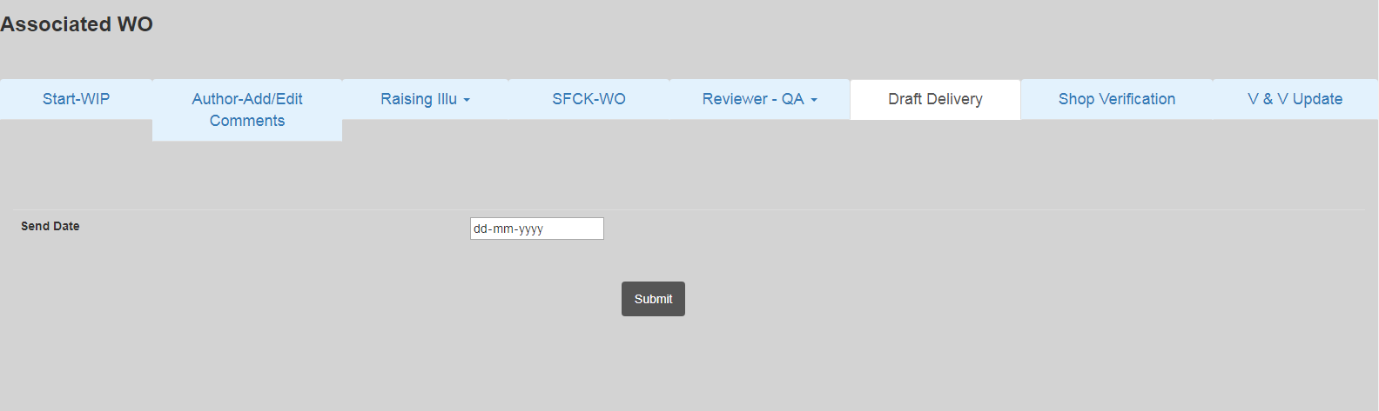

## Shop Verification

For this tab also only manager will have access. This will allow manager to do Shop Verification once Draft is delivered.

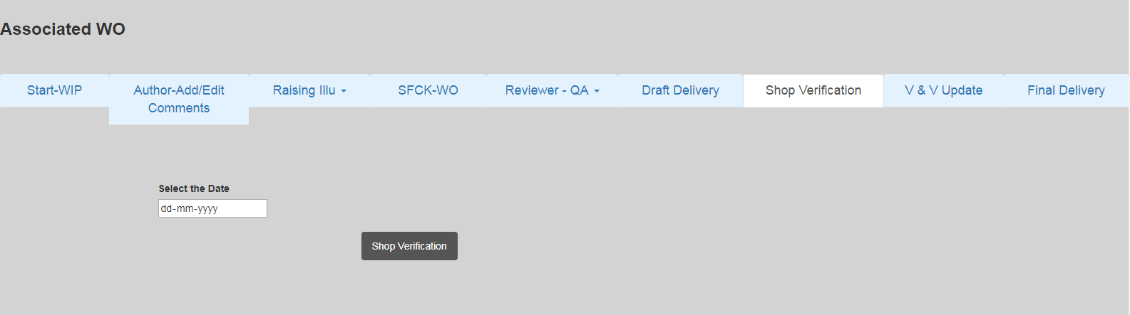

## V&V Update

This “V&V” tab will show verification and validation report in detail. OWNR, Reviewers and Manager will have access to this tab.

Once this tab is clicked, a report will appear as follows:

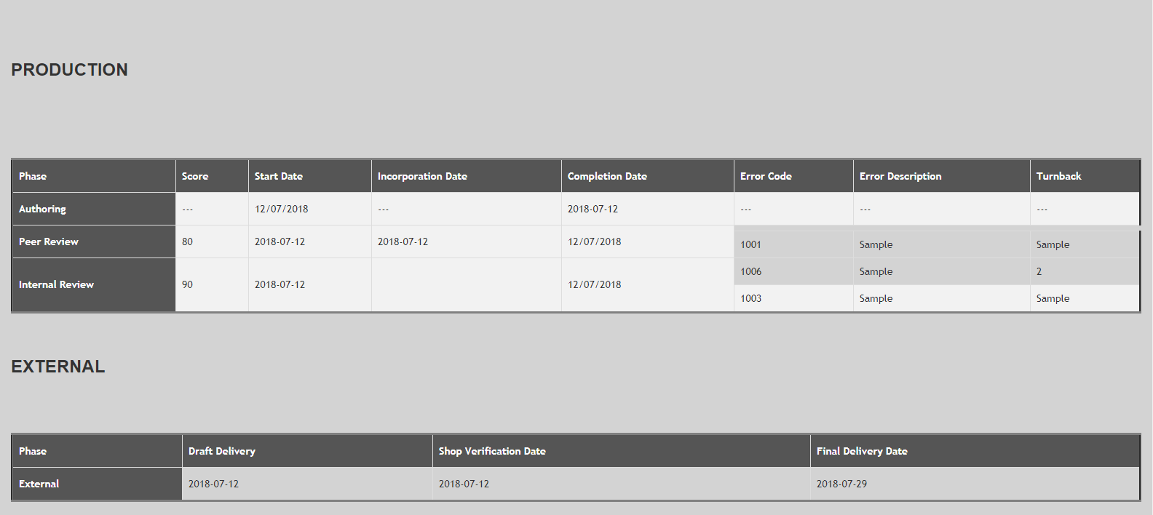

## Final Delivery

Once again only Manager will have access to this tab. He can send the WO for final Delivery once all previous stages are complete.

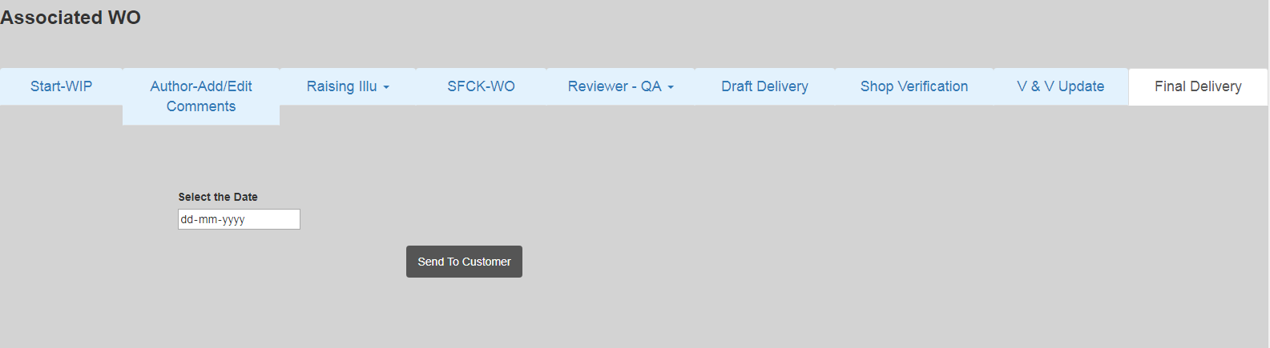

## Associated Illustration

This tab will contain all the Associated Illustrations in a WO. Only Author, Reviewers, Manager and Illustrator will be able to see the IO. Selecting the respective Radio Button will open up all the buttons as shown below i.e. Start-WIP, Illustrator –Add/Edit Comments, SFCK-IO, Reviewer-QA, Send to Author, Author-QA and V&V.

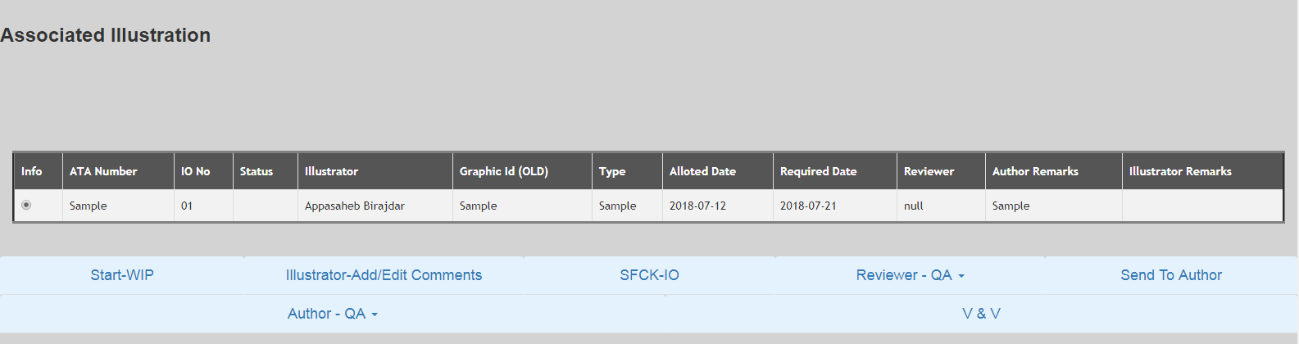

### Start-WIP

Clicking the Start-WIP Button will open a button “**Accept IO”.**

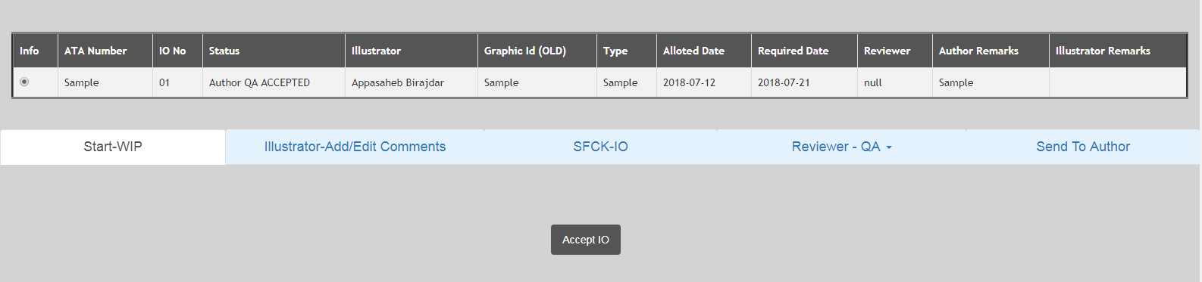

Clicking this button will update the Start Date of the Illustration Order and its status to “**IO ACCEPTED”**. The date will be taken automatically from the System. Input Date option is not given due to obvious reasons. This button will only start the order if the Illustrator is trying to start the order. Internal reviewer, Peer reviewer and Manager can’t start the order. An apt message will also be displayed on starting the Order.

### Illustrator-Add/Edit Comments

Clicking this button will open a textbox with the functionality to add multiple paragraphs.

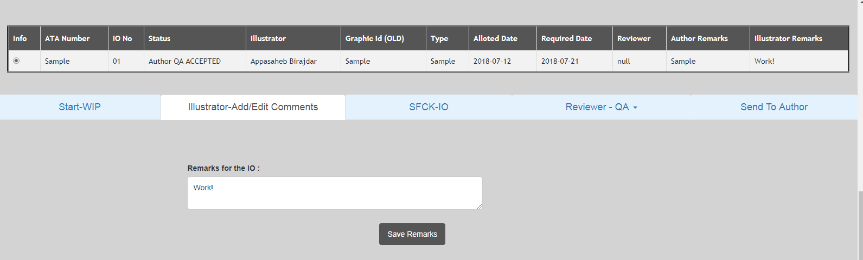

The Illustrator can input his/her remarks here. The remarks will be visible to everyone but only Author will be able to change it.

### SFCK- IO

Once again this tab will only be accessible only by Illustrator. The Illustrator can do SFCK here and IO status will get updated accordingly.

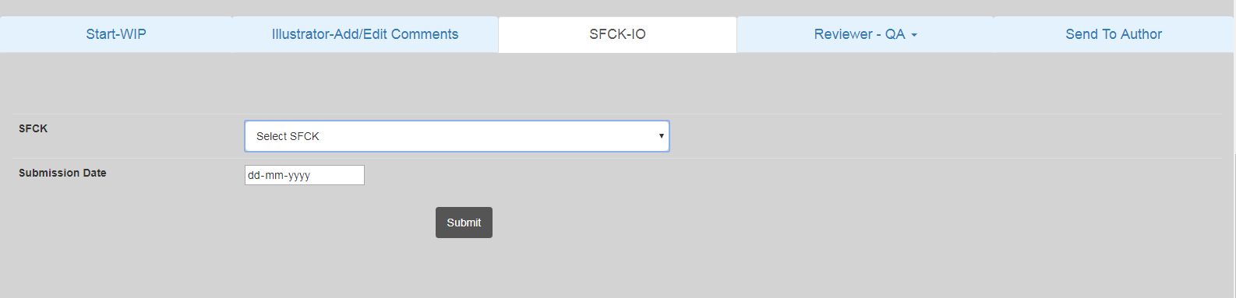

The user can select the type of SFCK he wants to perform the respective IO from the dropdown menu.

### Reviewer-QA

The Illustration Reviewer from here can Add, Edit, Delete, Calculate Score, and Submit a Review. All these option will be accessible through a dropdown menu.

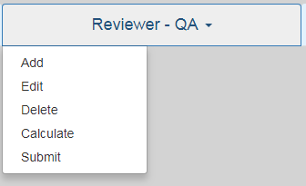

* **Add -** Reviewer will click thisto fill the Error Code, Error Description, Quantity, Review Start Date and Review Completion Date.

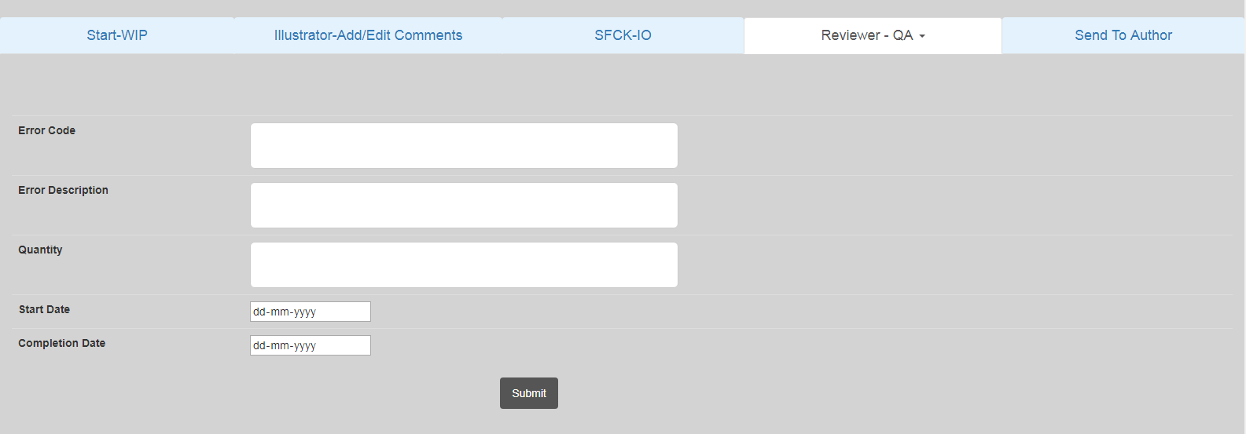

* **All the following Illustration Reviewer- QA Button in work in similar way it works for WO Reviewer QA.**
* **Edit –** Reviewer will be able to edit any error that he has filled. He can edit any error code by selecting the respective Error Code Button.
* **Delete -** The reviewer can use this button to delete a Wrongly Entered Error Code. The display will be same as Edit Button and reviewer will select the Radio Button corresponding to the Error Code and select delete to delete that respective Error Code.

**Calculate -** Any-one can use this button. This will allow the user to calculate the score of a particular Review.The user needs to select the respective Review Type for the respective WO and the click the calculate button to Calculate the score.

* **Submit –** This will allow the Reviewer to close the review or submit the review. The Reviewer will select the review and then click the Submit button to submit it. This will automatically add the current system date to the review Completion Date.

### Author – QA

Only Author will have access to this button. Author can add any comment/error for IO and he can also directly accept the IO.

* **Enter/Comment Error-** Author can add his/her errors for a specific IO.

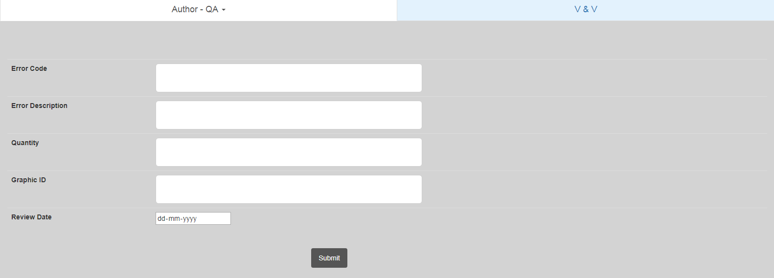

**Accept-** Author will click **“ACCEPTED”** button. This action will auto update current date. The IO status will change to **“ACCEPTED”**.

### Send to Author

Illustrator will click this button to send the illustration order to the author. Clicking this button will open up a date field. The illustrator can fill in the details and send it to Author.

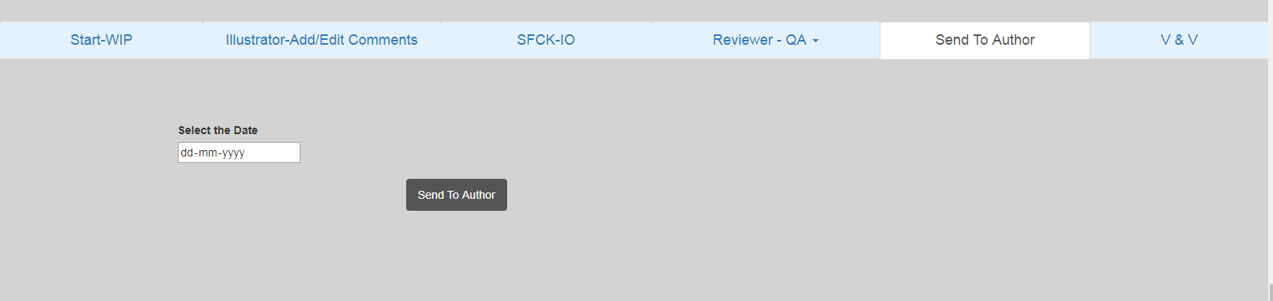

### V&V

This **“V&V”** tab will show verification and validation report in details. Once this tab is clicked, a report will appear as below:

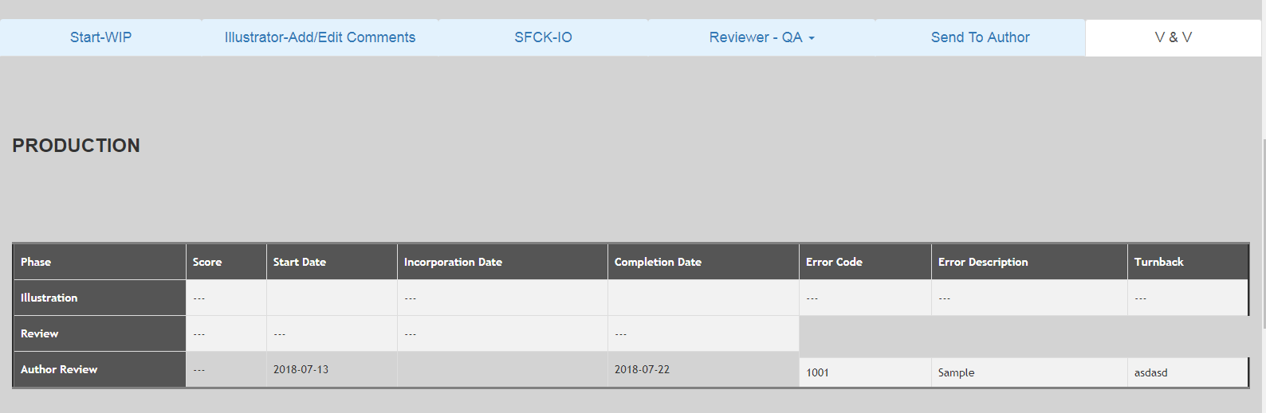

## Report

The report tab will have a drop down menu which will contain two options –

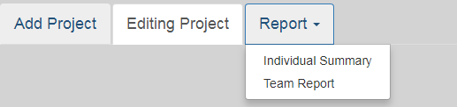

* **Individual Summary –** It will show all the data according to the unique Employee ID which is being input during the login time. It will show all the Projects, Work Orders and Illustration Order related to one’s Employee’s ID.

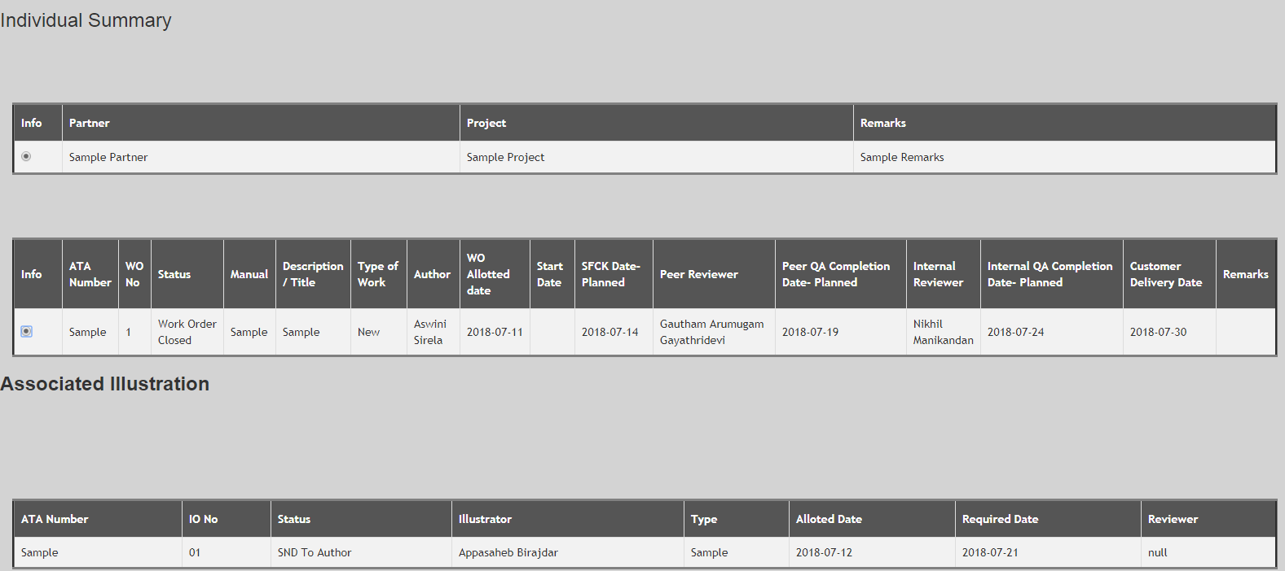

* **Team Report –** It will show all the all the Projects, Work Orders and Illustration Orders which are in the added.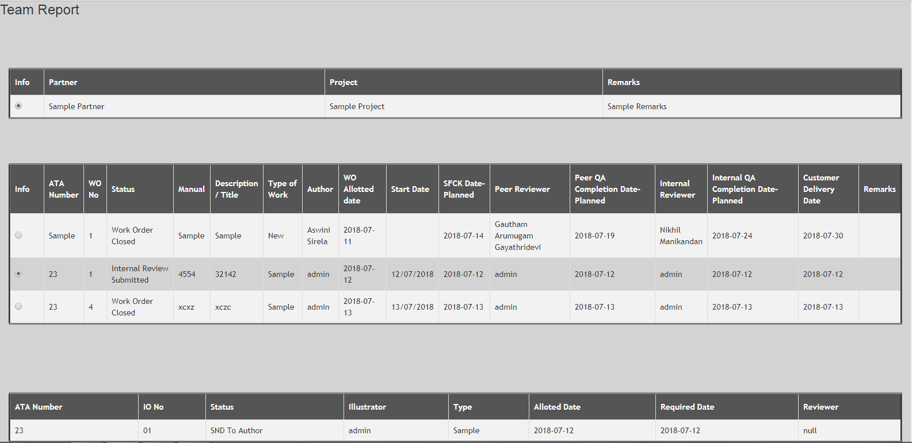

# References

* EINQ-OOOO-QMTPT-0000v1.0_Tas Tracker Tool Requirements_Document.docx
* [www.google.com](http://www.google.com)

# Limitation

Please run this tool in Google Chrome as some requirements and features are not supported in Internet Explorer.