Rice

**Predicted values (2002-2011)**

54.89177555 87.47433749 101.53517844 92.92986156 86.83863493

89.02776194 49.27309226 94.43767704 83.37225051 81.73665818

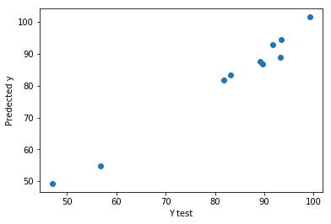

Maize

**Predicted values (2002-2011)**

6.42641242 19.29407801 19.5995304 16.59728597 11.08928041 11.96834095

6.76839498 18.04310833 15.57069458 10.79174357

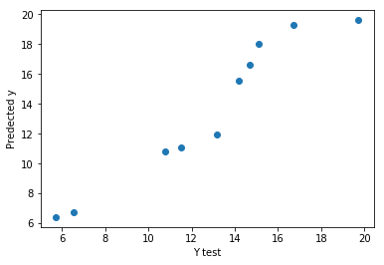

#Gram

**Predicted values (2002-2011)**

3.52899004 6.47621313 6.07607363 5.94285595 4.73813134 5.13401161

4.75251554 6.32827397 5.45631424 4.97714097

