A project report on

**MediHome (Online Medical Consultation)**



**CENTRE FOR DEVELOPMENT OF ADVANCED COMPUTING**

**KNOWLEDGE PARK, BANGALORE**

**UNDER THE SUPERVISION OF**

**Srinivas P. Vasu**

**C-DAC Bangalore**

**Submitted By:**

**ISHITAA KULSHRESTHA 200250120033**

**KIRTI 200250120041**

**RITESH KUMAR DUBEY 200250120079**

**SAURABH KUMAR 200250120089**

**VISHAL SINGH 200250120109**

**PG DIPLOMA IN ADVANCED COMPUTING**

**C-DAC, BANGALORE**

**CANDIDATE’S DECLARATION**

We hereby certify that the work being presented in the report entitled **MediHome (Online Medical Consultation)**, in the partial fulfilment of the requirement for the award of **PG-DAC** and submitted in the department of **DAC** of the C-DAC Bangalore, is an authentic record of our work carried out during the period 18th November 2020 – 28th January 2021 under the supervision of **Mr Srinivas P. Vasu and Mr. Shanmuganathan** C-DAC Bangalore.

The matter presented in the report has not been submitted by me for the award of any degree of this or any other Institute/University.

(**Name** **and** **Signature** **of** **Candidates**)

Ishitaa Kulshrestha 200250120033

Kirti 200250120041

Ritesh Kumar Dubey 200250120079

Saurabh Kumar 200250120089

Vishal Singh 200250120109

**ACKNOWLEDGMENT**

We take this opportunity to express our gratitude to all those people who have been directly and indirectly with us during the completion of this project.

My sincere gratitude to my Supervisor Mr. Debashish Das for guiding me throughout the planning and development phase of the system. Without his strategic guideline and counselling I would not have reached the final stage of the development. I would like to thank **Mr Srinivas P. Vasu** and **Mr. Shanmuganathan** for briefing the student regarding the Project. **Mr Srinivas P. Vasu and Mr. Shanmuganathan** sincere guidance and always cooperating nature has provided us with proper knowledge and directions on how to prepare for the final documentation.

We acknowledge here out debt to those who contributed significantly to one or more steps. We take full responsibility for any remaining sins of omission and commission.

**Student Name PRN**

Ishitaa Kulshrestha 200250120033

Kirti 200250120041

Ritesh Kumar Dubey 200250120079

Saurabh Kumar 200250120089

Vishal Singh 200250120109

**ABSTRACT**

Medihome is a web-based API which introduces a scheme where patients can avoid wasting time in a hospital and ensure proper treatment by diagnosing the problem in advance. The project aims to bring comprehensive and integrated healthcare right to our homes.

MediHome aims to end the contemporary method of health care delivery system and reinforce the family doctor concept. Moreover, recover the trust and relationship between doctors and family; create a health-conscious society and make people live as healthy as possible lifelong.

To achieve this, we provide complete medical services from consulting doctors to pharmacy. We provide preventive check-ups by doctors in the comfort of one’s home hereby avoiding the hazards and hassles of hospital visits. Our specially trained staffs are well equipped to provide the finest care to our clients.

The purpose of the project is to build application program to reduce the manual work for managing the doctor, appointment, doctor’s fees, patient. It tracks all the details about the patient,booking,doctor schedule.

1. **INTRODUCTION**

Appointment scheduling has become a complex task especially for healthcare professionals in hospitals and clinics. Few reasons that could cause these complications range from a heavy flow of patient traffic to a physician that practices in a number of clinic and moves from one medical facility to others. An ineffective appointment management could also cause overlapping appointments, rise in number of no-shows, patient dissatisfaction in general and revenue loss for healthcare institutions.

In recent days, many medical institutions use a combination of phone-based scheduling and computerized appointment scheduling. Even though this combo along with out-sourcing services make a better efficient system, few gaps for technical and human error still remains. This online facility is an effective add-on to any hospital or clinic’s website. It lightens the hard work associated with managing a medical facility. More time on hand to commit to patient care, better patient compliance and fiscal viability are other rewards.

The key mission of an efficient online patient scheduling is to reflect patient satisfaction and revenue gains. An active appointment scheduling a bridge that connects efficient healthcare services and timely access to the services. The proposed Online medical system aims to even out workflow and reduce the thronging of people in waiting rooms.

Any medical centre that handles patients’ scores and healthcare responsibilities are at risk of wasting too much time and money on patient scheduling. In comparison to paper-based appointment scheduling, web-based patient scheduling is faster that allows multiple user access at any given time. Web-based appointment scheduling enables to generate appointment reports and email appointment reminders and minimizes no-shows.

* 1. Purpose

The software product is a standalone system and not a part of a larger system. All the forms used in the product follows a clear and logical structure. Errors will be minimized through the use of drop-down buttons and command buttons to eliminate the excessive use of text input. Management of data includes searching, adding, modifying and deleting. The minimum required version of the operating system is Windows XP and any subsequent version of Windows will be compatible with the system. It does not also require any new hardware to function.

* 1. **Problem Context**

Online Patient Scheduling also commonly known as Online Appointment booking system an optimized phase of medial healthcare service to improve patient healthcare journey in hospitals and clinics. Motivated by the rising popularity of electronic appointment booking system, this project aims to develop an appointment-scheduling model that takes into account the patient preferences regarding when they would like to be seen. Currently, it is rational to establish the fact that, very few hospitals provide online scheduling doctor-patient session. In fact, majority of the medical centres provide traditional patient scheduling routines. In traditional appointment scheduling process, patients are scheduled for a future appointment time and the number of patients granted an appointment has an upper limit each time period.

* 1. **Rationale**

When on Online Patient Scheduling System is replaced with traditional appointment reservation service, patients are the prime benefit holders. Hospitals and medical centres would definitely have a better appointment management process as well as sophisticated control over doctors’ schedule and employee productivity. The advantages will be time saving for both patients and doctors and much convenient for the administrative staffs to manage all the appointments and paper work. Online appointment scheduling would reduce the workload of the administrative staff and provide much better customer satisfaction.

* 1. **Potential Benefits**

Online Patient Scheduling has its tangible and intangible benefits to both users who would book appointments and the hospital management including doctors and staffs.

**Flexibility**: Online scheduling features advanced functionalities that are automated and improve the appointment reservation process and provide customers a simple healthcare flow. For example, time-saving.

**Security**: Maintains patient confidentiality and provide information protection. For example, protected health information is not shared or discussed within even hearing distance of other patients.

**Connectivity**: Keeps organizations better connected with their customers and patients. By staying connected with their customers, institutions get a better view of their management process. For examples, reviewing and rating doctor-patient experience flow that helps the hospital management to overview doctors’ average performance.

* 1. **Scope and Objectives**

Patient growth certainly is beneficial for healthcare business but it also creates challenges for facility admins and staff. Procedures that were previously adequate may no longer be effective in handling a rise in new patients. The appointment process especially in large organizations is challenging. It is often burdensome task that requires significant time and staff resources to manage. The proposed patient scheduling system replaces traditional booking chaos with online facility in addition with automated e-mail and text message reminders. Patient scheduling system allows the users the power to book their own appointments with respective doctors online that benefits organizations to manage a tremendous amount of time that would otherwise have been spent answering phone, responding to e-mails and voice messages. This online platform improves flexibility of healthcare service with customized reporting and security features.

**1.5.1 Aims**

The aim of patient scheduling service is to provide patients full access to manage their hospital appointments which, facilitates with an online service for appointment reservation, management minimizing customer inconvenience and assuring a better healthcare.

**1.5.2 Objectives**

• To develop a system that allows users to have control over their appointment making

service.

• To facilitate the patients with real time healthcare scheduling.

• To manage staff resources needed for managing appointments.

• To maximize operation hours.

• To make the use of online platform for less customer inconvenience and high productivity among staff.

• To optimize time savings and monetary savings as both staff time and services translate into expenses and revenue.

**Definitions, Acronyms, and abbreviations Acronyms**

**C-DAC** Centre for Development of Advanced Computing

**SRS** Software Requirement Specifications

**HTML** Hypertext Mark-up Language

**CSS** Cascading Style Sheets

1. **REQUIREMENT ANALYSIS**
   1. **Hardware Requirements**

|  |  |
| --- | --- |
| **Number** | **Description** |
| 1 | CPU 2.0 GHz or CPU (laptops) Core 2 |
| 2 | CPU (desktops) RAM 2 GB RAM |
| 3 | RPM6 GB or at least 10% free space (whichever is greater). |

* 1. **Software Requirements**

|  |  |  |
| --- | --- | --- |
| **Number** | **Description** | **Type** |
| 1 | Operating System | Windows XP / Windows |
| 2 | Frontend | Bootstrap 3, HTML 5, CSS 3 and Angular 10 |
| 3 | Backend | NodeJS (JavaScript, Express.JS) |
| 4 | Database | MySQL |
| 5 | IDE | Visual Studio Code |
| 6 | Browser | Google Chrome |

**Database:**

**Microsoft SQL Server:**

The developer has chosen Microsoft SQL as the Database Management System environment. Microsoft SQL Server is a rational DBMS. One of the major reasons for choosing Microsoft SQL Server is that, the system is scalable. SQL Server features built-in automated back-up and recovery tools that protects information in case of a system failure

**Operating System:**

**Windows 10:**

The developer would choose Windows 10 as the operating system platform for the development and implementation of the Online medical consultation system. The key reason to run the program on Windows 10 is that, the OS provides Universal Application platform. Thus, less codes to write for the developer and the program runs on multiple platforms.

**Web Browser:**

Web browser is a media of displaying information on the computer by interpreting the Hypertext Mark-up Language. The developer would be using Google Chrome browser to implement the Online Patient Scheduling System.

**Google Chrome:**

An open-sources web browser designed for modern day internet users that offers a simple user interface. One of the important characteristics of Chrome is its multi-process architecture.

**Angular(V10):**

AngularJS is a toolset for building the framework most suited to your application development. It is fully extensible and works well with other libraries. Every feature can be modified or replaced to suit your unique development workflow and feature needs. It lets you extend HTML vocabulary for your application. The resulting environment is extraordinarily expressive, readable, and quick to develop.

**NodeJS:**

Node.js is an open-source, cross-platform, back-end JavaScript runtime environment that runs on the Chrome V8 engine and executes JavaScript code outside a web browser. Node.js lets developers use JavaScript to write command line tools and for server-side scripting—running scripts server-side to produce dynamic web page content before the page is sent to the user's web browser.

1. **REQUIREMENT SPECIFICATION**
   1. **Consultation Process Modelling**

Consultation process modelling is a part where all the process of the system can be shown. So we have made a model that has fully working flow of the full management system. Here is the figure which shows the business process modelling of the system:

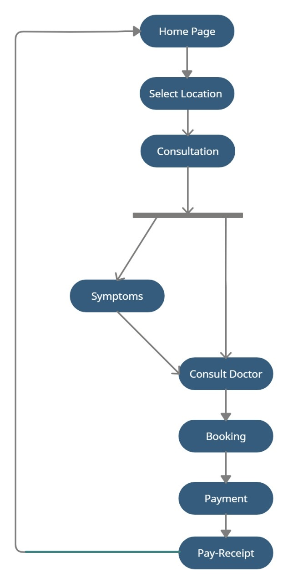

**FIGURE: Business Process Modelling**

In this model we have tried to show the full system working procedure of user, starting from selecting the location and getting appointment date fixed and lastly getting payment receipt. On the other hand, it has also showed the relationship that showed with dotted line. Which give complete statement of the process how the action is working with the steps?

**3.2 Diagram and Description**

Flow diagram represents all the actors whose are related to the system and then show them how they can participate to the system. Here is the figure which will show the flow diagram of the online medical consultation (Medihome) with relations among tasks:

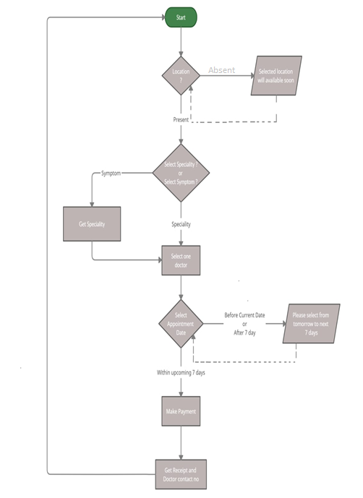

**Figure: Flow Diagram of System**

1. **USE CASE MODELLING AND DESCRIPTION**
   1. **User Model:**

In the case diagram represent the patient who are related to the system and then show them how they can participate with the system. Here is the figure which will show the use case diagram of the online medical consultation (Medihome) for patient with relations among tasks. It shows all the functionalities that is provided to the patient like, they can select location, select symptoms or speciality and based on above details they can select doctor of their choice from the given list. These are the main functions of user apart from surfing the website.

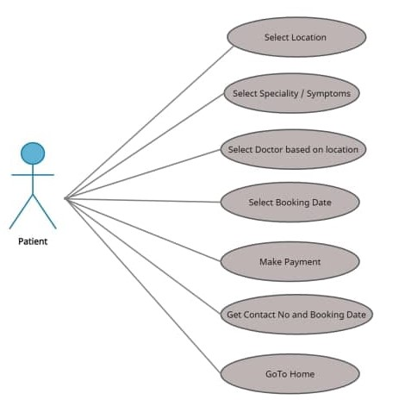

**Figure: Patient Use Case**

1. **DATABASE SCHEMA**

A database schema is the skeleton structure that represents the logical view of the entire database. It defines how the data is organized and how the relations among them are associated. It formulates all the constraints that are to be applied on the data. The term "schema" refers to the organization of data as a blueprint of how the database is constructed.

This figure will show the UML diagram for this event management system:

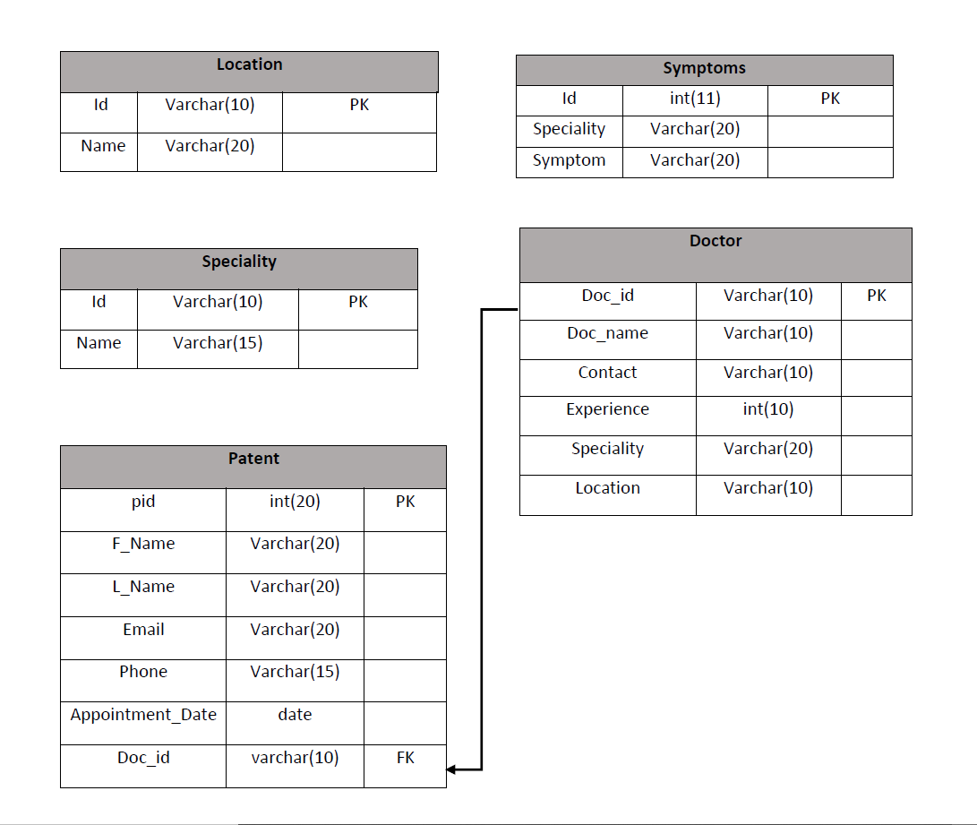

**Figure: System schema**

1. **SYSTEM FLOW**

Home will be the default page of the website and will have some options. i.e., (‘Home’, ‘Locations’, ‘About us’, options for the Users.)

The main roles in the website that can register to avail access to the services are User.

### Client will select their preferred location and speciality.

* If location selected by the client does not have any doctors list to be displayed a message will be prompted stating “Selected Location will be available soon”.

#### Client can also select multiple symptoms in place of speciality.

### Location and speciality will be matched with the database.

### The client will be redirected to respective doctor’s page.

### After selecting doctor from doctor’s page, client can book an appointment but selected date should be within next seven days.

### Client will pay the consultation fee and get receipt.

### If client wants, they can redirect themselves to home page.

1. **FLOW OF EXECUTION OF PROJECT**

The proposed Online medical consultation is developed using Hypertext Mark-up Language (HTML 5), Bootstrap 4, Cascading Style Sheet (CSS3), Angular 10, NodeJS and SQL server 2018.

The relational database is adopted because it is made up of a group of logically connected tables (data that has a relationship to other data).

Therefore, establishing a relational database management system is a great way to increase data integrity, efficiency, ask questions, sort and filter data, provide stronger security, and share information, ease of use, data independent among others.

We follow the three-tier architecture in our project, service and DAO layer is built as a RESTful web service. So basically, it is independent from the presentation layer.

* 1. **Home Screen**

MediHome will be the default page of the website that have some options. i.e., (‘Home’, ‘Locations’, ‘About us’ options for the Users.)

* User can select their preferred location from the given drop down.
* If location selected by the client does not have any doctors list to be displayed a message will be prompted stating “Selected Location will be available soon”.
* If selected location have some doctors, then user will be redirected to consultation page.
* If anybody wants to see the details prospective of the website, they can click on the ‘About us’ section.

**7.2. Consultation**

* Consultation page have two options: Speciality and Symptoms
* User can select either of the two options available.
* If user is sure about their disease type which is matched with one of the given list of Speciality then they can directly select that Speciality and proceed to Consult-Doctor page.
* Else user can select from the given multiple choice of Symptoms and proceed to Symptoms page.

**7.3. Symptoms**

* Selected symptoms from the consultation page, will be displayed inside textarea.
* Now user will click on the button to get their related Speciality which will be displayed on the card.
* After clicking on the card, user will proceed to Consult-Doctor page.

**7.4. Consult-Doctor**

* This page will display the list of doctors based on the selected Location and Speciality.
* User can choose a doctor from the given list and book an appointment for the same.

**7.5. Booking**

* User need to choose an appointment date within next seven days .
* Click on “Proceed To Pay” button that will redirect to Payment page.

**7.6. Payment**

* In this page, user need to fill their personal as well as card details there.
* User’s personal details will get inserted into the database.
* Click on “Confirm Payment” button that will redirect to Pay-Receipt page

**7.7. Pay-Receipt**

* This page will display that appointment is booked with the selected Doctor on the selected Date.
* And give Doctor’s Contact Number to the user to interact.
* Return to Home Page.

**7.8. About Us**

* This page tells the objective of this website.
* And details of our Team Member.

**8 TEST CASES**

**8.1Test Case 1**

|  |  |  |  |  |  |  |
| --- | --- | --- | --- | --- | --- | --- |
| **Test case id** | **Test Scenario** | **Test Steps** | **Test Data** | **Expected results** | **Actual results** | **Pass/Fail** |
| TCID 1 | Check location  if it is valid or not | 1. Go to site  2. Go to location drop down  3.Select your location. | Location: Delhi | The user will navigate to consultation page along with selected location | As expected | pass |

**8.2 Test Case 2**

|  |  |  |  |  |  |  |
| --- | --- | --- | --- | --- | --- | --- |
| **Test case id** | **Test Scenario** | **Test Steps** | **Test Data** | **Expected results** | **Actual results** | **Pass/Fail** |
| TCID 2 | Check location  if it is valid or not | 1. Go to site  2. Go to location drop down  3.Select your location. | Location: Assam | The user will navigate to consultation page along with selected location | Selected location will come soon | fail |

**8.3 Test Case 3**

|  |  |  |  |  |  |  |
| --- | --- | --- | --- | --- | --- | --- |
| **Test case id** | **Test Scenario** | **Test Steps** | **Test Data** | **Expected results** | **Actual results** | **Pass/Fail** |
| TCID 3 | Check appointment date | 1.Go to site  2.Navigate to Booking page  3.Select convenient date from calendar.  4.Click on “proceed to pay” button | Date: If Selected date is in between tomorrow up to next seven days | User can navigate to payment page with selected date | As expected | pass |

**8.4 Test Case 4**

|  |  |  |  |  |  |  |
| --- | --- | --- | --- | --- | --- | --- |
| **Test case id** | **Test Scenario** | **Test Steps** | **Test Data** | **Expected results** | **Actual results** | **Pass/Fail** |
| TCID 4 | Check appointment date | 1.Go to site  2.Navigate to Booking page  3.Select convenient date from calendar.  4.Click on “proceed to pay” button | Date: If Selected date is: “before the current date or after seven days”. | User can navigate to payment page with selected date | “Please select Date interval from tomorrow up to 7 days” | fail |

1. **OUTPUT SCREEN**

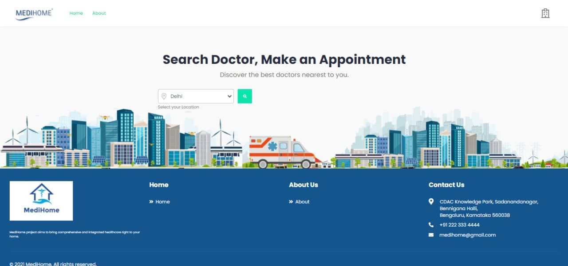

**Home Page (MediHome)**

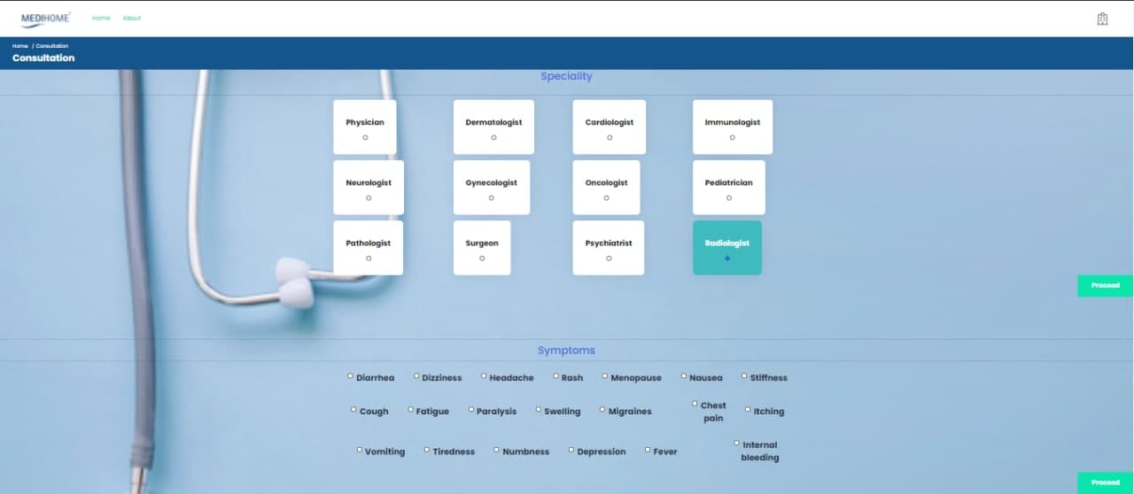

**Consultation Page (Speciality)**

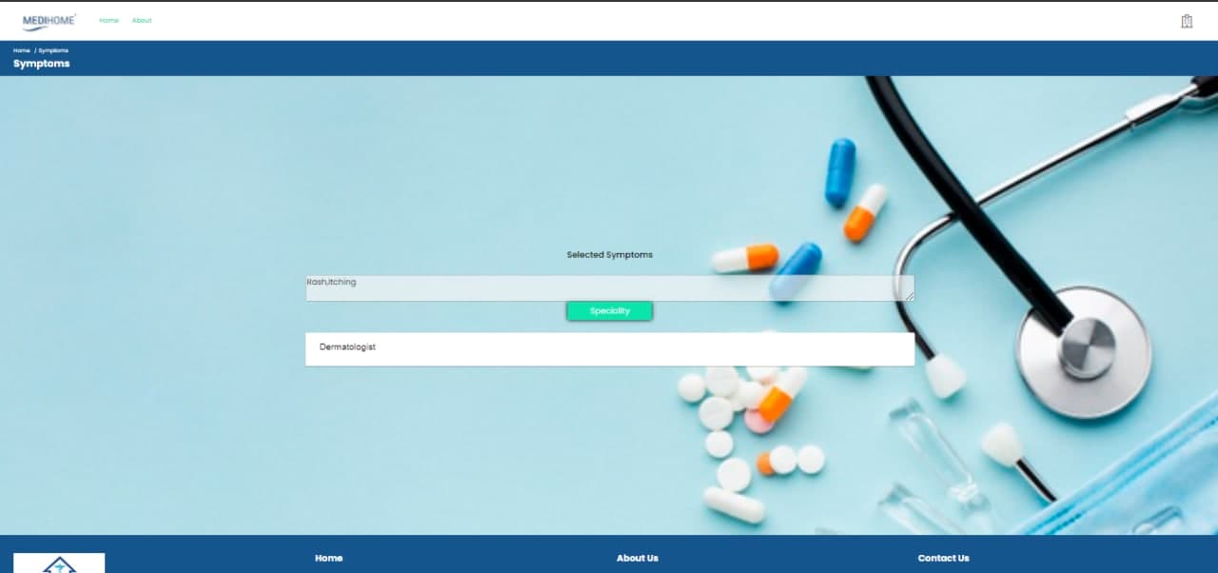

**Symptoms Page**

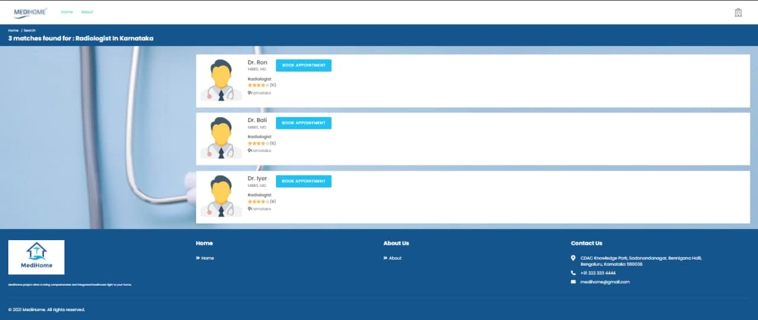

**Consult Doctor Page**

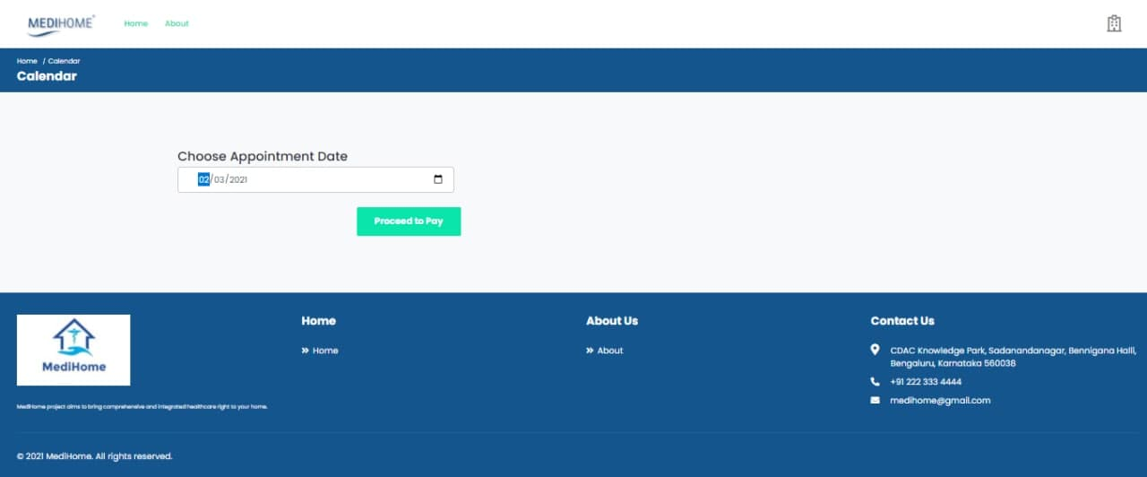

**Booking Appointment Page**

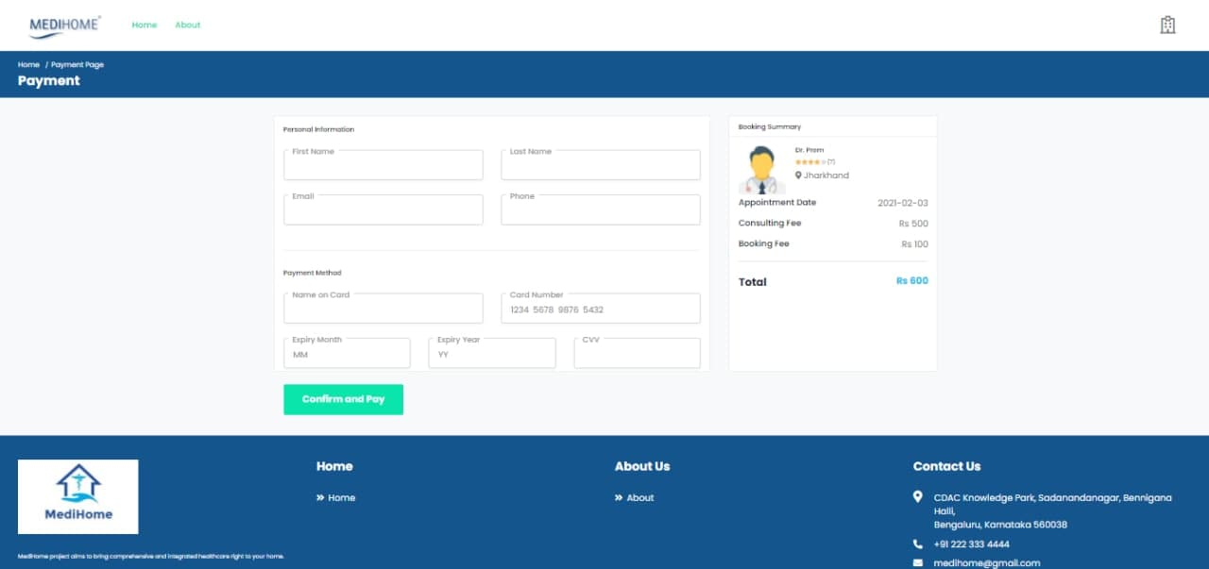

**Payment Page**

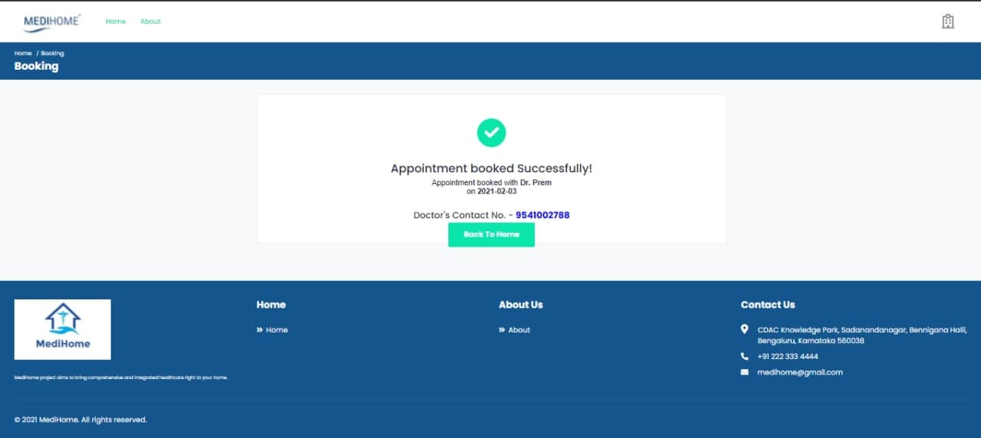

**Payment Receipt Page**

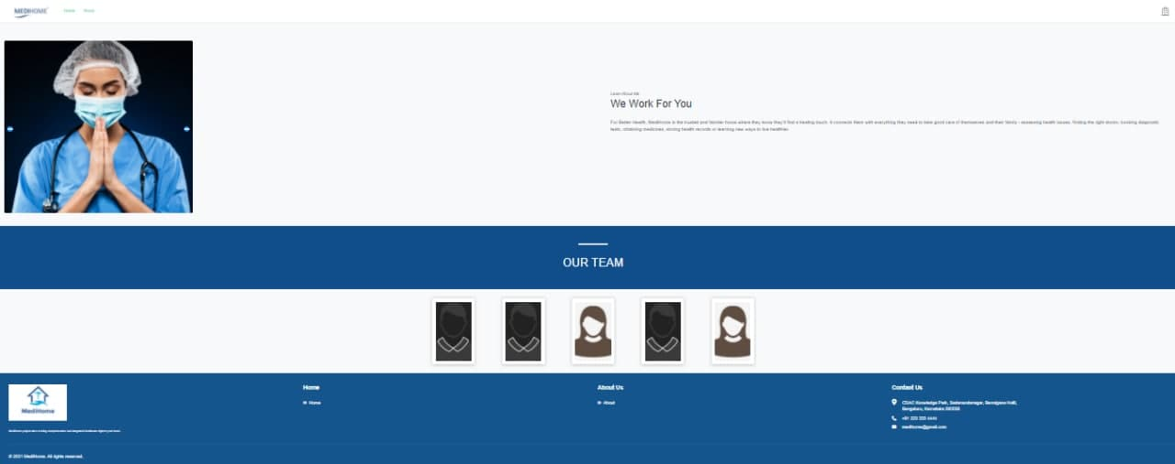

**About Us**

1. **OVERALL PRODUCTIVITY ACHIEVED** 
   1. **Completion**

We have completed our project 100%. We have met all the functional requirements that we discussed.

* 1. **Accuracy**

Our project is working 100% accurate. It fulfils all the functional and non-functional requirements as we promised.

* 1. **Correctness**

As we have tested all the requirements and made their test cases mentioned and clear all the mistakes so now our project is 100% correct.

1. **ESTIMATED AND ACTUAL START AND END DATES OF THE PROJECT**

Estimated time for ending the project was third week of January 2021

Start date: - 30 November 2020

End date: - 24 January 2020

1. **CONCLUSION**

One of the prime reasons that Online Medical Consultation system is gaining popularity in recent days is that, the system provides an easier for receiving healthcare facilities to the general users.

The paper has proposed an Online Medical Consultation system built on the Web Service architecture. The Web Service architecture would provide an appropriate paradigm for developing this integrated healthcare system. The prototype of the system would provide the feasibility of the proposed architecture. This case study also provides a preliminary research on the consumers ‘acceptance and the functionality of each unit.

The system integrates technology of Angular (10) and NodeJS development environment. This combination of the two technologies have been used as an experimental teaching technique in the Hospital Information System field for years. The system is designed to achieve maximum user satisfactory. Since the functionality of online credit card payment is too complex for the developer to implement, only stimulation of the online transaction would be implemented. As the project evaluated, each step of the development process met the system’s objectives and primary user requirements. Certain enhancements could be suggested for the system in future are to integrate actual online payment transaction, SMS integrated and implementing Artificial Intelligence features that could make this Online Patient Scheduling system an automated intelligence clinic management.