JOE BIDEN

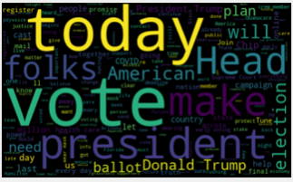

Word Cloud

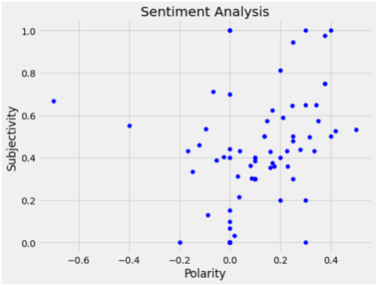

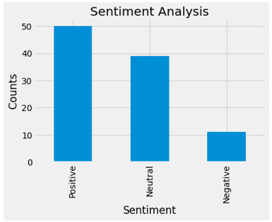

Bar Plot

From these illustrations, Joe Biden out of his 100 recent tweets, 50 of them are positive, 11 are negative and the rest are neutral. So, we can say that Joe Biden is barely making a relevance in the upcoming election