Arduino.Beginners Workshop

Arduino / Atmel:
https://www.arduino.cc
http://www.microchip.com/wwwproducts/en/ATmega32u4

IDE (Web, Mac, Linux, Win 32/64/PortableApp) / China CH340 Drivers:
https://www.arduino.cc/en/Main/Software
https://www.arduino.cc/en/Guide/HomePage
http://www.wch.cn/download/CH341SER_MAC_ZIP.html

Tutorials / Sketches / Libraries / C++:
https://www.arduino.cc/en/Tutorial/HomePage
https://www.arduino.cc/reference/en/
https://www.arduino.cc/en/Tutorial/LibraryExamples
https://www.arduino.cc/en/Reference/Libraries
https://www.programiz.com/cpp-programming/examples
http://www.studytonight.com/cpp/basics-of-cpp.php

Books (1 iTunes, 3 Kindle):
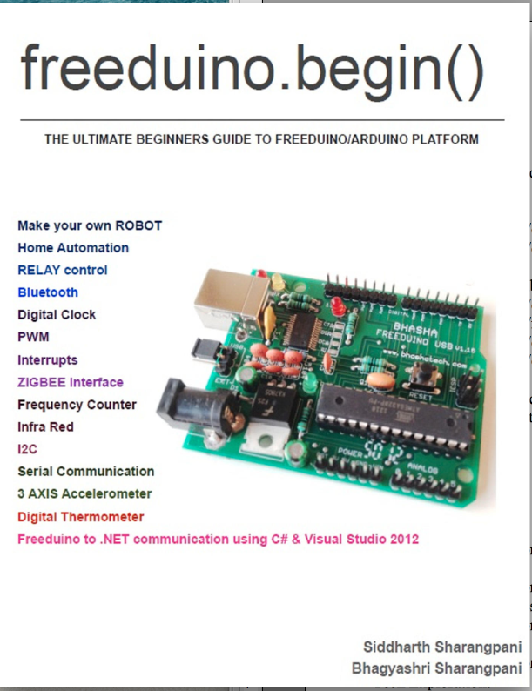
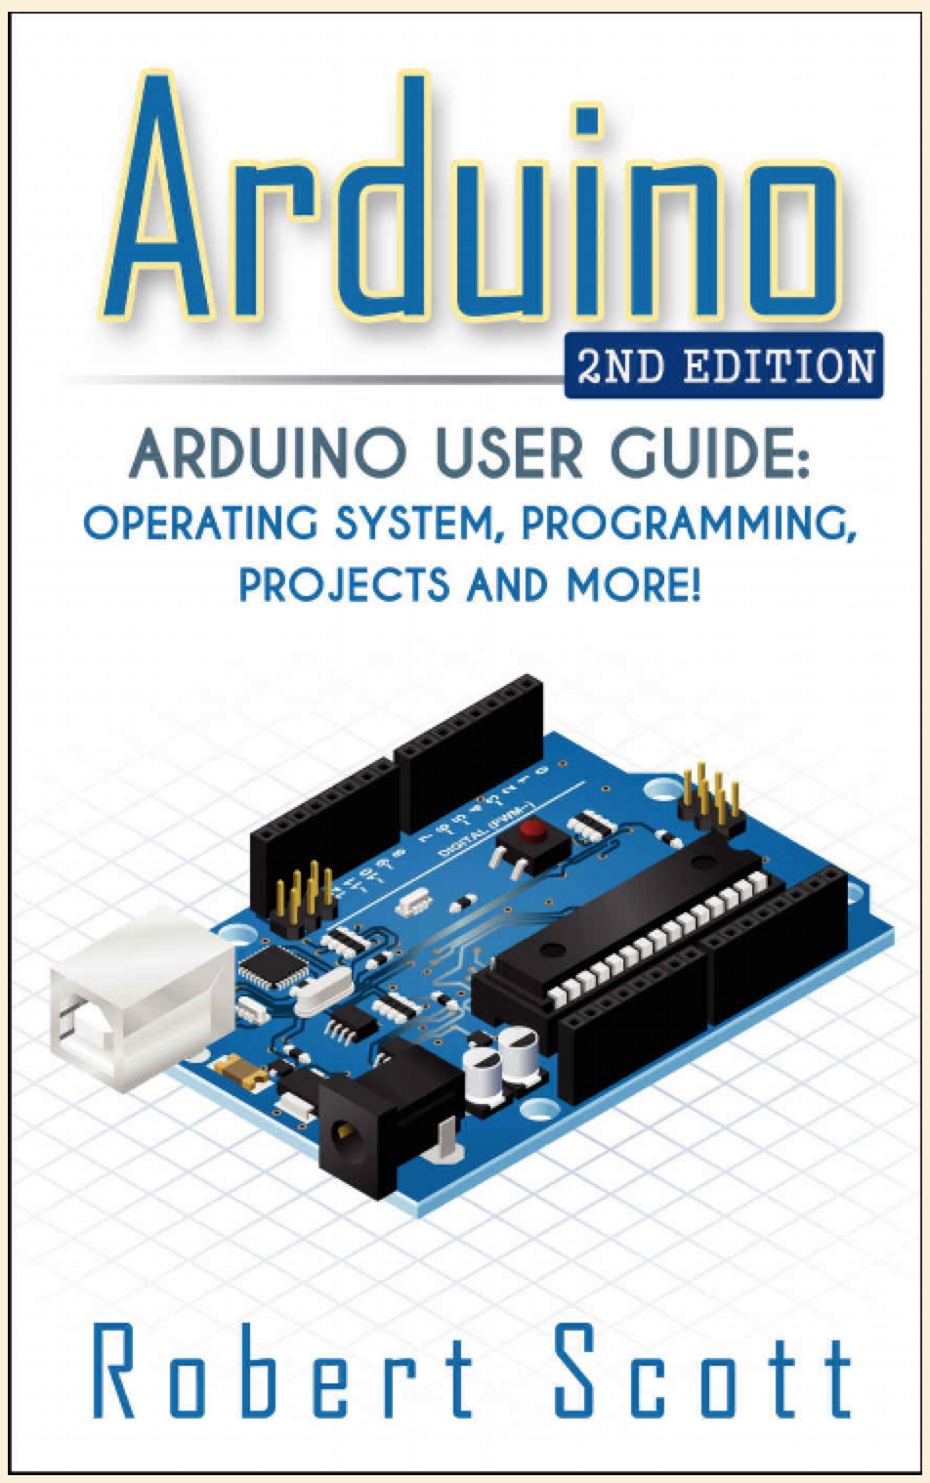
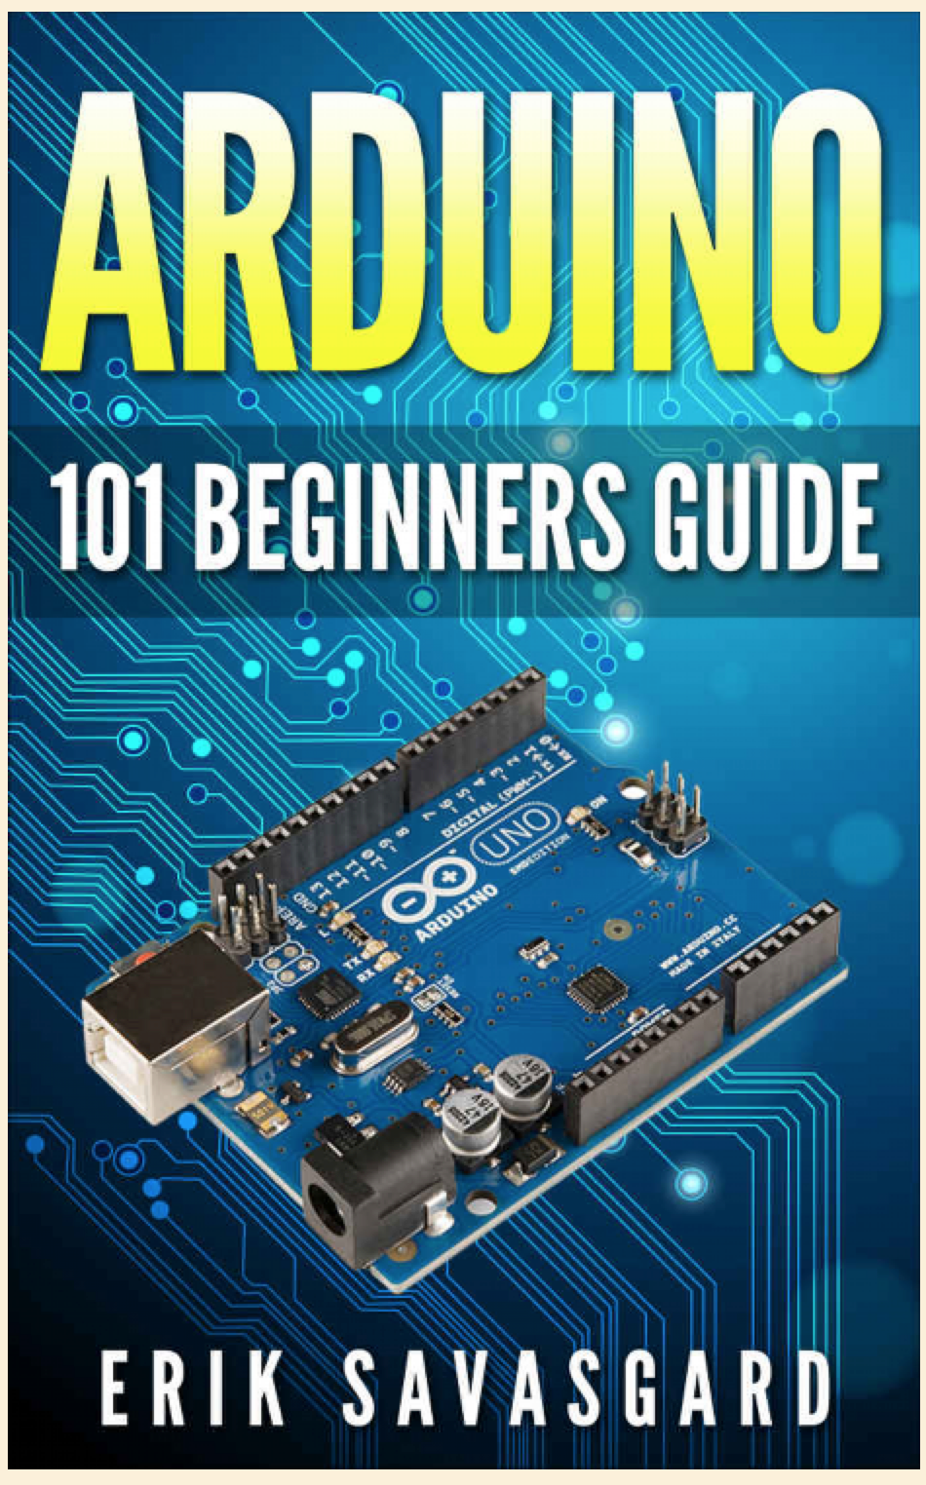
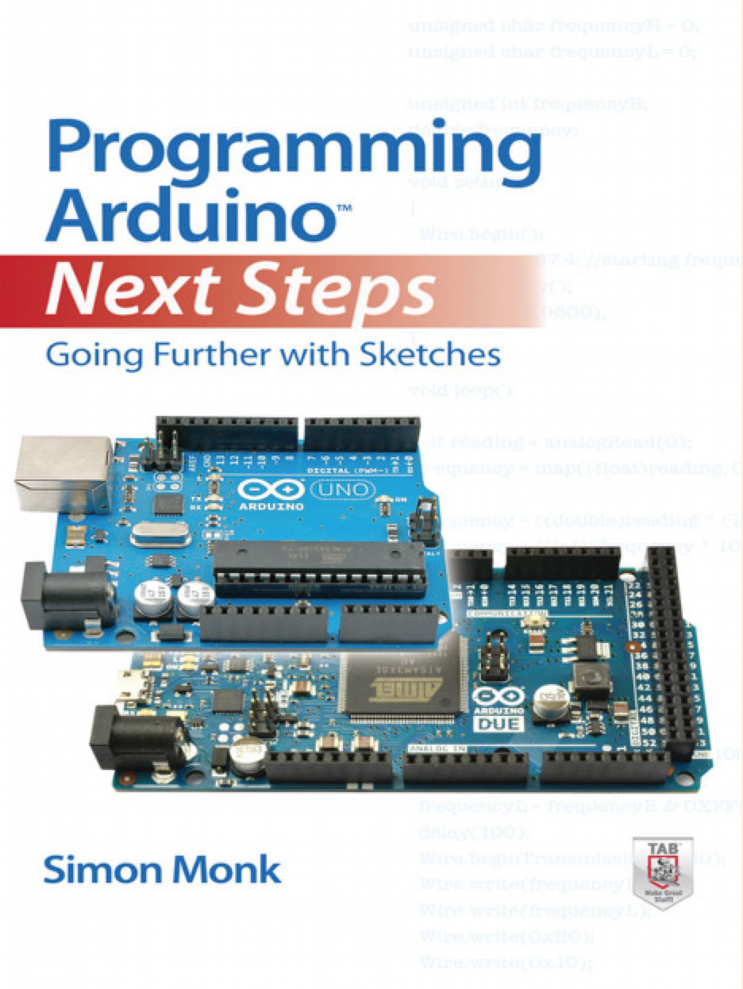
... further books as PDF attached ...

Shops
https://www.aliexpress.com
https://www.banggood.com
https://www.boxtec.ch
https://www.play-zone.ch
https://www.adafruit.com
https://www.dfrobot.com
https://www.roboter-bausatz.de
https://www.conrad.ch
https://conradconnect.de

Youtube
A.Spiess:
https://www.youtube.com/channel/UCu7_D0o48KbfhpEohoP7YSQ
DevChannel:
https://www.youtube.com/channel/UCQQrt6IIF3cKi6OzvvTsmHw
ProgrammingElectronics:
https://www.youtube.com/channel/UCDGAg1pqcy8IScMqHHTy9Gg
J.Blum:
https://www.youtube.com/channel/UC4KXPjmKwPutGjwFZsEXB5g
R.Paz:
https://www.youtube.com/channel/UC7uJBXcRdGlDlKIyr6ZbjBw
Tech Exploration:
https://www.youtube.com/channel/UCWDoV_pvMOBr7ekrZJ7qEbQ
educ8s.tv:
https://www.youtube.com/channel/UCxqx59koIGfGRRGeEm5qzjQ
electrics:
https://www.youtube.com/channel/UCW4TAgZxnC0OxCzlrzs6GGw
B.Easter:
https://www.youtube.com/channel/UCS0N5baNlQWJCUrhCEo8WlA
A.Stukan:
https://www.youtube.com/channel/UC3xgpZk3l047_66oQNow3Aw
GreatScott:
https://www.youtube.com/channel/UC6mIxFTvXkWQVEHPsEdflzQ
J.Ilett:
https://www.youtube.com/channel/UCmHvGf00GDuPYG9DZqQKd9A
Lesson Studio:
https://www.youtube.com/channel/UCjDVZ7PHvbp-G_pkVW-yrqw
Pi4IoT:
https://www.youtube.com/channel/UCxaSH4F6vIWtDKjXxUPcU6Q
ProtoPICVideos:
https://www.youtube.com/channel/UCbY2TD_5xhtALksyOZ4aCqw
T.deCamino:
https://www.youtube.com/channel/UC37oanR3n-pEdaIrIx_VVlw

Github:
https://github.com/ritzeng/Zurich_New_ICT_Technology_Meetup

