CCS
Documentation

Version 1.3, 24. November 2003
Projects: internal
Author: Peter Ritzmann
File: CCSDoc.doc
Status: in progress
Copyright © 2003 by
2i Industrial Informatics GmbH
Wirthstraße 7a
D-79110 Freiburg
Tel. +49 (0) 761 / 45205-0
Fax +49 (0) 761 / 45205-90
E-Mail info@2igmbh.de
www.2igmbh.de

1 Overview 3
2 Data Modelling 6
2.1 Data Abstraction 6
2.2 Data Aggregation 6
2.3 Further Specifications 6
2.4 Data Model 7
2.5 User Functions 7
3 Basic Communication Principles 8
3.1 Sync Communication 8
3.2 The Client Server Interface of a CCS service 8
3.3 Async Communication 9
3.4 Event Channels 9
3.5 Event Objects 10
3.6 Implementation Technology 11
4 CCS Service Functionality 12
4.1 Data Logistic 12
4.2 Job Management 13
4.3 Control Programs 14
4.4 Creation and Management of a Variable Database 14
4.5 Access to Variable Data 14
5 Drivers 15
6 System Abstraction Layer 16
7 CCS Service Configuration 17
8 A Short Tour through CCS Service Functionality 18
8.1 Start Up 18
8.2 A Value in the State of a Device has Changed 18
8.3 A Variable Value is set Through the Sync Interface of CCS 18
9 CCS Client Interfaces 19
9.1 CCS Client Interface for C++ 19
10 CCS Tools 20
10.1 Data Model Designer (CCSDMD) 20
10.2 Data Model Compiler (CCSDMC) 20
10.3 Configuration Editor (CCSCE) 20
11 Glossary 21

Overview
Core Control Services is a software layer that connects abstract device data access to a well defined, simple and reliable service interface that can be used by Visualization systems to manage and access device data as well as internal state data.
CCS is extendable to specific functional requirements by user functions (full ANSI C) and plugins (ANSI C++). User functions and plugins are “free programmable”. CCS enables data abstraction and offers controlling functionality.
A CCS service is a service that runs elsewhere in a TCP/IP network. To fulfil requirements to scalability and performance, a CCS service can also be run within a specific client process.
A CCS service is by design capable to serve multiple clients.
A CCS service is designed for platform independence. A System Abstraction Layer wraps access to system functionality supplied by different operating systems.
The basic model behind a CCS service is that of a process that controls a couple of devices, generating events depending on changes of device state and immediately propagate these events to “interested clients”. Beside the event generation and propagation mechanism a CCS service offers an interface to read and manipulate device and internal state data through a well defined interface.
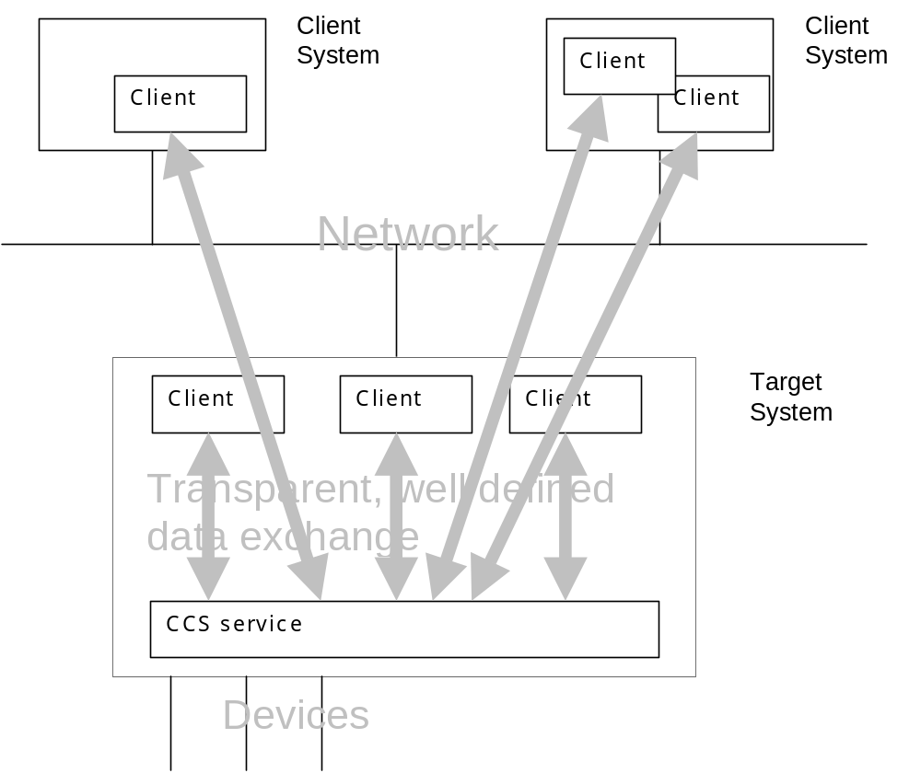

Fig. 1-1 Usage scenario for CCS services

Figure 1-1 shows the flexibility of integrating CCS services into higher software layers. A great benefit is their capability to serve an arbitrary number of clients. This property of CCS service gets into consideration when the view on potential clients leaves the narrow view of an operator station or process control system and is widened to whatever software that is interested in gathering information from the device layer. Using CCS, there is no need for the client software to deal with protocol or hardware specific code.
Interfacing CCS services across process or even network boundaries is transparent to client software. Beneath this transparency the possibility of data modelling together with free programmable, custom specific extendability, CCS offers a powerful base technology for the building of high sophisticated visualization systems.
Here is a list of possible client applications:
- Operator Stations
- Process Control Systems
- Proprietary Host Interfaces (for example OPC, EUROMAP 63). Note ! Meant is the server part of host interfaces. These interfaces act as servers with respect to the host system, but they are implemented as CCS clients.
- Service Interfaces
- Diagnostic Interfaces

Data Modelling
The need to model manufacturing data in a central integral process evolves from the situation that the view to machine data is no more restricted to just one user. This statement addresses both persons and software.
The main part of the modelling process is to put specific properties of data that should be visualized into central control of one instance that decides how machine data should appear to visualization systems. This instance clarifies how machine data will be structured and what data types should be used for presentation.
After this job has been done, a lot of data items designed in the first step must be mapped to specific values located on devices, that are accessible via specific hardware and protocols.

Data Abstraction

Separation of logical and physical views of machine data
The task of data abstraction within CCS is motivated by separating the logical view of a user to device and state data from the physical view on the device level.
The physical view is determined by following aspects:
- A physical protocol to exchange data with a device.
- A data type that is based on device and protocol specific requirements

Data Aggregation
Aggregation of data at the device level is in the same way determined by protocol and device specific conditions. Data abstraction can deliver a common, consistent aggregation of device data that does not depend on device specific aggregation possibilities.
Data aggregation in CCS services is supported by the possibility to model arrays and matrices of data up to 4 dimensions.

Further Specifications
Beside the aspects of exchanging data with devices there are some more aspects of data from the view of an operator station application programmer. Here are some examples:
- Caching (refresh) mechanisms to avoid unnecessary system load. This corresponds to the existence of an event driven interface between a CCS service and potential clients.
- Specifying a logical data storage location to support saving and reloading machine data from and to arbitrary media types.
- Specifying a persistence type to determine the duration of validity of the data.
- Textual description of the data item.
- …

Data Model
The CCS data model is a description of the data that is managed by a CCS service and therefore should be the result of the data modelling process. The data model describes structure and data types of the data that is maintained by the CCS service through a list of structured and typed data items that are called variables consecutively. The data model can be specified using CDDL, a specific language to describe CCS data models. On CCS start up start up the data model is parsed and real variable instantiations are generated by the parsing process including resource allocation and mappings to physical devices. The CCS data model enables an application programmer or a system engineer to describe machine data with respect to the aspects stated in the preceding chapters.

User Functions
Specifying a Data Model includes referencing functions that can be used to add custom specific functionality. This is one way to alter or extend the behaviour of a CCS service.

Data Conversion and Manipulation Functions
To manipulate data on its way from the internal data storage to a device and reverse free programmable Ansi C-functions can be referenced within the variable description. All functions can be used with full parameter support for the base types of CCS. Functions are specified as function references in the CCS data model. The following function classes can be used:
- Conversion functions
Conversion functions are used to convert values from device representation to data representation and reverse. They are associated with the mapping specification of a variable.
- Filter functions
Filter functions are used to map functionality in the form of CCS variables that is not directly associated with a simple non mapped variable. For example the system time can be exported by a filter function that reads and returns the time of the hardware clock when this variable is read.

Basic Communication Principles
Throughout the architecture of a CCS service, two basic communication mechanisms are used. These basic principles are used two implement the client Interface of a CCS service. A CCS service offers two logical interface types:
- Async communication
- Sync communication

Sync Communication
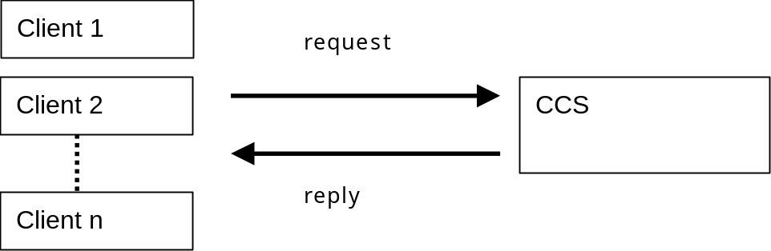
CCS Data Services are the client server interface of a CCS service. If a client needs some information from the CCS service, this information must be requested from the CCS. A response (even an error condition) is delivered synchronous. This mechanism guarantees to get a reply.

The Client Server Interface of a CCS service

Transparent Access to Variables
Using the Data Service interface, transparent access to variables within a network is enabled. This includes getting and setting values of variables. Location of the variable within a network or the mapping of the variable to a physical device must not be known when getting and setting the variable value. This is true for every client that uses the CCS service.

Access to Variable structure and type Information
If there is a need to get information about structure or data type of a variable (for calculation or formatting purposes) variable type and structure information can be queried using the client server interface of a CCS service.

Async Communication
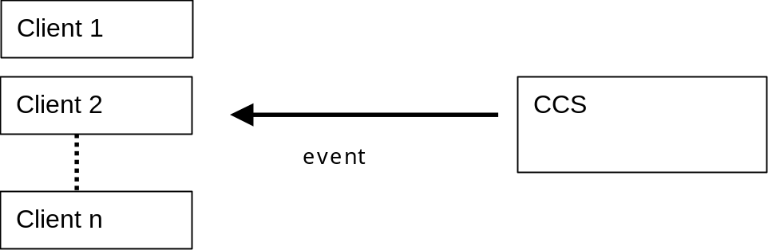
The async communication part can be viewed as a couple of channels that carry information as a sequence of events appearing over time. Events are available as event objects delivered over a specific channel called event channel.
Every interested part of programming code is able to register with the end of an event channel to receive events in the form of event objects. Sources for events in a CCS Service are the device control process, a timer process, a job Management process or a control program. A typical situation is to register for data change notifications of a variable. The deliverance of events is not synchronized with the client. There is no guarantee when or if at all an event is delivered.
In contrast to a simple callback mechanism, the CCS event interface is not coupled directly to a client. This construction avoids the possibility of negative side effects by directly calling client functions. Event delivery can neither delay nor crash CCS service functions.
The async communication interface of a CCS service is based on a more general communication mechanism used throughout a CCS service: Event Channels

Event Channels
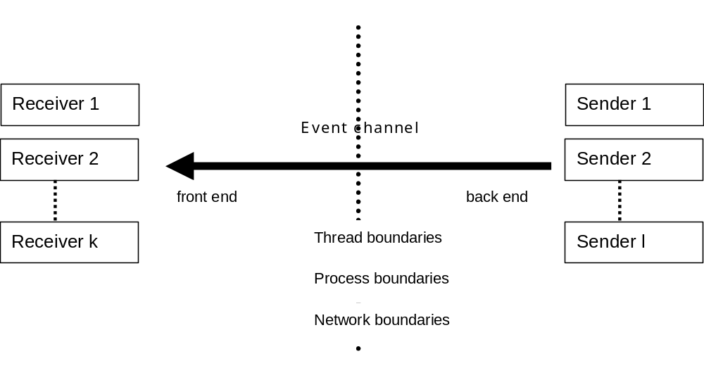
The event channel model must conform to the following requirements:
- An event channel has a front end to send data
- An event channel has a back end to receive data
- An event channel can be used by arbitrary clients to send data (senders)
- An event channel can be used by arbitrary clients to receive (listen to) data (receivers)
- The number of senders is not restricted nor is the number of receivers
- Every event sent by a sender to the front end of the event channel is transmitted to every receiver listening to the back end of the event channel.
Event channels are not restricted to transmit data within processes. As a consequence the CCS system offers different event channel implementations. Event channel implementations that are used within the CCS service are event channels that t propagate events with no time or performance consuming overhead. These event channels are very fast but restricted to in process usage. Receivers and senders can only be threads within the same process. These very fast event channel implementations can be used for the communication between clients and CCS service when the CCS service is housed within the client process.
There are further event channel implementations that offer the opportunity to propagate events across process and even network boundaries.
Actually there are two event channel implementations that are able to cross process and network boundaries based on similar technologies:
- An implementation based on the CORBA event service specification.
- An implementation based on UDP sockets.
The selection of a specific channel implementation can be configured using the CCS service configuration interface.

Event Objects
CCS event channels transmit so called event objects from the event channel back end to the event channel front end. Event objects are serialized (marshalled) into a flat representation in advance to send them to the back end of an event channel. Serialized representations are deserialized (unmarshalled) at the back end of a channel before they are delivered to a receiving (listening) client.
Here is a list of actually available event objects
- Info Object
- State Object
- Alarm Object
- Proxy Object
- Data Change Object
- Job Entry Object

Implementation Technology
To be flexible in interfacing client software technologies of different types the underlying interface technology offered by a CCS service is selectable using the CCS configuration mechanism.
Actually a Socket, a CORBA and a C++ function call interface is offered. Future versions of CCS will implement a DCOM based or a SOAP based service interface as well. Further types of interfaces can be integrated on demand.

CCS Service Functionality
CCS service functionality is organized as a couple of sub processes that serve a specific task. The CCS sub processes are communicating using internal event channels called logistic queues.

Data Logistic
A main task of the CCS service is to control all devices in the process environment. The devices of the process environment are the source of events that are detected by the CCS service and immediately sent to CCS data logistic queues.
Data logistic queues decouple the device control process from other CCS event processing parts (client interfaces, job management, control programs).
CCS controls devices conforming to the data model specification. This process generates events such as data change notifications or alarm events. Generated events are immediately sent to the CCS event logistic queues that prevent the control mechanism from being blocked by time consuming or other blocking operations (suspensions, waiting for other events and similar situations).
Events are finally emitted by CCS to all interested clients over the async CCS interface. A possible Configuration for the sub processes of a CCS service and their connection via logistic queues is shown in Figure 3-1. The logistic queues are depicted with arrows.
Logistic queues are implementations of specific event channels.
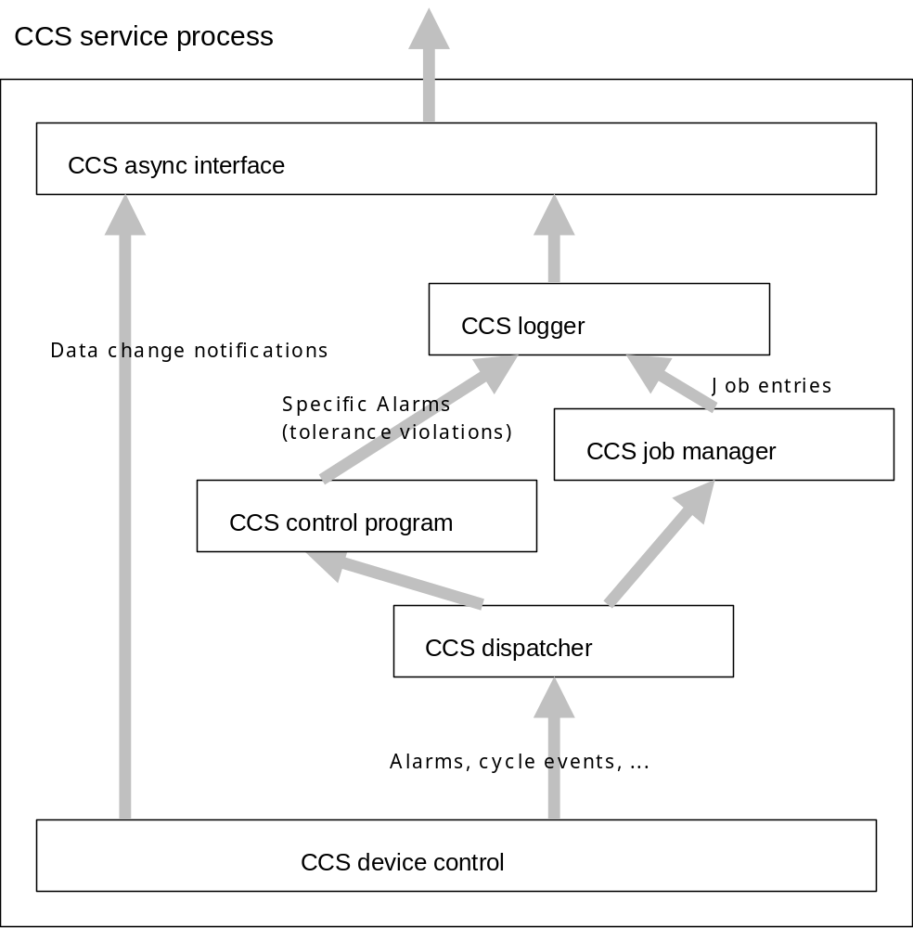
Fig. 3-1 CCS subprocesses and logistic queues

Job Management
CCS offers an interface for job specification that enables higher level software to delegate protocol functionality direct to a CCS service. The basic principle to specify a job is to bind a couple of variable references to an activation constraint (cycle event, timer expiration, alarm event, .. ). The real work is done by the CCS job manager process. The job manager checks for all jobs if the job constraint resolves to true. If so, the values of all referenced variables are read. A job entry object is created and immediately fed into the corresponding logistic queue.

Control Programs
Control programs act on events that are delivered by the device control subprocess or a timer subprocess.
A control program is able to act upon specific events by changing the state of a machine using the variable interface. Control programs can be programmed using pure C++ code over a special plugin or by loading programs that can be specified in a PLC like programming language.
A typical application could be the control of specific variables for tolerance violations.

Creation and Management of a Variable Database
CCS manages different types of memory where the values of different types of variables are stored. For variables with persistence type RAM memory in the system heap is allocated, for variables with persistence type BBRAM memory in battery backup ram of the system is allocated or synchronized.

Access to Variable Data
A CCS service controls access of clients to variables specified in the data model. The data model description determines the circumstances of reading and writing variables (cached, buffered, direct from or to a device, ..).
At this point restrictions to variable access may be specified and controlled by CCS (read access, write access, no access).

Drivers
Drivers are CCS C++ Objects that are used to implement device access.
Every CCS driver inherits from a base class. Abstract base class methods should be re implemented by concrete drivers.
Beside the direct integration of a driver into CCS source code a plugin interface is offered for driver development.
Actually implemented drivers:
- Philips PPCCOM driver full functionality
- MODBUS RTU driver

System Abstraction Layer
The system abstraction layer of CCS is a software layer, that wraps and abstracts the access to underlying operating system services. Thus porting CCS is to a new platform is restricted to port the SAL of CCS.
SAL covers areas such as:
- Threading
- File system and file access
- Messaging
- Shared memory access
- Socket access
- Semaphores, Mutexes

CCS Service Configuration
CCS uses a hierarchical object oriented configuration mechanism that is actually based on configuration descriptions realized on an extension to the “windows ini” file format. Nevertheless the configuration mechanism is not restricted to windows operating systems. The same files can be used also by a CCS service running under the Linux operating system.
CCS configuration addresses static configuration of the CCS service to meet hardware requirements without unnecessary waste of resource like memory. It enables to configure a CCS service with respect to drivers that are used to access devices and interfaces that will be offered to clients.
Another possibility is the configuration of logging and debugging support facilities of a CCS service. Theses facilities span from simple console protocols to socket based logging over a TCP/IP-network or file based logging to local or network file systems. If a CCS service runs on hardware with no writeable file system, no display and no network connection CCS can be configured to direct protocol output to a serial communication line.

A Short Tour through CCS Service Functionality

Start Up
- The CCS configuration is parsed, configured objects like drivers and interfaces are created.
- The CCS data model is parsed and the variable database is created. Variables located in persistent memory areas are synchronized. For volatile variables memory in non persistent memory is allocated and initialised.
- Interfaces are exported, that means they are accessible for interested clients.

A Value in the State of a Device has Changed
Note!: Device data is read conforming to data model descriptions. Device addresses that are assigned to variables with a cyclic refresh specification are reread after the refresh time is expired. Other addresses are read on demand.
- The specific value is read from the device using the corresponding driver.
- The read value is compared to the value last read at this address.
- The value is converted to the data type of the corresponding variable and if a conversion function is referred the value is converted by calling the referenced conversion function.
- The variable is set to the new value.
- If new and old value of the variable are different, a data change notification is generated and immediately propagated to all interested clients.

A Variable Value is set Through the Sync Interface of CCS
- If the variable is mapped to a device address the value will be converted to the desired type and if a conversion function is referred the value is converted calling this function.
- The converted value is set on the device using the corresponding driver and address.
- If the previous step succeeded, the variable is set to the original supplied value (not the converted).
- If new and old value of the variable are different, a data change notification is generated and immediately propagated to all interested clients.

CCS Client Interfaces
A CCS client is every part of software that requests or manipulates information from or in a CCS service in an event driven or sync manner. A CCS client can register with a CCS application to receive events (data change notifications, error conditions, …) or directly read and manipulate data.
The type and technology of a CCS client is not limited to C++ programs or specific visualization technologies. This property is guaranteed by the simplicity and the use of different middleware technologies to realize CCS interfaces.
A Java visualization program is able to use CCS services using the CORBA layer of the CCS interface, a Visual Basic visualization program can also use CCS services using the DCOM layer of the CCS interface. These are two examples for the ease and flexibility of integrating CCS services into existing GUI technologies.

CCS Client Interface for C++

Contexts
A context is a C++ object used to wrap CCS service functionality.

Event Channels
The C++ base class cChannel wraps event channel implementations that meet the requirements stated in 3.4 Event Channels.

Event Objects
The C++ base class cTransientObject is the base class for all C++ event object classes that can be transmitted over an event channel.

Event Channel Adapters
Event channel adapters are C++ classes that can be registered with the back end of an event channel. After registering with the back end of an event channel a specific event method (Object(cTransientObject *)) is called every time an event object is arriving.
All event channel adapters derive from a base class cAdapter that has an abstract method Object(cTransientObject *). Overloaded Object methods in concrete adapter classes handle incoming event objects. A typical implementation of a data channel adapter is an adapter that keeps track of referenced variables in a user interface client. The adapter filters data notification objects checks if the notification object addresses one of the referenced variable and if so refreshes the value of the user interface control that is associated with the variable reference.
The number of adapters registered with the back end of an event channel is not restricted. Adapters are stacked on the back end of an event channel.

CCS Tools

Data Model Designer (CCSDMD)
The CCS Data Model Designer is a tool that can be used to visualize and design CCS data models.

Data Model Compiler (CCSDMC)
The CCS Data Model Compiler checks an existing CCS data model for validity and generates the stubs for the declared Ansi C functions used in a data model (conversion and filter functions).

Configuration Editor (CCSCE)
The CCS Configuration Editor is used to create and maintain CCS service configurations that are part of the specific Operator Station Runtime system.
The data model compiler CCSDMC is fully implemented and functional.
CCSDMD and CCSCE designer and editor are in state of development. Nevertheless there is no problem to use a standard text editor to create data models and configurations.

Glossary
OMG: Object Management Group is an open membership consortium that tries to specify and synchronize interoperability of software products in the computer industry http://www.omg.org/
CORBA: Common Object Request Broker Architecture is an object oriented middleware specification supplied by the OMG and implemented by a lot of companies on different platforms.
TCP/IP:
UDP: User Datagram Protocol
DCOM: Object oriented middleware implementation specified by Microsoft and widly used within Microsoft platforms.
SOAP:
OPC: Ole for Process Control. Interface specification to access data of industrial devices.
EUROMAP 63: Specification of ahost computer interface to injection moulding machines.
CDDL: Control Data Definition Language is a language to describe CCS data models.
BBRAM: Battery Backup Ram is a special type of memory that persists system shut down

