Qt based Visualization Framework
Documentation

Version 1.1, 24. November 2003
Projects: internal
Author: Peter Ritzmann
File: QtVisuFramework.doc
Status: in progress
Copyright © 2003 by
2i Industrial Informatics GmbH
Wirthstraße 7a
D-79110 Freiburg
Tel. +49 (0) 761 / 45205-0
Fax +49 (0) 761 / 45205-90
E-Mail info@2igmbh.de
www.2igmbh.de

1 Overview 3
2 Parts of the Framework 4
2.1 CCS aware Qt Widgets 4
2.2 Runtime System 5
3 Integration of the CCS Interface 7
3.1 Integration of CCS interfaces into Qt aware Widgets 7
3.2 Advanced Techniques of Variable Referencing 9
3.3 Integration into the Runtime System 10
4 User function concept of CCS aware Widgets 11
4.1 Dark functions 11
4.2 Plausibility functions 11
4.3 Button functions 11
4.4 Free user functions 11
5 Functionality of the Runtime System 12
5.1 Background Printing 12
5.2 Language Switching 12
5.3 Logging, Protocol and Debug Support Functionality 12
6 Developing additional CCS aware Widgets 13
7 Glossary 14

Overview
Qt Visualization Framework is a framework to build visualization systems like machine operator stations or process visualization systems. It connects the facilities of Trolltech Qt GUI Builder with the facilities of CCS services.
For more information to the used base technologies Qt and CCS refer to ..http://www.trolltech.com/ and CCS Documentation CCSDoc.doc.
The Integration comes with two main sources. The first consists of supplying a runtime system consisting of a Qt application that is able to interface CCS services using the CCS C++ API. This runtime system consists of a dialog framework that is open to integrate screens of a certain type (called pages) in a structured and predefined manner. The “pages” can be designed using Trolltechs QT Designer. This enables WYSIWYG like designing of screen layouts. Beside this frame that supports rapid proceeding in large visualization projects, the runtime system offers additional functionality for example for background printing or language switching.
The second source of integration consists of CCS aware widgets that have been designed to interface CCS as simple as possible.
CCS aware widgets incorporate an additional function call concept that is based on Ansi C functions. This function call concept enables full Ansi C based programming of functionality behind the screen, avoiding application programmers to directly program Qt C++ classes.
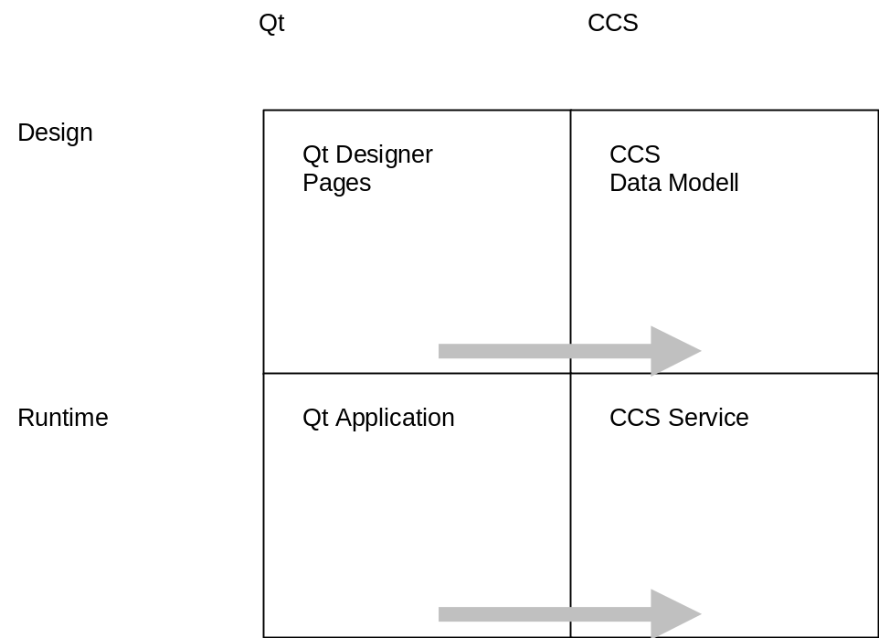
Fig. 1-1 Qt Visualization Framework

Parts of the Framework

CCS aware Qt Widgets
The Qt framework is extended with specific widgets that
- integrate the CCS interface in a simple and comfortable way.
- supply base infrastructure for a user function concept to freely integrate functionality to visualization screens by means of programming Ansi C user functions. Examples for user functions are plausibility functions, softkey or buttonclick functions or dark functions.

Page widget (CPage)
This widget is the starting point to create a new page of information containing widgets that enable showing and manipulating machine state using CCS variables. Container type widgets can be used to structure the layout of a page. Container widgets finally contain widgets to directly show or manipulate variables or to activate user functionality.

Frame widget (Cframe, Container)
A frame widget can be used to group coherent widgets.

Group Box widget (CgroupBox, Container)
Similar to the frame widget containing properties to add title information.

Push Button widget (CPushButton)
A push button is associated with a user function to be called when pushed (clicked). The layout of a push button can contain a textual description as well as a picture (icon) or both.

Tool Button widget (CToolButton)
Similar to the push button widget.

Fixtext widget (CFixtext)
A Fixtext widget displays fix textual information that is not associated with the state tof a variable.

Actual value widget (CActValue)
Shows the value of a variable as plain text.

Required value widget (CReqValue)
This is an input type widget that allows the manipulation of variable values.

Simple Graphic widget (CSimpleGraphic)
This is an experimental widget that shows value changes of a variable over time as a two dimensional graphical curve over time.

Character Push Button widget (CharPushButton)
Similar to the preceding button widgets for use in conjunction with a virtual keyboard.

Runtime System

Basic Dialog Structure
The model behind the basic dialog structure is a 2 level hierarchy of information. The runtime system offers a frame around a central information panel. The central information panel organizes page groups that contain a couple of pages.
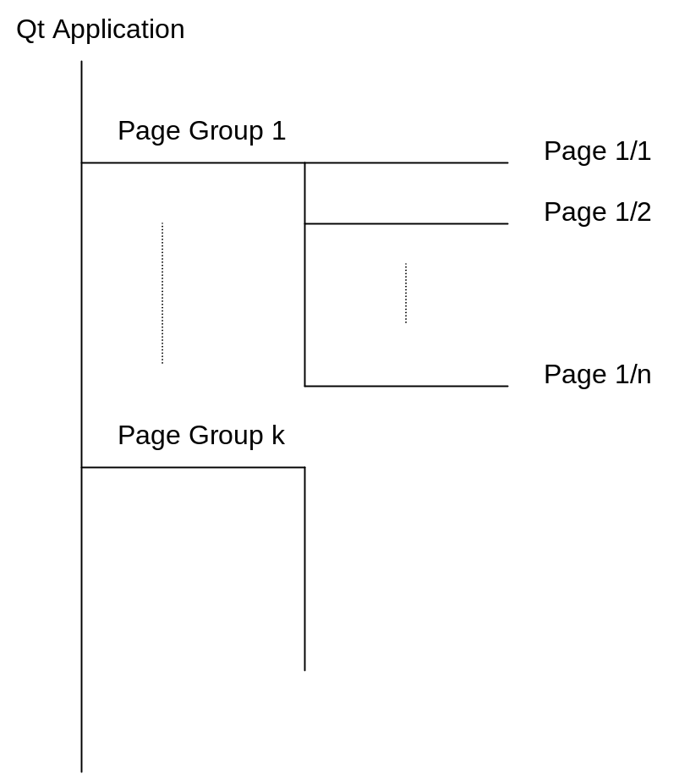
Fig. 2-1 Basic Dialog Structure

Additional Functionality
The following list outlines parts of the additional functionality supplied by the runtime system:
- Connecting to desired CCS service.
- Printing of arbitrary pages in background mode.
- Support for language switching.
- Support for an Alarm system.

Integration of the CCS Interface
In General the integration into the strictly C++ based Qt GUI building system is realized by using the CCS service C++ API. A description of this interface can be found in CCS Documentation CCSDoc.doc.

Integration of CCS interfaces into Qt aware Widgets
The integration into CCS aware widgets is done by using textual representations of variable references.
A variable reference denotes a specific data item in the variable space of a CCS service. The integration is shown in the following example:
ActTimMachCyc denotes the actual variable cycle time of an injection moulding machine. This variable must be modelled in the data model of the corresponding CCS service for example:
ActTimMachCyc ushort(1) // data type is ushort (fixed point decimal)
// dimension is seconds
vartype=act // this is an actual value
description="Cycle time" // textual description of the variable
map register ushort 0x72 // mapped to PPCCOM register 0x72
refresh=500 // actuality 500 milliseconds
;
When specifying ActTimMachCyc as variable name in a CCS aware widget internally a variable reference object is instantiated on start up of the runtime system. This variable is registered with the CCS service for data change notifications.
Figure 3-1 shows the procedure of connecting a CCS aware widget of type CactValue to the variable ActTimMachCyc of a CCS service. The steps to show the value of an arbitrary variable of the CCS service is reduced to the following steps:
- Start the designer and click the page where the value should be shown
- Pick a widget of type CActValue from the Toolbutton of the designer and place it somewhere on the desired page.
- Fill in the property Variable using the property editor of the Qt Designer.
This is all that must be done. After compiling and rebuilding a new runtime system the value of the desired variable cycle time of the machine will be refreshed whenever the state of this variable changes.
Note! An application programmer must not deal with refresh operations. Neither he has to specify refresh constraints nor he is forced to program refresh operations manually. All work is done by the CCS connection automatically set up for the widget. When there is no change in the value of the referenced variable, no system load will be generated to show new values when the variable state doesn’t change.
CCS keeps track of the state of this variable due to the specification made in the data model (check every 500 milliseconds for changes) and signals all interested clients if a data change has occurred.
The CCS aware widget of type CActValue automatically refreshes the value on the screen when signalled with a data change notification. This is one of the benefits of using CCS event channel technology.
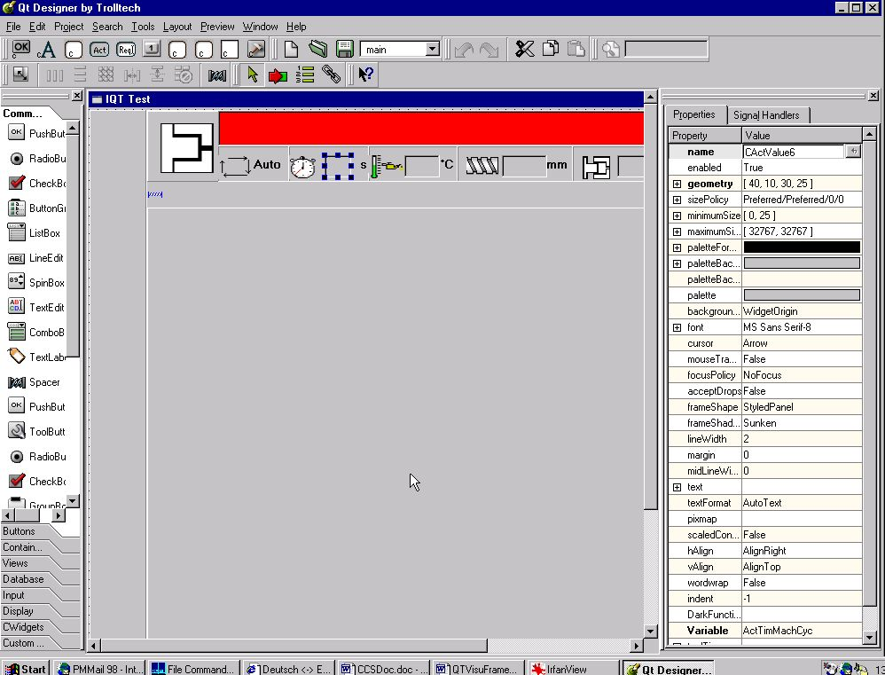
Fig. 3-1 Connecting a CCS aware widget to a CCS variable
The variable reference used in the above example is a reference to a non aggregated variable of the example data model. In this case the difference between variables and variable references is not obvious.
Using variable references to aggregated variables opens possibilities beyond referencing a simple name. These techniques are shown in the following chapter.

Advanced Techniques of Variable Referencing
An aggregated variable of the example data model is the variable SetTmpBrlZn containing all required values for all cylinder heat zones and all injection units of an injection moulding machine.
// macros for dimension sze
#macro InjUnits=8 #end
#macro InjHeatZones=9 #end
.
.
SetTmpBrlZn[InjUnits][InjHeatZones] short
// °C
vartype=set
description= "Required value of a cylinder heating zone"
map register ushort {0x72, 0x73, 0x74, 0x75, 0x76, 0x77, 0x78, 0x79, 0x7A,
0x92, 0x93, 0x94, 0x95, 0x96, 0x97, 0x98, 0x99, 0x9A,
0x202, 0x203, 0x204, 0x205, 0x206, 0x207, 0x208, 0x209, 0x20A,
0x22, 0x23, 0x24, 0x25, 0x26, 0x27, 0x28, 0x29, 0x2A,
0x52, 0x53, 0x54, 0x55, 0x56, 0x57, 0x58, 0x59, 0x5A,
0x82, 0x83, 0x84, 0x85, 0x86, 0x87, 0x88, 0x89, 0x8A,
0x42, 0x43, 0x44, 0x45, 0x46, 0x47, 0x48, 0x49, 0x4A,
0x502, 0x503, 0x504, 0x505, 0x506, 0x507, 0x508, 0x509, 0x50A,
0x512, 0x513, 0x514, 0x515, 0x516, 0x517, 0x518, 0x519, 0x51A}
// mapping to PPCCOM registers
refresh=10000 ; // actuality 10 seconds
A reference to a required value of one of these heating zones must be fully specified, that means both indices must be specified:
SetTmpBrlZn[0][5]
references heating zone no 5 of injection unit 0. This variable reference specifications denotes a fix temperature value to be selected.
Beside constant values a variable index can be specified by variable values of integer type or by user functions of integer return type. Assuming the existence of a user function Aggregate that delivers the number of a the actually selected injection unit:
ushort Aggregate(void);

SetTmpBrlZn[Aggregate()][5]
will now show heating value no 5 of the actually selected Injection Unit determined by the integer function Aggregate.
The same effect can be reached by using the value of another variable to select the first index of the variable reference. Assuming the existence of a CCS variable named Aggregat that contains the number of the actually selected injection unit to show:
Aggregate ushort;

SetTmpBrlZn[Aggregate][5]
will now show heating value no 5 of the actually selected injection unit determined by the value of integer type variable Aggregate.
Indices can be specified by arbitrary nested terms containing variable and function references. This mechanism of function and variable referencing supplies the basics for powerful multiplexing mechanisms that can be used designing pages that show values of an arbitrary number of objects of identical type without writing a single line of C or C++ source code (example: variables that are assigned to an injection unit of an injection moulding machine that has multiple injection units).

Integration into the Runtime System
The integration of the CCS interface into the runtime system is very simple. A start up code sequence interfaces to a CCS service instantiating the sync interface to the service and the back end interfaces of the associated event channels. For every event channel used by the CCS service one or more adapters of different types are created and registered with the back end of the event channels. The most important channel adapter is a data change adapter that handles data change notifications of the CCS service.
Every CCS aware widget that is created while setting up the screen is connected to the data change adapter.

User function concept of CCS aware Widgets
All user functions can be parametrized free with parameters of CCS base types. Every parameter can be a constant value, a function reference or a variable reference that resolves to the desired or a compatible type. All user functions are implemented as Ansi C functions.
User functions within the Qt Visualization Framework belong to 4 Classes of functions:

Dark functions
Dark functions are functions that decide if a widget will be visible, hidden or restricted. The concepts of dark functions takes into account the hierarchical parent-child structure between Qt widgets. This offers the possibility to hide the whole page or the whole frame within a page or a widget within a frame. As desired in a specific situation. Dark functions signal the desired state for the calling widget by returning a specific value (FREE, DARK, RESTRICTED).
A dark function can be specified with every CCS aware widget.

Plausibility functions
A plausibility function can be specified with an input widget to check the validity of user input. With this functional concept, input validity checking is not restricted to range checking.

Button functions
A button function is specified with so called action widgets like the push button widget or the tool button widget. When such a widget is pushed (clicked) the specified function reference will be called executing whatever is programmed within the function body.

Free user functions
Free user functions are not bound to a specific widget context. They can be freely declared and implemented. A typical usage are functions to determine indices of variable references as shown in chapter 3.2 Advanced Techniques of Variable Referencing.

Functionality of the Runtime System

Background Printing
To support background printing of pages two aspects come in consideration:
- A page exists as an identifiable object
- A page can be built in a graphic representation in the process background, that doesn’t affect the actual shown screen in either way.
Every page integrated into the Qt Visualization Framework can be identified and addressed by a page name. This offers the possibility to create a page list that can be recorded using user functions. Pages can be instantiated (built) and printed in background. The actually shown screen is not influenced by this operations.

Language Switching
The basic for language switching comes with the Qt. Qt offers a mechanism to enable dynamic translation of texts when running a Qt application. Additionally Qt offers tools to manage and translate texts into foreign languages including languages with fonts that need 16 bit representation.
These base mechanisms and tools are expanded by the Qt Visualization Framework to enable easy to use language online switching.

Logging, Protocol and Debug Support Functionality
The Qt Visualization Framework offers so called logger classes to assist logging in a way that can be configured for running Applications. The logging classes are designed to write logging output to different media or channels including console, serial ports parallel ports, sockets or files. These logging mechanisms can be easily extended to whatever application specific requirements.

Developing additional CCS aware Widgets
CCS aware widgets can be used to implement most of the simple tasks of visualization work. It is possible to place output and input widgets onto a visualization page. Functionality like input checking can be added straightforward by declaring and implementing specific user functions that are connected with the widget.
For more pretentious visualization and input mechanisms it may be a good choice to develop a new CCS aware widget that is more suitable to implement the intended task.
CCS aware widgets inherit from a base class called CWidgetBase. This base class integrates all CCS specific functionality like interfacing to CCS, parsing and instantiating variable and function references. Beside interfacing to the CCS service CWidgetBase contains the additional functionality for the integration of the user function concept.

Glossary
CCS aware widgets: CCS aware widgets are custom specific Qt widgets that are aware of the existence of CCS services. Technically spoken they incorporate an interface to a CCS service.

