Shacira
Whitepaper

Version 1.2, 18. August 2006
Projects: internal
Author: Peter Ritzmann
File: ShaciraWp.doc
Status: in progress
Copyright © 2003-2006 by
2i Industrial Informatics GmbH
Wirthstraße 7a
D-79110 Freiburg
Tel. +49 (0) 761 / 45205-0
Fax +49 (0) 761 / 45205-90
E-Mail info@2igmbh.de
www.2igmbh.de

1 General 3
2 Components of the Shacira Framework 4
2.1 Core Component Services (CCS) 4
2.2 CCS Clients 4
3 Core Component Services (CCS) 4
3.1 CCS Concepts 5
3.2 CCS Architecture 7
3.3 CCS Software Layers 7

General
Shacira (Scalable, High performant DAta and Control InfRAstructure) is a Visualization and Control Framework. Shacira is designed to overcome the drawbacks of classical Process Visualization (SCADA) systems.
- High costs per unit
- Platform Dependencies
- Poor performance for time critical control tasks or lightweight hardware components.
- Restricted Extendability
- Inadaquate programming interface for the integration of more sophisticated concepts.
To achieve these goals these items are directly addressed within the design of the framework. The framework design is strictly oriented in guidelines to fulfill following properties.
- Platform independence.
- Transparent distributability of functionality within processes and networks.
- Scalability with respect to ressource consumtion and functionality.
- Extendability of the base infrastructure is supported by well defined C++ Plugin interfaces.

Used Acronyms
CORBA: Common Object Request Broker Architecture
specification of the Object Request Broker Architecture, a plattform- and language-independent middleware.

Components of the Shacira Framework

Core Component Services (CCS)
The Shacira Core Component Services is a software layer that offers services that are strictly decoupled from application specific issues.
Anyhow this framework is extendable with application specific functionality and configurable for minimal system footprints.

CCS Clients
A CCS client is every part of software that requests or manipulates information from or in a CCS application in an event driven or syncchronous manner. A CCS client can register with a CCS service to receive events (data change notifications, error conditions, …) or directly manipulate data within managed by a CCS service.

User Interfaces
User interfaces are specific clients of CCS. They visualize state information available from CCS through powerfull Graphics functionality.
CCS places no restriction on the type of user interfaces to be used together with CCS.. As a consequence it is possible to integrate a wide range of technologies for GUI-Building

Core Component Services (CCS)
The CCS software layer is developed in C++ and contains platform specific abstraction layers to adapt to different platforms such as Linux, UNIX, Windows or others.
CCS integrates hardware and device related services and offers these services through well defined lean interfaces to interested clients.
CCS is configurable through base configuration files.
CCS can be adapted to application requirements using a device independent data model.
CCS can be functionally extended through clearly defined plugin interfaces (C++).
CCS services:
- Transparent data exchange with devices through drivers
- Caching of device data (configurable)
- Persistence management
- Event generation
- Housing of control programs.

CCS Concepts

Transparent distribution of functionality
The Scalability of CCS applications is supported by a flexible application model that is based on production cells. A production cell can be designed as view of a production process that is represented by potentially different interfaces to devices of the process environment (field bus, serial interfaces, ethernet …).
Production cells are processing units that can be distributed over a network. The distribution of production cells can be determined by the requirements of the production process (security, availability, overall costs …).

Data Modelling
All application specific functionality can be layered on top of an application specific data model that is accessible during runtime of the system. The data model itself is designed once and can be used by every client to store data, persist data and exchange data with devices. Nevertheless it can be used to implement application specific state data that is not mapped to external devices.
A Data model describes a set of variables and their properties such as
- Data Type
- Variable Type
- Variable Structure
- Persistence specification
- Device Mapping (if mapped)
- Cache strategy (if mapped)

Communication
Communication between clients and a CCS Application is based on 2 general communication mechanisms.
- Synchronous communication (Data Services)
- Asynchromous communication (Event Services)
A client of CCS is every Software that receives events from CCS via the Event Services or that is connected to CCS manipulating data by use of Data Services. The task a client serves is not restricted. In general a client is some type of user interface. Other client types are loggers, database backends and so on.
Both communication mechanisms are based on an abstract communication layer that is concretely implemented with respect to the underlying system (operating system and hardware) or other application-specific requirements.
The favorized implementation is based on CORBA. Some more implementations are:
- Local communication based on direct object access and internal message queues. This variant focuses on base systems with poor performance or no network access.
- TCP based communication

Data Services (Sync communication)
Data Services are specified in the following manner
- Everybody is able to send messages to an object
- The message is guaranteed to be delivered. If the message can not be delivered an error condition will be raised.
Data Services are the typical representation of a client – server communication.
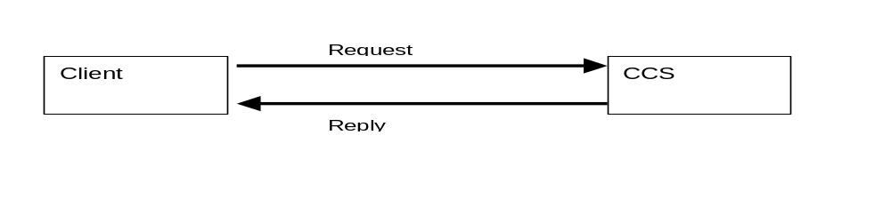

Event channels (Async communication)
An event channel is specified in the following manner
- Everybody is able to send messages to a specific evvent channel
- Everybody is able to receive messages from an event channel
- The message is not guaranteed to be delivered
An event channel is the typical representation of an m:n communication mechanism
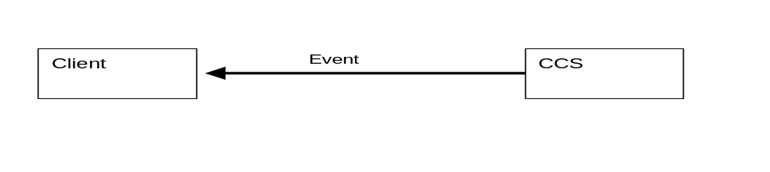
An example for async communication is notification for data changes. In this situation a client can register with an event channel to receive data change notifications whenever the value of a variable changes in CCS.

Adapter technology
Use of the Event Service interface is simplified through the use of a specific adapter technology. Adapters can be plugged to the end of event channels to serve specific tasks by deriving a very special adapter from the adapter base class.

CCS Architecture

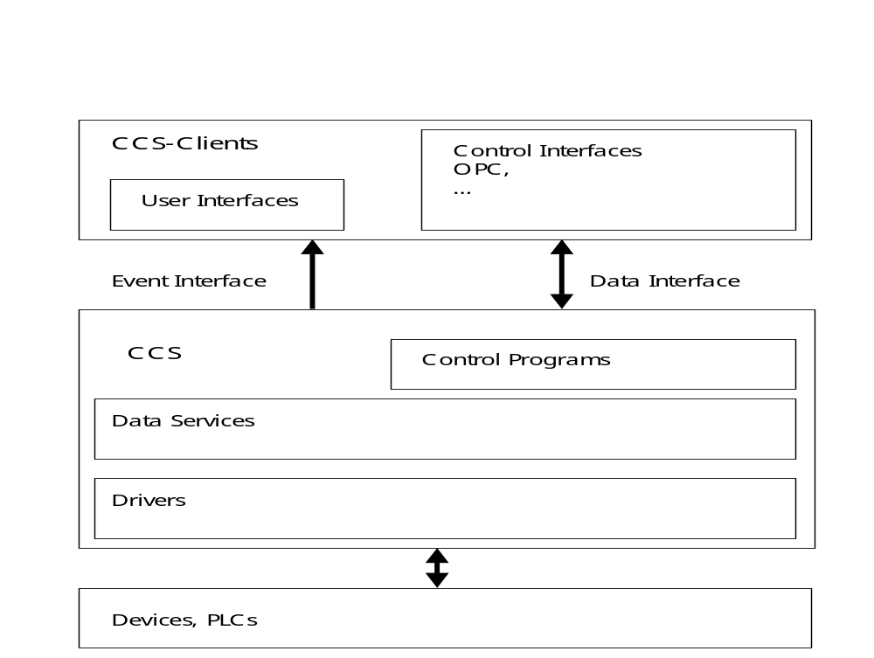
Fig. 3-1: Shacira System Architecture

CCS Software Layers

Control Programs
A control program is one of several possibilities used to extend CCS functionality.
Control programs enable aggregation of functionality to a context that extends atomic operations like setting and getting variable data.

Data Services
Data services are represented by a set of potentially structured Variables. Data services are set up creating an application specific Data Model at design time.
This process is determined by thinking about the variables a system engineer needs to fulfill system requirements and functionality. The result of this step is a view of the process to visualize and control in terms of Variables that are structured and typed.
Data Services offer the atomic functions to set and get variable data to control programs and clients.

Drivers
Drivers close the gap between variables and devices when a variable is mapped to a device (the mapping will be specified as part of the design process). A driver enables CCS to exchange data with a device due to the specified mapping.

